
Written Report
Accor Hotel Group

Md Jewel Ahmed (2117693)
Management & Organisational Behaviour (BMIH5004)
Jaliya De Sliva

Executive summary
The management has a strong influence on organisational behaviour, culture, structure, strategic goals, and performance. Organisational behaviour is an important element in adopting change, affecting daily operations, and achieving goals and commitments. An analysis of how management and organisational behaviour relate to the elements of organisational structure, cultures, change and strategic goals and objectives is provided herein. The report focuses on Accor Group Hotels and reviews its organisational structure, culture, and goals. Accor’s recent change initiatives are also examined before its strategic directions and business performance are audited. Recommendations are offered on how Accor can crystalise its change initiatives and forge a path to achieve its commitments and goals.

Table of Contents
Executive summary 1
Introduction 3
1.0 Accor’s Organisational Structure, Culture, and Goals 3
1.1 Organisational Structure 3
1.2 Culture 4
1.3 Goals 4
Accor’s Recent Change Initiatives 5
2.0 Accor’s Organisational Strategic Direction and Current Business Performances 8
2.1 Strategic Direction 8
2.2 Current Business Performances 8
Recommendations 9
Conclusion 10
References 11

Introduction
Management and organisational behaviour shape the culture, structure, change initiatives, and performance of organisations. Management is focused on the human, conceptual, and technical dimensions of companies and how they interact to obtain organisational success (Luthans et al. 2021, p.6). Managers should control organisational behaviour to capitalise on how change is facilitated, work is structured, teams are formed, jobs are designed, and employees’ differences and talents create a competitive advantage for organisations (Wagner III and Hollenbeck, 2020, p.1). The report focusses on the Accor Group Hotels’ management and organisational behaviour. A review and audit of Accor’s organisational structure, culture, goals, recent change initiatives, strategic direction, and current business performance is provided.

1.0 Accor’s Organisational Structure, Culture, and Goals

1.1 Organisational Structure
Accor recently revised its organisational structure to include two major divisions: The luxury and lifestyle division and the Economy, Midscale and premium division. The Luxury & Lifestyle Division covers 488 hotels globally and includes another 266 new properties in development (Accor, 2022). Given its name, the division focuses on luxury and lifestyle and is structured by four pillars brands: Ennismore, Sofitel & MGallery, Fairmont, and Raffles & Orient Express. The division is committed to investing in top talents, strengthening the iconic brand’s identities, and choosing the best locations to offer innovative and unique experiences. The Economy, Midscale & Premium Division has 4,816 hotels and another 948 new developing properties (Accor, 2022). The division will consolidate leadership positions in Asia-Pacific, Europe, Latin America, and the Middle East, while structured around regional headquarters in Singapore, Paris, Sao Paulo. The division will emphasise its strategy on brand rejuvenation, operating model industrialisation, and acceleration of Accor’s development enabled by its franchises (Accor, 2022). The restructuring aimed to attract the best talents, offer guests and owners relevant services and products, enhance financial and operational performance, and strengthen the organisation’s excellence in each of its business lines.
The divisions receive support from a global shared platform and a Group Management Board to provide services and expertise, including procurement, technology, and digital (Kostuch Media, 2023). With this structure, the organisation can address its market developments and accelerate growth, offer performance and clarity to its partners, enable effective and accurate fulfilment of guests expectations and needs, and provide service levels for all its stakeholder (Lodging, 2023). The restructuring aligns with Buchanan and Huczynski’s (2019, p. 125) assertion that for a business to be effective it needs to adjust its structure to consider the external factors.

1.2 Culture
Accor’s culture can be defined to include vital principles like willingness to illustrate transparency, increasing agility and capacity, bolstering employees’ responsibility, identifying and rewarding talented individuals, and creating new opportunities for the talented people to be innovative and generate new ideas (Camelia et al. 2019, p.90). The company’s culture is closely related to the organisation’s behaviour. Mullins and McLean (2019, p.4) define organisational behaviour as the prediction, comprehension, and control of people’s behaviour in an organisational setting. The managers and leaders in Accor had to predict, understand, and control employee’s behaviour to align them with the stated corporate culture. Also, some principles in the corporate culture relate to the functions of management. Taylor and Ciachir (2022, p.146) assert that one of the essential roles of human resource management (HRM) is maximising employee performance. The HRM would achieve this by providing opportunities for employees to grow their talents and skills to become innovative, rewarding their good performance, and promoting employee responsibility, as identified in the corporate culture.

1.3 Goals
Accor’s goals and commitments are grouped into three categories: people, operations, and food. Under the people category, Accor aims to offer unique opportunities for team members and local communities to grow, promote equity, diversity, and inclusion, and uphold human rights (Accor, 2023a). In buttressing sustainable hotel operations, the company aims to achieve net zero carbon emissions by 2050, grow its hotels’ energy efficiency, preserve water resources, recycle and reduce waste, and eliminate single-use plastic in its hotels. Commitments to achieving sustainability in the organisation’s food chain include fostering responsible and local sharing, eliminating food waste, changing eating habits, protecting biodiversity and natural ecosystems, and preserving local cultures and communities (Accor, 2023a). The organisation leaders will be at the centre stage of controlling organisation behaviour and employees’ commitment and activities to achieve these goals. Afsar et al. (2020, p.297) explains that responsible leaders will positively influence workers’ pro-environmental behaviour when the employees have a high internal environmental control locus.

Accor’s Recent Change Initiatives
One of the major challenges that Accor had to deal with was the threat digital disruptors like Airbnb posed to its business and industry. Airbnb entered the hospitality industry as a digital disruptor to change the shape of the industry and the form of acquiring guests. Digital disruptors resent a threat to the traditional hospitality industry since they are agile, innovative, fast in execution and rollout, and customer-centric (Wynn and Lam, 2023, p.501). Airbnb threatened hotel chains without owning any property. The digital disruptors are able to improve customer proposition using technology to provide better experiences, particularly to millennials, the tech-savvy generation, which emerged as the biggest consumer segment (Jelassi and Keller-Birrer, 2018, p.2). Accor realised the threat posed by Airbnb, especially considering that such digital disruptors could increase and affect hotel bookings. Therefore, the organisation embarked on a change initiative to transform from an asset-dependent, hierarchical company into an agile, dynamic, and fast-moving organisation (Accor, 2022).
The change initiative was a holistic process of digital transformation that followed a five-year plan focusing on three essential pillars. These pillars were a strong focus on the customer, a single, common mobile application for all hotels, and numerous ways to streamline the customer experience (Hernandez et al. 2018, pp.14-15). A way of achieving a customer-centric approach was extracting information from the customer database and utilising it to provide customised services for each client. Also, several tools were introduced to enhance customer experience at each stage to ensure a “seamless journey,” including online check-in like those in the airlines, one-click booking, and paperless payment among other (Jelassi and Keller-Birrer, 2018, p.2). Accor’s change initiative resembles the model of digital transformation for old companies as defined by Sebastian et al. (2020, p.133) who claims that the companies integrate the strategies of digitised solutions and customer engagement supported by the technology-enabled assets of digital services platform and an operational backbone.
Accor’s digital transformation initiative would go beyond IT modification. It required the transformation of its organisational structure and corporate culture. Accor was in competition with digital disruptors that were dynamic, agile, fast, and innovative. Therefore, it had to become more daring, faster, and flexible in execution and decision-making, which meant a fundamental change in employees’ and managers’ mindsets (Jelassi and Keller-Birrer, 2018, p.2). Fostering innovation required the management’s acceptance of the failure prospect. Accor (2023b) reorganised its international headquarters aiming to reinvent employees’ collaboration to support the organisation’s change from the inside. The new international headquarters premises had innovative technology and workspaces that improved connectivity everywhere.
Also, a change in organisational structure was required that aligned with the group CEO, Sebastian Bazin’s commitment to disrupt the organisation’s traditional approach. As part of the digital plan, the company’s codes had to be reviewed and challenged, since the company had not launched any new brands in three decades (Rach, 2018, p.4). This led to the creation of new flexible structures in the company’s Top-down hierarchy to promote flexibility, innovation, and speed. It saw the creation of a Chief Disruption and Growth Officer executive position, headed by a serial digital entrepreneur with responsibilities of identifying novel growth opportunities and fostering interactions with start-ups. A shadow Executive Committee was created and staffed with 12 millennials; six men and six women from 25 to 35 years, who worked as the “think tank” for innovation projects and helped the organisation to culturally transform and concentrate more on digital natives (Jelassi and Keller-Birrer, 2018, p.3). An Innovation Lab supported the Shadow Executive Committee in innovative projects, particularly focusing on creating new lifestyle brands for millennials. The structural change aligned with what Armstrong (2020, p.2) defines as vertical integration of performance management where team, business, and individual objectives (of digital transformation) are aligned with core competencies (of digital skills and innovative ideas). Also, the structural change to accommodate digital transformation aligns with Hanelt et al.’s (2021, p.1159) argument that digital transformation makes firms adopt flexible organisational designs to support continuous adaptation driven by and embedded in digital business ecosystems.
The change initiative was well-managed and executed with the implementation of various disruptive ideas aimed at millennials. One of these innovative ideas from the Marketing Innovation Lab is the creation of the Jo&Joe lifestyle brand, a groundbreaking hospitality concept described as an “open house,” with a unique environment blending the best of private hotel, hostel, and rental formats. Accor (2018) aimed to open 50 Jo&Joe venues in various fashionable destinations globally by 2020. More venues are still in development today. Accor (2023b) would also enter the digital economy through acquisitions, acquiring a 30% stake in Oasis Collections, an American rentals platform, a 49% stake in Squarebreak, a digital platform with specialisation in upscale villas, and complete ownership of onefinestay.com, a UK-based digital platform with specialisation in luxury apartments. More acquisitions would follow suit. With these and other similar lifestyle brands and acquisitions, Accor has now achieved the designation of an agile, dynamic, and fast-moving company. The change initiative also enabled the company to complete efficiently with digital disruptors like Airbnb.
Jelassi and Keller-Birrer (2018, p.4) analysed how companies can respond to digital disruptors after reviewing Accor’s change initiative and case study. Organisations start with understanding the market, digital disruptors, and the consumer before creating a vision and strategy to respond to the digital disruptors’ threat. The created strategy defines the structural, digital, and cultural transformation, with the structural and cultural changes directly affecting the resulting digital transformation. With these changes in place, the company can generate and execute internal and external innovative ideas. The process is summarised in the following chart.
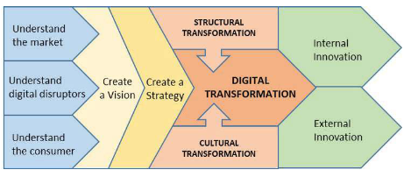
Figure 1: Strategic response to digital disruptors
Source: (Jelassi and Keller-Birrer, 2018, p.4)

2.0 Accor’s Organisational Strategic Direction and Current Business Performances

2.1 Strategic Direction
Accor’s strategic direction focuses on delivering value more than the hotel experience. The organisation seeks to design the lifestyle and travel experience of tomorrow by constantly being present in customers’ daily lives and offering premium and unique services. Accor is an augmented hospitality group and a performance-oriented brand that generates value for employees, partners and owners. The organisation is focused on powering the hospitality business with a holistic ecosystem of solutions, talents, and brands supported by four brand pillars maximising performance, empowering talent, fostering innovation and acting for good in the environmental, social, and ethical engagements ( Accor, 2019). Management’s role is stated to be important in creating and achieving strategic direction. Tipuric, (2020, p.323) claims that managerial and leadership skills are required to achieve the visionary and innovative actions of the strategic direction.

2.2 Current Business Performances
Accor’s business performance has been positive in the current year. Positive increases and business trends were observed in the second quarter of 2023 in the company’s two divisions, while the hotel demand from business and leisure guests remained strong. The company recorded increases in occupancy rates and average room rates. During the first half of the year, the organisation opened 114 new hotels with 14,500 rooms, indicating a unit growth of 3.5% in the last dozen months (Accor, 2023c). By the end of June 2023, Accor had a portfolio of 5,487 hotels with 805,436 rooms and 1,252 new hotels in development that will account for 217,000 additional rooms. Revenue for the first half (H1) of 2023 was €2,402 million, an increase of 35% from H1 2022 (Accor, 2023c). The growth resulted from a 40% increase in the Luxury and Lifestyle division and a 34% increase in the Premium, Midscale and Economy divisions. The Luxury division produced €174 million in EBITDA, while the Premium, Midscale, and Economy division created €330 million in EBITDA in H1 2023, showing significant increases from H1 2022.This resulted in a net profit of €248 million in H1 2023 which substantially differed from €32 million in H1 2023, as indicated in the following table (Accor, 2023c).
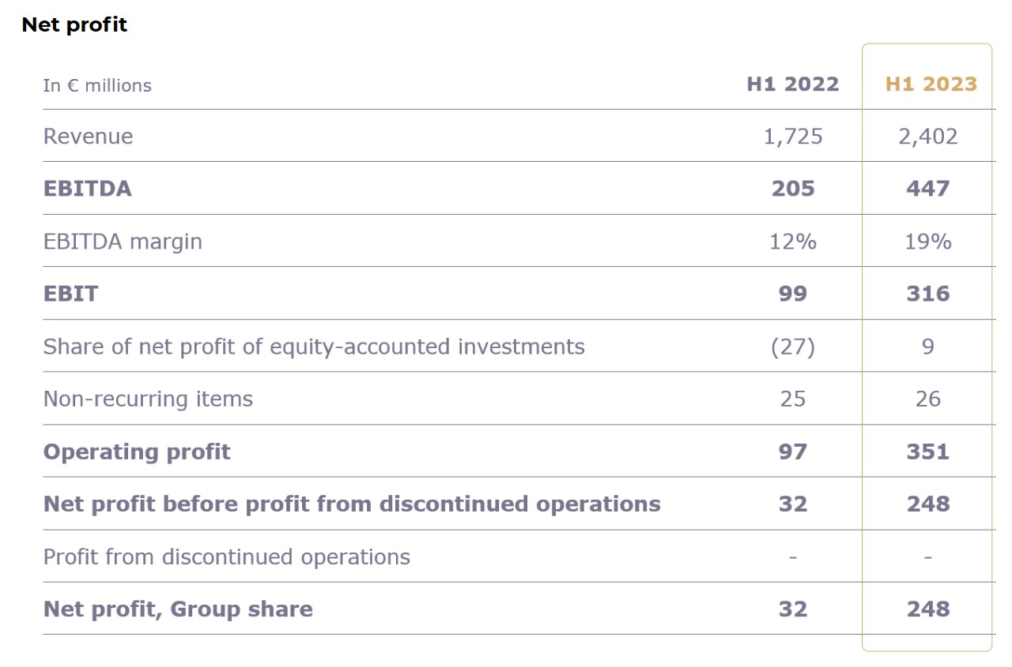
Table 1: Accor’s Net Profit in H1 2023
Source: (Accor, 2023c)

Recommendations
Accor’s excellent performance is a reflection of its successful leadership and management in implementing change and encouraging innovation among its employees. Also, positive aspects are noted in the organisation’s culture, its commitments, and strategic objectives. The management should consider the following recommendations to solidify change and help its employees achieve the pre-determined goals and strategic objectives.
- Create a network of leaders and followers to woo people into adopting the change that has meaning to its members (McChrystal et al. 2018, p.23). This will create a widening network movement from the top-down hierarchical order and also integrate partners, suppliers and other relevant stakeholders.
- Focus on establishing a value foundation before enacting the technical change elements (Satell, 2019). A supportive culture will enable the adoption of change that will last for a long time.

Conclusion
The report has illustrated how Accor’s management has controlled the organisation and the employees to restructure the business, modernise the culture, implement successful change initiatives, and adopt ambitious strategic directions and goals. The review and audit of the management function and organisation behaviour illustrate the importance of management in improving organisations by leveraging on its culture, organisational behaviour, and the talent of its employees.

References
Accor, (2018). How JO&JOE enhances travel experiences. Available at: https://group.accor.com/en/Actualites/2018/11/skift-jo-joe-report-creative-renaissance-europe (Accessed: 11 November 2023).
Accor, (2019). The new Accor strategy. Available at: https://group.accor.com/en/Actualites/2019/03/strategy-all-accor-live-limitless-sebastien-bazin (Accessed: 10 November 2023).
Accor, (2022). Accor continues to transform and simplify its structure by leveraging its leadership positions in the most buoyant hospitality markets and segments. Available at: https://press.accor.com/accor-continues-to-transform-and-simplify-its-structure-by-leveraging-its-leadership-positions-in-the-most-buoyant-hospitality-markets-and-segments/?lang=en (Accessed: 09 November 2023).
Accor, (2023a). People & Commitment. Available at: https://group.accor.com/en/commitment/areas-focus/people (Accessed 09 November 2023).
Accor, (2023b). Our history. Available at: https://group.accor.com/en/group/who-we-are/our-history (Accessed: 09 November 2023).
Accor, (2023c). Solid activity growth raised full-year guidance. Available at: https://press.accor.com/solid-activity-growthraised-full-year-guidance/ (Accessed: 11 November 2023).
Afsar, B., et al. (2020). Responsible leadership and employee's proenvironmental behavior: The role of organizational commitment, green shared vision, and internal environmental locus of control. Corporate Social Responsibility and Environmental Management, 27(1), pp.297-312.
Armstrong, M., (2020). Performance management: Key strategies and practical guidelines. Kogan Page. Available at: https://fliphtml5.com/vryon/vlrh/Michael-Armstrong-Performance-Management_-Key-Strategies-and-Practical-Guidelines-Kogan-Page-2006/157/ (Accessed: 10 November 2023).
Buchanan, D.A. and Huczynski, A., (2019). Organizational behaviour. Pearson UK.
Camelia, G., et al. (2019). Organizational culture: A case study of the impact of ethical organizational culture on the efficiency of Accor Hotels. Romanian Economic and Business Review, 14(2), pp.86-96.
Hanelt, A., et al. (2021). A systematic review of the literature on digital transformation: Insights and implications for strategy and organizational change. Journal of Management Studies, 58(5), pp.1159-1197.
Hernandez, J.J., et al. (2018). Tomorrow’s Experience, Today: Harnessing a Customer First Approach in a Changing World. KPMG Global Customer Experience Excellence Report (November 10), Available at: https://assets.kpmg.com/content/dam/kpmg/xx/pdf/2018/06/tomorrows-experience-today-harnessing-a-customer-first-approach.pdf (Accessed: 11 November 2023).
Jelassi, T. and Keller-Birrer, V., (2018). In the field with Accor hotels. Institute for Management Development, Research & Knowledge, 3(17), pp.1-4. Available at: https://imd.widen.net/view/pdf/8xmssziqw1/in-the-field-accorhotels-mp-20.11.17.pdf (Accessed: 09 November 2023).
Kostuch Media, (2023). Accor unveils a new organizational structure. Available at: https://www.hoteliermagazine.com/accor-unveils-new-organization-structure/?cn-reloaded=1 (Accessed: 09 November 2023).
Lodging, (2023). Accor begins implementation of new organizational structure. Available at: https://lodgingmagazine.com/accor-implements-new-organizational-structure/ (Accessed: 09 November 2023).
Luthans, F., et al. (2021). Organizational behavior: An evidence-based approach fourteenth edition. IAP.
McChrystal, S., Eggers, J., and Mangone, J., (2018). Leaders: Myth and Reality. Penguin Books Limited
Mullins, L.J. and McLean, J.E., (2019). Organisational behaviour in the workplace. Harlow: Pearson.
Rach, L., (2018). AccorHotels: A study in innovation and transformation. Available at: http://corpcom.bestwestern.com/AccorHotels%20Case%20Updated%20for%20District%20Meetings%20.pdf (Accessed: 10 November 2023).
Satell, G., (2019). 4 tips for managing organizational change. Available at: https://hbr.org/2019/08/4-tips-for-managing-organizational-change (Accessed: 12 November 2023).
Sebastian, I.M., et al. (2020). How big old companies navigate digital transformation. In Strategic information management (pp. 133-150). Routledge.
Taylor, S. and Ciachir, C., (2022). Improving organisational performance. Human Resource Management: People and Organisations, pp.145-171.
Tipurić, D., (2022). The Enactment of Strategic Leadership: A Critical Perspective (p. 323). Springer Nature.
Wagner III, J.A. and Hollenbeck, J.R., (2020). Organizational behaviour: Securing competitive advantage. Routledge.
Wynn, M. and Lam, C., (2023). Digitalisation and IT strategy in the hospitality industry. Systems, 11(10), p.501.

