Indigenous People:

Restricted Employment?
Sarah Marsh

SJSS6005

August 2020
Faculty of Education & Communities

DECLARATION

I am satisfied that this work is the result of the Student’s effort.

Signed Phillip Morgan
(Lecturer)

Date 05.08.2020

DECLARATION FORM



Name of the Programme of Study:

Name of Student (Capital Letters):

DECLARATION

I certify that the whole of this work is the result of my individual effort, and that all sources have been acknowledged.

Signed .........Sarah Marsh...................................................... (Student)

Date 4.8.2020...............................................................

DECLARATION

I am satisfied that this work is the result of the Student’s effort.

Signed Phillip Morgan
(Lecturer)

Date 05.08.2020

CONTENTS 2
ACKNOWLEDGEMENTS 3
ABSTRACT 3
ACRONYM 3
1. LITERATURE REVIEW 16
1.1. Introduction 16
1.2. Historical Perspectives of Civil Abuse 16
The Civil Rights Journey 16
2.1. Colonialisation 16
2.2. Cultural Impacts 16
2.4. Reparation 16
2.. Conclusion 16
3. RESULTS AND DISCUSSION 17
3.4. Traditional Work versus Employability 17
4. CONCLUSION AND RECOMMENDATIONS 18
5. REFERENCES 19
6. APPENDICES 20
6.1. Appendices 1 xxxxx 21
6.2. Appendices 2 xxx 22

ACKNOWLEDGEMENTS

I acknowledge the scholars, historians and current researchers who have provided the facts information and images which enabled me to carry out this work, learning about the lives of Indigenous peoples. I further acknowledge that the terms and descriptions of Aboriginal and Indigenous Peoples that are occasionally referenced in this work are those of the times in which they were written and are now considered offensive. These do not reflect the opinion or values of myself.

I would like to thank my fellow students for sharing their IT knowledge and advice with me during the writing of this paper and supporting me generally. Thank you to my family
member Amanda Beth Lines, resident and teacher in Perth, West Australia who steered me in the right direction to find authentic, relevant, and trustworthy sources for my research. I will be forever grateful to my older son Ashley Lawrence Marsh who in 2018 stoically undertook a road trip over 4.5 kilometres with me through some of the most beautiful yet inhospitable parts of the Western Australian outback in a very small camper van. This trip ignited my interest in the lives of Indigenous Australians struggling to survive , providing a glimpse of what life looked like when the sheep large stations existed with their labourers, utilising the local shops, looking past the surviving the grand houses, horse troughs on the main streets and dirt tacks to travel on.

Last but by no means least I wish to express my sincere thanks to my lecturers Joanne Davies, Ken Dicks and Phillip Morgan, who individually played their part encouraging me to follow my intuition to research this paper, advising me where needed but never criticising. I acknowledge their skills, guidance, pastoral support, and experience when working with a diverse cohort in what became a nightmare final semester due to the global pandemic of Covid 19.

Thank You All

ABSTRACT
Much is read about racial tension across the global continents and is often seen in high profile news items and in the press. What of Australia? Other than the recent horrific bush fires and currently the Covid 19 news, little is read or heard about Australia and the issues that rage within the White Australian and First Nations Australians.
This paper provides and overview of the far-reaching effects of Colonisation, Stolen Generations and the desire of the Aboriginal and Indigenous Peoples of Australia to retain their cultural ties against the possible distortion of what the general populous of Australia deems to be the desired lifestyle.
Using a variety of literature – online articles, government reports, autobiographic accounts, and reference books, the work explores the depth of feeling of the Stolen Generations and Colonialisation, and the ongoing issues that contribute to the present day situation regarding high unemployment poor infrastructure and overall negative connotations with Aboriginal and Indigenous Peoples.
This work has been completed with observation from the world of a White Welsh person who also has experience life in a small Principality in the UK. In comparison the five-hour journey from one end of the Principality does not compare with the four-day journey that covers a fraction of the West Coast and Mangers can have a four-hour flight to attend a meeting in the same State.
Aboriginal and Indigenous school age children living in remote areas may complete their education on-line with an annual visit from a teacher employed at the School of the Air.
It is impossible to imagine living a life with such huge difference in life.
The available research is relatively old with few statistics and little data being available beyond 2006, that contained in this work is displayed with a caveat that there are few papers written that guarantee Aboriginal and Indigenous People’s participation.

‘How deprived we would have been if we had been willing
To let things stay as they were.
We would have survived,
But not as a whole people,
We would neve have known our place’.

Sally Morgan (1987)

ACRONYM

ACARA Australian Curriculum and Reporting Authority
AHRC Australian Human Rights Commission
AIATSIA Australian Institute of Aboriginal and Torres Straits Islanders Authority
AIHW Australian Institute of Health and Welfare
ATSIP Aboriginal and Torres Straits Indigenous Peoples

CAR Council for Aboriginal Reconciliation
CDP Community Development Programme
CEP Community Employment Programme
COAG Council of Australian Governments

DRIPS Declaration upon the Human Rights of Indigenous Peoples.
UN United Nations

INTRODUCTION

1.1

In compliance with The Human Rights Resolution (United Nations General Assembly, 2006) Declaration of the Rights of Indigenous Peoples (DRIPS) and research protocols ; I Sarah Marsh fully recognise and acknowledge the rights therein of Article 31.1 DRIPS

“Indigenous peoples have the right, without discrimination, to the improvement of their economic and social conditions, including inter alia, in the areas of education, employment, vocational training and retraining, housing, sanitation, health and social security ” ( DRIPS 2007). The first such day took place in 1998 when a report entitled ‘Bringing them Home’ acknowledged that Aboriginal children had been forcibly removed from their families and homelands between 1905 and 1967 (The Independent 2018).”

The statement below was spoken by the then Australian Prime Minister Kevin Rudd on 13th February 2008 and later became to be known as ‘the sorry statement’ statements which are suggestive that both Indigenous and non - Indigenous Australians live on an equal footing

‘We apologise for the laws and policies of successive Parliaments and governments that have inflicted profound grief, suffering and loss on these our fellow Australians. We apologise especially for the removal of Aboriginal and Torres Strait Islander children from their families, their communities and their country’ (National Museum of Australia 2008).

Larissa Behrendt (2012) questions if this ‘symbolic change’ will impact on Indigenous Australian People’s lives and awaits to see if this will be the case,

This paper will examine the historical context in which Aboriginal and Indigenous Islanders have been prevented from participating in everyday inclusive life in Australia. In order to put the 21st century alleged discrimination against the Aboriginal and Torres Straits islanders into perspective it is important briefly illustrate the oppression that has taken place during and since British colonisation and the apparent disregard for the cultural practices and spiritual importance that Indigenous Peoples place on their homelands. Worsened by the fragmentation of Australia’s government and the differentiation between states and federation.

An article published in 2018 by Australian Broadcasting Corporation carried the headline ‘Indigenous Communities slapped with more fines under the Government work-for-the-dole scheme, data shows ‘ (Connifer, D. Casper, A. 2018). The data within the article was acquired by a freedom of information request and highlights the difficulties the mandatory Community Development Program (CDP) caused in some of the remote areas. This will be discussed further during this paper “Disturbing new data reveals the impact Australia's flagship remote employment program is having on Indigenous people across the country, prompting claims it is worsening poverty in communities” (Conifer and Kesper 2018).
Crucially important to this is the way in which Australia is currently governed; briefly demonstrating the differences between state and federate legislative practices and compare policies between different states.

The Australian States and its government system.
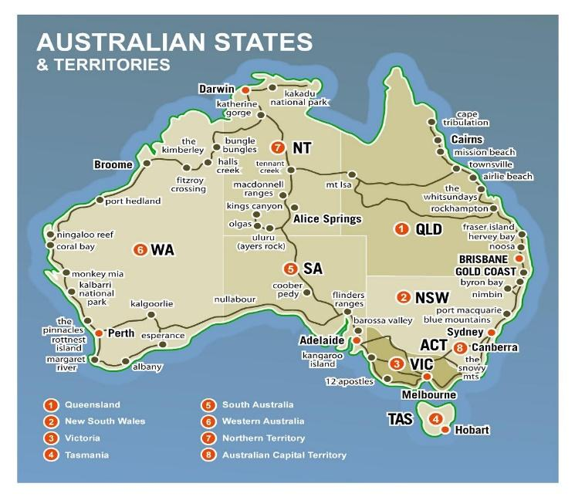Mapsland 2020

As can be noted from the above map there are eight states in Australia which is in fact a Federation. Section 51 of the Australian Constitution (Parliament of Australia, no date) sets down that New South Wales (NSW), Victoria (Vic), Tasmania (Tas), South Australia (SA), Western Australia (WA), and Queensland (QLD) each have their own constitutions (Library of Congress 2015). When discussing the differences in government between states and federations Tickner (2001) refers to Queensland ‘assaulting the rights of the Aboriginal people’. This means that each state can, where necessary, produce its own legislation. Australia has a constitution that provides – three arms of government, Parliament, The Executive Government, and the Judiciary, each of these bodies is allowed to investigate and overrule the other. (Parliament of Australia 2019). Each state has its own government system. These can vary considerably this can be evidenced when comparing various employment strategies.

New South Wales as an example released its Aboriginal Employment Strategy (2019 – 2022), (New South Wales Government Justice, (2018). Whereas in the state of Victoria, Victoria State Government, Health and Human Services 2020 produced its own strategy Aboriginal Employment Strategy 2016 -2021 ( Maddocks 2006).

The paper will critically explore existing information and research (Quantitative and/or qualitative) data, in order to investigate and analyse information and statistics, journal articles and industry journals related to the available employment, health and well-being of the Aboriginal and Torres Straits Indigenous peoples of Australia.

1.2
HISTORICAL CIVIL ABUSE
THE CIVIL RIGHTS JOURNEY AND TIMELINE
The timeline of events illustrated below affecting the rights of Aboriginal and Torres Straits Islanders Indigenous Peoples of Australia. (ATSIP), demonstrated the struggle ATSIP of Australia experienced to become recognised Tickner (2001) referring to the ‘European Invasion in 1788 after Cook first landed on Australian soil that Aboriginal people after living on the land for 50,000 years lost control of their lives becoming oppressed by the European bureaucracy until mid-1960s being subjected to massacres, dispossession of lands, removal of children and prohibition from speaking their own languages, living in their own culture.
The British Government did not perceive the privileges of Aboriginal and Torres Strait Islander people groups and exceptional association with land. Rather, they guaranteed the land for the British Crown and pronounce that Australia is land terra nullius – land having a place without an owner.
1901 The Commonwealth of Australia was formed
1932 William Cooper built up the Australian Aborigines' League. During the 1930s, Mr Cooper and other leaders of the Aborigines Progressive Association gathered 1,814 signatures on a petition addressed Prime Minister Joseph Lyons and King George VI to intervene “for the preservation of our race from extinction and to grant representation to our race in the Federal Parliament".
1938 The Aborigines Progressive Association and the Australian Aborigines' League announce that 26 January will be a day of mourning for Aboriginal individuals.
1948 The Commonwealth Nationality and Citizenship Act conferred the class of 'Australian Citizenship' to all Australians, including Aboriginal and Torres Strait Islander people groups, for the first time.
1962 The Commonwealth Electoral Act was amended to give the vote to all Aboriginal and Torres Straits Islander people groups at Federal elections.
1963 Yolngu pioneers presented the Yirrkala bark petitions to the Australian Parliament, dissenting against the seizure of in excess of 300 square kilometres of Aboriginal land in Arnhem Land for mining.
1965 University of Sydney student, rode the Freedom Rides, voyaging around NSW by bus to draw attention to the discrimination and oppression of Aboriginal individuals.
1967 On May 27, more than 90 percent of Australians voted 'yes' in a choice to give the Australian Government the ability to make laws for Aboriginal people groups and to incorporate Native individuals in the Census.
1972 January: The Aboriginal Tent Embassy was erected outside Parliament House Canberra, crusading for the acknowledgment of Aboriginal land rights.
1975 December: The Australian Government formed the Department of 1975 Aboriginal Affairs.
1975 The Australian Parliament passed the Racial Discrimination Act to help Australians of all background,
1976 Patricia (Pat) O’Shane became Australia’s first Aboriginal councilor
which led to the establishment of Land Rights legislation in most Australian states.
1985 Uluru was handed back to its Traditional Owners.
1988 The Barunga Statement, called for self-management and land rights for Aboriginal and Torres Strait Islander peoples, is presented to Prime Minister Bob Hawke, who indicates his support for a treaty.
1991 The Royal Commission into Aboriginal Deaths in Custody presented its final report into the deaths of 99 Aboriginal and Torres Strait Islander people in Australian jails.
The Council for Aboriginal Reconciliation (CAR) is established.
1992 The High Court recognised native title in the landmark Mabo v Queensland (No.2) (1992), overturning the myth of terra nullius.
Prime Minister Paul Keating delivered the ‘Redfern Speech’ recognising the history of
dispossession, violence and forced removal of Aboriginal children.
The Aboriginal and Torres Strait Islander Social Justice Commissioner position was created, Professor Mick Dodson AM appointed to the position.
1993 The United Nations declared 1993 the International Year of the World’s Indigenous People.
Australian Parliament passed the Native Title Act.
1995 The Australian Government officially recognised the Aboriginal and Torres Strait Islander flags.
1996 Council for Aboriginal Reconciliation (CAR) launched Australia’s first National Reconciliation Week.
1997 The National Inquiry into the Separation of Aboriginal and Torres Strait Islander Children from their Families released the Bringing them Home report.
1999 The Australian Reconciliation Conference was held in Melbourne.
1998 National Sorry Day commemorated for the first time on 26 May, the day on which the report Bringing them Home was tabled in Parliament.
2000 The Council for Aboriginal Reconciliation (CAR) delivered its final report to Prime Minister John Howard and the Australian Parliament at Corroboree 2000.
May: Approximately 300,000 people walked across Sydney Harbour Bridge as part of National Reconciliation Week, showing support for the reconciliation process.
2004 The Commonwealth Government establishes a memorial to the Stolen Generations at Reconciliation Place in Canberra.
2006 The Close the Gap campaign for Indigenous health equality is developed following the release of the Social Justice Report.
2005.Reconciliation Australia’s Reconciliation Action Plan programme was launched..
2008 Prime Minister Kevin Rudd formally apologises to the Stolen Generations on behalf of the Australian Parliament.
COAG – Council of Australian Governments committed $4.6 billion towards Closing the Gap on Indigenous Disadvantage for projects in health, housing, early childhood development, economic participation, and remote service delivery.
2009 Australia supported the United Nations Declaration on the Rights of Indigenous People.
2010 The National Congress of Australia’s First Peoples was established.
2012 The campaign to recognise Aboriginal and Torres Strait Islander peoples in the Australian Constitution began.
2013 The Australian Parliament passes the Aboriginal and Torres Strait Islander Peoples Recognition Act 2013 to maintain momentum towards a referendum.
2015 The Referendum Council was established.
2016 Reconciliation Australia released the State of Reconciliation in Australia report. (National Reconciliation Week 2017). The aim of this list was two-fold to shed light on the length of time taken to recognise the rights of Indigenous peoples in Australia and to pinpoint the apparent recognition that had taken place in the country.

If one selects and expands upon certain major events through the timeline of the battle for civil rights for the Aboriginal and Torres Straits Islanders it can be observed that the progress has been piecemeal with decades between major events, this highlights can be said to be evidence of the need for a consistent and ‘joined up approach to the disparate needs of the Indigenous peoples.

2 . Colonisation
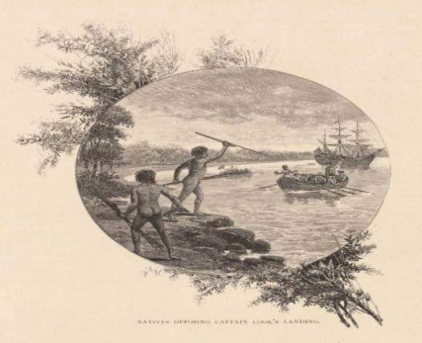 Britannica .com

The above image titled Natives Opposing Captain Cook’s Landing is a lithograph by W. (William) MacLeod, 1888, kept at the National Library of Australia. It showed the Aboriginal peoples attempting to stop the landings of Cook’s Endeavour. The first meeting of Aboriginal peoples and ‘white man’ Geoffrey Parsons in 1947 ; the meeting being between William Dampier, an English buccaneer and pirate in 1688 off the North West Coast of Australia. Dampier described the “Aborigines as the lowest race on earth” Parsons, G (1947).

Parsons states that the ‘Aborigines’ had overcome extreme hardships in an unforgiving land to establish social groups, tribes, clans and totemic groups, practicing exogamous marriage. It is further stated that these marriages took place under strict rules> The ‘Aborigines’ imposed strict sexual morality. Food was shared communally and in accordance with the rules of the elders of the clans. The clans and tribes lived off the land, carrying out sacred rituals in the belief that the land would repay in an abundance of food. Thus. the establishment of sacred grounds and spirits which characterises so much of Indigenous People’s histories characterised by both the practical and spiritual importance of land within the culture,
Parsons (1947) describes the colonisation by ‘White Europeans’ as the continent being stolen from the Aborigines because they had not been recognised as having any legal title to their lands .
In his essay Spitzer, A. J. (2019) raises a point that in order to set out boundaries within the parameters of Settle Colonialism ‘the people’ have to decide where the boundaries are set, but who are ‘the people’? The incoming settlers/invaders or the established ‘natives’ who have been described as non-human Tickner, R (2001). Parsons (1947) continues in his work, to describe the horrific treatment of ‘Aborigines’ being indiscriminately shot, their land and crops eaten by the imported cattle, their hunting dogs shot; others were put to work for no pay. From 1860s to 1901 ‘Aboriginal life continued to be poor, with their population declining from approximately 180,000 in 1860 to fewer than 95,000 in 1900 (Encyclopædia Britannica 2020). The reasons for this being attributed to the European settlers' belief in their racial superiority although the levels of violence varied from state to state with more ‘half caste’ children being born in the more liberal south. (id).

In the early 20th Century most governments in Australia continued to rule in an authoritarian fashion negatively towards the Aborigines., In 1932 the Australian Aboriginals League (AAL) was formed as a mainly political organisation the motto a ‘fair deal for the dark race’ was adopted .The most noteworthy success of the ALL was the establishing of A Day of Mourning which commemorates the sesquicentenary of Australian colonisation of the Aboriginal natives Bain, Attwood (2004). However, the organisation had little success in achieving a better quality of life. During the 1830s the British Colonial Government created Pastoral Leases, these allowed squatters who has merely taken over land without leasing from the government, to now lease the land for a rent which depended on the numbers of animals being farmed. Aboriginal peoples were not consulted about the taking of their lands, but now the land had a form of legality attached to it and the Aboriginal people were further being forced to give up their sacred land and were being forced away from towns into rural areas thus losing their communities Behrendt, L. (2012).
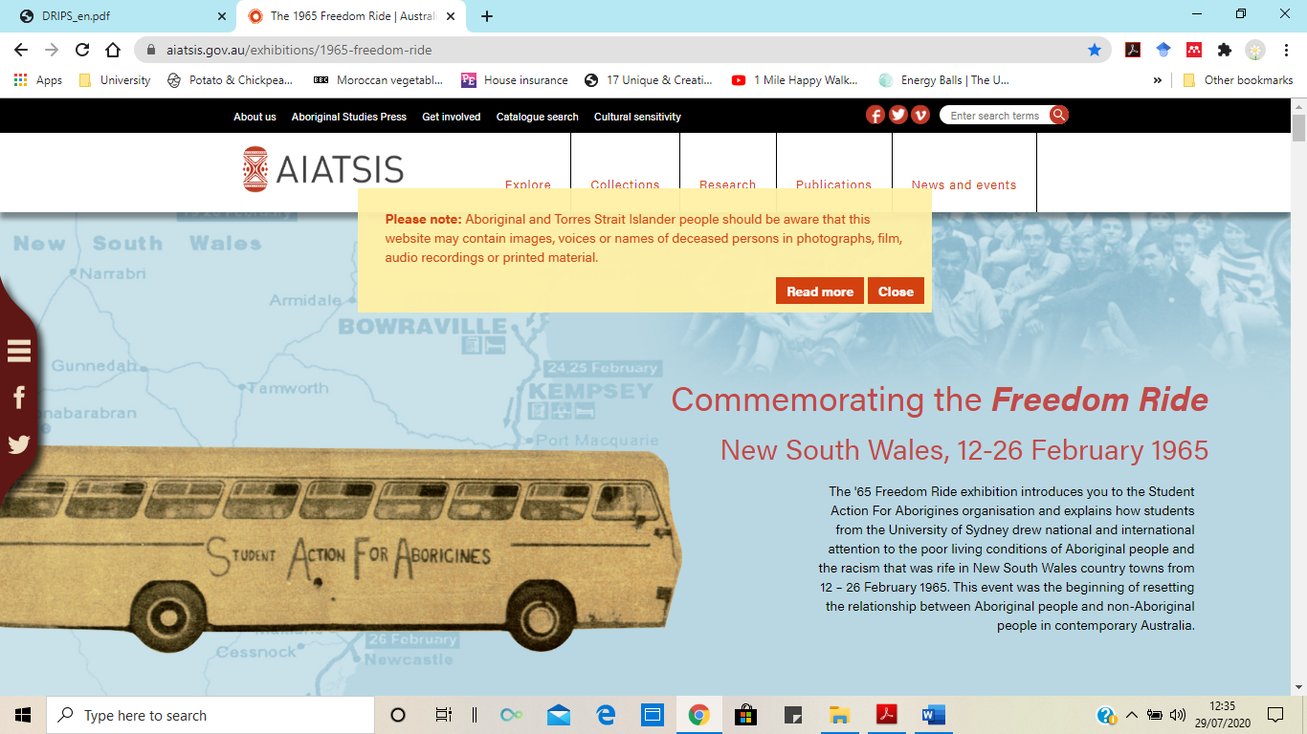
Although the Aboriginal peoples are still living segregated lives in 1945 Australian Citizenship

was conferred upon all Australians including Aboriginal and Torres Strait islanders, this was slowly followed by the right to vote at federal elections being consented. Although these actions appear to be moving in the right direction Aboriginal people at street level were being discriminated against and existed in poor conditions in and around the New South Wales region, and not being allowed to use public amenities such as swimming pools and public houses. This was brought to attention when in February 1965 several students from Sydney university organised and participated in The Freedom Ride to highlight these issues. A description of which is below (AIATS 2015). The illustration description of the freedom rides which included the AIATS warning on the page that refers to content which may distress Indigenous Peoples.

The Freedom Ride highlighted certain aspects such as living conditions and discrimination such as children not being allowed into the towns’ swimming pools and called at these towns. Demonstrating peacefully, the Ride organiser Charles Perkins recalled ‘ when we got down to the pool I said, ‘ I want a ticket for myself and these ten Aboriginal kids behind me. Here’s the money, ‘ Sorry darkies not allowed in’. Said the Manager’ (AIATSIS 2015). Perkins stated that the group of students blocked the entrance to the swimming pool, crowds of people gathered, eventually the children were let in but the pool closed two hours early. Also, in the mid-sixties advances were made in that a protest took place in Gurindigi against poor living conditions and the land rights for Aboriginal peoples. In the 1960s, Australians voted by 90.77% to allow Aboriginal people to be counted in the nation census. Equal pay was enforced for Aboriginal stockmen. A ‘tent’ embassy was established in front of Parliament house where a newly designed Aboriginal flag was flown (Tickner, R. 2001).

Moving into the 1970s it is important to note the growth of the mining industry, the acquisition of sacred Aboriginal lands, and subsequent disregard of the importance of said land to the Indigenous peoples in terms of their belief and culture, having already been forced live in reservations away from their communities and these lands ( Tickner, R, 2001, DRIPS 2008). The contributions both positive and negative will be referred to at a later point.

In 1985 Uluru was handed back to its Traditional Owners, the Indigenous People of Australia. Also known by its non- traditional name as Ayers Rock, this iconic and sacred site to climb it even installing a chain for assistance ( M. Gray 2020), (Appendices),

It is not possible to ignore the historical facts of the stolen generation that took place between 1900 and 1970 and comment will be made in other parts of the writing acknowledging that this took place, linking this to the possible subsequent health issues of descendants of this Stolen Generation, the 1987 the Bringing them Home Report and ‘The Sorry Speech’.
‘Are we going to have a population of 1,000,000 Blacks in the Commonwealth , or are we going to assimilate them into our white community and eventually forget that there were ever any Aborigines in Australia’ Neville, A. O (1937).

This statement epitomised the colonial belief that Aboriginal Peoples were inferior to white people. He supported the removal of ‘half caste’ children into foster care, institutional homes, and adoption by white people, believing that by removing the full-blood black aboriginal adults who were trained and put into service or manual labour, they would eventually die and the absorption of mixed race ‘half caste’ children into white households would cause the Aboriginal characteristics to be bred out. Astonishingly Neville was a civil servant who in 1915 was appointed as Chief Protector of Aborigines believing that the Aboriginals needed to be saved from themselves Kurbegovic, E, Leung C. (2013). This forcible removal of mixed-race children became to be known as The Stolen Generations. The practice of removing children was carried out long before it became policy Behrendt (2003) in the mistaken belief that Aboriginal people would die out and that mixed-race people/children would live better lives if they were white, to the extent that in certain states. s mixed – race women were only allowed to marry white men. In her autobiography Sally Morgan (1987) recalls the moment she realised that she is Aboriginal not Indian as she had been told by her mother - in a discussion with her sister, Morgan’s sister tells her “Boongs, we’re Boongs” . ‘I could see that Jill was unhappy with the idea. It took me a few moments to summon the courage to say, What’s a Boong?’ On learning that this was slang for being Aboriginal Morgan (1987) wrote ‘I suddenly understood, there was a great deal of stigma attached to being Aboriginal at our school. If they want to run you down they just say “Ah, you’re just a Boong”.
The removal of children was not discontinued until 1970, the year in which Kinchela Aboriginal Boys Training home was closed. Several reports carried out stated that they home did not fulfil requirements, alleging that boys placed there suffered extreme psychological, physical, and sexual abuse. At the time of its closure the home housed 600 boys. Upon ‘leaving’ Kinchela Boys Home, the boys’ troubles did not end there. Institutionalisation and the legacies of their treatment have resulted in ongoing pain and trauma for survivors, their families, and communities KBHAC (2020).
Whilst much planning was being carried out, it was not until 2005 that the national programme of reconciliation began. Although the Council of Aboriginal Reconciliation had been formed in 1995 it was not until 2000 at the Corroboree (a celebration of important events , singing and dancing performed by Aboriginal peoples), that its final report was presented, the council was then dissolved in 2001.

2.1 Cultural Impact
In 1905 the first Commonwealth Census took place, however the Census and Statistics Act, when establishing the Australian Bureau ,did not include AATSI peoples leaving the definition of who qualifies open-ended. At that time it was decided by the Federal Attorney General that ‘half-caste natives’ were not Aboriginal as described in section 127 of the Australian Constitution which state ‘in reckoning the numbers of the people of the commonwealth or State, or other part of the commonwealth, Aboriginals shall not be counted as stated by Arcioni in their article contained within Federal Law Review (no date).This section was repealed in 1967. 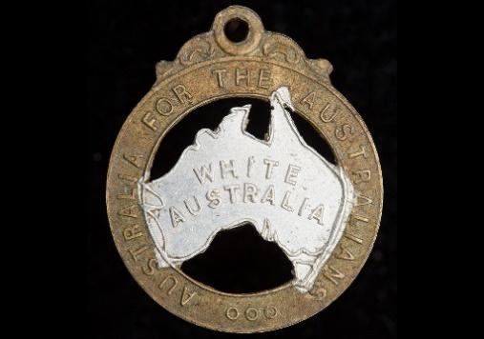

Census reports prior to 1967 could be considered unreliable when researching the numbers of people who identified as being Aboriginal. There is little evidence of population statistics pertaining to Aboriginal and Torres Straights Islanders beyond the 2016 Census.
The latest available statistics from the Australian Bureau of Statistics(ABS) are detailed in the table below.
Aboriginal and Torres Strait Islander peoples
 |  |  | 2016 | 2011
Total Aboriginal and Torres Strait Islander population |  |  | 649,200 | 548,400
% of total Australian Population |  |  | 2.8% | 2.5%
Median age |  |  | 23 | 21
Sex | Male |  | 322,171 (49.6%) | 270,333 (49.3%)
Sex | Female |  | 326,996 (50.4%) | 278,039 (50.7%)
State of residence | NSW |  | 216,176 | 172,625
 | QLD |  | 186,482 | 155,826
 | WA |  | 75,978 | 69,664
 | NT |  | 58,248 | 56,779
 | VIC |  | 47,788 | 37,992
 | SA |  | 34,184 | 30,432
 | TAS |  | 23,572 | 19,625
 | ACT |  | 6,508 | 5,184
Languages spoken at home (other than English) %
Arnhem Land and Daly River Region Languages | 1. |  | 16.1% | 18.2%
Torres Strait Island Languages | 2. |  | 11.7% | 11.0%
Western Desert Languages | 3. |  | 11.1% | 14.0%
Yolngu Matha | 4. |  | 10.6% | 11.2%
Median household income (weekly) |  |  | $1,203 | $991

ABS 2020
The information contained therein, indicates an overall increase in the population of AATSI persons in all states but decrease in the numbers of Aboriginal languages spoken. United Nations (UN)(2019) reports two Indigenous languages are lost every month.
United Nations (2019).

During the year of International Indigenous Languages (2019), Tijjani Muhhamad – Bande the President of the General Assembly outlined the importance of Indigenous language to their Native speakers, commenting that “With the death of languages, the indigenous people who speak them lose a significant part of their identity”, UN (2019). The loss of cultural languages could also affect and limit employment opportunities stated Oscar nominated Actress and UNESCO Goodwill Ambassador for Indigenous Peoples Yalitza Aparicio (UN 2019). ,
It must not be forgotten that Australia is a huge land mass with some areas still not easily accessible by transport, some areas need permission from Indigenous councils to enter.
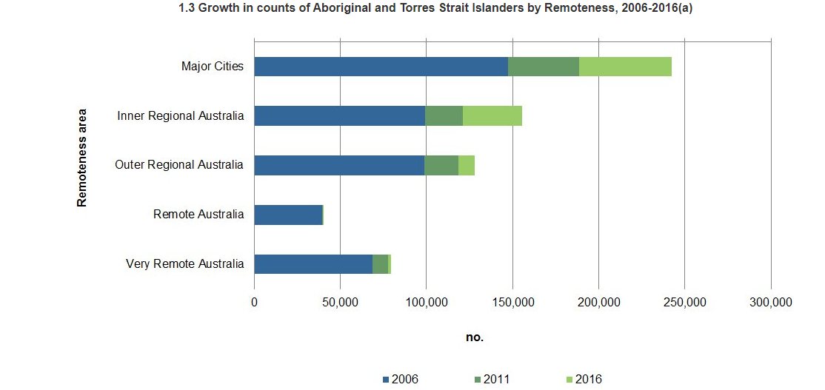
Australian Bureau of Statistics 2020

The above image clearly shows a clear shift to leaving more remote areas of Australia into the major cities, could this be related to the loss of languages commented upon at the United Nations Year of the International Indigenous Language Conference.

It must not be forgotten that Australia is a huge land mass with some areas still not easily accessible by transport, some areas need permission from Indigenous councils to enter.

‘Today Indigenous people still live right across Australia in a diversity of Circumstances. Close knit communities thrive in urban areas…… some Aboriginal people live in remote communities and on remote outstations where a family group sets up camp often away from the broader community.
Behrendt (2012)

Although those living in the most remote areas have adopted some aspects of 21st century life including wearing clothes and using four-wheel drive vehicles and using satellite technology, mainly out of necessity due to the remoteness of the areas, Behrent (2012). further writes that aspects of traditional life still remain such as traditional food, family closeness and relations within different communities as well as the spiritual connections with the land and the well-known cultural practices of communicating the Aboriginal Art. Below is a table that illustrates some generalised comparison of differences in outlook that can occur between Aboriginal peoples and European peoples.

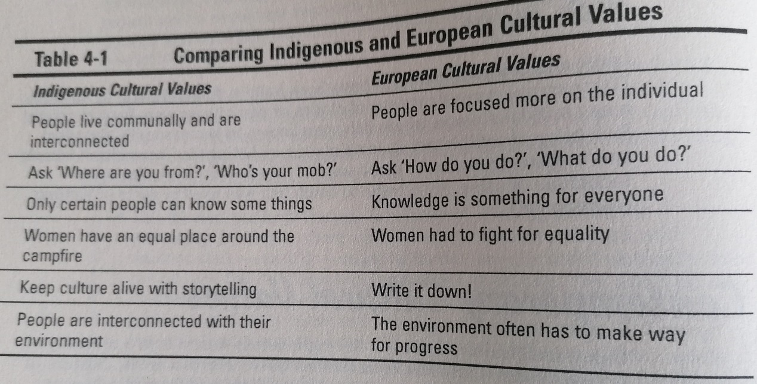

Behrendt (2012)

Overall the European column demonstrates a colder uncaring approach with no apparent connection to land, ‘it’s about me’, whilst the phrase on the indigenous column, only certain people can know somethings may refer to information staying where it is need and that could include family and community.

Using Hofstede insights of country ratings, the details of which can be translated from business to daily living Australia, with the caveat that no details have been provided as to the participation of Aboriginal of Torres Straits Islanders , it can be noted the highest rating is for Individualism , this would indicate that Australians possess a ‘looking after ourselves culture within their communities and families, it could be argued that Aboriginal and Torres straits islanders are being deprived of that right by not being allowed to live as they wish within their own culture that is heavily depended on the land, and their languages.
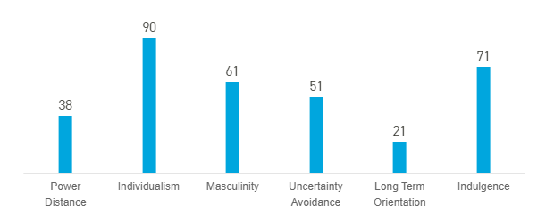Hofstede Insights 2020

Masculinity at 61 percent indicates an almost neutral result which could translate into the ancestry and descendance of the traditional hunter gather male, but also referring back to the earlier statement of ‘women having a place at the campfire’ i.e. being treated as equals. Contraindication could reign in the figure of Indulgence traditional Aboriginal values concentrated the culture, land, community, and survival and to a large extent this still remains. The work of Dudgeon et al, suggests that :-

‘There is agreement that Aboriginal identity is predicated upon descent and country of origin, about knowing and being a part of an Indigenous community and perceiving oneself as Indigenous. Descent does not necessarily pertain ‘to genetics as inherited essential characteristics but to the historical connection that leads back to the land and which claims a particular history’

Dudgeon, et al (2010)

It is important to note that it is impossible to determine how many Aboriginal or Indigenous people were participatory in this research, which could well affect such outcomes as Masculinity and uncertainty , there are no indications for opinions devolved to Indigenous and non- Indigenous Australians . It is also important to keep in mind , Hofstede Insights refer to commercial and business disciplines. The results yielded some interesting findings. Contrary to expectations when reading the figures for uncertainty avoidance Australia returned a midline figure of 51 this figure relates to people’s realisations of knowing that the future cannot be predicted however Hofstede (2020) states ‘the extent to which the members of a culture feel threatened by ambiguous or unknown situations and have created beliefs and institutions that try to avoid these’ could be interpreted that AAITSI peoples have been attempting to do just this by lobbying and fighting for the return of their own lands and maintaining their own culture to make a future for their Nation. A question could be asked whether or not they are such a minority that the figures do not count? Several findings of this study warrant further discussion, such as the rating of only 21 for the dimension relating to long term orientation indication that Australia has a normative culture, wishing to maintain its tradition, link to the past and viewing change as suspicious Hofstede (2020). This would indicate that both Indigenous and non-indigenous Australians are in agreement over this dimension. The ways in which this outlook may affect employment will discussed in further chapters.

The illustration below indicates the extent of land that was stolen from the Aboriginal peoples and how little has been returned. John Altman (2014), Emeritus Professor at University of Canberra justifies this in the following way at a seminar using much the same logic as the British did during the colonisation of Australia.

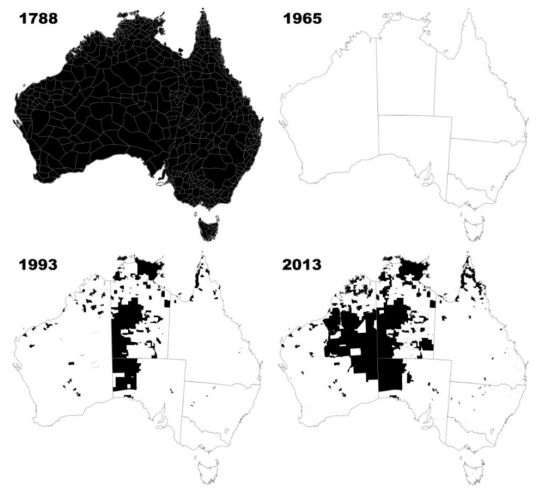 Altman (2014)
‘that native Australians were regarded as too savage or primitive to be landowners.
These peoples had no notion or practice, what we term today institutions, of land ownership in the western way and no government, again in western terms.
The land was deemed unoccupied although clearly this was not the case.
And finally and most importantly it was argued that as hunter-gatherers, indigenous Australians did not employ agricultural practices and so a Lockean logic, the labour theory of property was mobilised to justify dispossession—those who did not till the land productively had lesser ownership rights in it’.
Altman (2014)

Altman (2014) argues that the assimilation and removal of Aboriginal families/children was/still is an acceptable practice, however Calm in their 2009 report the catastrophic effects these actions had and continue to have for those associated with them, writing of loss of language and culture for those children who had been removed and the onset of poor mental health, alcohol misuse and suicides among Aboriginal and Indigenous Peoples . Atkinson, et al (no date), discuss the effects of transgenerational trauma on the descendants of the ‘stolen children’ as individuals and communities as a whole, suggesting that unresolved traumas from the past have manifested in antisocial behaviours in the present,

‘research also demonstrated a link between government policies and interventions, including the removal of Aboriginal children and behaviours associated with trauma experiences in Aboriginal people. These policies and interventions did so much damage, although they were often presented as bureaucratic generosity to people who were frequently living in clear distress’.

Atkinson et al (no date).
2.3 Reparation and Reconciliation .

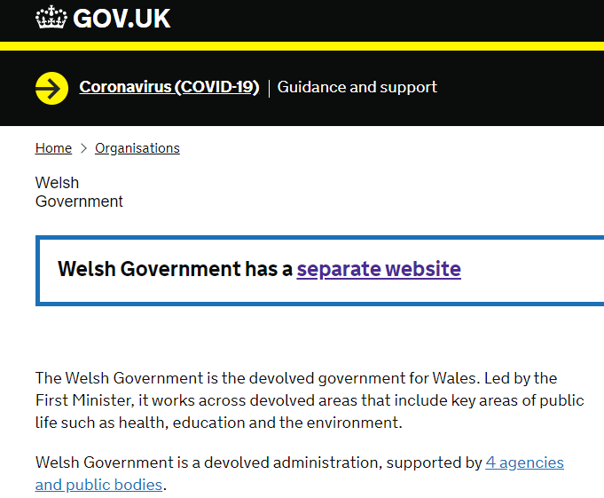
Examining the colonisation of Australia through the lens of a mature white Welsh person, living in a Principality within Great Britain valuing their heritage; it is not difficult to understand a Indigenous peoples wish to maintain their languages and cultures. The Welsh are also a Proud Nation with ancient roots dialects national emblems and a national costume; most importantly it is a devolved Principality setting out Welsh legislation. The atrocities that were carried out against the First Nations in Australia present as totally abhorrent and an attempt at extinguishing an entire nation. Phrases such as ‘ Australian Aborigines not

regarded as humans’ …… having no souls consequently not murder to kill them Wright (1947) ere written as a transcript for Australian Communist Review.

How does one make reparations for attitudes such as those reported above which resulted in the deaths of hundreds of thousands of people (ibd 1947)?

Reparation -‘ 1. the act of making up for something wrong that has been done. 2. Money paid or something done for this purpose 3. Compensation paid after a war by a defeated nation for the damage caused’ Chambers (1999).

Perhaps if one was speaking of the rebuilding of solid structures destroyed in war time, money could be considered to be partly acceptable to rebuild, however here the First Nations lost sacred lands, loved ones, and were forced into an programme of assimilation – to breed out their culture and black skin. On Friday December 12th, 2012, the Australian Human Rights Commission published the Government response to the Stolen Generations report – Bringing Them Home. Phillip Rudock MP, Minister for Immigration and Rural Affairs, opened his speech with the traditional Aboriginal Land acknowledgement which all persons, leading a meeting on Aboriginal land must do.

In his speech Rudock appears to do no more than acknowledge the difficulties of the past, putting forward ideas of what government ‘should’ do and addresses the difficulties of how this will be to accomplish the only tangible response he reported was that the Commonwealth Government showed its commitment to the reparation process by providing $A117M as funding for what was considered to be the most important aspect which was that of linking up families who had been split during the forcible removal of children during the assimilation process. He further states that it would not be feasible in any form to consider cases of compensation for the trauma and damage caused to people stating that no countries in similar circumstances such as New Zealand and South Africa had considered this (ibd 2012). However, The Department of Aboriginal Affairs (New South Wales Government) in 2017, launched a funeral assistance scheme which consists of a one off payment of $A7,000 in addition to the payment of $A75,000 payable to ‘living Stolen Generations Survivors who were removed from their families and ‘committed to the care of NSW Aborigines Protection or Welfare Boards, before 1969 an d still living on 2nd December 2016 ( the date the scheme was launched. The scheme expires in 2022. People in receipt of the scheme are eligible to request a personal apology from a representative of the New South Wales Government.

Reconciliation … - usually putting people back on friendly terms again, this is the approximate wording used in Collins (1999).

‘ Reconciliation is regularly invoked as a familial and fraternal embrace between settlers and Aboriginal people, in contrast to republicism’s ‘manly’ rejection of the mother country’s embrace’.

Probyn-Rapsey (2013).

Reconciliation Australia , a not for profit organisation aims to empower Australians to move forward, progressing and building trust between Aboriginal and Indigenous Peoples and non - Indigenous Peoples. Its lengthy constitution goes beyond equity and diversity by setting down an aim that includes the phrase ‘experience respectful relationships and have their history accepted in our nation’s story’, Reconciliation Australia (2016). One could argue that many non-Indigenous Australians will accept the story but not as the organisation would like. Our vision of reconciliation is based and measured on five dimensions: historical acceptance; race relations; equality and equity; institutional integrity and unity. (ibd 2016) Probyn-Rapsey (2013) argues that Aboriginal peoples have been denied not only not being embraced by non-indigenous Australians but also historically by being embraced by the national assimilation policies, and contests that by attempting to embrace the Indigenous nations reconciliation is being made more difficult and is in fact the opposite of reconciliation by not acknowledging the Indigenous cultures as a separate and valuable identity. Spigelman ( a Freedom Rider) cited in Probyn-Rapsey (2013) referred to the 2005 Charles Perkins Memorial Oration that millions of Australians have aboriginal ancestors, and that they should identify them to progress the Reconciliation process. This could be thought of as alluding to true ancestry rising up rather than being accepted and embraced by non-indigenous Australians.

My main goal in this section has been to determine whether on the basis of investigation so far, reconciling Aboriginal and Torres Straits Islanders can be achieved, My conclusion is that whilst the political stance remains static in the first quarter of the 21st Century then no, reparation and reconciliation will not be achieved. Tickner (2001) commented that any initiatives Ruddock undertook in support of indigenous issues regarding health and well-being , would need full support from the Prime Minister of the time John Howard who in Tickner’s words was full of empty rhetoric. (ibd 2001). Today 2020 Australia is in turmoil, politically, financially, and environmentally having a Prime Minister who appeared to go on holiday whilst his country burned due to bush-fires and is currently in the grips of a global pandemic. At a conference in Perth in 2008, The speaker Warren Baird described two colleagues ………….. ‘Tom Calma, my boss, and Katie Kiss an Indigenous colleague of mine’. They further went on to give robust suggested as to how best progress a project ‘ … education and information in plain English, then giving an explanation of a scheme ‘As a result of native title and state and territory land regimes Indigenous Australians have control to some degree, at a conservative estimate, of around 20% of the land-mass of Australia Human Rights (2020). The writer would suggest that this terminology is inappropriate for the platform in which it was used questioning the necessity of pointing out their Indigenous colleague? Using plain English to cascade information and Indigenous peoples having ‘some degree’ of control of land.

2. 5 Self - Perpetuation versus Culture
To what extent can Altman (2014) be considered as speaking an element of truth or indeed should they be dismissed as yet another illustration of colonial white Anglo society of the colonial and post-colonial era? Are the indigenous Australians in fact contributing to their own issues of being discriminated against by wishing to retain their identity as First Nations, Indigenous Peoples? The aim of this paper is to discuss evidence that Indigenous Peoples of Australia may be at risk of reduced opportunity of employment. How much of this if any is attributable to ‘clinging’ to the ‘old ways’? Firstly, consider the preferred way of referring to people with Aboriginal and Torres Strait Islanders, in this work the phrases Aborigine, Aboriginal, First Nations, Indigenous, Australian, Boong. There are many more, most of which have no place in today’s society except if used by Indigenous peoples themselves such as Blackfella and Whitefella. The term Indigenous although still used internationally and a government levels is not entirely popular as it is considered to cover all indigenous peoples e.g. Inuit, Maori, North American Indian rather than individual peoples Peters and Mika (2017). The terms Aboriginal and Torres Straits Islanders are often grouped together but indeed refer to separate groups of peoples entirely. The term Aboriginal refers to people from mainland Australia, whilst Torres Straits islanders could live in any one of nearly two hundred and fifty islands north of Australia Common Ground (no date). The term Aborigine is now considered offensive due to its Colonial connotations and the fact that it is a noun whereas Aboriginal gives the correct impression that there are many diverse tribes with their own identities and languages. First Nations describes exactly that the Aboriginal and Torres Straits Islanders are the first peoples of Australia (ibid no date).

The main aim of this section is to investigate how the traditions and cultural norms that represent the pride of the Aboriginal and Torres Straits Islands could be seen to impede their journey into employment. This section will be sub divided into sub sections .

Kinship Systems, Language.

Kinship is a system of relationship dynamics which has strong implications within the A original and Torres Straights Islanders lives. It sets outs parameters of how people relate to one another their roles, responsibilities and how the environments related to one another.
“The basis of the kinship system was that the Aborigines regarded their whole group as a family. Thus, the terms for family members, such as mother, father, brother, sister, uncle, aunt, were extended to everyone in the tribe. Everyone was well aware of who their blood mother and father were, but they called other people by these names as well. For instance, your mother's sisters would also be your mothers, and your father's brothers would also be your father”
Broome (1994)

Traditional legal systems existed within Aboriginal culture whereby matters were decided by elders – those who had “proved to be the most intelligent, diligent and conformist in the long period of learning the secret knowledge of the tribe which lasted until middle age “ (ibid1994).
Within the Kinships systems are three ‘foundations ‘ of kinships- moiety meaning that
the same moiety as another person means having to reciprocally support that person , however those two people are not able to marry (Australians Together 2020).

Totems
Each person has several totems representing their clan, tribe, nation and personal. There are not owned, people are accountable to them and must look after them.
“Totems are split between Moieties to create a balance of use and protection. For example, while members of one Moiety protect and conserve the animal, members of the other Moiety may eat and use the animal” (ibid 2020).

Lastly another form of kinship is skin name, these are names which are given to new borns, unlike their sound these are names that are pre-ordained sequentially either patrilineal or matrilineal and sequentially so husbands, wives and children do not have the same surnames, however the names are linked familiarly, and show generational links and gender L. Riley (2014). In their YouTube broadcast Riley explains the seemingly complex yet simple methods of skin names and the importance of these bonds in today’s society. Many of these rules are strongly adhered to including what is described as social distances and avoidance relationships which could have relevance in a working relationship for example a son-in-law may not be in the same room or car together Australians Together (2020).

Language.
It has been noted that many of the indigenous languages are being lost, it was not until 2009 , the first time in Australian history the Commonwealth Government launched a strategy setting out actions to target the preservation of Indigenous Languages namely; Indigenous Languages – A National Approach, (National Approach). This report was commissioned as the result of the previous National Indigenous Surveys Report 2005 (Survey Report). The Australian Human Rights Commission in its 2009 Social Justice Report noted that prior to the commencement of the report over 250 languages which sub divided into 600 hundred dialects had existed with fewer than 18 languages in existence at the time of the report, some of those being endangered. It is worth noting that in 2009, the life expectance of those remain languages was given as only 10 to 30 years.

‘Responsibility for Indigenous languages currently sits with the Federal Government. The Department for Environment Heritage and the Arts provides the funding for language resource centres across Australian and for language revival and language maintenance programmes’.
Calma, T (2009).

The report acknowledges the that loss of language affects the potential for employment within the Aboriginal and Torres Straits Islanders for example cultural knowledge including that of the environment is traditionally passed through generations in the language of that nation or tribe. This knowledge is informing the preservation of Australian bio-diversity systems that are coming under threat more and more due to extremes of weather (ibd2009). Alongside this traditional cultural education there is a need for more formal education within the Education system.
In addition, children’s education the need for adults to retain and maintain their language to be able to connect with themselves to maintain their own wellbeing

3. Conclusion
Despite differences in political and cultural stances which have been present since Australia was first discovered and subsequently colonised, there are areas of agreement that the Australian and Indigenous Peoples of Australia have been othered , oppressed and have had little opportunity to be acknowledged or recognised as a nation despite relevant legislations being passed. This can be evidenced by the propensity of legislation in each state (which will be discussed later in this paper). A number of scholars have acknowledged the fact that currently The First Nations Population still appears to be struggling to be heard this phenomenon is affecting lives culture equity of opportunity. In his final chapter Tickner (2001)states ‘ Above all else, people of goodwill, both indigenous and non-indigenous must take a stand to ensure there is no turning back.

4. Introduction
This section deals with education for First Nations children, and employment opportunities for Indigenous Peoples. Education for Aboriginal children is somewhat fragmented by remoteness and very little opportunity for indigenous children to include their culture into education barring a small entry in the curriculum for indigenous studies. Brief comparison will be made from a selection of employment sectors. Majorly the mining industry which not only relies heavily on the Indigenous/First Nations Peoples for their labour force but also acquisition of their land. Employability skills will also be discussed
Education
An abstract from the Forrest Review (2014) recorded the following :-‘The Australian Government believes there is a real opportunity to make a difference in the lives of Indigenous Australians, and the best way to do that is through real jobs………….. to provide further sustainable employment opportunities for Indigenous people and finally end the cycle of entrenched Indigenous disadvantage. When imagining and reflecting upon the physical size of Australia, taking into account the fact that many Australians both Indigenous and non- indigenous live in extremely remote areas it is worth noting the comments of teacher as follows.

The following is an example of part of the duties of a teacher employed by the Alice Springs School of the Air, the historic school romanticised in many Australian Film and books. The teacher is paying the mandatory annual journey to undertake a face to face lesson.
.
‘Arriving at the Aboriginal community of Papunya, Siobhan directed me, following a detailed mud-map supplied by Paul’s family and without which we’d be lost. We had to drive another 260 km through the Gibson Desert red sandy plains dotted with spinifex, buffel grass, wattles, purple wildflowers and a few desert oaks and gums – before reaching Kintore’.
Kylie Hanson (2010).

The reader after reading this may assume
the ASSOA teacher is describing a lesson that took place in the nineteen eighties, but no, this took place in 2010. The school still functions in the more remote areas where technology has almost but not quite replaced the ‘old’ days of school of the air using longwave radio. Nowadays it provides a small number of subjects and resources that cannot be covered using internet and local community schools. Alice Springs is a thriving tourist town with an airport and reasonable transport. One can only imagine the difficulties experienced by families in the outback or bush with no such facilities and language issues as well.

The majority of Indigenous people within Australia live in rural or urban settings (Matthews et al, 2003). Within these communities, instilling a strong sense of pride in the students’ Indigenous identity and culture is also a key element in a successful education (ibd 2003). The importance of indigenous cultures to education was discussed in Price ( 2015). Jessa Rogers, a matrilineal descendent of Wiradjuri and Darkinjung peoples describes herself as being an Indigenous educator, who stresses the importance of what is described as ‘the heart of Indigenous learning are three ideas, ‘who we teach, what we teach and how we teach’. It may be viewed that these are not ideas wholly belonging to Indigenous education, however in context these encapsulate the idea that Indigenous Peoples have a history covering more than 60,000 years with hundreds of nations each having different cultures and dialects. Her overall ethos is one of finding more information about her students to be able to address these concepts of difference. The Australian Curriculum and Assessment Reporting Authority (ACARA) states
‘ACARA (Australian Curriculum, Assessment and Reporting Authority) provides a curriculum framework for ‘the provision of a world-class education in Australia by setting out the knowledge, understanding and skills needed for life and work in the twenty- first century’ (ACARA, 2012c, p.5).
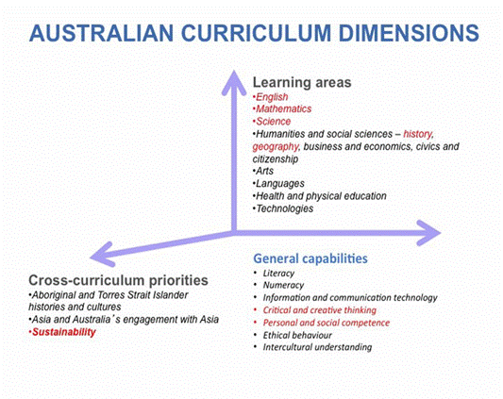ACARA (2012)
The 2012 Closing the Gap Clearing House Paper reported that increasing levels of formal education and training will help to increase the employment levels of Indigenous Australians, along side press assessment and customised training to increase employability, non-standard recruitment strategies and cross-cultural training facilitated by employers. The table below illustrates the 1996 employees’ salaries according the levels of formal education
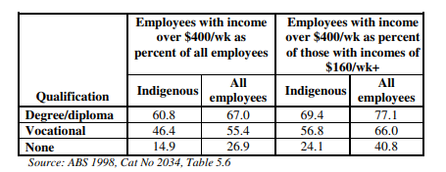Norris, R (2001).

This table quite clearly shows the increases in numbers overall, but also serves to highlight the pay gap between Indigenous and non - indigenous employees. What is not known are the reasons for this. Are there issues affecting entry into education finances, demographics or generally apathy or is the focus of the education being seen through ‘White Australian eyes’ (ibd 2001). This will be considered further).

Employment
The following are extracts from a variety of employers referring to the employment of ATSI staff. Specifically, the companies’ targets within the New South Wales Government Targets. New South Wales Government (2018)

Quotations from Matthew Spicer and David Coughtrie when being asked out of 11,000 professional pilots in Australia, how many are indigenous? “ our biggest airline has five across its Crew’. Spicer, a Wiradjuri man, realised there was a lack of Aboriginal pilots so started a flight school himself, running a programme for Aboriginal students, being highly successful after investing their own money the owners are looking for federal government investment, however they also asked for local government help, but the council stated there are no targets in the reconciliation action plan to help Qadar, S., (2018).
Research shows that in 2017 60% of mining projects in Australia were close to Indigenous communities thus able to support those communities. Statistical analysis illustrated that between 20006 and 2011 eleven the number of Indigenous Peoples employed had doubled, including a marked increase in the number of women employed. Mining People International (2020). The mines assisted the local communities providing infrastructure and local projects that promoted health and wellbeing. Unfortunately this programme of support failed, it was reported (ibd 2020) that in spite of millions of dollars ‘flowing’ to seven locally families in the Kimerley (WA) region for training and education, the area suffered high numbers of poverty stricken families, teens with poor mental health and a high suicide rate. Rio Tinto Sustainable Development Report shows that of $A25m paid in royalties to Argyle’s Traditional Owners over four years, 1,500 people spent one percent on training, five percent on health and six percent on education. The remainder of the money was spent on personal items. (ibd 2020). The report concluded that more support and consultation will be needed to provide better support to maintain sustainability of the mining industry and community projects.
Zeppel, (2001) states that Indigenous Peoples are becoming more involved in the tourist industry with tourist enterprises being controlled by Indigenous People particularly cultural and nature .- based attractions. Their work considers that the Indigenous tourist industry is making a shift from Ethnic to Indigenous tourism, allowing Aboriginal people to control tourism on their own lands, owning their own enterprises, becoming more empowered.
Despite the lack of recent reports and statistics regarding indigenous employment it is generally agreed in available research and government reports that Indigenous Australians have much lower employment rates than other Australians, and are disadvantaged in a range of ways including, unemployment occupational status, industry segregation and income. Norris (2001), (Australian Government 2012).
The Victorian Public Sector Commission (Aboriginal Employment) website provides an opening statement; ‘Aboriginal employees bring unique knowledge and expertise to the workforce and understand the needs and aspirations of the Aboriginal Community’ (VSPC 2018). The state government has the Aboriginal Employment Unit (AEU) which was established in 2016 to serve the Aboriginal (Indigenous) community. The strategy of the unit Barring Djinang was launched exemplifying the work that will be achieved for the Aboriginal peoples yet the social media publicity shows only the White Australian Politicians and an image of the handouts provided, heavily decorated with indigenous art. The Website itself is disjointed with several of the project’s recruitment pages not updated for several years whilst the graduate recruitment pages were undated less than one-month age at the time of writing. A noteworthy point is the blanket statement issued on the VPSC information page reads ‘ Throughout these documents the term Aboriginal is used to refer to both Aboriginal and Torres Strait Islander people. This terminology is not considered appropriate as stated in resources intended for training teachers in the State of Queensland at the preservice training stage of their professional qualification Appropriate terminology includes the following -Indigenous Australian people/s, Aboriginal people/s, Aboriginal person, Torres Strait Islander people/s ,Torres Strait Islander person; whereas the following terms explicitly include those terms used in the government strategy papers. Aborigines, The Aborigines , The Aboriginal people , Aboriginal, Aborigines, The Torres Strait Islanders, Blacks , Whites, Yellafellas, and Coloured. The capitalisation and placing of capitalisation is also important as if it is incorrectly used it can also cause offence.

In stark contrast to this statement The Guardian Australia (2020) published an article headlined ‘ Indigenous people are being displaced again – by gentrification. Jack Latimore, writer, a Gooori researcher and former resident of Brisbane(Guardian 2018) recounts his recent experiences of seeing Blackfellas and parkies (terms are acceptable when spoken by an Aboriginal person) being moved on from inner city suburbs of Brisbane. Reporting that this episode occurs in both urban and rural areas in order that governments can ‘neglect’ urban indigenous people if they are not in view. Latimore reminisced that the old shops he had once visited and industrial areas are now upmarket boutiques and high-rise apartments whilst there are still ‘Blackfellas’ being moved on from corners.

‘The Aboriginal English words ‘blackfella’ and ‘whitefella’ are used by Indigenous Australian people all over the country — some communities also use ‘yellafella’ and ‘coloured’. Although less appropriate, people should respect the acceptance and use of these terms and consult the local Indigenous community or Yunggorendi for further advice’ Appropriate terminology, Australian Indigenous Peoples (No date).
Latimore’s article provides an overview of current attitudes towards First Nations Peoples in larger cities. This attitude could be interpreted as one of the reasons that First Nations Peoples do not wish to participate in the ‘White Mans’ projects, if they are not perceived as citizens on the streets.
The incorrect use of such terminology in official paper could possibly be thought of as micro aggressive in the same way that the word ‘Taffy’ is sometimes used to describe a Welsh person. Mostly the word is used as a nickname , rarely it can also be used in a negative connotation referring to a poem/ song wherein Taffy Was a Welshman Taffy was a thief, each verse descriptive of ‘Taffy’ in derogatory terms. The song (according to history) was more often than not sung by English people on the Saint David’s Day. (Appendix ).
Song (2008) supports the notion that ‘Indigenous tourism is the draw- card for the national tourism market ………. Tourists are attracted by the exotic and minority cultures. Additionally, becoming involved in tourism is a beneficial means of development for Indigenous peoples’. One of the greatest advantages for the promotion of Indigenous tourism is as an income generator for the country as a whole (Zeppel 1998). It cannot be denied that there would be no better person to host indigenous tourism projects that a person who has the spiritual and cultural awareness to cascade the information with enthusiasm, truth and knowledge passed through native language and generational experience. ‘The possibility for Indigenous Australians to eliminate poverty through tourism can be demonstrated when both the economic benefits and costs of tourism are examined(ibd 2008).
Other innovative projects to encourage younger Aboriginal and Indigenous people to engage in employment have been adopted and trialled from a Canadian Junior Rangers programme. Working with a backdrop of similarity both in remotes and lack of educational engagement within the Indigenous Youth(s) of both countries it was easy for Schwab 2006, to utilise comparisons in their discussion paper, citing both ‘lack of educational attainment ‘ and a likely hood of language issues as two of the most likely reasons for non- engagement with employment. In the Northern Territory, Australia the Junior range programmes concentrate on utilising the fact that a high percentage of young Indigenous People’s live ‘on country’ and have great knowledge of the land this is harnessed to build enterprises that involve land management using plants for traditional remedies and carrying out conservation projects. (Appendices)‘These initiatives are exciting because employment opportunities are extremely rare in remote areas and many, if not most, Indigenous people in such areas have shown themselves to be uninterested in the largely unrealistic prospect of leaving their homes, families and traditional country to seek employment in metropolitan regions (ibd 2006).

Conclusion
The aim of this paper was to address the issue of possible discrimination in equality of opportunity in employment for Australian and Indigenous Peoples of Australia. The research carried for this work out has been restricted to reading, much of this carried out online. The findings of the research appear to indicate that there still exists a huge sense of loss and injustice within Aboriginal and Torres Straits Island Peoples that relates to the Stolen Generations which affects the functionality of Australia as a Nation unemployment is rife. Because of the variables in Government legislation and the demographics of the country there will be a difference in types of available employment i.e. Remote/Rural/ City, questions should be raised as to how the opportunities that are offered at viewed? If those opportunities require a higher standard of education the situation should be addressed in available training. The fact that the increasing opportunities for Indigenous Peoples is based on tourism that benefits Australia, The Traditional Owners, and lands (such as Uluru) and the Indigenous Peoples themselves may be viewed through a White Australian lens as – not work. Whilst traditional and Cultural methods of employment may not be seen as relevant. It must also be acknowledged that whilst the Declaration of Rights of Indigenous Peoples rightly sets out protective legislation for Indigenous Peoples’ the complex cultures and spiritual beliefs, these same cultures and beliefs may also be placing barriers to education and employment. A love and appreciation for ‘country’ may not always sit well within the employment being offered in the mining community or IT. There is an assumption that Indigenous Australians should aspire to the same lifestyle and status that other Australians enjoy, these differences are rarely acknowledged. (Norris 2001).

Recommendations: This paper has demonstrated that Aboriginal and Indigenous communities health, poor medical care, and trauma affected , broken families. Until this is researched and acted upon in a joined up multi-disciplinary approach throughout Australia using a totally inclusive approach the situation will continue. The ‘White Australian’ outlook towards traditional or mainstream work is not working for those First Nations who wish to be accepted as that First Nation Australians. Politicians saying ‘Sorry’ has been carried out, it is now time to purposefully look forward by acknowledging the history yes, but acknowledging that the First Nations Australians possess a culture and traditions that must not be lost but indeed encouraged and used to carry out Australia’s future successes.

This paper will be completed by the inclusion of a headline issued during the recent environmental disaster of the Australian bush fires.

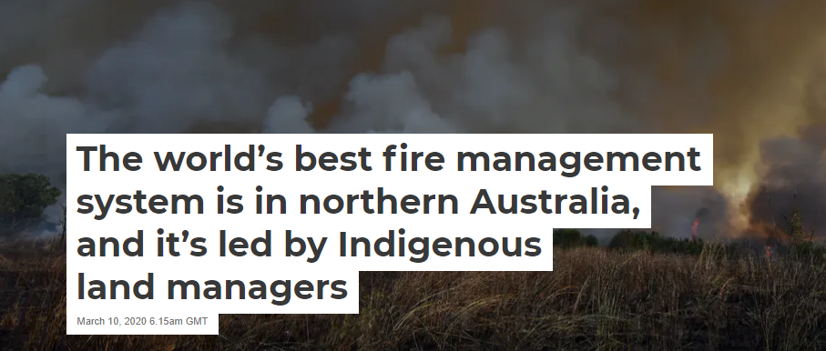
The Conversation Trust (UK) 2020.

REFERENCES
AITSIS, ‘Commemorating the Freedom Ride’, 2015, Available at: https://aiatsis.gov.au/exhibitions/1965-freedom-ride (Accessed: 18 May 2020).

Appropriate Terminology , Australian Indigenous People, (no date) Available at: https://www.ipswich.qld.gov.au/__data/assets/pdf_file/0008/10043/appropriate_indigenous_terminoloy.pdf (Accessed 31 July 2020).

Arcioni, E. (2012) Excluding Indigenous Australians from ‘The People’: A Reconsideration of Sections 25 and 127 of The Constitution Federation Law Review Volume 40. P9. Downloaded:17 June 2020.

Altman J, Fisher, R., (2020) ‘The World’s Best Fire Management System is in Northern Australia and it is led by Indigenous land managers’. Available at https://theconversation.com/the-worlds-best-fire-management-system-is-in-northern-australia-and-its-led-by-indigenous-land-managers-133071#:~:text=Traditional%20Indigenous%20fire%20management%20involves,season%20to%20reduce%20grass%20fuel.&text=Essentially%2C%20burning%20early%20in%20the,is%20a%20post%2Dcolonial%20practice. Accessed 18 May 2020)

Attwood, Bain and Markus, S. Australian Aboriginal League, ‘Thinking Black, William Cooper and The Australian Aborigines League’, Aboriginal Studies Press, Canberra, 2004. Available at: http://www.emelbourne.net.au/biogs/EM00110b.htm#:~:text=Multimedia%20Content-,Australian%20Aborigines'%20League,and%20other%20inner%2Dcity%20suburbs
(Accessed: 17 June 2020).

Australian Bureau of Statistics (2017) 2016 Census shows growing Aboriginal and Tories Straits Islander Population Census: Aboriginal and Indigenous Peoples Population. Available at: https://www.abs.gov.au/ausstats/abs@.nsf/MediaRealesesByCatalogue/02D50FAA9987D6B7CA25814800087E03 ( Accessed 30 June 2020).

Australian Bureau of Statistics (2018) Census Population. 2077.0 - Census of Population and Housing: Understanding the Increase in Aboriginal and Torres Strait Islander Counts, Growth in counts of Aboriginal and Torres Strait Islanders by Remoteness, 2006-2016(a) Available at: https://www.abs.gov.au/ausstats/abs@.nsf/Lookup/by%20Subject/2077.0~2016~Main%20Features~Overview%20of%20the%20Increase~122 (Accessed: 28 June 2020).

Australian Human Rights (2020) ‘Climate Change and Indigenous People’s’ Available at: https://humanrights.gov.au/about/news/speeches/climate-change-and-indigenous-peoples (Accessed 11 October 2019)

Behrendt, L., Achieving Social Justice (2003), Australia, The Federation Press, Sydney.

Behrendt, L. (2012) Indigenous Australia for Dummies, ‘Land, Livestock and Loss’. Australia, Wiley Publishing Australia Pty Ld. 42 McDougal Street, Milton, Qld 4064, p115.

Behrendt, L.(2012) Indigenous Australia for Dummies® , ‘Land, Taking the Children ’. Australia, Wiley Publishing Australia Pty Ld. 42 McDougal Street, Milton, Qld 4064, p 134.

Forrest, A (2014), ‘The Forrest review: creating parity’, Department of the Prime Minister and Cabinet, Canberra, Available at: https://www.pmc.gov.au/indigenous-affairs/employment/indigenous-jobs-and-training-review. (Accessed 31 July 2020)

Gov.UK (Welsh Government)Available at https://www.gov.uk/government/organisations/welsh-government (Accessed 28 June 2020).

Gray, M. (2020), World Pilgrimage Guide, Uluru Facts, Available at: https://sacredsites.com/oceania/australia/uluru_facts.html (Accessed: 11 October 2019).

Hatch, D., (2017) ‘What’s The Impact of Mining on Indigenous Communities’ Available at: https://www.miningpeople.com.au/news/whats-the-impact-of-mining-on-indigenous-communities (Accessed: 2 February 2020)

KBHAC, (2020), (History of Kinchela Boys Home), Kinchela Boy Home for Aborigine Children Available at: https://kinchelaboyshome.org.au/kinchela-boys-home-aboriginal-corporation/history/ (Accessed: 2 February 2020).
Kubergovic, E. Leung C. (2013) Neville A. O. Available at: https://eugenicsarchive.ca/discover/tree/5232aa925c2ec50000000027 (Accessed: 1 June 2020).

Latimore, J., (2018) ‘Indigenous people are being displaced again – by Gentrification’ The Guardian 13th April Australian Cities Week Available at : https://www.theguardian.com/cities/2018/apr/09/indigenous-people-are-being-displaced-again-by-gentrification-aboriginal-redfern-west-end-fitzroy (Accessed 20 February 2020).

Maddocks (2006) Employment and Labour Law in Australia, Lexology Available at : https://www.lexology.com/library/detail.aspx?g=a8a46fb9-725d-4176-8565-5befa7e10c44#:~:text=The%20Fair%20Work%20Act%20is,relating%20to%20specific%20areas%2C%20including%3A&text=workplace%20surveillance%3B%20and,anti%2Ddiscrimination. (Accessed 20 November 2019)

Morgan, S, (1987) My Place, Freemantle, Western Australia, Freemantle Arts Centre Press.

Morgan, S 1987, A Black Grandmother , My Place, Freemantle, Western Australia Freemantle Arts
Centre Press. Pp 98 – 99.

New South Wale Government Communities and Justice (2018), Aboriginal Employment Strategy 2019 – 2022 Available at https://www.justice.nsw.gov.au/ (Accessed on 20 February 2020).

Parliament of Australia, Info sheet 20 The Australian System of Government Available at https//: www.aph.gov.uk(Accessed: 20 November 2019).

Parsons, G (1947) Black Chattels, ‘The Story of Australian Aborigines’. The National Council for Civil Liberties, 11a Kings Road, London SW3 Available at: http://digital.slv.vic.gov.au/view/action/singleViewer.do?dvs=1595944996859~531&locale=en_GB&metadata_object_ratio=10&show_metadata=true&VIEWER_URL=/view/action/singleViewer.do?&preferred_usage_type=VIEW_MAIN&DELIVERY_RULE_ID=10&frameId=1&usePid1=true&usePid2=true (Accessed:25 June 2020).

Reconciliation Australia National Reconciliation Week 2017 Available at https://www.reconciliation.org.au/wp-content/uploads/2017/11/reconciliation-timeline_2017.pdf (Accessed: November 2018)

Reconciliation Australia ‘What is Reconciliation’, Available at https://www.reconciliation.org.au/what-is-reconciliation/ (Accessed: 20 March 2019).

Price, C (ed) (2015), ‘Education’, Knowledge of Life, Aboriginal and Torres Strait Islander Australia, Australia, Cambridge University Press Ch10.

Quadar, ., S (2018), ‘First Flight School of its Kind’ Available at : https://www.sbs.com.au/news/small-business-secrets/article/2017/04/28/indigenous-flight-school-first-its-kind (Accessed 2 February 2020).

Schwab, R. B., (2006) ,’Kids , Canoes, and Caribou: The Junior Canadian Ranger Programme for as a Model for Re-engaging Indigenous Australian Youth in Remote Areas. The Australian National University , Centre for Aboriginal Economic and Policy Research. Available at: https://openresearch-repository.anu.edu.au/bitstream/1885/44476/3/2006_DP281.pdf Accessed on 2 February 2020)
Sivak, L., Westhead, S., et al., . (2019) ‘“Language Breathes Life”—Barngarla Community Perspectives on the Wellbeing Impacts of Reclaiming a Dormant Australian Aboriginal Language’, International Journal of Environmental Research and Public Health. MDPI AG, 16(20), doi: 10.3390/ijerph16203918.
p. 3918. Available at https://www.mdpi.com/1660-4601/16/20/3918

Spitzer, Aaron John (2019) ‘Constituting settler colonialism: the ‘boundary problem’, liberal equality and settler state-making in Australia’s Northern Territory, Postcolonial studies, 22:4’, Available at: https://doi.org/10.1080/13688790.2019.169.1690763 p545-564. (Accessed 2 May 2020).

Summerlad, J. (2018). ‘National Sorry Day: How Australia apologises to the Aborigines for the wrongs of the past’. Available at: https://www.independent.co.uk/news/world/australasia/national-sorry-day-australia-aborigines-stolen-generation-healing-reconciliation-a8368486.html (Accessed: 4th May 2020)

Taffy was A Welshman, (2017), Nursery Rhymes, Origins, Available at : http://www.rhymes.org.uk/ (Accessed 3 August 2020).

Tickner, R. (2001) Taking a Stand ‘Does Reconciliation Stand a Chance’ . Australia: Unwin and Allen Alexander Street, NSW 2065. p326

Tickner, R. (2001) Taking a Stand: ‘Land Rights to Reconciliation’. Australia: Unwin and Allen Alexander Street, NSW 2065.

Tickner, R. (2001), The Historical Context, ‘Taking a Stand: Land Rights to Reconciliation’ Australia: Unwin and Allen Alexander Street, NSW 2065, p19.

United Nations General Assembly (2006) ‘United Nations Declaration on the Human Rights of Indigenous People 61/295’. Available at: https://www.un.org/esa/socdev/unpfii/documents/DRIPS_en.pdf (Accessed: 14 April 2020).

United Nations General Assembly (2006) ‘United Nations Declaration on the Human Rights of Indigenous People 61/295’. Available at: https://www.un.org/esa/socdev/unpfii/documents/DRIPS_en.pdf (Accessed: 14 April 2020) pp8 - 9.

United Nations News (2019), Global and Human Stories, ‘Two indigenous languages are dying every month: UN Assembly President’, United Nations News
Available at: https://news.un.org/en/story/2019/12/1053711 (Accessed on: 28 May 2020).

Victoria Public Sector Commission [VPSC] (2020). ‘Reimagining Attraction and Recruitment’ Available at : https://vpsc.vic.gov.au/aboriginal-employment/barring-djinang/initiatives/reimagining-recruitment/ (Accessed: 2 August 2020).

Zeppel, H., (2001), Aboriginal cultures and Indigenous Tourism, Special interest tourism: context and cases J Willey and Sons, Australia Available at: https://researchonline.jcu.edu.au/14334/ (Accessed: 20 February 2020),

APPENDICES

Appendices

Never has there been a greater need for Aboriginal fire-stick farming
- January 6, 2020
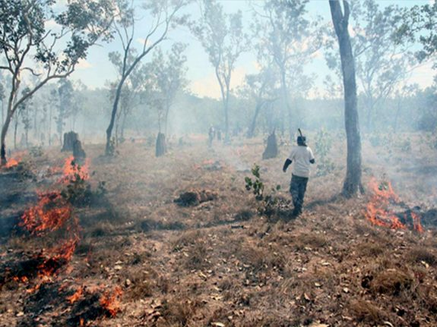Image from blogs.unimelb.edu.au (Photo credit: James Kidman)
- Michael Taylorhttps://theaimn.com
As the bush fires rage so too does the debate on how land should be managed, specifically to prevent the repeat of these catastrophic fires.
On the Left we have the realists who believe the scientists that have warned there is a link between bush fires and climate change; and on the Right we have those who deny the link and so are furiously looking for someone to blame. They are blaming the usual suspects: Lefties and greenies, for they are the ones – apparently – who have stopped hazard-reduction burning in the cooler months. I have never known it to happen (which is not to say it has not) but the Right want someone to blame regardless.
We all know that fires kill wildlife, whether it is through hazard-reduction burning or through uncontrolled fires. Ideally, what we want is bush fire prevention with the absolute minimum (or no) loss of wildlife, and which also reduces the future loss of all life, including human life.
This can still be achieved through hazard reduction burning. It is by ‘who’ that is the key.
Aboriginal Australians hold that key.
As traditional Aborigines were not landowners they felt that they had a responsibility to the environment. The environment, the land, and even the sky were created in one – as were the people – and all were related. With this attitude (belief) is it any surprise that the Aboriginal people never took anything from nature? Aborigines were the original conservationists and their use of land management promoted ecological health.
An example of this was fire stick farming: The low intensity burning of undergrowth in wooded areas that would promote the germination of new plants, and thus attract the animals that were an important part of an Aborigine’s diet. This burning was carried out before the dry season and was done carefully and systematically. No more was burned than necessary. Burning was also more than just sound land management; it was evidence that the land was healthy and being fully utilised. There was also a religious significance to burning: As the Ancestral spirits of the Dreaming still inhabited the land, the burnings provided these spiritual inhabitants with lands on which they could hunt. But fire-stick farming had another purpose: to decrease the risk of the wildfires now all too common in modern Australia.

