University of Wales Trinity Saint David
BA(HONS) Business and Management
Level 5, Weekend, Resit
Lecturer name: Emad Elkhashen
Student name: Ionut Cernea
Student ID: 1917345

Apple
Management Economics – Assesment 2

Table of Contents
Introduction 3
Describe the company 4
Analyse the market 5
Different market structure 8
Did the company operate in a different market structure? 11
Conclusion 13
References 14

Introduction

The study will be providing information on how business organizations are managed in an economic context. The report will be providing information about Apple Inc. and how it is functioning in the market. At first, the company chosen for the project will be described and information on its products/services will be provided along with it. After this, the market in which the company is operating since its inception will be explained in detail along with the market structure which the organization was following. Next, the report will provide information on whether the company has operated in different market structures before. This part will provide information on the market structure in which the company was functioning. After this, the study will discuss if it was optimal for the business organization to function in different market structures. This part will also comment on whether the company will want lesser or greater government intervention.

Describe the company

Apple Inc. was founded by Steve Jobs, Steve Wozniak and Ronald Wayne in the year 1976. It is a public limited company serving the whole world. The headquarters of the company is situated in California, U.S (apple.com, 2022). The company is dealing in various products like consumer electronics, software, and online services. The history of Apple Inc. can be divided into different stages from its inception to how the company became successful in the market. 1976-1980 were the initial stage of the company when they came up with their first product “Apple I”, which was made from the design made by Wozniak himself. The prototype was first debuted at the “Homebrew Computer Club”, California in 1976. Thereafter, “Apple Computer, Inc. got incorporated at the beginning of 1977. 1980-1990 marked the release of “The Macintosh”, the 1st personal computer which was sold without the use of programming language and was a huge benchmark for the company. The product got huge attention in the market, and it was widely appreciated on various platforms.
1990-1997 marked the decline and restructuring of the company. In 1992, the company came up with the tablet computer prototype of PenLite which was mainly designed to introduce Mac OS to the tablet platform. 1997-2007 marked the return of the company into the return of profitability for the company. During this time, Apple introduced the iMac, iBook, PowerBook G3 and Power Macintosh G3. 2007-2011 market the success of mobile devices for the company. The company announced the iPhone and Apple TV which improved the name of the company in the market. The company has touched heights from then and is still doing a great job in the market by coming up with innovations to attract customers.
Products of the Apple Inc. company include Macintosh, iPhone and iPad. The company is also selling wearables along with home and accessories to customers in the market (apple.com, 2022). Apple is offering many services in the form of Apple books, Apple TV+, Apple Music along with Apple Card, Apple Pay and AppleCare+. The company is also providing services like Apple News+, iTunes Store and Apple Fitness+ to customers in the market.

Analyse the market

Apple Inc. is functioning in the Consumer Electronics, Software and Online Service industry. The company is competing with the likes of business organizations like Google, Alphabet and Microsoft. Market structure can be of different types as it can be Perfect Competition, Monopolistic Competition, Oligopoly or Monopoly.
Perfect Competition: Perfect competition exists when there are many buyers exists in the industry. All sellers are considered equal in this type of competition as no one is small or big in this type of market (Miyauchi et al., 2021). There is no such thing as one seller will have an advantage over the other seller in the market. Therefore, all the firms in this type of competition are price takers. There are certain assumptions which need to be taken into consideration when talking about the Perfect competition. The assumptions will include the products which the sellers of the market will be selling will be homogenous and all the firms in the market will only have a motive of making maximum profit. These markets will have free entry and exit and there will be no barriers. Along with this, the competition will not be considering the concept of consumer preference.
Monopolistic Competition: This is a more realistic scenario when compared to the perfect competition. This type of market will also have more buyers and sellers, but they will not be selling homogenous products. The products of the firms will be similar, but they will be slightly different. In this type of marker, buyers have an option to choose one product over the other. Sellers also have an option to charge more for their products because of the difference it has. Therefore, sellers in the market have an option to be price setters in the market to a certain extent.
Oligopoly: In this market type, there will be a smaller number of buyers. There is not much clarity as to the number of sellers in the competition as it can be between 3-5 firms which are dominant in the market. In an oligopoly, there will be a greater number of buyers and the sellers will be very much low (Fan and Yang, 2020). The firms in the market either compete or they will be collaborating to make sales in the market. The companies will be using the market influence to set the prices for the product to maximise profits. There are huge barriers to entry to the market as firms will find it difficult to establish themselves here.
Monopoly: This market structure will have a single seller who will be controlling the entire market. These firms will be setting the price according to their wish and customers will have no option but to pay the price to access/enjoy the product/service provided by the firms in the market (Pasalic and Pavic, 2021). This market is the most undesirable of all the structures as buyers will not be having any power to pay according to their requirements. These types of market exist rarely in reality.
Apple Inc. is competing in an oligopoly market with other companies like Google, Alphabet and Microsoft. The company is serving a lot of customers from across the world. Apple Inc. is effectively using the market influence to set the prices for its products, and it is helping them to earn lots of profit. The company is effectively competing with others in the market as customers have an option to choose from other brands providing the same product line. The company is selling mobile phones, laptops, software and online services which other business organizations are also offering.

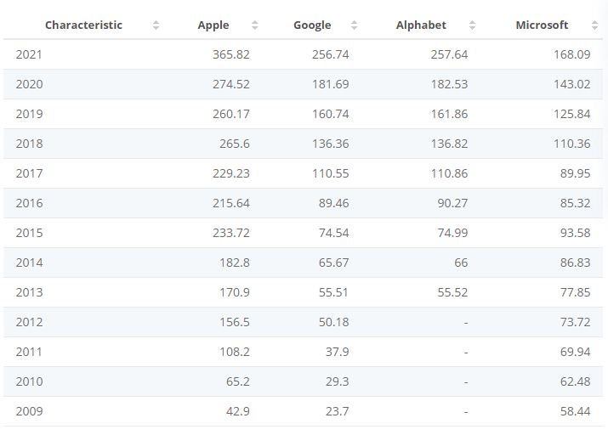

Figure 01: Revenue comparison of Apple, Google, Alphabet, and Microsoft from 2008 to 2021(in billion U.S. dollars)
Source: (statista.com, 2022)

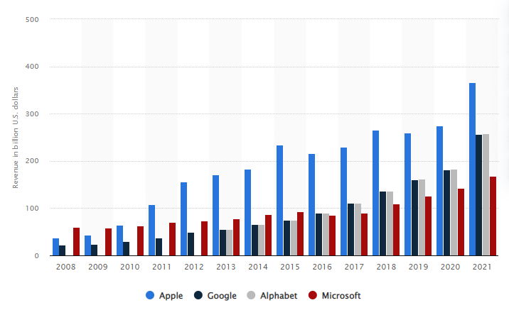

Figure 02: Revenue comparison of Apple, Google, Alphabet, and Microsoft from 2008 to 2021(in billion U.S. dollars)
Source: (statista.com, 2022)

The stats published in 2022 tells us the revenue share of Apple Inc. compared to its competitors in the market. The company has always been ahead of its competitor in the market and are very much looking forward to continuing this in the coming future. Companies like Google, Alphabet and Microsoft are proving to be giving good competition to Apple Inc. in the market. In 2021 the company earned a whopping $ US 365.82 billion revenue compared to others in the market. This tells the dominance of Apple Inc. in the oligopoly market and how the public is approaching the brand in the market. The company is getting a huge share of the revenue from the Consumer Electronics, Software and Online Service industry by coming up with new innovative ideas to attract customers in the market (statista.com, 2022).

Different market structure

Apple Inc. is competing effectively in the oligopoly segment of the smarts phone market and is competing effectively in the monopolist competition segment for branded computers. The company has not gone into different market structures in the past as it is existing in the oligopolistic and monopolistic completion segments in smartphone and branded computer segments respectively. In the smartphone, segment company is facing an oligopoly competition from limited brands in the whole world including Samsung, Vivo, Oppo and rising brands like google in the market. Samsung is currently the biggest competitor of the company as a good number of customers from around the world are using the smartphones of the company and they have become loyal to the brand.

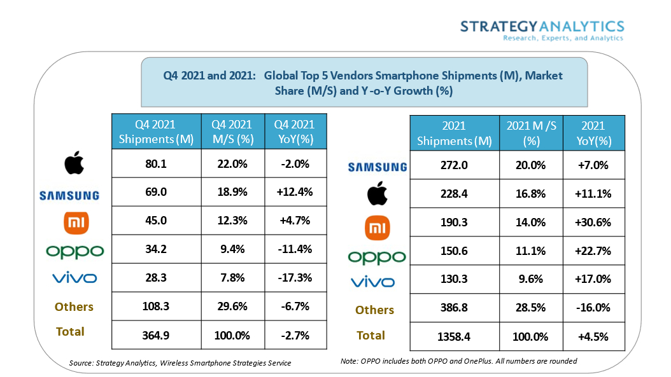
Figure 03: (Strategy Analytics: Apple iPhone Tops Global Smartphone Market in Q4 2021)
Source: (businesswire.com, 2021)
Based on the stats, it can be understood that the main competitor of Apple Inc. in the oligopoly market is Samsung. The stat is providing detailed information about the global shipments and market share of the companies in the smartphone industry in the fourth quarter of 2021. It can be understood that in the fourth quarter, Apple Inc. got a shipment of 80.1 million shipments to the global market when compared to the 69 million of Samsung company. Xiaomi, Oppo, and Vivo earned a shipment of 45, 34.2 and 28.3 million respectively in the fourth quarter of 2021 (businesswire.com, 2021). Other than Samsung in the oligopoly segment, companies like Xiaomi, Oppo and Vivo are not even matching the stats of the company. For the whole year also, Apple Inc. got a shipment of 272 million when compared to other brands in the world. Apple Inc. is currently getting more shipments from other countries. But it can be understood from the study that Xiaomi, Oppo, Vivo and Samsung got more market share when compared to Apple Inc. in 2021. From this, it can be understood that the cheap brands are also able to compete with the likes of a company like Apple in the oligopoly market. New smartphone brands are also showing huge potential for the future, and they are also attracting a good number of customers in the market.
In the branded computer segment, Apple Inc. is facing monopolistic competition from others in the market. There are many companies which Apple Inc. is facing competition from as there are lots of legit brands offering computers for competitive prices. Some of the companies include Acer, Asus, Dell, HP and Lenovo. Companies are selling computers with different operating systems as Apple Inc. is using iOS when compared to other companies selling computers on Windows platforms. The monopolistic competition will include companies selling not selling exactly homogenous products as there will be some difference in the products/service sold. Customers in this type of market have an option to choose from the available brands. Apple Inc. has an option to charge the price they want for its products. People know what they need to pay for computers and laptops produced by the company when compared to other competitors in the market selling laptops and computers on Microsoft platforms.

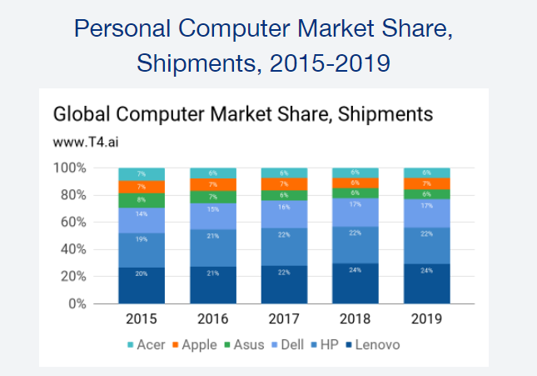
Fig 04: Apple Market Share
Source: (t4.ai, 2019)

According to stats from 2019, Apple Inc. only had a market share of 7% of the total global market share shipments for personal computers. Other companies like Lenovo, HP, Dell, Asus and Acer had a market share of 24%, 22%, 17%, 6% and 6% respectively. It can be understood that only Asus and Acer are only having less market share than Apple Inc. in 2019 (t4.ai, 2019). The remaining market share according to the stats is 18% and it will include all other existing brands in the whole world. Monopolist competition allows a company to set prices for its products. Apple is selling its personal computers for the price they want as they are using iOS platforms to run their computers. Customers who want a different experience will be buying the products from Apple Inc. but will be paying more to enjoy the service of the company.

Did the company operate in a different market structure?

The company is offering products different from others in the market. Apple is selling products with different operating systems. The company is selling products on iOS platforms to its customers in the market. The company can switch to a Monopoly market to sell its brand to customers. The company is having a different image among customers and competitors in the global market as they are providing high-quality products/services at high prices to customers. Loyal customers will be still purchasing the products of the company even if it has been shifted to a different market structure (Appiah et al., 2019). The company is now charging high prices for its products and customers know to what extent the prices will go. Apple to stay in the monopoly market need to make sure that they are not charging too much than what they are charging for its products. After a line, the company will lose loyal customers who spend money to purchase the brand. The company can operate in the monopoly market by keeping many matters of concern in the mind. Through this, the company can keep the focus of customers on themselves because of the solo nature of the market. Apple Inc. Still need to come up with innovative ideas to strive in the solo market as customers can choose products from oligopoly market where they will be getting more products to choose from.
Government intervention is very much important in a country, and it must be to an extent as companies do not face difficulties in functioning properly in an environment (Joo et al., 2018). Government should come up with high restrictions when they find that the business organizations are exploiting the public present in the country. Less or no intervention can be applied when the government feels that the business organizations are functioning properly in the market without exploiting the public there. Oligopoly market and monopolistic competition have a good amount of competition and companies know to what extent they can increase the price of their products/services. From these markets, customers can find expensive and inexpensive products and there are companies which they can choose from. The customers can spend on what they want and there is no pressure on spending a certain sum of money to get the product/service. Government can place less intervention on these market structures to allow the companies to keep a competitive competition in the market allowing them to sell products at competitive prices to customers. The monopoly market is very much different from other markets as there is only a single seller and this solo firm can charge what they want from the customers without thinking twice. This market will get a good amount of demand on how the existing company approaches matters there, and the loyal customers will be looking forward to purchasing goods and services from them. Government must intervene in the activities of this market to control them charging high prices for their products.

Conclusion

The study provided information on how business organizations are managed in an economic context. The report provided information about Apple Inc. and how it is functioning in the market. At first, a Description of the company was provided along with its history and products/services sold. Then, the study analyzed the market structure of Apple Inc. and the revenue share of the company was provided and explained. After that, a market analysis of the company was made as it which market it has operated. This part also provided the market share of the company in the market. Then, the report discussed if it was optimal for the business organization to function in different market structures. This part also commented on whether the company will want lesser or greater government intervention.

References

businesswire.com 2021 [online] Available at: https://www.businesswire.com/news/home/20220127006139/en/Strategy-Analytics-Apple-iPhone-Tops-Global-Smartphone-Market-in-Q4-2021 [Accessed on 30 April 2022]
statista.com 2022 [online] Available at: https://www.statista.com/statistics/234529/comparison-of-apple-and-google-revenues/ [Accessed on 30 April 2022]
t4.ai 2019 [online] Available at: https://www.t4.ai/company/apple-market-share [Accessed on 30 April 2022]
apple.com 2022 [online] Available at: https://www.apple.com/ [Accessed on 30 April 2022]
Miyauchi, Y., Nakajima, K. and Redding, S.J., 2021. Consumption access and agglomeration: evidence from smartphone data (No. w28497). National Bureau of Economic Research.
Pasalic, I.N. and Pavic, I., 2021. Market Concentration in the Personal Computer Industry. International ournal of Economic Sciences, 10(1), pp.84-99.
Joo, H.Y., Seo, Y.W. and Min, H., 2018. Examining the effects of government intervention on the firm’s environmental and technological innovation capabilities and export performance. International Journal of Production Research, 56(18), pp.6090-6111.
Appiah, D., Ozuem, W., Howell, K.E. and Lancaster, G., 2019. Brand switching and consumer identification with brands in the smartphones industry. Journal of Consumer Behaviour, 18(6), pp.463-473.
apple.com 2022 [online] Available at: https://www.apple.com/shop/accessories/all [Accessed on 30 April 2022]
Fan, Y. and Yang, C., 2020. Competition, product proliferation, and welfare: A study of the US smartphone market. American Economic Journal: Microeconomics, 12(2), pp.99-134.

