

COVID-19 Impact on
The World

Module Name: Data Analysis & Visualisation
Module Code: ACCB4002_LON
Lecture Name: Suneth Fandaro
Student Name: Dzhuliano Alenov Stefanov
Student ID: 2027630

Table of contest

INTRODUCTION……………………………………………………………. …..2
COVID-19 DEMAND SHOCK………………………………………………………….3
COVID-19 impact on people’s lifestyle and emotions ………………………………………………5
CONCLUSION……………………………………………………………………6
REFERENCE LIST ………………………………………………………………………….8

Above we can see the infographic showing how covid 19 impacted the business, education retail, financial services, government, healthcare.

Introduction

Covid -19 had a critical impact on business with 66 %, and the possible resolution for that is that we are going to need a change in our operating model due to Covid- 19, its good that only 4% of business may have to close permanently due to the pandemic, 2% have no threat to their business, we can see that 15% of the business have a positive impact – example are online delivering services such as amazon.com, ebay.com, we also have small businesses that develop during that pandemic which are offering protective equipment for the pandemic such as masks, hand sanitisers, and even air purifiers.

COVID-19 demand shock

The demand for education it’s also decreasing by 60%, and the students must study and have exams and projects online due to the pandemic.
We have healthcare that’s its decreased with 15% but increased with 54% and that’s what’s make that pandemic so impactful on business and health industries -above we can see the increase coloured with green and the decrease coloured with blue.
(Khaliq, n.d.)Retail demand it’s also impacted and decreased with a whole 71% many of the shops were closed and we can see the percentage decreased coloured in blue.
According to Springboard and the Department for Business, Energy, and Industrial Strategy
(Khaliq, n.d.)In the UK there was a downfall when the national lockdown began.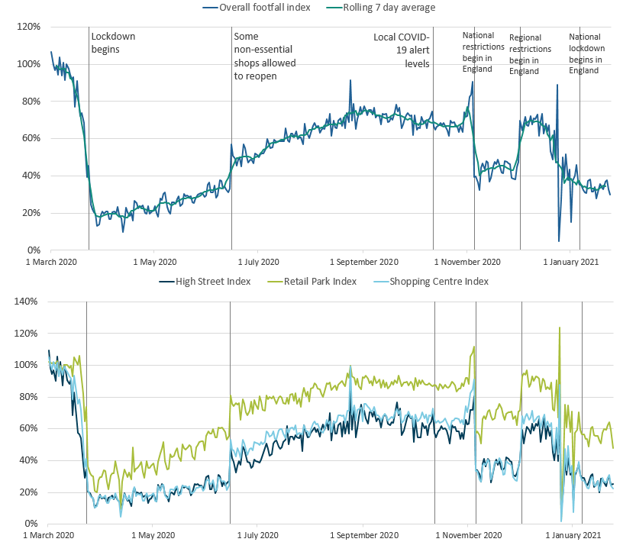

Notes:
- The spike on Monday 24 August 2020 was caused by the comparison with 26 August 2019, which was a bank holiday Monday with good weather. The bank holiday the previous year (2020) was a week later, on 31 August 2020. (Khaliq, n.d.)

(www.economicsobservatory.com, n.d.)We also have a financial service demand decreasing by 49% which are coloured in blue.
and increased by 16% which is coloured in green.
According to Economics observatory (Banking & Financial market)
The lockdown which was used to prevent Covid-19 spread hurts the Banking sector and the new financial service providers, where firms stopped working because they miss revenues and therefore not be able to repay loans.
(Jaana Remes, n.d.)According to McKinsey Global Institute.
Government demand is increased by 32% and decreased by 29%.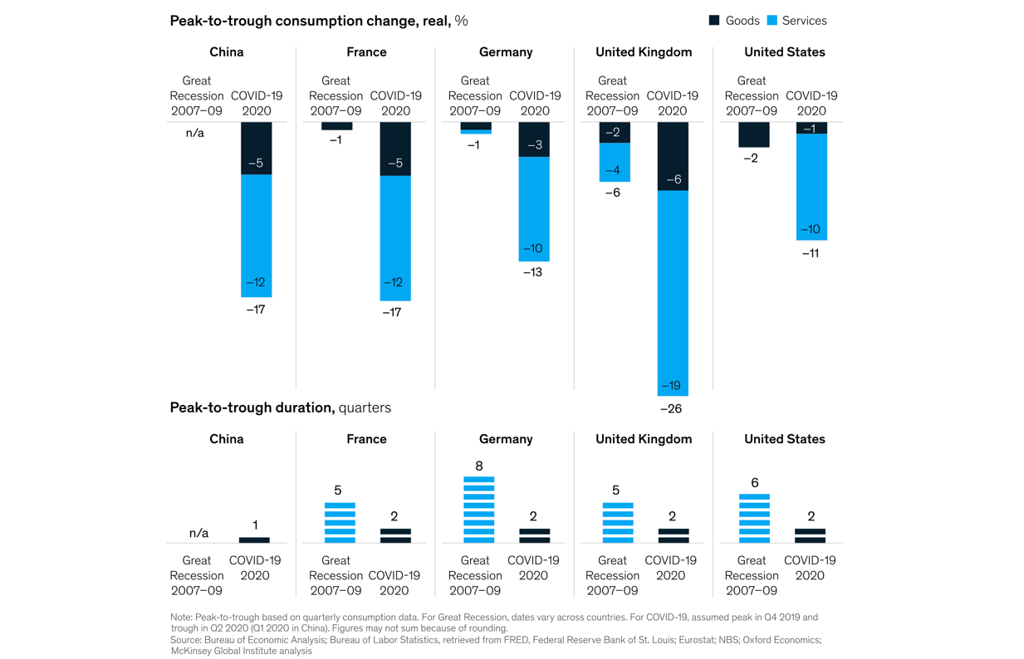

(www.instituteforgovernment.org.uk, n.d.)According to The -Institute for Government UK -Another main impact since the pandemic started it’s that a lot of people need more flexible support, such as extended payment terms and that increased by 63% since the pandemic started.
Also increased the Update on supply chain issues witch 45%.
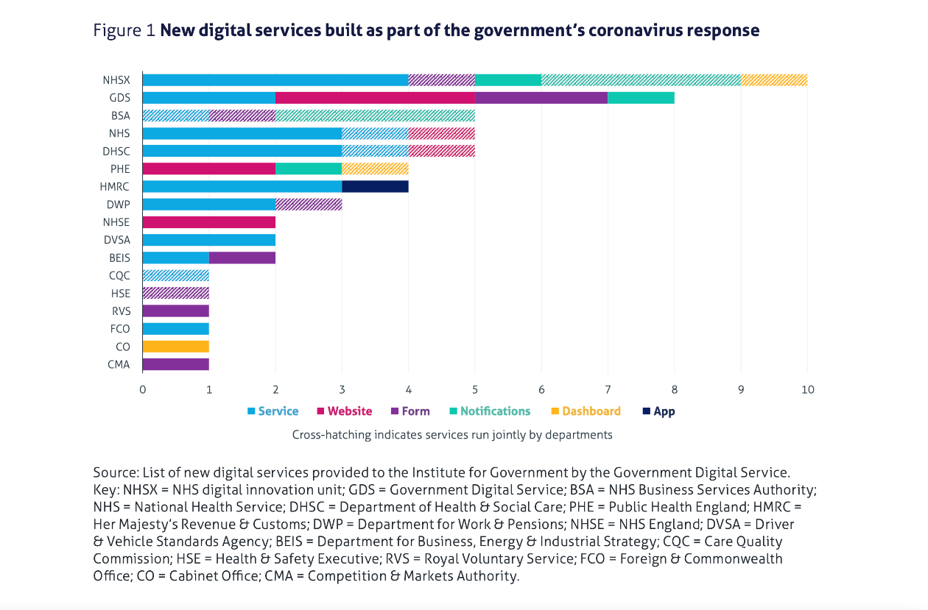

77% of the people agree that Covid-19 presents the opportunity for innovation.

COVID-19 impact on people’s lifestyle and emotions

77% of the people agree that Covid-19 presents the opportunity for innovation.
84% of the people strongly agree that Covid -19 caused a significant impact on the industry negatively.
However, 66% of the people are agreeing that we are going to need a new and adaptive operating model due to Covid -19.
We can also see the office print volumes decreased significantly by 68% - many people must work from home and sometimes the work can be disrupted by connectivity issues.
Good thing it’s that Cloud digital workflow solution improved by 89% since the pandemic,
Also, we use less paper now using digital copies and storing them in the cloud storage which it’s easily accessible by everyone in the working environment, that is increased by 85%.
In those hard times, collaboration services increased by 96% which allowed us to work together and have a positive impact on our current situation.

Coloured in green we have 35% of the people who believe that it’s going to take between 6 to 12 months to recover to the pandemic personally I think that it would even take more than that and that’s why am part of that 16% of the people. Coloured in blue we have 32% of the people that believe recovery is going to take place between 3 and 6 months for the business recovery time. In stone, grey is that 6% that believe that there won’t be business as usual anymore.
In light grey are the other 6% that believe business recovery time will be less than a month – which I cannot agree with judging from the current situation. In dark grey are those that believe that business recovery will be between 1 and 3 months.

We also have increased in personal guidance by 27% many people are found in a difficult situation, which is impacting their mental health, that’s why I think in those hard times we must be more helping and supporting for each other helping and giving a hand when needed we should also take care of us and fallow the government guidelines for our health and safety in that big pandemic.

Conclusion
My recommendations and ways for the infographic to be improved its that it can be divided into separate sections and under each section to have information about the percentage of the research and the sections in my opinion should be separated like this:
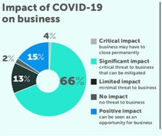
And under it to be informed about the percentages

- Also, another thing, in my opinion, it’s that the colours used in the infographic are not very distinguished from each other for example are the dark grey, stone grey. and light grey in my opinion those colours could be swapped with Yellow because according to (J.Elliot, n.d.)Andrew J. Elliot (Department of Clinical and Social Sciences in Psychology, University of Rochester, Rochester, NY, USA) the yellow colour can quickly grab attention and it’s easily recognizable in all light conditions. According to Kuniecki Maja by who conducted a psychology study for the University of Rochester, the Red Colour can grab attention and deliver a strong message so, we could end up with three different colours, another main thing is that about the Cyan colour we can replace it with the colour Green because Green (www.londonimageinstitute.com, n.d.) according to London image Institute can be easily recognisable and can give a positive energy percentage in the infographic. colour red – since it easily makes a negative visual appearance and is noticeable just like the sign STOP the three main colours in my opinion for an infographic should be Green, Red, and Blue

Red indicates the negative impact
Yellow indicates the medium percentages
Green indicating the positive and growth percentages
Since just like the traffic lights
Red – stop
Green -go

So, if I follow the colour studies my infographic will start by looking like this.

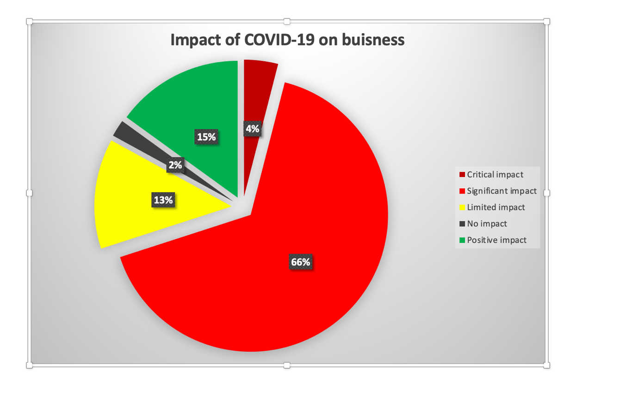with the Red indicating the highest percentage, so it can attract attention according to studies at the University of Rochester -USA (J.Elliot, n.d.)

References List

(n.d.). “Infographic: COVID – 19 Accelerating Print Industry Transformation.
J.Elliot, A. (n.d.). www.verywellmind.com. Retrieved from https://www.verywellmind.com/the-color-psychology-of-yellow-2795823
Jaana Remes, A. B. (n.d.). www.mckinsey.com. Retrieved from https://www.mckinsey.com/industries/consumer-packaged-goods/our-insights/the-consumer-demand-recovery-and-lasting-effects-of-covid-19
Khaliq, M. (n.d.). www.ons.gov.uk. Retrieved from https://www.ons.gov.uk/economy/grossdomesticproductgdp/articles/impactofthecoronaviruscovid19pandemiconretailsalesin2020/2021-01-28
www.economicsobservatory.com. (n.d.). Retrieved from https://www.economicsobservatory.com/how-coronavirus-affecting-banking-sector
www.instituteforgovernment.org.uk. (n.d.). Retrieved from https://www.instituteforgovernment.org.uk/sites/default/files/publications/digital-government-coronavirus.pdf
www.londonimageinstitute.com. (n.d.). Retrieved from https://londonimageinstitute.com/green-color-psychology/

