TASTE OF SYLHET
Samosas £ 9
Ground Meat, Chicken or Vegetables with spices and potato, encased in a crispy, perfectly fried Filo Pastry. Comes with House tamarind sauce.
Shish Kebab £ 11
Ground lamb with spices, onion and chili grilled over hot charcoals and served with mint sauce and naan bread
Naan Bread £ 2
Flatbread made by using a clay oven till cooked, perfect for curries and our other starters.
Onion Bhaji £ 6
thinly cut onions bundled up and put in a seasoned, light batter and fried till crispy. Comes with a house yogurt sauce
Poppadum £ 5
Lentil-based crispy tortilla fried till golden
Chicken Tikka Masala £ 13
Chicken breast cut into small pieces and spices our homemade tandoori spices, then roasted in a clay oven till perfectly cooked. Comes with Naan and Salad

Butter Chicken £ 16
Chicken curry with spices, chili and cream, served with fluffy basmati rice.
Fish Curry £ 19
Bengali fish curry cooked with onions, spices and chili served with white basmati rice and Bengali lemon.
Lamb Korma £ 19
Lamb cooked with onions, garlic and ginger with spices and chili, with yogurt and topped with cream. Served with white basmati rice and salad

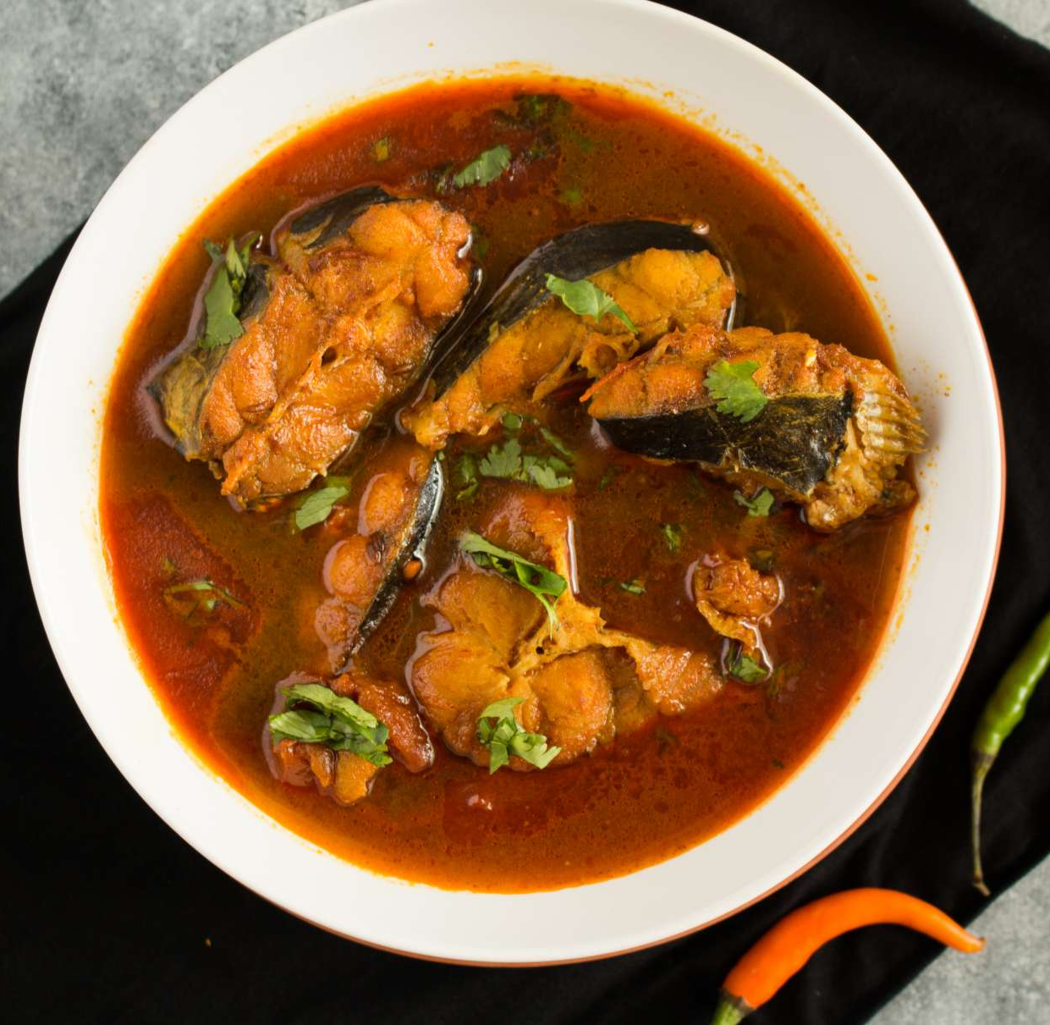
Menu
Starters
Mains

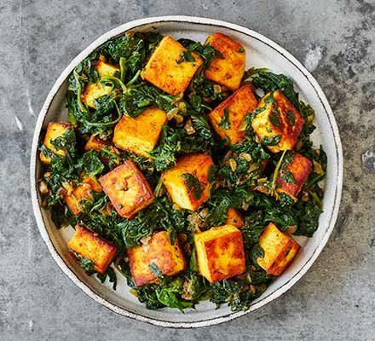
Specials
House Biryani £ 16
Rice dish with spices, meat and vegetables. Changes every week, ask house staff for what the week’s biryani is
Saag Paneer £ 19
Spinach which is cooked down with garlic and chili, then blended and cooked with shallow-fried paneer. Served with rice
House roast chicken £ 24
¼ chicken coated in raisins and nuts, with chili and then roasted until perfectly tender and cooked. Served with special rice and house pickle

Desserts Drinks
Water Free
Coffee, Tea, Chai, Latte £ 3
Soft Drinks (Cola, Fanta, Juice) £ 5
Wine (Per Bottle) £ 26
Spirit (Per Bottle) £ 19
Lassi (Strawberry, Mango, Milk, Pistachio) £ 9
Gajar Ka Halwa £ 15
Carrots grated and cooked down with milk, sugar and almonds served with pistachios and ice cream
Cake of the Day £ 12
House-made cake that changes every day

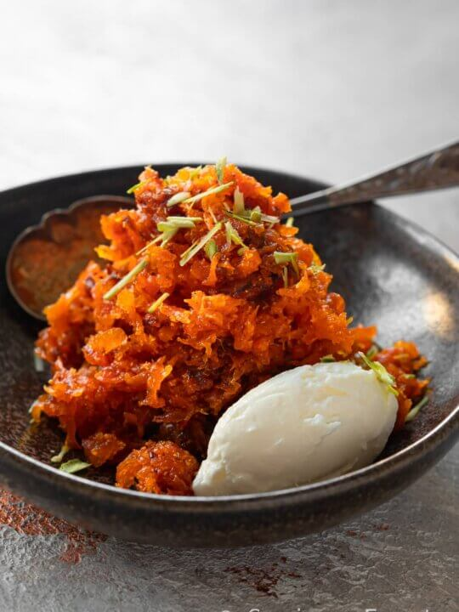
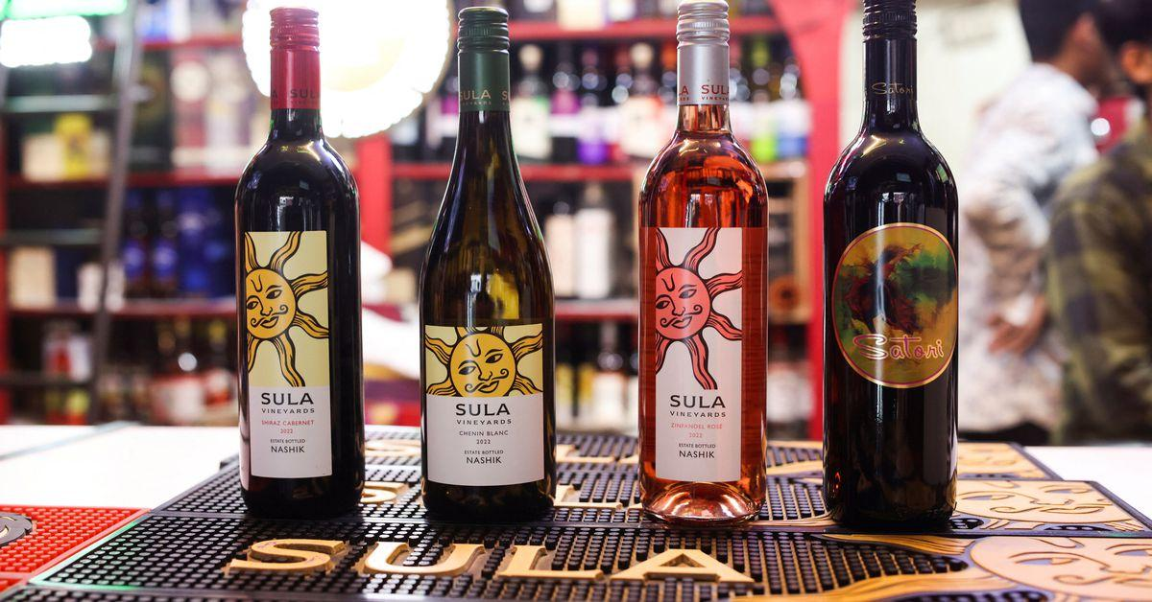

Feel free to ask for any allergens, food in green is vegan friendly

Why did I choose the foods I selected?
This is some of the food I grew up with, and eat frequently, but aren’t talked about a lot. They’re not as well known as other indian/bengali foods like chicken tikka, tandoori and other curries, even though a lot of these are more authentic, tastier and unique compared to the foods mentioned. I want people to try and expand their palettes and move away from the british-bengali/indian food and move to more authentic cuisines.
For the starters, I wanted them to be foods a lot of people know about when thinking of Indian cuisine. Samosas, Shish Kebabs and Naan bread are all foods very common in an Indian takeaway.
Moving to the mains, I wanted it to be a lot more Traditional Sylheti foods. Sylhet is a city/area in Bangladesh which has a very diverse food culture. A big ingredient native to Sylhet is Satkora; It’s the citrussy, fragrant fruit which is very similar to Lemon/Orange. It’s sour and adds a greatly needed acidic flavour. It’s mainly added to meat curries because of its acidity cutting the fatiness of beef/lamb curries.
Fish is a very common food in Bangladesh; Many of our dishes are Fish based, like fish curries or fried fish. It was something I could not leave out when designing a menu for a Sylheti-Bengali restaurant.
The desserts are very typical Indian/Bengali/Pakistani desserts. Bengali desserts aren’t that good in my honest opinion, and that’s why I wanted it to be more Indian. Lassi is a drink/dessert which is milk based and is one of my favourite desserts.

