Assessment 1

Online Portfolio of set exercises (E-Portfolio)

Module name: Changemakers: Creativity and Value Creation

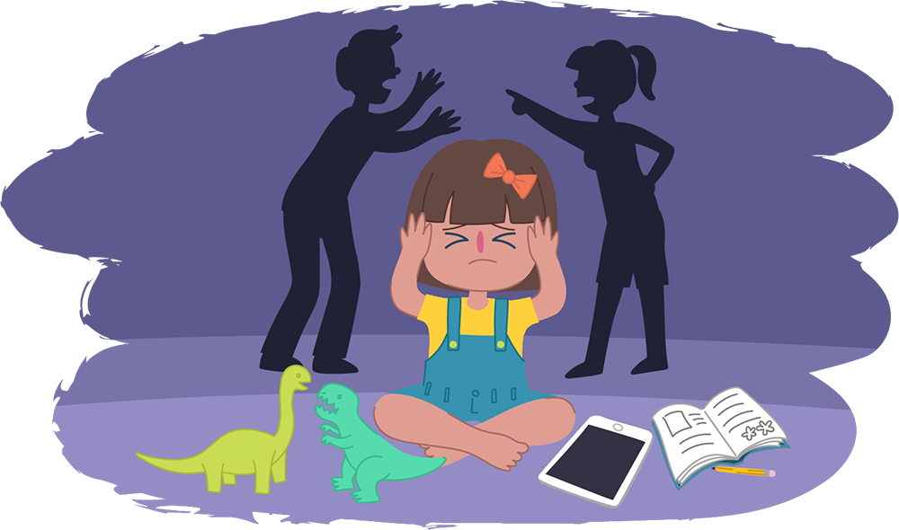
Module code: BMHP5014
Lecturer name: Eleni Koutsogeorgou
Student Name: Catiana Braganca

Table of Contents

Assessment 1 1
Online Portfolio of set exercises (E-Portfolio) 1
Module name: Changemakers: Creativity and Value Creation 1
Introduction: 3
Artefact 1- Mind-map 4
Artefact 2 – Blog 5
Conclusion: 6

Introduction:

The aim of this assignment is to create an e-portfolio of set exercises about a campaign of passion related to health and social care created by me and provide a cause or mission including 2 artefacts which are artefact 1- mind-map and artefact 2-blog , I will be discussing the risks, disadvantages, causes, preventions and a solution to the problem, the topic that I choose is prevention of children that suffer from abuse or harm.

I choose to discuss this topic because it is very interesting and common nowadays, we can see from social media or television that many children are suffering different types of abuse by talking to a stranger online and meeting the person or even at school with colleagues that blackmail a child and use physical force to harm, with this portfolio I am willing to research and get more knowledge about ways to prevent children from abuses.
According to the research (Cleveland Clinic,2022) the term child abuse means when a child is in a situation where another person closer can be from the family or a friend hurts, neglects or mistreat the child can be in different types such as physically, emotional, sexual.

Artefact 1- Mind-map

- Effects
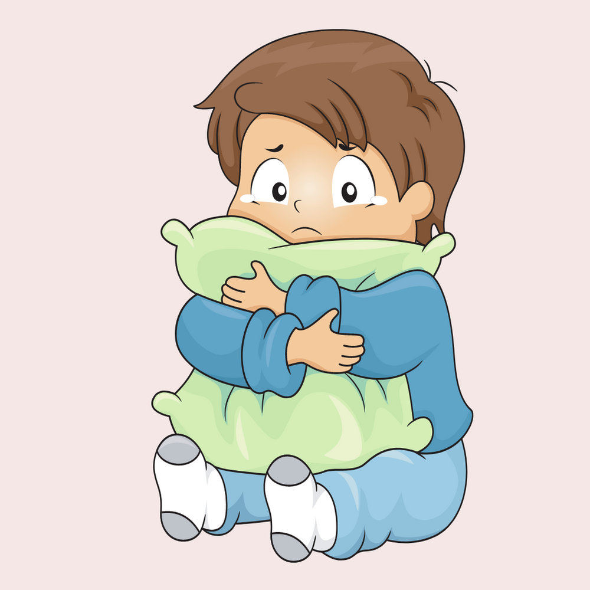

c. RIsks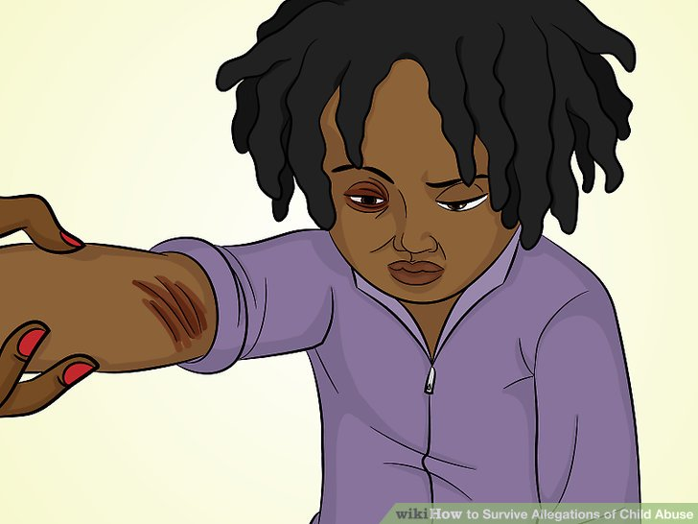SKS

b. Types of abuses
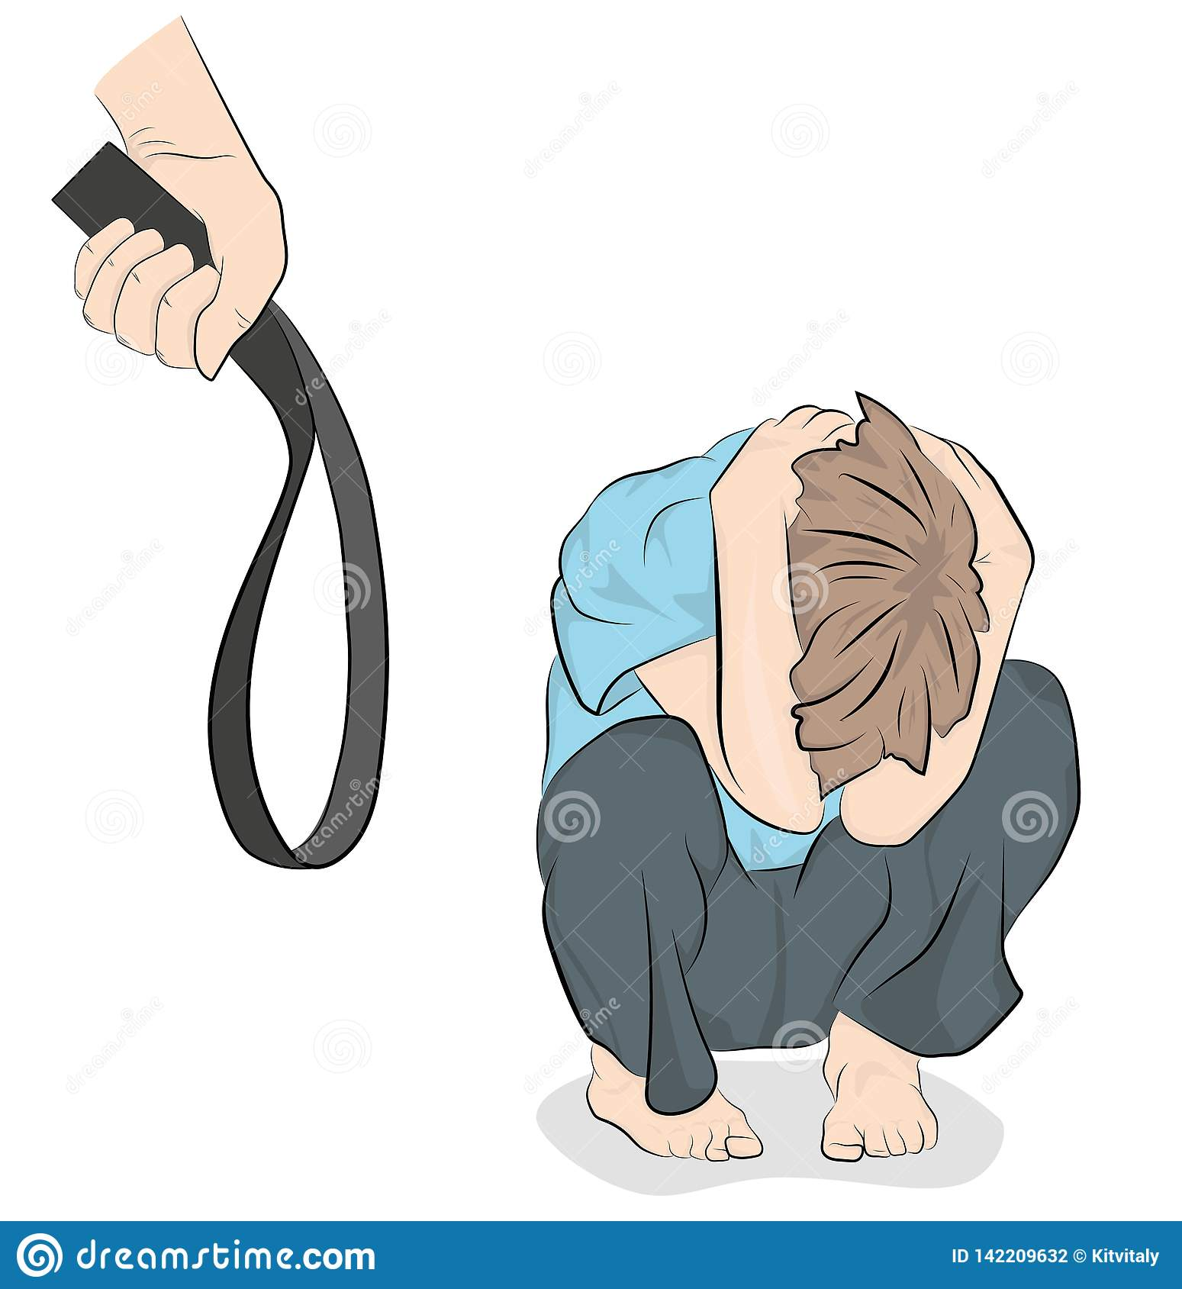

d. Prevention
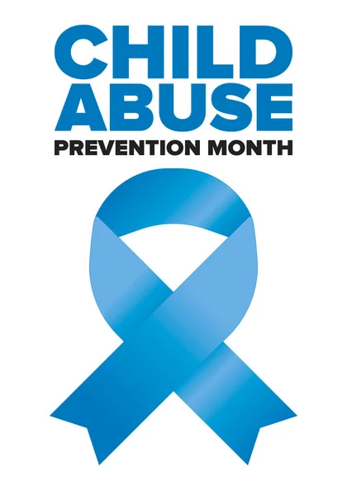
Child abuse and harm
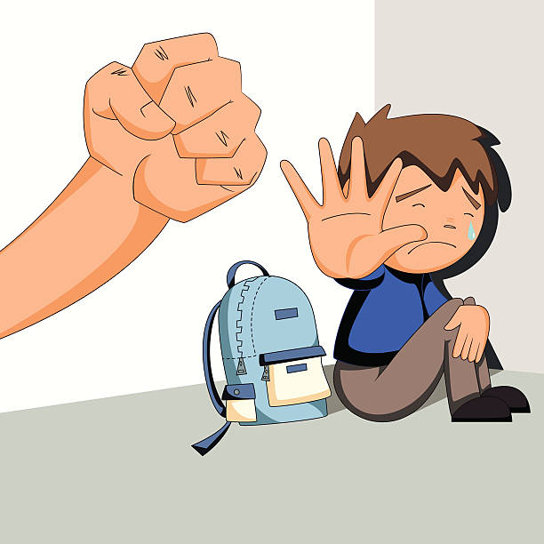

f. Solutions
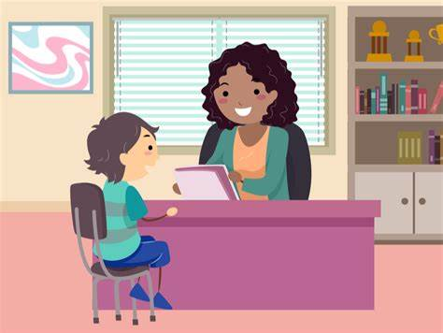

e. Causes
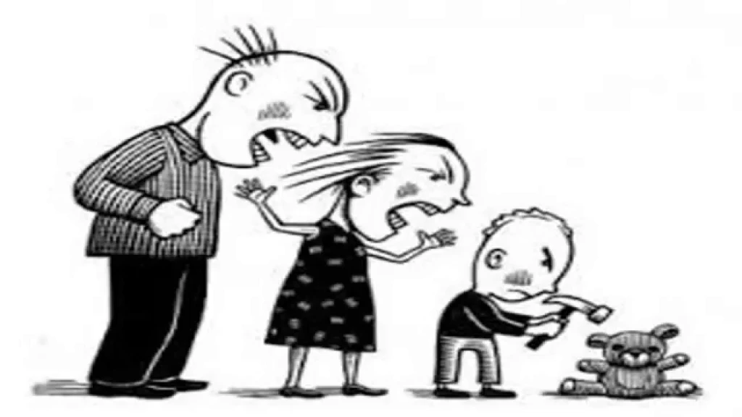

(Stephanie Innovative Media,2013)

In this mind map I will start by explaining more about children that suffer from abuse and harm, we can see in the picture in the middle that a child is suffering from physical abuse and around it a mind map with different ideas related to the children abuse, I divide it in 6 items that I found more important which first is effects, that can cause on children, second are types of abuse such as sexual, physical and mental, third is the risks that may cause with a child, fourth is ways of prevention to safe the child from harm, fifth causes to understand why the child is going through this situation and to finish sixth solutions I will be discussing some solutions to help the child.

a. Effects, some of the effects that can influence physical and cause trauma in children are burn marks , head trauma because of the excessive abuse can cause long term trauma, difficulty in brain development , the children might have less capacity in learning or concentrate for example in the class, poor higyene, the children cannot take a shower or dress because of the big impact of phisycal abuse caused.
Mental effects that can cause in the child are depression, anxiety, persistent fear. (Joyful Heart Foundation,2022)
b. Types of abuse
Physical abuse is defined as a situation when a child is being harmed or hurt on purpose (NSPCC,2022) including any type of physical abuse that causes the child sickness or unwell, slapping and beat the child.
Sexual abuse is when a child less than 18 years old is hurt sexually by an adult and is related to intimate contact for example penetration or touching, it can be also child pornography without contact normally is a man that abuse the child. (HealthyPlace,2022)
Child Mental abuse means when a child is abused mentally such as restricting the child, self-esteem, sense of worth, social development and emotions. ( Child Advocacy Center Hidalgo,2022)
c. Risks, there are many risks that can influence children for example
Parent factors that contribute to child abuse and neglect, Society, and home factors that contribute to child abuse and neglect. ( Child welfare Information,2015)

d. Prevention, the ways to prevent the child from abuse is implementing activies out of school time for the child and parent, support prevention programmes that can help child preventing from abuse before it happen for example family conselling and home visits from nurses. ( Whashington State Department of CHILDREN, YOUTH & Families )
e. Causes
The child can be isolated from others and without enough support from the family in terms of care, Parents that had been abused in childhood may impact the child development, and mental health problems ( State of Queensland,2022)
f. Solutions
.Talk to your child in a proper way calm without anger or stress
Apologize when you say something bad or that makes him feel sad.
Ask for help in schools or community centres for advice in parenting skills

Artefact 2 – Blog
November 2022
Hello my name is Catiana! Welcome to my blog ,
In this blog I will start by explaining you the reason of choosing this topic and where the idea come from. To understand more about children that suffer from abuse I will write some causes that lead an adult to hurt a child, as you can see above in the mind map I already provided 2 examples of causes and in this blog, I will provide more information in relation to the causes and solutions.

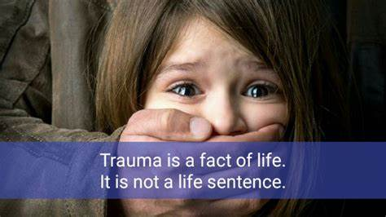
I choose to discuss about children that suffer from abuse and harm to advice others people on ways that you can protect and prevent your child from getting hurt, physically, sexually and mentally.
The idea of this topic come out from my past experience, when I was child I was abused mentally by one person that was close to me it make me feel sad, it really impacted on me before and at the moment as well, I can consider as a trauma that need to be solved with a help of a psychologist, the reason why I choose this topic is to help others children that are dealing with this situation and doesn´t know how to seek for help or are afraid of asking for support.
In the previous artefact, I discuss 2 causes related to children that suffer from abuse but in this blog, I will be explaining more about why this happens with more examples so that the parents of the child can be more aware in what they can do to prevent this situation.

Why do children suffer from abuse and harm?
There are many reasons that can cause an adult in hurting a child
One of them is the lack of communication and relation between the parent and the child, if the parent does not show affection, doesn´t show care for the emotions and health of the child it is considered as mental health abuse.
The second cause of abuse in children is a lack of parenting skills, it exists cases that new parents don´t know or had experienced before in relation of raising a child it leads to parents raising a child in another way beating the child, and shouting.
The third cause might be family stress or causes influenced by separation or domestic violence.
I just choose three points that I consider more important but there is more causes that increase an adult to hurt a child where you can find more information on this link Causes of Child Abuse: Why Some Adults Hurt Children (healthline.com)

If you are aware of someone that is experiencing child abuse try to recognise the signs, sometimes is hard because you can not see but you can notice when a child is different regarding being alone not talking much or spots on the body.
Another solution is look for parent and family support classes this can help parents with parenting skills, economic support it has been said by Dr John Degarmo,2017 that this helps reduce the risk of child being abuse.
The important thing to support the child is to give them therapy, counselling support and any other service that may help on child’s healthy development.

Conclusion:

References:
Mind Map of Child Abuse - Stephanie Innovative Media (weebly.com)
Child Abuse: Definition, Signs, Child Neglect, Emotional Abuse (clevelandclinic.org)
Identifying Child Physical Abuse & How to Prevent It | NSPCC
What Is Child Sexual Abuse? | HealthyPlace
Effects of Child Abuse and Neglect | Joyful Heart Foundation
How to Recognize Mental Child Abuse | Childrens Advocacy Center (cachsc.org)
Risk Factors That Contribute to Child Abuse and Neglect - Child Welfare Information Gateway
Ten Things You Can Do to Prevent Child Abuse | Washington State Department of Children, Youth, and Families
What causes child abuse | Community support | Queensland Government (www.qld.gov.au)
Solutions for Child Abuse – Preventing Child Abuse (cuny.edu)

