Student Name: | Gareth Rhys Francis
Student Number: | 1707331
Module Name: | Lean Six Sigma Manufacturing Strategies
Module Code: | M6X00466
Exam Date: | 12/02/2021

Question 1 (a)
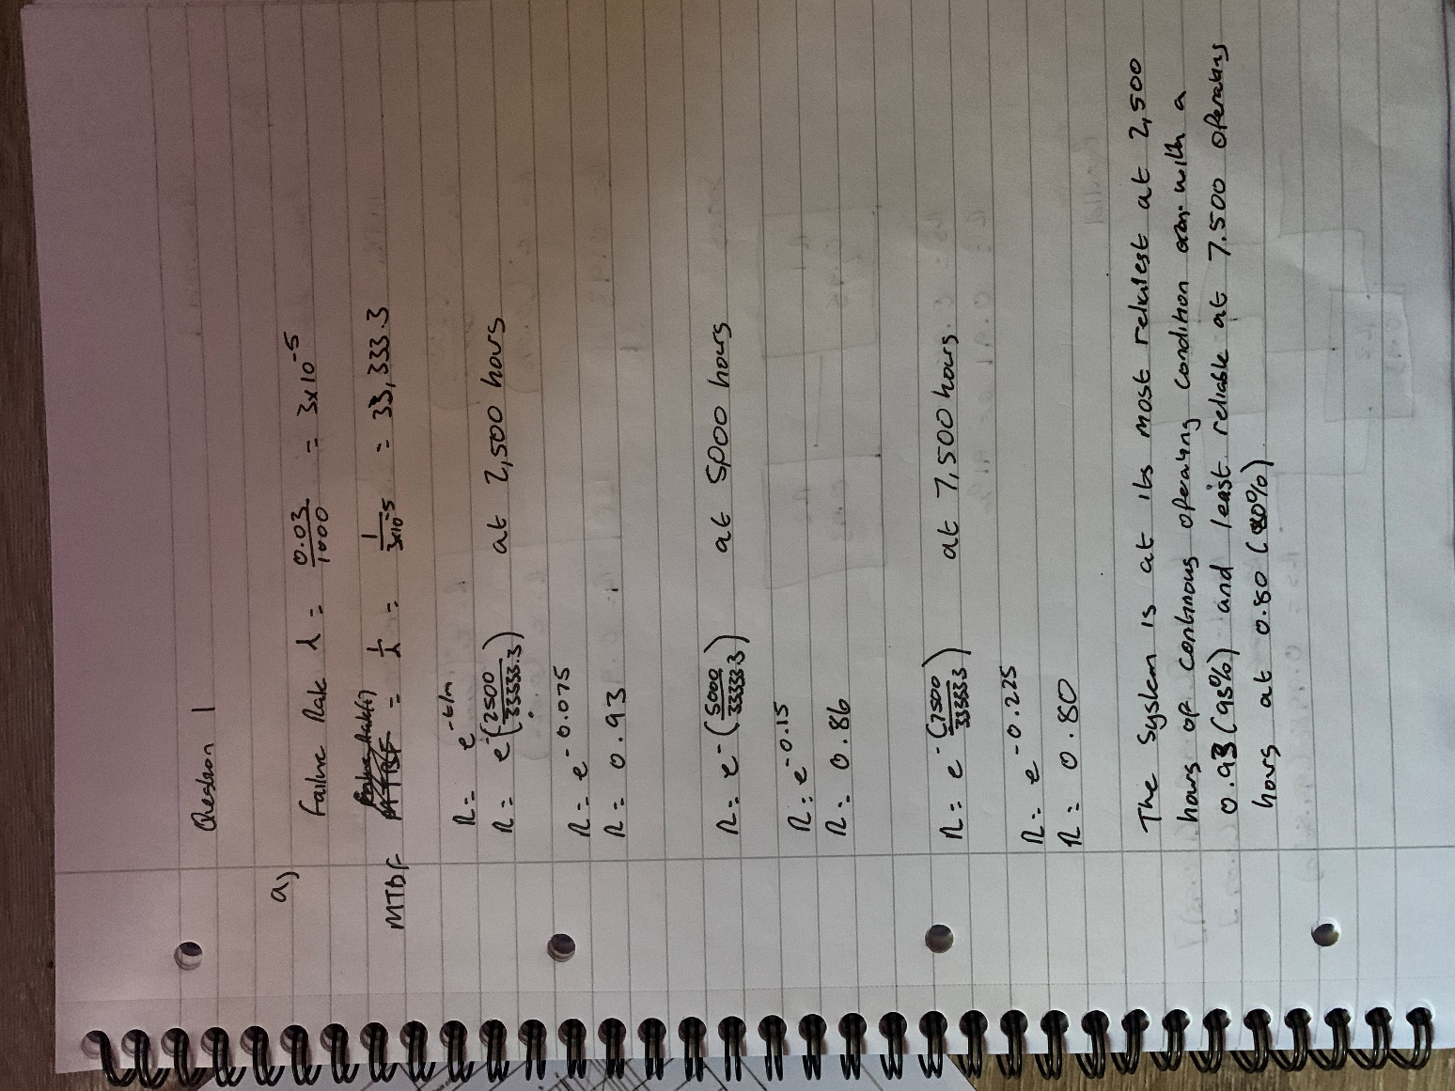

Question 1 (b)
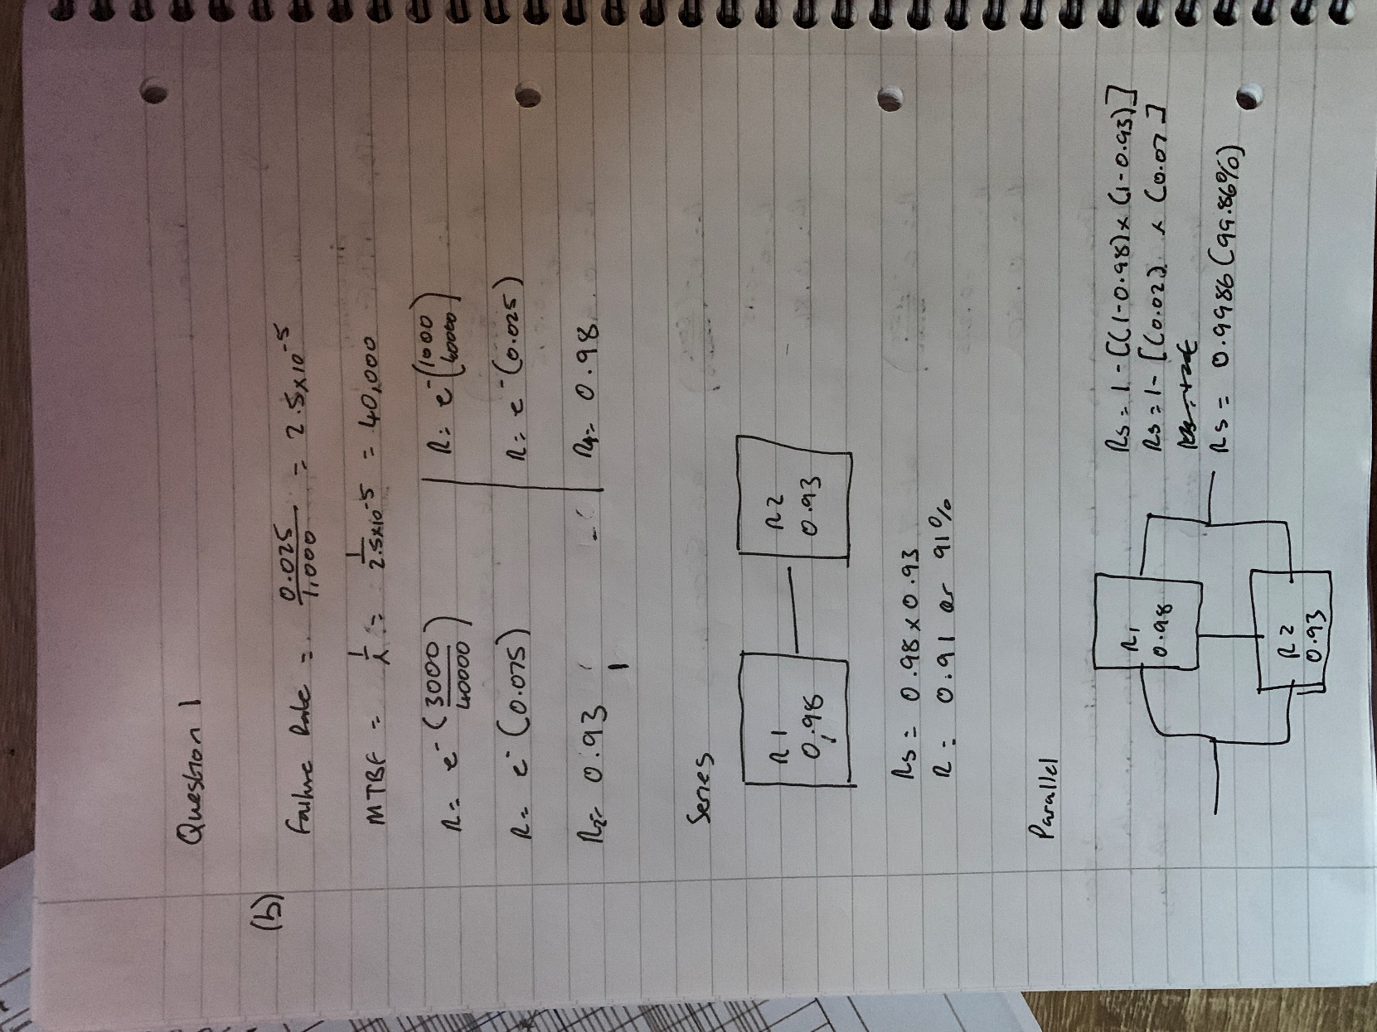

Question 1 (c)
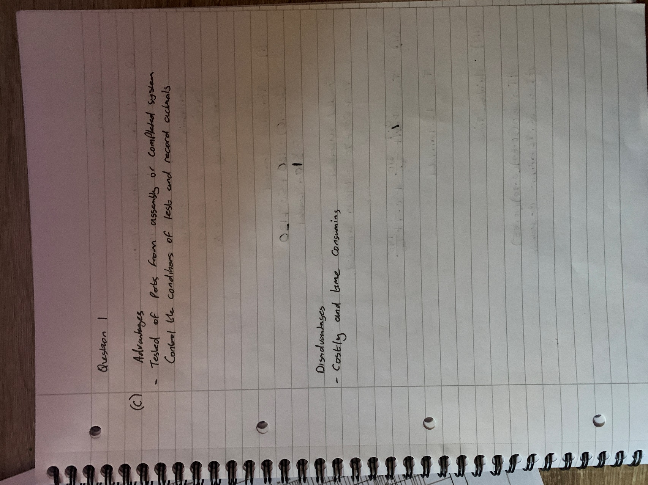

Question 2 (a)
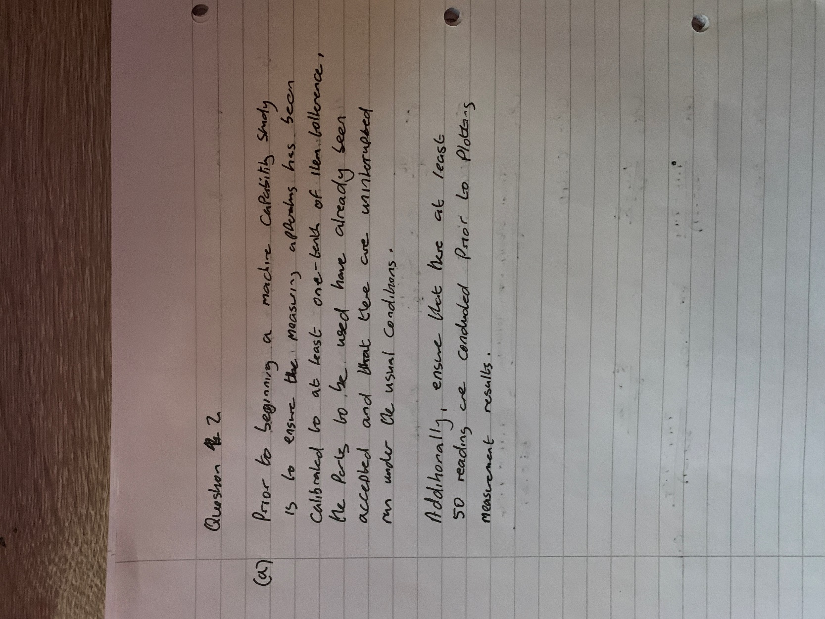

Question 2(b)
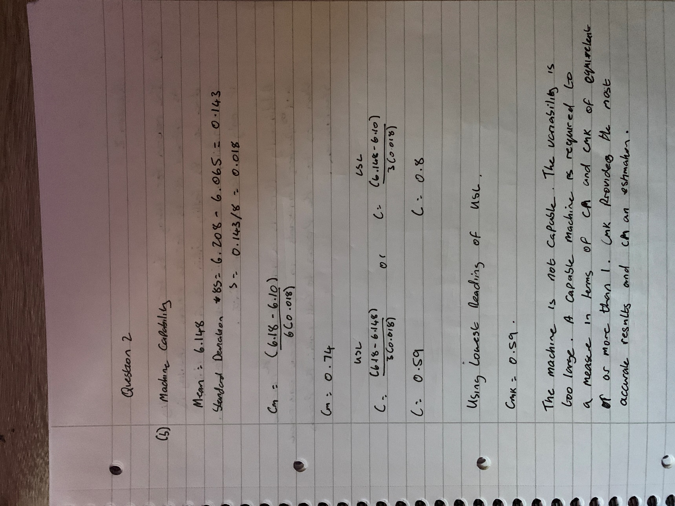

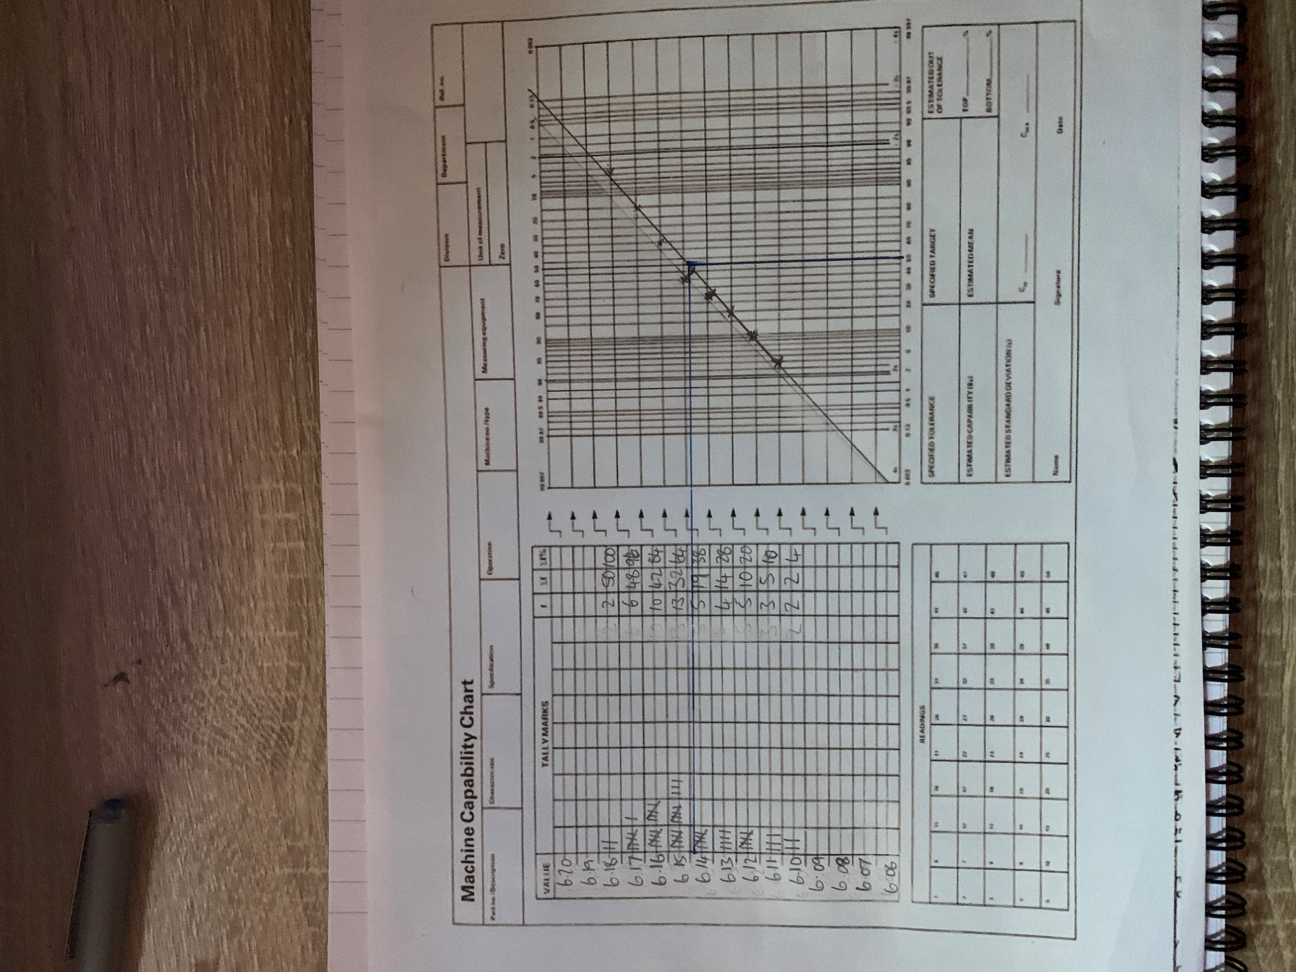

Question 2 (c)
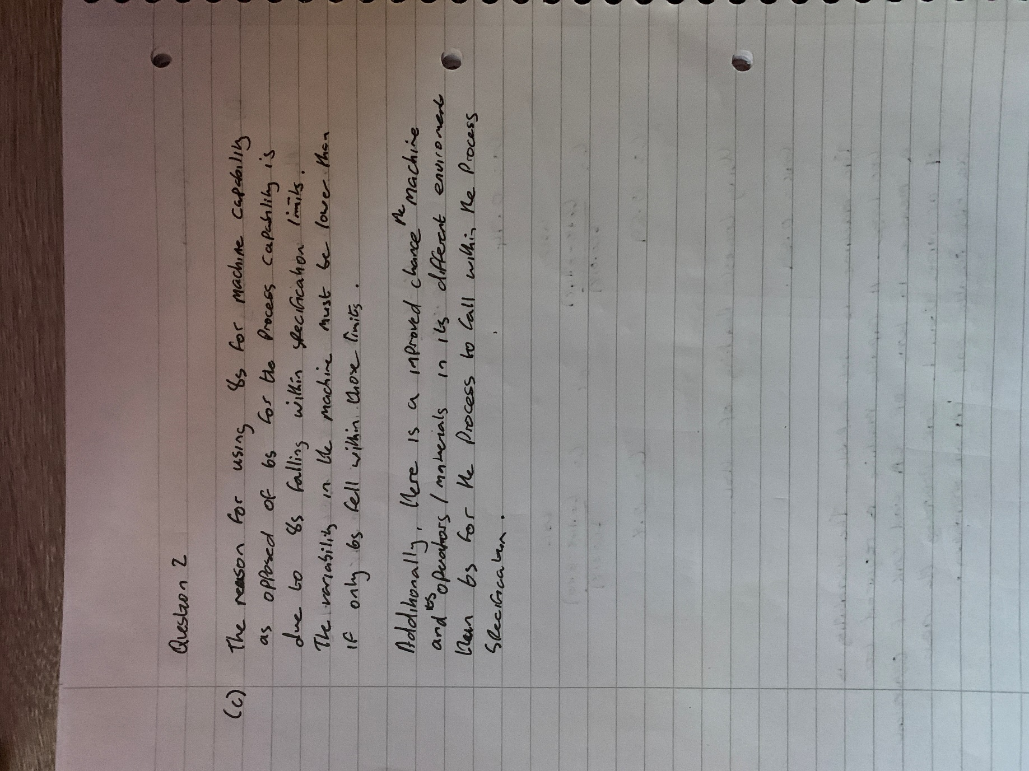

Question 3 (a)
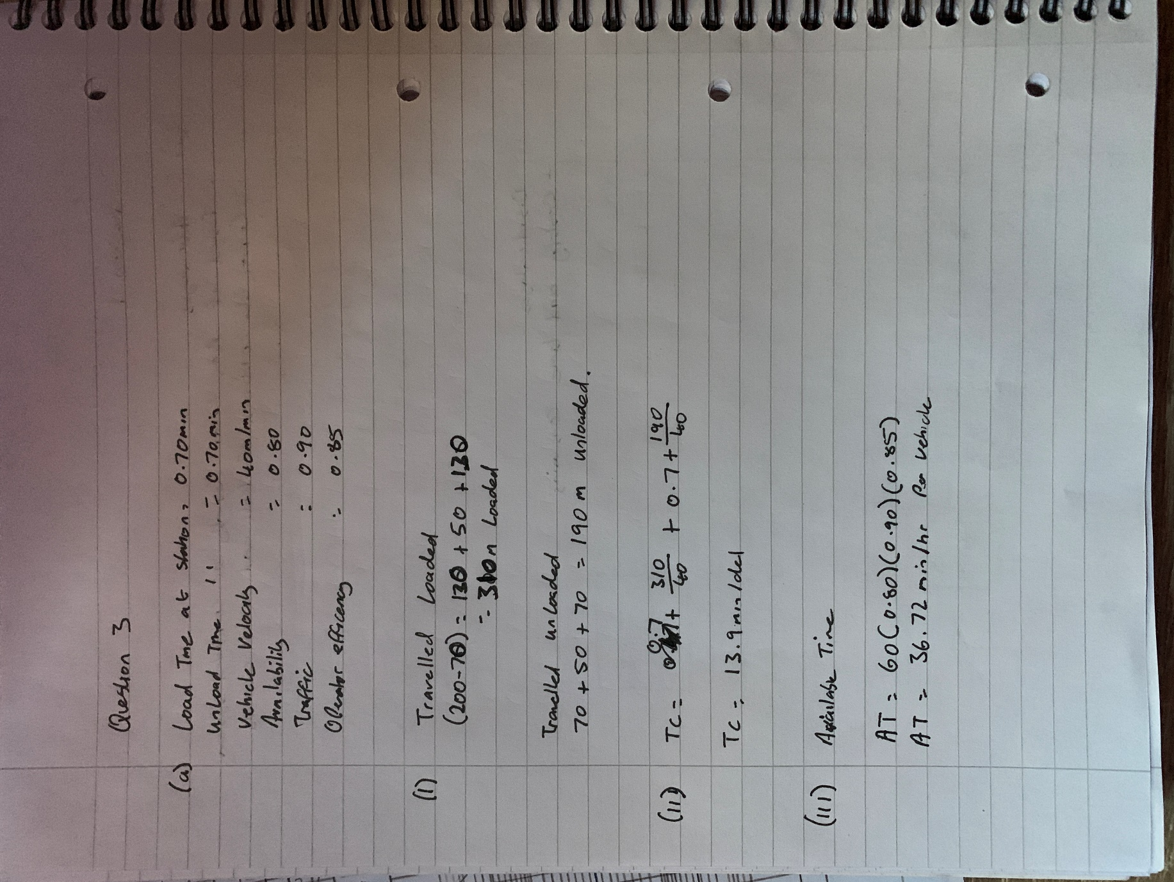

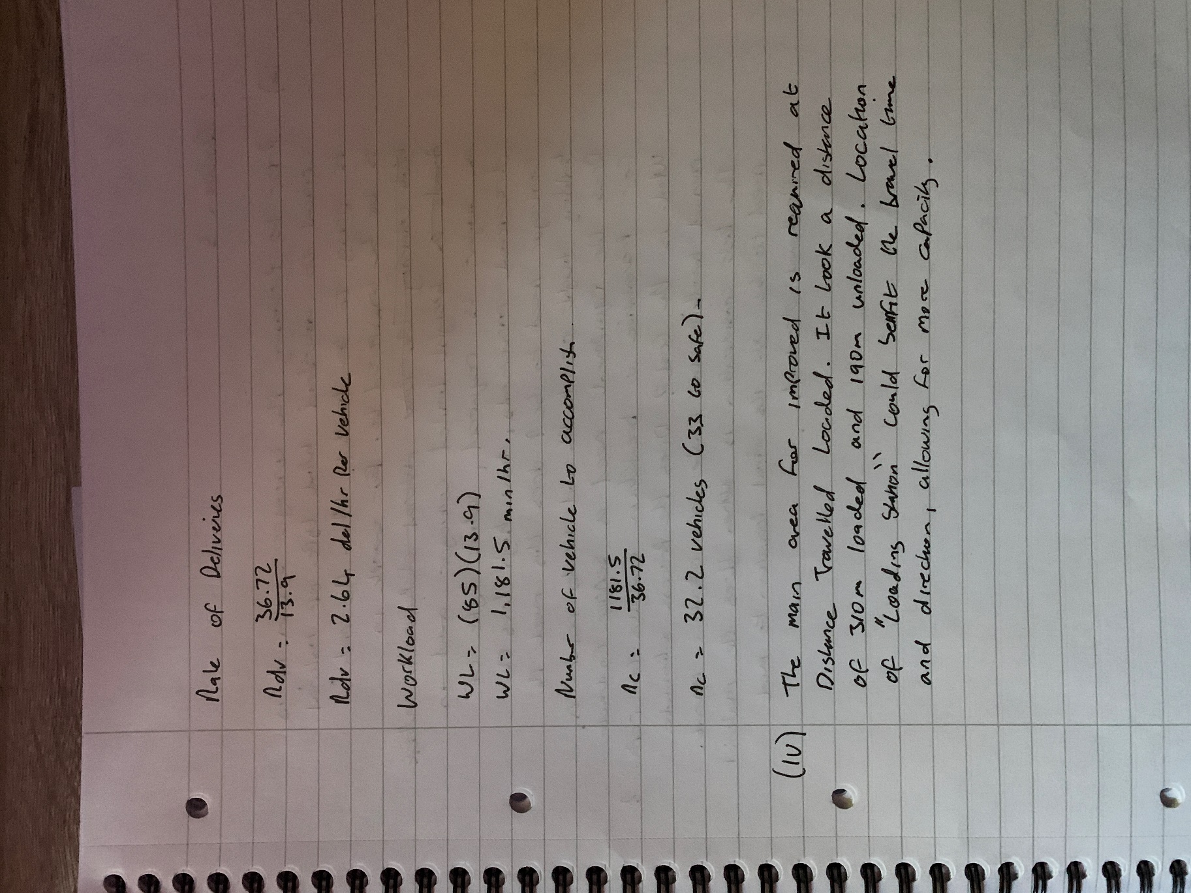

Question 3 (b)


