Global Business Environment

Assessment 2: Environmental Analysis of an Aston Martin Lagonda Global Holdings plc
Galina Rais ID: (2020307)

Contents
I. Introduction: 3
II. Literature Review: 4
1. Automotive dealers: 6
2. Auto suppliers: 7
3. Finance companies 7
4. Sale: 7
III. Discussion: 8
IV. Conclusion: 11
V. References: 13

Introduction:
Aston Martin Lagonda Global Holdings plc. A flamboyant sports car company founded in 1913 by Robert Bamford and Lionel Martin. Its main mounting community is in Warwickshire, England. To become the North's leading 100 year old wacky automaker in the best desire to give out wacky and quality auto items (Aston, 2018). The organization offers a variety of models, most of which are GT DB11, Super GT and Rapid S Sports Coupé. Since its inception, the organization has participated in several business expansion programs and in 2015 launched the "Second Century Plan", focused on 3 main regions. Business establishment, business strengthening and growth guidelines (Aston, 2018). The organization completed 876 million Euro in financial transactions in 2017 and closed its activities in 2018 with growth of 25%, measuring £ 1.096 million (market, 2019). In this report, the impact of Covid-19 will be examined on the employees, finance, and customer behavior.
During the underlying shock of COVID19 and worldwide lockdowns, business pioneers revitalized to save their organizations, keep supply chains moving and secure workers. Presently, as the world keeps on reckoning with the human and financial cost from the Covid, they are attempting to outline a course for the following typical notwithstanding the numerous questions that lie ahead. Never in present day times have such countless ventures been confronted with such vulnerability (Burch et al., 2016). For versatility administrators in the United Kingdom (UK), COVID19 struggles. In January 2020, global exchange relations were continually advancing as the terms and costs of Brexit were characterized. The business was upset by new advances, including computerization, jolt, availability, and man-made brainpower. In the meantime, developing natural worries, changing client inclinations, and developing versatility shares were evolving long-standing interest designs tension from falling deals, rising RND expenses and rising costs. Around the world, OEM net revenues tumbled from 6% in 2018 to 3% in mid-2020 (Hertzke et al., 2020). Aston Martin intends to cut up to 500 positions to meet the declining need for wacky vehicles due to the Covid pandemic. The UK organization will start talking to workers and associations in no time to assemble fewer front-engine sports cars, Aston Martin said. Today. The automaker intends to save around £ 18million ($ 22.6million) in assembly and operating costs, while reducing the use of capital by an additional £ 10million (Bloomberg, 2020).

Literature Review:
The pandemic is not only disturbed the lives of human but also disturbed the financial and economic activities across the world.. To level it all, the states of nearly 162 nations have declared a severe end to public and global borders, travel restrictions, and barricade measures. As a result, the trading sectors of the world's major monetary nations and others are working out of fear of disruptions in the global monetary trading sectors (Jazeera, 2020). Important regions, for example, supply chains, business, travel industry, agricultural industry, auto industry, travel and transportation, etc. were severely disrupted due to the COVID-19 episode. The economics of different fields such as aeronautics, the media, games, etc. It has also been seriously hampered across the planet by barricades or bars. In UK, the main case was counted during the last seven-day period of January 2020 (Nayak et al., 2021).
The COVID19 has dove the overall economy and mankind into disaster. To control this pandemic, the public associations of all nations have constrained a public barricade. Though the blockade may have helped with limiting the spread of the disease, it truly affected the country, disturbing entire stock chains of tremendous associations (Giampieri et al., 2020). The episode drastically affects all qualities of companies, including the automotive sector, with the total closure of large manufacturers following lawsuits backed by neighborhood legislatures or the management of an association with less staff in government units. for the safety of your staff. 12 and a half years, the automotive industry has experienced a long delay due to the initiation of underlying changes with the valuation of jobs and products, changes in pivot loads, progress towards the exchange of versatility, the urgency of liquidity, etc. they have experienced significant impacts and have been completely inactive since March 24 due to the COVID19 closure (Nayak et al., 2021). There is a delayed shutdown in customer interest due to the shutdown by the automakers. Most organizations are eager for RDD (research and development) support to monitor the capabilities of the center and possibly find the development achieved with innovations in terms of fuel and versatility.
The literature explained the consequences of COVID19 in the automotive field. The study carried out by Rajamohan et al. (2020) on variations in stock market, in particular the “National Automobile Exchange”, was affected by COVID19. The results show that the most important protections were sold at an ever lower price. In addition, lower yields have been factored into the increases for automatic zone cards. Therefore, looking at the results, it is almost certain that the COVID19 pandemic fundamentally influenced stock transactions in the automotive sector (Giampieri et al., 2020). A study used to examine the effect of socio-demographic factors, plague, and mental inactivity on the powerful vehicle purchase price. The results reveal that the pandemic is worryingly affecting vehicle acquisition (Nayak et al., 2021). Factors such as family wages, lack of mobility and the severity of the pandemic in neighboring regions are influencing the dynamism of individual purchases. , 2020).
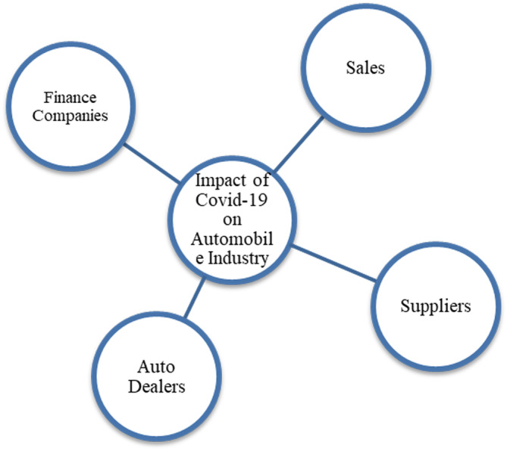
Figure 1 Automotive Industry fields affected by COVID-19
There are different Automotive fields that are affected by COVID-19 mentioned in Figure1.

Automotive dealers:
Car dealerships have encountered big problems. There are currently 15,000 top car dealerships including two-, three- and four-wheelers across UK (Nayak et al., 2021). They were unable to transport vehicles during the lockdown period. Auto dealers have reported 30-45 days of finished goods registration, probably at a very low price before the next block. Over the next 6 months, at least 8-10% of these concessions are expected to close.

Auto suppliers:
Auto suppliers are heavily reliant on foreign labor, the absence of which is expected to further delay post-closure rebuilding, leading to a domino result across the valuation chain. Suppliers face liquidity difficulties that could meet unclear market conditions, causing major difficulties throughout the assembly organization. Auto suppliers are heavily reliant on foreign labor, the absence of which is expected to further delay post-closure rebuilding, leading to a domino result across the valuation chain (Giampieri et al., 2020). Suppliers face liquidity difficulties that could meet unclear market conditions, causing major difficulties throughout the assembly organization.

Finance companies
These financial organizations are likely to face this burden, as misrepresentation is claimed to increase and new advancements decrease, given the complexity of finalizing customer credit ratings. automobiles, portability agreements and later specialized commercial cooperatives, whose monetary aid depends on projections of wild development.

Sale:
COVID-19 had a very negative impact on new car sales, especially in February 2020. For example, new car sales in China fell 92% in February (Nayak et al., 2021). Furthermore, in European countries, total vehicle sales fell 7.4% compared to last year's sales. Also, in countries like UK, many auto industries like TVS, Toyota, Honda, Aston Martin Lagonda Global Holdings and BMW have suspended the sales and production due to the COVID-19 restrictions and other sectors also have been interrupted (Giampieri et al., 2020).

Discussion:
The auto industry is one of the foundational efforts charged with turning the nation's financial milestones and achievements. For example, in the United Kingdom the turnover of the automotive sector exceeds 7% of its GDP, in the United States the turnover is between 3 and 3.5% of the total GDP, and in China the turnover is situated somewhere between 3 and 3.5%. of total GDP. the activity is 10% (Yan, Y., et al. 2020). The floods caused by the COVID19 pandemic have kept the auto business under exceptional pressure due to supply and interest factors. The company faces a clash of interests with a recovery mode unbalanced by the abandonment agreements. The world's automobile creation is mainly subject to China's auto parts and trim products. The effect of the lack of supply in China influences the consolidation of single hardware producers (OEMs) in North America, the United Kingdom and Asia. It can be seen very well that the UK is generally facing disruption from the Chinese auto parts and trim product, which amounts to $ 11.7 billion. Later, Japan suffered $ 3.2 billion from the disruption of Chinese raw materials. While Mexico, Germany and South Korea suffered a disruption of US $ 2, 1.7 and 1.2 billion in Chinese commodities (Yan, Y. , et al. 2020).
The global outbreak of COVID-19 has occurred and will likely occur continue to affect the Company and many suppliers, vendors, and customers indefinitely. Specifically, the pandemic caused both the seller and the customer Interest in vehicles and outrageous merchandise deals mostly declined mostly, to some extent due to foreclosure measures. forced through the districts where we work. This included impacts on the seller network with a huge rate of our organization closed for prolonged periods for year. This is the main factor behind the 32% drop in our retail offers (which are sales offers to our customers) to year.
The pandemic has affected almost all companies in the world. Due to foreclosure restrictions, many businesses have been forced to close or lay off employees. In Aston Martin's case, it lost almost £ 119 million in the first quarter of 2020. Sales are almost half compared to 2019 last year (Attwood, 2020). The company sold about 578 cars in the first quarter of 2020, while in the last year it sold about 1,057 cars in 2019, a decrease of almost 45% (Aston Martin Houston, 2020; Attwood, 2020). But the company quickly resumed production on May 5 for a simultaneous surge in demand for SUVs.
During the pandemic, Aston Martin chose to cut more than 500 positions due to declining interest in luxury cars among the customers. From that point on, this has been one of the most impacting social elements of the business (Bloomberg, 2020). Due to the bar of the public authority and the closure of creation, the development of the most demanding vehicles has hardly worked. Since the purchasing quality of individuals has shifted from unnecessary purchases to basic commodities. The organization has chosen to save nearly £ 18million in labor and start-up costs of up to £ 10million by reducing the use of capital (Bloomberg, 2020). The financial year 2019 was the hard year as there was 23% reduction in revenue was observed that is a huge loss in finance (Aston Martin Houston, 2020). This can also be seen in the figure 2.

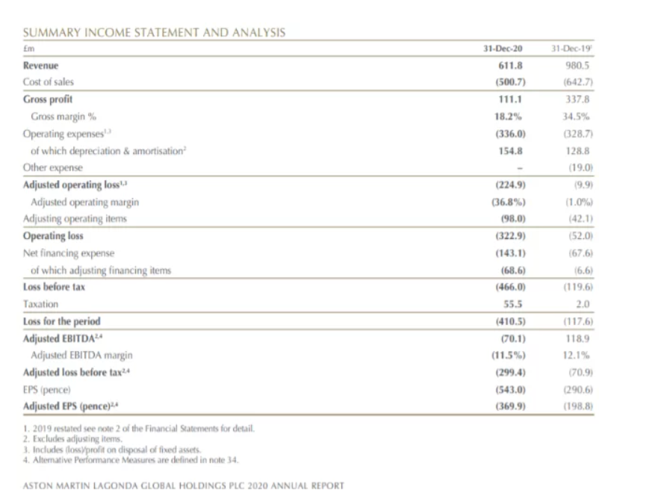
Figure 2 Financial Analysis (Aston Martin, 2021)
dellers' jobs have been affected by COVID19, leading to system outages and showroom closures. Some steps have been taken to provide sufficient support to affiliates and customers, including administrative agreements and rules to focus on customer and material safety. These activities reflected territorial hazards and government preconditions, as well as expected development effects (Giampieri et al., 2020). The provider network continues to operate within significant government constraints identified with COVID19 and adapts to the effect on the economy and customer behavior. These conditions have accelerated progress towards further digitization and the development of online engagement. The future retail methodology is created to reflect an extravagant customer experience developed before it satisfies individual and online engagement inclinations. Strong and effective inventory reduction measures have been taken within the supplier organization to rebalance market interest and ensure agreement with the new strategy. This will be a constant goal until 2021 to achieve the best pipeline inclusion (Aston Martin Houston, 2020). New showroom execution in which board processes are expected to ship in 2021 to further develop execution and perceive greatness.
Stakeholders’ support is critical to the future performance of the company. The company has raised gross funds of £ 813 million which, despite the increase in our bond development profile, has greatly bolstered the company's monetary strength and maintains the execution of this groundbreaking deal to become a leading company in automotive (Aston Martin Houston, 2020). The organization will continue, as you can imagine, assessing the freedoms to extend this fortified position.

Conclusion:
The COVID-19 pandemic that occurred at the end of December 2019 in the city of Wuhan, in southern China, began to spread rapidly from March 2020 to different regions of the planet. This COVID-19 emergency has not only reversed the pain of people across the planet but has also disrupted the social and financial activities of people across the planet. As the number of cases began to increase significantly in different parts of the world, at that time, at that time, experts from public specialists from different nations have spoken out about blockades, travel limitations and eliminations. Public and global borders to prevent spread. of illness. As a result of these foreclosure strategies, there was an extraordinary disruption in the network of supply chain in various countries, affecting the economy of the countries and companies. Due to lockdown and different restrictions, Aston Martin lost 500 valuable employees as well as 23% revenue in the year 2019. Aston Martin also disrupted supply chain and dealers that interrupted the sales of cars.

References:
Hertzke, P., Middleton, S., Neu, G. and Weaver, H. (2020). McKinsey Center for Future Mobility. [online] Available at: https://www.mckinsey.com/~/media/McKinsey/Industries/Automotive%20and%20Assembly/Our%20Insights/Moving%20forward%20How%20COVID%2019%20will%20affect%20mobility%20in%20the%20United%20Kingdom/Moving-forward-How-COVID-19-might-affect-mobility-in-the-United-Kingdom-vF.pdf.
Bloomberg (2020). Aston Martin to axe 500 jobs with Covid-19 stifling demand for cars. [online] @bsindia. Available at: https://www.business-standard.com/article/companies/aston-martin-to-axe-500-jobs-with-covid-19-stifling-demand-for-cars-120060401505_1.html [Accessed 19 Dec. 2021].
Yan, Y. , et al. (2020). An empirical study on consumer automobile purchase intentions influenced by COVID‐19. Available at SSRN 3593963.
Jazeera, A. (2020). Coronavirus: Travel restrictions, border shutdowns by country. [online] Aljazeera.com. Available at: https://www.aljazeera.com/news/2020/6/3/coronavirus-travel-restrictions-border-shutdowns-by-country [Accessed 19 Dec. 2021].
Burch, T. R. , Emery, D. R. , & Fuerst, M. E. (2016). Who moves markets in a sudden marketwide crisis? Evidence from 9/11. Journal of Financial and Quantitative Analysis, 51(2), 463–487.
Philip, S.V. (2021). Aston Martin surges as demand for $223,000 SUV brightens outlook. Business Standard India. [online] 26 Feb. Available at: https://www.business-standard.com/article/automobile/aston-martin-surges-as-demand-for-223-000-suv-brightens-outlook-121022600023_1.html [Accessed 22 Nov. 2021].
Giampieri, A., Ling-Chin, J., Ma, Z., Smallbone, A., Roskilly, A.P., 2020. A review of the current automotive manufacturing practice from an energy perspective. Applied Energy.. doi:10.1016/j.apenergy.2019.114074
Impact on the Automotive Industry: Navigating the Human and Business Impact of COVID-19. (2020). [online] Available at: https://www.accenture.com/_acnmedia/PDF-121/Accenture-COVID-19-Impact-Automotive-Industry.pdf.
Nayak, J., Mishra, M., Naik, B., Swapnarekha, H., Cengiz, K. and Shanmuganathan, V. (2021). An impact study of COVID ‐19 on six different industries: Automobile, energy and power, agriculture, education, travel and tourism and consumer electronics. Expert Systems. [online] Available at: https://www.ncbi.nlm.nih.gov/pmc/articles/PMC8014102/#exsy12677-bib-0005 [Accessed 19 Dec. 2021].
‌Rajamohan, S. , Sathish, A. , & Rahman, A. (2020). Impact of COVID‐19 on stock price of NSE in automobile sector. The International Journal of Advanced Multidisciplinary Research, 7(7), 24–29.
Attwood, J. (2020). Aston Martin posts £119 million loss due to coronavirus impact. [online] Autocar. Available at: https://www.autocar.co.uk/car-news/industry/aston-martin-posts-%C2%A3119-million-loss-due-coronavirus-impact.

‌

‌

