
BA (Hons) Leadership and Management Skills for the Workplace
Research Methods for Business (LCLM6004)
Assignment Title: Business Research Proposal
The Role of Social Media Marketing in increasing customer engagement: A case study of JD Sports

Student Name: Daniela Castravet
Student ID Number: 2321952
Lecturer: Rameses Manalang

Table of Contents
1. Introduction 3
2. Research Aim, Objectives and Questions 4
3. Critical Literature Review 5
4. Research Methodology 8
5. Business Relevance and Practical Implications 9
References 11

1. Introduction
Background of JD Sports
JD Sports was established in 1981 in Bury, Greater Manchester and is considered one of the world's largest sports fashion retailers with 4,811 stores in 38 countries (JD Group, 2025). The company sells high-quality sportswear, shoes and lifestyle products in collaboration with world-leading brands like Nike, Adidas, Puma and New Balance. JD Sports' online sales accounted for 20.8% of total revenue, highlighting the significant role of digital platforms in the retailer's business model (JD Sports, 2025). The retailer has also placed a big bet on social media to build brand awareness, to promote exclusive product launches and to communicate with the younger generation.
Business Problem
Even though JD Sports has made a substantial investment in digital marketing, increasing customers' engagement on social media is a big challenge for them. This is an aggressive marketplace in the sports fashion retail sector with competitors like Foot Locker, Sports Direct and Nike adopting cutting-edge digital campaigns, influencer partnerships and personalised content to grab consumers' attention. While JD Sports is well established on Instagram and TikTok, the metrics of customer engagement also differ significantly between campaigns. It is challenging to identify the most effective social media marketing activities that lead to customer interaction, trust and purchase intent (Lamba, 2025). This uncertainty can affect the ROI of marketing, affect customer loyalty, and hinder future digital marketing efforts.
Significance of the problem
Retailers rely on customer engagement as an important metric because engaged customers tend to buy again, recommend to others via electronic word-of-mouth, and are more likely to become loyal (Miranda et al., 2026). The ability to engage more customers is important to JD Sports as online sales revenue is already 20.8% of total Group revenue, and digital commerce sales are growing globally (Snyder, 2024). Social media platforms offer an opportunity to directly reach millions of consumers through partnerships with influencers, interactive campaigns and user-generated content (Nkegbe and Abor, 2023). But research is still ongoing on identifying dimensions of social media marketing that bring the highest engagement in sports fashion retailing.

2. Research Aim, Objectives and Questions
Research Aim
The study aims to assess the role of social media marketing in enhancing customer engagement at JD Sports.
Research Objectives
Objectives | Specific | Measurable | Achievable | Relevant | Time-bound
To assess the strategies of social media marketing used by JD Sports | Focus on the Social media strategies of JD Sports | Through customer survey | Online questionnaire | Address the business problem | Two months
To assess the connection between the social media marketing and customer engagement at JD Sports | Focus on social media and customer engagement | Engagement scores | Statistical analysis | Analyse the marketing effectiveness | Two months
To analyse the activities of social media marketing with high influence on customer engagement at JD Sports | Focus on Influencer marketing, content and promotion campaigns | Rate effectiveness through social media activities | Survey data analysis | Recognise effective activities | Two months
To suggest strategis for developing customer engagement through the social media platforms of JD Sports | Focus on the practical marketing plans | Study findings | Evidence-related recommendations | Enhance customer engagement | One month

Research Questions
- What strategies of social media marketing are used by JD Sports?
- How does the process of social media marketing influence customer engagement at JD Sports?
- Which activities of social media generate the highest customer engagement?
- What strategies can JD Sports utilise to enhance customer engagement using social media?

3. Critical Literature Review
Social Media Marketing as Customer Engagement Driver
Social media marketing has grown from a marketing tool to a marketing strategy to enhance customer engagement. According to Chuang et al (2023), interactive social media content allows companies to build a more meaningful relationship with their customers, which allows for two-way communication and stronger brand engagement. Likewise, Oualid et al (2024) discovered that personalised information and ongoing online interactions have a considerable impact on consumer engagement and buying behaviour. On the contrary Kusi et al (2022) argue that too much promotional material can cause information overload, decreasing consumer interest and engagement. In a similar way, Arya et al (2022) argues that people are now more interested in genuine communication than in the regular posting of brands. These divergent results suggest that it is not quantity of posts that brings about engagement, but rather the quality of content. The fact is that for JD Sports, having an active Instagram and TikTok account might not be enough unless the content sparks meaningful interactions with customers and fosters long-term relationships.
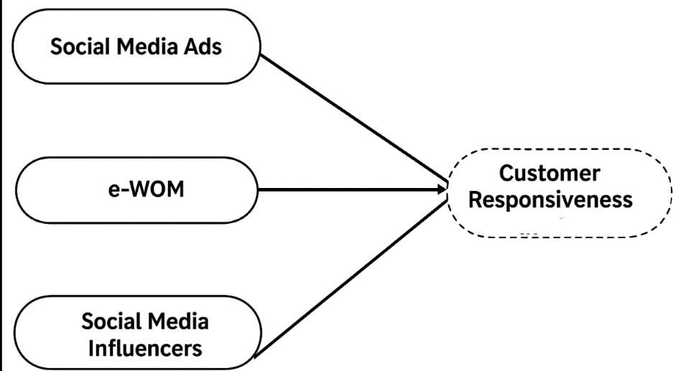
Figure 3.1: customer engagement
(Source: Chuang et al., 2023)
Effectiveness of social media marketing activities
There has been a disagreement among researchers about which types of social media marketing activities provide the best return on customer engagement. According to Mohamed et al (2023), the credibility of influencer marketing and user-generated content can be attributed to the fact that consumer recommendations are more trusted than brand advertisements. Haushalter et al (2023) reported that live streaming, short videos, Facebook, and Instagram marketing contribute to higher emotional engagement and customer engagement in interactive campaigns. On the other hand, Jhawar et al (2024) suggest that influencer marketing can backfire if the audience feels that the content is more of a promotion than a true reflection of the influencer. The selection of inappropriate influencers can have a negative impact on brand credibility and customer confidence. The conflicting perspectives show that there is no single marketing activity that guarantees customers' reactions. JD Sports can include the use of influencer marketing, real customer content, and interactive campaigns to ensure maximum engagement and credibility for digitally active customers.
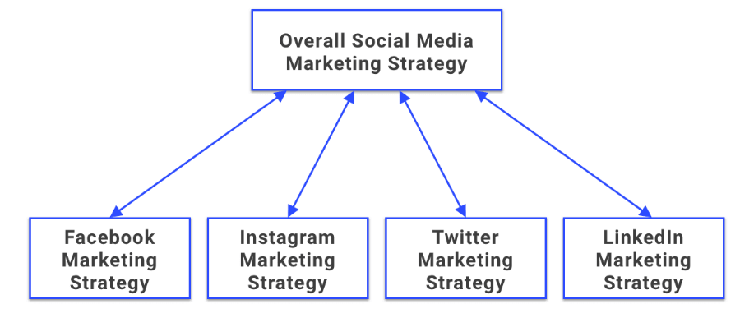
Figure 3.2: Social Media Marketing
(Source: Haushalter et al., 2023)
Challenges and limitations in social media marketing
While social media marketing can be a great way to connect with customers, there are also some challenges to consider when implementing a strategy. According to Alam et al (2024), algorithm updates and the growing competition are limiting the reach of brand content and making it harder to engage with customers. Similarly, Alavi et al (2024) discovered that privacy worries and advertising fatigue have fuelled consumer scepticism of branded social media content. These difficulties can be addressed through data-driven personalisation and interactive communication techniques in organisations. On the contrary, as per Karami et al (2025), overuse of personalised marketing can lead to ethical issues, such as the use of customer data and privacy online. The conflicting views indicate that there is a need for a balance between personalisation and transparency and responsible marketing practices within organisations. For this reason, JD Sports should focus on genuine interaction, honest messaging, and customer confidence.
Theoretical Frameworks
There are a number of theories that describe the impact of social media marketing on customer engagement. According to Customer Engagement Theory, cognitive, emotional and behavioural engagements help to build stronger customer relationships in the long-term by creating meaningful brand experiences (Ahmad et al., 2022). Relationship Marketing Theory also focuses on trust, commitment and retention of customers over the long term and not on exchanges (Hidayat and Idrus, 2023). However, its offline relationship-building roots might not capture the current digital landscape. The Social Media Marketing Activities (SMMA) Framework overcomes this by emphasising the importance of using entertainment, interaction, customisation, trendiness, and electronic word of mouth to drive engagement (Alghamdi and Wahid, 2024). The framework does not consider the differences in various industries. Incorporation of these theories will provide a more solid conceptual basis for the research of the role of JD Sports' social media marketing activities in the sports fashion retail market.
Literature Gap
Studies have been conducted in the context of social media marketing in general retail or global brands, and there is relatively little research regarding social media marketing for JD Sports specifically or for the UK sports fashion retail sector more broadly. There is a lack of studies that compare the effectiveness of social media marketing activities that will stimulate customer engagement.

4. Research Methodology
Research Design
Research design is the general approach that is followed in the collection and analysis of data in order to answer research questions (Doran et al., 2026). This study is a quantitative research design as the data gathered are numerical data of JD Sports customers. The design allows for objective measurement of customer perceptions and can be statistically analyzed to get insight into the relationship between social media marketing and customers' engagement.
Research Philosophy
It is considered an explanation of how knowledge is created and understood. The philosophy used in this study is positivism, where it is assumed that there is a real objective entity and can be objectified through observable evidence. Positivism is appropriate in that the perceptions of the customers will be gathered in a structured questionnaire and analysed using numerical techniques (Winata and Arma, 2025).
Research Approach
According to Balwan et al (2022), the approach in a study is a logical method of research. The study takes a deductive method since it is testing the existing theories in the realm of social media marketing and customer engagement. The data will then be analysed to see if these theories can be applied in the context of JD Sports.
Data Collection Method
Data collection is the act of collecting the data to respond to the research questions (Thomas et al., 2026). This study will use primary data, which will be collected through a structured online questionnaire that will be sent to JD Sports customers. The questionnaire will be comprised of closed-ended questions that will be rated on a five-point Likert scale. This approach works well as it allows the collection of customer views on social media marketing and engagement to be done efficiently, consistently and cost-effectively.
Data Analysis Method
Data analysis consists of arranging and interpreting data that is collected to find patterns that make sense (Monaro et al., 2022). The responses to the questionnaire will be analysed in Microsoft Excel. The Data will be analysed by using descriptive statistical techniques such as frequencies, percentages, mean scores, tables and charts, which will help to interpret customer responses and answer the research questions objectively.
Sampling Strategy
Sampling is the process of selecting members from the population to be included in the study (Hossan et al., 2023). The study will be conducted through convenience sampling of around 50 of the customer base of JD Sports who actively use the company's social media platforms. This method is appropriate because those who participate are not only accessible, but relevant to the study goals.
Research Ethics
Research ethics aim to safeguard the subjects of the study up to the time of the research (Ombaka and Muturi, 2024). Consent will be obtained prior to participation, and anonymity, confidentiality, and voluntary participation will be ensured. Personal identifying information will not be collected, and all responses will be for academic purposes only.
Reliability, Validity and Limitations
Reliability is the consistency of research results, and validity is the extent to which research measures the concepts that researchers want to measure (William, 2024). Reliability will be enhanced through the use of simple and consistent questionnaire items and by conducting a pilot test before data collection. The validity of the instrument will be achieved by making sure each question corresponds to the research objectives. Convenience sampling and self-report data, however, may limit the generalisability of the results, as may the small number of participants.

5. Business Relevance and Practical Implications
Business Relevance
Business relevance has to do with the usefulness of research to the decisions made by organisations (Rose, 2023). The findings of this study are applicable to JD Sports as it highlights the impact of social media marketing on customers' engagement, which is crucial for building brand loyalty and sales metrics. The results will enable marketing managers to select appropriate digital strategies, enhance customer engagement on social media, and enhance JD Sports' competitive advantage in the UK sports fashion retail market.
Practical Implications
The findings from the study will help to give practical guidance in enhancing JD Sports' social media marketing strategy. The company can engage customers by engaging more with interactive content, user-generated content and working with appropriate influencers. Through regular analysis of campaign performance, customer engagement can be monitored and will support evidence-based marketing decisions (Kudapa, 2024). These enhancements should further improve customer relationships, boost loyalty, and help make future digital marketing initiatives more effective.
Contributions to Applied Business Research
This study is applied business research as it will address a genuine marketing challenge of JD Sports. It provides an example of how quantitative research methods can provide practical evidence for managerial decision-making. The study also contributes to the knowledge of social media marketing and customer engagement in the sports fashion retail industry in the UK, offering valuable ideas for future academic and business studies.

References
Ahmad, F., Mustafa, K., Hamid, S.A.R., Khawaja, K.F., Zada, S., Jamil, S., Qaisar, M.N., Vega-Muñoz, A., Contreras-Barraza, N. and Anwer, N., 2022. Online customer experience leads to loyalty via customer engagement: Moderating role of value co-creation. Frontiers in Psychology, 13, p.897851. https://www.frontiersin.org/journals/psychology/articles/10.3389/fpsyg.2022.897851/full?utm_source=chatgpt.com
Alam, S., Susbiyantoro, S., Yuwantiningrum, S.E., Suwastika, I.W.K. and Muhdaliha, E., 2024. The Influence of Social Media Algorithms on Consumer Behavior: A Strategic Analysis for Brand Positioning. The Journal of Academic Science, 1(7), pp.832-841. https://thejoas.com/index.php/thejoas/article/download/133/174
Alavi, S., Iyer, P. and Bright, L.F., 2024. Advertisement avoidance and algorithmic media: The role of social media fatigue, algorithmic literacy and privacy concerns. Journal of Digital & Social Media Marketing, 12(3), pp.276-292. https://hstalks.com/article/8921/advertisement-avoidance-and-algorithmic-media-the-/
Alghamdi, G. and Wahid, N.A., 2024. The use of social media marketing activities to promote a tourism destination: A review. Advances in Social Sciences Research Journal, 11(7), pp.246-259. https://www.researchgate.net/profile/Ghazi-Alghamdi/publication/385076576_The_Use_of_Social_Media_Marketing_Activities_to_Promote_a_Tourism_Destination_A_Review/links/671f32e8edbc012ea1428622/The-Use-of-Social-Media-Marketing-Activities-to-Promote-a-Tourism-Destination-A-Review.pdf
Arya, V., Paul, J. and Sethi, D., 2022. Like it or not! Brand communication on social networking sites triggers consumer‐based brand equity. International Journal of Consumer Studies, 46(4), pp.1381-1398. https://www.researchgate.net/profile/Justin-Paul-6/publication/356286004_Like_it_or_not_Brand_communication_on_social_networking_sites_triggers_consumer-based_brand_equity/links/67605cc9996d2552c3ecf2e8/Like-it-or-not-Brand-communication-on-social-networking-sites-triggers-consumer-based-brand-equity.pdf
Balwan, A.K., Balwan, W.K. and Saba, N., 2022. Glance of research methodology for researchers: A logical assessment. Sch Bull, 8(3), pp.95-100. https://saudijournals.com/media/articles/SB_83_95-100.pdf
Chuang, H.M. and Chen, C.I., 2023. The role of two-way influences on sustaining green brand engagement and loyalty in social media. Sustainability, 15(2), p.1291. https://www.mdpi.com/2071-1050/15/2/1291
Doran, J., Kirby, A. and Bourke, J., 2026. Survey & questionnaire design: Collecting primary data to answer research questions. Axel NEEFS.
Haushalter, K., Pritschet, S.J., Long, J.W., Edwards, C.G., Boyland, E.J., Evans, R.K. and Masterson, T.D., 2023. User engagement with a popular food brand before, during and after a multi-day interactive marketing campaign on a popular live streaming platform. Public Health Nutrition, 26(4), pp.716-724. https://www.cambridge.org/core/services/aop-cambridge-core/content/view/9822E161B8DABF81B61668E18DEB7E8A/S1368980023000083a.pdf/user-engagement-with-a-popular-food-brand-before-during-and-after-a-multi-day-interactive-marketing-campaign-on-a-popular-live-streaming-platform.pdf
Hidayat, K. and Idrus, M.I., 2023. The effect of relationship marketing towards switching barrier, customer satisfaction, and customer trust on bank customers. Journal of Innovation and Entrepreneurship, 12(1), p.29. https://link.springer.com/content/pdf/10.1186/s13731-023-00270-7.pdf
Hossan, D., Dato’Mansor, Z. and Jaharuddin, N.S., 2023. Research population and sampling in quantitative study. International Journal of Business and Technopreneurship (IJBT), 13(3), pp.209-222. https://ejournal.unimap.edu.my/index.php/ijbt/article/download/263/218
JD Group (2025) JD sports fashion - investor relations, Jdplc.com. Available at: https://www.jdplc.com/overview/default.aspx (Accessed: July 25, 2026)
JD Sports (2025) Full YEAR results 2025/26 (FY26), Jdplc.com. Available at: https://www.jdplc.com/investor-relations/regulatory-news/regulatory-news-details/2026/FULL-YEAR-RESULTS-202526-FY26/default.aspx (Accessed: July 25, 2026)
Jhawar, A., Varshney, S. and Kumar, P., 2024. The grey side of influencer marketing: content, contexts, and consequences. Journal of Consumer Behaviour, 23(5), pp.2413-2439. https://www.researchgate.net/profile/Anand-Jhawar/publication/382657904_The_grey_side_of_influencer_marketing_Content_contexts_and_consequences/links/670764a6ffe5b728123e05d7/The-grey-side-of-influencer-marketing-Content-contexts-and-consequences.pdf
Karami, A., Shemshaki, M. and Ghazanfar, M.A., 2025. Exploring the Ethical Implications of AI-Powered Personalization in Digital Marketing. Data Intell., 7(4), pp.1035-1084. https://dds.sciengine.com/cfs/files/pdfs/2096-7004/48055D6284BF4B1787603C006B47F477.pdf
Kudapa, S.P., 2024. AI-enhanced data science approaches for optimizing user engagement in US digital marketing campaigns. Journal of Sustainable Development and Policy, 3(03), pp.01-43. https://jsdp-journal.org/index.php/jsdp/article/download/19/20
Kusi, G.A., Rumki, M.Z.A., Quarcoo, F.H., Otchere, E. and Fu, G., 2022. The role of information overload on consumers’ online shopping behavior. Journal of Business and Management Studies, 4(4), pp.162-178. https://www.academia.edu/download/98308314/3568.pdf
Lamba, T. (2025) JD sports social media and content analysis., Tanmeet Lamba. Available at: https://tanmeetblog.wordpress.com/2025/03/18/jd-sports-social-media-and-content-analysis/ (Accessed: July 25, 2026)
Miranda, S., Santos, S. and Gonçalves, H.M., 2026. Do Emotions Influence Buying Frequency and Word‐of‐Mouth in Online Shopping? The Role of Shopping Well‐Being and a Loyal Decision‐Making Style. Psychology & Marketing, 43(3), pp.638-661. https://onlinelibrary.wiley.com/doi/pdf/10.1002/mar.70078
Mohamed, N.N., Jaafar, N. and Ayupp, K., 2023. The influence of user-generated content information credibility and information adoption on consumer purchase intention. International Journal of Academic Research in Business and Social Sciences, 13(2), pp.475-488. https://www.researchgate.net/profile/Kartinah-Ayupp/publication/372400001_The_Influence_of_User-Generated_Content_Information_Credibility_and_Information_Adoption_on_Consumer_Purchase_Intention/links/64b3eb23b9ed6874a5247d16/The-Influence-of-User-Generated-Content-Information-Credibility-and-Information-Adoption-on-Consumer-Purchase-Intention.pdf
Monaro, S., Gullick, J. and West, S., 2022. Qualitative data analysis for health research: A step-by-step example of phenomenological interpretation. Qualitative Report, 27(4), pp.1040-1057. https://www.academia.edu/download/90474551/viewcontent.pdf
Nkegbe, F. and Abor, Y., 2023. The role of social media in enhancing customer engagement and brand loyalty. Journal of Policy Options, 6(3), pp.26-34. http://resdojournals.com/index.php/jpo/article/download/305/775
Ombaka, B. and Muturi, M., 2024. Importance of Ethics in Safeguarding and Ensuring High Quality Research. J. Afr. Interdiscip. Stud, 8, pp.89-100. https://cedred.or.ke/jais/images/june2024/PDF_Ombaka__Muturi_Importance_of_Ethics_in_Safeguarding_and_Ensuring_High_Quality_Research.pdf
Oualid, C., Selma, D. and Soufyane, B., 2024. The impact of content personalization on customer engagement and market risks of E-Stores. Financial Markets, Institutions and Risks, 8(3), pp.37-56. https://armgpublishing.com/wp-content/uploads/2024/10/FMIR_3_2024_3.pdf
Rose, S., Spinks, N. and Canhoto, A.I., 2023. Management research: applying the principles of business research methods. Routledge.
Snyder, K. (2024) 35 E-Commerce statistics of 2024, Forbes. Available at: https://www.forbes.com/advisor/business/ecommerce-statistics/ (Accessed: July 25, 2026)
Thomas, D.B., Oenning, N.S.X. and de Goulart, B.N.G., 2026. Essential aspects in the design of data collection instruments in primary health research. Revista Cefac, 20(5), pp.657-664. https://www.revistacefac.org.br/article/10.1590/1982-021620182053218/pdf/cefac-20-5-657.pdf
William, F.K.A., 2024. Mastering validity and reliability in academic research: Meaning and significance. International Journal of Research Publications, 144(1), pp.287-292. https://ijrp.sfo3.cdn.digitaloceanspaces.com/pubjournal/6106/1001441320246160.pdf
Winata, V. and Arma, O., 2025. Analyzing the effect of e-wallet usability on customer retention in mobile payment apps. JUMDER: Jurnal Bisnis Digital dan Ekonomi Kreatif, 1(2), pp.38-57. https://journal.dinamikapublika.id/index.php/JUMDER/article/download/23/20

