

Title: Menu Engineering

Student: Loredana Leonte

ID: 2234509

Date: 09 June 2023

Hotel Placement - Food & Beverage Operations (BMIH4002)

Lecturer: Muhammad Cassamo

Word count: 397

The concept of the Balkan Flavour Restaurant within the Trinity Hotel in London features a variety of traditional dishes from the Balkan region, from countries such as Serbia, Croatia, Bosnia and Herzegovina, Bulgaria, Turkey and Romania. The target audience for the restaurant is hotel guests, business professionals, and locals who are looking for a unique and authentic dining experience.
The restaurant is located on the ground floor of the hotel and has a casual yet elegant atmosphere. The dining room is decorated in warm colours and features large windows that let in natural light. The design considers the importance of a customer’s impression on entering the restaurant, where the right choice of décor and furnishings inspires an appropriate atmosphere (Motarjemi and Lelieveld, 2014, p. 55).
In the past, instead of menus, lists of meals for guests to choose from were used. The first modern menus appeared in the nineteenth century in France, as a tool for the ‘à la Russe’ service (meals portioned, brought to the table on individual plates). By using an appealing and interesting design, the menu is the main instrument for selling the dishes in a restaurant. It must contain clear information about the name, provenience, and ingredients of the dishes, and also prices (Cousins, 2020, p. 85). A customer’s decision to buy a traditional dish is enormously influenced by its descriptive explanation, that should also include, for instance, the assortment of beverages that go with it. The dishes must be “priced in a way that will make […] business profitable but won't scare away customers”.
The menu of the Balkan Flavour Restaurant, an à la carte menu, was made with the target audience in mind. The dishes are all flavourful and visually appealing, made with fresh, seasonal ingredients, which ensures that the food is of the highest quality, with a proper balance between nutritional value and flavour because “eating healthily is all about balance”.
The menu is varied to appeal to different dietary needs, with vegetarian and vegan, as well as gluten-free options.
The restaurant is open for breakfast, lunch, and dinner. Reservations are accepted. Hotel guests will appreciate the convenience of having a restaurant located in the hotel, the casual yet elegant atmosphere and its convenient location near the city's business district will appeal to business professionals, while locals will appreciate the restaurant's unique and authentic dining experience.

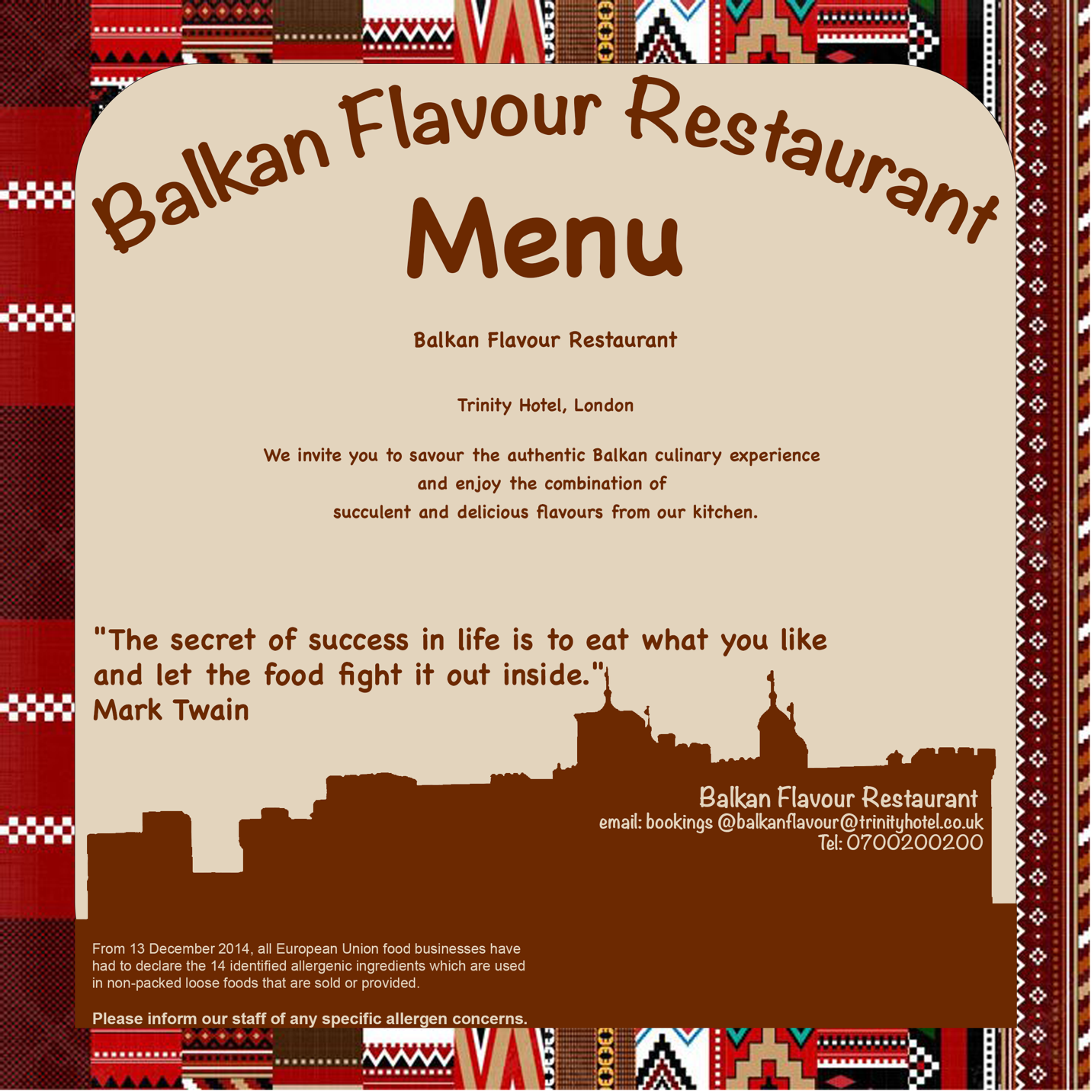
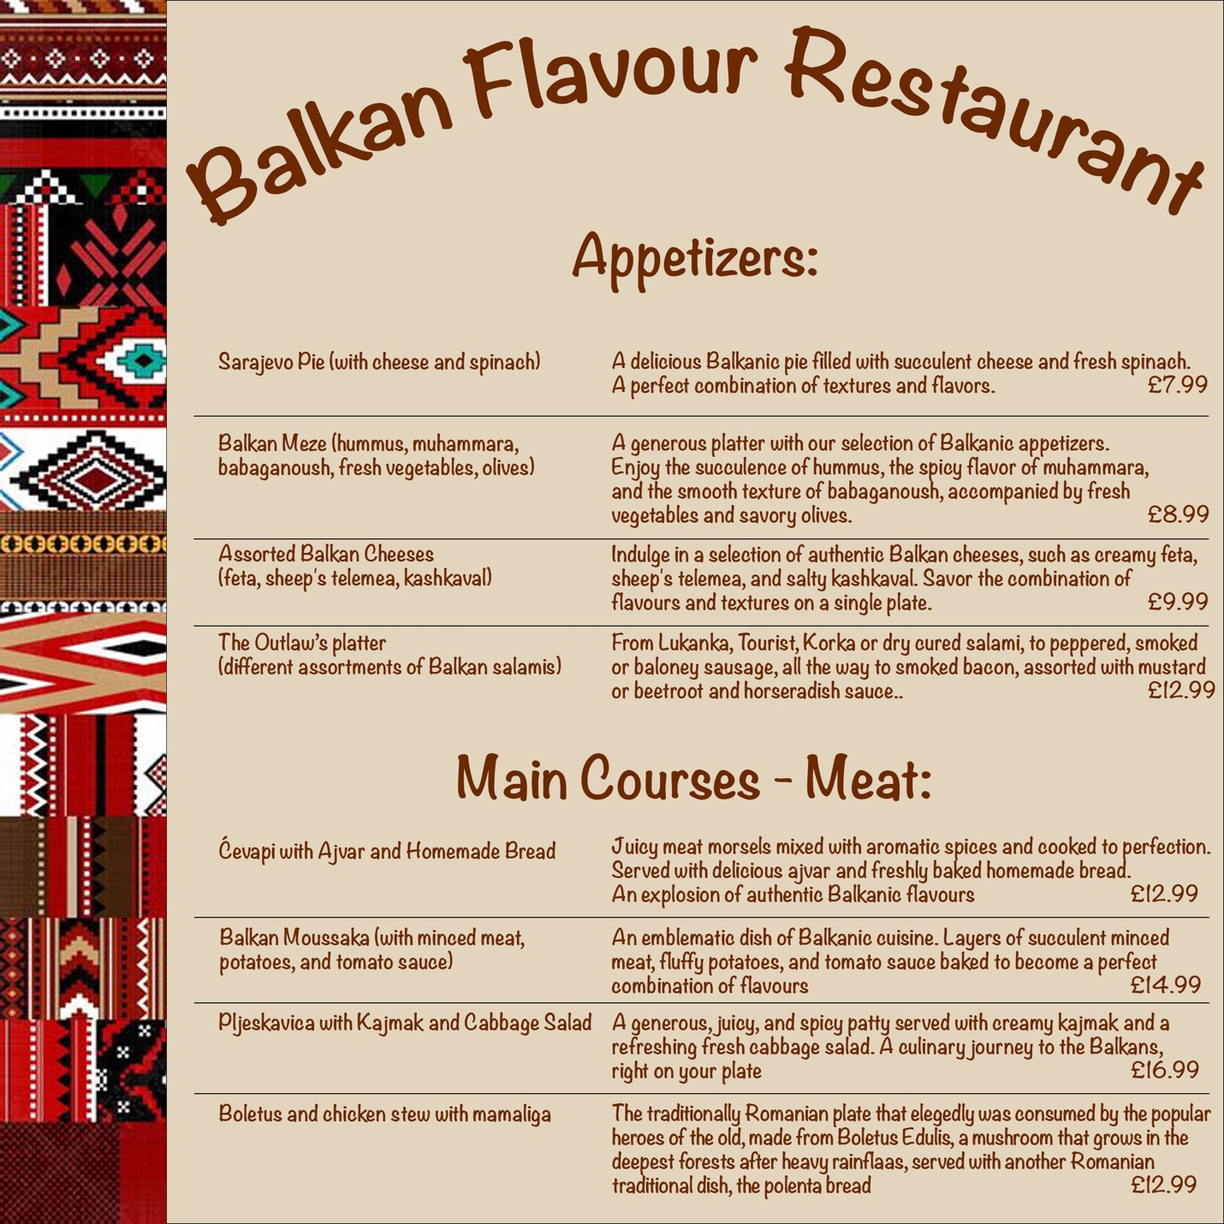
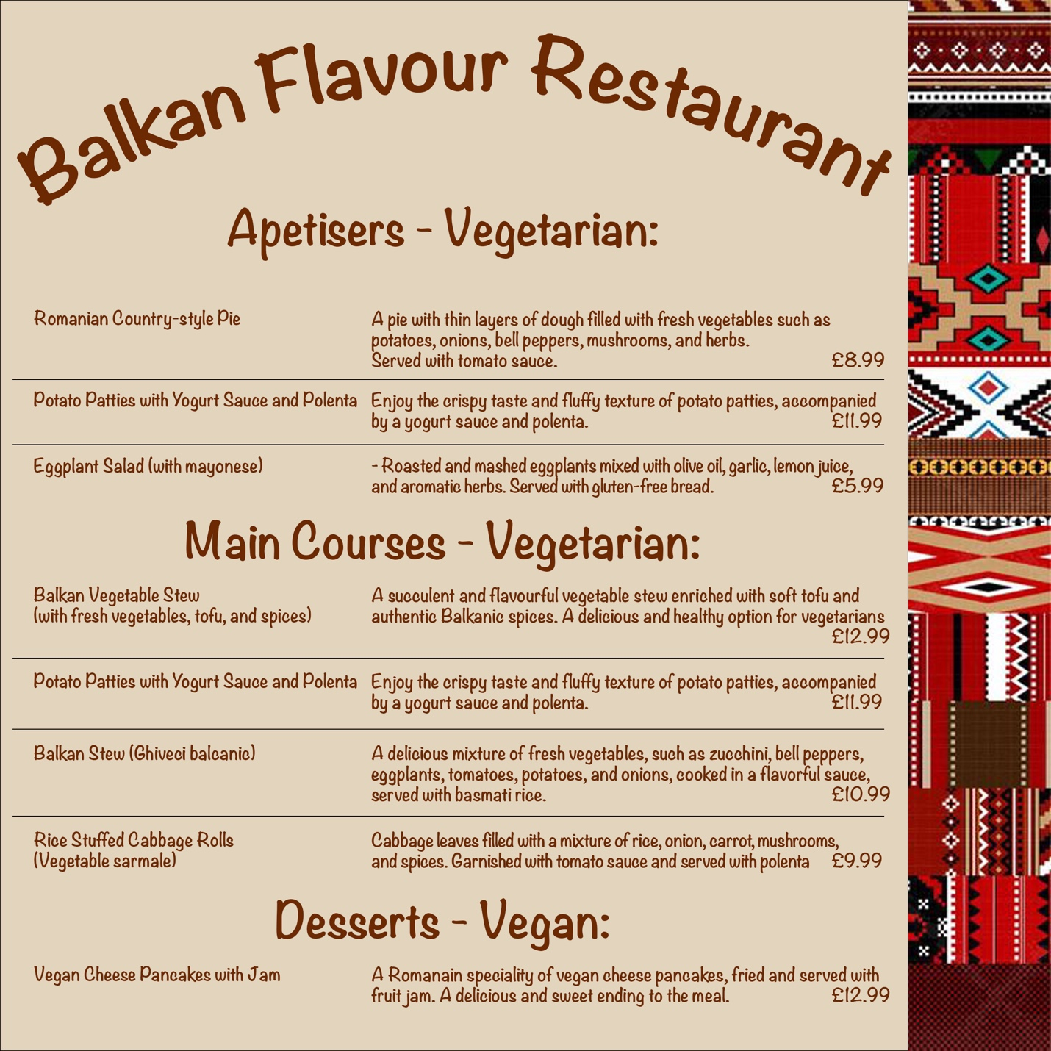

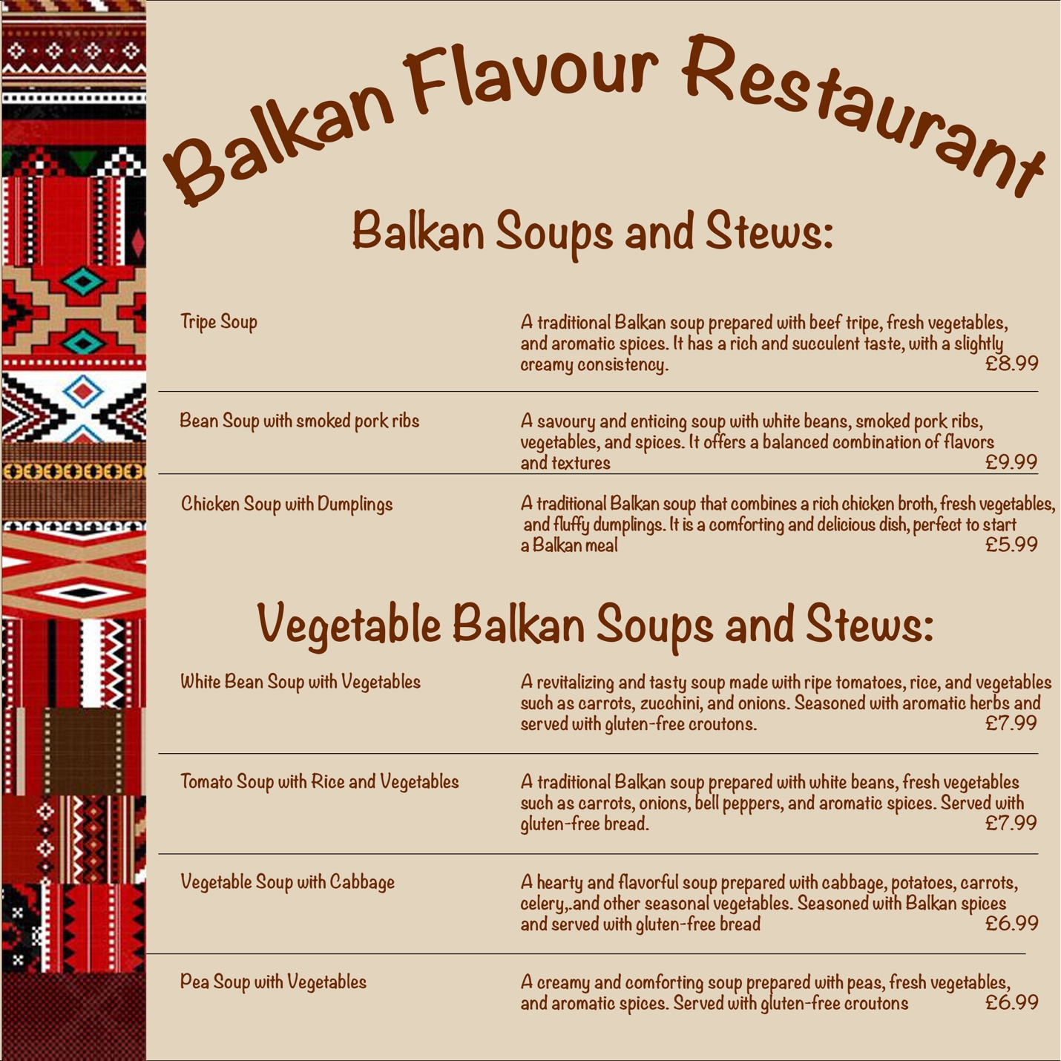
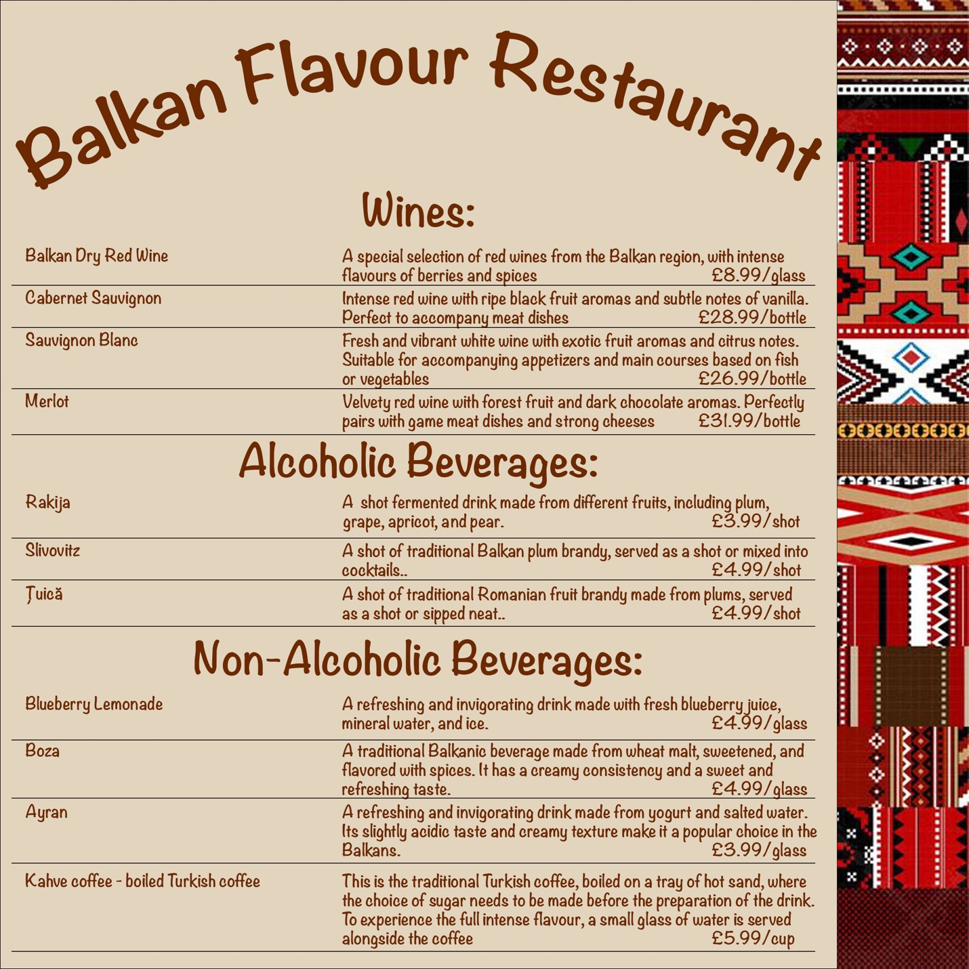

References:
- Cousins, J. (2020) Food and beverage service. 10th edn. London: Hodder Education Group.
- Motarjemi, Y. and Lelieveld, H. (2014) Food safety management: a practical guide for the food industry. Illustrated edn. Amsterdam: Academic Press.
- Katičić, J. (1987) The Balkan cookbook: Yugoslavia, Rumania, Bulgaria, Albania, Greece, Turkey. 1st edn. Belgrade: Jugoslovenska Knjiga.
- Nikolic, M. (2021) The Only Balkan Cookbook You Will Ever Need: Get Your Taste Of Balkan With 80 Plus Recipes From Serbian, Bosnian, And Croatian Cuisine. 1st edn. Independently published.
- https://www.webstaurantstore.com/article/129/restaurant-menu-pricing.html (accessed at 08/06/2023 at 12:30)
- https://www.jamieoliver.com/nutrition/healthy-eating-10-easy-tips/ (accessed at 07/06/2023 at 15:32)
- https://www.allianceonline.co.uk/blog/2016/11/how-to-design-a-menu-that-does-your-dishes-justice/#a3 (accessed at 08/06/2023 at 11:23)
- https://www.restaurant-website-builder.com/restaurant-menu-descriptions (accessed at 08/06/2023 at 15:11)
- https://www.goodreads.com/quotes/3696-part-of-the-secret-of-success-in-life-is-to (accessed at 07/06/2023 at 18:39)
- https://balkanrecipes.com/tripe-soup-shkembe-chorba/ (accessed at 07/06/2023 at 16:12)

https://www.webstaurantstore.com/article/129/restaurant-menu-pricing.html
https://www.jamieoliver.com/nutrition/healthy-eating-10-easy-tips/

