Title
An Evaluation of the Environmental Factors Impacting the Organisation and its HR Strategy.

Executive Summary
A report of the major environmental factors impacting Tata Steel UK Limited including an evaluation of HRM and Business Strategies which will influence the organisation. Using the PESTLE tool the writer has identified and analysed the impact of Technological and Sociological Factors.

Table of contents
- Introduction Page 1
Including a summary of Tata Steel UK Ltd
- Methodology Page 3
Providing an overview of the analysis tools used in the report
- Findings Page 4
Focus on Technological and Sociological environmental factors and strategic recommendations
- Conclusion Page 8
- References Page 9
- Appendix Page 13

Introduction
Tata Steel UK Ltd (Tata) is one of Europe’s leading hot strip mill steel manufacturing businesses. Annual turnover is around £2 billion with sales exceeding 3million tons. Of the 8,500 employees, around 4,000 are based at Tata’s main integrated steelmaking site in Port Talbot with the remaining distributed across Tata’s processing facilities in the North East, North Wales, South Wales and the Midlands.

External factors have been challenging since the 2008 Financial crisis with low sale prices for products and a relatively strong pound. The past 18 months have been particularly challenging for Tata with the decision to put the UK business up for sale on 29 March 2016 and the signing of a Memorandum of Understanding to pursue a Joint Venture with Thyssenkrup. Current business strategy for Tata is contained in its recently revised Mission, Vision and Values which can be found in the appendix. Their mission is to create a business that is sustainable in every sense, with a focus on a differentiated product strategy and developing the next generation of premium products.

This report will consider the most significant external environmental factors affecting Tata and what business and HR strategic decisions are required in response. Kew and Stredwick (2016) classify the external environment in two ways. The General/Macro environment relates to Industry level impact factors and the Task/Micro environment relate to factors impacting an individual organisation. It is recommended that HR Professionals regularly scan the environment for any emerging external factors and work closely with Leaders to ensure strategic business responses are aligned with strategic HR responses. This is particularly important in today’s VUCA Environment. VUCA is an acronym which stands for Volatile, Uncertain, Complex and Ambiguous. Tata as part of the manufacturing Industry are especially vulnerable to external environmental.

Methodology
In order to analyse the external environment, the writer has used the PESTLE framework. The CIPD recommended the use of PESTLE (Political, Economic, Sociological, Technological, Legal and Environmental) as one of the most effective analysis tools. It is simple, facilitates the understanding of the wider environment, encourages external thinking and helps organisations to anticipate any future trends/threats and make appropriate strategic decisions. Despite the risks of collating too much data and the pace of change making it difficult to anticipate all trends/threats on balance the advantages of using PESTLE outweigh the disadvantages. Due to the nature of this report, the writer was unable to collaborate with a range of experts from different disciplines as recommended by the CIPD. However, despite this, by conducting research of key textbooks, collating company information both internally and externally and internet resources, the writer has gathered sufficient data in order to draw recommendations. It is recommended that Tata follows up this report with other analytical techniques, such as SWOT, Porter’s Five Forces, Competitor Analysis and Scenario Planning.

Findings
For the purposes of this report Technological and Sociological factors have been selected for detailed analysis. A full PESTLE of other external environmental factors are beyond the scope of this report.

Technological
According to Brynjolfsson and McAfee (2014) ‘We’re living in a time of astonishing progress with digital technologies’. The pace of Technological advances are developing at a rapid rate, far outpacing our ability to keep up. Leading global research reports from Deloitte (2017), PWC (2016), CITI workforce v2.0 (2016) and CIPD (2017) conclude that technological advances will have a fundamental impact on what the workforce of the future will look like and the type of work humans will be required to do. There will be a high demand for skills such as digital know-how, management capability, creativity, entrepreneurship and complex problem solving. The World Economic Forum (2017) report that the top 10 skills required for the future include complex problem solving, communication skills and critical thinking. Work tasks will also change, with an increasing amount of jobs becoming automated. According to the CIPD (2017) 35% of current jobs in the UK are at risk of computerisation and automation over the next 20 years.

There are some who are pessimistic about this advancement and predict apocalyptic scenarios, notably Musk (2014), however it is widely accepted that this change is positive and as a result this report recommends that this development should be embraced. With low productivity continuing to be a problem in the UK, particularly in the manufacturing sector where it fell 1.3% from Quarter 1 (Jan to Mar) 2017 to Quarter 2 (Apr to June) 2017, technological advances in the production process represent a significant improvement opportunity. Success will not just be dependent on hardware investment. It will be important for Tata to attract, retain and train those already digitally skilled but equally to develop existing to effectively collaborate with new Technologies.

Developments in Technology will not only change the workforce and require Tata’s HR Strategy to respond but also change the way the HR operate. According to the CIPD (2017), onerous HR tasks are likely to disappear and a real opportunity n exists to improve administrative flows within the organisations, where there are large volumes of data (e.g. recruitment processes) or large scale data needs scrutinising (e.g workforce planning).

A PWC report (2016) suggests that one of the key requirements for companies within the digital age will be a focus on people and culture to drive transformation. People-focused factors are clearly within the remit of the HR function and policies can be produced to incentivise desired behaviours, however culture change will require a change in direction with Leaders playing a key role in modelling those behaviours and leading by example. HR will play a key role in facilitating change and ensuring everyone is on board with it. In a study by Crail (2007) the two main barriers were communication breakdown (90%) and employee resistance (81%) As highlighted by the CIPD (2015) resistance can fall into two categories, resistance to the content and process of change. There are a number of change models which can be applied to ensure successful transition, notably the McKinsey Change Model which not only provides a framework to prepare for change but also an Influence Model designed to get people ready for change.

The current HR Model at Tata is based on the Ulrich model (1997), where the HR department are separated into Centres of Excellence, Business HR and Shared Services. However the silo working structures of the Ulrich model can in practice be value sapping. Given that this model is now 20 years old and with the pace of technological change impacting the world of work so fundamentally, there is a compelling argument for a new approach encouraging HR to be more agile in order to respond more effectively to future advances. A recent article from CapGemini (2017) propose a development towards Centres of Value, Digital and Robotized Shared Service Centres and Business Partners adapting to the Gig Economy. Further Kew and Stredwick (2016) refer to a new model of labour, a core and disposable labour force. The core labour force will be your full time permanent employees, whereas the disposable labour force will consist of employees whose work can be automated and their employment will be more temporary with the ability to be flexed up or down as required.

What is clear is that with Technological advances having such an impact on both business and HR strategies, HR will need to be at the heart of these strategic decisions and acting as a strategic partner (Ulrich 1997) to the business set the agenda (Cappelli 2015). As Charan et al (2015) recommended a G3 should be set up to ensure strategic decisions are a collaborative process between the CEO, CFO and CHRO.

Sociological
ONS data (2017) shows that the UK population is projected to increase by 3.6 million (5.5%) over the next 10 years. There will also be an increasing number of older people; the proportion aged 85 and over is projected to double over the next 25 years. According to the CIPD 2017 over 30% of people in employment in the UK are over the age of 50, and there are currently unlikely to be enough young people entering the labour market to replace them as they leave the workforce, taking with them their skills and experience. If as suggested by Ulrich and Smallwood (2012) we live in a knowledge, talent led economy, with an ageing workforce Tata will not only need to do more to accommodate older workers but also maintain a talent pipeline with the right skills.

Tata along with many other organisations are facing the prospect of managing 5 generations in the workforce. Each of these generations come with a diversity of experiences, perspectives, personal values and ideas as discussed by Knight (2014). Despite the benefits that this diversity will bring it will also create challenges and opportunities for HR to develop policies to effectively cater to each of these different generation’s needs, motivations and levels of engagement. Hewlett et al (2009) suggest that companies who align their HR policies to the shared values of older and younger workers will enjoy a major talent advantage.

Strategic HRM provides a strategic framework to support long-term business goals and outcomes. This should be fully aligned with business strategy (Boxall and Purcell 2011). There is no universal agreement on a single HRM Model. There are many different viewpoints ranging from a ‘Best fit’ approach where HR strategy is defined based on the unique needs of an organisation to a ‘Best practice’ approach where it a one size fits all universal bundle of HR strategies and practices which can apply to any organisation will result in increased operational performance (Guest 1997). What is important is to distinguish between HR Strategies and Strategic HRM which is the overall framework determining the shape and delivery of the individual strategies. The ‘best fit’ approach originates from the Harvard framework (Beer et al 1985) whereby HR strategy is based on a consideration of stakeholder interests and situational factors. HR outcomes flow from the strategy and have long term impacts on organisational effectiveness and back into stakeholder interests and the external environment. HR choices are vast and as summarised by Beer et al, when facing a complex environment it might be wise to choose a combination of different models. The reverse argument comes from the supporters of the ‘best practice’ ‘high commitment’ approach, including Pfeffer’s Seven Practices (1998) which lists seven key HR strategies with the consistent application of these within the organisation leading to performance improvements. Integration with business strategy involves a very different approach, driven by top down management promoting the benefits of these best practices and incentivising managers across the business hierarchy to implement consistently.

This approach is evaluated with reference to the Cynefin framework (Snowden and Boone 2007). Best practice approaches assume a simple environment where the outcome of a course of action will be easily predicted. In this context, if these practices are applied as a package they will result in improved performance. Equally, according to Marchington and Wilkinson (2005, p 95) ‘best practice’ works on the assumption that employers have the luxury of taking a long-term perspective. And therein lies the problem for Tata who operate in a complex not simple environment. The external environmental factors are constantly changing and at times changing at such a fast pace it is difficult to see how such best practice approaches which assume a specific outcome regardless of the external environment can work in practice. When considering the Beer Model (1985) those external or situational factors feed HR policy, outcomes and long term consequences so it follows that HR policy will always be changing. However the best practice approach should not be completely disregarded, at the very least represents a good place to start, and by applying the Cynefin’s framework Tata’s HR policies will be emergent.

Conclusions

In conclusion the writer highlights that in today’s VUCA Environment, with Tata especially vulnerable to external environmental factors, regular PESTLE analysis coupled with other analytical tools such as SWOT, Porter’s Five Forces, Competitor Analysis and Scenario Planning will be essential to ensure both business and HR strategy continue to be effective.

References

Textbooks
Boxall, P. and Purcell, J. (2011) Strategy and Human Resource Management. 3rd edn. Hampshire: Palgrave Macmillan
Kew, J. and Stredwick, J. (2016) Human Resource Management in a Business Context. 3rd edn. London : CIPD
Farnham, D. (2015) Human Resource Management in context strategy, insights and solutions. 4th edn. London : Chartered Institute of Personnel and Development
ASTON CENTRE FOR HUMAN RESOURCES (2008) Strategic human resource management: building research-based practice. London: Chartered Institute of Personnel and Development.
Brynjolfsson, E. and McAfee, A. (2014) The Second Machine Age: Work, Progress, and Prosperity in a Time of Brilliant Technologies. 1st edn. W.W. Norton & Company, New York.
PORTER, M. (1998) Competitive strategy: creating and sustaining superior performance. New York: Free Press
Journals
Musk, E. (2014) ‘I Hope Artificial Intelligence Is Nice to Us’, New Perspectives Quarterly, 31(1), pp. 51-55.
Hewlett, S. A. et al. (2009) ‘How Gen Y & Boomers Will Reshape Your Agenda’, Harvard Business Review, (July/August) 87(7, 8), pp.71-76.
Knight, R. (2014) ‘Managing People from 5 Generations’, Harvard Business Review, (September) 92 (9).
Gratton, L. and Scott, A. (2016) ‘Our Assumptions About Old and Young Workers Are Wrong’, Harvard Business Review, (November) 94 (11).
Boudreau, J. and Rice, S. (2015) 'Bright, Shiny Objects and the Future of HR’, Harvard Business Review, 93 (7/8) pp. 72-78.
Charan, R. Barton, D. and Carey, D. (2015) 'People Before Strategy: A New Role for the CHRO', Harvard Business Review 93 (7/8) pp. 62-71.
Snowden, D. and Boone, M. (2007) ‘A Leader’s Framework for Decision Making’, Harvard Business Review, (November)
Cappelli, P. (2015) ‘Why we love to hate HR…and what HR can do about it’, Harvard Business Review, (July-August)
Ulrich, D. and Smallwood, N. (2012) 'What is talent?', Leader To Leader, (month) 63, pp. 55-61.
Guest, D. (1997) Human resource management and performance: a review and research agenda. International Journal of Human Resource Management. Vol. 8, No. 3, 236-76.

Internet Resources
Guardian (2008) https://www.theguardian.com/business/2008/dec/28/markets-credit-crunch-banking-2008
CIPD (2017) Strategic Human Resource Management. Available at: https://www.cipd.co.uk/knowledge/strategy/hr/strategic-hrm-factsheet (Accessed: 28 November 2017)
CIPD (2015) Productivity: Getting the best out of people. Available at:
https://www.cipd.co.uk/Images/productivity_2015-getting-best-out-of-people_tcm18-10313.pdf (Accessed: 28 November 2017)

CIPD (2017) PESTLE Analysis. Available at: https://www.cipd.co.uk/knowledge/strategy/organisational-development/pestle-analysis-factsheet (Accessed: 28 November 2017)
CIPD (2017) PESTLE example for retail industry. Available at:
https://www.cipd.co.uk/Images/pestle-analysis-example_tcm18-27108.pdf (Accessed: 28 November 2017)
Tata Steel (2017) Tata Steel UK Factsheet. Available at: https://www.tatasteeleurope.com/static_files/Archive/Old%20StaticFiles/Corporate/News/tsukfactsheet%20(10).pdf (Accessed 12 December 2017)
ONS (2017) UK Manufacturers’ Sales by Product (prodcom): provisional estimates. Available at: https://www.ons.gov.uk/businessindustryandtrade/manufacturingandproductionindustry/bulletins/ukmanufacturerssalesbyproductprodcom/provisionalestimates2016 (Accessed 8 December 2017)
Deloitte (2017) Rewriting the rules for the digital age. Available at:
http://moodle.uwtsd.ac.uk/pluginfile.php/95201/mod_resource/content/1/hc-2017-global-human-capital-trends-us.pdf (Accessed 8 December 2017)
Accenture (no date) Future Workforce, Where the Technology Meets Human Capital: Learn how to lead in the digital workforce revolution. Available at: https://www.accenture.com/gb-en/future-workforce-index (Accessed 8 December 2017)
World Economic Forum (2017) The Global Human Capital Report 2017 ‘Preparing people for the future of work’. Available at: https://weforum.ent.box.com/s/dari4dktg4jt2g9xo2o5pksjpatvawdb (Accessed 8 December 2017)
European Commission (2017) Ten actions to help equip people in Europe with better skills. Available at: http://europa.eu/rapid/press-release_IP-16-2039_en.htm
(Accessed 8 December 2017)

Citi GPS: Global Perspectives & Solutions (2016) Technology at Work 2.0: The Future Is Not What It Used to Be. Available at:
https://www.oxfordmartin.ox.ac.uk/downloads/reports/Citi_GPS_Technology_Work_2.pdf (Accessed 8 December 2017)

PWC (2016) Industry 4.0: Building the digital enterprise. Available at:
https://www.pwc.com/gx/en/industries/industries-4.0/landing-page/industry-4.0-building-your-digital-enterprise-april-2016.pdf (Accessed 8 December 2017)
PWC (2014) Tata Steel: Understanding the economic contribution of the Foundation Industries. Available at:
https://www.tatasteeleurope.com/static_files/StaticFiles/Functions/Media/Foundation_Industries_Report.pdf (Accessed 8 December 2017)
ONS (2017) Labour productivity: April to June 2017. Available at: https://www.ons.gov.uk/employmentandlabourmarket/peopleinwork/labourproductivity/bulletins/labourproductivity/apriltojune2017 (Accessed 8 December 2017)
Capgemini (2017) The Digital Talent Gap Are Companies Doing Enough? Available at:
https://www.capgemini.com/consulting-gb/wp-content/uploads/sites/34/2017/10/digital-talent-gap-infographic1-1.pdf (Accessed 11 December 2017)
Capgemini (2017) Digital HR Transformation. Available at: https://www.capgemini.com/consulting-nl/diensten/digital-hr-transformation/ (Accessed 11 December 2017)
ONS (2017) National Population Projections: 2016 based statistical bulletin. Available at: https://www.ons.gov.uk/peoplepopulationandcommunity/populationandmigration/populationprojections/bulletins/nationalpopulationprojections/2016basedstatisticalbulletin (Accessed 9 December 2017)
ONS (2017) Labour market: November 2017. Available at: UK labour market : November 2017 (Accessed 9 December 2017)
Department for Work and Pensions (2016) Fuller working lives – background evidence. Available at: https://www.gov.uk/government/statistics/fuller-working-lives-background-evidence (Accessed 12 December 2017)
Government Office for Science and Department for Business, Innovation & Skills (2013) Future of manufacturing. Available at: https://www.gov.uk/government/collections/future-of-manufacturing#history (Accessed 12 December 2017)
CIPD (2017) Skills development in the UK workplace. Available at: https://www.cipd.co.uk/knowledge/work/skills/skills-factsheet (Accessed 9 December 2017)
CIPD (2016) Creating longer, more fulfilling working lives: Employer practice in five European countries. Available at:https://www.cipd.co.uk/Images/creating-longer-more-fulfilling-working-lives_2016-employer-practice-in-five-european-countries_tcm18-14265.pdf (Accessed 9 December 2017)

CIPD (2015) Managing an age-diverse workforce: What employers need to know. Available at: https://www.cipd.co.uk/Images/managing-an-age-diverse-workforce_2015-what-employers-need-to-know_tcm18-10832.pdf (Accessed 9 December 2017)

Age Alliance (no date) Employer Toolkit: Guidance for Managers of Older Workers. Available at: http://ageactionalliance.org/employer-toolkit/(Accessed 9 December 2017)

Appendix

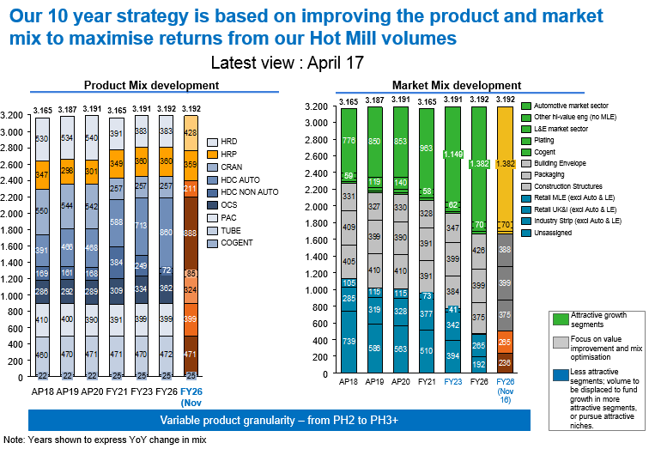

Figure 1. Tata 10 year Strategy

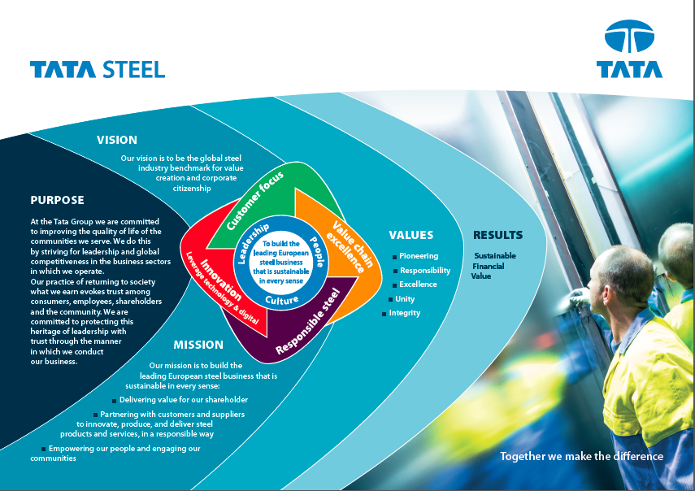

Figure 2. Tata Mission, Vision and Values

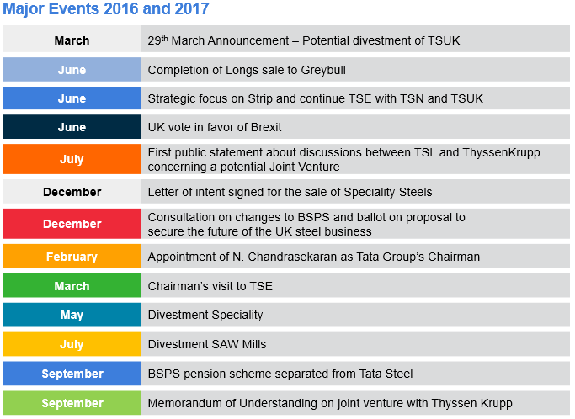

Figure 3. Tata Recent timeline

