DESTINATION MANAGEMENT: THE LAKE DISTRICT, UK

Student Name: Alina Smalbergher
Student ID Number: 2114414
Sustainable Hospitality & Tourism Management (BMIH5006)
Lecturer: Ruth Taylor-Davies

Contents
Introduction 2
Sustainability 2
Socio-cultural Sustainability 2
Economic Sustainability 5
Environmental Sustainability 6
Butler's Life Cycle Model and Doxey's Irridex Model 7
Challenges Limiting Sustainability in Lake District 8
Recommendations 8
Conclusion 9
References List 10

DESTINATION MANAGEMENT: THE LAKE DISTRICT, UK

Introduction
Tourism has been a pillar of great significance in the United Kingdom for many decades. For instance, Lake District is the primary source of income for many residents and businesses (Porter, 2020). Development radicalisation that sustainability principles have steered has transformed the hospitality and tourism sector to high heights, becoming one of the most reliable economic pools in the United Kingdom. Hospitality and tourism go hand in hand, and their development means social, cultural, economic, and environmental growth (Grilli et al., 2021). Lake District has established various partnership management plans, such as the Lake District management plan 2015 – 2020 and Partnership's Management Plan 2020 - 2025, which have steered towards long-term social, environmental, and economic sustainability (Lake District National Park, 2020). According to Park (2020), the Mid-Year 2018 Office for the National Statistics Population Estimates found that 40,478 people lived in the Lake District and 68% owned residential areas.
The Lake District has a history of long sustainability commitment, evidenced by initiatives such as Go Lake Travel and Lakes Responsible Tourism Network, which comprises the voluntary network. The voluntary network abides by the United Nations Guidelines for Responsible Tourism and Guidelines and substantially promotes social, environmental, and economic sustainability. This paper seeks to evaluate the sustainability of the Lake District and how it has been influenced by socio-cultural, economic, and environmental making it a destination of choice.

Sustainability
For the Lake District to maintain a balance between tourism growth and conserving its natural and cultural resources, sustainability is essential (Grilli et al., 2021). The destination can assure long-term viability, improve the well-being of residents, draw responsible tourists, and support global sustainability goals by implementing sustainable practises.

Socio-cultural Sustainability
The main objective of socio-cultural sustainability is to keep the activities and culture of the local community vibrant, promote the uniqueness of the cultural identity and cultivate a sense of community within the people in the region (Parry, 2020). Following the Covid-19 pandemic, many social activities were restricted. Therefore in the joint Management plan 2020 – 2025 for the Lake District, which was initiated following a partnership of 25 organisations in the Lake District National Park Partnership, the plan aimed to reach out to people and promote their health and well-being (Lake District National Park, 2020). The management plan targeted reaching out to underserved people and offering them opportunities of benefits in the local outdoor activities spaces. FitzGerald, Collins, and Potter (2021) also highlight that the strategy planned to promote community care by improving the tourists understanding of the Lake District's environment.
As the Lake District community depends on the hospitality and tourism sectors to preserve cultural sustainability, the charming residents preserve their vibrant culture through daily commitments (Tanulku, 2019). According to the research conducted by VisitBritain between April 2015 and September 2016, a high number of visitors in the lake district were young people aged between 25 -34 years, and the lowest number of visitors were those aged 65 and above
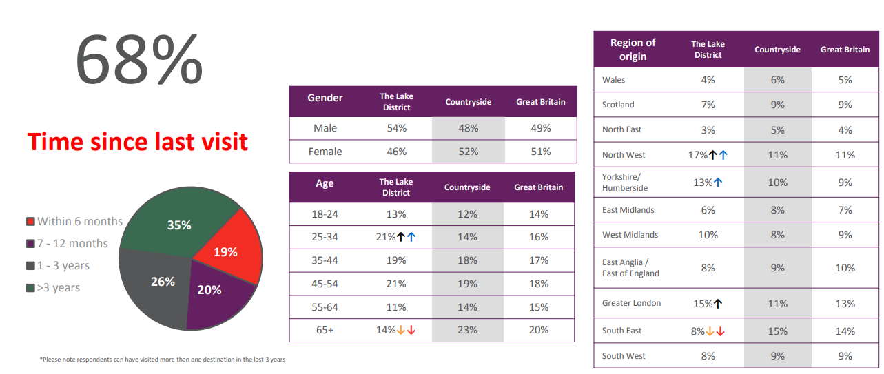

Figure 1: Lake District destination report in three years (The Lake District destination report. (n.d.)

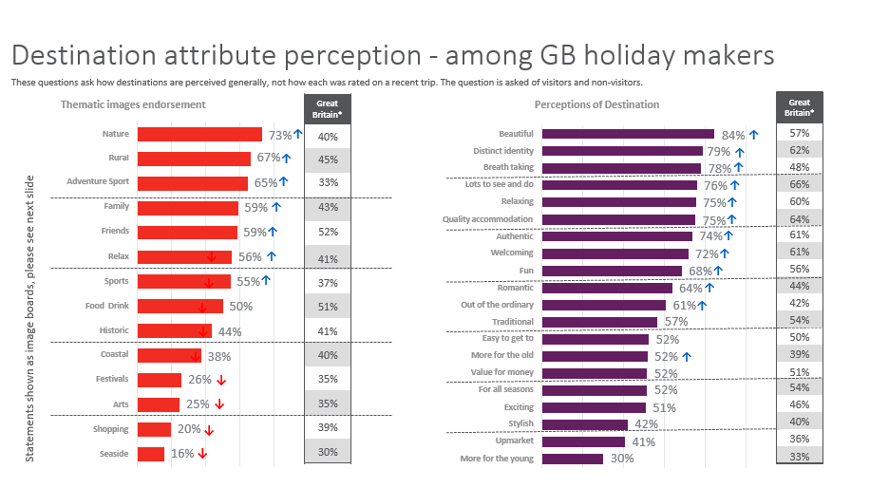
Figure 2: Destination attribute perception among GB holidaymakers (The Lake District destination report. (n.d.)
The hospitality sector preserves cultural sustainability by serving guests traditional cuisines, locally made products, and displays of traditional crafts such as souvenirs at the hotels (Tanulku, 2019). Such practices display the unique cultural identity of the area. Hotels also hire local employees to encourage ideas, experience, and language exchange with tourists.
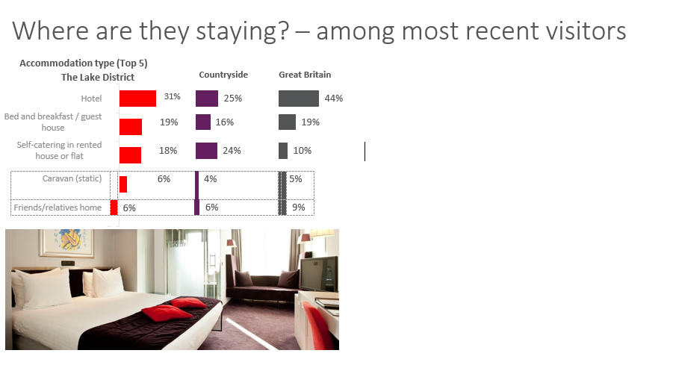
Figure 3: Hotel Overview (The Lake District destination report, n.d.)
According to Cullen and Keefe (2022), through adventure, the local culture and heritage are introduced to tourists, widening the culture and knowledge of the people. Due to the commitment to preserve its culture, UNESCO inscribed the region on the World Heritage list in 2017 (Place et al., 2021).

Economic Sustainability
The Lake District Management Plan 2015-2020 built a base that defined the economic sustainability of the Lake District. The partnership plan highlighted displaying Lake District's universal values and beauty as a World Heritage site (Porter, 2020). The plan highlighted the strategies that will be the base for the Lake District's informed decisions. The strategies were identifying the risks and threats to universal values and establishing mitigation responses to serve the community from another economic breakdown.
The Cumbria community is aging and poses a threat to the economic sustainability of the area. However, establishing the joint Management plan for 2020 – 2025 for the Lake District poses a sigh of relief to the future of the Cumbria region (FitzGerald, Collins, and Potter, 2021). The plan that was adopted on 20th October 2021 by the Lake District National Park Authority aimed to retain the Lake District's sustainability glory as the recovery plan after an economically threatening Covid-19 pandemic by absorbing and retaining young skilled human resources back to the community following their training completions in education centers. However, the housing problem threatens them as many of the houses have been subjected to secondary or holiday homes with high selling rates falling short of affordability by the young people to own a home.
However, to counter the housing concern, stakeholders had transformative plans. The partnership stakeholders aimed at lobbying Homes England to establish relevant social rent for all the housing schemes by 2022, not only available to South Lakeland (Kools and George, 2020). Additionally, the local strategy sought the central government's commitment to introducing a mechanism that controls the conversion of the first homes to second homes in the Lake District area and abolishing the established small business rates exemptions for the holiday homes by 2023. Furthermore, the plan aimed to partner with mortgage lenders to create a flexible environment when lending properties with occupancy controls to the locals.
Among the highlights of the local industrial strategy is increasing the natural capital's private finance pool to expand the economy and create more job opportunities. LDNPA work closely with the businesses within its vicinity and supports them with grants and financial help to encourage them to diversify their businesses and encourage more growth (Prus and Sikora, 2021). The management plan aims to expand the agricultural economy in farming, preserving forestry, fighting for a stable economic outcome, and natural recovery to develop the product for the community. Additionally, digital infrastructures are a target for creating diverse economic sustainability. According to Derek (2021), tourists are encouraged to take their meals and purchase goods from local suppliers through a partnership between the Lake District National Park and the local communities. Porter (2020) argues that economic stability is further promoted by authorities such as the Environmental Protection Agency, the Cambria local Governments, and businesses. LNDPA's contribution to economic stability accounts for over 60% of the income.

Environmental Sustainability
As global warming marked one °C in 2017, according to the Intergovernmental Panel on Climate Change (IPCC), and is further projected to have increased to 1.5 °C by 2050, the gradual climate change poses a threat to the environmental sustainability of the Lake District (Guldberg et al., 2019). Therefore, The United Kingdom government implemented policies in 2019 to bring greenhouse gas emissions to zero by 2050. The Lake District management plan of 2020 – 2025 aims at establishing transformative steps to achieve zero gas emission plans. The measures included pleading with the government to grant low VAT on the maintenance and repair of the traditional buildings within the Lake District (The Lake District National Park, 2020). According to Novotny (2020), the strategy aims to agree with all the partners by March 2024 on the effective approaches to reducing carbon emissions by adopting integrated climate actions into businesses.
A campaign named 'Love Stone' has been championed by the National Trust to engage the public through education on the importance of recycling plastic and other litter and adopting efficient methods of energy sources. Additionally, according to Wise, Jones, and Moncaster (2021), the National Trust has established the Ten Year Carbon Plan to ensure a 10% carbon constituent emission target is reduced yearly in its land and other properties within the Lake District by 2030. Lake District is also rich in attractive mountain sceneries, wild animals, and a beautiful forest endowed with woodland trees, tarns, lakes, and coastlines, which have been the core of tourist attraction.
The Lake District National Park Authority has contributed immensely to environmental sustainability in the tourism sector (The Lake District National Park, 2020). Introducing the Sustainable Tourism Management Scheme was a significant step aimed at only accrediting the accommodation providers, such as hotels that abides by the sustainable tourism plan of energy efficiency, green initiatives, and waste management, according to Mordue, Moss, and Johnston (2020). The management plan also aimed to lobby the government to establish net zero incentives that trigger acceleration in renewable energy production.

Butler's Life Cycle Model and Doxey's Irridex Model
The Lake District can be classified as mature using Butler's life cycle model proposed by Tang, Zhong, and Ng (2017). The area has seen substantial growth in the tourism industry and is now concentrating on maintaining sustainability and striking a balance between visitor expectations and socio-cultural and environmental preservation. The destination is underscored by the positive experiences gained by the tourist who affirmed to have had a great experience in the area, and their anticipations were satisfied with everything they encountered in their tourism exploration. From the statistics provided, tourists considered Lake District the best, and many reconfirmed a revisit due to their excellent outdoor activities. According to Doxey's irridex model, the Lake District is currently experiencing overcrowding and visitor discontentment due to the high number of tourists (KILIÇ and Seçilmiş, 2022). Therefore, sustainable development measures are essential to maintain a great visitor experience while protecting the destination's resources.

Challenges Limiting Sustainability in Lake District
In recent years, Lake District has been credited for its sustainability techniques in all sustainable principles. However, several challenges are yet to be addressed, ranging from all pillars of sustainability. High rental fees for houses in the Lake District have been a burning concern to tourists and locals (Slätmo et al., 2019). Due to increased rental rates of up to even 20%, many holiday houses have remained unoccupied for a long period while the locals flee into the Lake District outskirts like Kendal in search of affordable housing rates. Additionally, constant conflict between tourists, park rangers, and locals is still challenging as tourists who come along with dogs pose a disturbing environment for wildlife and other tourists. Additionally, about 90% of the tourist opts to use private transport during their visit over public transport. Therefore, private transport has highly contributed to severe traffic congestion. Some of the cars these tourists use have rattling and chugging sounds causing air pollution and noise pollution to the people (Ji et al., 2023). Additionally, private transport deteriorates economic sustainability as tourists might purchase goods from supermarkets rather than local businesses.
The power boats and ferries used in the water do not guarantee safety in environmental conservation. The fuel spillages from these machines cause water pollution, killing all the iconic aquatic creatures in a tourist attraction (May, 2020). Additionally, mass tourism may be challenging to contain, and as a result, erosions are experienced and extreme littering, especially on the beauty avenues. Furthermore, although tourism provides job opportunities, the jobs created, such as tour guides, sports instructors, and hospitality, are seasonal. During the Covid-19 period, tourism was restricted in many parts of the world. Wallace et al. (2023) argue that locals dependent on tourism experienced hardships in providing for their families since they were left unemployed.

Recommendations
The authority and the local people should fight to ensure that the third principle of sustainability follows the latter. The regulations require people to engage in activities or practises that do not pollute the environment (Cowx and Owhayo, 2019). For example, cars with leaked engines or causing chugging sounds should be serviced more often. Additionally, to avoid disturbance and conflict between the tourist and authorities, policies that restrict the accompaniment of the dogs should be enacted. The local government should fund programs and schemes campaigning for renewable energy to create awareness for the locals (Mordue, Moss, and Johnston, 2020). National Trust should implement more campaign measures such as holding renewable energy events and educating the public by providing reading materials to seek public participation in their Ten Year Carbon Plan. All the authorities should join in pursuing green initiatives to build renewable energy points.
Furthermore, the authority should enact regulations restricting private transport usage at various destination points. By such enactment, the local economy will thrive, create job opportunities for young people, and reduce congestion for transport efficiency. The authorities should diversify to contain mass touring, as Ji et al. (2023) outline. Additionally, dustbin pits and sign boards should be erected in all corners of the Lake District to remind tourists of the proper disposal of plastics and other litter. Moreover, the local authority should commit to building affordable housing to avoid losing revenue to the neighboring areas.

Conclusion
The hospitality and tourism sectors have been integral in promoting long-term sustainability in the three pillars, including Socio-cultural, environmental, and economic sustainability, by showcasing regional practices to the visitors and working in collaboration with the local people and authorities. Tourism has been iconic in promoting the awareness and preservation of natural beauty and heritage sites (Porter, 2020). The partnership management plan has aided Lake District authorities in establishing a base for fighting carbon concentration in the air and promoting dimensional sustainability for sustainable tourism (Howe, 2019). Many tourism practices, such as strict budgeting processes, a sustainable tourism plan, and clear and objective-oriented goals, have been implemented for efficiency in operations. The sustainability principle includes minimising the negative environmental and social effects, conserving the natural beauty of sites, and maximising the benefits for the people. Tourism practices, education training, and partnerships have steered this area's sustainability.

References List
Cowx, I.G. and Ogutu‐Owhayo, R., 2019. Towards sustainable fisheries and aquaculture management in the African Great Lakes. Fisheries Management and Ecology, 26(5), pp.397-405. https://onlinelibrary.wiley.com/doi/abs/10.1111/fme.12391
Cullen, S. and Keefe, G., 2022. Lake District 2.0: Mutability and Low-Density Landscapes in an Accelerated Culture. In Design for Regenerative Cities and Landscapes: Rebalancing Human Impact and Natural Environment (pp. 65-90). Cham: Springer International Publishing. https://link.springer.com/chapter/10.1007/978-3-030-97023-9_4
Derek, M., 2021. Nature on a plate: Linking food and tourism within the ecosystem services framework. Sustainability, 13(4), p.1687. https://www.mdpi.com/986734
FitzGerald, O., Collins, C.M. and Potter, C., 2021. Woodland expansion in upland national parks: an analysis of stakeholder views and understanding in the Dartmoor National Park, UK. Land, 10(3), p.270. https://www.mdpi.com/1023876
Grilli, G., Tyllianakis, E., Luisetti, T., Ferrini, S. and Turner, R.K., 2021. Prospective tourist preferences for sustainable tourism development in Small Island Developing States. Tourism Management, 82, p.104178. https://www.sciencedirect.com/science/article/pii/S0261517720301047
Hoegh-Guldberg, O., Jacob, D., Taylor, M., Guillén Bolaños, T., Bindi, M., Brown, S., Camilloni, I.A., Diedhiou, A., Djalante, R., Ebi, K. and Engelbrecht, F., 2019. The human imperative of stabilizing global climate change at 1.5 C. Science, 365(6459), p.eaaw6974. https://www.science.org/doi/abs/10.1126/science.aaw6974
Howe, D., 2019. Rocks and Rain, Reason and Romance: The Landscape, History and People of the Lake District. Saraband. https://books.google.com/books?hl=en&lr=&id=zmfIDwAAQBAJ&oi=fnd&pg=PT6&dq=Howe,+D.,+2019.+Rocks+and+Rain,+Reason+and+Romance:+The+Landscape,+History+and+People+of+the+Lake+District.+Saraband.&ots=JG3MrqPnmG&sig=-1kcMO6XnZF2HpwTVMjcA5cx3Ng
Ji, M., Guo, W., Chen, Z. and Morgan, N., 2023. Managing tourist congestion: Insights from Chinese package tours to the UK and Ireland. Current Issues in Tourism, 26(5), pp.752-771. https://www.tandfonline.com/doi/abs/10.1080/13683500.2022.2037525
KILIÇ, İ. and Seçilmiş, C.İ.H.A.N., 2022. Effects of exceeding social carrying capacity on residents' support for tourism: The mediating role of community participation and quality of life. Turizm Akademik Dergisi, 9(2), pp.341-355. https://dergipark.org.tr/en/pub/touraj/issue/70329/1056384
Kools, M. and George, B., 2020. Debate: The learning organization—a key construct linking strategic planning and strategic management. Public Money & Management, 40(4), pp.262-264. https://www.tandfonline.com/doi/full/10.1080/09540962.2020.1727112
Lake District National Park. 2020. Partnership's Management Plan 2020-2025. https://www.lakedistrict.gov.uk/caringfor/lake-district-national-park-partnership/management-plan.
May, S., 2020. Heritage, endangerment, and participation: alternative futures in the Lake District. International Journal of Heritage Studies, 26(1), pp.71-86. https://www.tandfonline.com/doi/abs/10.1080/13527258.2019.1620827
Mordue, T., Moss, O. and Johnston, L., 2020. The impacts of onshore-windfarms on a UK rural tourism landscape: objective evidence, local opposition, and national politics. Journal of Sustainable Tourism, 28(11), pp.1882-1904. https://www.tandfonline.com/doi/abs/10.1080/09669582.2020.1769110
Novotny, V., 2020. Integrated sustainable urban water, energy, and solids management: Achieving triple net-zero adverse impact goals and resiliency of future communities. John Wiley & Sons. https://books.google.com/books?hl=en&lr=&id=3HvGDwAAQBAJ&oi=fnd&pg=PR10&dq=Novotny,+V.,+2020.+Integrated+sustainable+urban+water,+energy,+and+solids+management:+Achieving+triple+net-zero+adverse+impact+goals+and+resiliency+of+future+communities.+John+Wiley+%26+Sons.&ots=05iIssSxxk&sig=W_E4_jHnH-4QUfryowMeiaJ8zMk
Park, N., 2020. Population estimates for the UK, England and Wales, Scotland and Northern Ireland, provisional: mid-2019. Hampshire: Office for National Statistics. https://backup.ons.gov.uk/wp-content/uploads/sites/3/2020/05/Population-estimates-for-the-UK-England-and-Wales-Scotland-and-Northern-Ireland-provisional-mid-2019.pdf
Parry, C., 2020. Herdwick tales: breed and belonging in the English Lake District. Green Letters, 24(4), pp.406-420. https://backup.ons.gov.uk/wp-content/uploads/sites/3/2020/05/Population-estimates-for-the-UK-England-and-Wales-Scotland-and-Northern-Ireland-provisional-mid-2019.pdf
Place, C., Bendell, J., Chapman, I., Mcphie, J. and Murphy, D.F., 2021. Integral research on the Lake District Pound: six mixed methods for assessing the impact of a currency. International Journal of Community Currency Research, 25(1), pp.34-51. http://insight.cumbria.ac.uk/id/eprint/6047/
Porter, N., 2020. Strategic planning and place branding in a World Heritage cultural landscape: a case study of the English Lake District, UK. European Planning Studies, 28(7), pp.1291-1314. https://www.tandfonline.com/doi/abs/10.1080/09654313.2019.1701297
Prus, P. and Sikora, M., 2021. The impact of transport infrastructure on the sustainable development of the region—Case study. Agriculture, 11(4), p.279. https://www.mdpi.com/1046724
Slätmo, E., Ormstrup Vestergård, L., Lidmo, J. and Turunen, E., 2019. Urban–rural flows from seasonal tourism and second homes: Planning challenges and strategies in the Nordics. https://www.diva-portal.org/smash/record.jsf?pid=diva2:1372234
Tang, C., Zhong, L. and Ng, P., 2017. Factors that influence the tourism industry's carbon emissions: A tourism area life cycle model perspective. Energy Policy, 109, pp.704-718. https://www.sciencedirect.com/science/article/pii/S0301421517304822
Tanulku, B., 2019. The English lake district: a culturally wild landscape. International Journal of Wilderness, 25(2), pp.68-78. https://ijw.org/english-lake-district/
The Lake District destination report. (n.d.). https://www.visitbritain.org/sites/default/files/vb-corporate/Documents-Library/documents/England-documents/destination_report_-_lake_district.pdf
Wallace, C., Chen, X., Garrison, S. and Shaddock, J., 2023. The impact of Covid-19 on cultural tourism. Introductory article for special issue of tourism culture and communication. Tourism Culture & Communication. https://www.ingentaconnect.com/content/cog/tcc/pre-prints/content-23201
Wise, F., Jones, D. and Moncaster, A., 2021. Reducing carbon from heritage buildings: the importance of residents' views, values and behaviours. Journal of Architectural Conservation, 27(1-2), pp.117-146. https://www.tandfonline.com/doi/abs/10.1080/13556207.2021.1933342

