

An Investigation into Recommender Systems for Use in a Personalised Registration Plate Shopfront
by
Oliver Jordan

Supervisor: Tim Bashford
Second Marker: Mike Dacey

Project submitted as part of the requirements for the award of MSc Software Engineering (Web Development)

January 2024

DECLARATION

I, Oliver Jordan, declare that I am the sole author of this Project; that all references cited have been consulted; that I have conducted all work of which this is a record, and that the finished work lies within the prescribed word limits.

This work has not previously been accepted as part of any other degree submission.

Signed : 

Date : 20/01/2024

FORM OF CONSENT

I, Oliver Jordan, hereby consent that my Project, submitted in candidature for the Msc Software Engineering (Web Development) if successful, may be made available for inter-library loan or photocopying (subject to the law of copyright), and that the title and abstract may be made available to outside organisations.

Signed :

Date : 20/01/2024

Abstract
Recommender systems are present in many e-commerce and content delivery sites, providing user with recommendations of related content in order to keep them interest in the things the site may be offering. A notable lack of sophisticated recommender system is present when it comes to the personalised registration shopfronts, and this project lays out aims and objectives to investigate the recommender systems for use in such a scenario.
A literature report is carried out and it is found that various types of recommender systems exist – item-item; user-user; and user-item. These are explored before the possible methods of storing the information about relationships are discussed.
The project deliverable is then described and highlights some aspects of the API. The iterations of the recommender system are described, and justification of the decision to use weighted graphs to represent the relationship between topics is made. A survey is described.
The results of the survey are discussed and analysed. It finds that the first iteration only finds middling success in it approach, and following the feedback from the survey, a second iteration using Dijkstra’s algorithm to find the shortest path of related topics between two chosen nodes is used to allow recommendations to be made based on multiple chosen topics. The results gained from surveying this iteration show an improvement over the previous iteration, but the potential for further improvement is acknowledged.

Table of Contents

Abstract 3
1 Introduction 5
2 Project Aims and Evaluation Criteria 6
2.1 Aim and Objectives 7
2.2 Evaluation Criteria 7
3 Literature Review 8
3.1 Recommender Systems 8
3.1.1 The Challenges 8
3.1.2 Collaborative filtering and Content Based Methods 9
3.1.3 Tag Aware Methods 10
3.1.4 Observations 10
3.2 Graphs and Networks 11
3.2.1 Bipartite Networks 11
3.2.2 Traversing a Graph 12
3.2.3 Observations 13
3.3 Conclusion 14
4 Research Methodology 14
4.1 Action Plan 15
4.2 Assumptions and Acknowledgements 15
4.3 Conclusion 15
5 Design and Implementation 16
5.1 Representing Relationships 16
5.2 Storing the Relationship Data 16
5.3 The API 17
5.3.1 Design 17
5.3.2 Endpoints 17
5.4 User Interface 20
5.5 The survey 20
5.6 Conclusion 20
6 Results 21
6.1 Survey 1 21
6.2 Survey 2 22
6.3 Results Analysis 22
6.3.1 Responses to Question 1 22
6.3.2 Responses to Question 2 23
6.3.3 Responses to Question 3 23
6.3.4 Responses to Question 4 24
6.3.5 Additional Comment Responses 24
6.4 Conclusion 25
7 Evaluation 26
7.1 Evaluation Criteria 26
7.2 Objectives 27
7.3 Aim 27
8 Conclusions and recommendations 28
8.1 Summary 28
8.2 Conclusion 28
8.3 Recommendations for Further Research 29
9 Bibliography 30
10 Appendices 31
10.1 Final Dijkstra Algorithm Recommendation Code 31
10.2 Survey Responses 35
10.2.1 Survey 1 35
10.2.2 Survey 2 35

Table of Figures
Figure 1: An example of a user item matrix describing user's interactions with films, where the rating they leave are the measuring factor. 10
Figure 2: A bipartite graph. Notice how no edges exist between nodes within the same group. 12
Figure 3: A hypergraph, where the coloured ellipses are hyperedges surrounding the black circular nodes. Some nodes belong to more than one hyperedge. 13
Figure 4: The resulting shortest path from Dijkstra's algorithm [15] 14
Figure 5: The ERD of the database used for the project, generated in PGAdmin, the management tool for PostgreSQL. 18
Figure 6: A graph showing the lowest, highest, and average score from the numbered survey results. 22
Figure 7: A graph showing the lowest, highest, and average score from the numbered survey results in the second survey. 23
Figure 8: The first half of the first survey responses 36
Figure 9: The second half of the first survey responses 36
Figure 10: The first half of the second survey responses 36
Figure 11: The second half of the second survey responses 36

Introduction
The internet today is filled with many various storefronts and content delivery system, such as Amazon and YouTube. These sites often have a feature somewhere within them where items are recommended to a user, usually personalised to their tastes or previous interactions on the site. These systems are not just choosing random objects; they are complex systems that have evolved and learnt over time to ensure that a user only gets shown the best content for their needs. While some systems may be operating on small collections of data and users, as these systems have to scale up to millions of pieces of content, and just as many users, more complex systems must come into play – such as Google’s use of deep neural networks for YouTube’s recommendations [1]. However, these systems are not present in every corner of e-commerce [2], and many smaller shopfronts make use of different methods to help their users engage with items.
Through this authors time with the DVLA, a familiarity with the systems behind the sale of personalised registration plates has been gained. The shopfront that exists for these systems is noticeably lacking such a recommendations system, which could be for several reasons. Converting an interest into an appropriate 7-character plate is difficult and mixing several interests into a representing plate even more so. Nonetheless, it may be possible to used predetermined plates and assign them to relevant interests, and from there, build a recommendation system that so many other e-commerce sites have been using for years.
As such a recommendation system has been built, presented to survey participants and then iterated upon in an order to bring the technology to another style of storefront.

Project Aims and Evaluation Criteria
This section lays out the overall aims and objectives of the project.

Aim and Objectives
This project was carried out with the following as the projects aim:

To develop and refine, based on user feedback, a system that can understand provided interests and make recommendations based on the information.

The following objectives were set to help achieve this goal:
- To develop a graph-based data structure that can represent the relationship between various interests.
- To survey volunteers about the efficacy and accuracy of said developed system.
- To refine the system based on the given feedback to improve each iteration of the system.
- To analyse the outcomes of the surveys and each build, to understand how the changes and results between each build of the system affect the perceived effectiveness of it.

Evaluation Criteria
At the end of the project, these evaluation criteria should be assessed to consider if the project has been successful in what it had hoped to achieve:
- Has the project developed a system with the required functionality?
- Were the surveys conducted in such a way that valuable information could be gathered?
- Did the number of volunteers to test the system have any potential effect on the outcome of the surveys?
- Were any challenges encountered on the project adequately dealt with?
- Does each iteration of the system properly consider the results of the previous iteration’s surveys?

Literature Review
This section will present some background research relating to the project and discuss the implications it might have on the development of the project’s main deliverables.

Recommender Systems
Within e-commerce and content delivery systems, the concept of a recommender system has appeared and evolved [3]. These systems are designed to recommend similar items or content to what a user may be currently viewing, perhaps in an effort to keep them interested in content on a site, or perhaps to attempt to sell additional products. These systems are highly sought after, to the point where Netflix once set a competition with a prize of one million dollars to incentivise people to find an improvement on their own system [4].
The term “recommender system” is a broad term, and as such there is not one best practice solution for these systems and are dependent on the environment the system would be used in. Many methods of choosing recommendations have been developed over the years, and many more will likely be continued to be made.

The Challenges
Where there’s a solution, there must be a problem to solve first. While a recommender system exists to allow users to find similar items without knowing their existence, there are additional challenges which refined systems must consider. Data sparsity [5] refers to how a system may have millions of items to draw from, but only thousands of interactions with little to no overlap. Without this overlap, creating recommendations based on other users with similar interests becomes tricky, and large systems should account for this. Scalability is another issue to tackle, as the computational cost may become increasingly large for systems with millions of items, and updating the relationships between them when new data is added will be expensive [6]. In order to make recommendations, the data needs to exist in the first place, leading to systems potentially experiencing a “cold start”. Systems facing this cannot make accurate recommendations, proving a challenge for new systems with little data [5].
Several other challenges exist, including the effect of old data over time on recommendations, tackling if easy to find, popular items should be included in the results and the affect the user interface has on the acceptance of recommendations [5].
Finally, an issue arises when it comes time to evaluate these systems. While many algorithms can be compared to others based on their speed and accuracy, many recommender systems aim to solve a large array of their own problems – a recommender system that finds new books for a user to read cannot always be compared equally to a system that shows interesting holiday destinations to a user based on their preferences.

Collaborative filtering and Content Based Methods
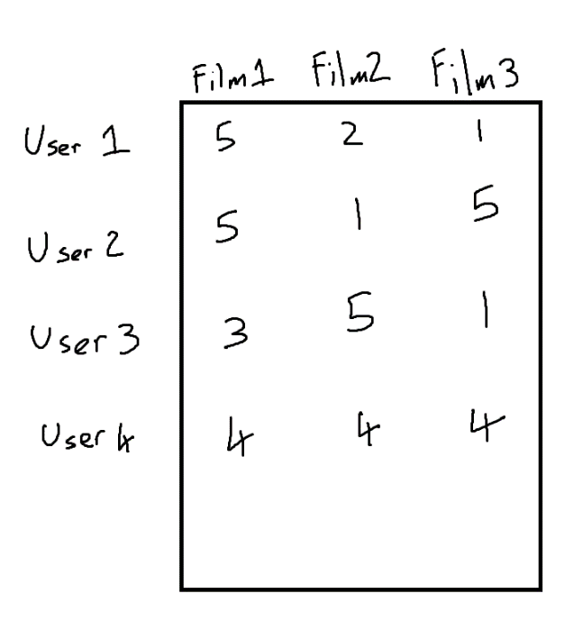
Before discussing specifics methods employed by recommender systems, consider the following categorisations used to describe them. Collaborative filtering refers to the methods using past interactions of users with items in a system and uses these values to make recommendations [7]. These interactions are stored in some user-item matrix, a structure that describes the interactions between the two in some way – an example may be the rating a user leaves for a movie on a movie site, or if a product is viewed when it is recommended to them.
Figure 1: An example of a user item matrix describing user's interactions with films, where the rating they leave are the measuring factor.

These interactions may then be used to dictate which items are suitable for recommendation to a user, and the idea these methods rely on is that said past interactions are sufficient data for this [7].
Within these methods, there exists two approaches – memory-based collaborative filtering and model based collaborative filtering. Memory-based methods attempt to choose items which are often selected by users with similar interests and preferences, or items which are like other items the user has previously picked [5].
Model based collaborative filtering employs some model that is trained to recommend patterns in a data set. As an example, a model might be trained to identify that when a user watches lengthier videos about retro video game consoles, they are highly likely to also be interested in videos about game development in the 90s. The results and decisions these models develop will obviously vary based on the input data and those developing it, alongside what they may be used for.
On the other side of the coin, content-based methods look only at the items themselves, and builds recommendations based on similar items to the one a user may be currently viewing [5]. This allows for a recommender system to ignore any data about a user and allow them to remain anonymous, while still potentially curating recommended lists that are relevant.
There are, as with many things, pros and cons to each of these methods. While collaborative filtering approaches may be more accurate to the user’s interests, it necessitates a need for an accurate profile of the user, and for memory-based methods, every other user in order to achieve this accuracy. This also leads into the challenge of how these profiles will be built. Should a new user be required to fill out a lengthy survey on their interests, leading to a potentially cumbersome onboarding experience? Should their interests be learnt by the system over time based on their previous interactions, leading to new users not receiving accurate recommendations due to low interaction rates and the system experiencing a cold start [5]?
Content based approaches can avoid some the above issues as if the items exist within a system, then there is sufficient data to draw recommendations from. This does, however, rely on the relationships between the items already being sufficiently described, and only provides items similar to what is currently being viewed, not what the user may be interested in.
But why settle for one approach or the other, when the two could be used in tandem? Hybrid approach systems can utilise parts of both kind of approaches to suit the required needs of a system [5]. Do you have a new user that has no profile built? Use content-based methods to make recommendations until the system has enough interactions to build a profile and switch to collaborative filtering! Have some users who don’t want potentially identifying information about their interests stored? Use their previous interactions to create recommendations of similar items for those users and continue using the preference-based system for users that allow this information to be stored! Hybrid approaches create the possibility of hundreds of unique approaches using combinations of methods to suit the needs of both the user and the system. The major downside with this approach is not all methods co-exist well, leading to some hybrid approaches needing additional memory footprints to store the data needed to drive them, data which may not be suitable for the other approaches being used.

Tag Aware Methods
While many methods already discussed tend to be very invisible to the user, tag aware methods encourage users to improve recommender systems by applying tags to content describing them – the ever popular hashtag system found on Twitter is an example of this, and implementing a tagging system into a site is common after the advent of Web 2.0 [5]. These tagging systems are effective at applying abstract categorisations to content and allows users to observe and participate in the system, potentially leading to trust in the recommender. These methods are effective at solving the cold start problem and have been shown to help improve recommendation accuracy [8].

Observations
Recommender systems are the backbone of item discovery on the web, allowing for relevant items to be shown to the user. There is an established number of methods and approaches to the existing challenges to the system, with many covering for the shortcomings of other approaches. This shows the strength of hybrid approaches, and just how complex these systems could potentially build up to be, all to make sure the next video somebody watches, is right for them.
The tag aware methods that exist show that these systems can tackle problems in unique ways – the ways the data is categorised can fundamentally change how a system might be able to approach the decision of what to recommend next.
A relevant noticeable gap in the research done for this proposal is what the systems are concerned with recommending – existing items. While these methods may prove valuable in the decision making of a registration plate to recommend, they would rely on plates already existing and having relationships to topics – for example a registration plate “F00TY” would have a strong link to football, or sports in general. Should the resulting system be building registration plates on the fly, a unique system that learns how to interact with the recommendations to do so will need to be explored.

Graphs and Networks
To represent a collection of relationships between topics, an appropriate data structure is needed. Graphs are collections of nodes and edges, with weighted graphs giving these edges a weight to describe the strength of that connection somehow. Networks [5] are weighted graphs [9] where each node represents some element, with the edges representing the relationship between them [10] and Graph Theory [11] is the study of such networks. An example of an application of a network in this way, is to assign each node as a train station, and connect them with edges representing the route from each station to their connected node’s station. With such a network you could no traverse from one station through other nodes to a destination to describe a whole train journey. Adding weights to the edges could describe the distance travelled on that route, adding more information to your route.
An undirected graph is a graph with edges between nodes that can be traversed both ways, such that connected nodes a and b are described as a↔b. Conversely, a directed graph has connected nodes a and b, but also describes the direction of the connection as a→b. Directed graphs also allow for multiple connections between nodes, allowing b→a and a→b to c-exist.
Graphs also have descriptors for several characteristics, such as nodes relative to each other - the nodes adjacent to a node χ can be called the neighbourhood of χ, denoted by Γχ. Several other descriptors for graphs and networks exist, proving them to be a robust data structure [5].

Bipartite Networks
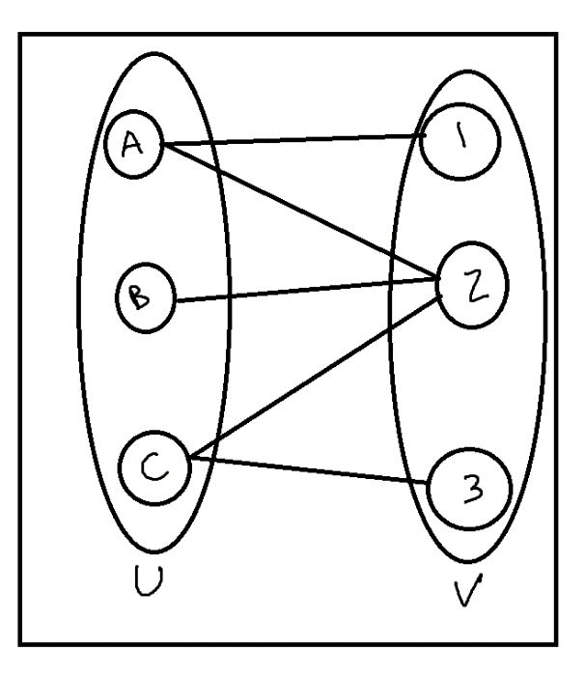
Bipartite networks are networks in which the nodes can be split into two groups, U and V, where every node in group U connects to nodes in group V, and none in group U. The same should also be true for the reverse – no node in group V connects to another group V node, and to nodes in group U [12]. These networks are handy for describing user-item relationships, or for describing any two groups that relate to each to each other [5].
Figure 2: A bipartite graph. Notice how no edges exist between nodes within the same group.

An evolution of bipartite graphs is the hypergraph [13], a graph that gives subsets of nodes a hyperedge, that is an edge surrounding nodes that describes them as some sort of group.

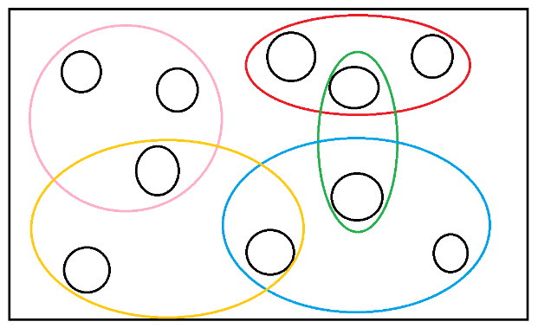
A hyper graph allows for a collection of nodes to be connected to as one, allowing for relationships of groups of items to be described in a more general sense than that of the individual nodes. These hyperedges can overlap, allowing one node to be present in several hyperedges, and can help describe a single item belong to two or more larger general attributes that describe these groups. To describe this, imagine a node describing “Swansea City” as an item. A hypergraph could be designed such that “Swansea City” belongs to both a hyperedge describing “Places” and “Football Teams”, as Swansea City could indeed be referring to both those things. Hypergraphs are already seeing many uses, such as their use to describe cellular networks [13].
Figure 3: A hypergraph, where the coloured ellipses are hyperedges surrounding the black circular nodes. Some nodes belong to more than one hyperedge.

Traversing a Graph
While a graph can describe the relationships between a set of items well, how could that be used to discover items with similar relation? For adjacent nodes, it would be simple – for all edges connected to a node, where the edge’s weight describes more relevancy the lower the value, the lowest weight is the best recommendation. However, it may become necessary to traverse several nodes to reach a destination for some reason, along the shortest path. Dijkstra’s shortest path algorithm can find the shortest path through a weighted graph, given the start and end destination through a method of queuing and assigning tentative costs to nodes before fully computing them [14].
Dijkstra’s algorithm performs well on graphs, however, does not correctly work on graphs with negative weights, which should be kept under consideration as sometimes, negative weights could prove useful for indicating certain relationship types.
The calculation of such an algorithm follows the following steps:
- Populate a list of all nodes as an unvisited node list, an empty list of nodes as a visited list.
- Assign the source node with a cost value of 0 and every other node a weight of infinity.
- Then, select the node u with the smallest cost, remove from the list of unvisited nodes and add to the visited nodes.
- For every edge e attached to node u and the node v at the end of it:
  - Set the node v cost to (node u cost + edge e weight), but only if said calculation is less than the current value.
  - Describe the node v’s parent as the node u.
- Repeat steps 2, 3 and 4 until all nodes from the unvisited list are in the visited list.
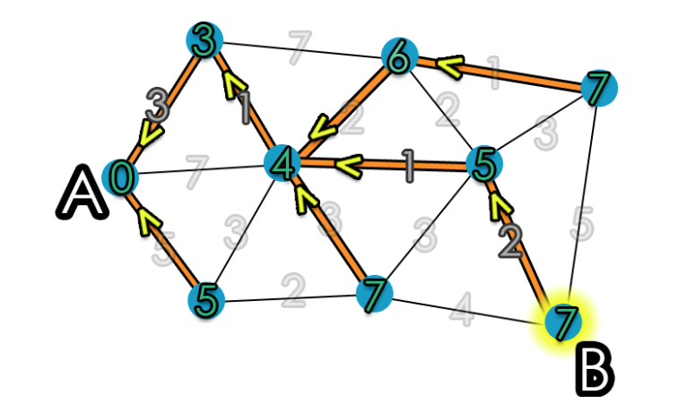
Figure 4: The resulting shortest path from Dijkstra's algorithm [15]
The outcome of the algorithm should be a representation of the shortest path through a graph as a tree and can now be traversed from root to desired leaf, where each node passed through down the tree is part of the path [15].
A* algorithm is another search algorithm that works with graph structure [16], traversing nodes and applying a cost based on the weights travelled through to get there. It calculates this by:
$$F=G+H CITATION Nic17 \backslash l 2057 [16]$$
Where F is the total cost of a node, G is the distance between the current node and the starting node, and H is the heuristic, the estimated distance between the start and end nodes [16]. Using these costs, the shortest path through a graph can be found.
Both algorithms have their strengths, with Dijkstra’s algorithm being memory effective and not needing to always store every node’s result, while A* is fast at finding a direct shortest route but needs to keep the calculations within memory [14]. This becomes a particular issue when a graph may be dynamic, ruling out the possibility of pre-calculating common routes or partial routes to remove computation time at execution, and graphs and networks used in recommender systems may be likely to do so to reflect changes in relationships between both items and users.

Observations
Networks represented by graphs appear to be a suitable method for storing the relationships between entities. This would be useful to describe how closely related concepts are, by applying a weight based on their perceived closeness. Since this is a subjective measure, any datasets made through this method would have to make large assumptions originally, and a recommender system using the data may experience a cold start. However, if a system for recommending registration plates based on a user’s profile were to update it’s the underlying data’s relationships based on some factors, it could quite easily develop the network to suit its users over time, akin to how some machine learning systems might work.
Based on the discussion of a tagging system in the previous section, a graph could work very well using tags as node entities, and having appropriate registration plates directly connected to those nodes with weighting to describe how close any registration could be perceived as describing the tag – as an example, the tag “Music” may see the registration plate “JAZZ M4N” connected with a strong weight, “BRA55” could be perceived as only tangentially related and have a much lower weight. The issue arises when multiple tags are used – the question becomes whether the ideal scenario involve showing plates close to each tag individually, or should an average of the two interests attempt to be calculated? In the event of an average, traversing the node through the shortest path between the two tags and recommending something in the middle of the path might yield some interesting results. Hypergraphs could also prove useful for allowing much more general tags and contain the more specific tags within, allowing for multiple ways to query the data the network holds.

Conclusion
This section has laid out some the relevant existing research that should direct the project. The concept of a recommender system is useful to direct how the system may want to interact with the underlying data it has at its disposal and informs of some common challenges that exist for the systems.
The discussion of a relevant underlying data structure to use to store the information needed by the project’s deliverable has allowed for some initial ideas to form on the implementations needed, as well as revealed some interesting questions on potential ways to query the data it stores.
The subjective nature of how concepts relate to each other was also acknowledged and the potential requirement of some user to help the system to refine the graph or a data set that makes these assumptions initially was discussed.

Research Methodology
During the course of the development of this project, a proposal and rough plan was submitted and followed. In order to facilitate the replication of this project by any interested parties, this section will lay out some key elements used.
The project used a subjective approach, requiring analysis of user’s feedback to produce results, as the perceived relation of a suggested registration plate is a subjective opinion and not able to be quantified as single value appropriately. A document review strategy was used in order to guide the building of the deliverables, so as to ensure previous research is used for direction and being built upon.
The following tools were used when developing the deliverable:
- Java programming language – To build the API that interacted with the data and performed to logic to recommend plates, Java was used, alongside the SpringBoot 3 libraries.
- PGSQL – the database uses PGSQL, a standard and widely used database language.
- Ruby on Rails – In order to have a front end to ease interacting with the API, Ruby on Rails was used. React was considered, but as there was no requirement to make use of the dynamic single page app style that it uses here (and along with the author’s familiarity with Ruby on Rails), it was decided that Rails was the better approach.
- Faraday gem – within the front end, the Faraday gem was utilised to make http requests to the API.
- Docker – the resulting app is able to be run in a docker container, allowing for easy use without having to run and set up everything natively.

In addition, the following tools were not necessary to development but proved useful:
- Postman – to manually fire http requests to the API, Postman was used. The tool proved incredibly useful during development.
- PGAdmin – the standard way to inspect and manually manipulate data without using the PGSQL command line interface.
- Docker Desktop – while container logs can be viewed from the command line where the containers were started from, Docker Desktop provides a nice GUI to interact with the containers.

Action Plan

Using the “5W2H” action plan template and answering the questions defined by the template, elements of the project can be defined:
- What will be done? – An investigation into recommendation systems, specifically for the use case of applying to a personalised registrations shopfront.
- When will it be done? – The project occurred between August 2023 and was submitted in January 2024
- How? – The project carried out a literature review, then used that knowledge to guide and develop an app that will recommend registrations plates based on topics.
- Why? – Many e-commerce sites use recommender systems to provide related items to users to help them find things that they may want to spend money or time on. Investigating this in the context of a personalised registrations shopfront provides information that may be able to enhance the service.
- How much? – The project produced a limited set of data representing the relation of topics between each other and a database to store it, an API to manipulate, query and retrieve various data based on said dataset, and a UI to interact with that API.

Assumptions and Acknowledgements

There were some necessary assumptions made in the process of the project. Firstly, the assumption that the recommender can simply provide a string of up to 7 characters to represent a registration number and that any formatting into the standard registration plate layouts would be handled by some system afterwards. Secondly, that the registrations the system recommend should either exist for purchase or be filtered out of the list by their availability.
It is also necessary to acknowledge that registration plates are not fully customisable like one may assume – registrations are released for purchase, sometimes through auctions, and as such, while the registration somebody could want to buy may not be registered to a vehicle, it may not even be available to purchase in the first place. All this means for a recommender system, as previously assumed, is that it should only show those plates ready to be bought and would be a system handled after the recommender has done its work.

Conclusion
This section has laid out the methods and tools needed throughout the course of this project. This should allow anybody who may wish to replicate the project to understand exactly what has been used should they wish to make use of the same tools.

Design and Implementation
The following section describes the design of the system built to investigate how a recommender system may perform for recommending registrations plates to users. Where appropriate, the decisions made will be justified. Notable code segments can be found in the appendices at the end of the document.
It was decided that this project would focus on a tag-based system, where certain topics would be available for a user to utilise to guide the recommendations they receive. This decision was made based on the low number of plates that are bought by individual users, meaning that user to user recommendations would be built on sparse data. As discussed by previous works, this sparsity would reduce the effectiveness of the system [5]. Furthermore, businesses are able to purchase registrations under the same account system as individual users and would further muddy the data if used to make recommendations.
As such, this project focused on an item-to-item based recommender system. It was not appropriate to build these recommendations based on the plate content alone, as while a relationship between individual words could be built, it would be lacking a lot of content. To contextualise registration plates, as previously mentioned, a tag-based topic system was decided on. Registration plates would be linked with a topic – for example “SWANSEA” would be linked the topic “Swansea”. These topics could then have their relationships with other topics described and then used to indicate which plates may or may not be related closely to each other.

Representing Relationships
With the overall system designed, the next step was to find a suitable method of storing these relationships. In order to represent the relationships between topics, the following things would need to be stored:
- The topics themselves.
- Some representation of how closely they related to other topics.
- The registrations linked to the topics.
Previous recommender systems have made use of various methods of representing relationships between entities, such as item matrices [7]. While this would be able to store the data sufficiently, navigating the data may prove difficult. There are however, methods of doing so efficiently, such as Poisson factorisation [17] and Lattice navigation [18], however these approaches are based on a user-item matrix, rather than an item-item matrix.
A second approach is using a network [5] – a weighted graph would appropriately describe each topic as a node, with weighted edges describing the strength of their relation to other nodes. Registration plates could also be described with weights and links to nodes, linking to a topic node separately, rather than being part of the full graph. Using the underlying graph structure of a network also opens up the capability to use established graph traversal algorithms as discussed in section 2.2.2 [14] [16].
Ultimately, the latter approach was chosen as it was felt it suited the use case appropriately and presented opportunities to apply some interesting algorithms to use during the recommendation process.

Storing the Relationship Data
With the representation of the relationships decided upon, the next job was deciding how that data would be stored. A relational database was used, opting for the well-established PostgreSQL [19], to represent the graph. Each topic is represented as an entity in the database, storing the topic name. Edges are then stored in their own table, storing the two topics attached to the edge, the weighting, and sample size value that is used to help update weightings. Registrations are then stored, storing their topic parent, and their own weighting and sample size relating to the topic. This database then fully stores the information for the weighted graph and can be used to make decisions about what plates to recommend.
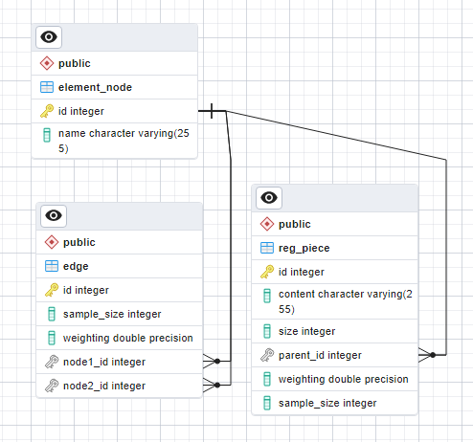
Figure 5: The ERD of the database used for the project, generated in PGAdmin, the management tool for PostgreSQL.

The API
In order to properly interact with, manipulate and use this data, an API was built. This was built using Spring Boot [20] and the Java programming language, along with an OpenAPI tool for designing API endpoints [21].
The API contains all the logic needed for building the data, updating the relationship links between the topics and querying the data to make decisions about which plates to recommend. This section aims to discuss and highlight the key features of the API. Notable code segments may be found in the appendices at the end of the document.

Design
Following common practices, the API code is split into controller, service and repository files. A controller will hold the top level code that an endpoint calls – typically, only calling out a service, returning data, or reporting errors back to the client. The related service class then holds all the business logic that the controllers call upon. For example, an endpoint that adds data would call the service to perform any logic required to be performed on the input. The repository classes then handle the interaction with the data, performing the actions needed to find data from the data store, or manipulate it in some way. These repositories make use of Spring JPA, a framework that helps data transport by proving a library of commonly used repository actions.
Registrations are stored as any string of characters up to a max size of seven. They are referred to as “Reg Pieces” through a lot of the API as they are later used to build new registrations when making recommendations.

Endpoints
This section will go over each endpoint in more detail, discussing their actions and the underlying code.

GET /element-node
This endpoint returns a list of data transfer objects (DTOs) representing the elements of the weighted graph. It’s a simple fetch from the database, some remapping to the data object and then returning of the list to the client.

GET /element-node/{id}
This endpoint returns a single DTO describing the node found at the provided ID. If no node exists at this ID, an error is returned to the client.

POST /element-node
This endpoint will allow for addition of a new element node to the database. The client provides a name, and the related repository inserts it into the database.

GET /edge
This endpoint returns all edges in the database as a DTO list. These edges will return with their weightings and sample sizes, but also with both of the attached node names and IDs.

POST /edge
This endpoint adds an edge to the database and requires the two attached nodes’ IDs. This endpoint also contains code to check if the node pair already have an edge between them, and they do, will return an error describing this to the client. Optionally, the weighting and sample size can be set rather than using default values by passing them in the request.

GET /edge/pairing
This endpoint takes in two query parameters of two node IDs and checks to see if an edge exists between the two nodes. If it does, it’ll return this edge as a DTO to the user.

POST /edge/{id}/weighting
When we want to update the relationship link between two topics, we have to update the weighting between the two nodes in the graph. The method used for this update, is to simply track the average weight across samples, rather than simply adding or subtracting values, so as to ensure a true representation of all inputs is kept.
This endpoint takes in a weighting value and, based on the edge’s current sample size and weighting, updates the average weight. The sample size is increased during this procedure in order to be able to accurately update the average in the next operation.
If no edge exists at this ID, the error is reported to the client and no updates are made to any data.

GET /RegPiece
This endpoint returns all the reg pieces stored in the database. As with the other respective “retrieve all” style endpoints this is achieved with a simple repository call and some reformatting to fit the required DTO list.

POST /RegPiece
This endpoint will take some string to represent the reg piece content, and a parent node’s ID to represent the linked topic. To prevent duplicate data, the endpoint will check if the same content has been saved as a reg piece already and report the error back to the client if it has. Optionally, the weighting and sample size can be set rather than using default values by passing them in the request.

POST /RegPiece/{id}/weighting
Much like the same endpoint for edges, this endpoint will take some value and use it to update the weighting attached to this reg piece. The same logic used in the edge endpoints for updating averages is used again here. This weighting represents the link to the parent node attached to this entity.

GET /element-node/{id}/closest-node
This endpoint will get the node with the strongest relation and return it to the client. To do this, the relevant service needs to retrieve all the edges with this node attached at either end of it by calling to the edge repository for a search. From the returned list of edges, if any, they are then sorted by weight to find the strongest edge. With this edge, the node that isn’t the original one is able to be reformatted to a DTO and returned to the client, allowing them to see the data of the topic most linked to their original one.

GET /element-node/{id}/nodeList
Much like the previous node, this endpoint will be searching for edges attached to this node. The difference however, is that the API returns all nodes on the other side of all these edges as a DTO list. This allows a client to the nhave all the data of all related nodes and the weights of their relations to this one.

GET /element-node/{id}/regPieces
This endpoint will retrieve all the attached reg pieces via the relevant repository and return them as a DTO list. If no reg pieces have been added for the related node yet, an empty list is simply returned.

/recommend
This endpoint takes a provided element node’s ID and attempts to build a list of registration plates closely related to it. Once the node is found and it’s reg pieces retrieved, the API will pick the strongest related reg piece, and build as many registrations with the correct amount of characters (anything seven characters or less) using the remaining pieces. These are added to a list in order as they are built. Once all combinations have been made using the closest related reg piece, the next on in the list is chosen and the previous operations are performed again. Once all of this node’s reg pieces have been exhausted, the next closest node is considered. One last time, all the original reg pieces are used with the next closest node’s reg pieces in an attempt to build more registrations, building in order of strongest to weakest linked piece as before.
With a list of registrations built, this is returned to the client, and represents a list of built, possible registrations that are related to the provided node.

/recommend/dijkstra
This node is a second implementation of the previous recommend endpoint, built upon feedback received when surveying the first implementation. This endpoint takes two node IDs from the client, representing two topics that the user is interested in and would like plate recommendations for. These topics don’t have to be close on the graph and may not even have a valid link between them, but the endpoint still attempts to find suitable registrations regardless.
For this approach, Dijkstra’s algorithm was implemented, as we have two nodes in a weighted graph, and want to find a path along the graph from one to the other. By performing the steps discussed in section 2.2.2, we can build a representation of the shortest path between the two nodes [15]. This shortest path will prove useful for building registrations, as each node subsequent node, while become less related to the source topic, should be becoming more related to the destination topic, so all have some relation to both topics chosen.
Registrations are then built in a similar manner to the previous implementation, except this time, we build from each end of the path. The reg pieces from source node s are built with itself, as before, then destination node d does the same, all adding to the list as the registrations are built so that they are in order of weighting. Once that is done, just as the next node was considered in the previous implementation, registrations are built using the next node in the path – reg pieces from node s are used with the reg pieces from s + 1 and the reg pieces from node d are used with the reg pieces from previous node d -1. This cycle is repeated until we have stepped through the whole path and finally build using each end of the path. This list, as before, is then returned to the client, representing a list of registrations related to both given topics.
A small challenge encountered when programming this endpoint was in the fact that the relationship data had been gathered using larger values indicating a stronger link, as opposed to the typical smaller ones used with Dijkstra’s algorithm. The endpoint accounts for this as there’s a max weighting value anything node can have, so it simply inverses these values. Of additional note, while Dijkstra’s algorithm doesn’t work with negative values [14] [15], the implemented weighted graph uses negative values to indicate that there should be no relation between certain nodes, and as such we simply reject any edges that are described as negative weighting and treat them as non-existent for this algorithm.

User Interface
While not the focus of the project, a user interface to interact with the API endpoints can only provide additional ease of use, and as such, a simple UI was built using Ruby on Rails [22]. This UI contains sections where data can be added, viewed and weightings updated. It also provides a simple display of the result of the recommender system output.
As UI design and usability was not the focus of the project, the UI forgoes styling and most design and simply provides a more usable interface to the system than manually sending http requests through a program such as Postman.
It is worth noting however, that with the design of the weighting update pages, it should be noted that the values are gathered from users by presenting two topics and asking how strongly the user agrees that they are related or not using the typical “strongly disagree” to “strongly agree” 5-point scale. These options then update the weightings using set values from -50 to 50, in increments of 25.
This UI was used to build the data set by asking whoever was nearby and available to donate some time, suggest some topics and update some weightings.

The survey
In order to gather results, a small survey was conducted. Participants were asked to use the system, donate a small amount of time to updating the weightings through the UI, and then asking them to choose some topics to view recommended plates for their choices. They were left with enough time to satisfy their curiosities on the different recommendations for different topics then presented with some question to respond to with a scale of 1-10, with 10 being a more positive weighting. The exception was the final question, which was an open-ended question asking for feedback. The questions were as follows:
- How well did the recommended registrations fit the chosen topic(s)?
- Are these registrations you would recognise as custom if you saw them in the wild?
- If you had searched for the most recommended plate, and it was not available, how likely would you be to buy one of the other recommended plates?
- How well do you feel these plate recommendations would be suited to an e-commerce environment?
- Do you have any recommendations for improvements?
This survey was carried out after the first implementation of the recommender system was built, to allow a second version to be guided by the results. The survey was then carried out again after the second version of the recommender system was built. The results from this survey are discussed in section 5.

Conclusion
This section discussed the design and implementation of a recommender system for registration plates. The tools and languages used to build the system were presented and the API endpoints discussed, along with the notable parts of the logic that had been programmed.

Results
As discussed in the previous section, analysis of the success of the recommender system was carried out using a survey (see section 4.5 for details). The responses can be found in the appendices at the end of the document and will be analysed in this section.

Survey 1
This survey found 20 responses, and the averages of the responses to each question are presented below.

Figure 6: A graph showing the lowest, highest, and average score from the numbered survey results.
The last question of the survey asked for recommendations for improvements. While not every participant had a comment to make, listed below are the comments received:
- “Be able to add my name to plate search”.
- “Make sure recommended plates are actual full words”.
- “Perhaps group smaller topics by larger topics”.
- “Allow me to choose part of my own reg”.
- “Get recommendations for when I choose multiple topics”.
- “More numbers in registrations to replace letters”.
- “Let me mix and match topics”.
- “More short plates”.
- “Better registration plates”.
- “More appealing plates”.

Survey 2
The same survey was carried out again after the second implementation of the recommender system was made. This time, 19 participants took part. The results of the survey are presented below.

Figure 7: A graph showing the lowest, highest, and average score from the numbered survey results in the second survey.
As before, while not everybody had recommendations for further improvements, below are the comments that were received:
- “Let me order topics by importance to me”.
- “Show me all plates then filter out by topic rather than a list of plates from two topics”.
- “Plates overall are kind of average”.
- “Some topic combinations have very few plates”

Results Analysis
In this section, the results will be analysed. The numbered results will be discussed and their implications for the success of the recommender system considered. Then, the comments provided will be addressed and considered, both to analyse if they may be a future improvement or if it is the result of a design choice already made that caused the recommendation to occur.

Responses to Question 1
For the first question, which asked how well the recommended registrations fit the chosen topic, the score was an average of 5.05, suggesting a middling success on producing relevant registrations for the chosen topic. The range of scores for this question were somewhat large, ranging from a 3 at the lowest all the up to a 7 from two participants. This may suggest that the success of the recommended plates was inconsistent across the topics, or that some topics were able to piece together plates that made sense for their topic more than others. As an example of this, it was possible for the topic “Swansea” to generate the registration plate SWANSEA as both the partial registration pieces SWAN and SEA were present, but the same list would also present SEASWAN as a recommendation. While this plate may be suitable for some topics, for the topic “Swansea”, SEASWAN doesn’t quite make sense. Based on some of the comments made, low quality registrations, or unappealing ones were mentioned by a couple of participants, and others mentioned wanting to see full words or inject their own partial registrations in to be used, backing up this analysis.
In comparison, the second survey saw a higher score average of 7.26, suggesting the newer implementation did improve the recommended plate’s relation to the chosen topics. This may be because the second implementation allowed for users to select two topics to guide the recommender, and as such had more range to consider when thinking of if the recommendations related to their choice or not. Alternatively, it may be because the introduction of Dijkstra’s algorithm and build plates based on a path of nodes in the topic graph allowed for more relevant plates to be produced as opposed to simply selecting the next best topic node and building with the reg pieces from there. A few participants did give some lower scores, with the lowest being a five. With the highest score being a nine, the success rate had a larger range, meaning that the consistency of the recommendations may have decreased across user’s experiences compared to the first implementation.
Overall, these results suggest that the relevancy of the produced plates has increased across the two implementations, but with the increased range of the scores, care should be taken that this approach may introduce inconsistencies into a recommender system.

Responses to Question 2
The second question, asking if participants would recognise these plates as custom if they were seen in the wild, was intended to gauge the appeal of the plates, as many people value these plates for being recognised as custom. The average response for this question was a low 4.15, suggesting that would only occasionally recognise the recommended plates as custom. The responses saw a lot of threes and fours, but one participant did give a relatively high score of six. The ability to recognise words or patterns in custom registration plates would vary from person to person, which would explain the range of scores, however it may also suggest that there are more unrecognisable plates or plates one would not expect to have been custom ordered in the list than desired.
The second survey had an average response score of six, with the lowest score being five and the highest being seven. This small range seems to indicate the consistency of the plates being recognised as custom plates has increased, and the average score has improved over the previous version, however, there appears to be some room for improvement still, as a score of six is still only just above average. One user even calls out that the recommended plates were lacking in appeal and was the source of one the low five scores in the second survey.
From these results, it may be concluded that some of the reg pieces being used to build the plates from the graph are not able to produce plates that users feel they would recognise. Perhaps a different approach to their relation to topics would allow for the graph to describe how well a reg piece itself would relate to multiple topics, butter driving how the system chooses pieces to make plates from.

Responses to Question 3
The third question asked users to consider the top plate in the lists of plates they had been recommended and consider if the plates in the rest of the list would make suitable recommendations for alternative options for the first plate. This question was intended to measure the efficacy of the recommender to produce consistently related responses not only to the topics chosen, but to the other results in the list.
In the first survey, the average score was 6.4, with scores ranging from four to eight, suggesting an average, but inconsistent, success on this front. The second survey saw only a slight improvement in the average score, with a 6.79, and only managed to tighten up the range of scores by one point at the low end. This makes sense with the way the registration plates are built, as while the second approach uses more nodes to consider reg pieces from, both implementations cycle through the reg pieces in the same way, by considering the strongest weighted piece with every other, then the next strongest, etc.
No comments seem to mention anything about the consistency of the lists of registrations presented, so while there’s no clear way to improve this aspect based on these results, some considerations may be to allow the system to check for registrations elsewhere that have a similar character set, for example a plate containing the string PIG may benefit from pull the reg piece B4CON even if it does not have a strong link to the current topic.

Responses to Question 4
The last question is somewhat similar to the previous one, as it asks users to gauge if they would consider these recommendations to fit well if they saw them when shopping on an online store for registration plates.
The first survey saw an average score of 6.05 and a wide range, with lows being fives and highs reaching as far as eights. The inconsistency may stem from the nature of the next immediate neighbour used to build additional plates, as sometimes this neighbour may be highly related, but lead to some not so interesting plates - an example being the topics “Wales” and “England” being related, as they are both countries, but the reg pieces WAL and ENG building WALENG as a registration plate does not seem appropriate to recommend next to plates to do with Wales.
In the second survey, this question had an average score of 6.95, and fairly tight range of responses, with the lowest response a six and the highest response an eight. Despite the similarity to the last question, there was an ever so slightly higher success rate. Perhaps this signifies users of online stores don’t always expect the most highly related recommendations as much as a user simply looking at a list? This could also indicate that with the system lacking a user-item style of recommendation that established recommenders make use of both user-item and item-item styles of recommendations, leading to recommendations that aren’t perceived as directly related are not out of place (as a user-item system may pull something not related to the current item, but related to the current user from elsewhere in the network). However, the difference in scores is minimal so may not even indicate any such correlation.

Additional Comment Responses
Finally, participants were asked if they had any recommendations for improvements. While many had nothing to offer for this question, a good number of comments were generated.
In survey one, multiple comments were received about the content of the recommended plates. One participant wanted to see more full words built in the recommendations, while another wanted to inject their own input to use with the system. These comments suggest that grater user interaction would be desirable, and allowing for some control over the result plate’s contents other than buy topic alone would increase the satisfaction with the system. A few other comments touch on the same train of thought, however those were vaguer in how they felt about the contents they were unsatisfied with.
Another comment asked to have smaller topics grouped by a larger topic and be able to drill down through recommendations using different ranges of topic size. This would be achievable using hypergraphs [13] to group the smaller topics, and would allow certain topics to fall under multiple larger ones, opening some interesting new ways to travers through topic relations.
Other comments mentioned wanting to be able to choose multiple topics as opposed to just the one available for the first implementation. These comments were what guided the second implementation towards using Dijkstra’s algorithm in an attempt to provide good recommendations across multiple topics.
The second survey also asked for these comments, and while there were less made for this survey, they may still indicate some things about the success of the system. One participant asks to order topics by importance so that all topics could be considered at all times, or at least those near the top of the theoretical importance range. This would be an interesting direction to take the system in, because it begins to open the door to user-item style systems, where we can build a profile of the user based on their topic order and find different approaches to recommend plates, or perhaps a way to meld the item-item and user-item approaches.
One participant wished that they could start with a full list of registrations and filter the list down by choosing topics instead. This is what’s called a facet [23] in web design and allows for users to do exactly what this comment asks for. While not directly related to the analysis of how items relate to each other and recommender systems, a combination of facets and recommendations based on those facets chosen could make for an interesting approach for further research.
Another comment suggests that plate content is still somewhat lacking – the comments from the previous survey surrounding having greater control over the resulting registrations may help alleviate this, as a user would be able to see plates with even more things that they want from it, not just ones that relate to a topic.
Lastly, a participant raised the fact that some topic combinations seem to have far fewer plates recommended than others. After a quick investigation into why this may be, the conclusion was drawn that some topics would have far more four-letter plates, and when combined with other topics with similar sets of reg pieces, these pieces could not be used with a lot of other pieces, as it was more likely that they would exceed the max character size of seven. This issue may have contributed to the previous comment that plates were not appealing if the range of plate choices was made lower by it.

Conclusion
This section presented and discussed the results of the surveys carried out to gauge the effectiveness of the developed systems and analysed the results, including addressing the recommendation comments made by survey participants on how to improve the system.
Overall, the results from the surveys suggest that the second implementation of the system saw some improvement over the first, in particular in the strength of the recommendations made for the chosen topics. While this is positive, participant comments make it clear that there is still potential for this system to improve in terms of how appealing the plates recommended are, and that greater input control is a desirable trait.
The chosen method of representing the relationships in a data structure, networks, has proven to be successful and allowed the recommender system to adequately make recommendations using the information the data structure provides, showing that the structure continues to be useful to such systems [13].
While the term “collaborative filtering” tends to refer to more explicit user-item interactions, the method of data collection for this system, where a user would be presented with two topics and asked how well the relate to each other, could be considered to fall under the same umbrella [7]. Given that the system presents recommendations for items based on information about it (in our case, the simple topic tag), it also has aspects of content based filtering methods [5]. The use of past interactions with the data and information on the relationships between topics to inform the system how to make decisions on how to recommend plates allowed it to achieve its goal successfully.
The troubles with negative weightings and the traversal of the graph in the second implementation were aspects of Dijkstra’s algorithm that back up what is already known of it [15] [14] and the algorithm has shown it could be useful for recommender systems that use networks and weighted graphs as their representations of data.
While the exact algorithms used in recommender system can often be tricky to find, and comparing the efficacy of one to another can be difficult, as mentioned in section 3.1.1, simply finding an approach to a recommender system that produces favourable outcomes where there were no approaches yet is a boon – having some system is likely better than having no system at all.
One challenge this system may face, and even during this development could be considered to have faced, was the issue of sparse data causing a cold start, something which new systems are known to face [5]. By taking the time to ask people to kindly donate their time telling the system if topics are related or not before ever carrying out a survey, this challenge was mitigated, but in a real use case, a store may not have data the day such a system goes live. This challenge presents a different line of research that could be carried out for a recommender system, where an algorithm that can deal with sparse data across a large data set could be developed and analysed.

Evaluation
This section will aim to assess the overall success of the project and consider if the project aim has been met.

Evaluation Criteria
As mentioned in section 2, the following criteria were set out in order to help assess the success of the project at the end. These were:
- Has the project developed a system with the required functionality?
  - The project has produced a recommender system capable of building and recommending registration plates. Each iteration successfully returns some list of plates to the client requesting it, and based on the survey results, these plates have a fairly strong correlation to the topics chosen to be considered by the system. Overall, this criterion can be considered to be met to a more than satisfactory degree.
- Were the surveys conducted in such a way that valuable information could be gathered?
  - Surveys were conducted by asking anybody nearby if they were able to donate some time to participate, and as such, the survey process could be a little unorganised at times. While the questions were presented in a structured manner and opportunity for participants to express their thoughts on the system outside of a scoring system was given, no thought was given to who was participating in the survey. It may have been beneficial to consider reaching out to gather several people beforehand to participate at a later date and gather information about them on the off chance that it may have shown some correlation with how they perceived the system. However, the results gathered from those who did participate were informative and the comments provided helped guide the development of the system, so this criterion may be considered met, but able to have been improved upon.
- Did the number of volunteers to test the system have any potential effect on the outcome of the surveys?
  - While the number of participants may not have had an effect on the outcome of the surveys, the participants were asked after the surveys, alongside several participants even before the surveys began, to donate some time and help build the relationship data set the system was using. While it is not likely to have swung the outcome any which way, it is worth considering using an existing data set, or building a new data set independently of the survey participants, just in case that did have an effect. Otherwise, this criterion can be considered met, as the surveys had an ok sample size for the scale of the system and likely did not affect the survey outcomes in any than other than they should have.
- Were any challenges encountered on the project adequately dealt with?
  - While a few small challenges encountered on the project were expected and dealt with sufficiently, such as the issue with the data gathered not being immediately suitable for use with the algorithm desired for use, on e problem that arose surrounded the timing of development on the project. In order to get the second survey done before the submission period approached and allow time to write this document, some extra time away from the authors normal responsibilities at DVLA was taken in order to track down and find participants. This was solved with a simple chat with the author’s manager but shows that this criterion can be considered met.
- Does each iteration of the system properly consider the results of the previous iteration’s surveys?
  - While the resulted system only ended up with one survey to draw upon before the final survey, the results from that survey were considered. The desire of some participants to be able to get recommendations from more than one topic was observed and directly contributed to the decision to use Dijkstra’s algorithm in the next iteration. This criterion can be considered to have been met.

Objectives
The following objectives were presented at the start of the project as a guide to help the project aim be achieved, and the success of the project against each of these are evaluated below:
- To develop a graph-based data structure that can represent the relationship between various interests.
  - This data structure has been successfully built and is stored in a database system ready for use in the system. This objective has been met.
- To survey volunteers about the efficacy and accuracy of said developed system.
  - Surveys were carried out and the questions covered both the topics of efficacy and accuracy. Open ended questions asking for feedback also helped facilitate this. This objective has been met.
- To refine the system based on the given feedback to improve each iteration of the system.
  - The second iteration, as previously discussed, has taken feedback from the surveys to guide its further development.
- To analyse the outcomes of the surveys and each build, to understand how the changes and results between each build of the system affect the perceived effectiveness of it.
  - This document has analysed the results of the survey and presented evidence that the changes to system has improved to effectiveness of it. This objective has been met.

Aim
This project was begun with the following aim at its helm, in an attempt to guide the project to a desirable outcome:

To develop and refine, based on user feedback, a system that can understand provided interests and make recommendations based on the information.

The resulting system was built using previous research and iterated upon using the results of a survey. The final iteration of the system received good scores from participants, who’s scores on the survey suggested that they felt this iteration was an improvement over the last and provided satisfactory recommendations for registration plates based on the topics chosen.
Based on this, overall, this project has achieved this aim to a satisfactory degree.

Conclusions and recommendations
This section will summarise the document and discuss possible further avenues of research.

Summary
This project was begun with the intention of investing the way recommender systems work and investigate their efficacy for use in the context of a personalised registrations online shopfront.
A literature review was carried out, where various methods of recommender systems were discussed, and the challenges laid out. The methods of storing the information about the relationships between entities used to make recommendation decisions were discussed, and graph traversal methods are looked at following the mention of various graph types.
Then, the methods and tools used for the project were described, allowing for easier replication of this project by those who wish to do so.
Next the design and implementation of the recommender system produced for this project were discussed. The decisions made behind the various structures used for representing the relationships between objects was discussed and justified. The Various elements of the deliverable were then discussed, with attention paid to the API developed as it is where the recommendation logic lives. Where endpoints had some key element to discuss, it was brought up alongside a description of any challenges faced and solved. It was mentioned that while a UI exists to interact with the API, it was not the focus of the project and thus lacks proper design. The survey’s questions are also laid out in this section.
The results from the survey were then analysed and it was concluded that the second iteration of the recommender system was able to provide improved recommendations compared to the previous one. The responses to the survey are discussed and the changes in score between each implementation are evaluated, with the potential reasons for the scores being considered. Participant comments left on the survey are discussed next, with consideration given to how the recommendations participations have given could improve the system or guide further research.
Lastly the project was evaluated against the project aims, objectives and evaluation criteria set at the beginning of the project. Decisions were made as to whether the project was successful based on the various criteria and ultimate, it was concluded that the project had sufficiently met the project aim.

Conclusion
The deliverable developed as part of this project has proven that it can build and recommend registration plates based on a user’s selected topic. Dijkstra’s algorithm has shown to be useful for navigating the graph and the shortest path the algorithm finds can be used to step through related topics shared by two selected topics. This content based filtering method follows conventions previously discussed in other works [5] [7], showing potential issues with cold-starts when the data set is sparse, and providing good recommendations using information about items.
It can be concluded, then, that recommender systems can be applied for use in a personalised shopfront context with a good level of success and may lead to enhanced user experiences if they find accurate registration plate recommendations based on their interests.

Recommendations for Further Research
Based on the research carried out for this project, several avenues of research are recommended for further research. Firstly, a comparison of the data structures used to represent the relationship between entities – such as a user-item matrix, and networks – could be carried out, and perhaps their ease of traversal or flexibility in utilization would be analysed, so that the appropriate data structures for future implementations can consider additional aspects of these. Next, based on the work done with Dijkstra’s algorithm, an investigation into using the A* algorithm for traversing a graph in a recommender system could be investigated, perhaps alongside the introduction of hypergraphs, as A* methods require some approximations to be made about the distance between the nodes it wishes to traverse between [16].
More generally, an investigation into some recommender systems used on large data sets, particularly by large sites that recommend content, such as YouTube or X (formerly Twitter), could be sought, producing some use case studies into existing industry level approaches to the technology, in order to inform and guide the additional research.

Bibliography

[1] | P. Covington, J. Adams and E. Sargin, “Deep Neural Networks for YouTube Recommendations,” in RecSys '16: Proceedings of the 10th ACM Conference on Recommender Systems, Boston, 2016.
[2] | J. Lu and E. Al., “Recommender system application developments: A survey,” Decision Support Systems, vol. 74, pp. 12-32, 2015.
[3] | P. Resnick and H. R. Varian, “Recommender Systems,” Communications of the ACM, vol. 40, no. 3, pp. 56-58, 1997.
[4] | J. Bennett and S. Lanning, “The Netflix Prize,” in KDDCup'07, San Jose, 2007.
[5] | L. Lü and E. Al, “Recommender Systems,” Physics Reports, vol. 519, no. 1, pp. 1-49, 2012.
[6] | B. Sarwar and E. al., “Incremental Singular Value Decomposition Algorithms for Highly Scalable Recommender Systems,” in International Conference on Computer and Information Science, Amsterdam, 2002.
[7] | B. Rocca, “Introduction to Recommender Systems,” Medium, 3 June 2019. [Online]. Available: https://towardsdatascience.com/introduction-to-recommender-systems-6c66cf15ada. [Accessed 22 July 2023].
[8] | Z.-K. Zhang and E. Al., “Solving the Cold-Start Problem in Recommender Systems with Social Tags,” Europhysics Letters, vol. 92, no. 2, pp. 1-6, 2010.
[9] | M. Simic, “Weighted vs Unweighted graphs,” Baeldung, 6 November 2022. [Online]. Available: https://www.baeldung.com/cs/weighted-vs-unweighted-graphs. [Accessed 20 July 2023].
[10] | S. N. Dorogovtsev and J. F. F. Mendes, “Evolution of Networks,” Advances in Physics, vol. 51, no. 4, pp. 1079-1187, 2002.
[11] | B. Bollobás, Modern Graph Theory, New York: Springer, 1998.
[12] | M.-S. Shang and E. Al., “Empirical analysis of web-based user-object bipartite networks,” Europhysics Letters, vol. 90, no. 4, pp. 1-7, 2010.
[13] | Graphs and Hypergraphs, Amsterdam: North-Holland Publishing Company, 1973.
[14] | A. Crauser and E. Al., “A parallelization of Dijkstra's shortest path algorithm,” in Mathematical Foundations of Computer Science, Brno, 1998.
[15] | T. Abiy and E. Al., “Dijkstra's Shortest Path Finder,” Brilliant.org, 27 December 2023. [Online]. Available: https://brilliant.org/wiki/dijkstras-short-path-finder/. [Accessed 27 December 2023].
[16] | N. Swift, “Easy A* (star) Pathfinding,” Medium, 27 Febuary 2017. [Online]. Available: https://medium.com/@nicholas.w.swift/easy-a-star-pathfinding-7e6689c7f7b2. [Accessed 20 July 2023].
[17] | P. Gopalan, J. M. Hofman and D. M. Blei, “Scalable Recommendation with Poisson Factorization,” arXiv, Ithaca, 2014.
[18] | S. Senatore and G. Pasi, “Lattice navigation for collaborative filtering by means of (fuzzy) formal concept analysis,” in ACM Symposium on Applied Computing, Coimbra, 2013.
[19] | The PostgreSQL Global Development Group, “PostgreSQL: The World's Most Advanced Open Source Relational Database,” The PostgreSQL Global Development Group, 21 December 2023. [Online]. Available: https://www.postgresql.org/. [Accessed 21 December 2023].
[20] | V. Tanzu, “Spring Boot,” Broadcom, 21 December 2023. [Online]. Available: https://spring.io/projects/spring-boot/. [Accessed 21 December 2023].
[21] | SmartBear Software, “API Code and Client Generator | Swagger Codegen,” SmartBear Software, 21 December 2023. [Online]. Available: https://swagger.io/tools/swagger-codegen/. [Accessed 21 December 2023].
[22] | Rails, “Ruby on Rails — A web-app framework that includes everything needed to create database-backed web applications according to the Model-View-Controller (MVC) pattern.,” Rails, 21 December 2023. [Online]. Available: https://rubyonrails.org/. [Accessed 21 December 2023].
[23] | E. Milonas, “Does Design Contribute to Ease of Use: An exploratory study of Web Facets in The Result Pages of Two Search Engines,” Advances in Classification Research Onlline, vol. 23, no. 1, pp. 62-65, 2013.
[24] | N. Kai, Z. Yao-ting and M. Yue-peng, “Shortest Path Analysis Based on Dijkstra's Algorithm in,” TELKOMNIKA Indonesian Journal of Electrical Engineering, vol. 12, no. 5, pp. 3476-3482, 2014.

Appendices

Final Dijkstra Algorithm Recommendation Code
public List<RecommendationsResponseDto> getDijkstraRecommended(int nodeId, int destId) throws ElementNodeNotFound
{
//Dijkstra alg doesn't like negative numbers. It also looks for shortest path, whereas data is stored with heavy weighting. Need to do some magic.
//what if, since numbers shouldn't get more than 50 due to the way the data is gathered, we find the diff between the node weight and 50
//so with node 50 weight, 50-50 = 0, lower weight 49 becomes 50-49 = 1. Should do the trick.
//unsure if having potential 0s in the graph weights messes with the alg, so a final shift of +1
//Negatives become super high values in relation
List<DijkstraNode> dijkstraNodes = getDijkstraNodes(nodeId);
List<DijkstraNode> visited = new ArrayList<>();
while(!dijkstraNodes.isEmpty())
{
DijkstraNode nextNode = getShortestDistanceNode(dijkstraNodes);
List<ElementNodeRelationDto> adjacentNodes = elementNodeService.getAllRelations(nextNode.getNode().getId());
adjacentNodes.forEach((adjacent) -> {
if(adjacent.getWeighting().doubleValue() > 0){
int index = getListIndexByNode(adjacent.getNode(), dijkstraNodes); // if this returns -1 node is removed from list and has been visited already
if(index != -1)
{
if(nextNode.getDistance() + (50 - adjacent.getWeighting().doubleValue()) < dijkstraNodes.get(index).getDistance()){
dijkstraNodes.get(index).setDistance(nextNode.getDistance() + (50 - adjacent.getWeighting().doubleValue()));
nextNode.addNeighbourAndSort(dijkstraNodes.get(index));
}
}
}
});
visited.add(nextNode);
}
List<DijkstraNode> shortestPath = new ArrayList<>();
List<DijkstraNode> rejected = new ArrayList<>();
shortestPath.add(visited.get(getListIndexByNode(elementNodeService.getNodeById(nodeId), visited)));
boolean destReached = false;
//dfs through resulting tree to find the shortest path
while(!destReached)
{
DijkstraNode thisNode = shortestPath.get(shortestPath.size()-1);
//add closest neighbour to list that isn't rejected path
if(thisNode.getNeighbours().isEmpty())
{
rejected.add(thisNode);
shortestPath.remove(shortestPath.size()-1);
}
else {
boolean foundAcceptable = false;
for(int i =0; i< thisNode.getNeighbours().size(); i++){
if(!rejected.contains(thisNode.getNeighbours().get(i)))
{
//add, don't care about the rest just yet
shortestPath.add(thisNode.getNeighbours().get(i));
foundAcceptable = true;
break;
}
}
if(!foundAcceptable){
//if we reach here, all childs are rejected
rejected.add(thisNode);
shortestPath.remove(shortestPath.size()-1);
}
}
if(shortestPath.get(shortestPath.size()-1).getNode().getId() == destId)
{
destReached = true;
}
}
List<RecommendationsResponseDto> recommendationsResponseDtos = new ArrayList<>();
for(int i = 0; i < shortestPath.size(); i ++){
//two trains of building reccs - we do front of path looking at dest, dest looking at source, then step along path each loop from each side
ElementNodeResponseDto frontNode = shortestPath.get(0).getNode();
List<RegPieceDto> frontPieces = elementNodeService.getNodeRegPieces(frontNode.getId());
int index = i;
frontPieces.forEach((piece) ->
{
List<RegPieceDto> targetNodePieces = null;
try {
targetNodePieces = elementNodeService.getNodeRegPieces(shortestPath.get((shortestPath.size() - 1)-index).getNode().getId());
} catch (ElementNodeNotFound e) {
//this should never occur as we pull our records from db for this
throw new RuntimeException(String.format("FATAL: Element node %d should exist here, but does not.", shortestPath.get(shortestPath.size()-index).getNode().getId()));
}
buildRecommendation(targetNodePieces, recommendationsResponseDtos, piece);
});
//doing opposite side of path
ElementNodeResponseDto backNode = shortestPath.get(shortestPath.size()-1).getNode();
List<RegPieceDto> backPieces = elementNodeService.getNodeRegPieces(backNode.getId());
backPieces.forEach((piece) -> {
List<RegPieceDto> targetNodePieces = null;
try {
targetNodePieces = elementNodeService.getNodeRegPieces(shortestPath.get(index).getNode().getId());
} catch (ElementNodeNotFound e) {
//this should never occur as we pull our records from db for this
throw new RuntimeException(String.format("FATAL: Element node %d should exist here, but does not.", shortestPath.get(index).getNode().getId()));
}
buildRecommendation(targetNodePieces, recommendationsResponseDtos, piece);
});
}
return recommendationsResponseDtos;
}
private List<DijkstraNode> getDijkstraNodes(int nodeId) {
List<ElementNodeResponseDto> nodes = elementNodeService.getAllElementNodes();
List<DijkstraNode> dijkstraNodes = new ArrayList<>();
nodes.forEach((node)->{
DijkstraNode incomingNode = new DijkstraNode();
incomingNode.setNode(node);
incomingNode.setDistance(999999999); // let's use -1 to signify infinity
if(node.getId() == nodeId)
{
incomingNode.setDistance(0);
}
dijkstraNodes.add(incomingNode);
});
return dijkstraNodes;
}
private void buildRecommendation(List<RegPieceDto> pieces, List<RecommendationsResponseDto> recommendationsResponseDtos, RegPieceDto reg) {
pieces.forEach((reg2)->{
if(reg2.getWeighting().doubleValue() > 0)
{
if((reg.getSize() + reg2.getSize()) <= 7)
{
RecommendationsResponseDto recommendationsResponseDto = new RecommendationsResponseDto();
recommendationsResponseDto.setContent(String.format("%s%s", reg.getContent(), reg2.getContent()));
if(!recommendationsResponseDtos.contains(recommendationsResponseDto))
{
recommendationsResponseDtos.add(recommendationsResponseDto);
}
}
}
});
}
private DijkstraNode getShortestDistanceNode(List<DijkstraNode> input)
{
DijkstraNode shortest = new DijkstraNode();
shortest.setDistance(999999999);
int index = 0;
for(int i = 0; i < input.size(); i++){
DijkstraNode compare = input.get(i);
if(compare.getDistance() != -1 && compare.getDistance() < shortest.getDistance()){
shortest = compare;
index = i;
}
}
input.remove(index);
return shortest;
}
private int getListIndexByNode(ElementNodeResponseDto node, List<DijkstraNode> list){
int index = -1;
for(int i = 0; i < list.size(); i++){
if(Objects.equals(list.get(i).getNode().getId(), node.getId())){
index = i;
}
}
return index;
}

Survey Responses

Survey 1
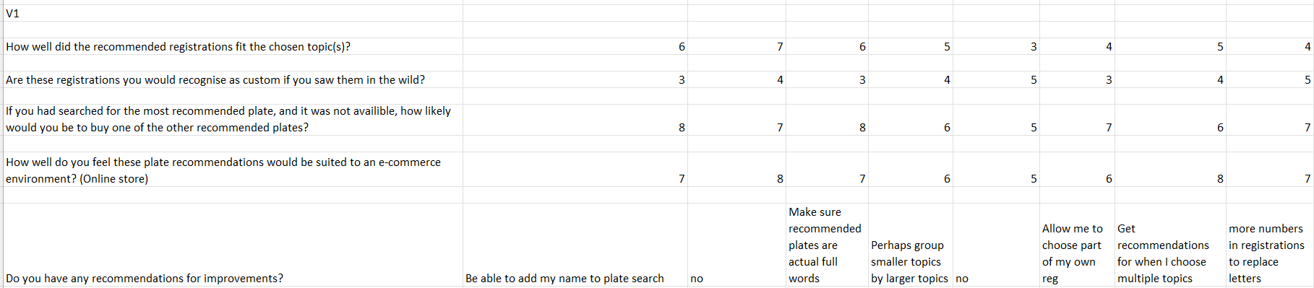
Figure 8: The first half of the first survey responses
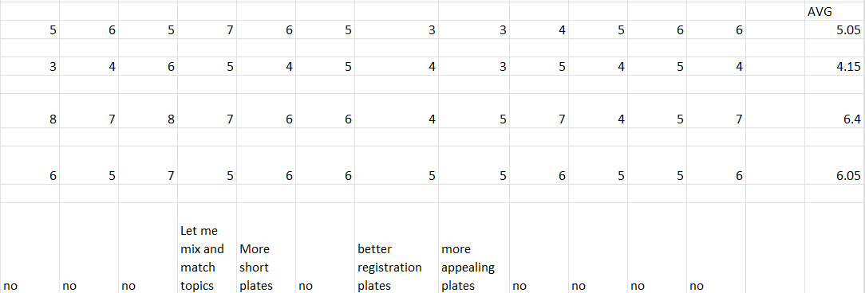
Figure 9: The second half of the first survey responses

Survey 2
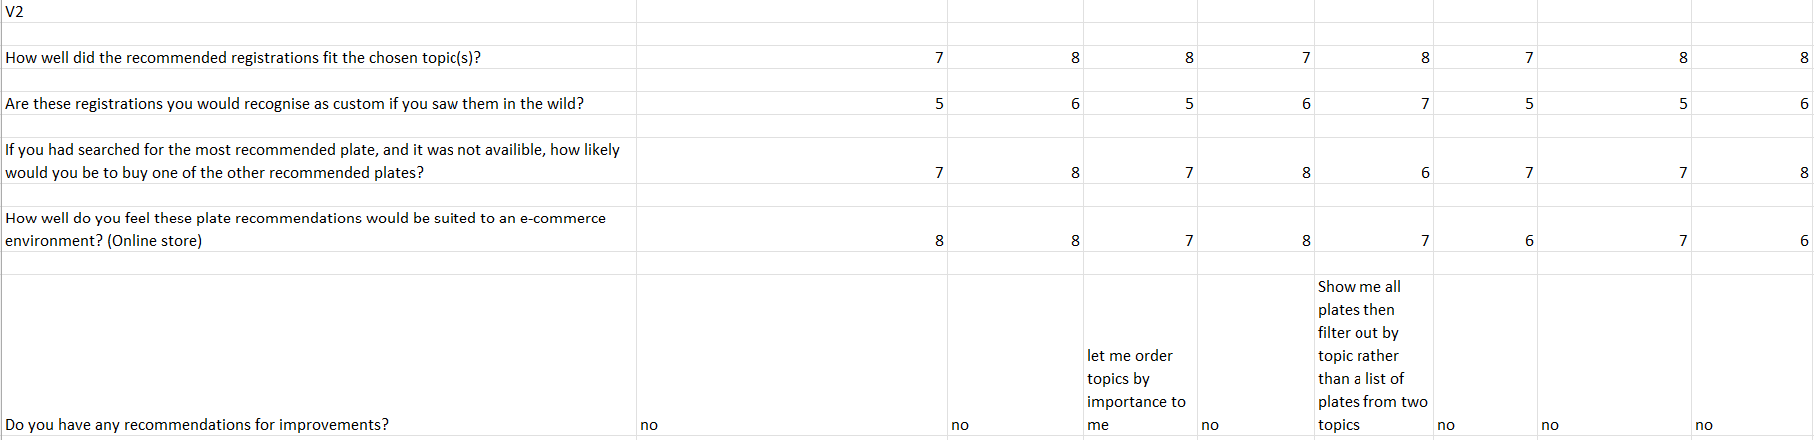
Figure 10: The first half of the second survey responses
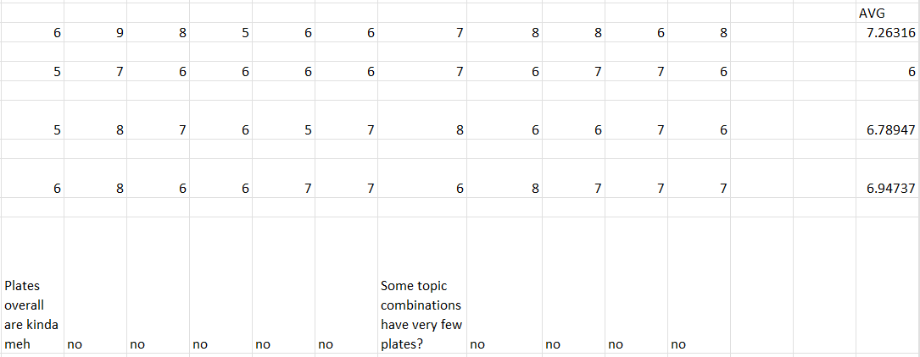
Figure 11: The second half of the second survey responses

GitHub Repository
The repository for the code developed can be found publicly at https://github.com/glugg12/registrationRecommender.

