

Accounting Fundamentals
LCBB4001
Component 1: Coursework: Essay
Student ID: 2247387
Daniela Mihaela Visan

Introduction
The aim of the essay will be for researchers to find the truth of the statements. The essay will be divided into a parts-wise format. The essay will contain the details of the researchers of the statements to provide the importance of the statements. The essay will be made for the researchers of the Wales plc financial report researchers. The easy will holds the formation of the income statement of Wales plc. The essay will also evaluate the ratio of Sweets plc. The ratio analysis and the compatibility ion the ratio of the company will be reflected in the essay.

Question 1:
Statement 1: According to the researchers, the report that defines the accounting position of the business is the balance sheet report. The statement which has been made in the question related to the cash-based reflection is made by the cash flow report which holds all the cash-related information of the business (Karaila, 2021). The balance sheet is also part of the financial report of the business but it holds all the translation details related to the total liabilities, assets, or the debt or equity of the business. The report is said to be the three core strategies that have been evaluated by the business for knowing their wealth in the business and positions. The report holds various accounts but all accounts of the evolution of the shareholders' equity, assets, or liabilities-related data of the business (Zoho, 2021). From the researchers, it has been found that the report which provides detailed information related to the cash data is the cash flow accounts. According to the decision, the statement is not true.
Statement 2: According to the statements which were made in the question noncurrent assets are non-moveable assets for the business. From the viewpoint of the literature or books, the assets for business have been purchased for a long or short time in the business. The non-asset values are not fully realized in the business accounting years (Sey and Darling, 2020). Some of the assets of the business are easily moveable and some of them are not. For example, the vehicles, and equipment which are business incurred in the business for their working purposes are easily mobile by the business because they are for a short time. More non-current assets like land, investment, and office building this asset are not easily moved by the business because they have been for a long time (Peterdy, 2023). From the research of the points, the statement that has been formed can be true for the long-term non-current assets but not true for the short-term non-current assets.
Statement 3: In this part of the statement, it has been provided that the managers only should provide the financial information to the shareholders who currently join the business. However, from the viewpoint of the researchers it has been found that there are various shareholders of the business internal and external (Mio et al., 2020). On that point, each of the holders has the right to look after the financial information of the business. The managers of the business should provide detailed information to each of the holders like the employees, creditors, investors, employees, and more. For example, the creditors which are the external users of the business need to see the health and the debt payment of the business and their frequency. The internal users like the employees research the information to know the benefits that are provided by the business to them (Tamplin, 2023). From the researchers, this statement is not true.
Statement 4: The recording of the accrual and prepayment in the financial position is part of the business accounting. The researchers according to the accrual concept describe the recording process of the expenses and income that have been formed by the business (Stefanescu, 2020). In this, the recordings are made by the business before getting the payments for the products or services. The business records the expenses that have been accounted for in the year and the payment for the future process. This statement has been formed by the business to gain the right financial picture of the business. This also helps the business in making the right decision in the business by the help of the report which has been formed by the business (Corporate Finance Institute, 2023). From the viewpoint of the statements the statements which were formed about the discussion related to the involvement of the value of prepayment or accrual are not true.
Statement 5: The statements that have been made related to the regulation in accounting are the essential regulations that are followed by each business. The main aim of the financial information part of the business is to reflect their wealth, position, and basic needs, and the work that they provide to society has been researched on that basis (IMF, 2024). The main aim of the regulation is to protect the business investors, it also benefits the business by promoting the integrity of the business in the market. It also benefits the business by strengthening its image in the public. For example, in the UK the accounting regulations which are formed by the FRS are followed by the business for forming the accounting information (Bourne, 2024). From the researchers, it has been found that the business should follow the regulations for providing the information related to their accounting so the statement that has been found is not true.
Statement 6: From the researchers, it has been found that the business prepares its accounting information by seeing both the accounts which are the ledger account and the trial balance. From the researchers, it has been found that business information gets misled some time for making it correct the account of the business researchers the ledger and trial balances of the business from there they get the accurate information and then make it correct (Article Library, 2019). The ledger accounts hold the brief classification of the transactions that have been made by the business. From the ledger, the trial balances of the business have been formed. According to the researchers, the trial balances hold all the expenses and revenue of the business from which the accounting information of the business is formed (Gridlex, 2024). From the discussion, it has been found that the statement which has been formed is true.

Question 2:
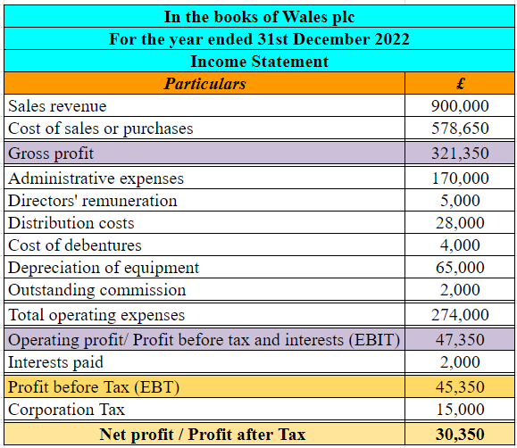
This statement presents the evaluations of the net income of Wales plc. This work is done by using the income statement of the accounting. This statement compares the difference between the total revenue generated by a company and the total business expenditures of a business in a specific period (CFA Institute, 2023). The basis calculation for this statement is revenue less total expenditures. The statement is essential for the inventors of a business. This statement provides many different aspects about a company that helps investors to analyze their investment options. The process for calculating the above income statement is given as follows.
The evaluation of gross income is the first stage of this statement. Under this stage, the total income made by a business after paying all of its direct overheads is calculated (Berry-Johnson, 2024). The value can be calculated by differentiating between the values of net sales and the values of direct expenditures. The direct expenditures are also known as COGS. In the case of Wales plc, the total difference between the COGS and sales amount is (£900,000 - £578,650) = £321,350.
Determination of the cost of operation expenditures is also an essential step in the estimations of the P&L Statement. These costs are all about the indirect overheads that a business makes during its operations. The difference between the values of operating expenditures and the value of gross total profit is known as operating profit (Berry-Johnson, 2024). This profile stands for the total profit made by a company after paying all of its direct and indirect overheads. In the case of Wales plc, the value of operating profit is determined by (£321,350 - £274,000) = £47,350.
The estimation of net loss or income is the last stage of this statement of accounting. This stage aimed to decrease the amounts of interest and taxes from the values of the operating income of an organization (Berry-Johnson, 2024). In case of a positive amount, a company has generated a profit in a specific period. However, a negative balance indicates a company has earned a loss in the specified period. In the case of Wales plc, the total net income for the year ending 2022 is {£47,350 - (£2,000 + £15,000)} = £30,350.

Question 3:

a) Calculations of different ratios for Sweet plc:
1. ROCE:
The ROCE made its basic focus on the earnings of the employees. Following the earnings capability of the stakeholders the calculations need to be made simple divisions between the EBIT and Capital employed values and then it needs to be multiplied by 100 (Shrotriya, 2019). We are following the formula the ROCE ratio of Sweet Plc is 10% and 12%.
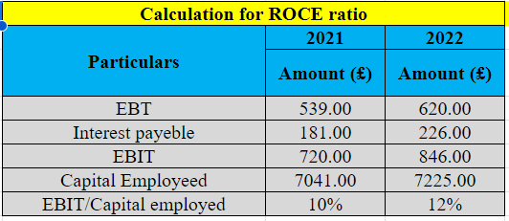
2. ROE:
The ROE calculations help find the earnings of the equity holders of the business as a part of their net profit. In addition, it helps to reflect the portions of the equity included in the profit-making capabilities of the business. Following that, the net profit needs to be divided by the total equity of the company (Kumoro et al. 2020). Following this formula, the ROE ratio of Sweet Plc is between 13% and 14%.
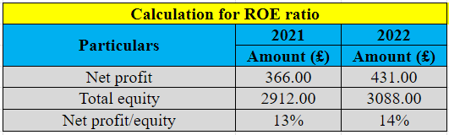
3: Earning per share:
The calculation of earnings per share helps reveal the earning capabilities of shareholders depending on their per-unit share or equity purchased. For that, the calculations of this concept need to divide the net profit of the business by outstanding shares (Sunaryo, 2020). Following this formula, the earning per share value of Sweet Plc is between 122% and 144%.
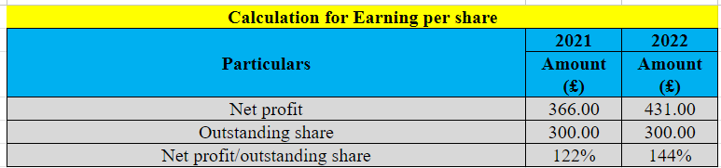
4: Net profit margin:
Net profit margin helps to reflect the ability of the business to earn appropriate profits from its revenues. In addition, the calculations help to reflect the earnings of the business from their review activities, which is called the net profit margin. To find this value, the net profit of the business needs to be divided by total revenue (Öztürk and Karabulut, 2018). Following the formula, the net profit margin of Sweet Plc is between 5.7% and 6.4%.
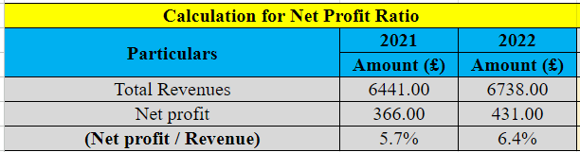
5. Assets Turnover Ratio:
The asset turnover ratio is an effective calculator that helps reveal the portion of assets directly involved in the sealing activities of the business. To find the values of this ratio, net sales need to be divided by average total assets (Kumoro et al. 2020). Following this formula, the asset turnover ratio of Sweet Plc is 0.64:1 and 0.68:1.
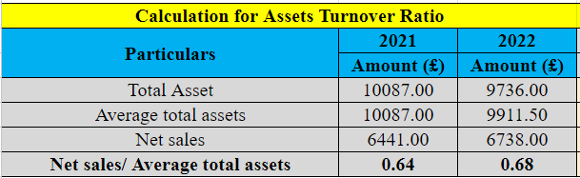
6. Stock holding day:
The valuation of stock holding day reveals the periods or time range the business needs to hold their inventories and make their inventories available for sealing activities. To find this portion, the closing values of inventories in the business need to be divided by COGS values (Indeed, 2024). Following this formula, the stock holding days for Sweet Plc are 78 days and 80 days, respectively.
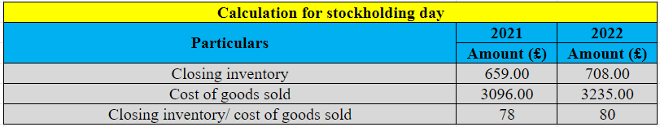
7. Debtors collection period:
The debtor's collection period helps reveal the money collection period of the business. It helps to reveal the period when the business can recollect their necessary debts, which they served through their trading process. To reveal this period, the total debts of the business need to be divided by the total assets (Kumoro et al. 2020). Following this formula, the debtor's collection period of Sweet Plc is 73 days and 68 days.
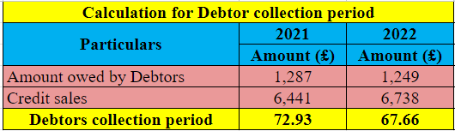
8. Current ratio:
The current ratio helps reveal the ability of the business to settle its liabilities by using its current assets. Following that, the value of current assets needs to be divided by the value of current liabilities (Öztürk and Karabulut, 2018). Following this formula, the current ratio of Sweet Plc is 0.77:1 and 0.92:1.
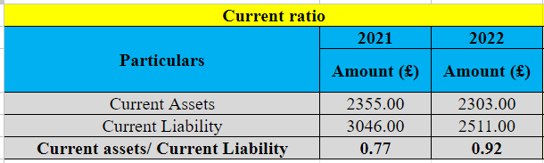
9. Gearing ratio:
The gearing ratio is another effect of calculations that help reveal the comparison between the debts and equity of the business. Following that, it helps to reveal which portions of the business's debts are included with their equities. To calculate the total loans and borrowings of the business, they need to be divided by the combined values of shareholder equity and non-current debts (IG, 2024). Following this formula, the gearing ratio for Sweet Plc is between 57% and 59%.
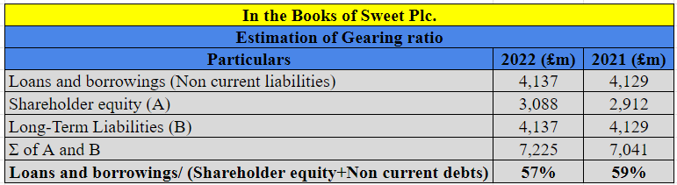
10. Interest cover:
The interest cover ratio of the business helps to reveal the ability of the company to cover expenses in its interests. For that, the EBIT of the business needs to be divided by interest expenses (Corporate Finance Institute, 2023). Following that, the interstate cover ratio of Sweet Plc is between 3.98 and 3.74.
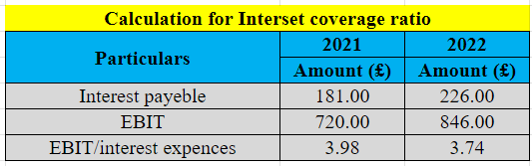

b) Financial performance and position of Sweet plc:
Ratio analysis helps to analyze the liquidity, debts, assets, and turnovers of the business. The structure and position of the company, as well as the upcoming opportunities and threats, can be defined very clearly (Tamplin, 2023). The ratio of ROCE in 2021 is 10%, which turns to 12% in 2022. It reflects the earning portions of the stakeholders in the business. Similarly, the ROE ratio in 2021 is 13%, which turns to 14% in 2021. Thai ROCE and ROE can help Sweet Plc attract the attention of investors as they reflect the rainy earnings of the stakeholders as well as shareholders. In addition, the earnings per share were 122% in 2021, which increased to 144% in 2022. For that, portions of shareholders are raised by the rising profit of the business, which can be helpful to keep engaged shareholders. The net profit margin in 2021 was 5.7%, which turns to 6.4% in 2022. For that, the business can create a proper profit-earning position, which can help them survive in the competitive market. The asset turnover ratio of the business is 0.64:1 in 2021, which turns to 0.68:1 in 2022. At this changing rate, the involvement of assets in the business is increasing.
In addition, the stock holding days of the business in 2021 are 37, which turns to 38 days in 2022. It can raise the closing inventories and affect the sales positions of the business. The debtor collection period of Sweet plc is 149 days in 2021 and 155 days in 2022, which reflects that the debt collection abilities of the business are reducing. The recurrent ratio of the business reveals that Sweet Plc has slowly increased its ability to settle its current liabilities by using the maximum of its current assets. Following the gearing ratio, the risks of involvement of debts in equity are reducing, as the ratio in 2021 was 1.42, which turns to 1.34 in 2022. Lastly, the rate of interest expenses is reduced, which helps Sweet Plc raise its profit-earning abilities as much as possible.

Conclusion:
This essay concludes by evaluating the financial reports of Wails and Sweet plc by using various kinds of accounting reports. This report includes P&L statements, ratios, and much more. The analysis of the financial concepts was also displayed in this assignment. The analysis of that statement was done by evaluating different kinds of accounting concepts, and other such things.

References:
Berry-Johnson, J. (2024) What is an income statement and how to make one, Legalzoom. Available at: https://www.legalzoom.com/articles/what-is-an-income-statement-and-how-to-make-one (Accessed: 04 March 2024).
Bourne, M. (2024) UK Accounting Regulation - Bournemouth University. Available at: https://eprints.bournemouth.ac.uk/3074/1/296.pdf (Accessed: 04 March 2024).
CFA Institute. (2023) Understanding income statements, CFA Institute. Available at: https://www.cfainstitute.org/en/membership/professional-development/refresher-readings/understanding-income-statements (Accessed: 04 March 2024).
Corporate Finance Institute (2023) Interest coverage ratio, Corporate Finance Institute. Available at: https://corporatefinanceinstitute.com/resources/commercial-lending/interest-coverage-ratio/ (Accessed: 04 March 2024).
Corporate Finance Institute, T. (2023) Accrual principle, Corporate Finance Institute. Available at: https://corporatefinanceinstitute.com/resources/accounting/accrual-principle/ (Accessed: 04 March 2024).
Gridlex, (2024) The role of trial balance reports in ensuring financial accuracy. Available at: https://gridlex.com/a/the-role-of-trial-balance-reports-in-ensuring-financial-accuracy-st8152/ (Accessed: 04 March 2024).
IG (2024) Gearing ratio definition, IG. Available at: https://www.ig.com/en/glossary-trading-terms/gearing-ratio-definition (Accessed: 04 March 2024).
IMF, (2024) The role of financial regulation in a world of deregulation and market forces - Lawrence J. White - prepared for delivery at the IMF Conference on Second Generation Reforms, International Monetary Fund. Available at: https://www.imf.org/external/pubs/ft/seminar/1999/reforms/white.htm (Accessed: 04 March 2024).
Indeed (2024) How to calculate days in inventory (with 3 examples) | indeed.com. Available at: https://www.indeed.com/career-advice/career-development/how-to-calculate-days-in-inventory (Accessed: 04 March 2024).
Karaila, J., (2021). Money Flows Between Securities: Network Analysis in a Stock Market (Master's thesis). https://trepo.tuni.fi/handle/10024/135580
Kumoro, D.F.C., Novitasari, D., Yuwono, T. and Asbari, M., (2020). Analysis of the Effect of Quick Ratio (QR), Total Assets Turnover (TATO), and Debt To Equity Ratio (DER) on Return On Equity (ROE) at PT. XYZ. Journal of Industrial Engineering & Management Research, 1(3), pp.166-183. Available at: https://www.jiemar.org/index.php/jiemar/article/view/77/55
Mio, C., Fasan, M., Marcon, C. and Panfilo, S., (2020). The predictive ability of legitimacy and agency theory after the implementation of the EU directive on non‐financial information. Corporate Social Responsibility and Environmental Management, 27(6), pp.2465-2476. https://onlinelibrary.wiley.com/doi/abs/10.1002/csr.1968
Öztürk, H. and Karabulut, T.A., (2018). The relationship between earnings-to-price, current ratio, profit margin and return: an empirical analysis on Istanbul stock exchange. Accounting and Finance Research, 7(1), pp.109-115. Available at: https://www.researchgate.net/profile/Hakki-Oeztuerk/publication/321169857_The_Relationship_Between_Earnings-to-Price_Current_Ratio_Profit_Margin_and_Return_An_Empirical_Analysis_on_Istanbul_Stock_Exchange/links/5a2e74a70f7e9b63e53d779c/The-Relationship-Between-Earnings-to-Price-Current-Ratio-Profit-Margin-and-Return-An-Empirical-Analysis-on-Istanbul-Stock-Exchange.pdf
Peterdy, K. (2023) Non-current assets, Corporate Finance Institute. Available at: https://corporatefinanceinstitute.com/resources/accounting/non-current-assets/ (Accessed: 04 March 2024).
Sey, A. and Darling, C., (2020). Acquisition and management of non-current assets: A case study of Ghana shippers’ authority. https://ir.ucc.edu.gh/xmlui/handle/123456789/7100
Shrotriya, V., (2019). Analysis of return on total assets (ROTA) and return on capital employed (ROCE) of IFFCO limited. International Journal of Research and Analytical Reviews, 6(2), pp.746-754. Available at: https://www.researchgate.net/profile/Vikas-Shrotriya/publication/337464978_Analysis_of_Return_on_Total_Assets_ROTA_and_Return_on_Capital_Employed_ROCE_of_IFFCO_Limited/links/5dd8ec51299bf10c5a2a9e43/Analysis-of-Return-on-Total-Assets-ROTA-and-Return-on-Capital-Employed-ROCE-of-IFFCO-Limited.pdf
Stefanescu, C.A., (2020). Public management reform under the dome of accruals: Reforma de la gestión pública bajo la dominación del devengo. Revista de Contabilidad-Spanish Accounting Review, 23(1), pp.91-101. https://revistas.um.es/rcsar/article/view/369821
Sunaryo, D., (2020). The Effect of Earning Per Share (EPS) and Dividend Per Share (DPS) on Share Prices. Journal of Research in Business, Economics, and Education, 2(5), pp.1027-1038. Available at: https://e-journal.stiekusumanegara.ac.id/index.php/jrbee/article/view/160
Tamplin, T. (2023) Ratio analysis: Importance, significance, merits, and limitations, Finance Strategists. Available at: https://www.financestrategists.com/accounting/accounting-ratios/accounting-ratios/ (Accessed: 04 March 2024).
Tamplin, T. (2023) Users of Accounting Information: External & Internal Users, Finance Strategists. Available at: https://www.financestrategists.com/accounting/introduction-to-accounting/users-accounting-information/ (Accessed: 04 March 2024).
Your Article Library, (2019) Top 8 advantages of Ledger: Financial Accounting, Your Article Library. Available at: https://www.yourarticlelibrary.com/accounting/ledger/top-8-advantages-of-ledger-financial-accounting/72395 (Accessed: 04 March 2024).
Zoho, (2021) Balance sheet: Definition, example, elements of a balance sheet - Zoho books, Essential Business Guides. Available at: https://www.zoho.com/books/guides/balance-sheet.html (Accessed: 04 March 2024).

