DS 1 Template

My Screenshots/Photos
- Please add 4–6 screenshots or photos of your digital life.
- You can use your phone or laptop.
- For each screenshot, write one or two sentences explaining what it shows.

Screenshot/Photo 1
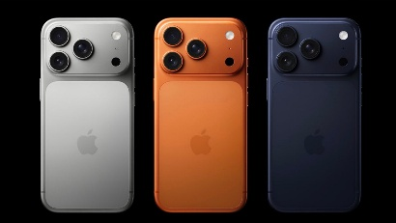
I use my phone every day to communicate with family and friends. It helps me stay connected with people.

Screenshot/Photo 2

I use Microsoft Word to complete my university assignments. I am learning how to create and edit documents.

Screenshot/Photo 3

I use Google to search for information and learn new things. It helps me with my studies.

Screenshot/Photo 4

I use WhatsApp to send messages and make calls. It helps me communicate with my family and friends.

Screenshot/Photo 5

I use online shopping websites to look for products and compare prices. It helps me save time and find things I need.

Screenshot/Photo 6

I use YouTube to watch tutorials and improve my computer skills. It helps me understand how to use different digital tools.

My Short Reflection
- Write 5–8 simple sentences about your digital life.
- You can use the sentence starters below if helpful.
- Technology is an important part of my daily life.
- I use my phone and laptop for different activities, such as studying, shopping and keeping in touch with people.
- I enjoy using Google and WhatsApp because they are easy and useful.
- I am becoming more confident when using digital tools.
- However, I sometimes need help when working with Microsoft Word.
- I would like to learn more about computers and improve my skills.
- I believe these skills will help me with my university work and future job opportunities.

Sentence starters
- I use digital tools to …
- I feel confident when I …
- I want to improve …
- I often use these tools: …
- I sometimes feel nervous about …
- I hope this module will help me …
- Digital skills are important for me because …
You can write more if you want.

Submission Checklist
Before you submit, please check:
​​​ ☒ I added 4–6 screenshots
☒ I wrote short sentences for each screenshot
☒ I wrote my short reflection
☒ My work is my own
☒ My file opens correctly
​​☒ My file opens correctly

