

Module: Marketing Fundamentals
LCBB4004

Component1: Coursework: Individual Blog

Student Name: Oleksandra Chebotareva
Student ID: 2247384
Tutor’s Name: Dr Tushara Balendran

BACKGROUND OF THE BMW
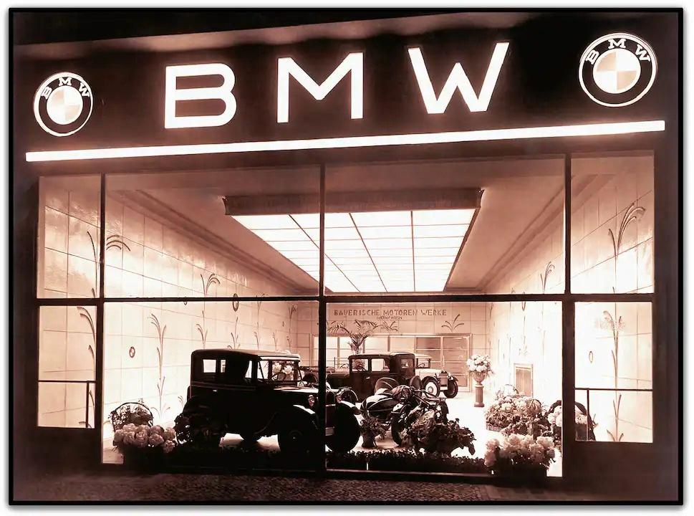
Cars, in our day’s cars are understood as machinery that help us to improve our life and our comfort, this can be divided in machinery who are for house use and for outside use, a use that can be determined by each person necessity.
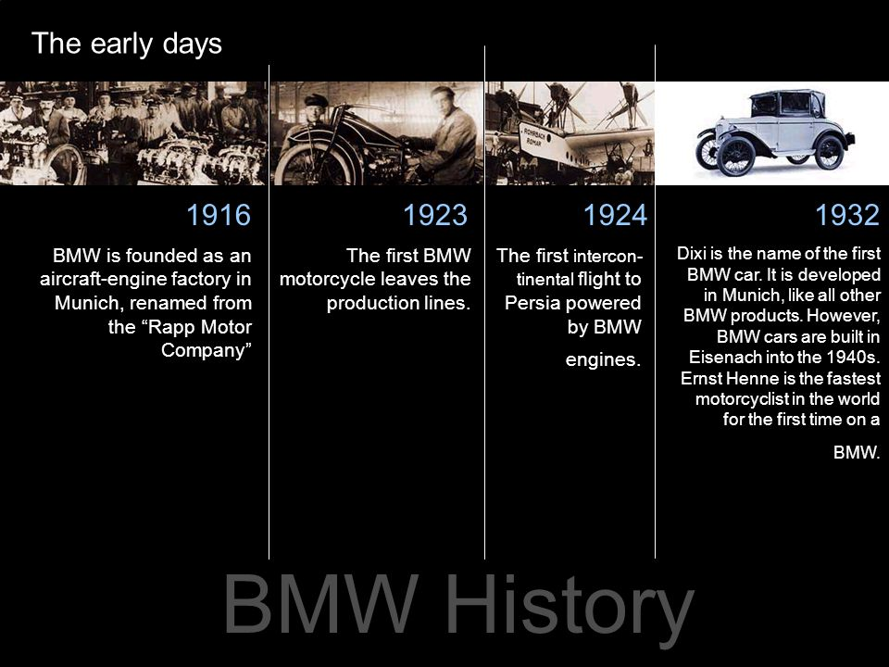
Jorge Lucendo in his book “Cars of Legend: First Cars of History” presents us the first car in the world who has been built in China in 1678, a simple machinery on steam and on 3 wheels, made by French engineer Jesuit Fedinand Verbiest. Since this first invention 100 years after in Europe in France and in England different engineers like Nicholas Joseph Cugnot, William Murdock, William Symington (who built first car at human size) tried to build different size and shape until 1801, when Trevithick was invented first fully functional car and had a demonstration where was transporting 6 persons. (Lucendo, 2019).
In the “The Art of BMW: 90 Years of Motorcycling Excellence” Peter Gantriis presents rocky start of a company who now over a century distance still survive and more it is one of the most successful and branded company in the world. (Gantriis, 2018).
BMW this acronym comes from Bayerische Motoren-Werke established in 1922. It was a first and very welcomed segmentation process of the company in order to assure stability, enough budget and fulfil market necessity on that time in German society. Based on acerb competition market always in change with big companies who was able to develop each day more the first success comes in 1933 with the first 6-cylinder car and more space for passengers. (Lewin T., Purves T., 2016)
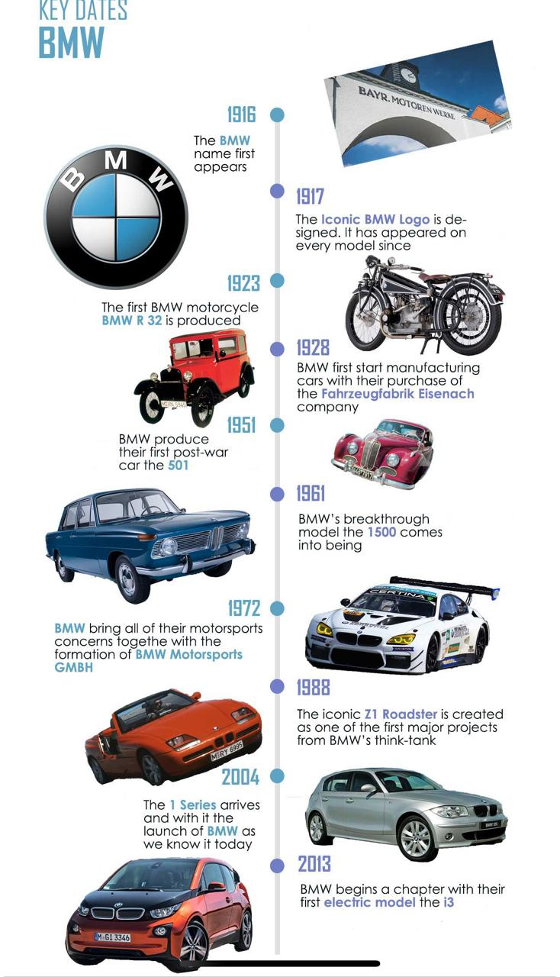

MISSION AND VISION
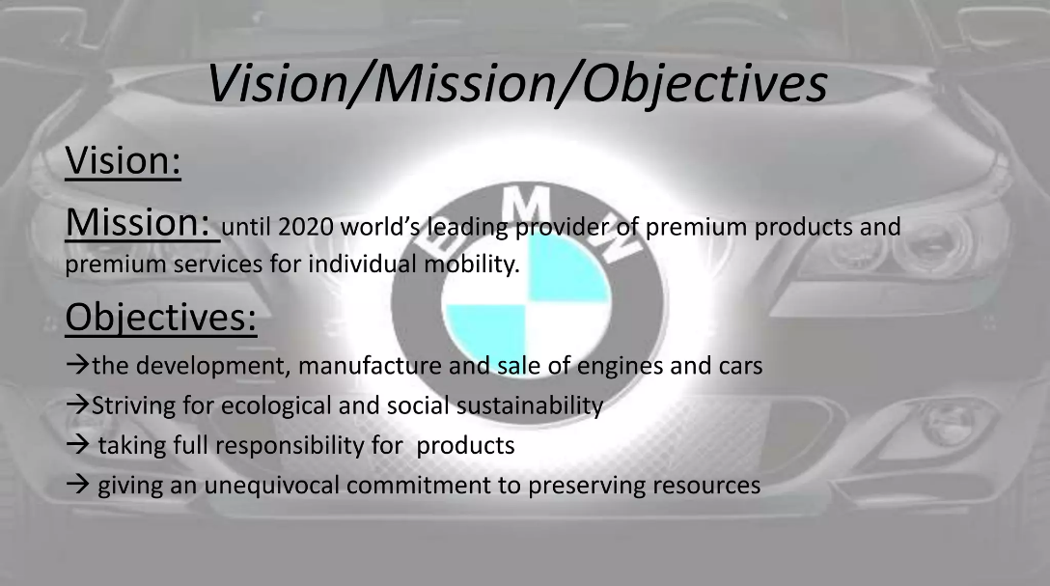
Main target was to create an engine and to be used into an industry (one of the most important customers was Lufthansa), then a solid product to assure finance and keep the company in production (R32), and to be finalized with a premium product and targeting more customers worldwide.
Into a continue growing market start, maintain and advance are crucial, but you always depend on marketing mix strategies of the company.

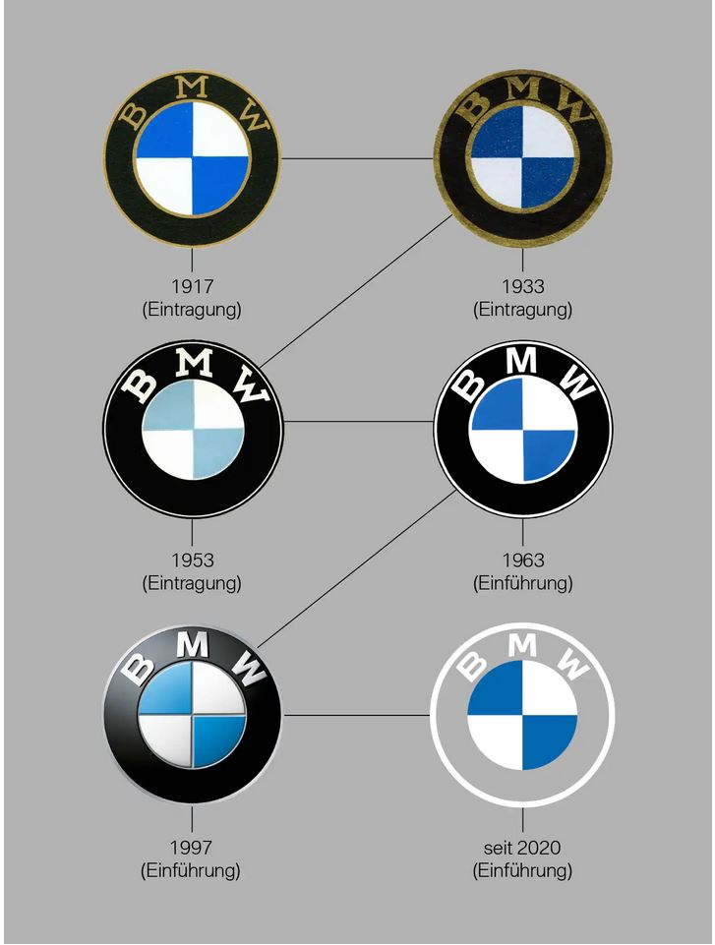
Every big brand needs a logo and the logo of blue and white has been chosen when company officially entered into motor sport section in 1973 and three surrounding bands in purple, bright red and mid blue but the idea has been derived from the first early time when BMW was made airplane engine when they make a similar design with a circle in black felt up with blue and white colours.

In order to realise the mission some steps need to bear in mind and engineers from BMW soon was start with the first one ask yourself the right question like what your purpose is to be in this industry what is that you want to offer to your employees, yourself and your customer have a view about what make your organisation different. As you chase same market as your competitors, and you should always have this in mind need to feel what make customer to choose your product building your brand strong is another important step where BMW was necessary to create a strong and reliable message for customers being honest.
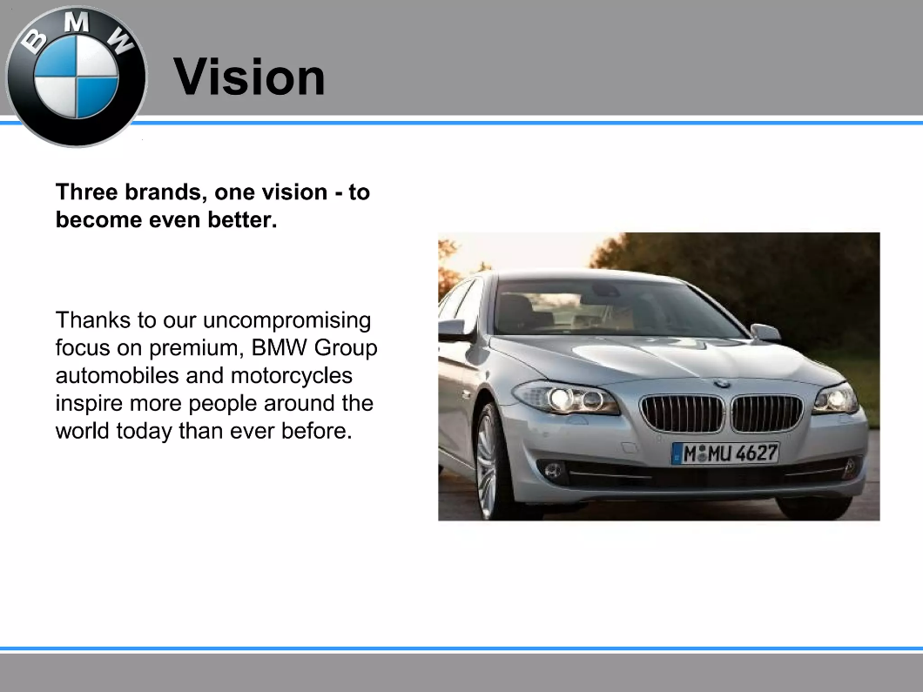
It’s a very important step for the producer were they need to truly believe in what they do and never to have too much self congrats and live with idea that you are the best on the market make it a join effort, every business need help from outside company and its always better to associate with collaborators who can make you aware of your weakness and strengths.
Spread the word publicity was helping BMW in its mission to escalate step by step each day. BMW was clearly organised with these steps and was successful in its mission so far nevertheless more improvements need to be done in order to reach more from the global market. (Chapman G., 2015)
Hard times for BMW was all decades of 50th until Herbert Quandt save this company with the first successful product of this company worldwide in1962 called BMW1500 sedan a high-quality car with accent of driver enjoyment.
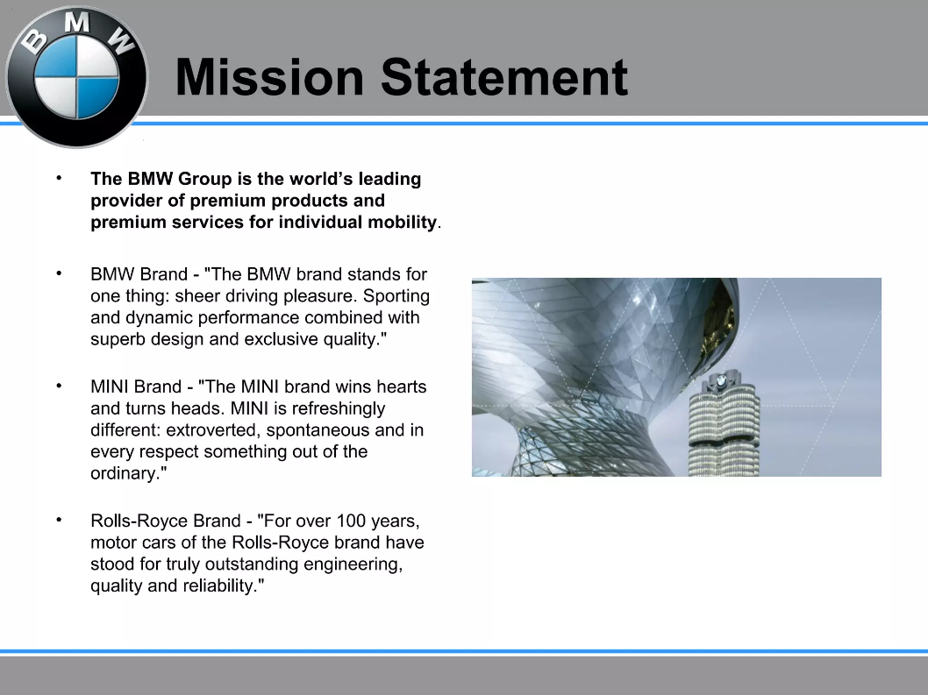
In our days BMW is having a presence in 140 countries as seller and 8 countries from different 5 continents producing different models, a strategic move considering the cost of transportation and labour on some of the continents where they have cheap labour and price for product same as anywhere. (BMW group, Locations, no data).

As a number last year, a new record of the company has been reached with a total of 2.253.835 units sold and an increasing of 7.3 % from previous year. (BMW group, Press club global, 2024).

SEGMENTATION
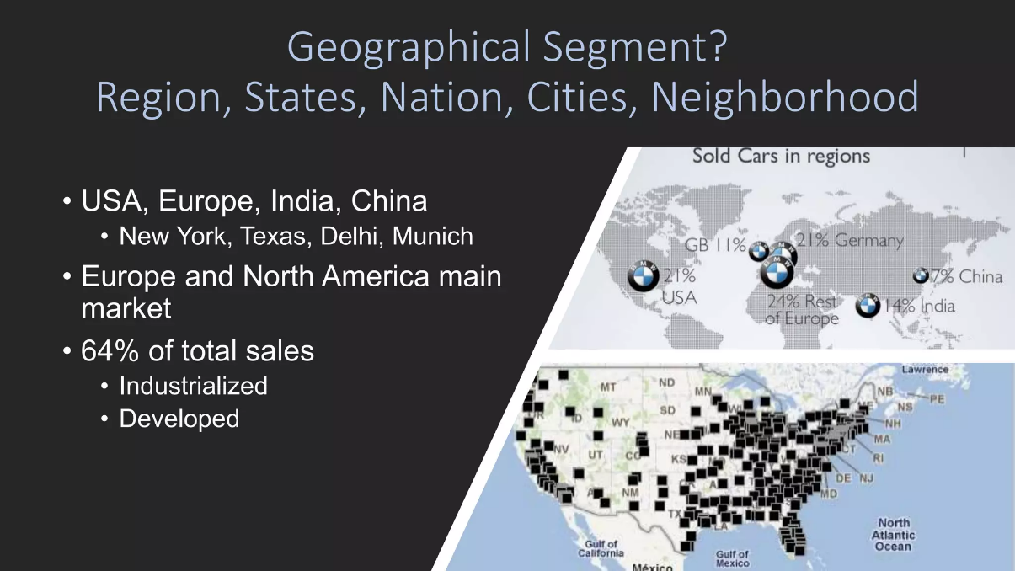
Segmentation which is divided potential customers into different groups based on gender, age, social class, lifestyle which is demographic and geographic as depending on each country preferences are vary for instance in area were fuel are more expensive peoples first choice will be a combination of premium car but with a smaller engine size as to have enough to keep daily expenses lower and make the smaller differentiated target customers.
Advantage for segmentation is split in:
- Targeting marketing so we present how it will be analysed and divided by criteria and based on this will be able to increase their activity to bring more customer on board.
- Product customization will allow company to find out the unique need of each person and enable to create products that will meet those expectations.
- Market penetration based on the segmentation and exploring customer needs can also identify segments from market which has been unexplored and could be potentially customers.
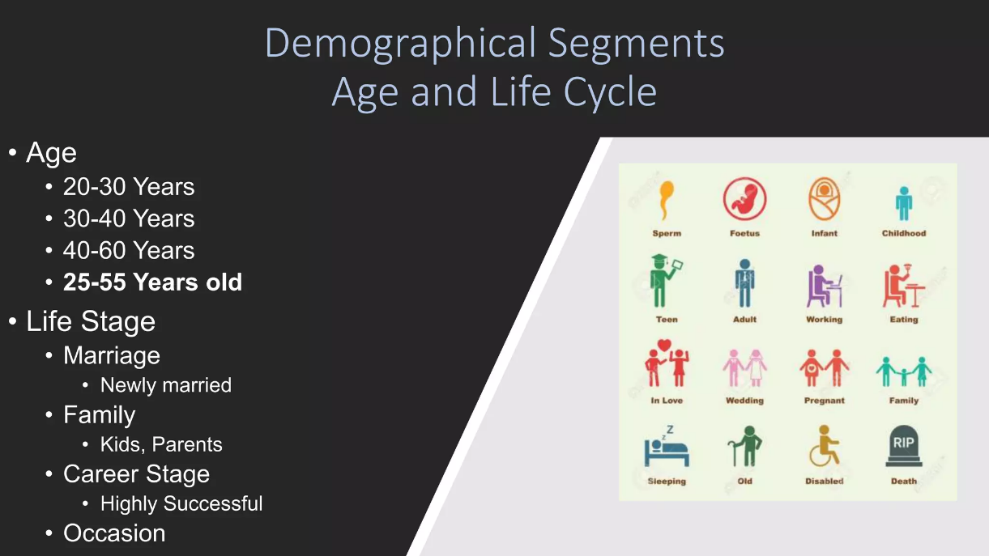
- Brand image, this is an area were the company tries to target a certain number of customers and need to develop much stronger on that customer area.
- Improved customer satisfaction they start to deliver goods and services who definitely make customer happier.
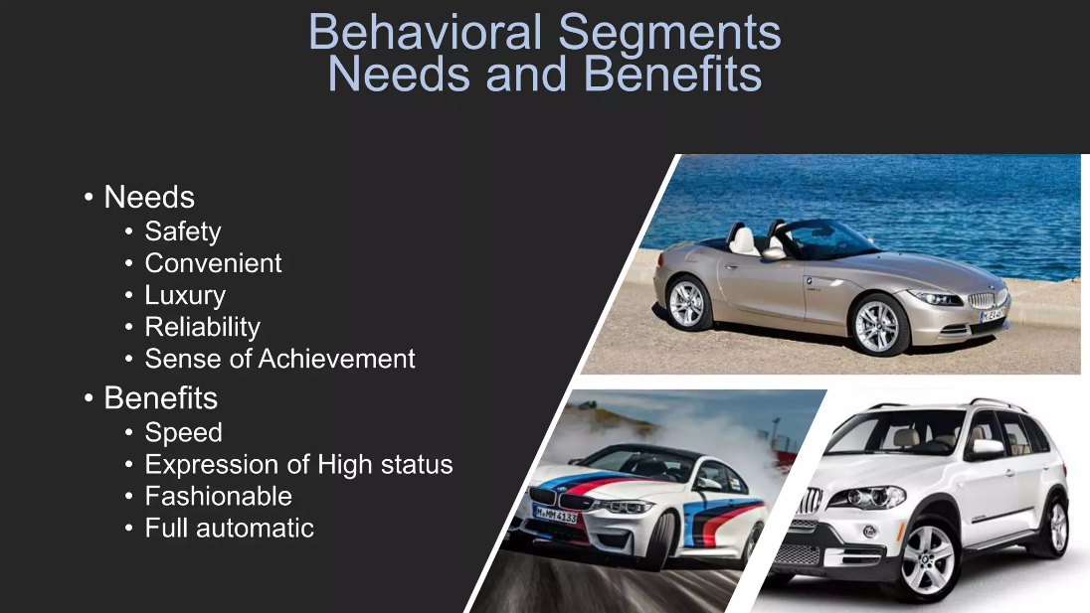
And like any other thing segmentation advantages come with disadvantages as well which in the majority of the industry companies are trying to keep them at minimum.
Disadvantage for segmentation:
1. Complexity, company have too many segments were needed to develop sometimes and requires allocating more founds and research.
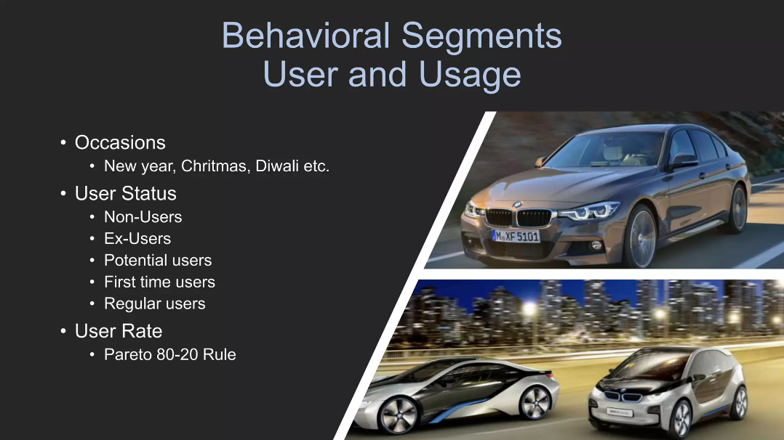
2. Costs are coming in a full pack of:
- Implementing
- tailoring
- promotional efforts
- customizations and each this investment will never guarantee the success of the product.

3. Missed opportunities to much concentration on the segmentation can lead to miss potential opportunities.
4. Cannibalization where a product or more can decrease market for another product and make another product inefficient in sale.
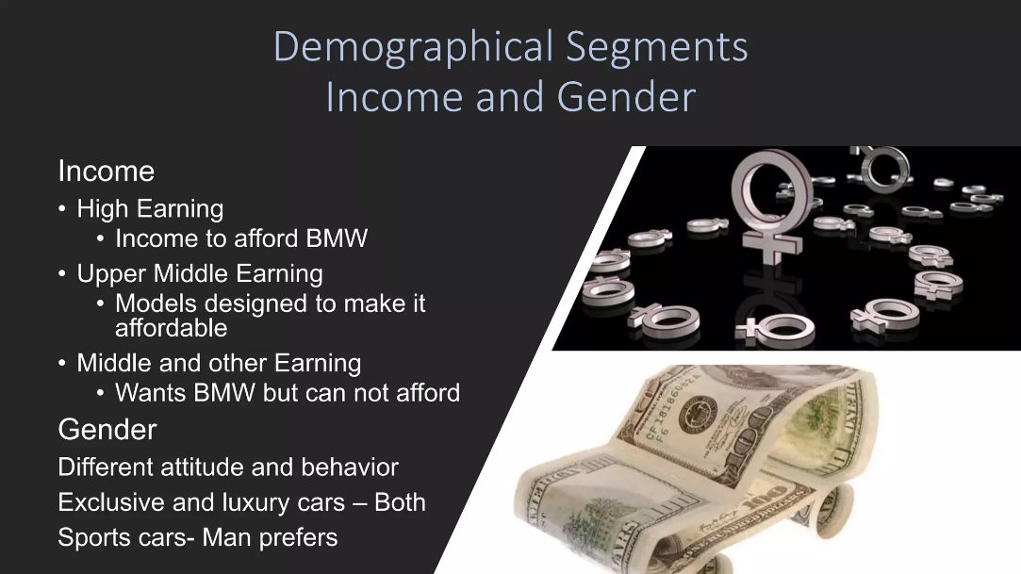
5. Fragmentation of brand sometimes too much attention to some customers can create and sent confused message about the brand and prestige that company owes. (Third eye blind productions, 2023).

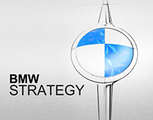
STRATEGY

Strategy for BMW is to maintain an image of luxury and performance in auto industry the main aim age for this brand is between 30-60 years old and male gender predominantly as the sport and race side which involve a high number of breaking horsepower as the slogan of brand is “The Ultimate Machine Driving”.

Company its concentrated targeting on rich people who don’t mind spending to get a premium product, affluent professional people with money and sophisticated tastes of cars. Young urban people which look for an urban dynamic image driving a BMW whit a very high-performance spec. Tech-savvy consumer people who are after intelligent cars who are in love of futures and online connectivity around the car and intelligent gadgets. Environmental customers by hybrid units or fully electrical cars for drive with a very high performance and driving range. Performance enthusiast are classics customers who need to feel the power of the car at the max and they are very often involved in motorsport activities.
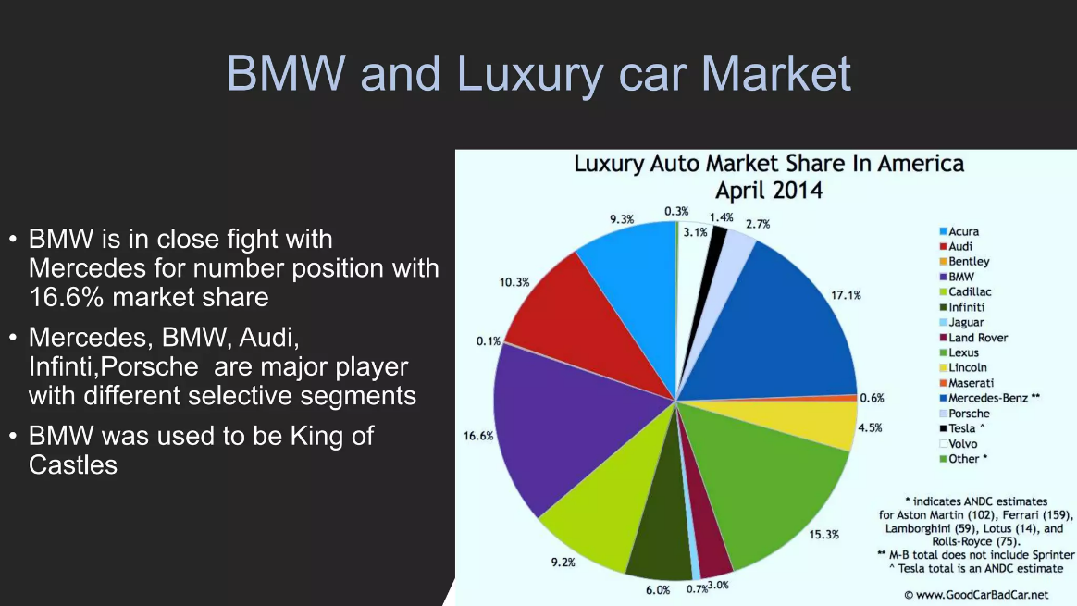
Differentiated targeting where company offers diverse shapes and sizes of this cars for different customers like luxury cars segment like 7 series and SUV like X7, X6, X5 then could be performance segments based on ultra performance speed engine and more breaking horsepower, compact segment who address more for young urban customers, electric segment, and crossover and family cars.

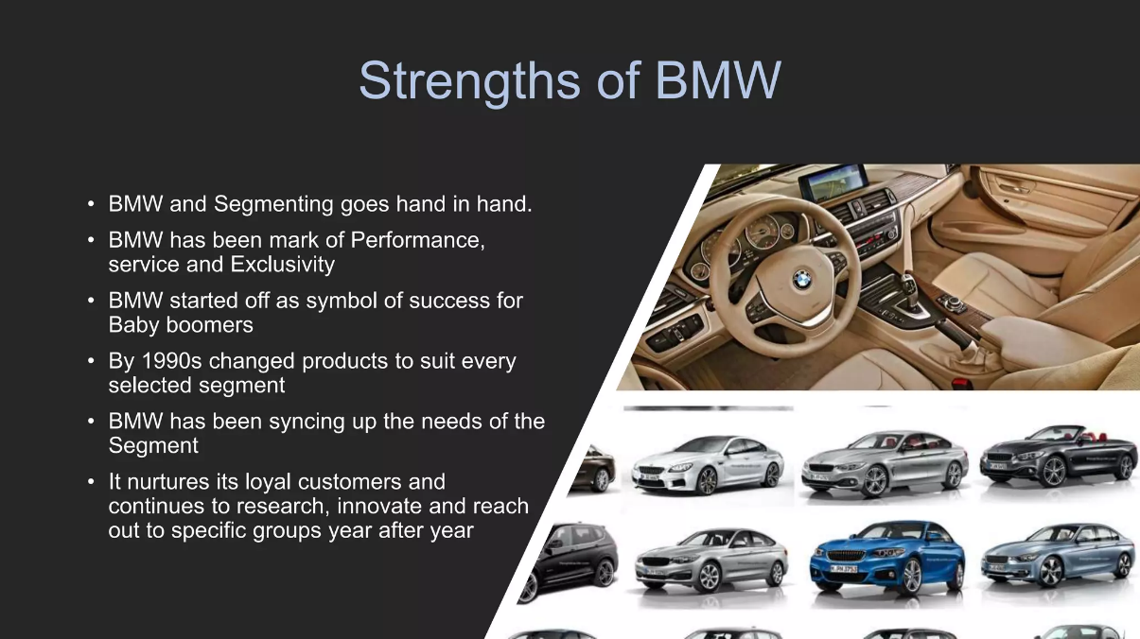
Advantages of this kind of targeting are:
- customization
- variety of options
- improved satisfaction

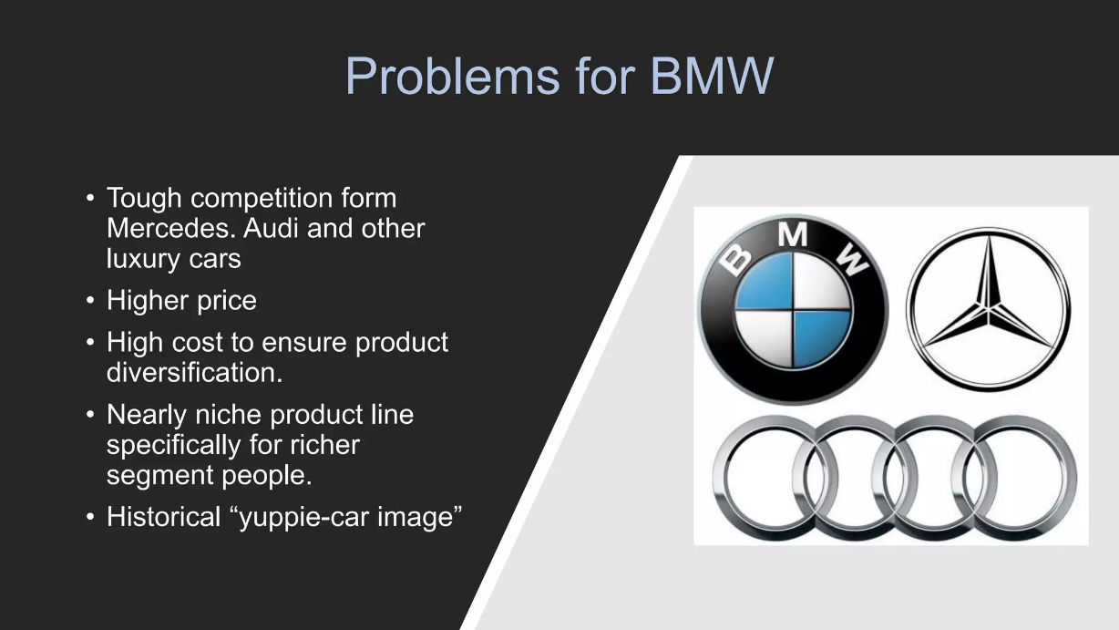

Disadvantages are:
- complexity
- price variation
- inconsistency
- overlap. (The Brand Hopper, 2023)

Undifferentiated targeting known as mass marketing offering a single product for the market mass and advantages are cost efficiency, brand awareness, simplicity, product standardization, market saturation, but this could have a double effect and might not the best approach to sell this product as being a luxury brand need to relay on segmentation.

MARKETING STRATEGY FOR BMW COMPANY IN COURSE
Every strategy its hard in these days when competition and fast development of any industry with help of artificial intelligence who offers new standards and new vision.
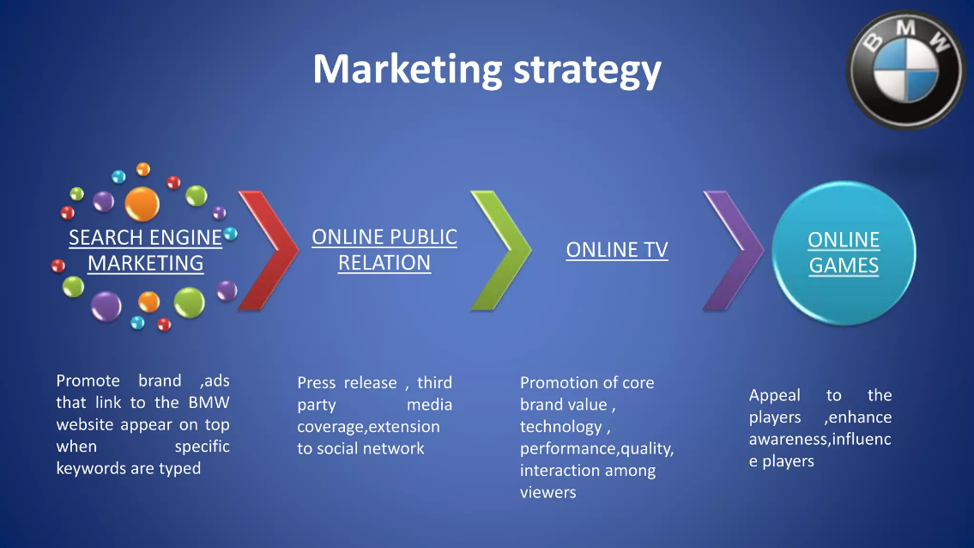
One of the principles of BMW is to keep customers happy as this happiness will translate into loyalty from customers to the brand.
BMW create a mix platform for its customers based on:
- Innovation - presenting the latest technological and advanced products like electrical cars and autonomic driving in one of the commercial of product “BMW I drive” the future company send a clear message about the new product and futurist one where even the voice of the computer it’s made like a future robot and transform your vision in reality at once to drive a machine of the future.
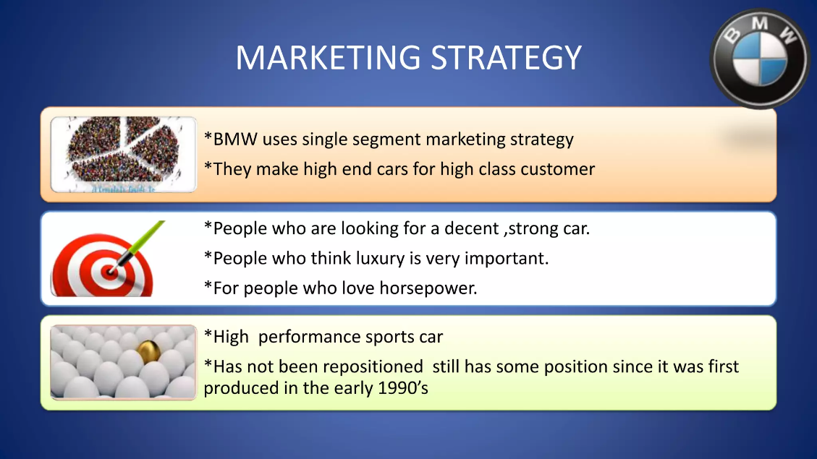
- Product strategy
- Technology advance
- Distribution channel
- Pricing strategy - digital marketing, when company tries to keep in contact with the customers and engage with them on different online channels, different social media, different platforms.
- Direct marketing - sponsorship and partnership who try to connect with different events and different celebrities who can increase new demographic areas also creating public content and trying to associate the company with a certain lifestyle where BMW only improve their experience in 2016 Mini Copper was presented on Superbowl spot commercial where millions watched it in a few seconds just being presented by Serena Wiliams. (Huntington, S. 2020)
Main strategy to develop a worldwide company found BMW involved in McLaren design engine, subsidiaries for Rolls Royce and Mini Cooper.
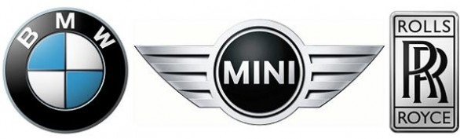
Distribution plays a key role for each company BMW like any other car company use ordinary network like dealers, showrooms, sales and private that I mention previously.
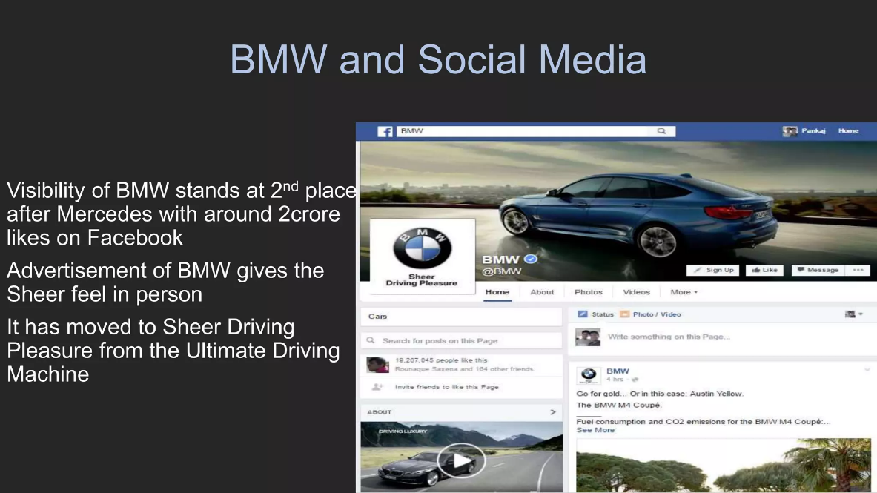
Social media with all new platforms where everyone can join and receive the latest news about company and product on Facebook, Instagram, podcasts where diverse engineers are welcomed to come and analysis. Media influence got into a level unexpected and big companies like BMW see this an important way of promoting specially that costs for this kind of promoting is very low and maximum effect.
Sales strategy contain premium strategy and mix promotion first it’s about luxurious cars created for exclusivist area and promotion mix strategy who offers short time possibility for each customer to experience high quality for lower prices. At this point in order to get much closer to Asia BMW produce at Chenai factory 11 models designed and priced specially to get more stronger inside Asia. Its producing drive terrain for Toyota so at this point BMW make concessions about collaboration with a big Asian brand just in order to penetrate the market more. (Bhasin H., 2023)
BMW this brand it’s still not reach its fully potentially strength on the market still so much to do into daily change market where you need to keep up with others and to surprise each day your customers where you need to develop new successful technology and where quality need to be in first place.

REFERENCES:
- Lucendo J., 2019
Cars of Legend: First Cars of History

Chapter: History of the First Automobile
Available at:
https://books.google.co.uk/books?id=C8mlDwAAQBAJ&printsec=frontcover&hl=ro&source=gbs_ge_summary_r&cad=0#v=onepage&q&f=false
(Accessed 20.03.2024)
- Gantriis P., 2018
The Art of BMW: 90 Years of Motorcycling Excellence
Available at: https://books.google.co.uk/books/about/The_Art_of_BMW.html?hl=ro&id=GvRKDwAAQBAJ&redir_esc=y
(Accessed 20.03.2024)
- Lewin T., Purves T., 2016
The BMW Century: The Ultimate Performance Machines
Available at:
https://books.google.co.uk/books/about/The_BMW_Century.html?hl=ro&id=3I8yDQAAQBAJ&redir_esc=y
(Accessed 20.03.2024)
- Chapman G., 2015
Car Emblems: The Ultimate Guide to Automotive Logos Worldwide, page 46
Available at:
https://books.google.co.uk/books/about/Car_Emblems.html?hl=ro&id=p8FQCgAAQBAJ&redir_esc=y
(Accessed 20.03.2024)
- BMW Group, Locations, no date
Available at: https://www.bmwgroup.com/en/company/locations.html (Accessed: 20.03. 2024).
- BMW group, Press club global, 2024
Available at: https://www.press.bmwgroup.com/global/article/detail/T0438999EN/a-successful-2023:-bmw-group-posts-record-sales-meets-ambitious-e-mobility-growth-targets?language=en(Accessed: 20.03. 2024).
- Third eye blind productions, 2023
MARKETING STRATEGY OF BMW IN 2023 – GAME CHANGER
Available at: https://thirdeyeblindproductions.com/marketing-strategy-of-bmw/
(Accessed: 20.03. 2024).
- The Brand Hopper, Team TBH, 2023
Dissecting BMW’s Marketing Strategies & Success Factors.
Available at:
https://thebrandhopper.com/2023/08/14/dissecting-bmw-marketing-strategies-success-factors/#google_vignette
(Accessed: 20.03. 2024).
- Huntington, S. 2020
The Ultimate BMW Forum, THE 15 BEST BMW COMMERCIAL ADS OF THE DECADE
Available at:
https://www.bimmerforums.com/2020/01/the-15-best-bmw-commercial-ads-of-the-decade/
(Accessed: 20.03. 2024).
- Bhasin H., 2023
BMW Marketing Mix
Available at:
https://www.marketing91.com/marketing-mix-bmw/
(Accessed: 20.03. 2024).

