Team: Eventegious email: redcarpetevents18@gmail.com
Password: redcarpet2018
https://www.weebly.com/editor/main.php#/
1.Mohammad Rahman 1709543 mohammad1709543@gmail.com
Password: gmailpassword12

2. Akhteruzzaman Quraishi 1709589
3. Foysal Ahmed 1709523
4. Zuhel Miah 1709521
5. Shahed Bakshi 1710633

I, Mohammad Rahman submitting the website we have built for our business “Redcarpet Event Management Company as a part of our group activities on 7th December, 2018.

Table of contents:
Particulars | Page number
Screen shots of business website | 2-5
Conclusion | 6

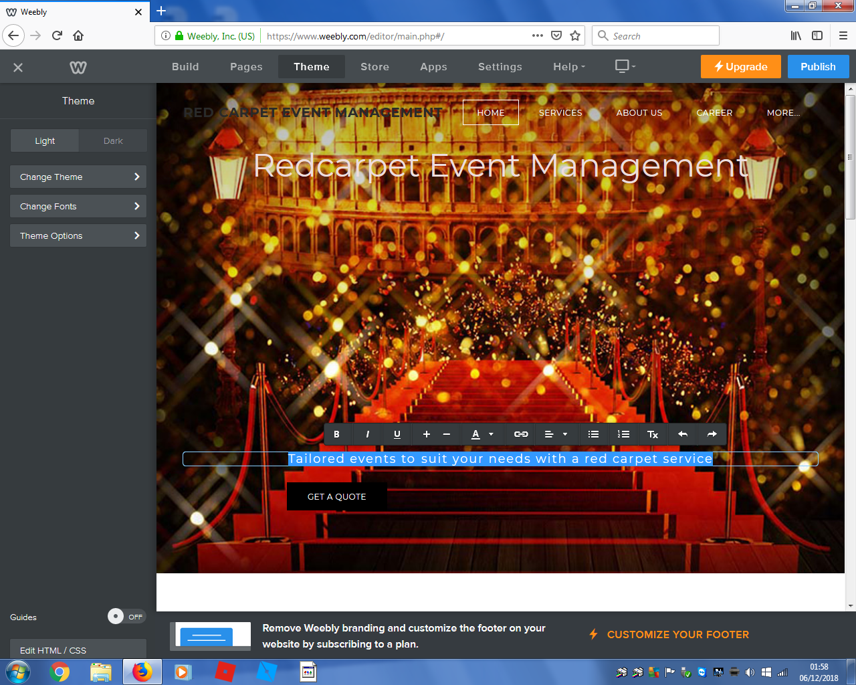
Slide 1

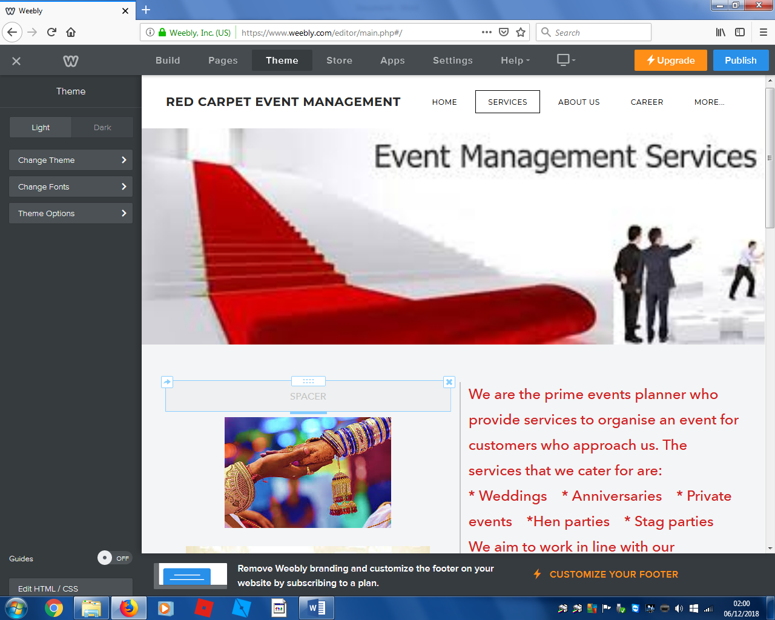
Slide 2
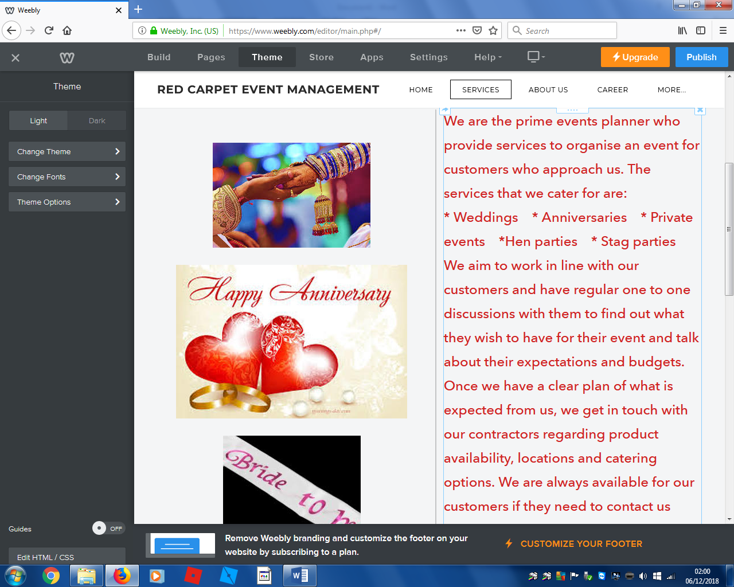
Slide 3
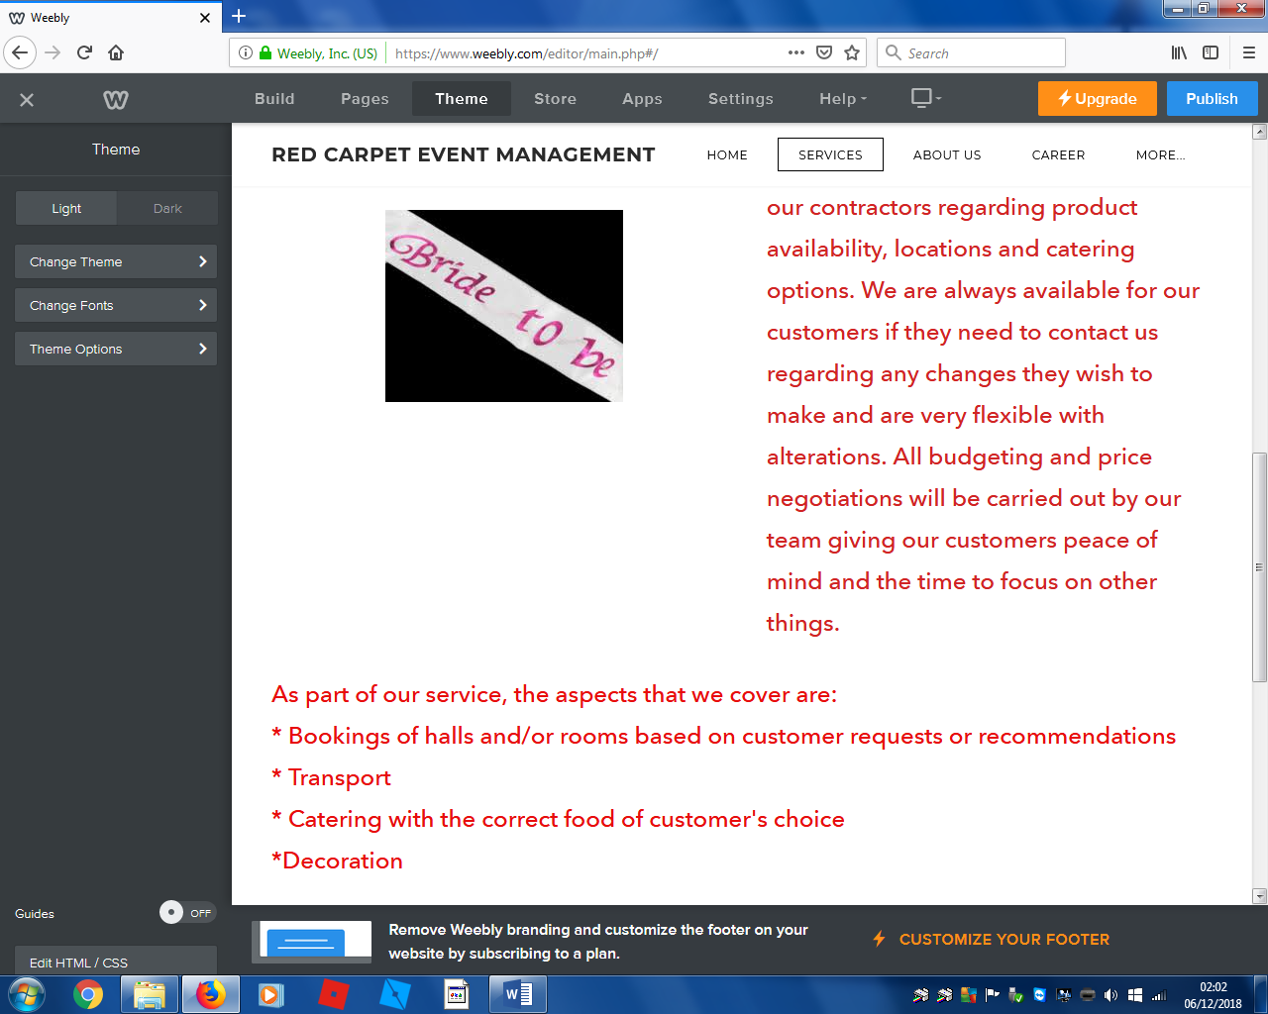
Slide 4

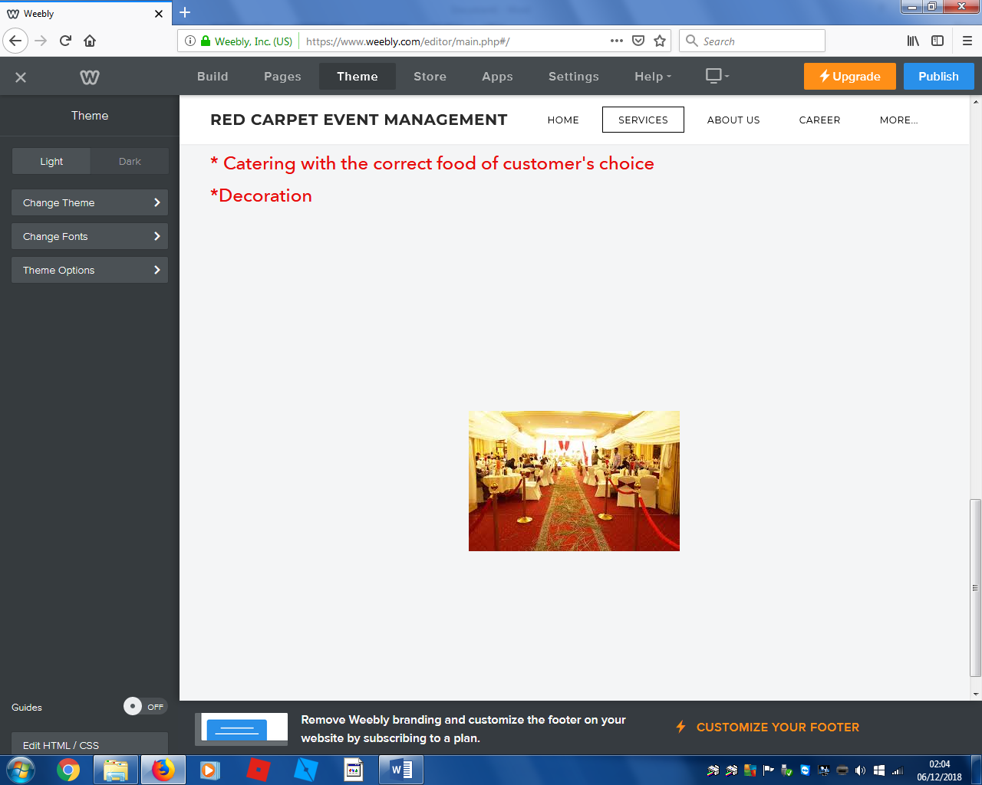
Slide 5
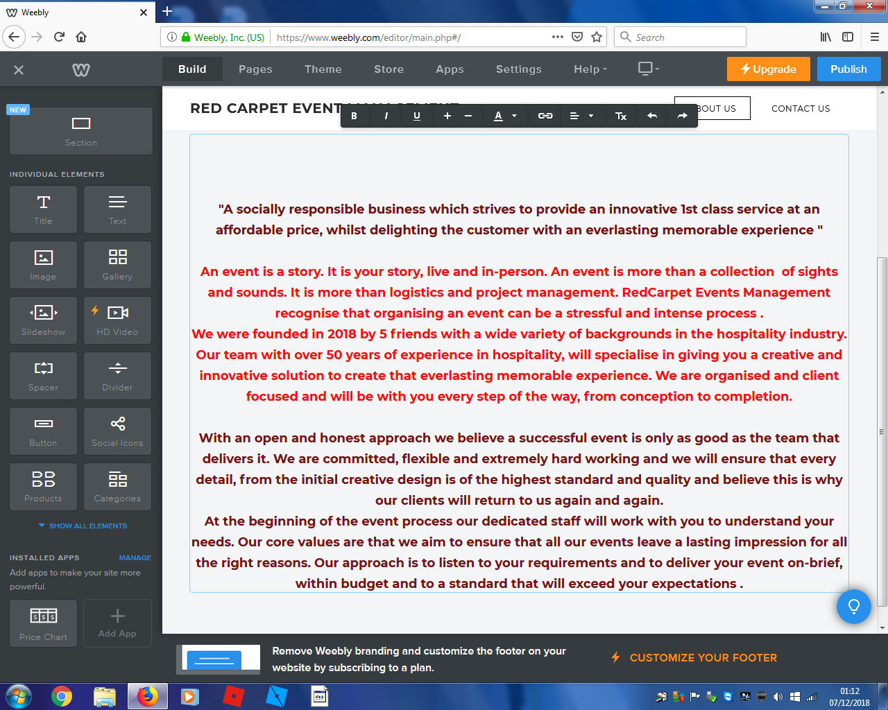
Slide 6
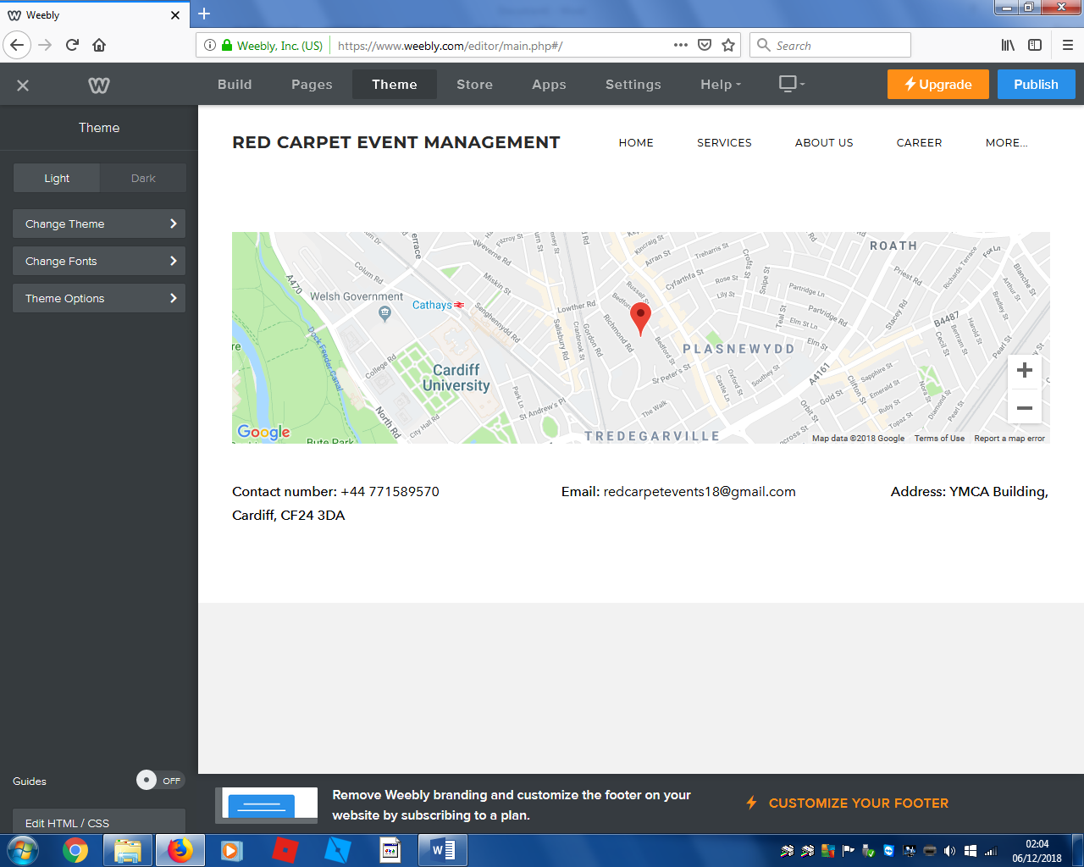
Slide 7
Conclusion:
We, Redcarpet Event Management Company has built and design a website which screenshots has been shown above. As a group we allocated tasks to our team members. I have submitted my skill audit in questionnaire link describing my contribution to the group.
Especially to the creation and have designed the website, I shared my ideas and opinions to our group meeting. Different ideas and opinions include the design, colour and photos, the font size and body structure. I am glad as my opinion has taken with high important. I as a part of the team became critic about this website and necessary amendments had been made according to my remarks.
I am grateful to my tutor, lecturer as well as my group members and classmates who provide me the support and help to complete this assignment successfully.

