BMIH5007 Financial Management for the Hotel Industry
Assessment 2

Student name : Florin Ionut Nitu
Student id : 2240772
Module Leader : Tristan Hawkins
I confirm that I have not used any AI tools in the research and creation of this
assignment. I confirm that I have not presented any AI generated materials as my own
work. I confirm I have copies of my drafts, notes, and other resources I used, which I may be asked to provide in evidence.

Table of contents
Assessment component 2: Report Case Study: The City Hotel 3
1. Introduction 3
2. Evaluation of the trends regarding the financial performance 3
2.1 Trends of revenue and expenses 3
2.2 Liquidity Patterns 4
2.3 Profitability Trends 5
2.4 Solvency Trends 6
3. Key reasons for the decline in profit 7
3.1 Rise in the cost of operation due to inflation 7
3.2 Labour shortage 8
3.3 Changing Travel Behaviour 9
4. Turnaround strategy to revitalize the financial health 10
4.1 Optimisation of cost and operational efficiency 10
4.2 Improved consumer experience along with personalised services 10
5.3 Brand differentiation 10
5. Conclusion 11
References 12
Component 2 12

Assessment component 2: Report Case Study: The City Hotel

1. Introduction
Management of the financial performance of the business is highly critical to allocate resources as well as develop new strategies. Through per development of new financial strategies, companies can improve their overall performance in the competitive market which can reflect on their profit margin. This study aims to analyse the financial consideration of the City hotel and recognise the major factors that contribute towards these changes. Based on this analysis, key turnaround strategies for this organisation will also be addressed to improve the brand reputation of this organisation.

2. Evaluation of the trends regarding the financial performance

2.1 Trends of revenue and expenses
Revenue, as well as expenses, is important in a competitive landscape as they determine profitability as well as the effectiveness of operations. High revenue allows a company’s market growth and reinvestment while controlling expenses to ensure a better profit margin (Olayinka, 2022). Effective revenue management helps increase a company’s capacity to completely innovate as well as adapt to changing market dynamics and secure long-level success. The last 3 years' revenue as well as expenses of the City Hotel highlights major fluctuations that affect the overall financial health. The revenue of the company includes inflows of funds in business from operational actions. On the other hand, expenses consist of the outflow of funds to manage both indirect as well as direct spending of the business. The profitability of City Hotel was affected because of fluctuation of the economy. Changes in demand from consumers' uncertain conditions of finance, rigid competition and high costs related to operation influence the level of expenditure as well as revenue (Liang et al., 2023). The overall financial position of the company is affected because of a decline in the occupancy rate, revenue as well as consumer satisfaction. Thus, consideration of revenue, as well as expense trends, helps make informed decisions related to cost reduction and optimisation of the capacity to increase income.
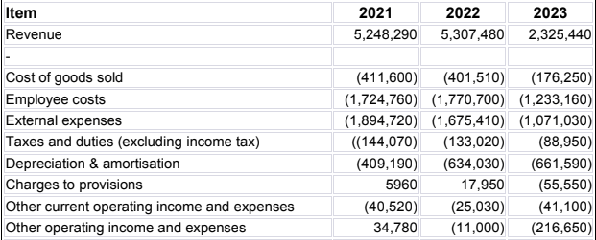
Table 1: Revenue and expense of City Hotel
Considering the above table, the reduction of revenues as well as expenses minimises the profit level of the organisation. Additionally, changes in guests’ preferences for selecting hotels minimise the rate of occupancy and impact City Hotel’s income level. Due to low rates of occupancy, the hotel leads to low turnover. This has affected the value of the brand in the dynamic business market. In city hotels, a negative revenue trend has been noted. This has affected the company’s performance and profitability. Therefore, service quality optimization and competition with other brands to improve guests' experience are important. The company needs to develop strategic planning to minimise costs and maintain the effective financial health of the hotel.

2.2 Liquidity Patterns
The pattern of liquidity mainly highlights the availability along with the flow of liquidity in the financial market that has a direct impact on the purchasing along with the selling of new assets whiteout hampering the price fluctuation (Naiket al., 2020). From the analysis of the City hotels, a liquidity pattern and a decremental condition have been found in the level of the cash flow. Changes in the policies regarding financial management are helpful in managing the optimum reserve of cash that has a direct impact on the liquidity condition of the organisation. Due to low revenue as well as profit margin, the city hotel has noted a noticeable decline in the liquidity which is affecting the levels of the cash flow to meet some of the vital requirements. Therefore, optimisation of the cash flow can improve the liquidity position of the business and improve the overall performance regarding the contemporary financial condition.
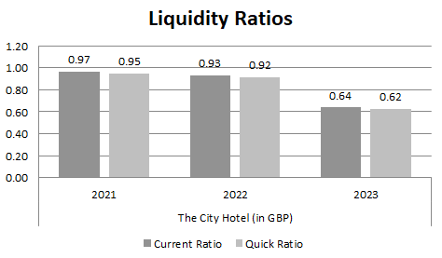
Figure 2: Liquidity ratio
The liquidity ratio suggests that from 2021 to 2023 company was unable to cover the short-term liabilities due to insufficiency of the present liabilities. Additionally, the hotel witnessed a lower rate of occupancy which has adversely affected the revenue and created barriers to meeting financial requirements. Therefore, embracing the resilience of the current liquidity condition is highly important for this organisation. Therefore, higher authorities of this organisation need to focus on fulfilling the daily requirements to manage the cash flow and improve the overall performance.

2.3 Profitability Trends
The changes in profit level are presented in profitability trends in diverse accounting years. The research reflects that City Hotel has encountered a severe decline in revenue due to negative expenses retrieved from consumers. The company has a poor strategy of pricing for rooms and this leads to shifting towards alternative providers for accommodations. This influences the hotel's profitability level. It is important for the concerned hotel to manage costs and set competitive prices for hotel rooms. This can drive rates of occupancy for the hotel and maximise profitability.
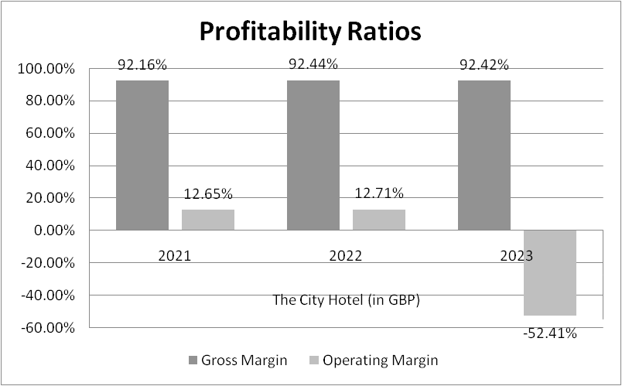
Figure 3: Profitability ratios
The above graphical demonstration reflects an exceptional trend and the operating margin reflects a decline. This means the profitability level of City hotel in the financial year 2021-2023 is negative. It is also seen that although the operating margin is negative, the level of gross profit is efficient because of the low engagement of consumers in the hotel. Consumer preferences have changed because of the availability of too many alternatives. Therefore, city hotels are required to manage demand from consumers and ask them for feedback to ensure effective delivery of service.

2.4 Solvency Trends
Trends in solvency mainly focus on the long-term ability of the organisation to meet the obligation regarding the debt that aids in sustaining the operation. From the analysis of the company and solvency trends, it is noted that the City Hotel has stressed upon high usage of debt in comparison to the assets along with equity. It has led to issues in business management. Due to low revenue streams the debt of this organisation has increased. Controlling this debt is important to improve the condition regarding business solvency (Atrilland McLaney, 2021).
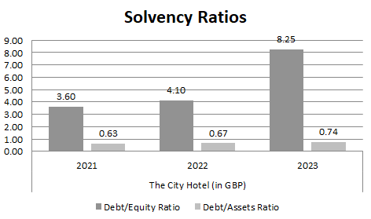
Figure 4: Ratio regarding solvency
According to the analysis, an increase in debt in the City hotels is noted along with lower equity and assets in the last 3 years. It has adversely impacted the solvency of the organisation. Additionally, controlling the level of debt in the capital structure along with optimisation of assets can help in improving the solvency of the company. Here, the City Hotel can use the equity capital to properly finance any type of long-term investment in the business.

3. Key reasons for the decline in profit

3.1 Rise in the cost of operation due to inflation
Current inflation has become one of the biggest reasons behind the rising cost of operating for most of the hotels across the UK. Due to this economic condition, a noticeable increase in the raw materials, energy sources and other essential outputs’ costs have been noted in the country which is collectively contributing towards the rise of the operational ist for businesses.
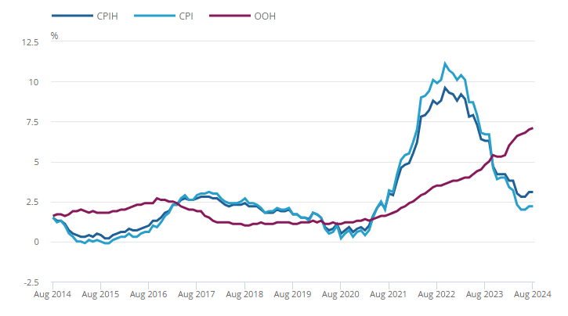
Figure 5: Inflation in the UK
(Source: ons, 2024)
In particular, the rise of the energy cost in the global market has particularly contributed towards the increase in raw materials cost (ons, 2024). In some cases, it has also disrupted the chain of supply for the hotel businesses. Furthermore, geopolitical tensions, tariffs as well as sanctions have also directly contributed to the worsening inflation of the global market and due to that operational costs are being affected. With increasing inflation, the purchasing power of the people is also declining which ultimately leads towards a decreasing rate of visiting hotels. It is also reflected in the profitability decrease.

3.2 Labour shortage
Another big reason behind the decrease in profit in the hotel businesses is the shortage of labour in the UK market. It has been noted that as of 2023, there is a 9.7% labour shortage in the country (statista, 2023). Although there has been some improvement since the previous year, still the current shortage is affecting the productivity of the companies and their overall profit margin. Among different sectors, hotel and accommodation sectors are largely affected by this issue.
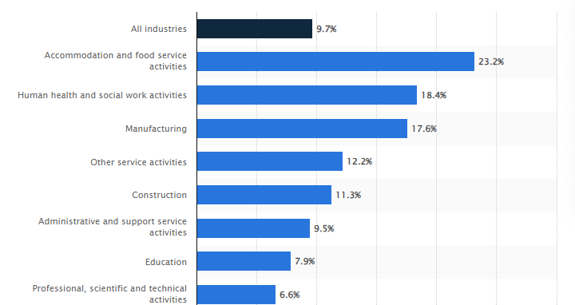
Figure 6: Shortage of workers in the UK
(Source: statista, 2023)
It is seen that in the accommodation as well as food service sectors, currently labour shortage is 23.2% which is the highest among the other sectors in this country (statista, 2023). It is strongly affecting the production of the hotels including the City hotels and it is reflected in the declining profit of the companies. Due to this labour shortage in hotels, companies are forced to increase the wages of the employees to retain them in the workplace and manage productivity (Atrill and McLaney, 2021). However, this provision of higher wages to the talented employees in the hotels has ultimately affected the profit margin of the hotels like the City Hotel which is creating barriers to managing long-term operational sustainability.

3.3 Changing Travel Behaviour
In the post-Covid pandemic session, behaviour regarding travel has changed significantly which is affecting the hospitality businesses in the global as well as in the UK market. Particularly, in business travel, a slow recovery rate has been noted which affects the accommodation services of the UK. It is seen that in 2022, businesses that are visiting the UK have reached 59% of the pre-pandemic levels whereas the overall spending has reached 86% of that of 2019 (visitbritain, 2024). However, it is considered as slow as the other European nations. Due to rise in the virtual meetings along with remote working across the different big organisations, travel for meeting purposes has been reduced. This factor is negatively affecting the profit margin of the business including the City Hotel in the contemporary business environment. On the other hand, the leisure hotel sector has moved relatively quickly (Spanakiet al., 2021). Still, people of the UK mostly prefer localised trips and favouring different types of vacation rentals along with accommodations for boutiques.

4. Turnaround strategy to revitalize the financial health
In order to improve the financial health of the City Hotel, different strategies can be considered by the higher authorities.

4.1 Optimisation of cost and operational efficiency
Reduction of operational expenses without hampering the quality of services is one of the most efficient turnaround strategies to revitalise the financial health of this organisation. Therefore, before allocating the financial resources to different segments, management needs to conduct a thorough analysis of the requirements and estimate cost (Kembauwet al., 2020). Different smart technologies such as LED lights and energy efficiency systems can be introduced to reduce energy costs. Furthermore, automation of routine tasks can also help in the reduction of cost as well as improve the margin of profit within the business. Additionally, streamlining the suppliers and management of inventory can also help to improve profitability.

4.2 Improved consumer experience along with personalised services
Management of guest satisfaction in the hotel business is critical to developing a good brand image (Hussain and Khanna, 2019). Therefore the management of the City Hotels needs to invest in the personalisation of the technologies that can provide specialised services to the guest according to their requirements. The company should also focus on the unique experiences of the consumers by tailoring the cultural experiences. It can in turn aid in attracting a larger consumer segment and increase the revenue and profitability scope for this organisation.

5.3 Brand differentiation
The development of a strong identity for the brand is a critical factor in marketing activities. Through the promotion of different sustainability initiatives, the City Hotel can effectively engage in contemporary agendas. It will aid the organisation in developing a good brand identity (Gupta et al., 2020). To share the contribution towards social and environmental sustainability, the marketing team of this organisation can use different digital media platforms including social networking channels. Furthermore, flexibility in the booking policies as well as setting up competitive pricing can also aid this organisation in attracting large consumer segments and increasing margin profit margin from the operation.

5. Conclusion
From the study, it can be concluded that the use of the current financial condition of the City Hotels is showing a negative situation of the business which can hamper the long-term profitability. A decrease in both profitability and cash flow and an increase in debt in the last 3 years is highlighting the worsening financial condition of this business. Mainly, inflation, shortage of labour and changing travelling behaviour of the consumers are contributing towards the decrease in profit for this business. To improve this current condition, the company should stress on brand differentiation, cost optimisation along with improvement of consumer experiences.

References

Component 2
ons, 2024, Consumer price inflation, UK: August 2024, Available at: https://www.ons.gov.uk/economy/inflationandpriceindices/bulletins/consumerpriceinflation/august2024 [Accessed on: 15 October, 2024]
statista, 2023, Percentage of businesses experiencing a shortage of workers in the United Kingdom in 2023, by industry sector, Available at: https://www.statista.com/statistics/1369216/uk-worker-shortages-by-sector/#:~:text=Percentage%20of%20businesses%20experiencing%20a,the%20UK%202023%2C%20by%20sector&text=As%20of%20October%202023%2C%20approximately,Kingdom%20were%20experiencing%20worker%20shortages [Accessed on: 15 October, 2024]
visitbritain, 2024, Understanding Business Visits to the UK, Available at: https://www.visitbritain.org/media/2896/download?attachment#:~:text=Post%2DCOVID%20recovery%20is%20underway,spend%20recovery%20in%20real%20terms [Accessed on: 15 October, 2024]
Naik, P., Poornima, B.G. and Reddy, Y.V., 2020.Measuring liquidity in Indian stock market: A dimensional perspective.PloS one, 15(9), p.e0238718.
Atrill P, and McLaney, E. 2021.Management Accounting for Decision Makers.FT Prentice Hall.
Brunello, G. and Wruuck, P., 2021. Skill shortages and skill mismatch: A review of the literature. Journal of Economic Surveys, 35(4), pp.1145-1167.
Kembauw, E., Munawar, A., Purwanto, M.R., Budiasih, Y. and Utami, Y., 2020. Strategies of financial management quality control in business. TEST Engineering & Management, 82, pp.16256-16266.
Hussain, S. and Khanna, K., 2019.Guest Satisfaction: A comparative study of hotel employees and guests perceptions.International Journal of Hospitality and Tourism Systems, 12(1), p.83.
Gupta, S., Gallear, D., Rudd, J. and Foroudi, P., 2020.The impact of brand value on brand competitiveness.Journal of Business Research, 112, pp.210-222.
Spanaki, M.Z., Papatheodorou, A. and Pappas, N., 2021. Tourism in the post COVID-19 era: evidence from hotels in the North East of England. Worldwide Hospitality and Tourism Themes, 13(3), pp.357-368.
Olayinka, A.A., 2022. Financial statement analysis as a tool for investment decisions and assessment of companies’ performance. International Journal of Financial, Accounting, and Management, 4(1), pp.49-66.
Liang, J., Yang, S. and Xia, Y., 2023. The role of financial slack on the relationship between demand uncertainty and operational efficiency. International Journal of Production Economics, 262, p.108931.

