Generating Business Data and Analysis
BMSP (4004)
Assignment 2
Principals and Concepts of Modelling


Claire Davies
Tutor: Rosin Mullins
Contents

- Introduction
- What is a spreadsheet?
- Example of spreadsheet applications
- Models of data on a spreadsheet
- Data analytics – What does it mean and how is it important?
- Data visualisation – what does it mean and how is it important?
- Strengths of using a spreadsheet
- Formulas and functions used in a Spreadsheet
- Conclusion
- Appendix
- Bibliography

Introduction
This report is going to looking into what spreadsheets are and what they are used for. It will explain the different functions and formulas used with in a spreadsheet, why they are used and what they are used for. This will also try to explain what their purpose is on a spreadsheet, how they are easily amended, how easy it is to change and update data on a spreadsheet. There are many strengths to using spreadsheets and this report will look into what they are and why they are classed as strengths.

What is a Spreadsheet ?

A spreadsheet is a computer program that allows the user to collect and store data. The data can then be used for making calculations, produce graphs and to analyse data.

A spreadsheet is a grid of cells and these are arranged into rows and columns and then information can be inserted into each cell. Each cell usually contains text, numbers and formulas.

Formulas are a calculation based on the data input into the cells or a combination of cells. The total in that formula can change if the content of the combination cells used is changed.

Spreadsheets can contain of a number of different worksheets, these can include different data as well as allowing cells on one worksheet to be used and referenced to on different worksheets. Information can also be filtered and sorted on a spreadsheet.

Spreadsheets have a variety of tools included to help support different types of calculations and can include graphical presentations such as graphs, pie charts, line charts and bar graphs.

Examples of Spreadsheet applications

- Pricing
  - setting prices for consumer and industrial goods, government contracts, and maintenance contracts
- Customer segmentation
  - identifying and targeting key customer groups in retail, insurance, and credit card industries
- Merchandising
  - determining brands to buy, quantities, and allocations
- Location
  - finding the best location for bank branches and ATMs, or where to service industrial equipment
- Social Media
  - understand trends and customer perceptions; assist marketing managers and product designers
(Evans, 2014).

Models of data on a spreadsheet:

Data analytics – What does it mean and how is it important?

What is data analytics?
Data analytics is a process of looking at data stored on a spreadsheet to find what information is contained with in the data. This is done by transforming data, modelling data, cleaning up data, with the goal of finding useful information with in the spreadsheet.

Why Data Analytics?
Data Analytics is needed in Business to Consumer applications. Companies collect data that they have gained from customers, businesses and personal experience. The data is then processed after it is gathered and is placed into categories it is required and analysis is done to study purchase patterns etc. (Sanon, 2017).

Why is it important?
Data analysis is important because a business and technology world, is indispensable. The data technologies and initiatives are increasing to analyse this data for gaining insights that can help in making strategic decisions. At the beginning of 21st century every technology giant is now making use of data technologies. Data refers to vast and voluminous data sets that may be structured or unstructured. This massive amount of data is produced every day by businesses and users. Data analytics is the process of examining the large data sets to underline insights and patterns. The data analytics field in itself is massive. (Verma, 2018).

Data visualisation – what does it mean and how is it important?

Data visualisation is a way of representing information and data by using visual functions like graphs, charts and maps, data visualisation tools provide you with accessible ways to see and to understand trends and patterns in a data file. In a world of data, data visualisation functions and technology are great for analysing mass amounts of information.
Common general types of data visualisation:
- Charts
- Tables
- Graphs
- Maps
- Infographics
- Dashboards
Another form is data visualisation, this is visual art that grabs our interest and keeps our eyes on data from a different perspective. When we see something visual like a chart, we quickly see data that has been simplified. If we can see something this simple, we internalise it quickly.. If you’ve ever stared at a complicated spreadsheet full of various types of data and couldn’t see a trend, this shows you how much more effective a visualisation can be. (Tableau, 2019).

Strengths of using a spreadsheet

Spreadsheets give you a range of advantages, especially to a business user. Programmes like Microsoft Excel give you the tools to analyse and visualize data sets in an accessible way. If you have sets of data that are numerical, financial, statistical or any other information, you can use a spreadsheet not only to store and keep this data but also for you to manage it, perform analytical processing on it and present it.
Spreadsheets help to provide you with complex processing in ways that even people with very little technological experience can use.
When a spreadsheet is built, data is entered onto a worksheet. Each item of data is stored with in a single cell. Spreadsheet cells can also contain formulas, these can be written by yourself or from the formulas already set on excel. For instance, you may have a cell in a spreadsheet that needs to perform a calculation using values from another cell. You can then update the values in these other cells, the result inputted into the formula cell will then update itself. So spreadsheets give you a way to carry out analyses and calculations on your data sets automatically.

Formulas and functions used in a Spreadsheet

“A formula can be just a simple calculation based on numbers you have entered or you can have excel plug in the values automatically.” (Murray, 2010).
Sum formula: This formula is used to calculate row or columns of numbered data that has been input into a spreadsheet, this allows u to add up the whole row or column to give you a final total of the row or column. (Pic 1 in Appendix).

Enter the SUM function manually to sum a column In Excel
- Click on the cell in your table where you want to see the total of the selected cells.
- Enter =sum( to this selected cell.
- Now select the range with the numbers you want to total and press Enter on your keyboard.

Average formula: The average formula is used to get the average across a row or column of numbered data that has been input into the spreadsheet. (Pic 2 in Appendix).
To calculate the average of numbers in a contiguous row or column
- Click a cell below, or to the right, of the numbers for which you want to find the average.
- On the Home tab, in the Editing group, click the arrow next to AutoSum , click Average, and then press Enter.

Vlookup formula: VLOOKUP is an Excel function to lookup and retrieve data from a specific column in table. (Pic 6 in Appendix).
- Summary. VLOOKUP is an Excel function to lookup and retrieve data from a specific column in table. ...
- Lookup a value in a table by matching on the first column.
- The matched value from a table.
- =VLOOKUP (value, table, col_index, [range_lookup])
- value - The value to look for in the first column of a table.

Pivot table: This is used to summarise data from a larger data file into a smaller report, this allowing you to choose what important or more valuable data you may need in the report. (Pic 7 in Appendix).
How to Create a Pivot Table
- Enter your data into a range of rows and columns.
- Sort your data by a specific attribute.
- Highlight your cells to create your pivot table.
- Drag and drop a field into the "Row Labels" area.
- Drag and drop a field into the "Values" area.
- Fine-tune your calculations

Graphs/charts: Excel spreadsheet programmes can transform your inputted data into various types of graphs. The charts section in Excel gives you the ability to present your data in a chart or graph. This gives users the ability to see and to communicate the data within a presentation, using pie or bar charts would be a great way of showing this. Visualizing data like this way can help the user to understand the data and can help future planning.
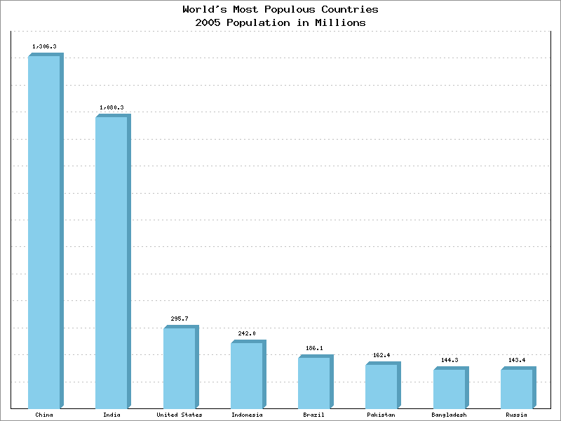

(Sourceforge, 2019).

Conclusion
While learning and researching about excel spreadsheets, it seems that it is programme that is used across the world by many people, companies etc. It is a great programme for holding various inputs of data. A spreadsheet can hold vast amounts of data in different forms, from word data, number data to visual data such as graphs and charts. It is also easy for data that has already been input to be altered at any time and because of the formulas used within the data file when information is changed it can do it automatically. It’s also very helpful that excel have the formulas already on the programme which makes the programme even easier to use. This allowing everyone even beginners to have the basic knowledge and ease of using excel spreadsheets.

Appenix
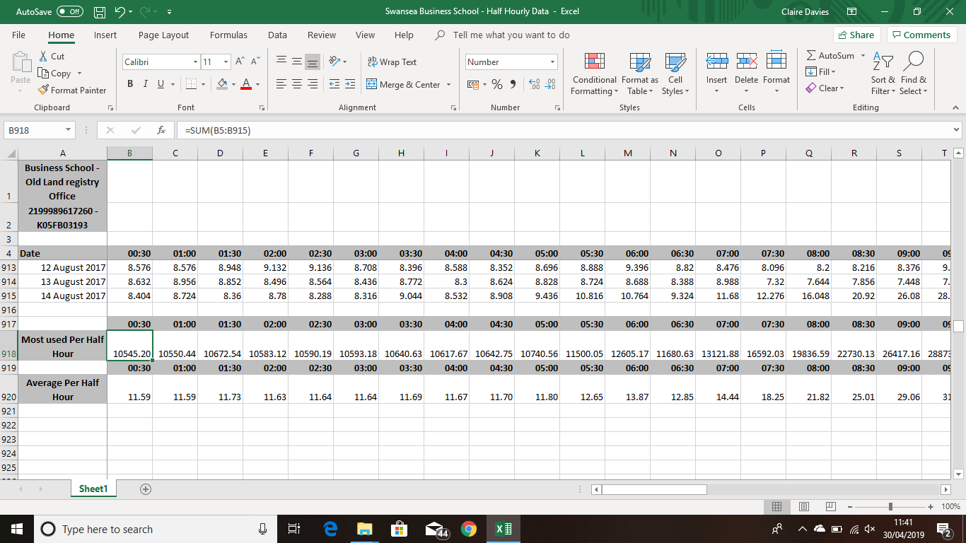
Pic 1

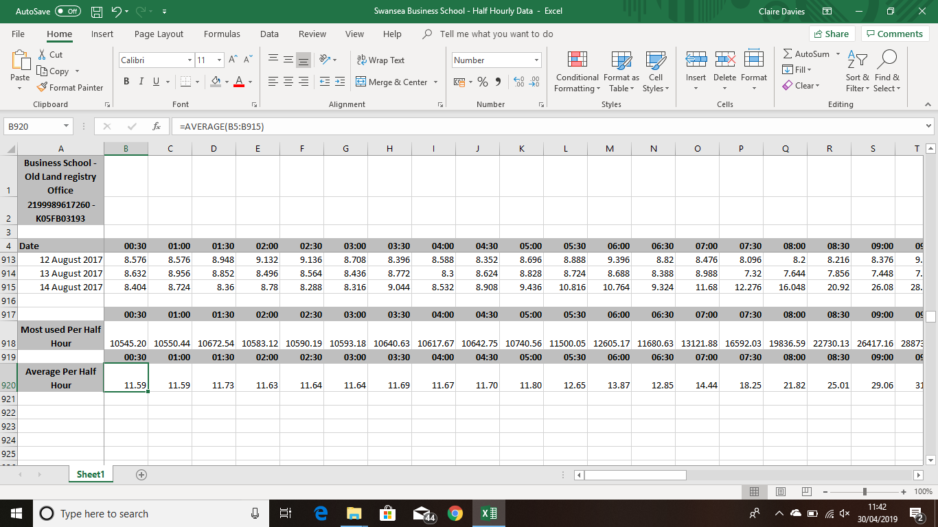
Pic 2

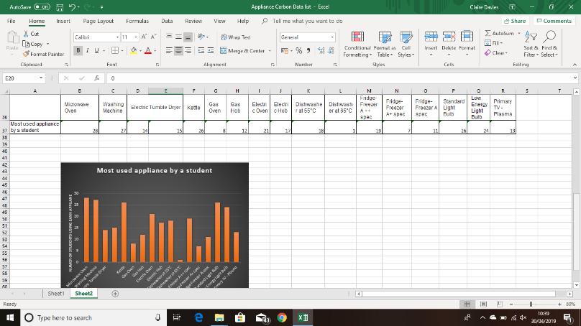
Pic 3

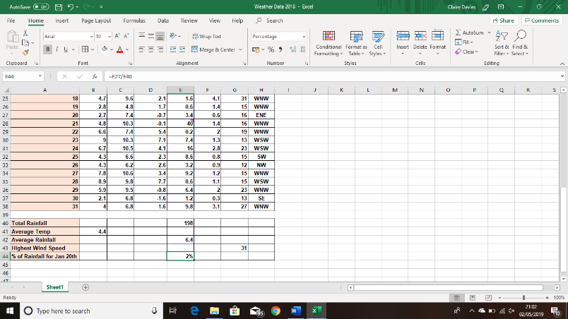
Pic 4

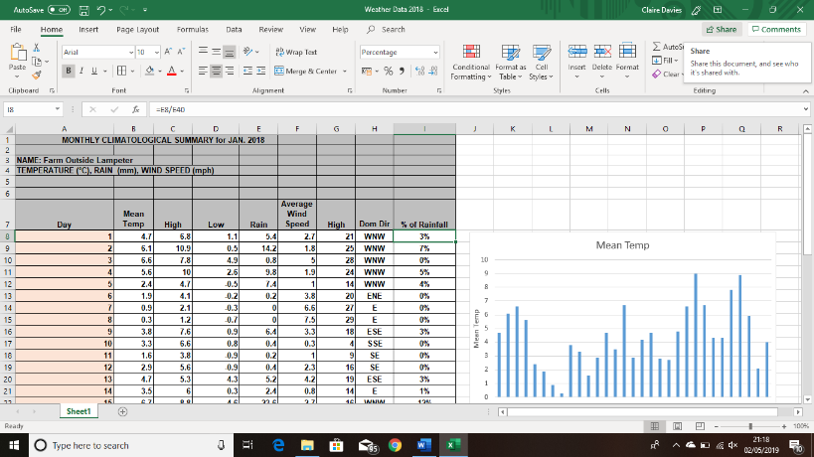
Pic 5

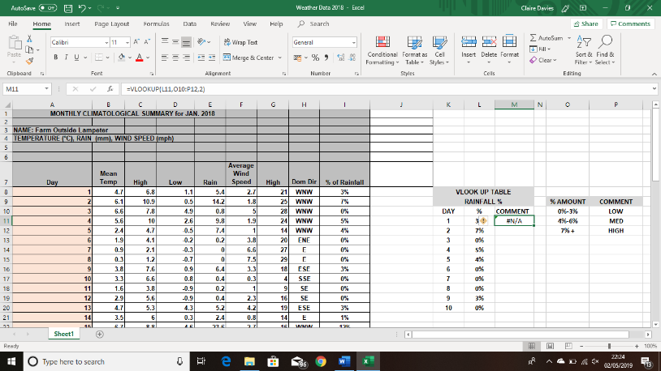
Pic 6

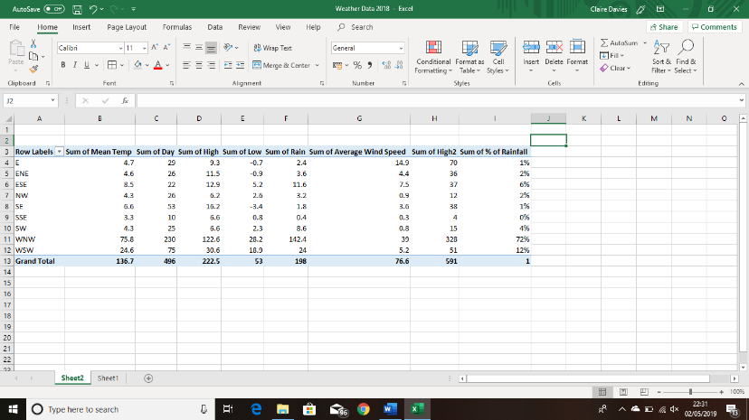
Pic 7

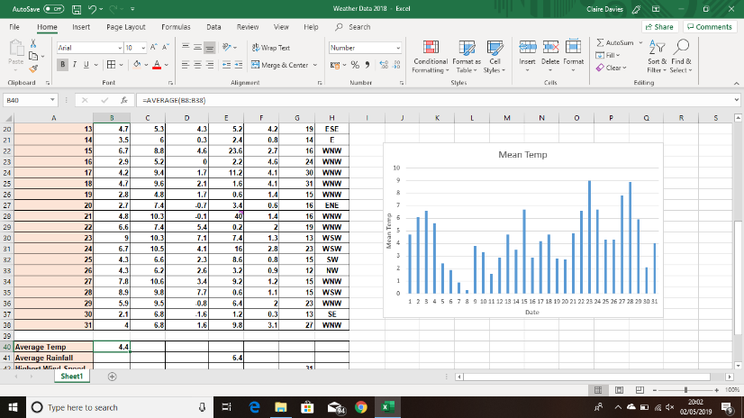
Pic 8

Bibliography

Evans, J. R. (2014). Business Analytics.
Murray, K. (2010). Plain and simple Microsoft Office 2010. Microsoft.
Sanon, M. (2017, April 28th). Retrieved from https://www.digitalvidya.com/blog/reasons-data-analytics-important/
Sourceforge. (2019). Retrieved from http://phplot.sourceforge.net/phplotdocs/ex-bars4.html
Tableau. (2019). Retrieved from https://www.tableau.com/en-gb/learn/articles/data-visualization
Verma, A. (2018, March 19th). Retrieved from https://www.whizlabs.com/blog/big-data-analytics-importance/

