Report - Part 2
Study Case: Fresh Direct

Ricardo Alexandre
2025546

BMSW5102
Developing workplace critical thinking

Lecturer`s name: Dr Sujeewa Herath
August 8th, 2022

Table of Contents
Introduction 3
Component1: Development of Individual Employees 4
Fresh Direct Benefit 5
Manage a Person's Development Expectations 8
Fresh Direct STP: 10
Develop a Critical Appraisal and Development 10
Needs hierarchy of Abraham Maslow 11
Theories of Herzberg 11
Planning of engagement with individuals 12
Leadership is key 13
360-degree feedback 14
Total Rewards Strategy 15
Component 2: An individual development plan 16
1 Step - Self-analysis or (newly recruited) 16
2 Step - Determining your goals or (newly recruited) 17
3 Step - Objectives for the future or (newly recruited) 19
Conclusion 20
References 21

Introduction
The report evaluates three development vehicles available to the organization as Fresh Direct. The author's job is to conduct a SWOT analysis and create a Personal Development Plan (PDP) for a newly recruited employee. Discuss the HRM recruitment and selection models, theories, and concepts that Fresh Direct has in place on the website to order fresh products and how these can influence employee behaviour within the workplace. Analyse and identify positive and negative elements of Fresh Direct's HRM models, Concepts, policies, and procedures. To finish with a reward system, how to motivate employees. A company's efficiency and productivity may also be affected by this factor.

Component1: Development of Individual Employees
Human Resources Officer Roles
The role of human resources (HR) promotes equality and diversity in the workplace and helps managers understand policies and procedures (Mahmood, et al. 2019). The role of a human resource officer is to develop, advise on, and implement policies related to the efficient use of human resources by staff. Fresh Direct expects its HR department to contribute value to the organizations with which it works (Yong & Mohd-Yusoff, 2016).

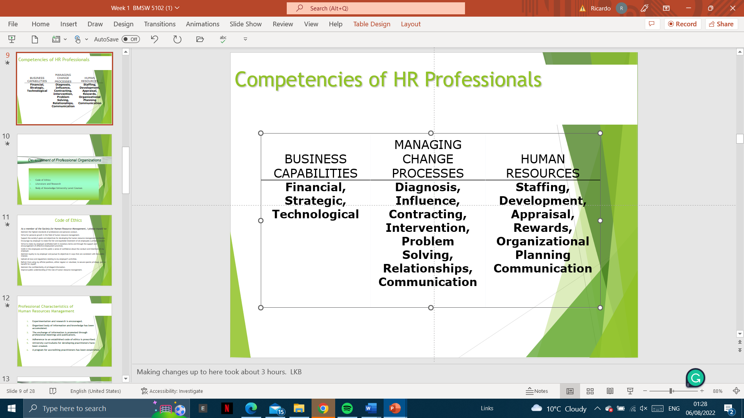
Figure 1 Source: Competencies of HR Professionals (Yong & Mohd-Yusoff, 2016).
For example: (Figure 1).
- Strategically planning staff requirements, both now and in the future.
- Conducting inductions for new employees and planning training.
- Together with departmental managers, analyse training needs.
Found the issues
The firm's operational productivity decreased, late or incomplete orders, and the first customer complaints since the firm opened were reported. There is an increase in staff working longer hours than they are contractually expected to work, considering leaving the company once they have found alternative employment (Nikoletta Bika, 2022).
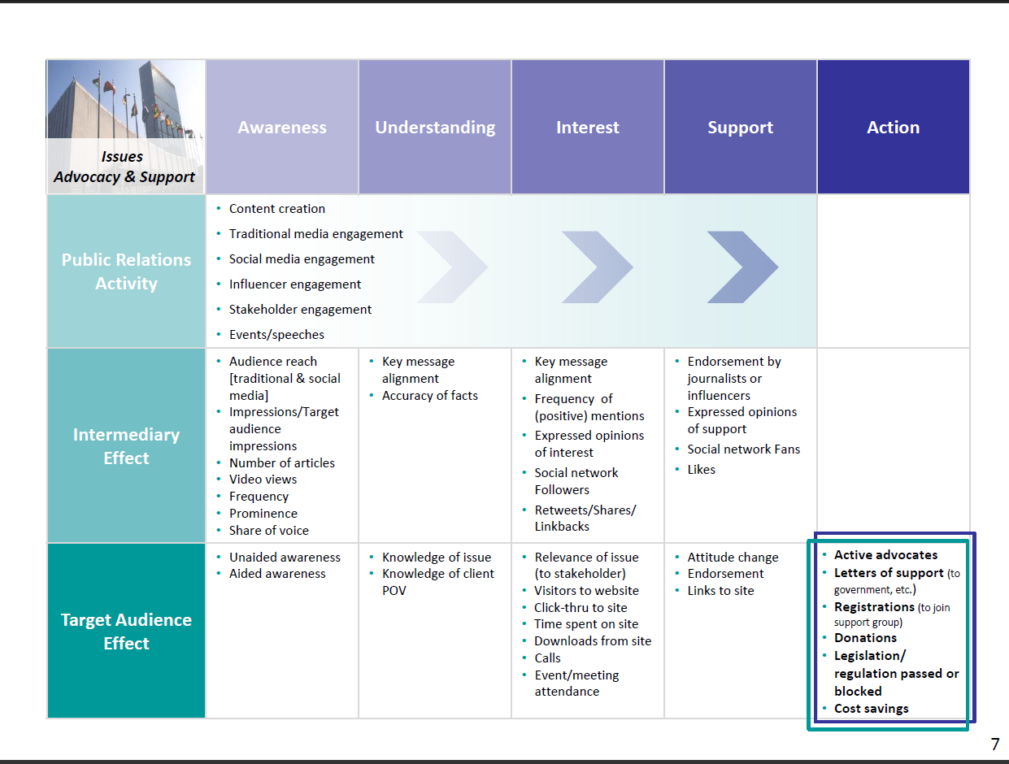
Figure 2. Source: Issues Advocacy and Support (Nilsson et al. 2011).

Fresh Direct Benefit
Fresh Direct looks at five benefits of organization development, ranging from the continuous improvement of employees to better traction towards business objectives. The practice of Organizational Development can help the middle business to achieve these outcomes. (Stewart & Brown, 2019).

Figure 3. Source: Strategic human resource management (Armstrong, 2008).

- Improvements:
Continuous improvement is at the heart of organizational development. The OD process creates a continuous cycle of improvement in organizations. A well-developed organization embraces change (internal and external) and harnesses it for its benefit. (Ryan & Deci, 2000).

Table 1 Source: Principal Innovation Consultant (Francisco, 2022)
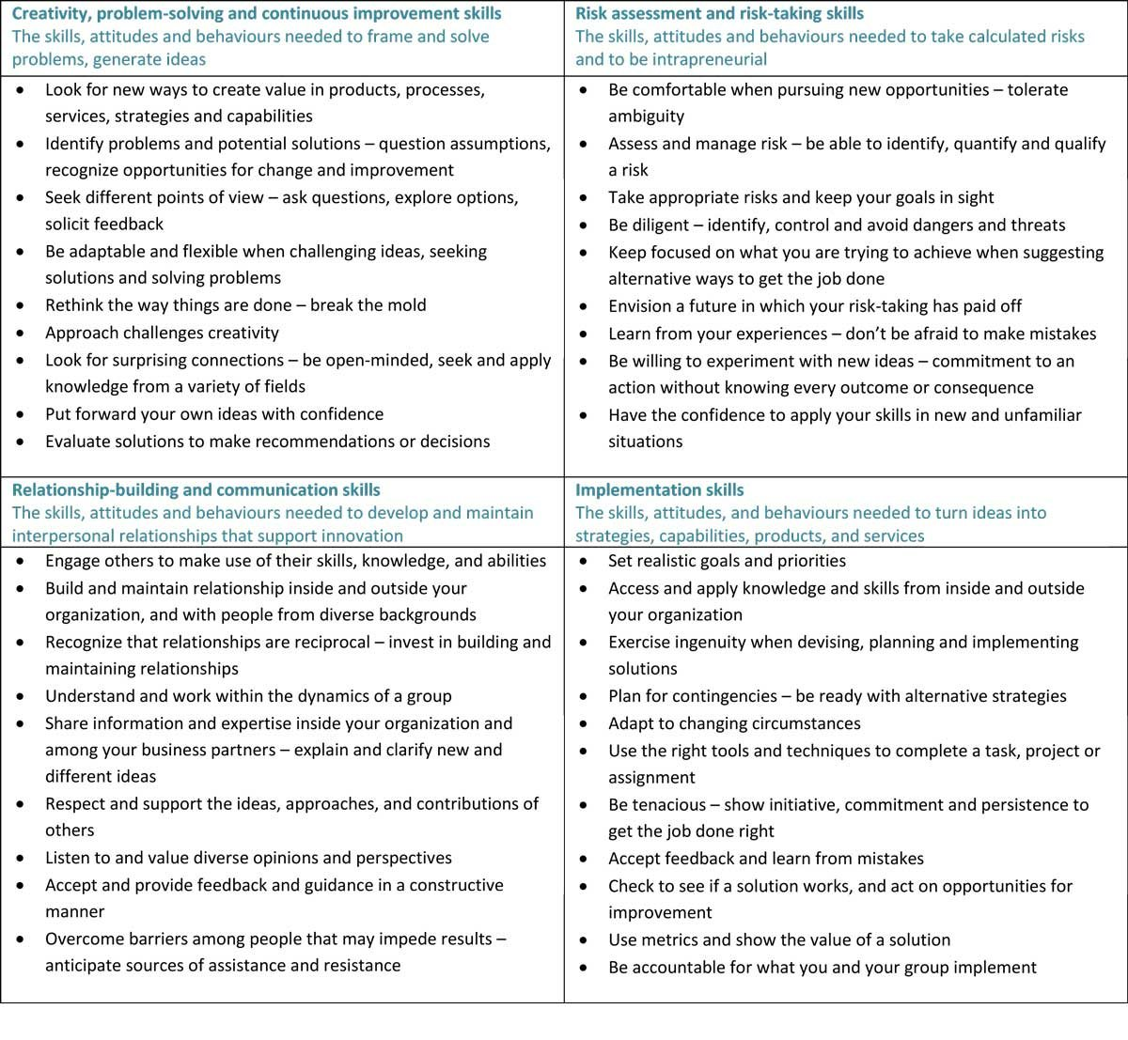
- Improved communication:
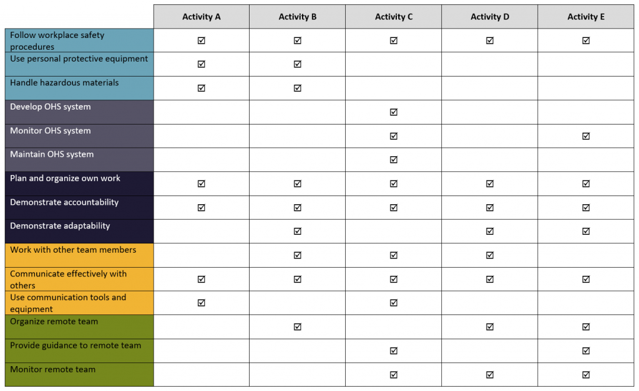
Aligning all employees with shared company goals and values is the goal of communication. The organization's need for change can also be better understood through candidate communication (Table 2). Throughout the organization, communication is open, and feedback is shared frequently (Bailey & Fletcher, 2002).

Table 2. Source: employees’ communication (Michela et al. 2022).
- Develop employees:
The goal is to improve skills, and competencies, and work through training and learning (Latham & Locke, 1979). Continuous changes in the industry and market require employee development at all levels of the organisation (Armstrong, 2020).

- Improved products & services:
Product innovation is a major benefit of working for OD. Motivating employees and rewarding successes are key to achieving innovation. Innovation and creativity increase in this scenario due to high employee engagement (Rožman et al. 2017).
- Business success:
Fresh Direct: Product/service quality and employee satisfaction increase when OD aligns objectives, says the director of sales and marketing. Absenteeism and turnover reduce costs as well as the company's productivity and efficiency increase. (Adams, 1965).
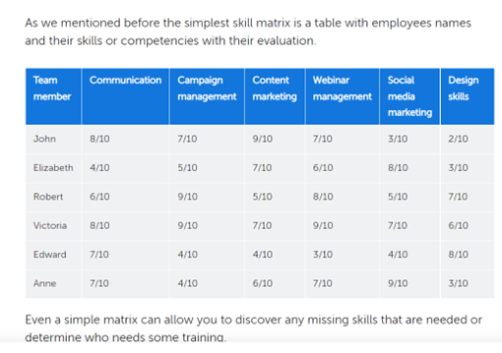
Table 3. Source: Learning and Development (Page-Tickell, 2014).

A skills matrix is a good place to start creating a skills matrix for teams and organizations. Developing better teams through this approach could improve our employees' learning and development. (Wernerfelt, 1984).

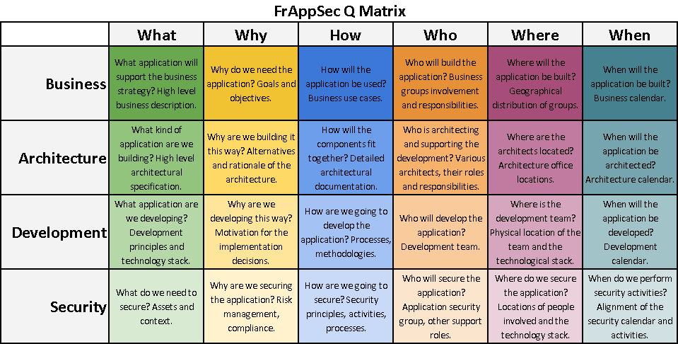
Table 4. Source: The Management Tool Kit (Kermally, 1999).

Manage a Person's Development Expectations
A person's expectations regarding personal development should be managed (Figure 4). It is common for brilliant employees to leave a company because they are refused the professional development opportunities they perceive as deserved or expected, so they search elsewhere for employment opportunities (Beardwell & Thompson, 2017).
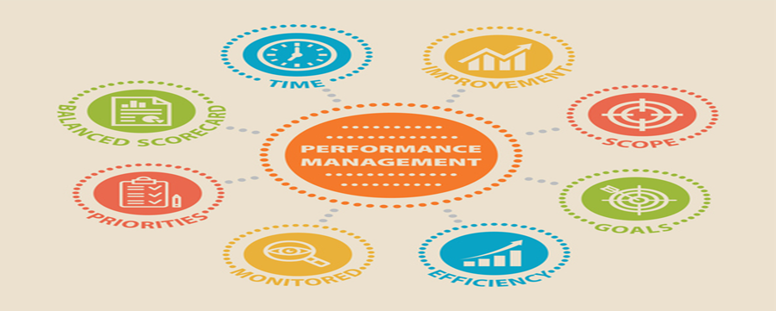
Figure 4. Source: Employee engagement: a practical introduction (Bridger, 2018).
In this paper, the HR department (Fresh Direct) discusses Managing Expectations, and how clear goals correlate with driving performance and achieving results. Rigoni & Nelson (2016), found that only employees report knowing what is expected of them in the workplace and that engagement is low. 'Agile Performance Management' encompasses a more modern approach to managing expectations. he Manager in Performance Management fosters engagement by harnessing, directing, and supporting teams and individuals to deliver the mission and objectives of the organization. Exponential Training believes a company's success lies in managing its management (Figure 5). Fresh Direct company's ethos and goals aligned with its goals? (Kearns et al. 2007).
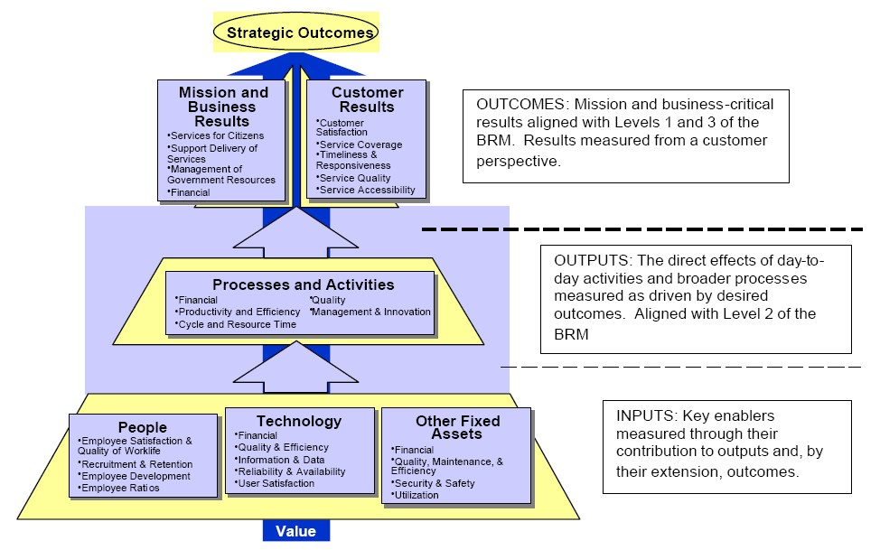
Figure 5. Source: The instinctive nature of basic needs (Maslow, 1954).
Teams of Fresh Direct performance cannot be assumed to improve just because individual performance is improved. Teams and Fresh Direct should also use performance management processes to improve their performance. (Otley, 1999). A study conducted by Shields (2007, p 21) indicates that individual results flow into group results, and thus affect the performance of an organization. As well as shaping individual behaviour, collective behaviour also arises from it. We discuss Fresh Direct Performance Management separately from individual performance management, despite their interconnected nature (Mitchell & Popham, 2008).

Fresh Direct STP:
Segmentation
- Individuals with irregular working hours or shifts may purchase impromptu items and who are Internet-enabled (Ropponen et al. 2022).
Target Market
- Even on weekends and late at night, professionals can buy groceries, toiletries, and drinks (Figure 6). Online ordering is convenient, but who has time? (Alderfer, 1972).
Positioning
- To provide their customers with a variety of delicious, nutritious meals, Fresh Direct delivers fresh, excellent quality food right to their doorsteps (Stanciu et al. 2022).
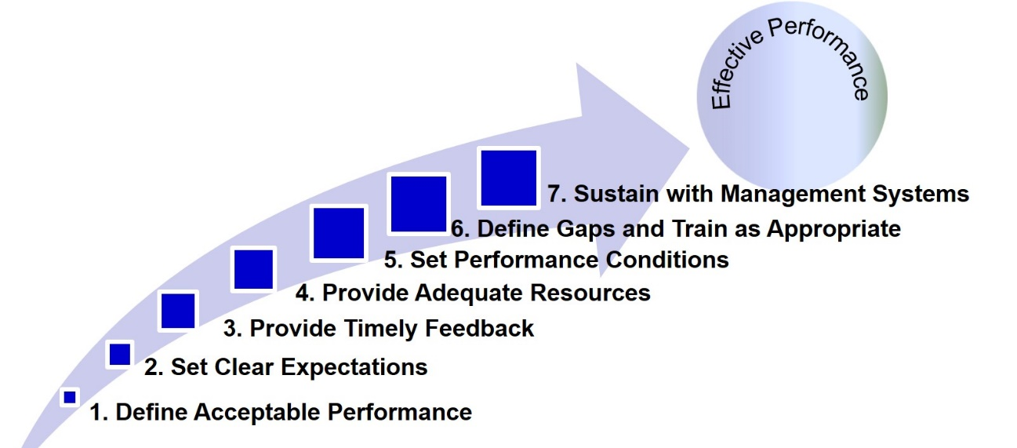
Figure 6 Source: Effective Performance (Robert et al. 2022).

Develop a Critical Appraisal and Development
The individual motivation theory
Individuals are motivated by specific factors according to the content theory of motivation. Complexity is key to motivation (Bong, 1996). The needs of individuals are often used to explain motivation. Power, achievement, love, and power are secondary needs (Porter & Lawler,1968).

Needs hierarchy of Abraham Maslow
Needs are physiological or psychological deficiencies that cause a person to feel compelled to fill them. According to Maslow's definition of need, humans are motivated by multiple needs. He contends that a satisfied need is not capable of motivating behaviour unsatisfied need can do so (Maslow, 1954)
Maslow hierarchy of Human Needs Table 2.
Table 5 Source: Hierarchy of needs (Maslow, 1943).
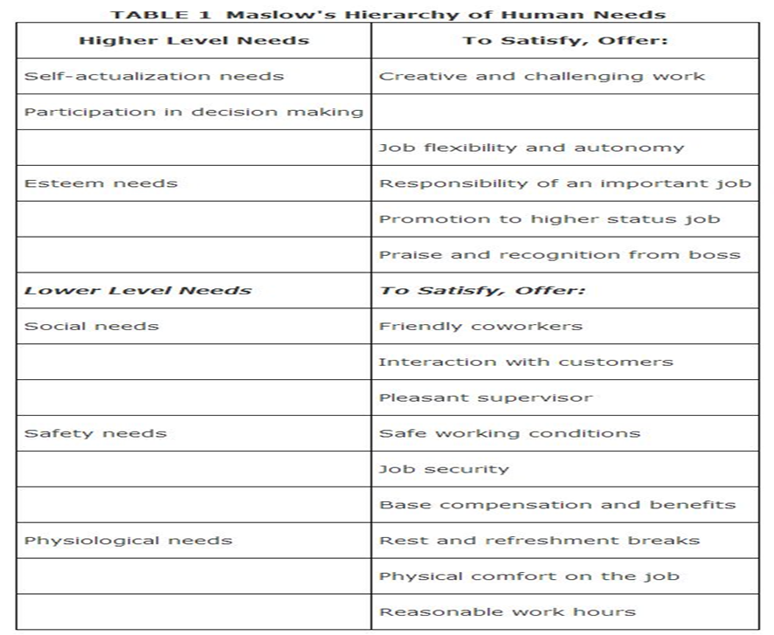
Researchers have not verified Maslow's deficit and progression principles, but his ideas can help managers understand and satisfy employees' needs (Maslow, 1954, p.1).

Theories of Herzberg
The work environments of Frederick Herzberg influenced motivation. Motivation in the workplace is impacted by two factors, according to Herzberg et al. (1957). The quality of supervision, job security, organizational policies and salary are hygiene factors. To build satisfaction into jobs, managers must ensure hygiene factors are in place.

Planning of engagement with individuals
Engagement is enhanced by job design. A decent job is what you give someone to do for them to do an excellent job, according to Herzberg (1968). There should be a variety of characteristics highlighted, including autonomy, mandatory interaction, optional interaction, knowledge, and skill (Vroom, 1964).
Working conditions
Promote a culture of positivity, reduce stress, and promote interest and excitement in the work people do (Rožman et al. 2017).
Programs for learning
People can learn and grow in their roles with these opportunities (Eraut, 2007).
Example: three months of the period of probation on training manner instructor.
Supervisors
When managers support, recognize, and develop their employees, engagement at work increases to maximise engagement, they need guidance and skills development. People's work environment and jobs are key enablers of engagement (Beardwell & Thompson, 2017). According to Macey et al. (2011), to engage employees, a work environment that promotes learning and collaboration is crucial.
According to Macleod and Clarke (2009):
It is important to organize work efficiently and effectively so that employees feel valued and that managers share their visions and goals and provide them with the assistance they need to do their jobs (Uddin et al. 2019). Managing with clarity, appreciating employees' efforts, and treating people as individuals is essential. A culture of values living and adherence to espoused behavioural norms should also be believed by employees (Sharma et al. 2019).
A leader's challenge
Behavioural theories and trait theories mix in transformational leadership. Keeping vision, leading change, and making complex decisions are all demands placed on leaders today. Leadership requires flexibility and adaptability also equally and achievement to get on the best practice (Taylor, 2004). Inspiring followers to think differently about problems is the hallmark of transformational leaders (Bryman, 1986).

Leadership is key
Action is needed to make the change smooth and quick. Change avoidance must be transformed into change acceptance by leaders. It may take decades for organizations to complete the four growth periods. Leaders transform employees' avoidance questions and statements into acceptance questions to effect change (Rowe & Guerrero, 2012).
From examples:
- Ask “Why?” to “What are the benefits of this change?” Instead of focusing on the negative aspects of the change, managers should focus on the positive aspects (Kahn, 1990).
- In addition to asking, “How will this affect me?” it is also important that managers ask, “What problems will this solve?” Management should inform employees of the problem and how they will contribute to its resolution (Kauppila, 2018).
- The transition from “We do not do it this way” to “What will be the results of doing it this way?” Often, the first reaction is that this has never been done before. Explaining and empathizing should be the goals of managers Marchington et al.2016).
- The question ranges from “When will this be over so we can get back to work?” to “How can I assist?” Managers should engage their employees in the implementation process (Mitchell & Popham, 2008).
Sharing responsibilities will make employees feel empowered. Leaders make others want to participate in a change by promoting it. Employees must feel that their contribution to the change was important. Motivated and useful team members are the ultimate goals of all managers and balance between power and responsibilities (Weber, 2013).
Learning in organizations
Employees identify and solve problems in a learning organization. Learning organizations are characterized by the following ingredients according to Peter Senge (1990). Learning organization. Having a shared vision makes learning organizations flexible. Rather than "controlling over" employees, think "controlling with" to co-ordinate and command (Fayol, 1937).
- Getting rid of old mental models.
- Self-awareness and openness to others are personal masteries.
- A plan of action based on systems thinking.
- Plan of action based on a shared vision.
- Learning as a team working together to achieve goals.
All members of the organization should be able to learn continuously through Senge's concept of the learning organization (Senge, 2017).

360-degree feedback
According to Ward (1997), an individual or group is evaluated by multiple stakeholders based on the results of a systematic process of collecting and evaluating performance information. It will need support from all departments to a final picture and get to right feedback (Maurer et al. 2002).
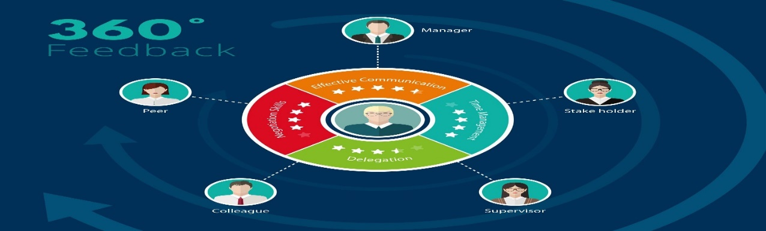
Figure 7. Source: 360-degree feedback (Ward, 1997),
For example, Feedback to receive the right communication by phone (Bailey & Fletcher, 2002).
- Everyone on the team is responsible for improving the current practices, as well as the work of others.
- When certain procedures are discussed, feedback is given. For the good of the entire team, people accept constructive criticism.

Table 6 Source: Feedback by SNAP (Martinez et al. 2018).
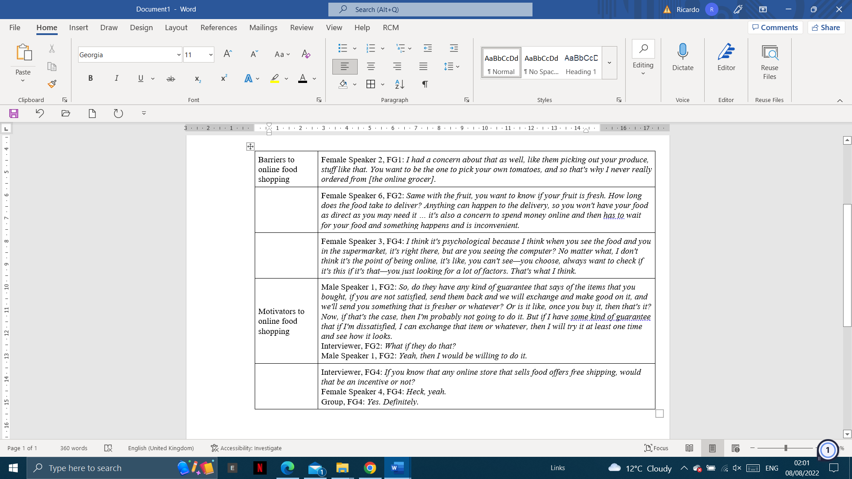
Total Rewards Strategy.
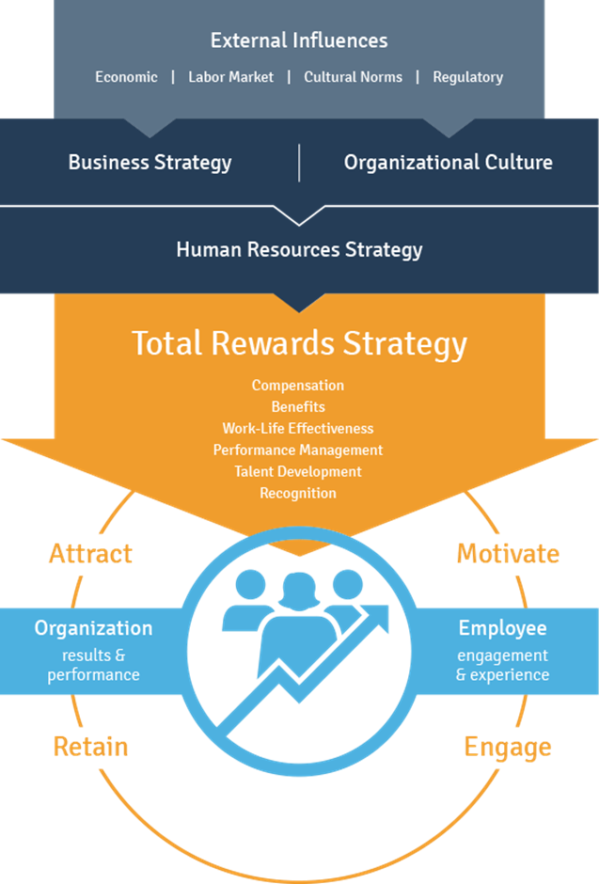
Figure 8. Source: Total Rewards Strategy (Weebly, 2022).
Rewards systems include more than just pay and benefits, but also engagement and development aspects that go beyond contractual obligations (ARMSTRONG, 2007). Organizations Fresh Direct use reward systems to ensure that reward management is conducted effectively and efficiently (Tyson, 2015, p. 277).

Armstrong and Brown (2006) discuss Towers Perrin's total reward model.
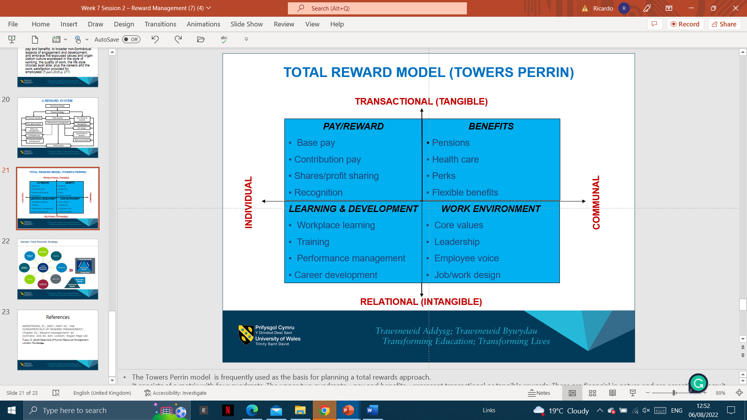
Figure 9. Source: Strategic reward: (Armstrong & Brown, 2006).
Organizations Fresh Direct that combine transactional and relational rewards are most powerful. The upper two quadrants are enhanced by human capital and human process advantage. Competitors can easily copy these financial strategies (Morgan et al. 2005). A useful distinction is also made between individual and communal rewards, especially those that arise from the work environment (Ronchetti, 2022).

Component 2: An individual development plan
Name: Mr Ricardo Alexandre or (newly recruited)
Department: HR
Organisation: Fresh Direct
Date: 28/07/2022

1 Step - Self-analysis or (newly recruited)
Table 7. Source: Self-awareness and leadership (Rubens et al. 2018).
Strengths | Weaknesses
- I have good administrative skills and basic knowledge for my level of training.  - My confidence increased when I proved I could manage the pressures of the L and M course.  - I provided clear direction and was composed during practical work. My ability to provide clear direction and manage people under pressure was demonstrated when  - I led a team over an extended period. | - Working and maintaining my fitness standards during academic studies were challenging.  - My physical fitness has suffered as a result. Before briefing my subordinates, I need to plan thoroughly.  - Solving the problem is not the problem.  - There is still to learn about estimate planning. Experience in team management in different scenarios will help me build confidence in command.
Opportunities | Threats
- Provide my employer with leadership and management training.  - Lead teams to accomplish specific tasks.  - My exposure to a more structured approach to problem analysis will allow me to provide clear solutions to the company I work for.  - In terms of my personal development, I can receive guidance from my line manager.  - Annual appraisals will ensure feedback. | - Maintain a balance between work and personal obligations.  - An employee's morale.  - Culture of the workplace.  - Qualitative control.  - Over quality control.

2 Step - Determining your goals or (newly recruited)
How can I learn? | How do I proceed? | What resources and support do I need? | Is success measurable? | Is there a target date?
Leadership in external activities with greater depth of knowledge. | Complete the M&L Course (4 weekends) Training and the Young Managers Programme (YM). | 1. YM Course Directing Staff at the Regional Training Centre.  2. There may be difficulty in finding two weeks for the (YM). | 1. Taking courses.  2. Assessment of YM courses.  3. Performance and potential will be assessed in Line Manager Appraisal Reports (LMAPs). | Report: 28 July
 | Build the trust and confidence of my departmental team. | Feedback from my team and my Line Manager. | 1. Informally and formally appraised.  2. Self-evaluation. | Report: 28 July
 | Deconflict work and social life by identifying training opportunities. My YM course may limit my business engagements. | Having discussed my priorities with my line manager, I will need to agree. | 1. My appraisal process includes prioritising goals.  2. I must attend all training considered high priority. | Report: 28 July
Develop my leadership skills. | Experienced managers can teach you.  Make friends and gain trust. | Co-workers. | Performance appraisals. When developing. | Report: 28 July
Improve my fitness. | Make fitness training a priority during the week and at weekends.  To keep it programs can enhance your fitness and stamina. | Fitness trainer's advice. | Self-evident improvement in fitness. A better result. | Quarterly  Bi-annually  Annual
l acquires core business skills. | Ensure that you have completed the mandatory organisation update training. An example: Continuing Professional Development. |  | Ensure that bonus benefits are secured, as necessary. | Annually on 28 July
Develop your leadership confidence. | Participate in cross-functional projects to develop your leadership skills. | Supervisor. | Feedback from the sponsor of the project on the team. | Project completion
Plan to make better decisions. | Improve your business analysis skills. To improve complex decision-making, use this in a working environment. | Train and revise. | Course Report for YMs.

3 Step - Objectives for the future or (newly recruited)
Goals for the next year
- Engage in complex business project activities after completing the Young Managers Course.
- I accept these goals and may move to the second year.
- Responsible for a cross-functional project.
Two to three-year goals
- Support a challenging business project with a small team.
- I gain a significant amount of exposure to the business by supporting a cross-functional project team.
Defining long-term goals.
- Throughout your career, colleagues and senior managers have supported your promotion to middle management.
- Direct responsibility for direct reports as well as a career goal of becoming a department head.

Conclusion
Programs designed to develop employees' skills and knowledge to manage tasks individually and as a team are intended to achieve this goal. The basis for achieving this is a comprehensive understanding of processes and a clear definition of the objectives. Knowing the skills required for a job will enable employees to find ways to perform tasks more quickly. Identifying the necessary skills. Since leaders develop their ideas and skills, they are born rather than made. This can be seen in history, where the greatest leaders were born talented and possessed all the qualities of leadership, but they polished them over time. It is through experience and examples from the past that they can learn. To improve the employees Fresh Direct offer reward achievement.

References
Adams, J.S., (1965). Inequity in social exchange. In Advances in experimental social psychology (Vol. 2, pp. 267-299). Academic Press.
Alderfer, C.P., (1972). Existence, relatedness, and growth: Human needs in organizational settings.
Armstrong, M., (2020). Armstrong's Handbook of Strategic Human Resource Management: Improve Business Performance Through Strategic People Management. Kogan Page Publishers.
Armstrong, M. (2008). Strategic human resource management [electronic resource]: an action guide. 4th ed. Philadelphia; London, Kogan Page.
ARMSTRONG, M., (2007). PART 01: THE FUNDAMENTALS OF REWARD MANAGEMENT; Chapter 01: Reward management: an overview. 2nd ed. London: Kogan Page Ltd.
Armstrong, M. (2006). A handbook of human resource management practice [electronic resource]. 10th ed. London, Kogan Page.
Armstrong, M. and Brown, D., (2006). Strategic reward: making it happen. Kogan Page Publishers.
Bailey, C and Fletcher, C (2002). The impact of multiple source feedback on management development; findings from a longitudinal study, Journal of Organizational Behaviour, 23, (7) pp 853-67.
Beardwell, J. & Thompson, A. (2017). Human Resource Management. Harlow, Pearson Education Limited.
Bong, M., (1996). Problems in academic motivation research and advantages and disadvantages of their solutions. Contemporary Educational Psychology, 21(2), pp.149-165.
Bridger, E. (2018). Employee engagement: a practical introduction. Second edition. London, Kogan Page.
Bryman, A., (1986). Leadership and corporate culture. Management Decision, 24(6), pp.50-53.
Eraut, M., (2007). Learning from other people in the workplace. Oxford review of education, 33(4), pp.403-422.
Francisco, J., 2022. CEO, Principal Innovation Consultant, Facilitator and Coach, BridgePoint Effect. [Online]
Available at: https://blog.bridgepointeffect.com/how-to-develop-innovation-skills
[Accessed 05 08 2022].
Fayol, H., (1937). The administrative theory in the state. Henri Fayol: Critical Evaluations in Business and Management, 1, pp.101-114.
Herzberg, F., (1968). One more time: How do you motivate employees (Vol. 65). Boston, MA: Harvard Business Review.
Kahn, W.A., (1990). Psychological conditions of personal engagement and disengagement at work. Academy of management journal, 33(4), pp.692-724.
Katcher, B.L. & Snyder, A. (2007). thirty reasons employees hate their managers: What your people may be thinking and what you can do about it. 1st ed. Saranac Lake, American Management Association.
Kauppila, O. (2018). How does it feel and how does it look? The role of employee motivation in organizational learning type. Journal of Organizational Behavior. [Online] 39 (8), 941–956. Available from: doi:10.1002/job.2270.
Kearns, W.D., Rosenberg, D., West, L. and Applegarth, S., (2007). Attitudes and expectations of technologies to manage wandering behavior in persons with dementia. Gerontechnology, 6(2), p.89.
Kermally, S. (1999). The Management Tool Kit [electronic resource]: Tools and Techniques That Work. London, Thorogood Publishing.
Latham, G.P. and Locke, E.A., 1979. Goal setting—A motivational technique that works. Organizational dynamics, 8(2), pp.68-80.
Lawler, E.E., Porter, L.W. and Tennenbaum, A., 1968. Managers' attitudes toward interaction episodes. Journal of Applied Psychology, 52(6p1), p.432.
Macey, W.H., Schneider, B., Barbera, K.M. and Young, S.A., (2011). Employee engagement: Tools for analysis, practice, and competitive advantage. John Wiley & Sons.
MacLeod, D. and Clarke, N., (2009). Engaging for success: enhancing performance through employee engagement: a report to the government.
Mahmood, A., Shuai, C., Akhtar, M.N., Talat, U., et al. (2019). Specific HR practices and employee commitment: the mediating role of job satisfaction. Employee Relations. [Online] 41 (3), 420–436. Available from: doi:10.1108/ER-03-2018-0074.
Marchington, M., Wilkinson, A., Donnelly, R. and Kynighou, A., (2016). Human resource management at work. Kogan Page Publishers.
Martinez, O., Tagliaferro, B., Rodriguez, N., Athens, J., Abrams, C. and Elbel, B., (2018). EBT payment for online grocery orders: a mixed-methods study to understand its uptake among SNAP recipients and the barriers to and motivators for its use. Journal of nutrition education and behavior, 50(4), pp.396-402.
Maslach, C., Schaufeli, W.B. and Leiter, M.P., (2001). Job burnout. Annual review of psychology, 52, pp.397-422.
Maslow, A.H., 1954. The instinctoid nature of basic needs. Journal of personality.
Maslow, A., (1943). Hierarchy of needs. [Online]
Available at: https://www.bing.com/images/search?view=detailV2&ccid=uNKW3g47&id=77E0F2A4704B96EF2F89332A2FD56FC904C8994B&thid=OIP.uNKW3g47fJd8GjhRkntKQQHaFb&mediaurl=https%3a%2f%2fc1.staticflickr.com%2f7%2f6204%2f6098017181_c5bb562b5c_z.jpg&cdnurl=https%3a%2f%2fth.bing.[Accessed 29 07 2022].
Maurer, T, Mitchell, D and Barbiette, F (2002). Predictors of attitudes towards a 360-degree feedback system and involvement in post-feedback management development activity, Journal of Occupational and Organizational Psychology, 75, pp 87-107.
Michela, E., Rosenberg, J.M., Kimmons, R., Sultana, O., Burchfield, M.A. and Thomas, T., (2022). “We Are Trying to Communicate the Best We Can”: Understanding Districts’ Communication on Twitter During the COVID-19 Pandemic. AERA Open, 8, p.23328584221078542.
Mitchell, R. and Popham, F., (2008). Effect of exposure to natural environment on health inequalities: an observational population study. The lancet, 372(9650), pp.1655-1660.
Morgan, A, Cannan, K and Culinane, K (2005). 360-degree feedback: a critical enquiry, Personnel Review, 34(6), pp 663-80.
Nikoletta Bika, 2022. Hiring an HR manager for the first time – A complete how-to guide. [Online]
Available at: https://resources.workable.com/tutorial/how-to-hire-your-first-hr-manager/
[Accessed 07 08 2022].
Nilsson, J.E., Marszalek, J.M., Linnemeyer, R.M., Bahner, A.D. and Misialek, L.H., (2011). Development and assessment of the social issues advocacy scale. Educational and Psychological Measurement, 71(1), pp.258-275.
Ormrod, J.E., (2008). Metacognition, self-regulated learning and study strategies. Human Learning, 5th ed., Upper Saddle River, NJ: Pearson/Merrill Prentice Hall, pp.350-390.
Otley, D., (1999). Performance management: a framework for management control systems research. Management accounting research, 10(4), pp.363-382.
Page-Tickell, R. (2014). Learning and Development. 1st ed. London, Kogan Page, Limited.
Ryan, R.M. and Deci, E.L., 2000. Intrinsic and extrinsic motivations: Classic definitions and new directions. Contemporary educational psychology, 25(1), pp.54-67.
Rigoni, B. and Nelson, B., 2016. Do employees really know what's expected of them? Business Journal, 27.
Ronchetti, L., (2022). Total rewards or not what the people want? Examining the preferred total rewards of those at home vs. in the workplace.
Ropponen, A., Koskinen, A., Puttonen, S., Ervasti, J., Kivimäki, M., Oksanen, T., Härmä, M. and Karhula, K., (2022). Working hours, on-call shifts, and risk of occupational injuries among hospital physicians: A case-crossover study. Journal of occupational health, 64(1), p.e12322.
Rowe, W.G. and Guerrero, L. eds., (2012). Cases in leadership. Sage.
Rožman, M., Treven, S. & Čančer, V. (2017). Motivation and Satisfaction of Employees in the Workplace. Business Systems Research Journal. [Online] 8 (2), 14–25. Available from: doi:10.1515/bsrj-2017-0013.
Rubens, A., Schoenfeld, G.A., Schaffer, B.S. and Leah, J.S., (2018). Self-awareness and leadership: Developing an individual strategic professional development plan in an MBA leadership course. The International Journal of Management Education, 16(1), pp.1-13.
Senge, P.M., (2017). The leader’s new work: Building learning organizations. In Leadership perspectives (pp. 51-67). Routledge.
Senge, P.M., (1990). The art and practice of the learning organization (Vol. 1). New York: Doubleday.
Sharma, N., Chaudhary, N. & Singh, V.K. (2019). Management Techniques for Employee Engagement in Contemporary Organizations. Hershey, IGI Global.
Shields, S.A., 2007. Passionate men, emotional women: psychology constructs gender difference in the late 19th century. History of psychology, 10(2), p.92.
Stanciu, M., Popescu, A., Antonie, I., Sava, C. and Nistoreanu, B.G., (2022). Good Practices on Reducing Food Waste Throughout the Food Supply Chain. The AMFITEATRU ECONOMIC journal, 24(60), pp.566-566.
Stewart, G.L. and Brown, K.G., (2019). Human resource management. John Wiley & Sons.
Taylor, F.W., (2004). Scientific management. Routledge.
Tyson, S. (2015). Essentials of Human Resource Management. London: Routledge.
Uddin, M.A., Mahmood, M. & Fan, L. (2019). Why does individual employee engagement matter for team performance? Mediating effects of employee commitment and organizational citizenship behaviour. Team performance management. [Online] 25 (1/2), 47–68. Available from: doi:10.1108/TPM-12-2017-0078.
Ward, P., (1997). 360-degree feedback. CIPD Publishing.
Weber, M., (2013). From Max Weber: essays in sociology. Routledge.
Weebly, (2022). TOTAL REWARDS STRATEGY. [Online]
Available at: https://creativemoveswin.weebly.com/total-rewards-strategy.html
[Accessed 29 07 2022].
Wernerfelt, B., (1984). A resource‐based view of the firm. Strategic management journal, 5(2), pp.171-180.
Yong, J.Y. and Mohd-Yusoff, Y., 2016. Studying the influence of strategic human resource competencies on the adoption of green human resource management practices. Industrial and commercial training.

