Civil Engineering Technology- Ground Improvement & soil strengthening techniques.
Name: Cerith Owen Davies
Student Number: 2115743
Module: ACBA5007

Table of Contents
Introduction 3
Method and techniques to improve soil conditions. 3
Vibro Compaction 4
Advantages and disadvantages 4
Vibro replacement 4
Advantages and disadvantages 5
Ground Freezing 5
Indirect ground freezing 5
Direct Ground Freezing 6
Advantages and disadvantages 6
Preloading of soil 7
Grouting 7
Advantages and disadvantages 7
Geosynthetics 7
Examples of real-life scenarios 8
Importance of ground improvement methods 8
References 9

Introduction
In this research paper I will be covering the different methods and mechanisms that can be used to improve ground conditions and soils properties. The research is important as it gives an understanding to engineers on how the properties of soil and the alterations it has on project outcomes. In this research it will include both advantages and disadvantages these methods and techniques have, also case studies of where these methods have had success in previous construction developments.

Method and techniques to improve soil conditions.
There is a variety of methods/techniques used for soil stabilisation, which can be seen listed below:
- Vibro compaction
- Vacuum consolidation
- Ground freezing
- Soil stabilisation by heating
- Vibro replacement stone columns
- Preloading of soil
- Soil nailing
- Micro-piling
- Grouting
All will be written about below in more detail, with their given advantages as well as their drawbacks.

Vibro Compaction
This form of ground improvement is achieved by the use of a specialized probe for in-situ sub surfaces, compacting gritty or sandy soils at depths beyond any surface compaction efforts are effective.
The way this technique works is a vibrator is hung from a crane cable or in other instances mounted to leads, similar to drilling equipment for foundation piles. The vibrator uses its own weight to penetrate, and with the use of water jets within the vibrator allows the soils to transfer to a denser state. Increasing the soils shear strength, bearing capacity as well as reducing any foundations settlement. However, does reduce permeability.

Advantages and disadvantages
One advantage of using this method is its positive effect on economic impacts, also on time saving and costs. As it is far cheaper and quicker to use this method than remove the soil and backfilling with a material not as poor in load bearing capacity. As vibro compaction can improve soils up to 165 feet in depth and can be used above and below water table levels.
However, dependant on the location and the future project design, as stated previously it can reduce permeability, so with the new age of soakaways and permeable roadways etc it will have a negative effect in that aspect. Another limitation is that the technique can only achieve the needed strength if the soil contains more than 12% silt or 2% clay.

This method has been used in a variety of construction forms those being:
- Storage tank foundations.
- Pipeline trench backfilling.
- Port and harbour construction.
- Airport runways.

Vibro replacement
Another form of soil strengthening is vibro replacement, similar process to vibro compaction as well as trying to achieve the same thing which is improving bearing capacity. Whereas vibro compaction was vibrating the soil in order to rearrange it, vibro replacements outcome is to replace the weak soils with a compacted crush stone creating columns of compacted material. As the probe is gradually withdrawn the replacement is simultaneously injecting the other material in. As can be seen in the image below.
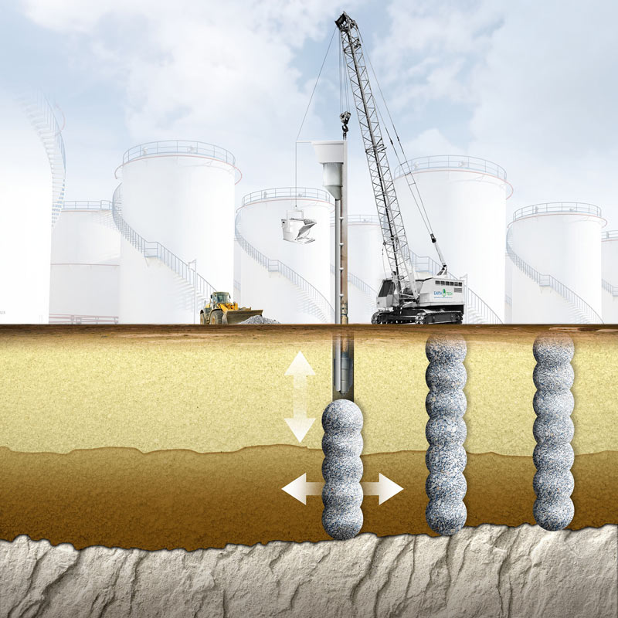

(Spears et.al. 2014)Image available at: https://www.semanticscholar.org/paper/Soil-Improvement-Using-Vibro-Replacement-Spears/b2f4697460af5d0be3ea960a46d27bf134e91cf2

Advantages and disadvantages
The obvious advantages are increased load-bearing capacity also reduction to settlement of soil. Some of the other advantages are its versatility as can be used in wide range of structures such as buildings, embankments and infrastructure projects. This process also produces minimal disruption due to not generating significant noise and vibrations.
On to the disadvantages, one of the major disadvantages is complexity of design as it requires careful consideration in regards of column spacing, dimensions and specific material. Another one is lack of support laterally as they hold vertical support well.

Ground Freezing
The process of turning pore fluids or pores into ice through constant soil refrigeration is known as ground freezing. The soil that holds water is very loose and lacks the shear and compressive strength required to support its own weight. The ground freezing procedure is used to strengthen these properties and temporarily render the water-bearing strata impervious. Usually, this is done to prevent ground water from flowing into the site area, offer temporary support, and provide structural foundation.
Ground freezing can be achieved with two separate methods known as direct and indirect.

Indirect ground freezing
This approach makes use of two coolants. Ammonia is the first coolant, and calcium chloride is the second. In the freezing unit, the ammonia is compressed and then allowed to cool. The ammonia is cooled by the condenser, changing its state from gas to liquid. In the cooling unit, the water is cooled. This liquid ammonia is passed, and its effect cools the secondary coolant down. The tubes that are driven parallel to the ground receive the cooled brine solution. The tubes freeze, and the ground around them likewise does. Repeat this cycle until the necessary amount of ground freezes. The time for completion of this process will have a variety of factors such as the size of the freezing plant and tubes as well as the size of the area and water content within the site.
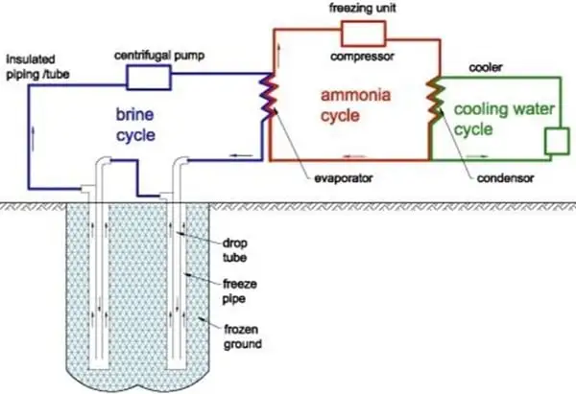

Image available at: https://theconstructor.org/geotechnical/ground-freezing-technique/16944/

Direct Ground Freezing
The direct method has two processes that can be used one being ‘by circulation of the primary refrigerant fluid through the ground tubes’ and the other being ‘by injection of a coolant into the ground, such as liquid nitrogen’.
Ammonia is the only substance employed in the freezing process in this kind of direct ground freezing approach. Although there is just one coolant utilised, the procedure is the same as with the indirect approach. After being crushed, the ammonia is injected into the underground tubes. The earth around the tubes freezes as a result of the ammonia. This procedure takes the same amount of time as an indirect process; however, it is more efficient than an indirect approach.
With the use of the other direct technique there's no need for an ant refrigeration facility using this strategy. Ammonia is transported to the location under mild pressure and kept there in insulated tanks. Return pipes are provided so that the tubes can be pushed into the earth and exhaust to the atmosphere. One benefit is that it may be quickly frozen without requiring complex fixed plant and equipment—perfect for emergency use. This could be doubly beneficial for locations far from power sources. Under these circumstances, nitrogen can be released straight into the atmosphere through tubes drilled into the earth.

Advantages and disadvantages
One advantage is that this method provides temporary underpinning to adjacent structures and support during permanent underpinning. It also allows shaft construction in non-cohesive, saturated grounds. However, there are some drawbacks those being the cost of the method as well as it needs continuous monitoring to detect any failures that can lead to subsidence of buildings and collapsing of soils due to lack of strength. A major advantage of ground freezing is that it can immobilise any radioactive or contaminated soil. This was shown in Japans radioactive plant known as Fukushima Daiichi nuclear power plant.

Preloading of soil
The pre-loading technique was created in the 1940s and was mostly applied to highway-related projects. However, this method is currently considered to be highly helpful and is applied to many different projects, including airfields, storage tanks, buildings, and flood control structures. This technique's disadvantage is that it doesn't produce good outcomes for structures with heavily concentrated loads.
However, soils with high moisture concentrations, high compressibility, and poor shearing strength respond well to this treatment. Eliminating settlements that would otherwise need to be done once construction is finished is another benefit.
The preloading approach is used to improve the weak soils before to beginning the proposed building. Pre-load pressure typically ranges from 1.2 to 1.3 times the actual structural pressure, or it may be marginally higher than the maximum pressure produced by the suggested structural load.

Grouting
This technique is widely applied in subsurface and foundation building for ground enhancement. It's a rather prevalent practice these days. The method involves using a liquid form substance to fill in cracks or cavities in hard stratum or soil in order to reduce permeability and boost cohesion once the material has set. Cement base grout mixes are typically utilised for severely layered surfaces. Grout mixtures that are chemical or organic are also utilised occasionally. The effectiveness of hydraulic base grout for soil treatment has increased recently with the development of ultrafine grout mixes.
The grout mix is dependent on the soil’s nature and gradation of the soil. The grouting categories consist of the following.
- Penetration grouting
- Displacement grouting
- Compaction grouting
- Grouting of voids
- Jet grouting

Advantages and disadvantages
Grouting has many advantages to new or existing structures; grouting helps with the control of groundwater flow and is suitable for all soil conditions. This procedure doesn’t produce any vibrations so can be used on existing structures as is doesn’t produce any structural damage, it also works on strengthening or lifting deformed foundations known as ‘slab jacking’.
Onto disadvantages grouting holds the usual disadvantages as most other forms which is time consuming, but it also has an economical effect with the manufacturing process of creating the grout due to the carbon emissions created.

Geosynthetics

Geosynthetic soil improvement techniques involve the use of synthetic materials to enhance the engineering properties of soil in various construction applications. These materials, collectively referred to as geosynthetics, offer solutions for reinforcing, separating, filtering, and draining soil, thereby improving its stability, durability, and performance. Here's an overview of some key geosynthetic soil improvement techniques:
Geotextiles are permeable fabrics made from synthetic fibers like polypropylene or polyester. They are used to reinforce soil, separate different soil layers, and provide filtration and drainage functions. Geotextiles are commonly employed in road construction, erosion control, and landfill engineering to enhance soil strength, prevent soil erosion, and improve drainage.
Geogrids are rigid or flexible mesh-like structures made from polymers or metals. They are used to reinforce soil by distributing loads over a wider area and reducing soil movement. Geogrids are commonly used in retaining walls, slopes, and embankments to improve stability and prevent soil erosion.
Geocells, also known as cellular confinement systems, are three-dimensional honeycomb-like structures made from interconnected panels or cells. They are filled with soil, aggregate, or concrete and used to confine and stabilize soil in applications such as slope stabilization, erosion control, and load support for pavements. Geocells improve soil shear strength, prevent soil erosion, and provide a sustainable solution for various civil engineering projects.

Examples of real-life scenarios
One case study is the land reclamation in Singapore and the use of dynamic compaction technique. With Singapore being well-known for its massive land reclamation initiatives. Sand layers overlying marine clays were hydraulically filled due to the requirement for more area for development. The problem was that the fill material's considerable variation in stiffness from the soft coastal clay underneath presented a risk of differential settling.
Another example of deep compaction was the Burj Khalifa, the project entailed challenges due to the weak soil conditions, the vibro compaction technique was used which involved vibrating probes to densify the ground and increase its bearing load.
Kansai International Airport, Osaka, Japan was built on a man-made island in Osaka Bay, Kansai International Airport required innovative ground improvement techniques due to the soft marine clay deposits. The airport's foundation includes a combination of deep cement mixing, surcharge preloading, and ground improvement using vertical drains to stabilize the soil and mitigate settlement.
Hong Kong-Zhuhai-Macau Bridge, China. The construction of the Hong Kong-Zhuhai-Macau Bridge, the world's longest sea-crossing bridge, involved ground improvement techniques to address challenging soil conditions and seismic risks. Various methods, including deep cement mixing, stone columns, and surcharge preloading, were employed to stabilize the soft marine clay and improve the bearing capacity along the bridge alignment.

These case studies demonstrate the critical role of ground improvement techniques in overcoming soil challenges and ensuring the success of complex civil engineering projects. By employing innovative and site-specific methods, engineers can effectively enhance soil stability, mitigate risks, and optimize the performance of infrastructure developments.

Importance of ground improvement methods
The choice of appropriate methods for soil strengthening and ground improvement is dependent upon a number of factors, such as the nature of the soil, site-specific characteristics, and project design features. In order to choose the best course of action for every project, engineers and geotechnical experts must carefully weigh these variables, considering both immediate performance and long-term sustainability. Furthermore, new developments in technology, materials, and building methods keep broadening the range of approaches that might need to be considered.
Vibro-compaction is one of the effective ways to improve bearing capacity and soil density using compaction techniques. These methods work especially well in granular soils, but they could be challenging to use in cohesive or saturated soils where it can be hard to achieve proper compaction. Furthermore, if compaction is not done correctly or if underlying voids are not sufficiently addressed, it may result in ground surface settlement.
Chemical techniques like grouting and ground freezing alters the soil properties resulting in improvement of strength, however these methods come at a price and are only beneficial within certain ground conditions e.g. saturated grounds.

References
TheConstructor (2024) Ground improvement techniques for stabilization of soil for various purposes. Available at: https://theconstructor.org/geotechnical/ground-improvement-techniques-soil-stabilization/1836/ (Accessed 8th April 2024)
Semantic Scholar (2014) Soil improvement using Vibro-replacement. Available at: https://www.semanticscholar.org/paper/Soil-Improvement-Using-Vibro-Replacement-Spears/b2f4697460af5d0be3ea960a46d27bf134e91cf2 (Accessed 8th April)
VIBRO (2024) Vibro stone columns- Advantages and disadvantages. Available at: https://vibro.uk/vibro-stone-columns-advantages-and-disadvantages/ (Accessed 8th April)
TheConstuctor (2024) Ground freezing techniques for soil stabilization-Methods, Advantages, Applications. Available at: https://theconstructor.org/geotechnical/ground-freezing-technique/16944/ (Accessed 13th April 2024)
CivilEngineeringTerms (2011) Preloading technique of ground improvement. Available at: https://www.civilengineeringterms.com/soil-mechanics-2/pre-loading-technique-of-ground-improvement/ (Accessed 14th April 2024)
Ayele (2017) A Case Study on Ground Improvement Techniques and Its Applications. Available at: https://www.ijser.org/researchpaper/A-Case-Study-on-Ground-Improvement-Techniques-And-Its-Applications.pdf (Accessed 14th April 2024)
Lavanya (2023) What are the pros and cons of grouting? Available at: https://civilenggblitz.com/grouting-advantages-and-disadvantages/#:~:text=Grouting%20advantages%3A%201%20Grouting%20works%20helps%20to%20control,levels%20or%20lifts%20the%20deformed%20foundations.%20More%20items (Accessed 16th April 2024)
Mainline Materials (2020) The ultimate guide to Geotextiles. Available at: https://www.mainlinematerials.com/blogs/mainline-materials-blog/the-ultimate-guide-to-geotextiles#:~:text=A%20Geotextile%20is%20permeable%20fabrics%20that%20can%20filter%2C,three%20forms%3B%20woven%2C%20needle%20punched%2C%20and%20heat%20bonded. (Accessed 17th April 2024)
NIH (2021) Polymer geogrids: A review of material, design, structure relationships. Available at: https://www.ncbi.nlm.nih.gov/pmc/articles/PMC8399111/ (Accessed 17th April 2024)
EGS geosolutions (2024) What is Geocells or cellular confinement systems? Available at: https://ecogeosolution.com/geocells/ (Accessed 17th April 2024)
TheConstructor (2024) Burj Khalifa construction of the tallest structure in the world. Available at: https://theconstructor.org/case-study/burj-khalifa-construction/62758/ (Accessed 19th April)
Simply Flying (2020) The airport island: The story of Osaka Kansai International airport. Available at: https://simpleflying.com/osaka-kansai-airport/ (Accessed 19th April 2024)

