Effective Team Work and Communication
Student name: Ioan-Alexandru Sumanaru
Student ID number:1713838

Communication on my friend workplace

Table of Contents
Introduction ………………………………….. 3
Employer’s performance at communication … 4
Improving Workplace Communication and performance … 10
Conclusion…………………………………………………. 12
References ………………………………………………… 13

Introduction
Great Communication is the vital part of making objectives reachable. The group pioneer communicates venture desires to every one of the players, and work is partitioned genuinely in view of every individual's extraordinary qualities and capabilities. According to Severin and Tankard (2010), communication is the way toward passing data and comprehension starting with one individual then onto the next. It is simply the way toward conferring thoughts and influencing oneself to comprehend by others (Dörnyei and Scott, 2011). In this reflective analysis communication skill and how teamwork makes the job much enjoyable will be discussed. One of my friends Tina work in Coca-Cola UK as an HR executive and she reports to the HR manager. Here Tina’s experience with her manager and various skills of her manager and some recommendation to better his performance at workplace will be expounded based on theories and models.

Employer’s performance at communication
Communication is a precise procedure in which people collaborate with and through expressions and symbols to make and translate meaning. Communication is giving, accepting, or trading thoughts, certainties, feelings, signals, information, or messages through fitting media, empowering people, or gatherings to convince, to look for data, to give data or to express feelings (Guetzkow and Simon, 2012). Business communication can likewise be said to be the way workers, administration and organization communicate with each other for reaching to the organization's end goal efficiently and effectively (McQuail, and Windahl, 2015). Employers should be proficient in communication whether it is face to face, over the phone or by letters. In this part, an employer’s performance in communication and teamwork will address with the support of some models and theories. For real-life experiences, I will be analyzing my friend’s employer’s communication skill who is an HR manager of Coca-cola UK.
In 1948, Shannon was a mathematician, Electronic designer of America and Weaver was an American researcher then them two consolidated to compose an article in "Bell System Technical Journal" called "A Mathematical Communication Theory" and furthermore called as "Shannon-Weaver Communication Model" (Abdin, 2008). This model is extraordinarily intended to build up the viable correspondence amongst sender and beneficiary. Additionally, they discover factors which influencing the correspondence procedure called "Commotion". At first, the model was created to enhance the Technical correspondence. Later it's generally connected in the field of general Communication.
The model manages different ideas like Information source, transmitter, Noise, channel, message, collector, channel, data destination, encode, and also decode (Frey, Fisher, and Everlove, 2009).
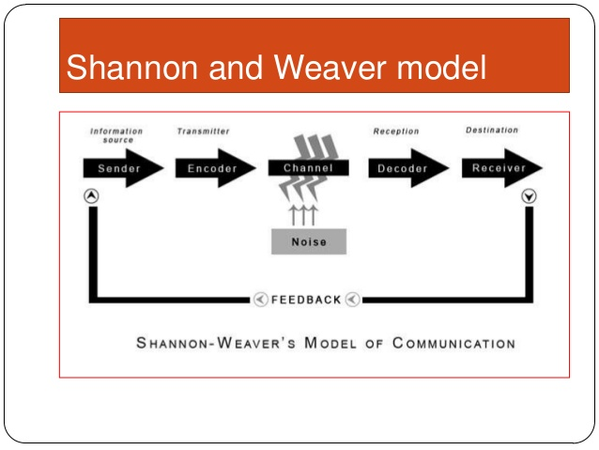
Figure- 1: Shannon and Weaver Communication Model
Source: (Abdin, 2008).
In the Shannon model, the first part is the sender who creates the message or the source from where the message will be transmitted. In Coca-cola company where my friends work under HR manager, everyone plays the sender’s role at the certain time. But mostly his direct boss the manager determines the way and methods of communication. The manager communicates mainly face to face, over e-mail, phone or sometimes giving written instructions.
This model was fundamentally proposed for specialized fields which is the reason the encoder component in the model mostly centers around the innovation that changes messages into binary codes or signals, for example, if there should arise an occurrence of phone discussion then the voice is changed into waves ((Abdin, 2008). In my friend's office, the correspondence isn't simply restricted to phone discussion; rather it can occur face to face or composed correspondence can likewise happen. The manager plays a vital role in oral communication because gestures and words are very important in this communication medium.
Channel of communication means the way through which the information is passed from sender to receiver (Stern, 2014). Previously people use the letter as a channel and also air if is a verbal communication. In this modern era, there are various channels like telephone wire and network. The HR manager of coca-cola UK uses cable for telephone or fax communication and network for online communication. In computerized communication decoding is used for reading secure messages.
Noise in communication alludes to impacts on fruitful communication that impact the translation of discussions (Frey, Fisher, and Everlove, 2009). While most often neglected, correspondence noise can have a significant effect both on our impression of connections with others and our study of our own communication capability. There are numerous types of noises such as physical, psychological, and semantic noise. Loud or low voice, mumbling, different jargons can be considered as noise in communication (Stern, 2014). So while doing communication these noises also interrupted my friend and her boss’s communication thus my friend might not understand the message. By analyzing the case of my friend’s manager, it has been found that he neglects these noises in communication, he barely takes any feedback from his executives and it creates a communication gap.
Transactional model is the procedure of uninterrupted change and transformation where each part is changing, for example, the general population, their surroundings, and the medium utilized (Barnlund, 2017). Because of this, it accepts the communicators to be free and act any way they need. Since both sender and beneficiary are important to keep the correspondence alive in a transactional model, the communicators are additionally reliant on each other. For instance, the correspondence isn't conceivable if the receiver isn't tuning in to the sender.
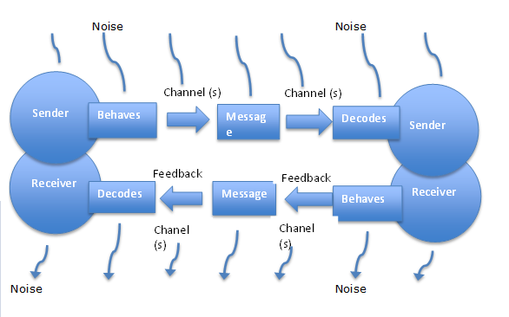
Figure- 2: Transactional Model of Communication
Source: (Barnlund, 2017).
By analyzing my friend’s situation it can be referred that they use “Transactional Model” in their communication. Her manager continuously gives instructions and she has to be very careful with every word. Sometimes she can give feedback but sometimes she can’t. Their channel of communication also varies from time to time such as face to face, email, telephone etc.
In the transactional model, there are encoding and decoding. While my friend and her boss communicate through the computer they encode and decode the messages. When the boss is the sender he encodes the message and my friend the receiver decodes the message with a password if it is confidential.
While the above-mentioned elements are rudimentary for any kind of communication, there are some other things for developing the performance at communication. Team development alongside plays a vital role in effective communication.
The forming– storming– norming– performing model of team advancement was first recommended by Bruce Tuckman in 1965, who explained that these stages are largely vital and unavoidable all together for the group to develop, look up to challenges, handle issues, discover arrangements, plan work, and convey results (Cassidy, 2017).
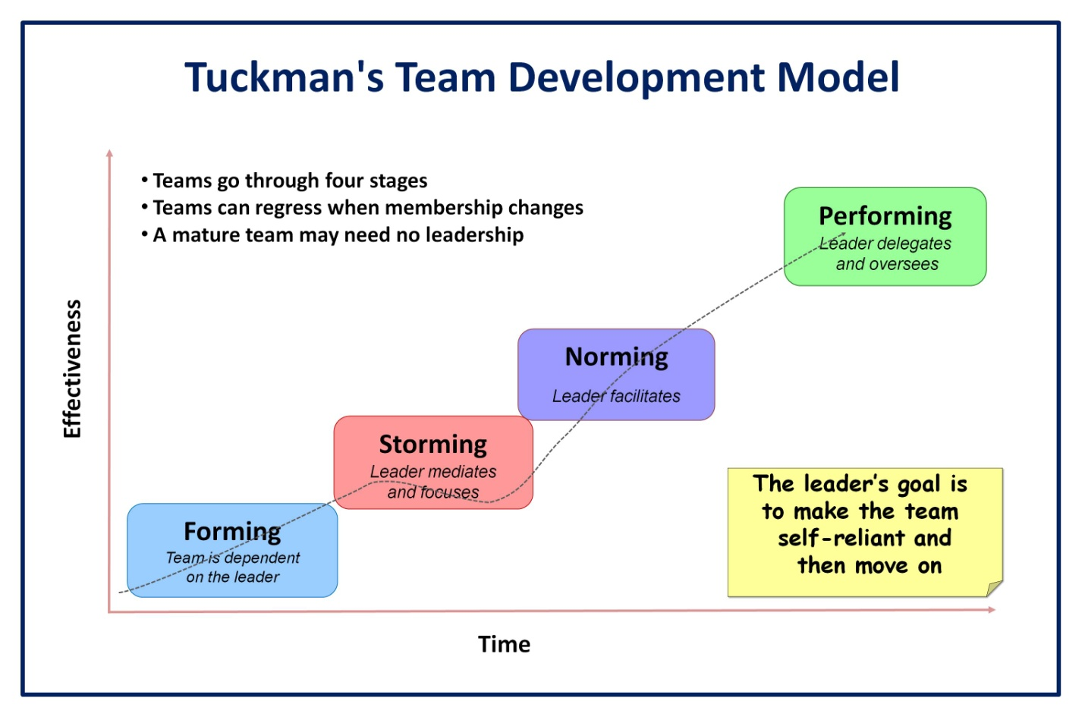
Figure- 3: Tuckman’s Team Development Model
Source: (Stern, 2014).
According to McQuail and Windahl, (2015), “In the forming period, the group meets and finds out about the opportunities and difficulties, and afterward concurs on objectives and starts to handle the errands”. Colleagues have a tendency to carry on freely. In my friend's team, most of the members are strangers to each other. Her colleagues are typically on their best conduct yet extremely centered on themselves. At first, they had an orientation program and they tried to know each other. They faced some communication problem among themselves and also the HR manager failed to make them understand their assigned work. There were some noises in the communication that prevent the executives to ask questions of the manager. It created a great mess but later sorted out with time.
This is the second phase of group improvement where the team begins to get itself straightened out and increase each other's trust. This stage frequently begins when they voice their sentiments and because of this, a contention may emerge between colleagues as power and status are allocated (Scarnati, 2010). The tasks of the group members are described by the team leader, he also depicts the distinctive practices to the team and how to the arrangement and handle dissensions. In my buddy’s case, the HR manager was the leader; he gave instructions to his executives from the beginning. He holds various meetings for assimilating works to other group members. He uses various business jargons, at first, the employees including my friend couldn’t comprehend those words, but later they learned that too.
In the Norming period, most of the contradictions faded away because the cooperation among the colleagues increases through trust and motivation (Cassidy, 2017). This happens when the group are aware about the rivalry and they share a shared objective. In this stage, my friend and her colleagues assume the liability and have the desire to work for the achievement of the group's objectives. They begin enduring the impulses and likes of the other colleagues. My friend’s manager started to know everyone and thus their understanding increased. Now they all understand the odds and share a single goal to reach.
In this phase with amass standards and roles given, team's individuals center around accomplishing shared objectives, frequently achieving an upper state of success. At this time, they are encouraged and learned. The colleagues are presently able, self-sufficient, and ready to deal with the basic leadership process without supervision (Severin and Tankard, 2010). In Coca-Cola's case, the HR manager was able to encourage the executives including my friend towards the organization’s goal. Their productivity and achievement are worthy now. Now my friend can also work on her own without the direct supervision of the manager, this saves time but she can’t be up to date with the manager all the time.

Improving Workplace Communication and performance
By analyzing the performance of my friend’s immediate boss HR manager at communication, there are some recommendations given in this part to flourish his communication skill and teamwork at the workplace.
It has been found that the HR manager lacked in giving proper instruction to the executives. Clear directions give representatives an activity plan and they can center on conveying the best outcomes in an auspicious way (Gersick, 2016). The manager can use organization pamphlets, manuals, graphs, intranet updates, and face to face meetings for passing clear headings to representatives with the goal that they know their obligations. This prompts a huge advancement of execution in the work environment and enhances profitability levels.
Sometimes using jargons make it difficult to pass the exact information to others. Jargon meddles with the stream of communications in three distinctive courses: by closing it off, by backing it off, and by muddying the thoughts people are endeavoring to impart (Frey, Fisher, and Everlove, 2009). It has been found that the HR manager uses jargons in his speech and this creates misinterpretation in the communication. The manager should use jargon-free simple speeches that are easily realized by others. This will also reduce any kind of misunderstanding and thus flourish the productivity.
From my friend’s case, it is clear that the HR administrator doesn’t look for any kind of feedback from his executives and this creates troubles in communication. Feedback is indispensable in communication in order to know whether the beneficiary has comprehended the message in indistinguishable terms from planned by the sender and whether he consents to that message or not (Cassidy, 2017).
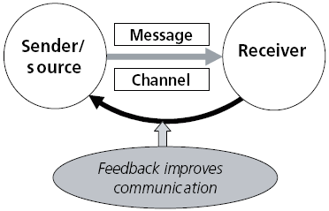

Figure- 4: Feedback in Communication
Source: (Cassidy, 2017).
There are various methods by which organization gets hold of feedbacks from their workers, for example, employee reviews, email, memos, open-entryway strategies, organization newsletter and so on (Dörnyei and Scott, 2011). The manager can use these methods to take feedback from the employees. Representatives are not continually ready to give criticism. The administrator needs to work a great deal to get the exact input. The administrator empowers input by making particular inquiries, enabling their workers to express broad perspectives, and so forth. The manager ought to be open to their representative's input.

Conclusion
Communication is not just talking and listening, it is more likely to connect with people. Good communication assists the employer to instruct the employees to achieve the desired goals. It also increases employee engagement in their work and aligns their objectives with the organization’s objectives. It is crucial that the employer should be effective in his communication and teamwork. Team development yields creativity by brainstorming, face to face meeting, and giving feedback. Feedback helps to remove any kind of misinterpretation and thus sender and receiver relation growths.

References
Severin, J. and Tankard, W., (2010) Communication theories: Origins, methods, and uses in the mass media. Pearson College Division.
Dörnyei, Z. and Scott, L., (2011). Communication strategies in a second language: Definitions and taxonomies. Language learning, 47(1), pp.173-210.
Scarnati, T. (2010). On becoming a team player. Team Performance Management: An International Journal, 7(1/2), 5-10.
Guetzkow, H. and Simon, H.A., (2012). The impact of certain communication nets upon organization and performance in task-oriented groups. Management science, 1(3-4), pp.233-250.
McQuail, D. and Windahl, S., (2015). Communication models for the study of mass communications. Routledge.
Stern, B., (2014). A revised communication model for advertising: Multiple dimensions of the source, the message, and the recipient. Journal of Advertising, 23(2), pp.5-15.
Gersick, J., (2016). Time and transition in work teams: Toward a new model of group development. Academy of Management Journal, 31(1), pp.9-41.
Cassidy, K., (2017). Tuckman revisited: Proposing a new model of group development for practitioners.
Abdin, J., (2008). The Barriers of Communication & Guidance of Effective Communication. SSRN Electronic Journal.
Frey, N. Fisher, D. and Everlove, S., (2009). Productive group work. Alexandria, Va.: Association for Supervision and Curriculum Development.
Barnlund, C., (2017). A transactional model of communication. In Communication theory (pp. 47-57). Routledge.

