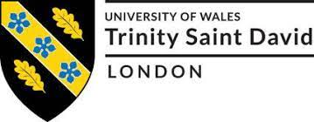

HUMAN RESOURCE MANAGEMENT
Programme: MBA – Masters of Business Administration
Module Title: Human Resource Management Assessment 2
Assignment Title: Human Resource Management Assignment 2
Module code: LCMB7000
STUDENT NAME: PRUDHVI RAJ GOUD PARUPALLY
STUDENT ID: 2130641
Date of submission: 14TH September 2022

Table of Contents
1. Introduction 3
2. Human Resource Strategies 3
2.1 Change management 3
2.2 Staffing: Recruitment and availability of skilled local labour 5
2.3 Learning and development 6
3. Impact of chosen strategies on team members 8
4. Conclusion 10
Reference List 11

1. Introduction
The report demonstrates the Human Resource Strategies that are important in organisations and how they would affect the employees. A human resource strategy is required to analyse the skills of the workforce and understand possibilities in which they could be improved and make sure that their employees are updated with the current market. The strategy for human resources is rooted in the process of managing human capital so it can perform in alignment with the company’s objectives. With Human Resource Strategy in place, the company can tap into the true potential of the employee and brainstorm various ideas and how to improve their workforce. Companies need to build their human resource strategies to be transparent to their employees about the way they plan to take care of them. The company can choose to set a code of conduct within the strategy and monitor the behaviour of the employees, to see if they are following the code or not.

2. Human Resource Strategies

2.1 Change management
The change management for any company might be overwhelming and hence the company should take care before implementing a change process in the company. A change is sometimes needed to keep up with the market trends and to stay relevant amongst the customers. However, the company might meet with some very resistant employees who might oppose change. In such a situation the company should not treat these employees harshly but instead the management should try to understand their point of view and why they resist the change.
The company of Microsoft has been around for generations and the company is one of the pioneers of software and computer systems. In 2020, Microsoft Business Operations collaborated with Microsoft Commercial sales and Microsoft Cloud Data Sciences to adopt modern business intelligence reporting solutions. The resulting solution was MSXi serves as an effective solution tool for every team across Microsoft like sales, organisation and finance teams (Delaini 2022). The change management system was implemented after the evaluation of the current state. In the traditional system, with the abundance of data, it was a major challenge for the leaders of Microsoft to align to the key metrics. Every team including finance, sales and operations used various types of sources for data collection which made it hard to discuss risks and effective issues.
The glaring security issue like data privacy was a key issue for Microsoft. The MSXi project aimed to serve the needs of the users of Microsoft and the employees who are involved with it. The technology required to create MSXi was challenging and the company devised a plan to choose a team (Xiao et al 2020). The technologies that were chosen were Microsoft Azure technologies and Microsoft Power BI. Rudy Nerinck, the senior business program manager in Employee Experience, commented that convincing people to shift to MSXi was not easy, even within the company. Human beings do not accept change instantly, they take time to adjust to that change. People working at Microsoft were also sceptical about accepting a new business strategy and had to be convinced about the different types of benefits this tool might bring.

The design of the MSXi solution was also tasked with addressing the change management in the workforce. The change management practices were described through the Warwick Model. Human resources are located at the centre of the business philosophy, and the companies are attentive to developing strategies based on the best solution to improve human resources. The Warwick Model was created by two scholars of the University of Warwick- Hendry and Pettigrew. The Warwick model places immense importance on a data-driven approach in connection with Human Resource Management (Uysal 2019). The model can also have a significant impact on the people's functions on the subject of human resource strategy. The Warwick model is constructed on five components:
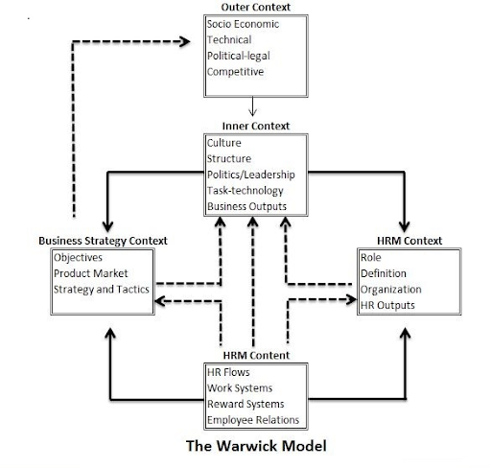
Figure 1: Warwick Model
(Source: Farndale et al 2020)
- Outside context (Macro Environment)
The macroenvironment context for Microsoft was the possibility of cyberattacks on their system from external forces. For a technology company like Microsoft, the amount of data that they store and the million users across the planet will be the other end of suffering consequences due to a data breach. The company is required to take care of the data of their company and its users. The consequences of the cybersecurity breach can have a major impact on the company. The reputation of the company might be irreparably damaged, and it can lead to the loss of customers who are key stakeholders of the company.
- Inner context (Microenvironment)
The inner context, in this case, is the massive amount of data that was scattered within the company and distributed amongst different teams like finance, sales and operations. With the MSXi, these teams can have one single solution for every problem.
- Business Strategy
Microsoft attempted to understand the areas they needed to focus on and how to navigate the resources in different company projects. The MSXi ensured that the objectives of the company were met and the tasks of the company were accomplished within the period.
- HRM context
The company invested time to realise the true benefits of the company and for the employees. The tool that can increase the productivity of the workforce. The executives of the company listened to the employees and understood what they required.
- HRM content
The company should remember to reward the people working under them and appreciate their hard work. The company should be attentive to recruiting talented people for their company.

2.2 Staffing: Recruitment and availability of skilled local labour

Microsoft is a global company and it has set up its offices across the world. The company has to recruit local citizens as employees for their company. Recruitment in a foreign country poses key challenges to Microsoft which has its roots in the USA. Microsoft recruits both students and experienced people. They have two recruitment programmes and through this, they ensure that the diversity of the workforce is ensured.
The local market can be filled with several challenges like automation and digitalisation challenges and a lack of skills. The management has to navigate through the cultural differences of that country. The market of that country might have different types of rules and laws regarding trade and business. Therefore, Microsoft will have less autonomy in these markets and they might experience constraints while conducting the business and suffer risk penalties. Simultaneously recruitment patterns of that country might be different from what the company uses in its recruitment process. Microsoft should examine the demography of that region and the local labour market and be attentive in supporting the skills and the policies of that market (Mohd Fateh Mohamed and Omar 2022). The company needs to tailor its recruitment policy in alignment with local employment and skills.
Microsoft needs to train the local employees to their level of skill and see to it that these new employees meet the requirements of the company. In developing countries, many migrants have moved from third-world countries and settled for a better life. Microsoft is known for its skilled employees and while operating in the foreign market it might experience a crucial skilled labour shortage. The company needs to pay attention to the participation of the local labour and properly motivate them.

2.3 Learning and development
Organisational learning is an extremely crucial measure for every company because the tension and the exchange of knowledge within the organisation will help to lay a stronger foundation for that company when a particular idea or a product is conceived by the management of the company or the employee (Zheng et al 2018). The company needs to reflect on that idea and understand how the outcome of the learning will occur moreover they should also realise how to create that product and turn that idea into reality.
Through the process of turning the idea of the product into reality, the organisation needs to understand that the knowledge that is gained from this method has to be retained with the company and used in the future (Ghahramani et al 2022). The knowledge that is retained by individuals alone may not be accurately retained and in the end and the employees in that company might leave because they might forget. The embedded knowledge should be stored in the organisational data which can be shared with the existing employees and the future workforce. Organisational learning is the process of understanding the importance of implementing a learning culture in the organisation and that this learning should benefit the individuals and the company as a whole.
The theory of organisational learning focuses on the process of creation of knowledge and the implementation of that knowledge in that organisation (Chung, Ding and Ma 2019). Within this theory the company should:

Figure 2: Components of Organisational Learning
(Source: Antunes and Pinheiro 2020)
- Develop a culture that emphasises the sharing of knowledge.
- Invest time in learning and taking lessons from failures.
- Encourage employees to learn and engage in learning in the long-term period.
The importance of organisational learning can read different benefits for the company. the employees might be more satisfied with the organisation and its policies, which might lead to job satisfaction. Organisational learning might serve to increase productivity and the efficiency of the employees working in the organisation and the operational processes of the company. When creating a process of continuous learning, the organisation can ensure that the employees might be teachers and students if there is an equal share of information within the workforce substantially.

3. Impact of chosen strategies on team members

These strategies chosen for the human resources of a company might have a crucial impact on the team members. The first strategy chosen by Change management can have a significant impact on the employees and might change their behaviour in the aftermath of the change. Change management can be overwhelming for team members and therefore the company should understand the impact that it would leave on its employees. Learning and development as explained above are important for the organisation and the employees to keep updated with the various changes that occur in the business environment. the organisation needs to Remember that the employees will not be able to perform properly if they are not informed of the different changes that have occurred in the business environment. Since Microsoft is an International Technological company, they need to renovate its recruitment strategies and pay attention to how the recruitment pattern changes in the various foreign markets in they operate. The local labour of that country might have different skills or have a crucial shortage of skills when it comes to dealing with technology. These three criteria an intricately linked with each other when it comes to dealing with the human resource working in the company.
Maslow's hierarchy of needs looks to be the different criteria that a human being needs to have to attain their full potential (Stewart, Nodoushani and Stumpf 2018). Microsoft as an international company should also pay attention to serving the essential and self-fulfilment needs of their employees. The theory of Maslow's hierarchy of needs states that human beings should fulfil their needs according to the pyramid that Maslow has suggested.

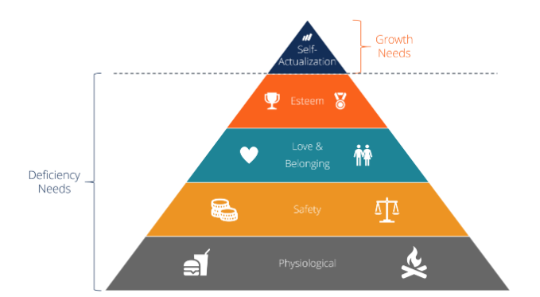
Figure 3: Maslow’s Hierarchy of Needs
(Source: Fallatah and Syed 2018)
The pyramid shown above begins from the bottom showing the physiological needs like shelter and food to be the force needs that are supposed to be fulfilled. The second part of the pyramid looks at the safety issues that might come into a person’s life. They need to find stability and security in their lives, which could be related to their source of income. The third rung in the pyramid is focused on family and belonging. Every person needs to belong somewhere and they need to be loved. Maslow stated that human beings crave family and love, thus this is an important element for human beings (Ștefan, Popa and Albu 2020). The employees who work at a company should also be made to feel a part of a family and appreciated for their hard work. The fourth pyramid is focused on the esteem needs of the person. Every human being craves to be appreciated, which can motivate them to work harder. The final stage of Maslow's hierarchy of needs looks at the self-actualisation of the person, which is the zenith of the individual's potential. The management should make sure that these needs are met, which will contribute to staff retention.
In the organisation, Microsoft practices a culture of a growth mindset. The growth mindset is based on a foundation of a workplace that cultivates growth and development. The Principal Developer of the department of Machine Learning, Jennifer emphasises that this “growth mindset” allows the employees to try amazing things and innovate in an unconventional manner (careers.microsoft.com 2021). The company is also committed to its pursuit of understanding the needs of its customers. Microsoft looks at the customers from the mind of a novice and tries to bring in solutions to meet their requirements. Microsoft is also attentive to recruiting a diverse workforce from every cultural background, which serves to elevate the skill of their workforce and the company. The company opines that they are bound by a single mission. Microsoft believes in collaboration and the ideas of different people and is committed to bringing the best to its customers.
'One Microsoft' is how the company refers to itself and is centred on achieving its vision, and empowering each individual and organisation. Swetha Machanavajhala joined Microsoft in 2019 and has been deaf since birth. She struggled to communicate with her parents on video calls since the internet connection back in India was poor, and Swetha was unable to read their lips (Ray 2019). Thus, Swetha decided to build certain features in Microsoft Teams and Skype which enabled her to blur the background. Nadella's decision to empower employees worked out well for Swetha, as she was able to bring in a host of new and unconventional features to the company. The Annual Hackathon held at the company helped light an innovative spark amongst the employees and they felt encouraged to work on new ideas. Nadella incorporated a new kind of management that concentrated on collaboration and openness. Chris Kauffman, a marketing manager of product licensing at Microsoft, felt energised at the Hackathon. The openness has led to the influx of new products and enhanced improvements.

4. Conclusion
The Human Resource Strategy is very crucial for every company, to realise the full potential of the employees. Microsoft is an internationally acclaimed company that has managed to expand its business across the globe. Thus, the company should be attentive to the type of human resource strategy they are undertaking. Change management and organisational learning are necessary for every business to stay updated with the rapid changes in the business environment. Moreover, the company has to recruit local labourers from the foreign market where they operate. Microsoft has the provision of hiring both young graduates and experienced candidates since they believe in talent more than skills.

Reference List
Antunes, H.D.J.G. and Pinheiro, P.G., 2020. Linking knowledge management, organizational learning and memory. Journal of Innovation & Knowledge, 5(2), pp.140-149. [Available at: https://www.sciencedirect.com/science/article/pii/S2444569X19300319 ]
Careers.microsoft.com, 2021.We listen and learn from the world around us. [online] Available at: https://careers.microsoft.com/us/en/culture [Accessed on 1st September 2022]
Chung, H.F., Ding, Z. and Ma, X., 2019. Organisational learning and export performance of emerging market entrepreneurial firms: the roles of RBV mechanism and decision-making approach. European Journal of Marketing, 53(2), pp.257-278. [Available at: https://www.emerald.com/insight/content/doi/10.1108/EJM-08-2017-0496/full/html ]
Delaini, 2022.How Microsoft used change management best practices to launch a new business intelligence platform. Serah Delaini [online] Available at: https://www.microsoft.com/insidetrack/blog/how-microsoft-used-change-management-best-practices-to-launch-a-new-business-intelligence-platform/ [Accessed on 1st September 2022]
Fallatah, R.H.M. and Syed, J., 2018. A critical review of Maslow’s hierarchy of needs. Employee Motivation in Saudi Arabia, pp.19-59. [Available at: https://link.springer.com/chapter/10.1007/978-3-319-67741-5_2 ]
Farndale, E., McDonnell, A., Scholarios, D. and Wilkinson, A., 2020. Human Resource Management Journal: A look to the past, present, and future of the journal and HRM scholarship. Human Resource Management Journal, 30(1), pp.1-12. [ Available at: https://onlinelibrary.wiley.com/doi/pdf/10.1111/1748-8583.12275]
Ghahramani, F., Yazdanmehr, A., Chen, D. and Wang, J., 2022. Continuous improvement of information security management: an organisational learning perspective. European Journal of Information Systems, pp.1-22. [Available at: https://www.tandfonline.com/doi/abs/10.1080/0960085X.2022.2096491 ]
Mayrhofer, W., Gooderham, P.N. and Brewster, C., 2019. Context and HRM: theory, evidence, and proposals. International Studies of Management & Organization, 49(4), pp.355-371. [Available at: https://www.tandfonline.com/doi/pdf/10.1080/00208825.2019.1646486]
Mohd Fateh, M.A., Mohamed, M.R. and Omar, S.A., 2022. The Involvement of Local Skilled Labour in Malaysia’s Construction Industry. Front. Built Environ, 8, p.861018. [Available at: https://www.researchgate.net/profile/Mohd-Ashraf-Mohd-Fateh/publication/359001661_The_Involvement_of_Local_Skilled_Labour_in_Malaysia's_Construction_Industry/links/6221a6af9f7b3246340c7a00/The-Involvement-of-Local-Skilled-Labour-in-Malaysias-Construction-Industry.pdf ]
Ray, 2019. Empathy and innovation: How Microsoft’s cultural shift is leading to new product development. Susanna Ray [online] Available at: https://news.microsoft.com/innovation-stories/empathy-innovation-accessibility/ [Accessed on 1st September 2022]
Ștefan, S.C., Popa, Ș.C. and Albu, C.F., 2020. Implications of Maslow’s hierarchy of needs theory on healthcare employees’ performance. Transylvanian Review of Administrative Sciences, 16(59), pp.124-143. [Available at: https://www.rtsa.ro/tras/index.php/tras/article/viewFile/624/612 ]
Stewart, C., Nodoushani, O. and Stumpf, J., 2018, July. Cultivating employees using Maslow's hierarchy of needs. In Competition Forum (Vol. 16, No. 2, pp. 67-75). American Society for Competitiveness. [Available at: https://search.proquest.com/openview/064449085a557cc2456df8989345f7e8/1?pq-origsite=gscholar&cbl=39801 ]
Uysal, G., 2019. Quantitative methods in human resource management. Uysal, Gürhan (2019). Quantitative Methods in Human Resource Management. Journal of Modern Accounting and Auditing, 15(7), pp.367-370.[ Available at: https://www.researchgate.net/profile/Guerhan-Uysal/publication/334670206_Quantitative_Methods_in_Human_Resource_Management/links/5d3945cc92851cd046844528/Quantitative-Methods-in-Human-Resource-Management.pdf ]
Xiao, G., Ma, J., Wang, S. and Chen, C., 2020. Deterministic model fitting by local-neighbor preservation and global-residual optimization. IEEE Transactions on Image Processing, 29, pp.8988-9001. [Available at: https://ieeexplore.ieee.org/abstract/document/9199561/]
Zheng, Y., Wang, J., Doll, W., Deng, X. and Williams, M., 2018. The impact of organisational support, technical support, and self-efficacy on faculty perceived benefits of using learning management system. Behaviour & Information Technology, 37(4), pp.311-319. [Available at: https://www.oaa.osu.edu/sites/default/files/uploads/nfo/2020/faculty-perceived-benefits-of-using-learning-management-system.pdf ]

