

Research Proposal

ACFA 7004

An Investigation of Text Generation Method of Maritime Traffic Scene

Table of Contents

1. Introduction 1
1.1 Purpose of the Study 4
1.2 Context 4
1.3 Rationale 5
1.4 Dependent and Independent Variables of the Experiments 6
1.5 Boundaries 6
2. Literature Review 7
2.1 Marine 7
2.2 Penetration Testing 12
2.3 Attack Surfaces and Threat Modeling 13
2.3.1 Microsoft Threat Modeling Tool 14
2.4 The OWASP ZAP Framework 15
2.5 Penetration Testing Tools 15
2.5.1 Kali Linux Tools 15
2.5.2 Miscellaneous Tools 17
3. Research Methodology 19
3.1 Introduction 19
3.2 Philosophical Worldview 19
3.3 Methodology 20
3.4 Research Approach 20
3.4.1 Deductive Approach 20
3.4.2 Inductive Approach 21
3.4.3 Quantitative, Qualitative and Mixed Methods 21
3.5 Ethical Issues 21
3.6 Research Strategy 21
3.7 Research Methodology Conclusion 22
4. Time Horizons: Gantt Chart 23
5. Results 24
5.1 Data Collection 24
5.2 Experiments 24
6. Evaluation 26
7. Conclusion 27
8. Bibliography 28
9. Appendix 1: CVE ‘Name:Wreck’ DNS Flaws in TCP/IP Stacks 35
10. Appendix 2: Gantt Chart 52

TABLE OF FIGURES

Figure 1: Growth of IoT Devices [4] 1
Figure 2: UK Drone Regulations [26] 5
Figure 3: Fixed Wing Drone [29] 7
Figure 4: Single Rotor Drone [29] 8
Figure 5: Quadcopter [29] 8
Figure 6: UAV Airspace [21] 10
Figure 9: Penetration Testing Cycle [35] 12
Figure 7: Microsoft Five Major Threat Steps [40] 14
Figure 8: Iterative Process of Threat Modeling [36] 14
Figure 10: Connection between Design, Research Methods and Worldviews [61] 19
Figure 11: Gantt Chart Text View 52
Figure 12: Gantt Chart Waterfall View 52

LIST OF TABLES

Table 1: Radio Frequencies [30] 9

Abstract
Maritime traffic scenarios involve complex and changeable environmental factors and the interaction between ships, which is an important issue for maritime traffic safety. The deep learning method is used to explain the maritime traffic scene, which is easy to understand, intuitive, and automatic, and can assist maritime traffic management and ship intelligent decision-making. The purpose of this paper is to find a method and analyze the possibility of quickly generating commentary text from videos. The research is still in its infancy and there is a lack of relevant benchmark data sets; moreover, marine traffic scenes are usually affected by factors such as ship navigation status and weather conditions, showing multi-modal characteristics; the interpretation needs to track marine traffic scenes in time to ensure timeliness accuracy and so on.
There are currently a large number of datasets available for general video-to-text tasks, but benchmark datasets for marine traffic scenes containing multimodal information are relatively scarce. In the multi-modal maritime traffic scene, the general neural network has insufficient ability to capture the spatio-temporal features of continuous video frames, and it is also difficult to represent and fuse multi-modal scene data. The literature reviews methods for constructing multimodal datasets and performance comparisons of various multimodal models, and concludes that this task can be accomplished with manually annotated datasets and multimodal models.

Introduction
At present, the development of the maritime transportation industry is changing with each passing day. There are more than 25,000 berths of more than 10,000 tons in the national ports [1]. Although the current satellite positioning function has brought convenience to the driver, the ship driver still cannot obtain more comprehensive maritime traffic information in time, so it is impossible to predict the danger in advance, which brings a huge safety hazard to the ship's navigation. At present, marine traffic broadcasting has alleviated these problems to a certain extent, but marine traffic broadcasting often has the characteristics of lag and incomplete information capture. The traffic station can learn the specific situation after a long time after a traffic incident occurs. In addition, in the huge marine traffic system, traffic incidents occur frequently, and the limited number of traffic broadcasts can't cover everything, which also leads to traffic chaos. At the same time, the maritime monitoring system is becoming more and more complete, and has basically achieved coverage of important ports and sea areas. However, due to the large number of monitoring scenarios, it is not only a waste of manpower to use manpower on duty around the clock, but also the work intensity is extremely high, usually unable to achieve satisfactory results, and it is also difficult to call so many human resources. In the busy maritime transportation, the transportation task is against time, and it is necessary to understand the traffic scene information more quickly, so as to provide better navigation safety guarantee.[12]
In the field of artificial intelligence, the research on extracting and describing effective information from multimodal scenes is attracting more and more researchers' attention. In recent years, thanks to the development of computer vision and natural language processing, some excellent Research results. Image subtitles, video summarization, and video narration are the main research directions of these works. The purpose is to express the content in the image or video in the form of human language. The visual content is usually movies, life records, or photographic works. The description sentences in these works generally do not combine information from other modalities, resulting in further improvement in the description accuracy. [13]Now there are studies that use the background information of characters to assist the interpretation of visual scenes, but because the marine traffic scene needs to consider the changing navigation indicators and weather indicators, rather than the relatively static background knowledge of characters.
These works cannot be directly transferred to this study. Therefore, there is a need for a method that can use multi-modal data to automatically interpret marine traffic scenarios to provide marine traffic managers and ship drivers with understandable and more intuitive marine traffic information and reduce labor costs. At the same time, since the surveillance video of the marine traffic scene has a strong time dependence and a fast scene evolution speed, the scene interpretation method should consider the spatio-temporal characteristics of the scene, and also need to have a high interpretation efficiency, so as to adapt to the maritime traffic. The characteristics of the scene. As far as we know, the current automatic interpretation method of marine traffic scenes is still in its infancy. By studying the differences between marine traffic scenes and other scenes, we can also explore more suitable artificial intelligence methods to solve the problems in marine traffic scene understanding.[21]

Purpose of the Study
The purpose of the study is to automatically interpret marine traffic scenes using multi-modal data is used to provide understandable and more intuitive marine traffic information to marine traffic managers and ship drivers, reducing labor costs.

Rationale
According to the current status of China's transportation system, it is found that the current maritime traffic monitoring system is already very developed, and its coverage rate ranks among the top in the world. In addition, although maritime satellite positioning and maritime traffic broadcasting are developing rapidly, the problem of maritime traffic safety still exists. Secondly, the development of artificial intelligence technology is changing with each passing day, and the research from video to text is also growing rapidly. Therefore, this paper also examines the research status of image-to-text and video-to-text tasks at home and abroad.[22]

Scope and Limitations
Because different data have a certain degree of heterogeneity, in the multimodal deep learning task, the multimodal processing method faces many difficulties, mainly including the following problems:
(1) Multimodal representation problem
The problem of multimodal representation is to express it in a more reasonable way by examining the characteristics of different modalities, and at the same time facilitate the processing of deep learning models. Representing multimodal data is a difficult task. Good representation has always been a key factor affecting the performance of deep learning models, which has been demonstrated in the performance improvement of speech recognition and visual object classification. In machine learning, a vector or tensor is usually used to represent a piece of data, but in the multimodal field, it becomes to use multiple such representations to represent multiple modalities. Unimodal representations have been extensively studied. In the visual field, most visual descriptions are learned from data using convolutional neural networks. In the textual field, the representation of words has transitioned from relying on a lexicon to using words. Embedding. [25]At present, most multimodal representations involve simple connections of unimodality, but this status quo is changing rapidly. More and more machine learning tasks are beginning to use multimodal data input. For marine traffic scenarios , choosing an appropriate way to represent video data and meteorological data is crucial to the learning effect of the deep learning model.
(2) Mode conversion problem
To convert data from one mode to another, not only the heterogeneity of data needs to be considered, but more importantly, the relationship between modes is often open or subjective, and there are many ways to describe a form , but there is no absolutely perfect description. In the maritime traffic scene, it is necessary to use natural language to explain the scene. This is a process of converting multi-modal scene data into text. What method to use to solve the problem of mode conversion is also a difficult problem faced by this paper.
(3) Alignment problem
The alignment problem is to find the corresponding relationship between the modes based on certain rules, and to align the meteorological data with a video. It not only needs to measure the similarity between the two modes, but also needs to deal with the long-term dependence and ambiguity that exist. Weather conditions usually affect the navigation of ships, and weather data usually cannot be updated at the sub-second level. Therefore, which time point to choose to align the meteorological data with a set of video sequence samples is also a problem to be solved in this paper.
(4) Multimodal fusion problem
Multimodal fusion is one of the research directions of multimodal deep learning. The reason why multimodal information is fused in the maritime traffic scene interpretation task is that this method will have a more robust effect. Secondly, video data and marine meteorological data can be used to obtain more complementary information, and a single modality often cannot achieve better results than multimodality.
There are two types of multimodal fusion methods, one is a model-independent method, and the other is a method based on a machine learning model. The model-independent method is simply connected manually after feature extraction. The currently widely used fusion method is the use of neural networks. Wollmer [38] used long short-term memory networks for continuous multi-modal emotion recognition, showing the advantages of multi-modal fusion methods based on neural networks over other fusion methods. Therefore, what kind of neural network to choose to fuse the video data of the maritime traffic scene with the meteorological data is a problem to be considered in this paper.
(5) Selection of evaluation methods
After the deep learning model successfully converts the scene information into the commentary text, choosing an appropriate evaluation method to evaluate the commentary text will promote subsequent model improvement, which will directly affect the performance of the commentary. Therefore, this paper needs to investigate the evaluation methods in related fields, make trade-offs according to their advantages and disadvantages, choose a method suitable for the evaluation of marine traffic scene explanatory texts, or propose a new evaluation method suitable for the shipping field.[18]
(6) Collaborative learning problem
The last problem is collaborative learning. Usually there is a missing video frame of a marine traffic scene, or a certain piece of marine meteorological data is missing. By learning the knowledge of one of the modes, it helps the computing model to train another different mode. It is particularly important in a special case.

Literature Review

Construction of Multimodal Datasets
At present, a large number of images or video data of marine traffic scenes can be obtained, such as HRSC2016, DOTA-v1.5, etc., but these video data are not aligned with marine meteorological data and text descriptions based on time stamps. After investigation, there is currently no video at the same time , meteorological data, and a dataset of text descriptions are proposed.
In addition, because the scenes in the current video-to-text work are mostly life scenes or pictures of film and television works, the maritime traffic scenes are quite different from these scenes. On the one hand, from the perspective of the described objects, life or film and television scenes pay more attention to people or living objects and the relationship between them, while the main focus of marine traffic scenes is the type of ship, navigation status and other factors in the scene. Impact. On the other hand, from the perspective of description, the description of life or film and television scenes is closer to the language of human life, with simple and vivid features, while the explanation of maritime traffic scenes should be professional and in line with the language habits in the maritime field.
Due to the above reasons, the existing video-to-text models cannot be applied to maritime traffic scenarios. In addition, the natural language processing pre-training models cannot be applied due to the lack of aligned multi-modal data and professional commentary annotation text. Therefore, a marine traffic scene dataset containing multimodal data is needed to better train a deep learning model for marine traffic scene interpretation tasks.
In order to construct a complete multi-modal maritime traffic scene dataset, it is necessary to include maritime traffic surveillance video, marine meteorological data in the corresponding monitoring area, and a professional maritime description of the scene. Therefore, the specific considerations for the construction of the dataset include the following Four key points.
(1) In terms of maritime surveillance video, the first thing to ensure is the diversity of the video, that is, the diversity of navigation scenes. A variety of navigation scenes enable the deep learning model used for explanation to learn more patterns, so as to make more accurate Therefore, in addition to using data from shore-mounted cameras, data from cameras mounted on moving ships should also be used.
(2) In terms of marine meteorological data, due to the different meteorological conditions in each season, there are also significant differences in weather conditions in various time periods of the day, and the sea voyage of ships is usually affected by meteorological factors such as wind and waves. In the best case, the control ability of the ship is weakened, and unknown accidents are prone to occur.
Therefore, sea voyage scenarios under various meteorological conditions should be captured.
(3) In terms of commentary texts, since the commentary of marine traffic scenes is a brand-new task, currently
There is a lack of descriptive text for this scene, and the maritime traffic scene is different from other scenes. The explanatory text in this scene should be more professional, which makes it impossible to apply the annotations generated by the pre-trained model, and the text cannot achieve the ideal Effect. Therefore, manual labeling for maritime traffic scenes should be performed by maritime professionals.
(4) In complex and changeable maritime traffic scenes, unpredictable unknown events occur from time to time, such as low visibility in foggy days, the camera cannot capture more visual information, or the shipboard camera is seriously out of focus due to severe turbulence. Information also needs to be incorporated into the data set to enhance the pattern learning of the deep learning model.
According to the above considerations, the video data should adopt the Singapore Maritime Dataset [39], the recording device is Cannon 700D camera, and the recording location is the waters around Singapore. All videos have a high resolution (1080×1920), the video data can be divided into two types, one is captured by shore-mounted cameras, and the other is captured by ship-mounted cameras, where the ship-mounted cameras are turned on and recorded while the ship is moving. Since different data collection locations are selected, a single scene picture is avoided, and data diversity is guaranteed. In addition, in order to enrich the environmental information of the scene, multiple recording times were selected, namely 40 minutes before sunrise, sunrise, noon, afternoon, evening, two hours after sunset, rainy day and foggy day. In addition, in order to collect the marine traffic scene characteristics in different seasons, the video recording dates are from 2015 to July to 2016 May. The video data in the Singapore Maritime Dataset contains 81 video segments, of which 70 video segments were recorded by shore cameras, and the remaining 11 video segments were collected by mobile ship-mounted cameras, as shown in Figure 1 and Figure 2. Example frame samples.
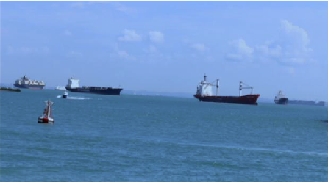
Figure1: Sample video frame1

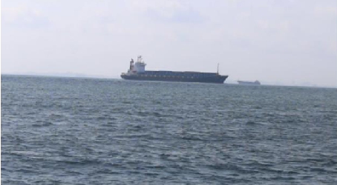
Figure 2: Sample video frame2

In the maritime traffic scene, the navigation environment changes rapidly, especially in the scene with high ship density, the relative position of each ship will change greatly even in a short period of time, in order to improve the efficiency of interpretation and prevent loss The key information is to divide all the video data obtained from the Singapore maritime data set into video frames with the rule of taking 2 frames per second, and the noise data is also included in the division, and finally a total of 2500 video frames are obtained. Due to the limited video data in the Singapore Maritime Dataset, in order to use more samples to train the model and let the model learn more patterns, it is necessary to expand the video data. This chapter uses a data enhancement method based on image processing technology. Frames are flipped, cropped, position transformed, and rotated to increase the amount of data. In the process of data enhancement, the angle value of the random rotation of the video frame is controlled to be 0 to 45 degrees clockwise and counterclockwise, which is consistent with the ship Normal fluctuation angle of onboard camera while sailing.

Multimodal Fusion Method
Multimodal fusion methods can be divided into two categories: traditional methods and deep learning methods. Traditional methods include rule-based methods, statistical methods, and machine learning methods[20]; deep learning methods include methods based on neural networks, convolutional neural networks (CNN), recurrent neural networks (RNN), and attention mechanisms. These methods are reviewed below and some related papers are listed. The rule-based method refers to the use of prior knowledge or expert system knowledge to fuse information from multiple modalities. This method can be realized by means of weighted average, logical operation, decision tree, etc. For example, Xu et al. (2017) [19]used a rule-based approach to fuse image and text information for video annotation. Statistical methods refer to the use of statistical principles to fuse information from multiple modalities. This method can be realized by means of principal component analysis, factor analysis, cluster analysis, etc. For example, Wang et al. (2016) used principal component analysis to fuse image and text information for video classification[40].The machine learning method refers to the use of machine learning algorithms to learn a fused model from information of multiple modalities. This approach can be implemented with support vector machines (SVM), decision trees, random forests, etc. For example, Wang et al. (2018) used the SVM method to fuse image and text information for video recommendation. The neural network-based method refers to the use of neural network models to fuse information from multiple modalities. This method can be implemented by multi-layer perceptron (MLP), convolutional neural network (CNN), recurrent neural network (RNN), etc. For example, Hao et al. (2018) used an MLP approach to fuse image and text information for video classification.[41]
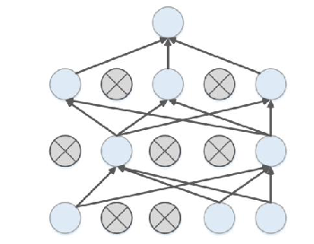
Figure3: regularized neural network
CNN is a deep learning model that can automatically extract image features. By inputting information of multiple modalities into CNN, a fused model can be learned. For example, Ngiam et al. (2011) used a CNN approach to fuse audio and video information for sentiment analysis.[33] RNN is a deep learning model that can automatically learn sequence information. Inputting the information of multiple modalities into the RNN can learn a fused model. For example, Chen et al. (2018) used the RNN method to fuse speech and text information for speech recognition.[32]
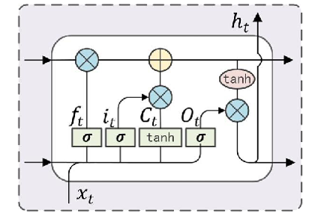
Figure4: LSTM cell

Research Methodology

Introduction
It is relatively easy for humans to describe maritime traffic scenes in natural language. It is not difficult for professionals in the maritime field to explain maritime traffic scenes in professional language, but for machines, the scenes contain rich There are many factors that need to be considered, so it is a challenging task for the machine to explain a scene in professional maritime terms.
There are usually important dependencies hidden in multimodal information, which can restore the real scene with higher accuracy. Therefore, multimodal deep learning considers capturing the patterns hidden in multimodal information from multiple dimensions, strengthening for the understanding of real scenes, more and more studies are using multi-modal deep learning methods to solve real-world problems. Ngiam et al. first proposed a multi-modal deep learning method [21]. Woolmer et al. adopted the architecture of multi-modal machine learning [31], and built a deep neural network for processing emotion classification by superimposing long-term and short-term memory networks. Su et al proposed to use multimodal unsupervised learning to solve machine translation tasks [41], and realize semantic correspondence and fusion by connecting cross-lingual corpora. At present, multimodal research mainly focuses on the refined representation of multimodal samples, multimodal fusion framework, and unsupervised multimodal learning methods.

Methodology
At present, the relevant research on the professional interpretation of marine traffic scenes using multi-modal data is very limited, but some excellent research results have also been born. The work related to marine traffic scene interpretation mainly includes picture subtitles [15] and video subtitles [16], the task of picture captioning is to generate a description text for a picture, while the task of video captioning is to generate a text description for a continuous sequence of video frames. Compared with image subtitles, video subtitles are more difficult. It consists of two parts. First, you need to understand the content of the video, and second, describe it in a language that conforms to grammatical rules. Since one of the modalities in this paper's maritime traffic scene is maritime surveillance video, the work of this paper has a higher relevance to video subtitles. Research on video subtitle methods has transitioned from the initial traditional method based on language rules to general machine learning methods, and now it has transitioned to the method using neural networks.

Research Approach

3.3.1 Language rule-based methods
In traditional language template based methods, a sentence template is used to connect the subject, predicate, and object discovered from the video. According to Reiter and Dale's description [7], this method is divided into three stages. Firstly, the order and structure of the generated text need to be determined. Secondly, when entities discovered from the video need to be mentioned, appropriate words are selected to aggregate them. Additionally, synonyms can be used to improve the readability of the sentence. Finally, use linguistic knowledge such as morphology, grammar, and semantics to generate real sentences. Early work focused on establishing descriptive structures and learning relationship representations between text blocks. Currently, a large amount of work has been proposed based on template rule models, which improve text generation capabilities by introducing statistical methods such as sentence compression, reordering, vocabulary rewriting, and grammar conversion.

3.3.2 Machine learning based methods

After experiencing traditional methods of object recognition and action discovery, and embedding visual content into sentence templates, researchers began to use machine learning methods. Through large-scale training, they strengthened the ability of object recognition and tracking in computer vision. Some machine learning methods were used in subtasks of video subtitle work, mainly target discovery, action recognition, and sentence generation. Kojima extracts Semantic information from human actions based on thresholds [28], focusing on human head position, arm position and head direction. In order to detect human motion in video frames, they use different thresholds, and each threshold represents a specific activity. Kim and Park use local histogram analysis to define edge features composed of three attributes: local contrast, region proportion, and edge potential [29]. Based on edge feature information, different thresholds are used to label or label segments.

3.3.3 Method based on deep learning
In recent years, the scheme of using ResNet and VGG as visual feature extractors and three-dimensional convolutional neural networks as spatiotemporal feature extractors has been widely used. In addition, long-term and short-term memory networks have also been used as the main language model. At present, GRU and Transformer [23] are gradually replacing long-term and short-term memory networks and being more used in the field of computer vision and natural language generation. A video subtitle system based on deep learning consists of two parts, namely an encoder and a decoder. The general approach is to use convolutional neural networks or recurrent neural networks as encoders to capture visual features, and use models such as recurrent neural networks as decoders to generate text descriptions for visual features. Yao et al. proposed a video description method [24], which is based on an encoder decoder architecture, in which a spatiotemporal convolutional neural network combined with temporal attention mechanism is used as the encoder. Donahue et al. developed an end-to-end trainable large-scale visual learning model [45], In terms of sentence generation, Yao uses the short-term memory network as their decoder under the encoder and decoder architecture [44] to generate video description text.

Ethical Issues
Usually, research collects data regarding people and therefore ethical issues can be extremely delicate in nature [50].
For this project, most of the datasets collected in this topic are public datasets, including the situation of ships in Singapore and the East China Sea. They do not involve any private information and are all captured through cameras in public waters. The completed Ethics Form can be found in the additional documents section of Turnitin.

Research Strategy
Before conducting the experiment, we need to find relevant videos of marine traffic and text-mark the videos. After completing these tasks, we need to conduct the following experiments:
- Clean and enhance video data
- Annotate the video with text
- Choose a model for training
- Compare the experimental results

Time Horizons: Gantt Chart
Time horizons is an estimation of how long the project will take to complete and is useful in keeping the project on track.
According to [50] there are two kinds of time horizons, the longitudinal and the cross-sectional. If data is gathered over a long time-period to record how it has changed during this time, then it is a longitudinal study. Whereas a cross-sectional timeline refers to a ‘snapshot’ of data at any given time.
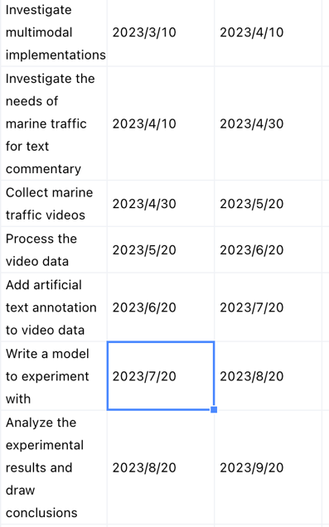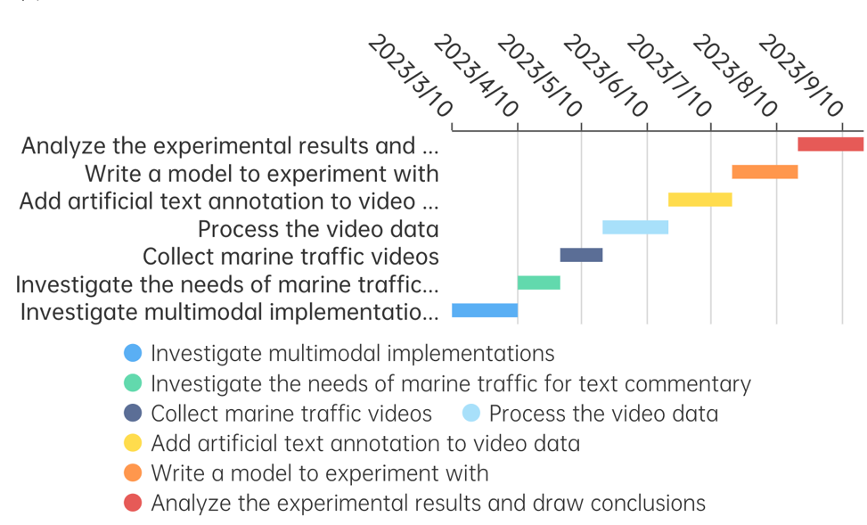
Figure5: regularized neural network

Results

Data Collection
The marine meteorological data is obtained from the historical meteorological data of the Meteorological Bureau of Singapore. In real maritime navigation, different meteorological conditions have different effects on ship navigation. For example, wind speed is an important factor affecting navigation safety. After comprehensive measurement, it is also to reduce Unnecessary data, select the main meteorological indicators as the description of meteorological conditions, including precipitation in the past 30 minutes, 60 minutes and 120 minutes, current temperature, minimum and maximum temperature in the past 24 hours, current wind speed, average wind speed, past 24 hours Hourly maximum wind speed and visibility, through manual comparison, the meteorological data and video data are aligned according to time.
In terms of commentary text labeling, since the commentary tasks of maritime traffic scenes have higher requirements for the professionalism of the commentary text, and at the same time, the content and method of commentary are closer to the broadcast of the ship’s watchman, therefore, the manually marked commentary text refers to the ship’s Lookout personnel training manual. The lookout personnel training manual stipulates the broadcasting methods of specific events in different navigation scenarios, mainly broadcasting the type, orientation, characteristics and status of ships in maritime professional terms. The specific labeling process is to find the meteorological data corresponding to the time according to the time stamp of the video sequence, and make professional maritime commentary on 5,500 video frame sequences.

Experiments
- Hardware tools are:
- This experiment is expected to be carried out under the Pytorch deep learning framework. The experimental code runs on Google's Colab platform. The server processor model is the hard disk is Google Cloud Drive. The data set is uploaded to Google Cloud Drive. You can first limit the number of words in the target commentary text For the 10,000 words with the highest frequency in all labeled texts in the training set, the word vector dimension after word embedding is set to 512. The video encoder first processes the video frame with a two-dimensional and three-dimensional convolutional neural network. This experiment uses 18 layers The pre-trained ResNet-152 and ResNet-3D convolutional neural network, in the training and testing process, set the data size of each batch to 64, the hidden layer dimension is set to 512, the model training process uses Adam[ 40] Optimizer.

Evaluation and Conclusion
In order to test the superiority of the proposed method using multi-modal and attention mechanisms in maritime traffic scenarios, this paper retrieves text generation methods in recent years and trains them under the dataset of this paper. The evaluation methods are compared, and the machine learning models of the comparison methods are as follows. The S2S-T model [45] is a traditional sequence-to-sequence model, which was originally applied in machine translation, using a multi-layer long-short-term memory network to convert the input sequence into a fixed-length vector, and then using other depth The LSTM network decodes intermediate vectors to generate new sequences; The S2S-V model [46] is a sequence-to-sequence model that converts video sequences into subtitle texts. It uses long-term short-term memory networks and has achieved excellent results in image and video subtitle tasks. Since the interpretation of marine traffic scenes has high requirements for timeliness, strengthening the efficiency of interpretation has become a difficult problem for this task. In addition, fine-grained interpretation texts can play the role of interpretation tasks to a greater extent. Therefore, this paper believes that based on multimodal Transformer's traffic scene commentary text generation method is better, because the advantages of the self-attention mechanism and the stronger ability to capture scene details make it meet the timeliness requirements of marine traffic scenes.

Bibliography
[1] Felzenszwalb P, McAllester D, Ramanan D. A discriminatively trained, multiscale, deformable part model [C]. Proceedings of the 2008 IEEE Conference on Computer Vision and Pattern Recognition, 2008: 1-8.
[2] Ngiam J, Khosla A, Kim M, et al. Multimodal deep learning [C]. Proceedings of the 28th
International Conference on Machine Learning 2011: 197-387.
[3] Wöllmer M, Metallinou A, Eyben F, et al. Context-sensitive multimodal emotion recognition from speech and facial expression using bidirectional lstm modeling [C]. Proceedings of th 2010 INTERSPEECH, 2010: 2362-2365.
[4] Su Y, Fan K, Bach N, et al. Unsupervised multi-modal neural machine translation [C]. Proceedings of the 2019 IEEE/CVF Conference on Computer Vision and Pattern Recognition, 2019: 10482-10491.
[5] Bernardi R, Cakici R, Elliott D, et al. Automatic description generation from images: A survey of models, datasets, and evaluation measures [J]. Journal of Artificial Intelligence Research, 2016, 55: 409-442.
[6] Pasunuru R, Bansal M. Multi-task video captioning with video and entailment generation [C]. Proceedings of the 55th Annual Meeting of the Association for Computational Linguistics, 2017: 1273-1283.
[7] Reiter E, Dale R. Building applied natural language generation systems [J]. Natural Language Engineering, 1997, 3(1): 57-87.
[8] Kojima A, Tamura T, Fukunaga K. Natural language description of human activities from video images based on concept hierarchy of actions [J]. International Journal of Computer Vision, 2002, 50(2): 171-184.
[9] Kim B-G, Park D-J. Unsupervised video object segmentation and tracking based on new edge features [J]. Pattern Recognition Letters, 2004, 25(15): 1731-1742.
[10] Roy P P, Bhunia A K, Bhattacharyya A, et al. Word searching in scene image and video frame in multi-script scenario using dynamic shape coding [J]. Multimedia Tools and Applications, 2019, 78(6): 7767-7801.
[11] Das P, Xu C, Doell R F, et al. A thousand frames in just a few words: Lingual description of videos through latent topics and sparse object stitching [C]. Proceedings of the 2013 IEEE Conference on Computer Vision and Pattern Recognition, 2013: 2634-2641.
[12] Blei D M, Jordan M I. Modeling annotated data [C]. Proceedings of the 26th annual international ACM SIGIR conference on Research and development in informaion retrieval, 2003: 127-134.
[13] Felzenszwalb P, McAllester D, Ramanan D. A discriminatively trained, multiscale, deformable part model [C]. Proceedings of the 2008 IEEE Conference on Computer Vision and Pattern Recognition, 2008: 1-8.
[14] Laptev I, Marszalek M, Schmid C, et al. Learning realistic human actions from movies [C]. Proceedings of the 2008 IEEE Conference on Computer Vision and Pattern Recognition, 2008: 1-8.
[15] Thomason J, Venugopalan S, Guadarrama S, et al. Integrating language and vision to generate natural language descriptions of videos in the wild [M]. University of Texas at Austin Austin United States. 2014.
[16] Li L-J, Su H, Fei-Fei L, et al. Object bank: A high-level image representation for scene classification & semantic feature sparsification [C]. Proceedings of the 23rd International Conference on Neural Information Processing Systems, 2010: 1378–1386.
[17] Everingham M, Van Gool L, Williams C K, et al. The pascal visual object classes (voc) challenge [J]. International Journal of Computer Vision, 2010, 88(2): 303-338.
[18] Deng J, Krause J, Berg A C, et al. Hedging your bets: Optimizing accuracy-specificity trade- offs in large scale visual recognition [C]. Proceedings of the 2012 IEEE Conference on Computer Vision and Pattern Recognition, 2012: 3450-3457.
[19] Xu R, Xiong C, Chen W, et al. Jointly modeling deep video and compositional text to bridge vision and language in a unified framework [C]. Proceedings of the 29th AAAI Conference on Artificial Intelligence, 2015: 2346-2352.
[20] Wang H, Klaser A, Schmid C, et al. Action recognition by dense trajectories [C]. Proceedings of the 2011 Conferencee on Computer Vision and Pattern Recognition, 2011: 3169-3176.
[21] Sun C, Nevatia R. Semantic aware video transcription using random forest classifiers [C]. Proceedings of the 2014 European Conference on Computer Vision, 2014: 772-786.
[22] Rohrbach M, Qiu W, Titov I, et al. Translating video content to natural language descriptions [C]. Proceedings of the 2013 IEEE International Conference on Computer Vision, 2013: 433- 440.
[23] Vaswani A, Shazeer N, Parmar N, et al. Attention is all you need [M]. Advances in Neural Information Processing Systems. 2017: 5998-6008.
[24] Yao L, Torabi A, Cho K, et al. Describing videos by exploiting temporal structure [C]. Proceedings of the 2015 IEEE International Conference on Computer Vision, 2015: 4507-4515.
[25] Donahue J, Anne Hendricks L, Guadarrama S, et al. Long-term recurrent convolutional networks for visual recognition and description [C]. Proceedings of the 2015 IEEE Conference on Computer Vision and Pattern Recognition, 2015: 2625-2634.
[26] Venugopalan S, Rohrbach M, Donahue J, et al. Sequence to sequence-video to text [C]. 52Proceedings of the 2015 IEEE International Conference on Computer Vision, 2015: 4534-4542.
[27] Guo Z, Gao L, Song J, et al. Attention-based lstm with semantic consistency for videos captioning [C]. Proceedings of the 24th ACM international conference on Multimedia, 2016: 357-361.
[28] Zhang C, Tian Y. Automatic video description generation via lstm with joint two-stream encoding [C]. Proceedings of the 2016 23rd International Conference on Pattern Recognition (ICPR), 2016: 2924-2929.
[29] Pan Y, Mei T, Yao T, et al. Jointly modeling embedding and translation to bridge video and language [C]. Proceedings of the 2016 IEEE Conference on Computer Vision and Pattern Recognition, 2016: 4594-4602.
[30] Chen X, Zhang M, Wang Z, et al. Leveraging unpaired out-of-domain data for image captioning [J]. Pattern Recognition Letters, 2020, 132: 132-140.
[31] Zhang Z, Shi Y, Yuan C, et al. Object relational graph with teacher-recommended learning for video captioning [C]. Proceedings of the 2020 IEEE/CVF Conference on Computer Vision and Pattern Recognition, 2020: 13278-13288.
[32] Torabi A, Pal C, Larochelle H, et al. Using descriptive video services to create a large data source for video annotation research [J]. arXiv preprint arXiv:150301070, 2015.
[33] Rohrbach A, Rohrbach M, Tandon N, et al. A dataset for movie description [C]. Proceedings of the 2015 IEEE Conference on Computer Vision and Pattern Recognition, 2015: 3202-3212.
[34] Chen D, Dolan W B. Collecting highly parallel data for paraphrase evaluation [C]. Proceedings of the 49th annual meeting of the association for computational linguistics: human language technologies, 2011: 190-200.
[35] Xu J, Mei T, Yao T, et al. Msr-vtt: A large video description dataset for bridging video and language [C]. Proceedings of the 2016 IEEE Conference on Computer Vision and Pattern Recognition, 2016: 5288-5296.
[36] Papineni K, Roukos S, Ward T, et al. Bleu: A method for automatic evaluation of machine translation [C]. Proceedings of the 40th annual meeting of the Association for Computational Linguistics, 2002: 311-318.
[37] Devlin J, Chang M-W, Lee K, et al. Bert: Pre-training of deep bidirectional transformers for language understanding [C]. Proceedings of the 2019 Annual Conference of the North American Chapter of the Association for Computational Linguistics, 2019: 4171-4186.
[38] Wöllmer M, Kaiser M, Eyben F, et al. Lstm-modeling of continuous emotions in an audiovisual affect recognition framework [J]. Image and Vision Computing, 2013, 31(2): 153- 163.
[39] Prasad D K, Rajan D, Rachmawati L, et al. Video processing from electro-optical sensors for 53 object detection and tracking in a maritime environment: A survey [J]. IEEE Transactions on Intelligent Transportation Systems, 2017, 18(8): 1993-2016.
[40] Kingma D P, Ba J. Adam: A method for stochastic optimization [M]. Proceedings of the 23rd International Conference for Learning Representations. 2015.
[41] Das A, Kottur S, Gupta K, et al. Visual dialog [C]. Proceedings of the 2017 IEEE Conference on Computer Vision and Pattern Recognition, 2017: 326-335.
[42] Banerjee S, Lavie A. Meteor: An automatic metric for mt evaluation with improved correlation with human judgments [C]. Proceedings of the ACL Workshop on Intrinsic and Extrinsic Evaluation Measures for Machine Translation and/or Summarization, 2005: 65-72.
[43] Vedantam R, Lawrence Zitnick C, Parikh D. Cider: Consensus-based image description evaluation [C]. Proceedings of the 2015 IEEE Conference on Computer Vision and Pattern Recognition, 2015: 4566-4575.
[44] Lin C-Y. Rouge: A package for automatic evaluation of summaries [C]. Text Summarization Branches Out: Proceedings of the ACL-04 Workshop, 2004: 74-81.
[45] Sutskever I, Vinyals O, Le Q V. Sequence to sequence learning with neural networks [C]. Proceedings of the 27th International Conference on Neural Information Processing Systems 2014: 3104-3112.
[46] Vinyals O, Toshev A, Bengio S, et al. Show and tell: A neural image caption generator [C]. Proceedings of the 2015 IEEE Conference on Computer Vision and Pattern Recognition, 2015: 3156-3164.
[47] Zeng W, Abuduweili A, Li L, et al. Automatic generation of personalized comment based on user profile [C]. Proceedings of the 57th Annual Meeting of the Association for Computational Linguistics: Student Research Workshop, 2019: 229-235.
[48] Ma S, Cui L, Dai D, et al. Livebot: Generating live video comments based on visual and textual contexts [C]. Proceedings of the 2019 AAAI Conference on Artificial Intelligence, 2019: 6810- 6817.
[49] Lin T-Y, Goyal P, Girshick R, et al. Focal loss for dense object detection [C]. Proceedings of the 2017 IEEE international conference on computer vision, 2017: 2980-2988.
[50] He K, Zhang X, Ren S, et al. Deep residual learning for image recognition [C]. Proceedings of the 2016 IEEE Conference on Computer Vision and Pattern Recognition, 2016: 770-778.

