Databases and Application Development

The Smile Factory Case Study

Author: Kallum Gordon
Prepared for: Bev Holland
5th January 2021

Abstract
A database has been produced using Microsoft SQL Server Management Studio adhering to the brief provided by The Smile Factory. The database has been coded using SQL and contains relevant data, primary keys, foreign keys, check constraints, indexes and queries which all work together to allow for the tables to be populated and interacted with to pull relevant information.
Table of Contents
1.0 Abstract 2
2.0 SQL Report 3
2.1 Entity Relationship Diagram 3
2.2 Primary keys 3
2.3 Referential integrity constraints 3
2.4 Check constraints 4
2.5 Indexes 4
2.6 Database population 4
2.7 Transactions 4
2.8 Queries 4
2.8.1 Issues encountered 5
2.9 Constraint testing 5
3.0 Performance Tuning 6
3.1 Data queries 7
References 7

SQL Report

2.1 Entity Relationship Diagram
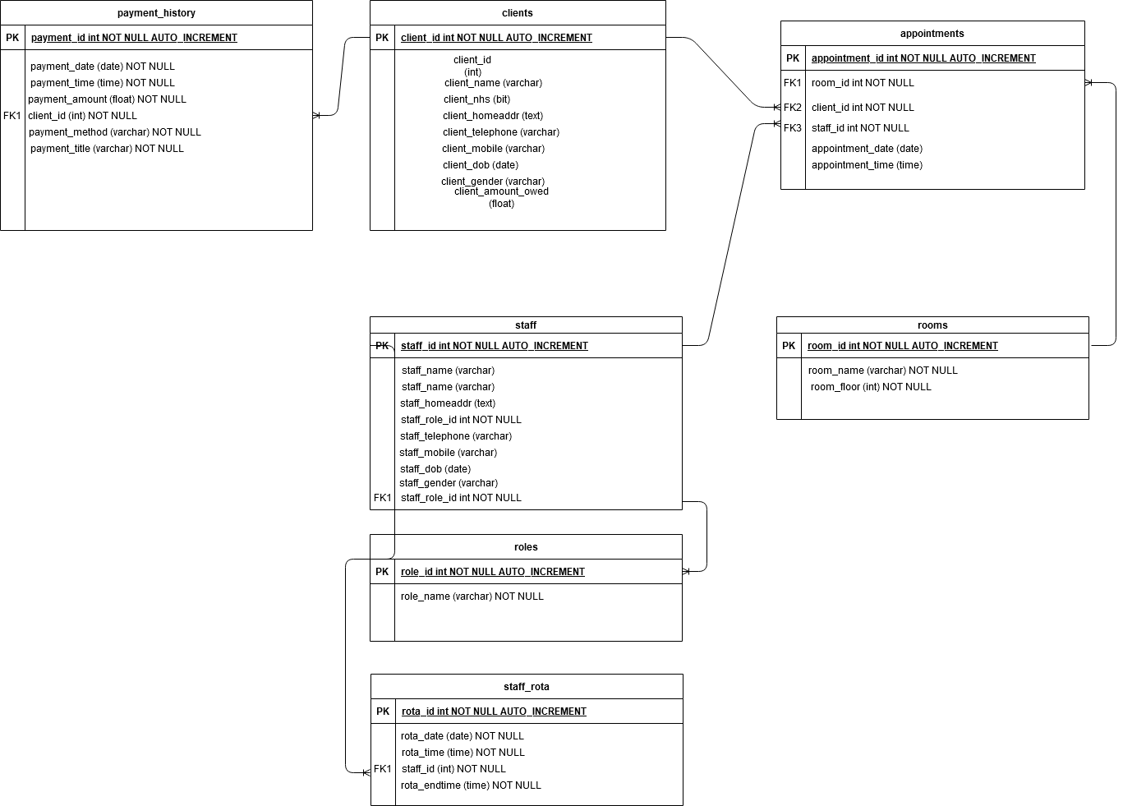
Below is an ERD used to plan and develop the database.

2.2 Primary keys
Primary keys denote a unique identifier in each table. The primary keys included in The Smile Factory database include: client_id for clients, role_id for each staff role, staff_id for staff members, room_id for rooms within the surgery, appointment_id for each appointment, rota_id for staff rotas, and payment_id for transactions.

2.3 Referential integrity constraints
These are foreign keys and allow a primary key to be placed within another table to establish relationships and allow queries to be produced which shows relevant information within one table such as a client, the staff member they will be seeing, the room they will be in, and the time.
Foreign keys aid in making sure accurate data is imported into the table. For example, in the staff table we have a ‘role_id’ column which has a foreign key constraint linking it to the ‘roles’ table. If the user was to insert a new staff members information into the database but the ‘role_id’ value did not exist in the ‘roles’ table, an error will be produced, and the query would be aborted.

2.4 Check constraints
Check constraints stop information being entered into the database that is considered irrelevant. Check constraints have been placed liberally as they are easy to implement but provide a lot of use and keep databases from being easily overloaded and destroyed. Check constraints within the Smile Factory database have been placed on almost every field in the way of a ‘NOT NULL’ check, which forces the user to enter data into the field before submitting. Other constraints include restricting the gender field to three options, ensuring that the mobile number submitted is unique, and restricting the length of home and mobile numbers.

2.5 Indexes
Each table has an index which uniquely identifies each entry. It makes it easier to differentiate each entry and to link tables. For example, in the client table there is “client_id”, and for staff there is “staff_id”.
If there was not a unique index ID for each entry, it would be near impossible to link tables together. For example, if there were two clients with the same name but different address, there would not be a way to accurately or reliably make SQL requests that give the correct data when linking tables together (for example, appointments and clients).

2.6 Database population
There are two SQL files. The first file consists of the queries needed to create the tables, their structures, and constraints. The second file consists of the INSERT statements needed to populate the database.
Each entry is automatically given a unique ID/index/primary key as the table has an auto increment attribute set. This makes each imported entry unique. The data that populates the database consists of staff details such as full name, address, profession and contacts (with some foreign keys set for the profession, for better space optimisation). [1] Similarly, the clients table also has fields for name, address, if their payments are fulfilled by the NHS or not, their date of birth, dental procedure [2], and contact details to name a few.
Ultimately all data is unique and assigned an index, which has proven useful when using JOIN queries.

2.7 Transactions
The type of procedure a client goes through is listed and the price for that procedure is also listed. If they are with the NHS they don’t have to pay this, but if they’re a private patient, they will have to pay for their procedure. Queries have been created to easily spot which clients owe what amount, and if they are with the NHS or private.

2.8 Queries
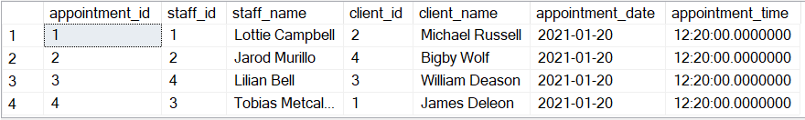
A query has been written that shows which staff member is appointed to which client and provides the appointment date and time. This is useful as it will show who needs to be where at a quick glance.

Additional queries have been created to document the relationships between multiple tables. These include information on client transactions, staff rotas, and one where four tables were joined which provides a large amount of information such as appointment, client, staff, and room information. This was obtained using a single query rather than having separate queries for each table which improves the speed of the query and reduces the load on the database.
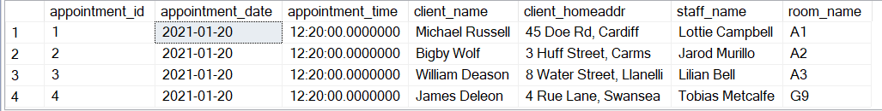
.

2.8.1 Issues encountered
When querying the staff rota, each rota id appears a total of three times when it should only come up once. This could be fixed given more time.
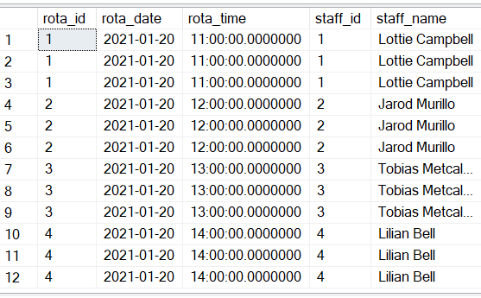

2.9 Constraint testing
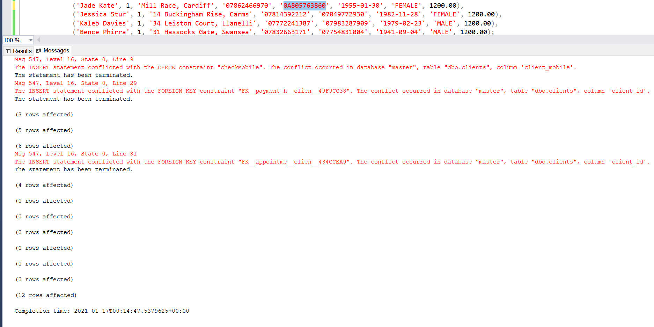
To test constraints, a phone number has purposefully been made to include a letter, this breaks the import process as expected.

The patients gender must also be correctly defined as one of three options or the import process is broken as expected.
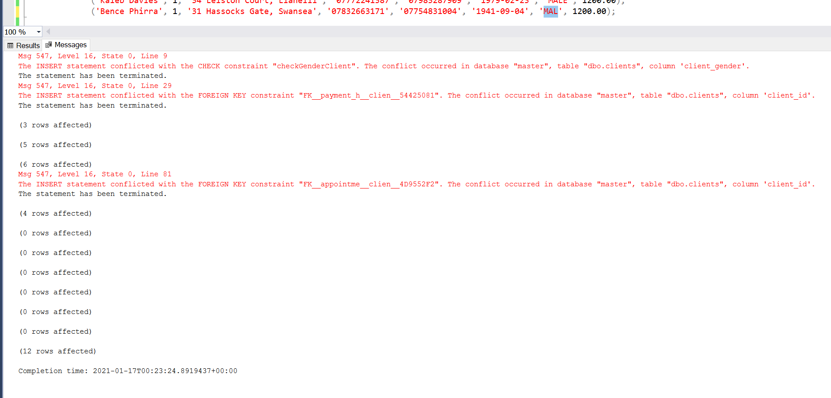

The last constraint checks if the staff’s role is an actual role. There are dentists (1), nurses (2), and cleaners (3).
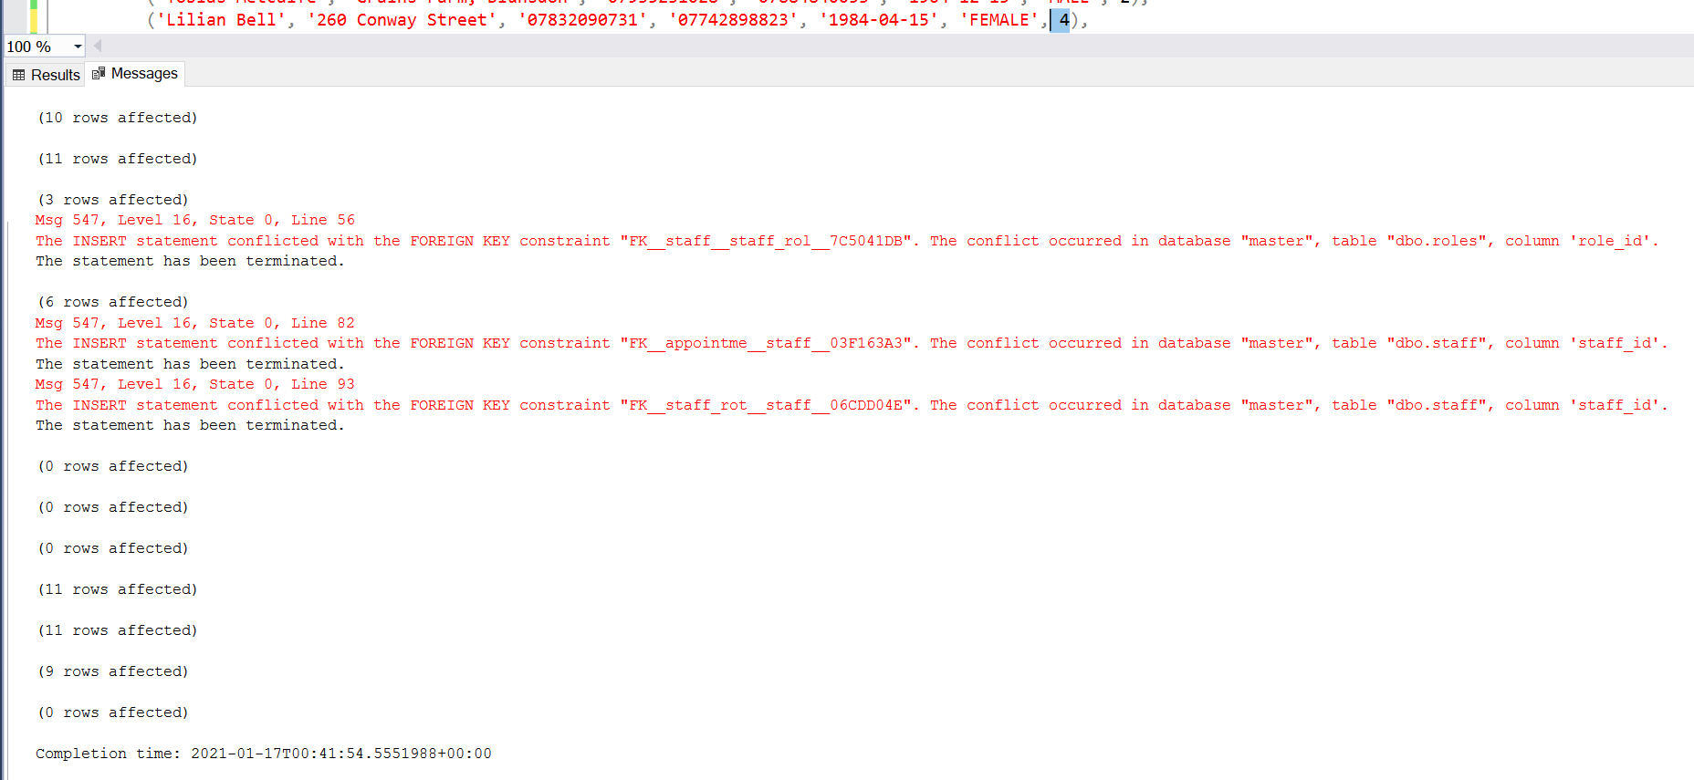

Performance Tuning
Secondary keys have not been implemented, so the implemented solution does not have the added performance benefits that secondary keys would provide, however, the queries to the database and the way certain information is stored seem to be optimal to the point where performance is still improved.
The first optimisation was the way in which phone numbers are stored. It could be thought that storing such data as an integer would make sense since it is built up of integer values. However, this has some disadvantages. The first disadvantage being that the first occurrence of 0 in the number is removed and phone numbers can contain special symbols such as spaces and “-“. To remedy this, phone numbers are stored as a VARCHAR, allowing for more than just integer values. [3] Storing phone numbers as an int can cause other issues depending on the back-end database solution being utilised, a good example being in MySQL the maximum integer value is 2147483647.

3.1 Data queries
Another performance enhancement made was the way in which data is retrieved from the database. Using the various JOIN functions (such as LEFT, RIGHT OUTER/INNER etc) allows for the selection of various sets of data from multiple tables in a single query. [4] [5] This reduces how many requests are needed to be made to the database. Optimised queries are crucial to any large-scale deployment where the database could be handling millions of daily requests, so reducing how many individual requests are made will benefit both server and client-side performance.

References

[1] | Microsoft, “CREATE TABLE (Transact-SQL),” Microsoft, 22nd September 2020. [Online]. Available: https://docs.microsoft.com/en-us/sql/t-sql/statements/create-table-transact-sql?view=sql-server-ver15. [Accessed 5th January 2021].
[2] | A. Smith, “Different Oral Surgery Procedures,” Barming Dental Centre, 28th December 2018. [Online]. Available: https://barmingdentalcentre.co.uk/different-oral-surgical-procedures/. [Accessed 7th January 2021].
[3] | BigDataCloud, “What is the best way to store phone numbers in a database to avoid duplication?,” BigDataCloud, 15th January 2020. [Online]. Available: https://www.bigdatacloud.com/blog/what-is-the-best-way-to-store-phone-numbers-in-a-database-to-avoid-duplication. [Accessed 7th January 2021].
[4] | w3schools.com, “SQL FULL OUTER JOIN Keyword,” w3schools.com, [Online]. Available: https://www.w3schools.com/sql/sql_join_full.asp. [Accessed 10th January 2021].
[5] | GeeksforGeeks, “SQL | Join (Inner, Left, Right and Full Joins),” GeeksforGeeks, 9th November 2020. [Online]. Available: https://www.geeksforgeeks.org/sql-join-set-1-inner-left-right-and-full-joins/. [Accessed 10th January 2021].

