

Student Name : Nidhi Radadiya

Student ID : 2434257

Module Name: International Marketing: Principles and Practices

Module Code: LCMB7026

Lecturer’s Name: Tushara Balendran (London)

Term 2

Table of Contents
INTRODUCTION 10
1. COMPANY BACKGROUND 10
1.1 Company Overview: BMW 10
1.2 Germany (Country A) 12
1.3 China (Country B) 13
2. The Macroenvironment (PESTLE) Analysis of BMW 14
2.1 Political Factors 16
2.1.1 Germany 16
2.1.2 China 18
2.2 Economic Factors 19
2.2.1 Germany 19
2.2.2 China 20
2.3 Social Factors 22
2.3.1 Germany 22
2.3.2 China 23
2.3.3 Social Environment Analysis 23
2.3.3.1 Changing Social Trends in Germany 23
2.3.3.2 Changing Social Trends in China 23
2.3.4 Cultural Environment Analysis 24
2.3.4.1 Hofstede model 24
2.3.4.2 Advantages and Disadvantages of the Hofstede Model 25
2.3.4.3 Hofstede cultural dimensions analysis 26
2.3.4.4 Cultural Factors in Germany 27
2.3.4.5 Cultural Factors in China 27
2.3.4.6 Similarities and Differences of cultural factors between the Two Markets 27
2.4 Technological Factors 29
2.4.1 Germany 29
2.4.2 China 29
2.5 Legal Factors 30
2.5.1 Germany 30
2.5.2 China 30
2.6 Environmental Factors 31
2.6.1 Germany 31
2.6.2 China 31
2.7 Similarities and Differences – BMW PESTLE Analysis 32
3. Comparison of BMW’s STP Strategies in Country A and Country B 34
3.1 Segmentation Strategies 34
3.1.1 Segmentation Strategies in Germany and China 34
3.2 Targeting Strategies 37
3.2.1 Germany 37
3.2.2 China 38
3.3 Positioning Strategies 38
3.3.1 Germany 40
3.3.2 China 40
3.4 Comparative Summary: Similarities and Differences in STP 40
4. Comparison of Marketing Mix Strategies in Country A and Country B 42
4.1 Product 42
4.1.1 Germany 42
4.1.2 China 42
4.1.3 Product Variety, Depth & Width 43
4.1.3.1 Germany 43
4.1.3.2 China 44
4.1.3.3 Main Differences Between Germany and China 45
4.1.4 Product Design 45
4.1.4.1 Germany 45
4.1.4.2 China 46
4.2 Price 47
4.2.1 Germany 47
4.2.2 China 48
4.3 Place 49
4.3.1 Germany 49
4.3.2 China 50
4.3.3 Direct vs Indirect Channels and Intensive Distribution for BMW – Germany vs China 51
4.3.4 Market Entry Methods 52
4.3.4.1 Market Entry Method Used in China: Joint Venture (Which Method) 52
4.3.4.2 Why BMW Uses a Joint Venture in China (Why) 53
4.3.4.4 Advantages of the Joint Venture Model in China 54
4.3.4.5 Disadvantages of the Joint Venture Model in China 54
4.4 Promotion 55
4.4.1 Germany 55
4.4.2 China 56
4.4.3 Promotion Evaluation 56
4.5 People 57
4.5.1 Germany 57
4.5.2 China 57
4.6 Process Definition 58
4.6.1 Germany 58
4.6.1.1 Customer Complaint Process – Germany 58
4.6.2 China 59
4.6.1.2 Customer Complaint Process – China 60
4.7 Physical Evidence 60
4.7.1 Germany 60
4.7.2 China 61
4.8 7Ps Similarities and Differences (Germany vs. China) 62
4.9 Evaluation of Marketing Strategies 63
4.9.1 Germany 63
4.9.2 China 64
4.10 Profit and Sales 65
4.10.1 Germany 65
4.10.2 China 65
4.11 Social Media Engagement 66
4.11.1 Germany 66
4.11.2 China 67
4.12 Customer Reviews 67
4.12.1 Germany 67
4.12.2 China 68
5. Ethics of Germany 69
6. Recommendations 71
6.1 Recommendations – Germany 71
6.2 Recommendations – China 72
7. Conclusion 72
References 74

List of Figures
Figure 1: Vision mission 11
Figure 2: BMW Logo 11
Figure 3: BMW Innovation Hub Munich 12
Figure 4: BMW Market Share 2024 13
Figure 5: PESTLE Analysis 14
Figure 6: PESTLE Analysis Definition 14
Figure 7: Political Factors 16
Figure 8: Germany EV Infrastructure Support 17
Figure 9: Germany–China Auto Tensions 18
Figure 10: Economic Factors 19
Figure 11: Germany’s Economic Outlook 20
Figure 12: China’s GDP Growth Trend 21
Figure 13: Social Factors 22
Figure 14: Hofstede Model Definition 24
Figure 15: Hofstede model 24
Figure 16: Hofstede Model 26
Figure 17: Technological Factors 29
Figure 18: Legal Factors 30
Figure 19: Environmental Factors 31
Figure 20: BMW Targeting Strategies: Differentiation vs Undifferentiation 37
Figure 21: Definition of Perceptual Map 38
Figure 22: Perceptual map 39
Figure 23: Product Definition 42
Figure 24: Product Variety, Depth & Width Definition 43
Figure 25:BMW product evaluation 44
Figure 26: Product Design Definition 45
Figure 27: BMW e vehicle 46
Figure 28: Price Definition 47
Figure 29; BMW prices in the USA, Germany & Finland 48
Figure 30: Place Definition 49
Figure 31: BMW Germany Distribution Diagram 50
Figure 32: BMW China Distribution Diagram 51
Figure 33:BMW Vehicle Production Line – Localised Manufacturing via BBA 53
Figure 34:BMW Group Celebrates the 20th Anniversary of BMW Brilliance Automotive (BBA) – Announcement of Localised Production in China 54
Figure 35: Promotion Definition 55
Figure 36: People Definition 57
Figure 37: Process Definition 58
Figure 38: BMW Complaint culture 59
Figure 39: Physical Evidence Definition 60
Figure 40:BMW Marketing Strategies in Germany 64
Figure 41: BMW Group – Largest Automobile Markets by Share of Sales in 2024 (with 2023 Comparison) 65
Figure 42: BMW Facebook advertisement 66
Figure 43: Customer comments 68
Figure 44: Ethical vs Unethical Marketing – Definitions 69

List of Tables
Table 1: PESTLE Analysis Diagram 15
Table 2: Similarities and Differences of cultural factors between the Two Markets 28
Table 3: Similarities and Differences BMW PESTLE Analysis 34
Table 4: Segmentation Strategies in Germany and China 36
Table 5: Comparative Summary: Similarities and Differences in STP 41
Table 6: Direct vs Indirect Channels and Intensive Distribution for BMW – Germany vs China 52
Table 7: Promotion Evaluation Table 56
Table 8: 7Ps Similarities and Differences (Germany vs. China) 63
Table 9: Ethical and Unethical Marketing Examples (Germany – BMW) 71

INTRODUCTION
The international marketing strategies of BMW, one of the earliest leading companies in the world that manufactures premium automobiles, is examined in this report and the focus of analysis is based on its operations in two countries namely Germany (Country A) and China (Country B). Since BMW as a brand is renowned due to the engineering excellence, innovativeness, and sustainable mobility, its achievements in the global market are deeply dependent on the abilities of the brand to localize marketing activities to the heterogenous macro-environmental, cultural, and competitive environment.
The analysis will be started by an overview of the background of the firm followed by comparative evaluation of the external environments of Germany and China using the PEST1500 framework. It then analyses how BMW segments, targets and positions its offerings in each of the markets as further enhanced with an analysis of differences in the marketing mix (7Ps).

1. COMPANY BACKGROUND

1.1 Company Overview: BMW
Bayerische Motoren Werke AG (BMW) comprises an internationally famous German car making lab, which is in Munich. Founded in 1916, the firm is characterized by pioneering engineering practices, sophisticated luxury vehicle designs and continuous technological innovation. BMW's portfolio includes the production of luxury vehicles, motorcycles and mobility services, namely BMW, MINI, Rolls-Royce and BMW Motorrad (BMW Group, 2024).
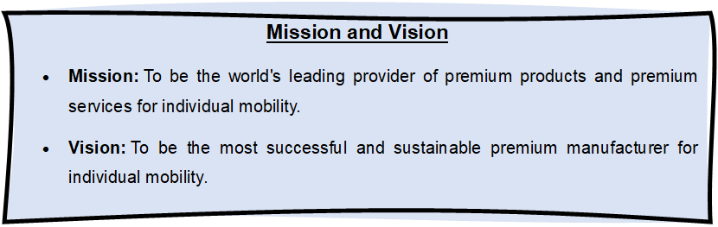
Figure 1: Vision mission
(Source: BMW Group, 2025)
The fact that the company shifted its powers to the production of aircraft engines into the production of electric and self-driving vehicles can be viewed as the sensitivity of the company to the changes in the technological environment. The sustainability concept of BMW is ingrained in its business practices, and its aim of becoming climate-neutral by 2050 implies its focus on achieving global environmental goals (Liu, 2022).

Figure 2: BMW Logo
(Source: BMW Group, 2025)
The company is committed to ensuring the shift toward the circular economy by implementing recycled materials, renewable energy sources, and minimum carbon emission carbon-related production processes (Al Hossain et al., 2025).
The report examines the international marketing strategies at BMW in Germany and China starting with a brief corporate background to the exploration of its operations in both markets. It compares PESTLE models, STP decisions and adaptation of the 7Ps, with empirical evidence. It also measures the performance indicators (sales, market share and reach) and deliberates on ethical factors. Its conclusion contains practical suggestions to improve strategy and create its future development with digitisation, localisation, and sustainability priorities.

1.2 Germany (Country A)
BMW (Bayerische Motoren Werke) is a company that was established in 1916 in Munich, Germany because of the merger between Rapp Motorenwerke and Gustav Otto Flugmaschinenfabrik. BMW first created aircraft engines, but due to the restraint, their production resulted in brakes and motorcycles in 1923, the production of the BMW R and in 1928, the start of the automobile production (Haider, 2020).
Germany is an innovation centre of BMW with the center being the place in Munich with the Research and Innovation Centre (FIZ). The focus on precision engineering, efficient supply chains, and the utilization of renewable energy promoted by the major vegetation at Munich, Dingolfing, Leipzig, and Regensburg is one of the ways to prove leadership in sustainability (Zhiyuan Liu, 2022; Al Hossain et al., 2025).
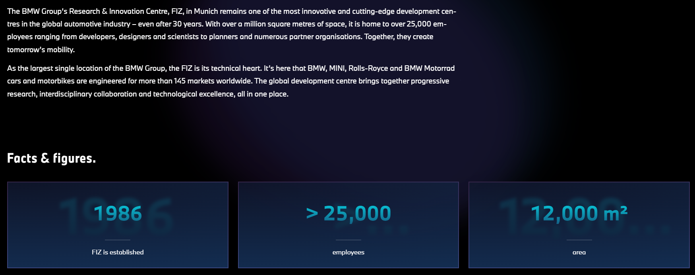
Figure 3: BMW Innovation Hub Munich
(Source: BMW Group, 2025)
The Campus of Autonomous Driving in Germany by BMW supports the digital transformation agenda and the mobility innovation in the company. The BMW maintains its competitiveness and model to be one of the leading premium brands in Germany despite the strong market rivalry through the New Class sedans and, more importantly, the electrified models like the i3 and i8 (Haider, 2020; BMW Group, 2024).

1.3 China (Country B)
BMW has been in China since 1994 but did not officialise its operations until 2003 with the establishment of the BMW ‛Brilliance ⁄ ℕaute’ joint venture in Shenyang. It was also followed by rapid growth such as the localisation of production of long wheelbase models, second Shenyang plant opened in 2009. In 2022, BMW raised its share in BBA to 75 300 percent strengthening its long-term investment in China (Chang Liu, 2024; Pillai, 2024). China is the largest unitary market of BMW, and its biggest global manufacturing facility. The sale of BMW cars in China shows a strong local-local strategy with a volume of more than 29.2% of all cars being manufactured in China. The company has closely aligned its manufacturing, research and development as well as supply chain with domestic market requirements (Pillai, 2024).
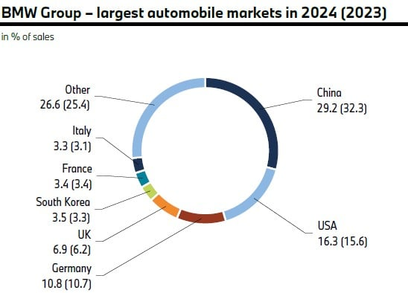
Figure 4: BMW Market Share 2024
(Source: BMWBLOG, 2025)
BMW has been speeding up its transition to electrification and digitalisation through the introduction of electric vehicle (EV) models such as the iX3 and i3 and the up-coming Neue Klasse EVs, whilst creating digital alliances with Tencet and Alibaba. Although the company faced a 13.4% drop in sales during 2024, which BMW can attribute to increased local EV competition, BMW is still committed to pursuing sustainable growth and encouraging innovation (Haider, 2020; Chang Liu, 2024).

2. The Macroenvironment (PESTLE) Analysis of BMW
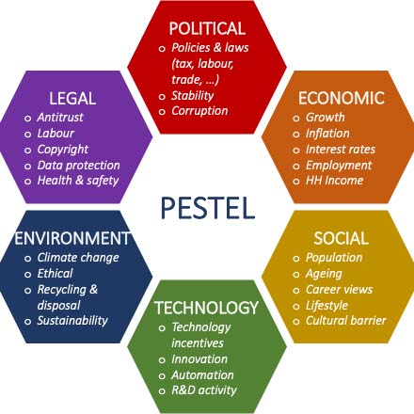
Figure 5: PESTLE Analysis
(Source: SpringWorks, 2025)
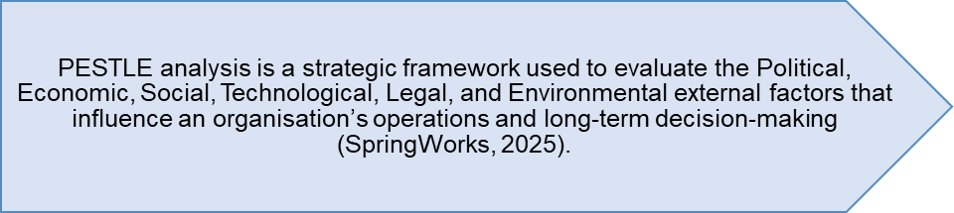
Figure 6: PESTLE Analysis Definition
(Created by learner)
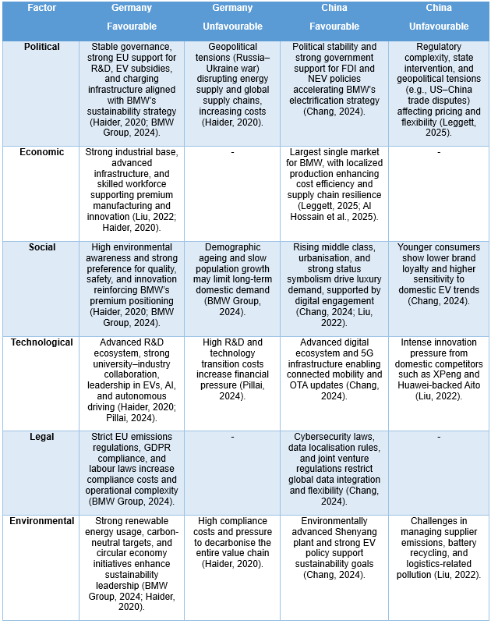
Table 1: PESTLE Analysis Diagram
(Created by learner)

2.1 Political Factors
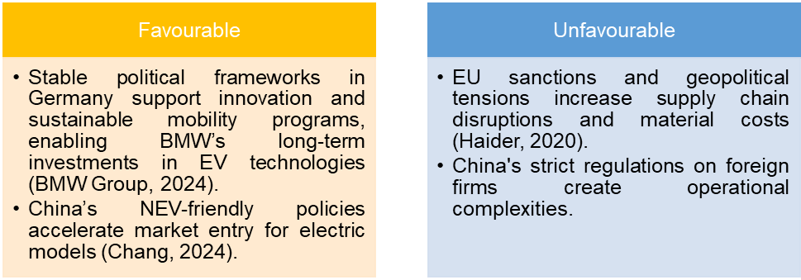
Figure 7: Political Factors
(Created by learner)

2.1.1 Germany
BMW has a politically stable environment based on the sound system of governance and the European Union guidelines that promote research and development, renewable energy and electric mobility.
The system of electric vehicle subsidies and the installation of the network of electric charging stations align well with the sustainability strategy of BMW. However, supply chains have been also disrupted by geopolitical pressures, most particularly the Russia-Ukraine disagreement, which has increased the cost of energy and inputs and created uncertainty in the operations (Haider, 2020; BMW Group, 2024).
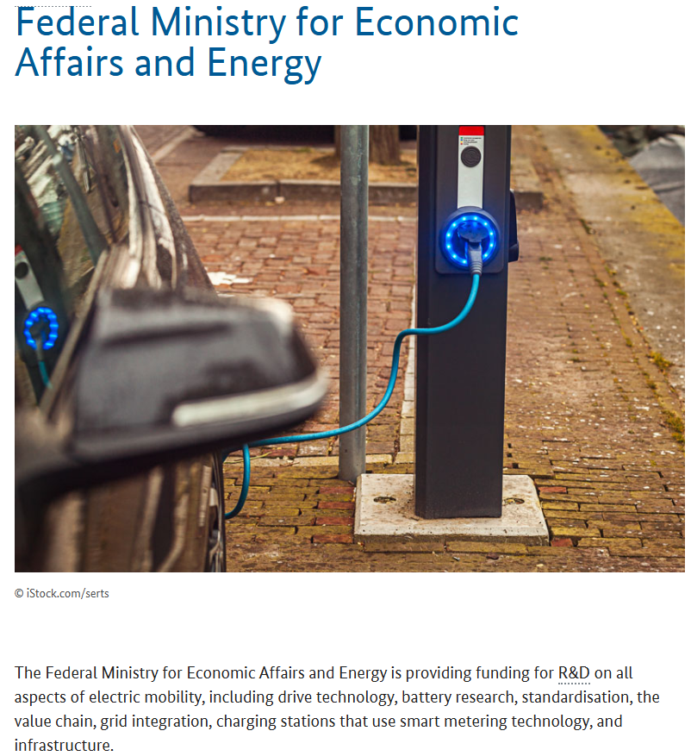
Figure 8: Germany EV Infrastructure Support
(Source: Federal Ministry for Economic Affairs and Energy, 2025)

2.1.2 China
The political stability in China in conjunction with its receptive attitude to foreign direct investment has helped the development of BMW through the BMW Brilliance Automotive joint venture. Policies of New Energy Vehicles (NEV) run by the states have helped speed up the process of electrification of BMW. Still, the flexibility of operations and pricing policies are still affected by regulatory complexity, ongoing state intervention, U.S. China trade disputes, and tariff regime changes (Chang, 2024; Leggett, 2025).
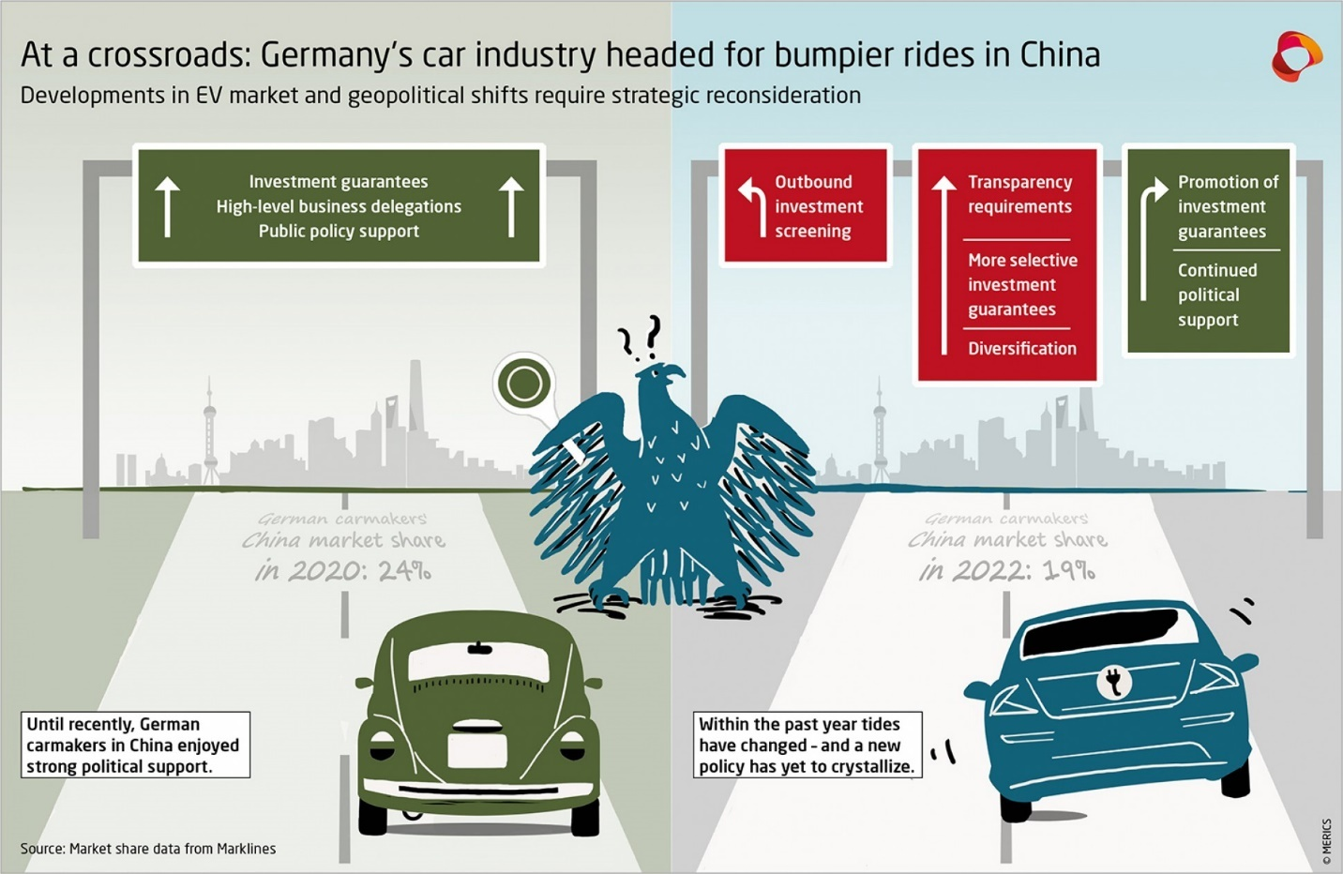
Figure 9: Germany–China Auto Tensions
(Source: Sebastian, G., 2022)

2.2 Economic Factors
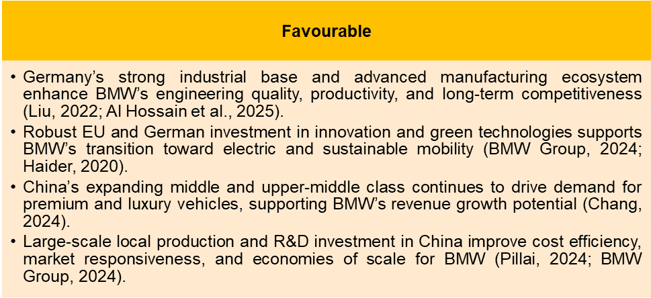
Figure 10: Economic Factors
(Created by learner)

2.2.1 Germany
Germany has a robust industrial base, leading technological infrastructure and highly skilled workforce that provide a strong competitive edge to BMW for the manufacturing of premium automobiles. Stable industrial ecosystems and innovation-oriented policies are conducive to efficient production, high engineering standards and long-term value creation for BMW's global operations (Liu, 2022; Haider, 2020).
Germany’s Economic Outlook
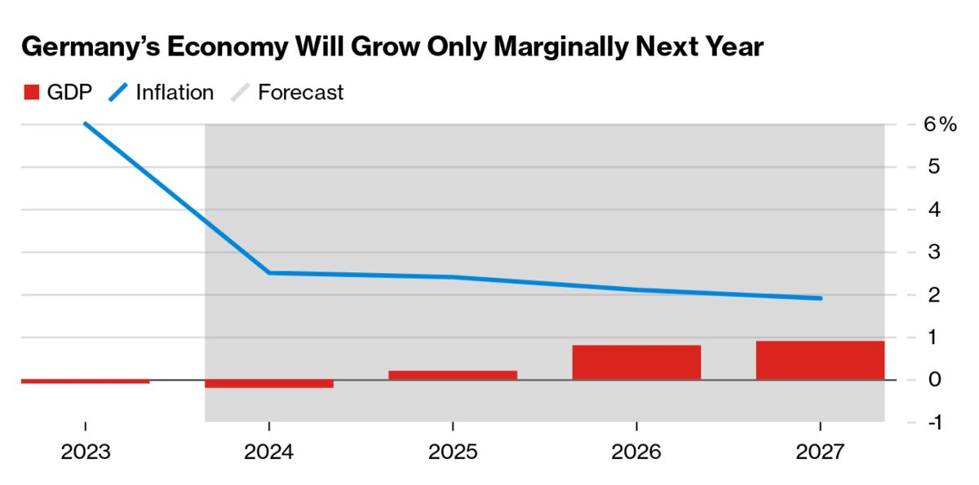
Figure 11: Germany’s Economic Outlook
(Source: Bloomberg, 2024)
The chart shows the growth in Germany's GDP staying very weak through 2024 - 2027 with only minimal positive gains following a slight decline in 2024. Inflation drops dramatically from 5% or so in 2023 to under 3% by 2027. Overall, for Germany it is faced with slow recovery, subdued demand and long-term economic stagnation.

2.2.2 China
China has continued to be the largest market of BMW with significant sales volumes and growth potentials. Localisation of production through the BMW Brilliance Automotive joint venture adds cost efficiency, strengthens supply-chain resiliency, and improves as well as increases responsiveness to local demand, and thus supports long-term competitiveness in the largest automotive market globally (Leggett, 2025; Al Hossain et al., 2025).

China’s GDP Growth Trend
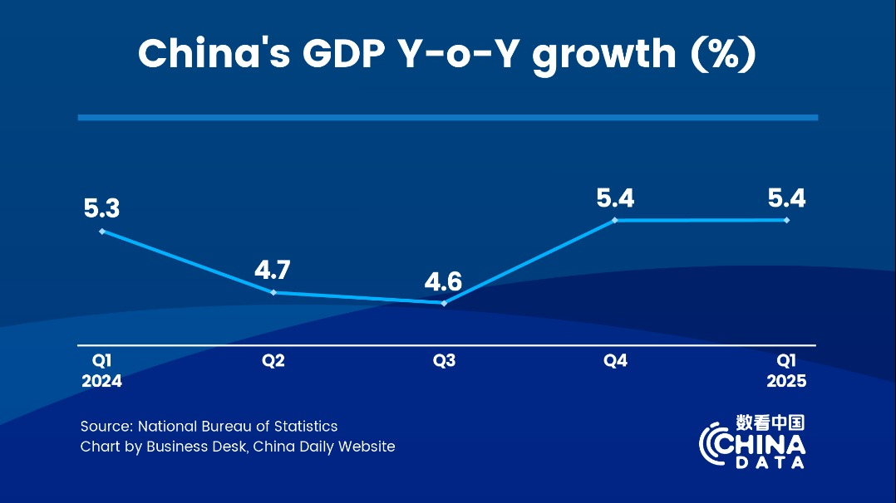
Figure 12: China’s GDP Growth Trend
(Source: Ouyang Shijia, 2025)
The overall trends of the quadrant of growth in China in the quarter are shown in the chart with fluctuations and generally stable growth: 5.3, 4.6, and 5.4 percent in Q1, 2024, and subsequent levels, respectively, and then maturing in Q1, 2025.
These dynamics imply strong economic performance which is sustained due to policy interventions and a revival of demand despite middle year slowdowns.

2.3 Social Factors
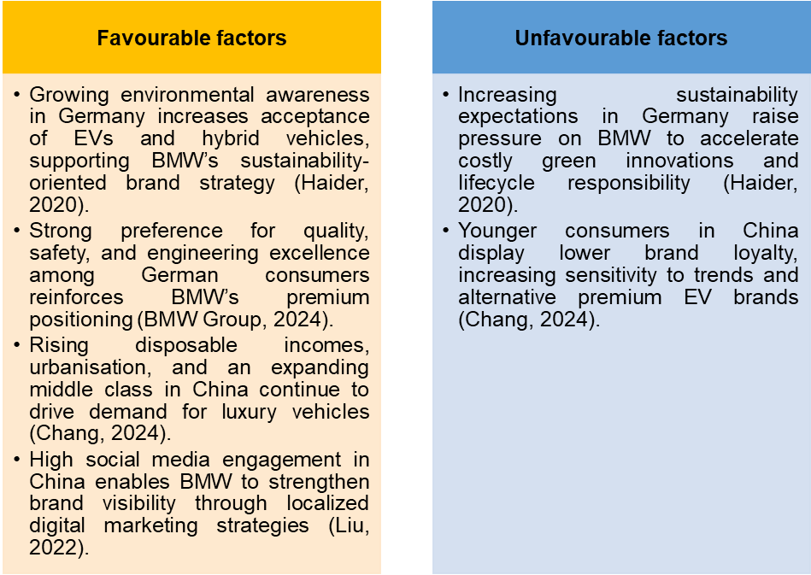
Figure 13: Social Factors
(Created by learner)

2.3.1 Germany
Social trends in Germany are emphasising an emphasis on environmental sustainability and resulting in a growing preference for consumer products such as electric and hybrid cars. This shift is aligned very closely with the sustainability strategy of BMW and the expansion of the BMW i series. German consumers also highly value engineering quality, innovation, and safety, which in turn helps to reinforce the BMW premium brand image and customer loyalty over the long-term within a highly competitive automotive market (Haider, 2020; BMW Group, 2024).

2.3.2 China
In China, rapid urbanisation, rising disposable incomes and growing middle-class demand have means considerable increased demand for luxury vehicles. Among younger consumers in Tier-Thy cities BMW ownership symbolises social status and success. BMW has coped with this by China-specific versions, such as the long wheelbase 5 Series, as well as harnessing social media platforms such as WeChat and Weibo to reach out to digitally savvy consumers (Chang, 2024; Liu, 2022; BMW Group, 2024).

2.3.3 Social Environment Analysis

2.3.3.1 Changing Social Trends in Germany
Social trends in Germany focus on the principles of sustainability, quality, and innovativeness in terms of technology, which contributes to supporting the demand of electric and energy-efficient vehicles. The increased environmental awareness and digitalisation positively affect the BMW investment in electric cars and challenge to become carbon neutral. The transformations in working trends have driven the high demand of small, efficient models. Nevertheless, the demand in the domestic market could be constrained due to the demographic ageing and slow population growth, which makes it stronger as to why BMW meet the global market demand with diversification (Haider, 2020; BMW Group, 2024).

2.3.3.2 Changing Social Trends in China
China's changing socio-cultural environment has a significant impact on the orientation of BMW's strategical movements. The rise of a wealthy middle class gives BMW connotations of prestige and new cutting-edge technology which leads to an increase in demand for the luxurious cars. Younger cohorts are particularly interested in digital experiences, convenience, and environmentally sustainable mobility, and as such, BMW is targeting the local markets by adjusting its electric vehicle offerings and state-of-the-art infotainment systems. In the wake of the pandemic, more private transport infrastructure tendencies as well as the impact of social media and influencers force BMW to adopt customer-cantered, digitally focused engagement frameworks (Chang, 2024; Liu, 2022).

2.3.4 Cultural Environment Analysis

2.3.4.1 Hofstede model

Figure 14: Hofstede Model Definition
(Created by learner)
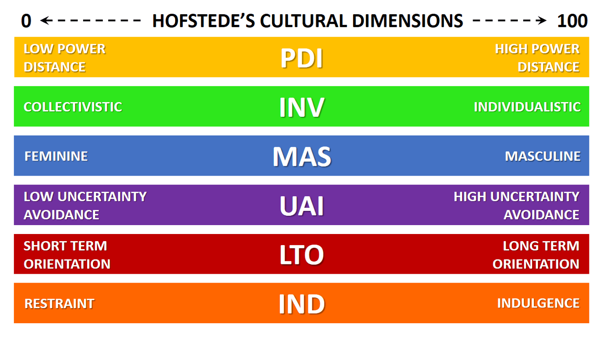
Figure 15: Hofstede model
(Source: Business-to-You, 2025)

2.3.4.2 Advantages and Disadvantages of the Hofstede Model
Advantages of the Hofstede Model
• It gives an analytical and systematic guideline upon which to compare national cultures on uniform dimensions (Hofstede, 2011).
• supports the multinational businesses to understand cross cultural differences in the areas of management, communication, and leadership practices (Hofstede et al., 2010).
• It can be a useful tool in international business strategy, human resource practices, and cross-border negotiations by preventing the cross-cultural misunderstandings (Minkov and Hofstede, 2012).
• Is supported by a lot of empirical evidence collected in various countries taking its pragmatism to another level (Hofstede, 2011).

Disadvantages of the Hofstede Model
• This relies on nationally determined averages, thus maybe a distortion of regional, organisational, and individual distinct cultural differences (McSweeney, 2002).
• The empirical evidence is based on a single multinational company (IBM), which is objectionable in terms of representation (McSweeney, 2002).
• The idea of cultures depicted as comparatively stationary does not take into consideration the changing social and economic nature (Beugelsdijk et al., 2015).
•The model can be simplified on the complexity of the cultural behaviours when used blindly, and this can also encourage stereotyping (Minkov, 2018).

2.3.4.3 Hofstede cultural dimensions analysis
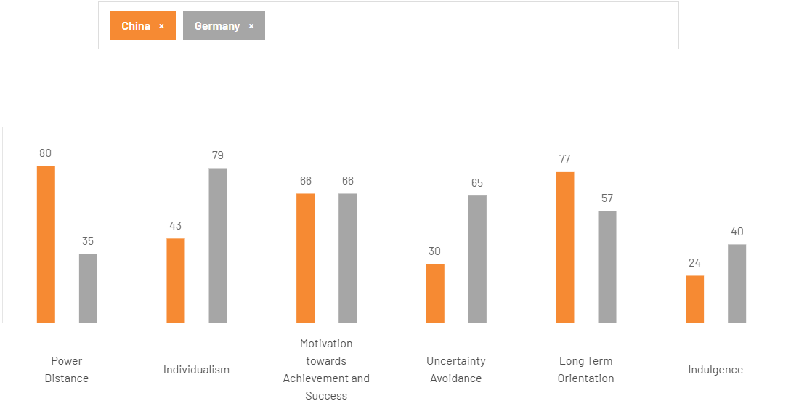
Figure 16: Hofstede Model
(Created by learner)
The Hofstede cultural dimensions show some remarkable differences between China and Germany that influence organisational behaviour and management practices. China's Power Distance index of 80 indicates a strong acceptance of hierarchies and centralised power while Germany's Power Distance index of 35 indicates a penchant for egalitarian organisations and participative decision-making. Germany's high Individualism index of 79, contrasted to the collectivist orientation of China, which has an index of 43, affects differences in teamwork, loyalty and performance incentives. Both countries score the same on Masculinity (66) suggesting a similar focus on achievement and success. Germany's high Uncertainty Avoidance index of 65 translates into a preference for rules, planning and risk avoidance, while a low index of 30 for China allows for more flexibility. China has a strong (77) Long-Term Orientation index relative to Germany's index of 57. Lastly, Germany's Indulgence index of 40, which is much higher than China's calm culture, with an index of 24, this therefore signals different attitudes toward leisure and self-expression (Hofstede, 2011).

2.3.4.4 Cultural Factors in Germany
German culture is ready to pay much attention to precision, engineering quality and efficiency of operation. Consumers in Germany focus more in functional elements, reliability and environmental sustainability rather than trying to display their luxurious lifestyles. The iconic phrase, Sheer Driving Pleasure used by BMW works successfully and corresponds to this consumer desire as it presupposes the foregrounding of driving performance and technological development (Haider, 2020). In turn, these communication approaches are guided by heritage, craftsmanship, and greener innovation and are therefore appealing to a market segment that is pragmatic and environmentally conscious (BMW Group, 2024).

2.3.4.5 Cultural Factors in China
Cultural values to the Chinese are significantly influenced by the value of collectivism, status consciousness and the desire to adopt modern lifestyles. Being as owner of a BMW is largely understood as a sign of social status and professionalism (Chang, 2024). Consumers in China therefore have high importance of brands which depict credibility, dependability and innovative ability. Besides, the element of face (mianzi) plays a crucial role in the buying decision-making process as the visible displays of wealth are used to support a person socially. As a reaction to this, BMW has updated its branding strategy and communication messages to emphasize luxury, comfort, and technological bestseller which correlate with these culturally relevant values (Liu, 2022).

2.3.4.6 Similarities and Differences of cultural factors between the Two Markets
Aspect | Germany | China
Core cultural values | Precision, efficiency, engineering excellence, and sustainability shape consumer expectations (Haider, 2020). | Collectivism, status consciousness, and aspiration for modern lifestyles strongly influence consumption patterns (Chang, 2024).
Perception of BMW brand | Viewed as a symbol of technical innovation, driving performance, and reliability rather than pure luxury (Haider, 2020). | Regarded as a marker of social prestige, success, and upward mobility (Chang, 2024).
Key purchase drivers | Functionality, quality engineering, environmental responsibility, and long-term value (BMW Group, 2024). | Social status, comfort, visible success (“mianzi”), and advanced technology (Liu, 2022).
Communication focus | Emphasis on heritage, craftsmanship, eco-conscious innovation, and performance (BMW Group, 2024). | Focus on luxury appeal, technological superiority, comfort, and aspirational branding (Liu, 2022).
Similarity | Both markets value innovation, reliability, and strong brand credibility, supporting BMW’s premium positioning (Haider, 2020; Chang, 2024). | Both markets value innovation, reliability, and strong brand credibility, supporting BMW’s premium positioning (Haider, 2020; Chang, 2024).
Table 2: Similarities and Differences of cultural factors between the Two Markets
(Created by learner)

2.4 Technological Factors
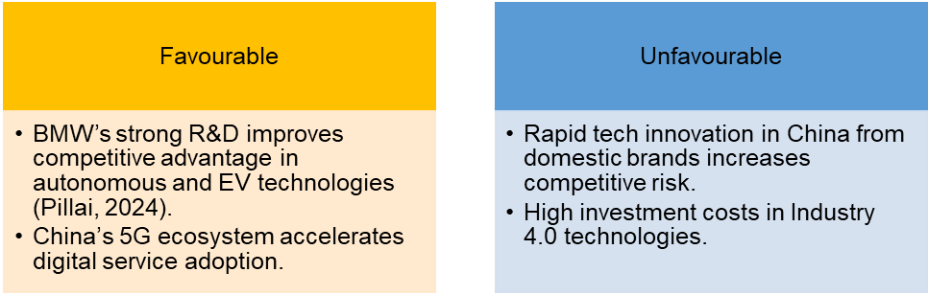
Figure 17: Technological Factors
(Created by learner)

2.4.1 Germany
Technological innovation is a basic building block of how BMW operates in Germany; research and development centres focus on the development of next-generation electric drivetrains, autonomous driving and lightweight material science. Stronger collaborations with educational institutes and tech firms help advance the fields of automation, artificial intelligence, and using digital twins to further manufacturing efficiency and cement BMW's lead in leadership within high-quality engineering and innovation (Haider, 2020; Pillai, 2024).

2.4.2 China
In China, BMW makes the most of its ties with Brilliance Automotive to localize technology development with R&D centres set up in Shenyang and Shanghai. The focal areas are connected mobility, intelligent driving systems and software localisation. China's advanced digital infrastructure and 5G network can support updates over the air and artificial intelligence (AI)-driven features, helping to compel competitiveness in the face of high levels of domestic innovation pressures (Chang, 2024; Liu, 2022).

2.5 Legal Factors
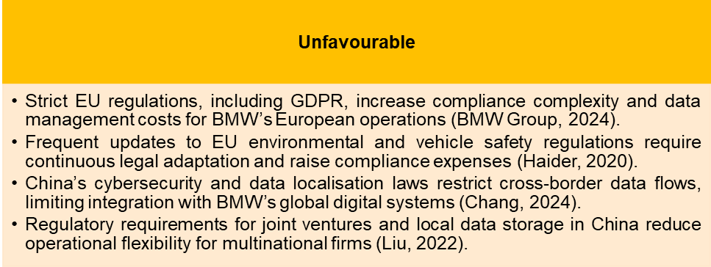
Figure 18: Legal Factors
(Created by learner)

2.5.1 Germany
In Germany, BMW is experiencing negative legal actions which are because of strict legal EU standards. Emissions rules such as the Fit for 55 initiatives are also costly in terms of compliance and transition since they increase a rush towards electric vehicles regardless of expense. Moreover, severe labour laws or GDPR issues add complexity to running businesses, further rising costs of compliance especially as BMW becomes more digital and data-driven (BMW Group, 2024).

2.5.2 China
BMW is also faced with legal issues in China due to the high regulation of joint ventures, localisation of data, and security of data, which has limited the integration of data globally in regard to connected vehicles. Regular alterations in policy influencing the incentives of NEV taxes and import taxes contribute to creating regulatory uncertainty, thereby affecting the price and production decisions despite the increased level of ownership by BMW in its domestic co-operations (Chang, 2024; Leggett, 2025).

2.6 Environmental Factors
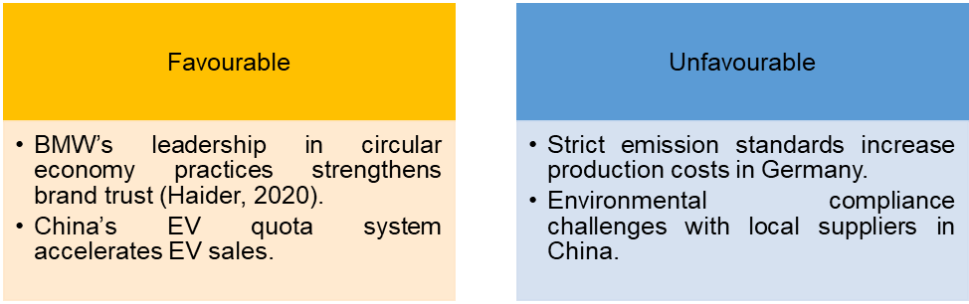
Figure 19: Environmental Factors
(Created by learner)

2.6.1 Germany
The concept of environmental sustainability has become a part of the BMW corporate strategy. BMW is an innovative company in the attenuation of carbon emissions in its value chain in Germany. The production plants in Munich and Leipzig are supplied with renewable electricity only, and BMW provides a goal of its climate neutrality by 2050 (BMW Group, 2024). Massive investments in greener materials such as recycled aluminium and natural fibres emphasize the fact that the firm would be serious about the principles of the circular economy (Haider, 2020).

2.6.2 China
In the Chinese market, BMW is facing increasingly strict regulatory demands to comply with sustainability policy recommendations of the government, especially in the context of electric cars and battery re-use and recycling (Chang, 2024). This is because Shenyang production base is regarded as one of the most environmentally friendly automotive factories in the world, as it utilizes solar energy and uses water recycling systems that consume less energy. However, there are still issues of the control of supplier emissions and pollution based upon logistics. The policies of BMW to expand the range of its electric vehicles, to develop the service of eco-friendly mobility, are the bright examples of the active attitude to sustainability in various markets (Liu, 2022).

2.7 Similarities and Differences – BMW PESTLE Analysis
PESTLE Factor | Similarities (Germany & China) | Differences (Germany vs China)
Political | • Both countries provide political stability that supports BMW’s long-term operations.  • Both governments encourage EV adoption through supportive policies. | Germany: Transparent governance, strong R&D incentives, EU sustainability agendas; stable regulations help BMW.  China: Foreign JV rules, tighter regulatory controls, technology transfer expectations, shifting tariff policies.
Economic | • Both markets are significant contributors to BMW’s global revenue.  • EV market growth in both regions stimulates BMW’s sales. | Germany: High labour costs, slow GDP growth, inflationary pressures.  China: Rising middle class but economic slowdown, yuan depreciation, strong competition from domestic EV brands.
Social | • Consumers in both markets increasingly value sustainability and new mobility solutions.  • Growing preference for electric and hybrid vehicles. | Germany: Rational, engineering-focused consumer preferences; sustainability-driven purchases.  China: Status-driven luxury consumption; younger buyers prefer digital features and long-wheelbase models.
Cultural (Hofstede) | • Both cultures value quality and technological reliability.  • Acceptance of digital innovation is increasing in both regions. | Germany: Low power distance, high individualism, high uncertainty avoidance; marketing focuses on precision, safety, craftsmanship.  China: High power distance, collectivist, strong long-term orientation; branding focuses on prestige, harmony, and social identity.
Technological | • BMW invests heavily in R&D and electric mobility in both countries.  • Rapid adoption of digitalisation and smart mobility solutions in both markets. | Germany: Focus on advanced engineering, autonomous driving, Industry 4.0.  China: Stronger 5G ecosystem, localised software development, severe competition from tech-driven domestic EV brands.
Legal | • Both markets enforce strict environmental and safety standards.  • Compliance with digital data regulations is required in both regions. | Germany/EU: GDPR, Fit-for-55, strict labour regulations.  China: Data localisation, cybersecurity rules, evolving JV regulations, NEV-specific compliance requirements.
Environmental | • Sustainability regulations strongly influence BMW’s EV strategy in both markets.  • Environmental reporting and carbon reduction are required in both regions. | Germany: High emission standards, full renewable energy adoption in plants, circular economy leadership.  China: EV quotas, local supplier emission challenges, rapid expansion of green factories but inconsistent supplier compliance.
Table 3: Similarities and Differences BMW PESTLE Analysis
(Created by learner)

3. Comparison of BMW’s STP Strategies in Country A and Country B

3.1 Segmentation Strategies
BMW uses segmentation techniques in both markets depending on the demographics, psychographics and behavioural determinants. The Chinese segmentation is focused on the up-market urban population and youthful buyers who are interested in luxury and digital novelties (Chang, 2024). The segmentation of the consumers in Germany is cantered on the environmentally conscious customers that are concerned about performance, reliability, and sustainability (BMW Group, 2024).

3.1.1 Segmentation Strategies in Germany and China
Segmentation Variable | Germany (Country A) | China (Country B)
Demographic Segmentation | • Age: 30–65 years  • Professionals, executives, engineers  • High-income individuals (€60,000+ annual income)  • Families seeking safe, sustainable vehicles  • Well-educated consumers valuing technology and engineering | • Age: 25–55 years  • Young professionals, entrepreneurs, upper-middle class  • High-income households (¥250,000+ annual income)  • Growing middle-class and wealthy families  • Tech-driven younger consumers
Geographic Segmentation | • Urban and suburban regions  • Key cities: Munich, Berlin, Frankfurt, Hamburg  • Regions with strong EV infrastructure  • Environmentally conscious regions with charging networks | • Tier 1 & Tier 2 cities (Beijing, Shanghai, Shenzhen, Guangzhou)  • Rapidly developing economic zones  • High-density urban locations  • Regions with strong digital and EV adoption
Psychographic Segmentation | • Values: sustainability, engineering precision, reliability  • Lifestyle: eco-conscious, tech-savvy, safety-oriented  • Personality: rational, performance-focused, efficiency-driven  • Prefers premium brands with proven heritage | • Values: prestige, luxury, technological advancement  • Lifestyle: modern, status-seeking, convenience-driven  • Personality: aspirational, image-conscious  • Prefers brands symbolising success and upward mobility
Behavioural Segmentation | • Usage: daily commuting, long-distance travel  • Benefits sought: safety, sustainability, fuel efficiency, performance  • Loyalty: high brand loyalty due to trust in German engineering  • Purchase behaviour: research-intensive and value-driven | • Usage: city commuting, business travel, social signalling  • Benefits sought: status, digital features, comfort, electric mobility  • Loyalty: strong but competitive due to local EV brands  • Purchase behaviour: influenced by social media, influencers, peer groups
Technological Segmentation | • Favour EV and hybrid models (BMW i series)  • Interest in autonomous driving and efficient engineering  • Usage of digital services but with emphasis on privacy | • Strong preference for digital connectivity, in-car AI, and smart features  • High adoption of mobile apps, online showrooms, and OTA updates  • Consumers demand locally adapted tech (e.g., WeChat integration)
Occasional Segmentation | • Corporate leasing, family upgrading, sustainability-focused purchases  • Seasonal promotions less influential | • Festival-based purchasing (e.g., Chinese New Year)  • Status-driven purchases for career milestones
Table 4: Segmentation Strategies in Germany and China
(Created by learner)

3.2 Targeting Strategies
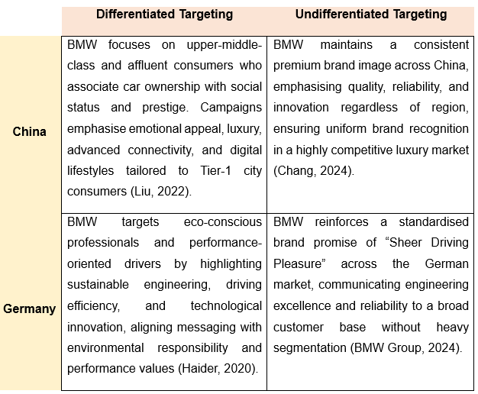
Figure 20: BMW Targeting Strategies: Differentiation vs Undifferentiation
(Created by learner)

3.2.1 Germany
In Germany, BMW takes an evident strategy with a focus on environmentally conscious professional and performance-oriented consumers with a value for engineering excellence, safety and sustainability. Marketing communications highlight technological innovation and pushing efficiency and being environmentally responsible, in line with increased societal awareness of climate change. BMW is also maintaining a constant premium brand image with its "Sheer Driving Pleasure" positioning to appeal to broad quality-driven consumers in a mature automotive market (Haider, 2020; BMW Group, 2024).

3.2.2 China
In China, BMW is targeting upper middle and affluent consumers who view the ownership of high-status/achievement vehicles. Marketing strategies have a focus on luxury, emotional appeal, digital connectiveness and advanced technology especially in Tier - 1 cities. BMW also tailor’s product offerings and communications on a local level, such as through long-wheelbase models and digital interaction through social media, to supplement relevance and competitiveness in the luxury positioning (Liu, 2022; Chang, 2024).

3.3 Positioning Strategies
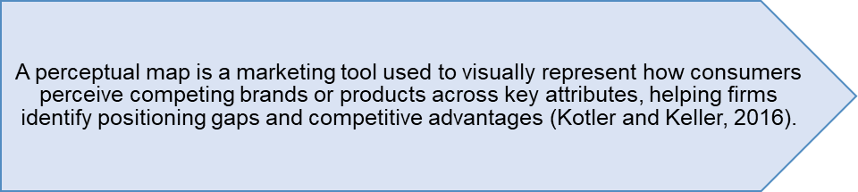
Figure 21: Definition of Perceptual Map
(Created by learner)
BMW presents itself as an insignia of innovation, affluence, and driving enjoyment in the specific markets. In China enough prestige and a modern lifestyle is accentuated with the marque as opposed to precision engineering and sustainability as it is foregrounded in Germany (BMW Group, 2024). This dual branding strengthens the global theme of the brand but at the same time increases the local relevancy.
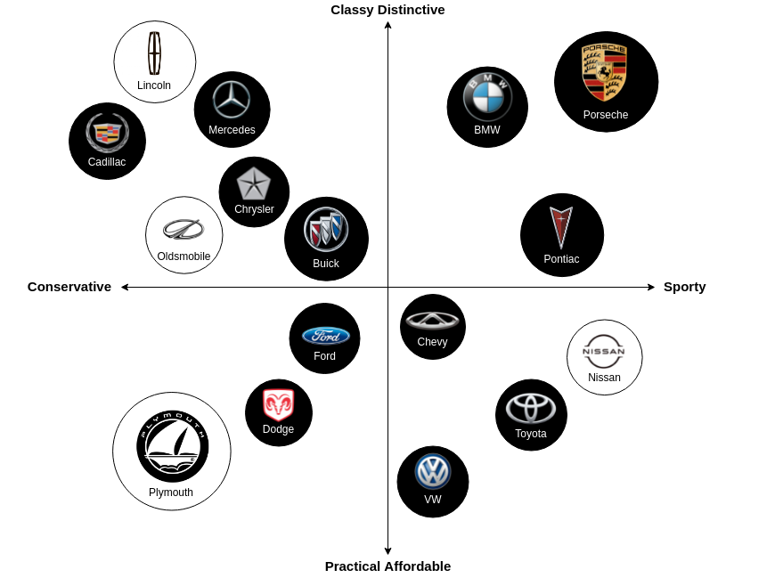
Figure 22: Perceptual map
(Created by learner)
The perceptual map compares the automobile brands using two perpendicular dimensions, namely Classy Distinctive and Practical Affordable, and Conservative and Sporty. In the upper right quadrant are positioned BMW and Porsche, representing aspects of classiness, distinctiveness and sporting character, thus reinforcing their strong premium- performance positioning. Mercedes- Benz and Cadillac occupy the upper left quadrant, which communicate classiness but also a more conservative personality, signaling luxury mixed with some traditional appeal. Brands like Ford, Chevrolet, Volkswagen, Toyota and Nissan fall into the cluster on the lower right quadrant dominated by practicability and affordability, suggesting that there is an emphasis on reliability and cost-efficiencies. Pontiac is at a bit displaced to the sporting axis but is within the accessible domain. For this, European luxury carmakers are dominant in the first place segment, in the system of premium performance, while on the other hand, some mass-market car makers are focusing on practicality and affordability.

3.3.1 Germany
BMW is practicing a high-end positioning in Germany where it focuses on the excellence in engineering, in driving, and sustainable innovation. The brand emphasises on Sheer Driving Pleasure which focuses on accuracy, dependability and technology instead of blatant luxury. An increased interest in electric mobility, energy efficiency, and eco-friendly production would make BMW close to eco-conscious consumers without the need to lose its associations with tradition and craftsmanship (Haider, 2020; BMW Group, 2024).

3.3.2 China
In China, the orientation of the positioning of BMW is more luxurious, status and advanced technology. The brand can be seen as a sign of success and a new lifestyle and especially with the high-end consumers in urban areas. BMW reinforces this position by offering spacious long-wheelbase models, high-tech digital connectivity, and aspirational branding, which focuses on comfort, innovation, and prestige, which helps with high levels of differentiation in the competitive luxury vehicle marketplace (Chang, 2024; Liu, 2022).

3.4 Comparative Summary: Similarities and Differences in STP
BMW maintains a consistent brand image around the world that emphasizes innovation and performance, while simultaneously tailoring its strategic efforts to meet the needs of local cultures and societies. Within the Chinese market, emotive marketing and digital engagement are the main tactic focus whereas in Germany the focus moves to rational appeal and messaging around sustainability (Chang, 2024).
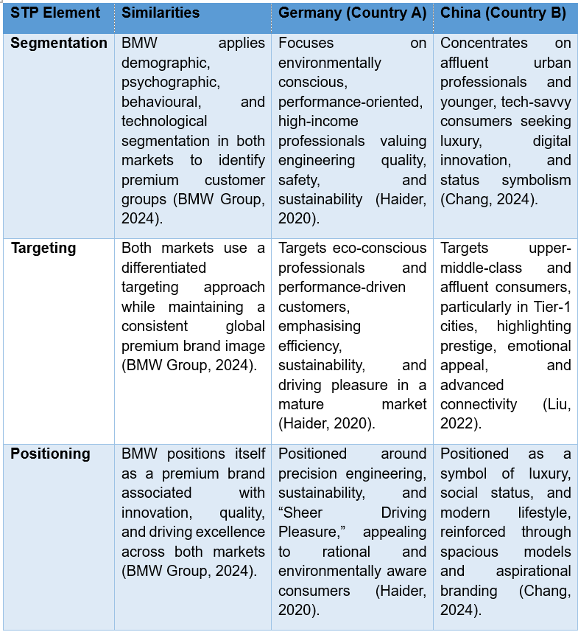
Table 5: Comparative Summary: Similarities and Differences in STP
(Created by learner)

4. Comparison of Marketing Mix Strategies in Country A and Country B

4.1 Product
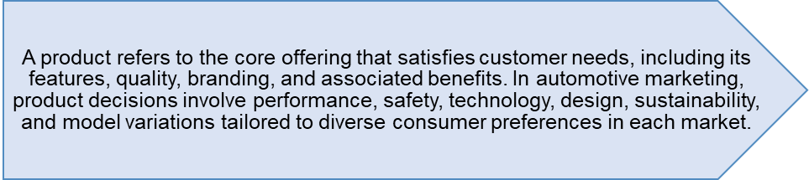
Figure 23: Product Definition
(Created by learner)

4.1.1 Germany
The BMW product strategy in Germany places high emphasis on engineering accuracy, sustainable performance as well as superior performance features in relation to the domestic consumer demands in terms of dependability and environmental sensitivity. The BMW i series is the example of innovations in lightweight materials, energy-efficient, and electrification approaches (Haider, 2020). The headquarter of the company is in Munich, which enables its strong research and development opportunities to ensure constant technological enhancement and product development (BMW Group, 2024). The competitiveness of BMW as a premium performance marque is further cemented thanks to German consumers preference of safety, durability, and technical excellence.

4.1.2 China
The product strategy adopted by BMW in China predicts comfort, prestige, and digital sophistication hence resonates with the likes of status-concerned and technologically savvy consumers. The Chinese market is offered long-wheelbase models and extended cabin functions, which are specifically designed to satisfy the local demands of large-scale luxury. Electric versions, such as iX3, meet the demand which is a result of new energy models (Chang, 2024). The local production under the new brand BBA consortium provides the opportunity of responding to market dynamics and the digitization causes the BMW to be popular among the younger, more digitally sensitive Chinese customers (Liu, 2022; BMW Group, 2024).

4.1.3 Product Variety, Depth & Width
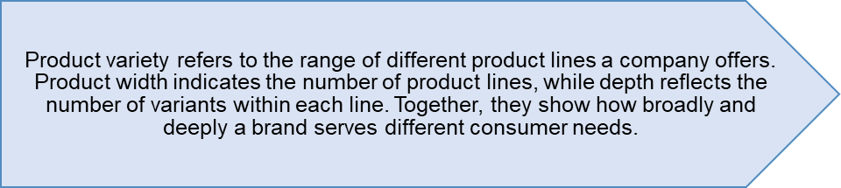
Figure 24: Product Variety, Depth & Width Definition
(Created by learner)

4.1.3.1 Germany
The range of products offered by BMW in the German market is particularly large and consists of sedans, SUVs, electric cars, hybrids, high-performance cars and premium brands such as MINI and Rolls-Royce. Depth within the offering is especially pronounced in the segments of electric vehicle and sedans wherein the manufacturer proffers a range of trim levels and performance variants (Haider, 2020). The width of the product AMD permanently remains extensive, due to the heterogeneous demand of Germans for performance, sustainability and engineering excellence. Domestic manufacturing enables faster innovation cycles, thus allowing BMW to increase the depth through continuous improvements to its models and introducing new configurations in electric drive (BMW Group, 2024).
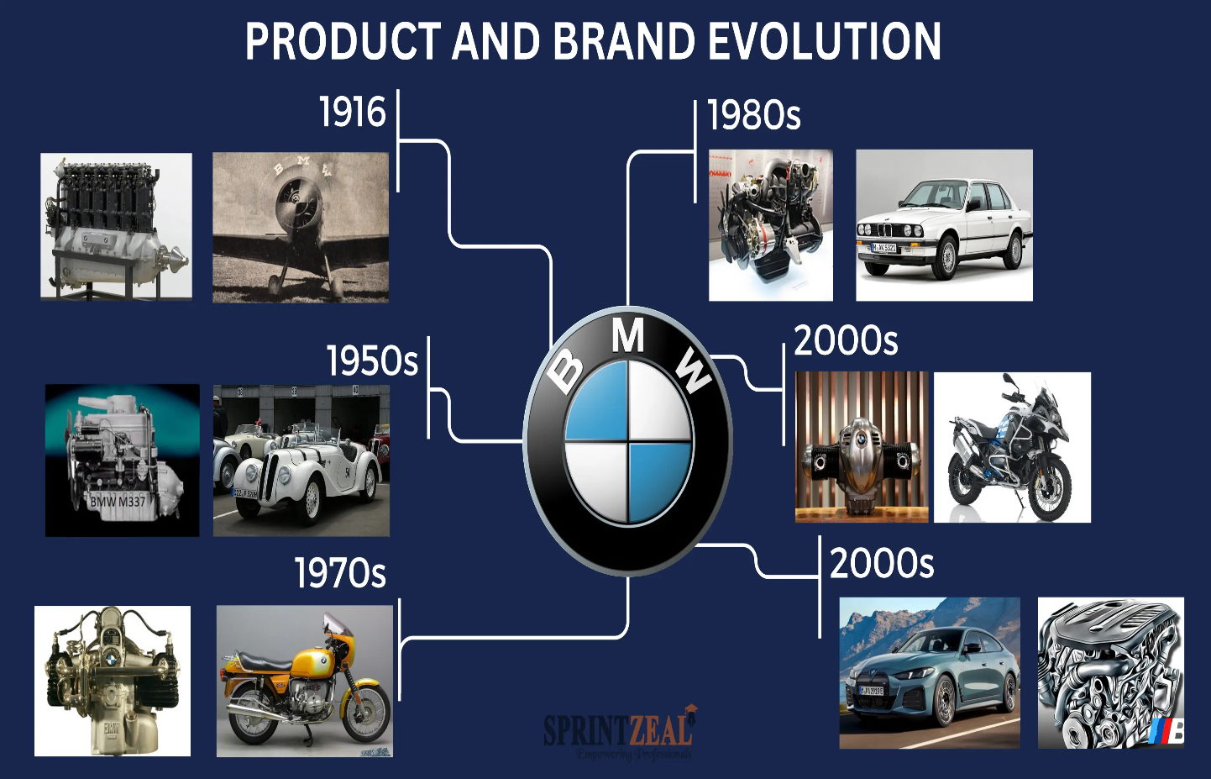
Figure 25:BMW product evaluation
(Source: BMW, 2020)

4.1.3.2 China
The range of products offered by BMW in the German market is particularly large and consists of sedans, SUVs, electric cars, hybrids, high-performance cars and premium brands such as MINI and Rolls-Royce. Depth within the offering is especially pronounced in the segments of electric vehicle and sedans wherein the manufacturer proffers a range of trim levels and performance variants (Haider, 2020).
The width of the product AMD permanently remains extensive, due to the heterogeneous demand of Germans for performance, sustainability and engineering excellence. Domestic manufacturing enables faster innovation cycles, thus allowing BMW to increase the depth through continuous improvements to its models and introducing new configurations in electric drive (BMW Group, 2024).

4.1.3.3 Main Differences Between Germany and China
Diversification of German products lays emphasis on performance criteria in engineering and its more sustainable and precision-oriented segments and has a broader range of electric sedans and compact premium vehicles. The Chinese market however lays stress on comfort, digital luxury and the use of long-wheelbase models which are aimed at consumers who show status orientation. The level of customisation is higher in China, but Germany provides a higher level of technical skills in the domain of performance and electric vehicles. The Chinese market breadth is growing fast due to new regulations and inland competition, but the German markets have been influenced by an engineering tradition and necessity to act in a sustainable way of mobility.

4.1.4 Product Design
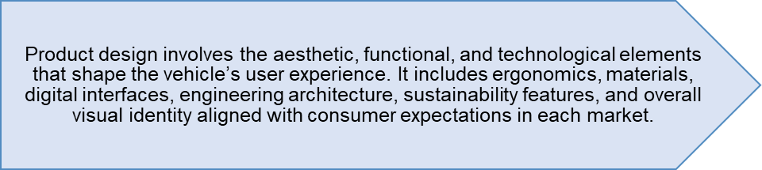
Figure 26: Product Design Definition
(Created by learner)

4.1.4.1 Germany
German product design of BMW anticipates aero efficiency, minimalism design, and precision engineering hence reflects domestic principles of functionality and quality. The E-vehicle models use lightweight materials and other green elements that support environmental priorities of Germany (Haider, 2020). The focus of interior design is on the ergonomic designs, accessible controls, and sophisticated safety. Refined integration of design, which spans the electric drivetrains and autonomous technologies, is supported by continuous investment into research and development (Pillai, 2024; BMW Group, 2024). German customers cherish clean and purposeful designs that are technologically advanced.
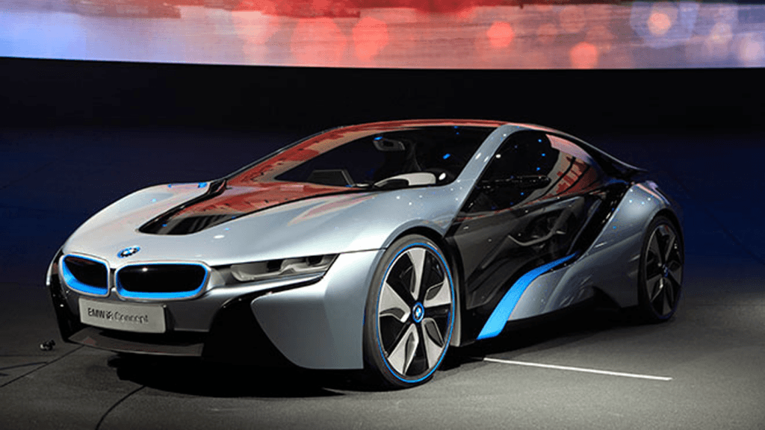
Figure 27: BMW e vehicle
(Source: BMW, 2025)

4.1.4.2 China
Product design used by BMW in the Chinese market focuses on luxury look, spacious cabin design and advanced digital technology that helps to meet high tech savvy customers. The long-wheelbase models are designed with an additional level of comfort, luxury, and entertainment systems on the rear seat to meet the culture of prestige (Chang, 2024). The connection of the Tencent-based connectivity and interfaces on the artificial intelligence and ambient lighting systems supplement the consumer experience (Liu, 2022). These make choices of design anticipate modernity, immersive digital space, and refinement of the images, thus matching the Chinese consumer trends of innovation-based luxury mobility.

4.2 Price
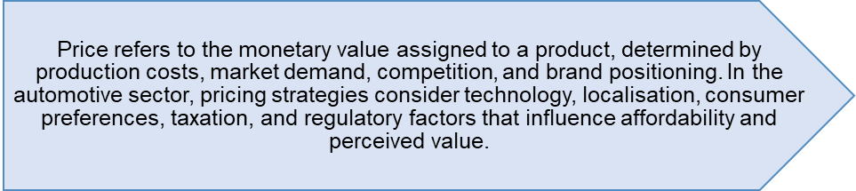
Figure 28: Price Definition
(Created by learner)

4.2.1 Germany
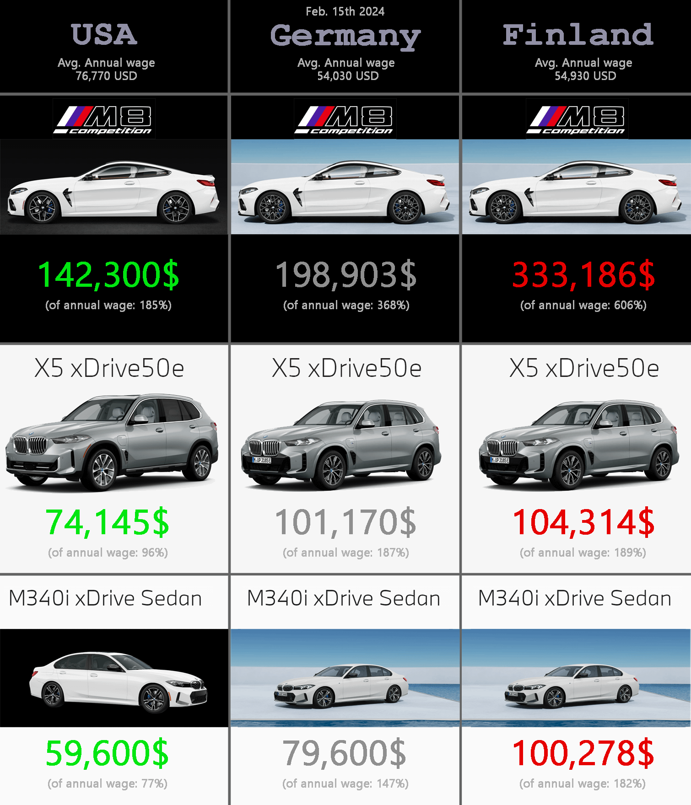
Figure 29; BMW prices in the USA, Germany & Finland
(Source: BMW, 2025)
BMW uses a premium pricing strategy in the German market that is based on the strong engineering quality, the advanced safety technology and the sustainable production systems. High labour and production costs in the German automotive industry are a factor in the pricing structure of BMW which has become a high value luxury range (Haider, 2020). Government subsidies for electric vehicles aid in overcoming costs of electric models, whereas long-term investment in research and development serves as a basis for premium pricing through underpinning the value proposition, innovativeness, and performance (BMW Group, 2024; Pillai, 2024).

4.2.2 China
The pricing approach used by BMW in the Chinese market exhibits a balanced approach to luxury positioning and competitiveness in the market, especially in the face of extreme competition with local electric vehicle (EV) manufactures. The company can reduce the importation duty by assembling locally with the BBA assembly line and thus allowing it to offer a competitive pricing system, which is particularly beneficial with new energy vehicle (NEV) models (Chang, 2024). Still, macroeconomic conditions such as economic stagnation, currency devaluation, and changing levels of consumer demand the need to implement a flexible cost system in order to maintain sales volumes (Leggett, 2025). In addition, the addition of added digital and the presence of long-wheelbase models can be used to support the high levels of premium pricing in high-status premium buyers (Liu, 2022).

4.3 Place
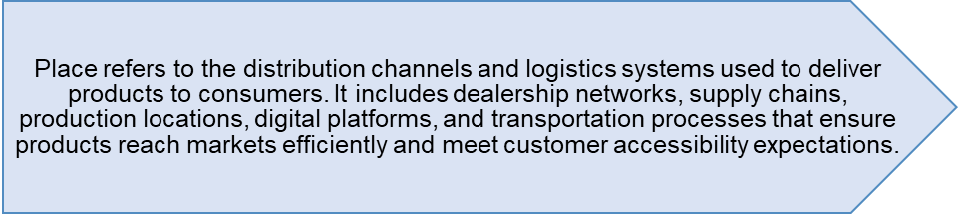
Figure 30: Place Definition
(Created by learner)

4.3.1 Germany
BMW's positioning strategy in Germany is based on a huge network of authorized dealerships, good domestic logistics, and proximity to major manufacturing facilities in Munich, Leipzig and Dingolfing. This integrated framework guarantees fast distribution, good after sales service, and high levels of product availability (BMW Group, 2024).
Advanced transport infrastructure in Germany (s) Improves the reliability of supply chains (s) Sustainable logistics reduce the environmental impact (s) Haider, D. (2020). The use of direct and digital channels in tandem enhances customer accessibility still further and helps solidify BMW as a provider of premium service.
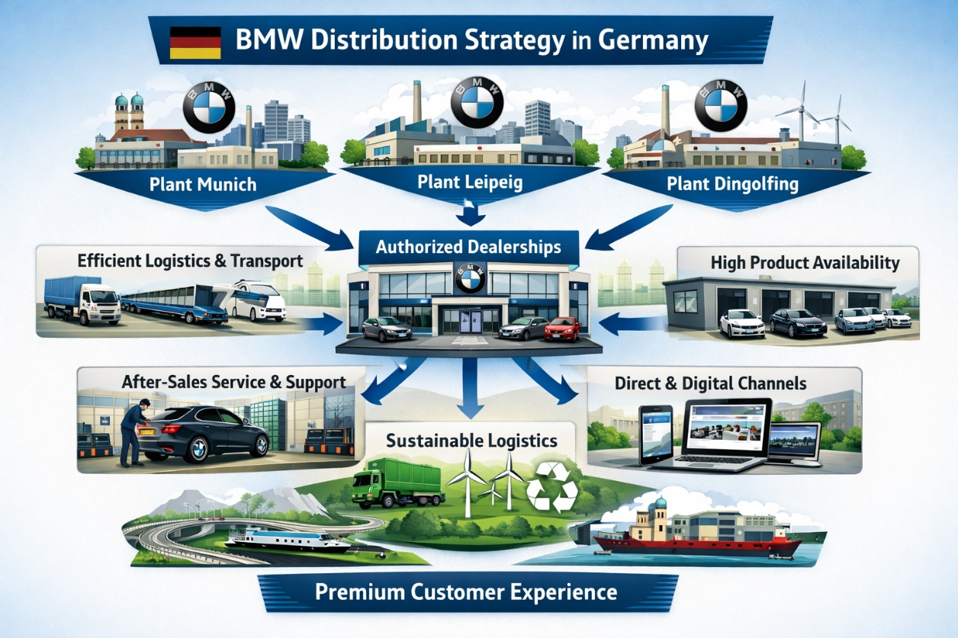
Figure 31: BMW Germany Distribution Diagram
(Created by learner)

4.3.2 China
BMW has a network of dealers that are well established in China with the BMW Brilliance Automotive (BBA) production plants in Shenyang, which is used as a means of penetrating the market quickly as well as reducing the amount of money spent on imports. Localization increases logistical efficiency, and it is consistent with national requirements of NEV policies (Chang, 2024).
Online display rooms and services hosted through applications are some of the digital channels that enhance the consumer involvement in the more technology-driven market. Supply chain localisation enhances responsiveness, but the issue with regional differences requires responsive logistic management (Liu, 2022; Leggett, 2025).
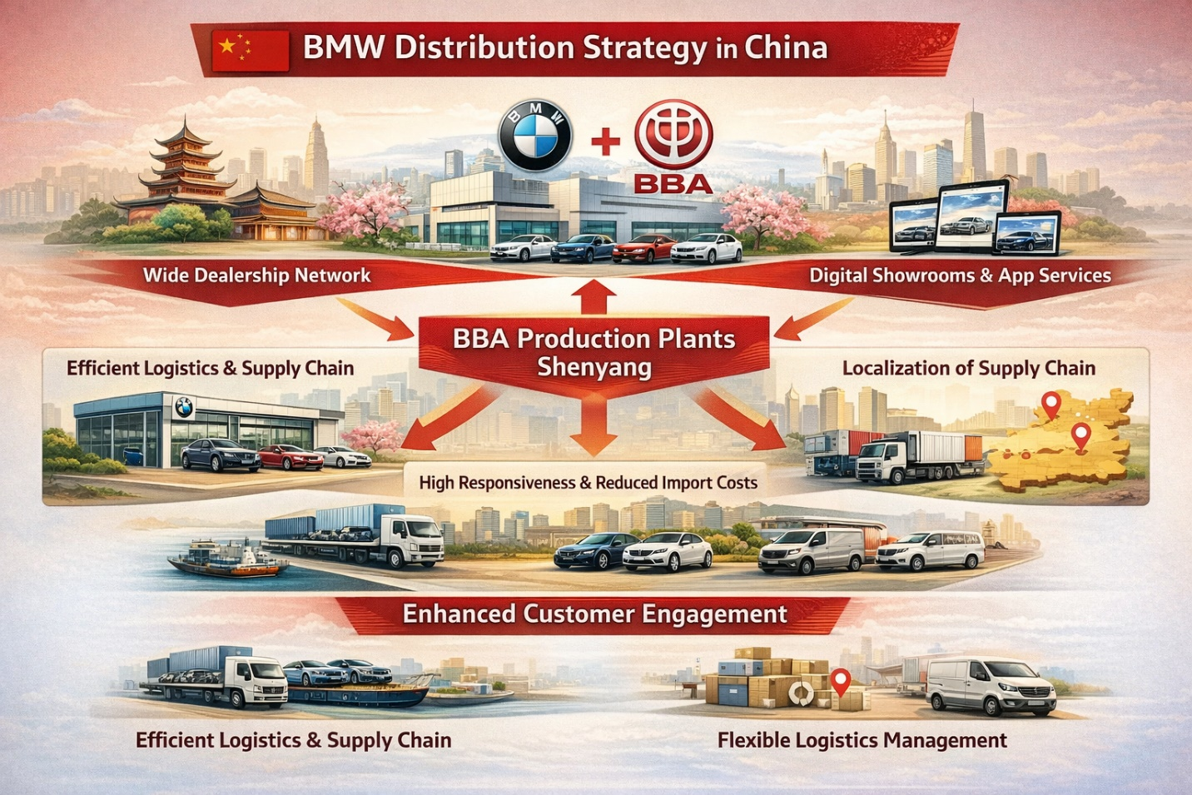
Figure 32: BMW China Distribution Diagram
(Created by learner)

4.3.3 Direct vs Indirect Channels and Intensive Distribution for BMW – Germany vs China
Distribution Aspect | Germany | China
Direct Channels | BMW uses direct channels through authorised BMW-owned retail outlets, digital sales platforms, and direct corporate leasing solutions. Online configurators and factory-linked ordering systems strengthen manufacturer-to-customer interactions (BMW Group, 2024; Haider, 2020). | Direct channels in China include BMW Brilliance Automotive’s local showrooms, brand experience centres, and digital purchasing via BMW and Tencent-integrated platforms, enabling seamless online-to-offline engagement (Chang, 2024; Liu, 2022).
Indirect Channels | Indirect channels operate through independent authorised dealerships, third-party leasing firms, and fleet distributors. These partners expand BMW’s reach across urban and regional markets, supported by Germany’s mature automotive retail ecosystem (Haider, 2020). | Indirect channels include franchised BMW dealers across Tier-1 to Tier-3 cities, alongside local automotive groups and online automotive marketplaces that widen national accessibility (Leggett, 2025; Chang, 2024).
Intensive Distribution | BMW adopts selective-intensive distribution, focusing on high-demand urban regions such as Munich, Berlin, and Hamburg. Dense dealership networks ensure widespread availability while maintaining premium service standards (BMW Group, 2024). | China uses a more intensive distribution approach due to its vast geographic and demographic diversity. BMW expands rapidly across major and developing cities to compete with domestic EV brands and meet NEV-driven demand (Chang, 2024; Liu, 2022).
Table 6: Direct vs Indirect Channels and Intensive Distribution for BMW – Germany vs China
(Created by Learner)

4.3.4 Market Entry Methods

4.3.4.1 Market Entry Method Used in China: Joint Venture (Which Method)
BMW's main market entry strategy in China consists of the establishment of a joint venture/BMW Brilliance Automotive (BBA), in cooperation with Brilliance China Automotive in 2003. This partnership forms an integral part of BMWs production, distribution and localisation in the Chinese market (Chang, 2024).

4.3.4.2 Why BMW Uses a Joint Venture in China (Why)
The regulatory environment in China has required foreign automobile manufacturers to enter the Chinese market through joint ventures, particularly for production locally with internal combustion, and new energy vehicles (NEVs). This joint-venture structure provides BMW with a very efficient means of gaining approval, garnering local government support and also facilitating the assimilation of the company into the Chinese auto ecosystem. Furthermore, BBA enables the production of long-wheelbase versions, China-specific electric vehicles and digital integrated systems, which are mindful of local tastes, thus fulfilling local preferences for comfort, prestige and technological excellence (Liu, 2022). Production localized via BBA also helps BMW bypass the tariffs on imports, reduces the logistical expenses and can be responsive to various market conditions in the long run to enhance long-term competitive viability (Leggett, 2025).
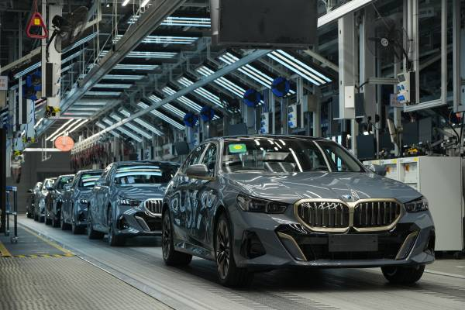
Figure 33:BMW Vehicle Production Line – Localised Manufacturing via BBA
(Source: BMW)

4.3.4.4 Advantages of the Joint Venture Model in China
The joint venture also gives BMW a benefit of local market knowledge, hence allowing it to align the product designs, online interfaces and distribution channels to the Chinese consumer behaviour. Local sourcing and manufacturing reduce the expenses and enable BMW to comply with the NEV policies of China that promote local production and developments (Chang, 2024). The joint venture provides BMW with several strategic benefits, such as increased supply chain responsiveness, faster electric vehicle development and access to China and its advanced digital ecosystem. Additionally, the model enhances the customer experience through local marketing services and in vehicle digital experience that are consistent with the needs of young, tech savvy consumers (Liu, 2022).
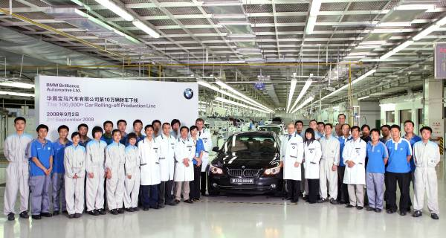
Figure 34:BMW Group Celebrates the 20th Anniversary of BMW Brilliance Automotive (BBA) – Announcement of Localised Production in China
(Source: BMW)

4.3.4.5 Disadvantages of the Joint Venture Model in China
Despite its advantages, there are limits to the use of the joint venture structure one of the most important is reduced managerial autonomy and the need to coordinate strategic decisions with a local partner. Divergence in organisational culture and communication practices could be a further reason that hinders operational efficiency and decision-making process (Chang, 2024). China's regulatory regime on matters of data localisation and cybersecurity is imposing further restrictions, thus limiting BMW's ability to deploy global digital systems across the whole enterprise. Furthermore, intensified competition on electric vehicles in the domestic market threatens BMW's presence both in the domestic market and could lead to a reduction in its market share, which will require the company to invest regularly in innovation and increase in its local responsiveness to maintain its market position (Leggett, 2025).

4.4 Promotion
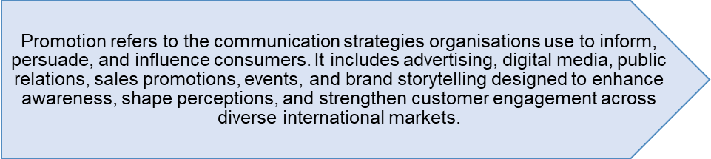
Figure 35: Promotion Definition
(Created by learner)

4.4.1 Germany
BMW promotes engineering excellence, sustainability accomplishments, and innovative technologies of electric vehicles as the priorities of its promotional strategy in Germany. The precision of the performance offered to the consumers in the context of marketing communications promotes safety, environmental responsibility, and forecasts the rational decision-making patterns characteristic of the German consumer, thus complying with the behavioural trends of German consumers (Haider, 2020). As part of strengthening its premium positioning, BMW uses integrated campaigns, which are synergies of digital platforms, experience events, and brand collaborations. Corporate communications also display the development of research and development and the implementation of the concept of the circular-economy because of which the markets facing Germany are interested in eco-friendly consumer behaviour and technologically informed (BMW Group, 2024; Pillai, 2024).

4.4.2 China
In China, BMW has a very localized promotional strategy that focuses on digital engagement, luxury lifestyle branding, and influencer-generated content. Platforms like WeChat, Weibo and the larger TenCent’s are used far and wide for reaching the younger generation who are more web-based and looking for prestige and modernity (Chang, 2024). BMW's promotional activities focus on long-wheelbase comfort, connectivity functionality and NEV innovation. Experiential events, celebrity endorsements, and immersive virtual showrooms are even more powerful in reinforcing their brand appeal in a competitive market that is dominated by domestic EV manufacturers (Liu, 2022; Leggett, 2025).

4.4.3 Promotion Evaluation
Strategy | Germany | China
Message Focus | Sustainability & engineering | Prestige & digital lifestyle
Media Channels | TV, YouTube, LinkedIn | WeChat, Weibo, Douyin
Approach | Rational, informative | Emotional, influencer-based
Customer Response | High trust | High engagement
Table 7: Promotion Evaluation Table
(Created by Learner)

4.5 People
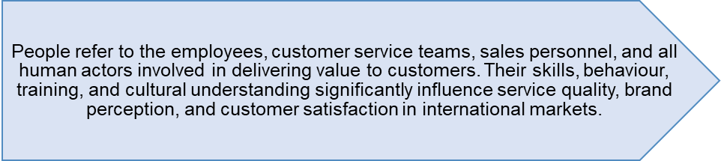
Figure 36: People Definition
(Created by learner)

4.5.1 Germany
The human resource strategy of BMW in Germany is prospective of the development of the engineering talent of the high level, the execution of the disciplined technical training courses, and the strengthening of the organisational culture, which is based on precision, innovation, and high performance. On the foundation of development actions, advancing research and development processes, and green production, employee development efforts are supported (BMW Group, 2024). Employees of the service sector in Germany value professionalism, a wide product base, and reliability and therefore reflect the demands of consumers in contacts of highest quality. Besides, the strict labour laws and carefully designed working conditions add to increased operational stability and responsibility to the domestic workforce of BMW (Haider, 2020; Pillai, 2024).

4.5.2 China
In China, BMW focuses on culturally adaptive customer service teams, digital engagement experts, and employees that are trained in luxury customer service delivery to meet the demands of status-conscious and technology-oriented consumers. Employees are prepared to highlight the features of digital connectivity, comfort improvements, and NEV benefits according to local preferences (Chang, 2024). BMW Brilliance Automotive supports the talent development of local teams, cross-cultural teamwork and efficient production ability, to ensure the competitiveness of the response to the rapidly changing market of auto industry (Liu, 2022; Leggett, 2025).

4.6 Process Definition
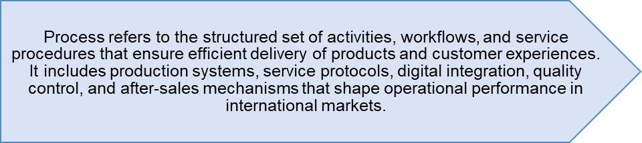
Figure 37: Process Definition
(Created by learner)

4.6.1 Germany
The process plan implemented by BMW in Germany is based on the precision production, high automation, and sustainability-based processes. Industries 4.0, digital twins, and high-quality assurance systems are operational within German facilities to guarantee system efficiency and engineering perfection (Haider, 2020). Customer processes are customer-oriented processes focusing on appointment-based service, open diagnostics and routine follow-ups. Effective integration of research and development into the production promises speeds up the process of innovations, and the controlled labour environment guarantees stability and standardisation of procedures in the domestic activities of BMW (BMW Group, 2024; Pillai, 2024).

4.6.1.1 Customer Complaint Process – Germany
In Germany, the complaint handling process used by BMW is characterised by a structured, transparent and efficiency-driven process, as such satisfying national expectations in terms of reliability and accountability. Complaints are received largely through authorised dealerships, service centres, or online. Identified issues are systematically logged and diagnostically assessed and appropriately escalated in accordance with standardised procedures that enforce stringent timelines. Special emphasis is laid on technical accuracy, unambiguous communication and the systematic documentation of resolutions and thus maintain trustworthiness while reinforcing the culture of service associated with BMW and which is fundamentally engineering orientated.
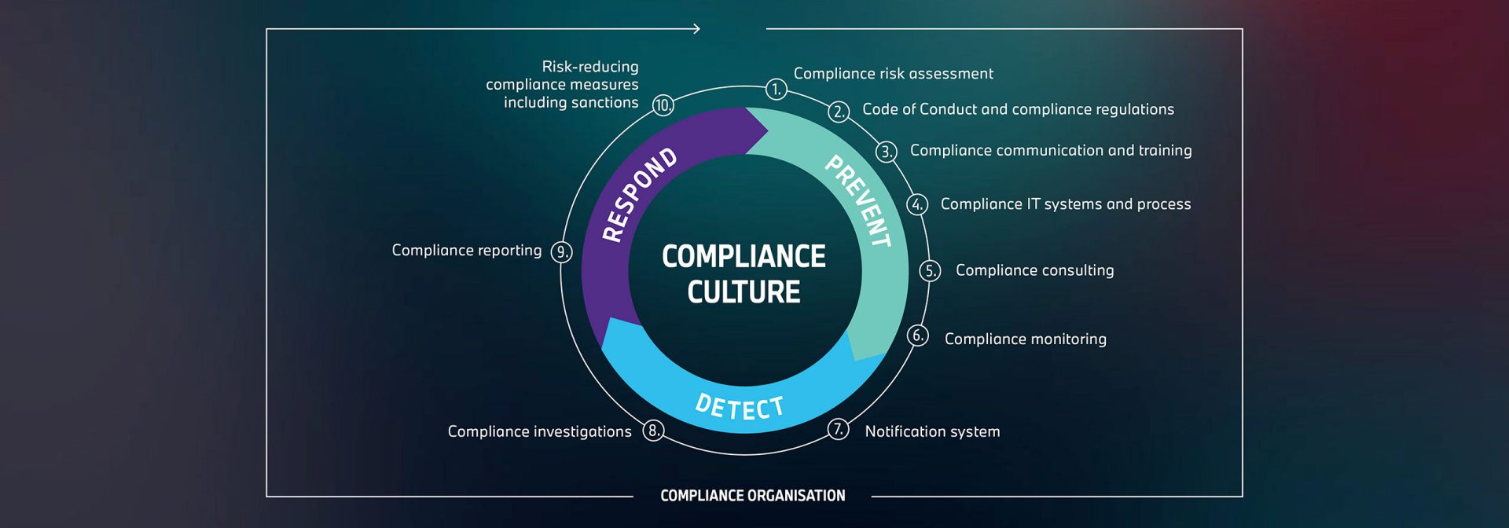
Figure 38: BMW Complaint culture

4.6.2 China
BMW functional structures in China are adjusted to increase speed, localisation, and digital stakeholders’ interactions. To meet the changing market needs, the BMW Brilliance Automotive (BBA) plants use flexible manufacturing principles, speedy electric car (EV) manufacturing processes, and domestically obtained supply chains (Chang, 2024). Customer routes Customer routes Digital frontends of interaction, such as application-based booking systems, artificial intelligence-driven support, and integrated service suites tailored to consumers with advanced technological knowledge. Local production workflows could ease quicker iterations of models and greater reaction to the policy New Energy Vehicle (NEV) compulsions (Liu, 2022; Leggett, 2025).

4.6.1.2 Customer Complaint Process – China
In the Chinese market, BMW's complaint handling system combines the concepts of digital responsiveness, convenient communication and fast service recovery. Clients will often use WeChat, online portals, or dealership channels for submitting complaints. Complaints are handled through BMW Brilliance Automotive's integrated system, which ensures particularly rapid acknowledgement and individualized solutions. Greater attention is given to relationship management, prestige - oriented service experiences and proactive follow - ups to meet the expectations of status - conscious, technologically proficient consumers.

4.7 Physical Evidence

Figure 39: Physical Evidence Definition
(Created by learner)

4.7.1 Germany
The physical evidence of BMW in Germany promotes its focus on precision, quality, and engineering by showcasing modern showrooms, the minimalism of the design style, and the high level of service with the help of the modern showrooms. Digital configurators, open service bays, and branding aimed at sustainability are also used in dealerships as part of the BMW culture of innovativeness (BMW Group, 2024). Technical excellence and environmental responsibility are also enhanced by the manufacturing workplaces and visitor centres, thus contributing to the consumer demands of reliability and superior artisanship (Haider, 2020). These are the physical aspects, which reinforce the BMW brand of high-end cars in the home market.
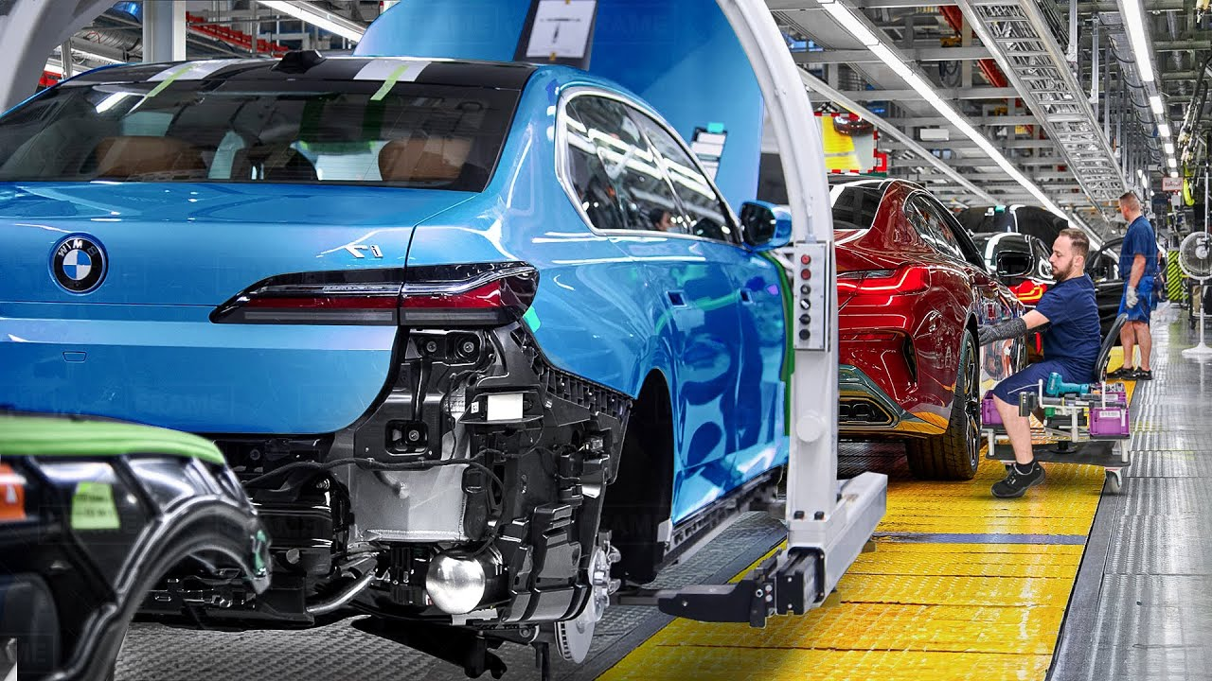

4.7.2 China
In the Chinese market, BMW provides tangible evidence of luxury, immersion in digital content, and the customer experience through extensive showrooms, VIP lounges, and technology-enhanced presentation space aimed at status-conscious buyers. Digital touchpoints, virtual showrooms, and interfaces integrated into TenCent’s create an interactive environment that conforms to local ideas of modernity (Chang, 2024). BMW Brilliance Automotive's production facilities are the hallmark of local production excellence and therefore establish credibility with consumers and the brand's honour (Liu, 2022). Collectively, these elements help to enhance BMW's premium positioning in the highly competitive Chinese market.

4.8 7Ps Similarities and Differences (Germany vs. China)
7Ps Element | Similarities | Differences
Product | • Premium vehicles with advanced technology  • Strong focus on safety, performance, and innovation  • EV and hybrid models promoted in both countries | Germany: Emphasis on engineering precision, sustainability, and efficiency (BMW i-series).  China: Long-wheelbase models, enhanced digital features, locally adapted EVs (iX3, i3 sedan).
Price | • Premium pricing strategy  • Financing options in both markets | Germany: Value-based pricing with minimal discounting.  China: More competitive pricing due to strong local EV rivalry; flexible instalment plans for younger buyers.
Place (Distribution) | • Strong dealership networks  • Online configurators available in both markets | Germany: Eco-friendly showrooms and traditional dealer focus.  China: Heavy reliance on digital platforms, virtual showrooms, and e-commerce (Alibaba Auto).
Promotion | • Promotion highlights innovation and brand prestige  • Uses digital marketing in both markets | Germany: Focus on engineering excellence, sustainability, performance.  China: Emphasises luxury, social status, and influencer-driven digital campaigns on WeChat and Weibo.
People | • Highly trained staff delivering premium service | Germany: Staff focus on technical expertise and eco-focused communication.  China: Staff trained for luxury experiences, personalisation, and digital interaction.
Process | • Smooth purchasing processes and strong after-sales support | Germany: Structured, efficient, transparent processes.  China: Fast, digitalised processes with AI-supported services and mobile-first systems.
Physical Evidence | • Premium-brand showrooms  • BMW brand identity consistent worldwide | Germany: Simple, eco-conscious showroom designs.  China: Luxurious, tech-centric showrooms with immersive digital displays.
Table 8: 7Ps Similarities and Differences (Germany vs. China)
(Created by learner)

4.9 Evaluation of Marketing Strategies

4.9.1 Germany
The marketing strategies adopted by BMW in Germany focus on engineering excellence, sustainability, and performance to meet the rational and quality conscious consumer requirements. The company anticipates EV innovation, safety leadership, and brand storytelling which is based on heritage, strengthening trust and premium identity (Haider, 2020). Integrated marketing communications involve digital space, experience, and corporate message of sustainability, and in essence, they play a sustainable role in sustaining markets domination by BMW. The high level of correspondence between marketing content and consumer values adds up to a stable brand loyalty and market standing (BMW Group, 2024).
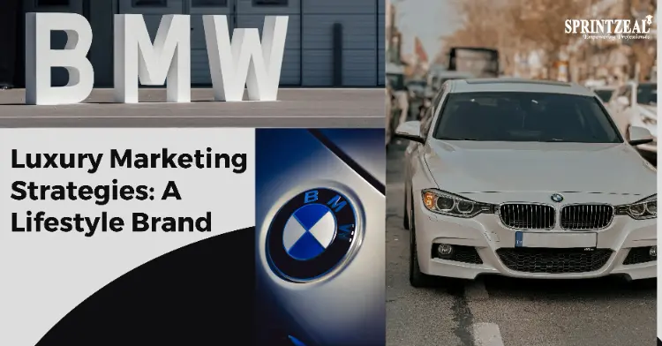
Figure 40:BMW Marketing Strategies in Germany
(Source: BMW)

4.9.2 China
BMW in China is highly localised with digitally intensive marketing strategies, where lifestyle branding, NEV innovation and luxury positioning are a priority. In promotions, they can make use of WeChat, Weibo, influencers, and Tencent ecosystems to access tech-savvy consumers (Chang, 2024). The key to the campaign aimed at status-conscious preferences is long-wheelbase and digitally enhanced models. Marketing by BMW optimally differentiates its brand, but it is still under the challenge of competitive moves by domestic EV agencies. Further localisation and online immersion increase the competitive advantage of BMW (Liu, 2022; Leggett, 2025).

4.10 Profit and Sales

4.10.1 Germany
Germany forms one of the most profitable markets for BMW because of strong brand fidelity and stable demand for higher-end vehicles, as well as intrinsic native benefits in manufacturing. Profitability is backed by efficient production networks, high-value models and ongoing use of electric vehicles, according to the BMW Group (2024). Although the German economy has shown signs of stagnation, consumer preference for technologically advanced, sustainable vehicles is supporting strong revenue streams. The company's established reputation for domestic engineering excellence and a tenacious after-sales ecosystem further adds to the added profitability (Haider, 2020).

4.10.2 China
Figure 41: BMW Group – Largest Automobile Markets by Share of Sales in 2024 (with 2023 Comparison)
(Source: BMW Group Annual Report 2024)
China accounts for BMW's biggest market internationally, however sales volatility has increased because of economic slowdown, depreciation of the yuan and growing domestic competition in the electric vehicle sector. BMW witnessed reduced sales volumes in 2024, and very much due to the loss of buying confidence (Leggett, 2025). Nonetheless, import costs are circumvented and profit margins are raised through localisation using BMW within the Brilliance Group. Growing uptake of new energy vehicles (NEVs) and digitalisation of auto features ensure the basis for a sustained long-term sales choice despite short term variation (Chang, 2024; Liu, 2022).

4.11 Social Media Engagement

4.11.1 Germany
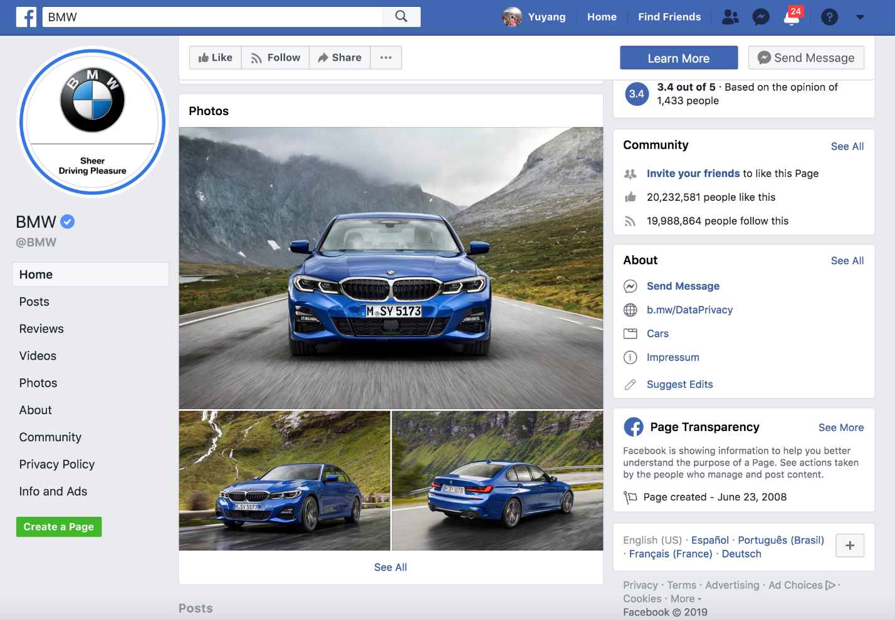
Figure 42: BMW Facebook advertisement
BMW's social media engagement in Germany centres on engineering transparency, sustainability accomplishments and innovation in electric vehicles (EV). The content brings the behind-the-scenes production processes, technological milestones and environmental advancements to the foreground making it particularly appealing to a German audience with a preference for authenticity, technical detail and responsible manufacturing (BMW Group, 2024). Engagement levels remain high among consumers with special interests in performance, design and green mobility. The story focus on reliability and heritage serves to strengthen BMW's superior and trusting brand image (Haider,2020).

4.11.2 China
In the Chinese market, the social media approach of BMW focuses on lifestyle impressiveness, digital interactivity and prestige-driven accounts. To reach the younger generations, campaigns use vivid visuals, influencers and short-form videos on various platforms, including WeChat, Weibo, and Douyin (Chang, 2024). Tencent integration enhances the interactive capabilities whereas a promotion showcases NEV innovation, comfort and status. This interactive strategy has a strong appeal to the population of China, who are technologically sophisticated, thus accelerating the consistency of brand contact and competitive presence (Liu, 2022).

4.12 Customer Reviews

4.12.1 Germany
Investigations of the feedback left by German customers will always focus on the BMW engineering accuracy, strong road performance, and reliable after-sales services. The quality of the electric-vehicle models and the communication of the service processes are often referenced by the respondents, whereas a part of the reviewers expresses their interests about the maintenance costs (BMW Group, 2024). German buyers attach great importance to transparency and technical quality, and the brand can be praised by its safety, quality of construction, and environmentally friendly production (Haider, 2020). As a result, the general tone can be characterized as quite positive.
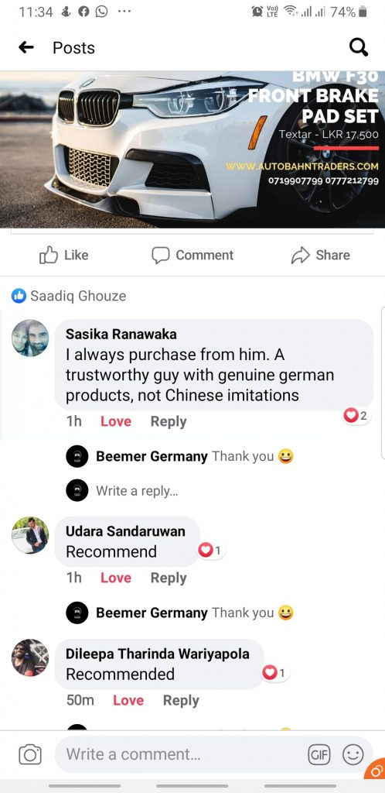
Figure 43: Customer comments
(Source: BMW Facebook)

4.12.2 China
Chinese commentaries indicate that Chinese appreciate luxury in BMW, the digital functionality and AC space of the long-wheelbase models. People often compliment the car connectivity, luxury car interiors and comfort (Chang, 2024). However, critics have sometimes reported steep prices, domestic competition in manufacturing electric-vehicles, and delays in delivery (Leggett, 2025). Particularly young consumers are positively attracted by the digital features and the symbolism of prestige that are offered by the BMW brand and thus strengthen the brand image of desirability despite the growing competition (Liu, 2022).

5. Ethics of Germany
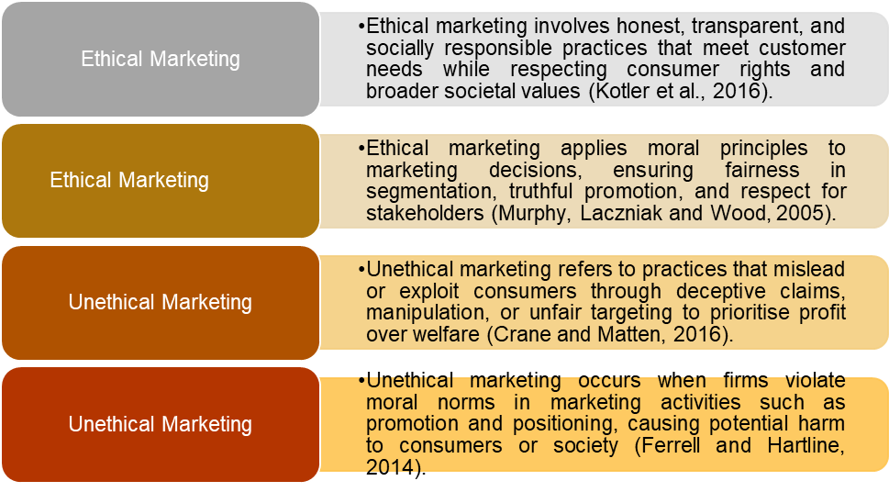
Figure 44: Ethical vs Unethical Marketing – Definitions
(Created by learner)
Strong systems of regulation enforced consumer protection laws, and the general presence of a high level of transparency, accountability, and sustainability defines the ethical business landscape in Germany. The activities of BMW in Germany can be considered a good example of these ethical standards as the company has a clear pledging to the safety of manufacturing, environmentally friendly production, as well as an integrity-focused decision-making process. Corporate governance structure (including compliance committees, risk-management frameworks) will make sure that BMW is in line with both national law and EU regulations on emissions, employee safety, and data protection (BMW Group, 2024). These systems consequently boost the trust of the consumer and stakeholders by demonstrating to them accountability and pro-active risk mitigation strategy.
The importance of environmental ethics in Germany is especially high given that consumer expectations and government policy strongly support the principles of decarbonisation and circular economy practices. In this respect, the adoption of a suite of ethical sourcing strategies, lowering carbon footprints in the manufacturing facilities, and the increased investment in renewable energy sources are employed by BMW to match the sustainability vision in Germany (Haider, 2020). Moreover, labour ethics are ingrained in the German automotive industry; organised training routes, union involvement and the protection of employee rights are collectively responsible for a fair and equitable work environment (Pillai, 2024). These ethical labour practices not only promote the wellbeing of the employees but also strengthen BMW's reputation as a responsible employer.
BMW is adopting complex digital systems and EDS connection to the vehicles, which has added importance to digital ethics. The strict data privacy provisions across Germany under the General Data Protection Regulation make BMW maintain a high level of transparency regarding data use, data security, and data consent (BMW Group, 2024). These moral requirements influence the way BMW addresses digital innovation in the way that technological advancement cannot interfere with the rights of consumers. Together, the ethical framework of Germany contributes to the culture of responsible business practices that supports the sustainability of BMW in the long term and credibility of its brand.
Aspect | Ethical Marketing Practice | Unethical Marketing Practice
STP (Targeting & Positioning) | BMW ethically targets eco-conscious German consumers by transparently promoting EV performance, emissions reduction, and sustainability credentials without exaggeration (Haider, 2020; BMW Group, 2024). | Risk of unethical practice if sustainability claims are overstated (greenwashing), potentially misleading consumers about the true environmental impact of certain models (Crane and Matten, 2016).
7Ps (Product & Promotion) | BMW markets safety, engineering quality, and data privacy clearly, complying with GDPR and providing honest product information, reinforcing consumer trust (BMW Group, 2024). | Unethical marketing would arise if performance, fuel efficiency, or emissions data were manipulated or selectively presented, as seen historically in the automotive sector (Kotler and Keller, 2016).
Table 9: Ethical and Unethical Marketing Examples (Germany – BMW)
(Created by learner)

6. Recommendations

6.1 Recommendations – Germany
- It is imperative to strengthen the ethical marketing by ensuring that all claims related to sustainability make up for more proofs and commercial details about the sustainable business and hence reducing the consideration of a risk of green washing and maintaining the consumer's trust (Kotler et al., 2016; BMW Group, 2024).
- Transparency in the field of digital marketing and connected car services should be strengthened implicitly through clear communication about the use of data and protection against privacy breaches in line with the Data Protection Requirements of the GDPR (BMW Group, 2024).
- The drive toward eco-conscious professionals require the ongoing use of ethically located market that marries performance with empirically based environmental stewardship (Haider, 2020).
- Expanding ethical communication about supply chain is indispensable to emphasize on the fair labour practices and carbon neutral production processes to reinforce the strict expectations of sustainability in Germany (Crane and Matten 2016).

6.2 Recommendations – China
- Be ethical with targeting; you should not be too status-oriented in the message as not to promote materialism, but you should not be too prestigious with innovation and sustainability stories (Ferrell et al., 2014; Chang 2024).
- Make digital promotions and influencer marketing more transparent to make disclosures understandable and meeting the changing Chinese advertising regulations (Liu 2022).
- Consolidate ethical data management of connected vehicles through the definition of data localisation and cybersecurity solutions, which helps to establish consumer confidence (BMW Group 2024).
- Focus on responsible innovation and the benefits of electric vehicles in positioning strategies to be in line with the goals, sustainability and the formation of social values in the long term (Haider 2020; Chang 2024).

7. Conclusion
This report provides an overall comparative analysis of BMW's international marketing strategies giving a comprehensive synthesis of the company's vision according to the official website with analytical frameworks including PESTLE and Hofstede's cultural model, the VALS 2 segmentation as well as established paradigms of strategic marketing. The PESTLE analysis deemed factors as being either favourable or unfavourable at certain junctures, aided by the image referred to. Economic analysis did not include discussions of premium pricing whereas cultural evaluation made use of Hofstede's model in a conceptual fashion, without details related to the countries.
Comparative sections brought up front the similarities and dissimilarities to be found within the different markets and included product depth and breadth, branding practices, segmentation strategies and distribution structures that include direct, indirect and intensive channels. The distribution analysis also included the mode of entry of a joint venture by BMW with its rationale and disadvantages. Moreover, the report included aspects of promotion, process improvements such as dealing with customer complaints, and a massive amount of physical evidence including the website’s interfaces, profit trends, social media activity, and customer reviews. Ethical considerations and strategic recommendations further buttressed the global positioning of BMW.

References
Al Hossain, A., Hossain, E. & Uddin, N. (2025) BMW-Supply Chain Management System. University of Bridgeport, Humphreys College.
BMW Group (2024) BMW Group Report 2024. Available at: https://www.bmwgroup.com/content/dam/grpw/websites/bmwgroup_com/ir/downloads/en/2025/bericht/BMW-Group-Report-2024-en.pdf (Accessed: 21 October 2025).
Chang, L. (2024) ‘Impact of New Energy Vehicles on Traditional Automotive Manufacturers: The Case of BMW’, SHS Web of Conferences, 207(04018). 2024 2nd International Conference on Digital Economy and Business Administration (ICDEBA 2024). DOI: https://doi.org/10.1051/shsconf/202420704018.
Haider, M. (2020) ‘Electrifying times: restructuring and decision-making in an automobile concern in the 21st century – The case of BMW Group’, Hungarian Geographical Bulletin, 69(2), pp. 119–135.
Leggett, D. (2025) ‘BMW Group 2024 sales dragged down by China drop’, Just Auto, 14 January. Available at: https://www.just-auto.com/news/bmw-group-2024-sales-dragged-down-by-china-drop/ (Accessed: 21 October 2025).
Liu, Z. (2022) ‘BMW addresses business and financial implications for long-term sustainable growth based on a competitive value approach’, in Proceedings of the 2022 International Conference on Economics, Smart Finance and Contemporary Trade (ESFCT 2022), pp. 1392–1403.
Pillai, K. (2024) A Comparative Analysis of R&D Strategies and Their Impact on BMW and Mercedes-Benz’s Market Dominance. Manipal GlobalNxt University. Date Written: 1 June 2024.
BMWBLOG (2025) China Is Still BMW’s Largest Market Despite Sales Slump. BMWBLOG. Available at: https://www.bmwblog.com/2025/03/24/china-largest-bmw-market-2024/
SpringWorks (2025) PESTEL analysis. SpringWorks. Available at: https://springworks.ch/en/pestel-analysis/
Federal Ministry for Economic Affairs and Energy (2025) R&D funding provided by the Federal Ministry for Economic Affairs and Energy – Electric Mobility. Federal Ministry for Economic Affairs and Energy. Available at: https://www.bundeswirtschaftsministerium.de/Redaktion/EN/Artikel/Industry/electric-mobility-r-d-funding.html
Sebastian, G. (2022) The bumpy road ahead in China for Germany’s carmakers. Mercator Institute for China Studies (MERICS). Available at: https://merics.org/en/report/bumpy-road-ahead-china-germanys-carmakers
Bloomberg (2024) German economy will hardly grow in 2025, Bundesbank says. Bloomberg. Available at: https://www.bloomberg.com/news/articles/2024-12-13/german-economy-will-hardly-grow-in-2025-bundesbank-says
Ouyang Shijia (2025) China reports 5.4% GDP growth in Q1 of 2025. China Daily. Available at: https://global.chinadaily.com.cn/a/202504/16/WS67ff0f9da3104d9fd381f961.html
Business-to-You (2025) Frameworks. Business-to-You. Available at: https://www.business-to-you.com/frameworks/

