

Module: Marketing Management
Module code: LCMB7024
Assignment Title: Assessment component 1: Marketing Environment Analysis
Student’s name: Dishantkumar Bipinbhai Patel
Student’s ID:2503795
Word Count:2770

Table of Contents
Introduction 3
Purpose 3
UK food delivery industry overview 3
Definition of Pioneers and Followers 4
Identification of two macro factors 4
Macro-environment analysis 5
Technological factor 5
Socio-cultural factor 6
Theory alignment 7
Strategic Response and Competitive Positioning based on external factors 8
Technological factor 8
Pioneer company 8
Follower company 9
Socio-cultural factor 10
Pioneer company 10
Follower company 11
Recommendation: 12
Conclusion: 13
References: 14

Introduction

Purpose
The purpose of this report is to analyse the marketing environment for business pioneers and followers. The marketing environment helps a business to understand the dynamics of the market. Supporting this statement, Erdi and Bambang (2021), found that external environments have a substantial effect on a business, such as the augmentation of taxes, which has the capability to decelerate purchases. Additionally, it is helpful for the identification of drawbacks or advantages of a company in the environment by identifying factors like regulatory compliance and market reputation. The UK food delivery company Deliveroo and Uber Eats have been chosen as the pioneer and follower in this report. This report examines the effect of two external factors, such as Technological Factors and Socio-Cultural factors, on the Pioneer company Deliveroo and the Follower company Uber Eats. In addition, a critical evaluation of response of Deliveroo and Uber Eats to maintain competitiveness is analysed using industry examples.

UK food delivery industry overview
In recent years, the food delivery industry has risen steadily in the UK, showing a revenue of USD 30,528.4 million in 2024 and is expected to reach USD 45,884.5 million by 2030. In addition, the market is predicted to grow at a CAGR of 7.6% by 2025-30 (Grand View Research, 2025). This shows the rapid growth of the UK food delivery industry.
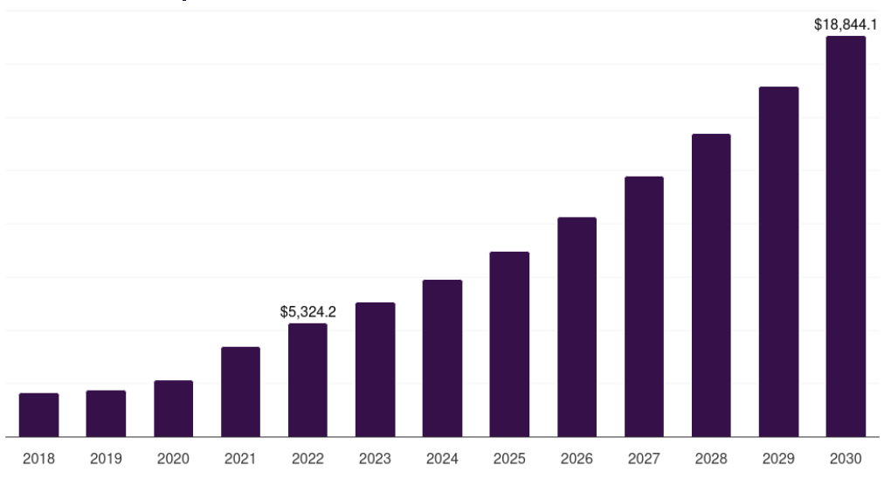
(Figure 1: UK online food delivery services market, 2018-2030)
Source: (Grand View Research, 2025)

Definition of Pioneers and Followers
The pioneers are first movers in a market, launching various new products and services. Supporting this statement, Kamp and Ruiz de Apodaca (2023), found that often, pioneers gain a temporary advantage for leading in the industry. As a first mover, the pioneer company holds a primary competitive advantage and brand reputation. Here, Deliveroo is a pioneer company which implements first-mover strategies. The pioneer company Deliveroo was first established in 2013 in London. This company is connected with 160,000 restaurants and grocery partners, and it provides food delivery in over 10 markets worldwide (Deliveroo, 2025). The follower company Uber Eats is focused on maximising the late-mover advantages. Followers are active contributors who follow the product or innovation. According to Kamp and Ruiz de Apodaca (2023), followers focus on maximising the late-mover benefits. The follower company will benefit by rectifying pioneers' mistakes and applying it. Here, the follower company Uber Eats was first established in 2014 in California, and it provides food delivery worldwide (Tracxn, 2025).

Identification of two macro factors
Out of many external factors, such as political, economic and environmental, two major factors are heavily influencing the food delivery market in the UK are technology and the socio-cultural factor due to the massive transformation of the UK people in lifestyle and technology because of the effect of the Covid-19 pandemic (Das et al., 2022). The technological factors enable the food delivery market to run the business through advanced technologies such as AI and Machine Learning for efficient workflow (Pereira, 2024). Additionally, socio-cultural factors such as demographics influence the food delivery market by financial independence and various customer preferences (Saad and Mohaimen, 2023).

Macro-environment analysis

Technological factor
Currently the generation is highly dependent upon technology usage, as 98% of the UK people have access to the internet (Statista, 2025). In previous years, the traditional technologies like telephone and manual logistics, physically arriving at the store for payment were popular but in this generation the technological shift of using contactless payment is rising (Cag, 2021). Additionally, the use of AI and ICT (Information communication technology) is shaping this generation's technology practices (BBC, 2025). Essentially, the implementation of AI in logistics assists in efficient food deliveries and optimised routes for delivery, resulting in enhanced customer satisfaction and reduction in delivery time (Meegle, 2025). Additionally, predictive analytics help food delivery markets to offer personalised recommendations in accordance with customer preferences and food habits. It also helps to predict demand and ensure timely deliveries by analysing the traffic patterns (Al Akasheh, 2022).
As these technological factors are driving today’s food delivery markets, they could help gain opportunities for Uber Eats and Deliveroo by reducing their delivery time and improving CRM. However, implementation of technological factors also has a probability of threats like data security and privacy concerns due to vulnerabilities in the system (Gomstyn and Jonker, 2025).
In this context, Customer Relationship Management unravels the art of collecting and using data in support of technology to foster long-term relationships with customers and providing exclusive customer experience (Ledro et al., 2022). The use of latest technological models like AI and ICT can be helpful for Deliveroo and Uber Eats to improve their performance and efficiency. Essentially, the automation techniques, like the use of AI in chatbots to reply 24*7 and focusing on the sentiment analysis of customers can lead the company to the paramount of CRM (Finn and Downie, 2025). Therefore, it can be concluded that the implementation of technologies like AI and ICT will be beneficial for Deliveroo and Uber Eats to provide an improved Customer experience.

Socio-cultural factor
The Socio-cultural factor is one of the external factors which help to evaluate the environment and opportunities for the business. Supporting this statement, Nasrudin (2025), found that the socio-cultural factor consists of fundamental aspects like behaviour, values, and attitudes that comprise a society. Essentially, these factors help businesses to understand different customer preferences, behaviours and values. Nowadays, the UK people are highly dependent upon food delivery markets due to busy lifestyles and urbanisation. According to Statista (2025), macroeconomic factors like economic stability and consumer spending habits are influencing the UK food delivery market growth.
Additionally, individuals' busy schedules and hybrid working patterns are also liable for the rapid growth of the food delivery market in the UK. In a survey of 2000 employees by CIPD in 2021, it was found that 63% of respondents prefer hybrid work in the UK, which leads to poor time management to make food, leading to increased demand for food deliveries (Mutebi and Hobbs, 2022). Moreover, currently there is a strategic shift in lifestyle changes among UK people, causing the adoption of healthy habits, which has resulted in personalised food preferences among consumers (Trewern, 2025).
In this context, online food delivery pioneer company Deliveroo focuses on the urban professionals and aims for convenience and globalised branding. As urban professionals are more susceptible to ordering food from online markets, it provides an immaculate chance for food delivery markets (Danley, 2019). This creates an opportunity for Deliveroo to improve its globalisation strategies through urbanisation and economic improvement. Conversely, it creates a threat of losing rural customers (Gangele and Kumar, 2025).
However, Uber Eats, as a follower company, focuses on localisation strategies to meet specific customer preferences, like their partnership with small vegan restaurants (Uber Eats, 2025). This will be beneficial for them to improve their sales and helpful to target customers precisely, as the demand for vegan food is rising in the UK (Protz, 2024).
This localisation strategy for providing personalised foods to vegan eaters shows the flexibility of the company with specific customer segments.

Theory alignment
The Maslow hierarchy of needs shows that the needs of humans are structured in a hierarchy starting from physiological and ending with Self-actualisation (McLeod, 2025). As Deliveroo and Uber Eats provide healthy foods to customers, they primarily meet the physiological needs of individuals. Additionally, it indirectly meets the second step of the framework, as it provides delivery during busy times. It may be perceived as a sense of security and stability. Therefore, it can be interpreted that the theory is aligned with the business strategies of Deliveroo and Uber Eats.

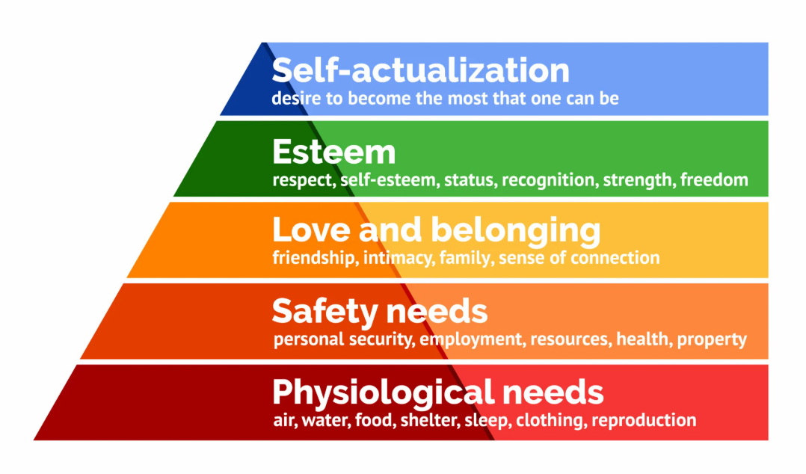
(Figure 2: Maslow’s Hierarchy of needs)
Source: (McLeod, 2025)
Therefore, it can be interpreted that the considerations of socio-cultural factors will pose opportunities for the pioneer and follower food delivery companies by understanding the demographics and cultural factors. Businesses can benefit from socio-cultural shifts and from global branding to localised strategies. Conversely, it can also be a threat to pioneer and follower companies if the company does not focus on the customer preferences and traditional cultures wisely.

Strategic Response and Competitive Positioning based on external factors

Technological factor

Pioneer company
The pioneer company Deliveroo has implemented the “FRANK” algorithm, which runs on machine learning, and helps in predicting the timing of every order. It also helps to deliver orders by assessing the location of drivers, customers and restaurants competently, helping in providing delivery service within a timely manner (Deliveroo, 2025).
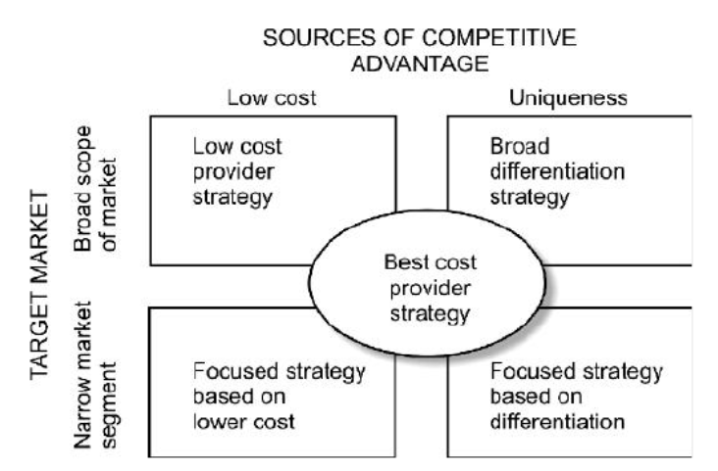
(Figure 3: Porter’s Generic Strategy)
Source: (Ali and Anwar, 2021)
Implementation of advanced technology signifies the implementation of Porter's generic strategy that brings competitive advantage to Deliveroo. The “FRANK” algorithm helps in supply chain optimisation, and helps businesses to enhance inventory management, resulting in the reduction of logistics costs. Therefore, it helps Deliveroo to improve its cost efficiency and helps in cost leadership, which helps to gain a competitive advantage (Ali and Anwar, 2021). Another pioneer company of UK food delivery, Just Eat, has also implemented machine learning and AI to analyse order history, browsing behaviour and preferences for creating personalised experiences for their customers to improve the retention rate and sales (Jain, 2025). Also, a company named ‘Pioneer Foodservice’ uses an online data pool and software system known as “Erudus” for providing detailed information about foods to their customers. This makes them unique and ensures it is one step ahead of their competitors (Pioneer Foodservice, 2023).
However, there are also some challenges regarding costs and competitive imitation, as machine learning is expensive, which can lead to excess computational costs (Lumenalta, 2025). The chance of competitive imitation is there due to the large number of follower companies. Moreover, due to the problems of machine learning, such as vulnerabilities of data loss, it erodes the chances of gaining a competitive advantage for the companies in the UK, if not properly handled (Lumenalta, 2025). Therefore, it can be interpreted that the implementation of technology helps Deliveroo to manage costs in the UK market, which brings a competitive advantage to the company; however, the complexities of such technology impose difficulties for Deliveroo to sustain competitiveness.

Follower company
The Follower company Uber Eats has implemented “Michelangelo”, a machine learning model which helps in predicting the meal delivery time and personalisation. Essentially, the estimated time of delivery (ETD) helps to enhance the customer satisfaction and provide the essential information to customers in real time. The personalisation helps to provide results based on previous searches and provides tailored experiences to customers (Uber, 2025). In this context, the porter’s generic strategy helps to assess the competitive advantage of a company. Here, the use of Michelangelo as a machine learning algorithm provides a prediction of the timing of delivery and provides personalised results which differentiate the company from its competitors. Alternatively, ‘One Delivery’ is also focused on technological factors by providing a seamless experience to its customers by implementing location detection features on its website. It shows a competitive business strategy from One Delivery’s side (One Delivery, 2025).
Such technological upgradation helps companies to enhance customer service and experience. As the delivery time prediction helps in maintaining the reliability and transparency, it improves customer satisfaction. Concurrently, personalisation helps to indicate to customers that their specific needs are understood, enhancing the service quality. Therefore, it can be understood that as the previously mentioned factors are aligned with providing significant value to customers, it builds the service unique and enables a differentiation strategy. Lastly, these factors will be helpful for Uber Eats to gain a competitive advantage by building customer loyalty and premium prices.

Socio-cultural factor

Pioneer company
Deliveroo, as a pioneer company, has focused on globalised branding and urban populations, as the economic growth is faster in urbanised areas than rural areas due to higher productivity (Lee and Xu, 2020). It provides fast food delivery service with electro mobility in urban areas, including the general population and restaurants. It also expanded its products to grocery in 2020 due to high demand for healthy foods in the UK (Pang et al., 2022).

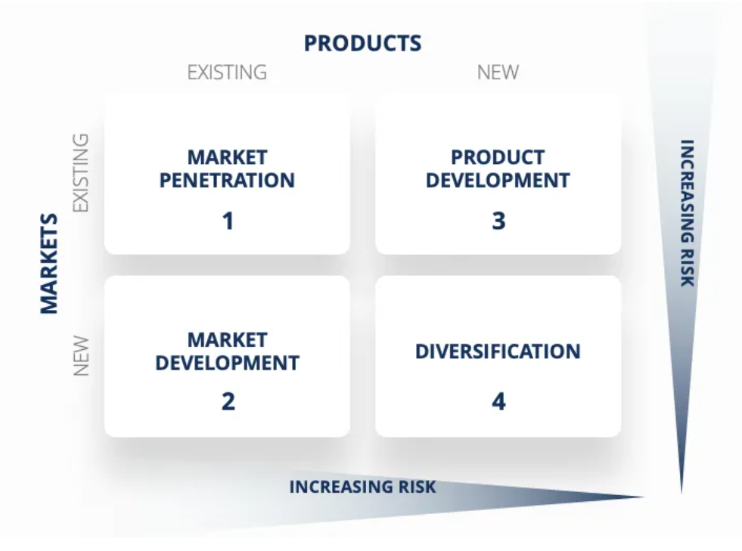
(Figure 4: Ansoff Matrix)
Source: (Peterdy, 2025)
The Ansoff matrix is the framework used by management teams to help businesses plan and assess development strategies (Peterdy, 2025). Here, the business strategies of Deliveroo are assessed to understand the opportunities and drawbacks of the company.
The fast food delivery service by Deliveroo is a classic example of market penetration due to the increased demand for food delivery in urban areas, especially helping the company to improve its cost efficiency and gain a sustainable competitive advantage. In addition, the expansion of Deliveroo in the grocery market signifies its product development strategy by introducing new products in existing markets (Pang et al., 2022). Alternatively, another pioneer company, named ‘Pioneer Foodservice’, uses an in-house quality assurance team to maintain hygiene practices and transparency regarding product information for customers and their health. This shows the company’s concern about customers’ health. By applying these smart strategies, the company also applies a market penetration strategy to gain a competitive advantage in the UK (Pioneer Foodservice, 2023). Therefore, it can be summarised that Deliveroo's marketing strategies are aligned with the Ansoff Matrix due to its strategic business plans, but quite different from its competitors.

Follower company
The follower company Uber Eats is focused on localisation strategies, as the company partners with vegan restaurants, which helps the company to specifically target certain customer segments. The localisation strategy helps to improve the sales of the company and fulfil customers' needs for vegan foods. Essentially, Uber Eats has implemented personalisation strategies to recommend restaurants to its customers based on their tastes. Essentially, the application also provides culinary options as per the buyer’s choice (Krishnamachar and Lee 2017). This reflects its flexible nature to meet current market needs.
In the context of the Ansoff Matrix, the localisation strategies of Uber Eats follow market penetration by manufacturing products and marketing closely relevant to the local audience. The partnership of Uber Eats with local vegan restaurants enables the company to specifically deliver food to vegan eaters, improving the conversion rate of the company. Building trust and credibility with customers. Essentially, the localisation also improves market development by specifically addressing vegan food customers in a locality, which improves the chance of Uber Eats to attract new customers more easily.
Additionally, localisation is helpful to achieve a competitive advantage through improved revenue streams. Similarly, Food Hub is also a follower food delivery company of the UK, which focuses on localised strategies and personalised service to develop specific customer segments based on food choices, which results in their sales growth (Foodhub, 2025). Following other companies, One delivery is also proficiently focused in satisfying its customers by partnering with various types of local restaurants. This shows a strategic move of the company to leave a mark on the local population and to be the best in the food delivery industry in the UK. However, focusing only on localisation reduces the chance of their globalisation, leading to global scalability (Uber Eats, 2025). Therefore, it can be interpreted that the strategic plans of Uber Eats and other competitor follower companies are properly aligned with the Ansoff Matrix.
In terms of comparison of pioneer and follower companies, it is seen that the popularity of follower companies is high in the UK, which reflects Uber Eats’ ability to sustain competitiveness.
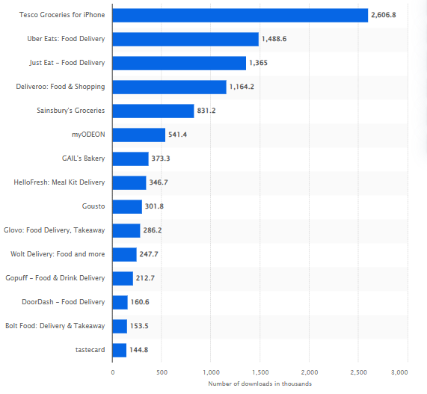
(Figure 5: Number of downloads of leading food delivery and takeout apps in the UK)
Source: (Statista, 2025)
Therefore, it is understood that flexibility is important, along with investing in technology for food delivery companies to maintain competitiveness.

Recommendation:
As it is seen that the pioneer company, Deliveroo, left behind follower companies to hold its position on the UK food delivery market, they should focus on their business strategies, providing discounts on meals, giving coupons and others. Additionally, it can focus on marketing campaigns and strategies to promote their brand image. On the other hand, to hold the position of Uber Eats in the UK, it must focus on maintaining its service quality and brand image.

Conclusion:
From the above discussion, it can be concluded that the key findings of this report include technical and social strategies of the Pioneer company, Deliveroo, and the follower company Uber Eats. These factors hold an immense chance of gaining a competitive advantage for the company; conversely, it can also be crucial to erode the company’s image. The theory of Maslow’s hierarchy of needs, Porter’s generic strategy and Kotler's sustainable marketing model have been implemented in the report to critically analyse the factors, including their advantages and drawbacks. By aligning with industry examples, it is also seen that both Deliveroo and Uber Eats tried their best to sustain competitiveness.

References:
Al Akasheh, M., Eleyan, N. and Ertek, G. (2022) ‘November. ‘A predictive data analytics methodology for online food delivery’, In 2022 Ninth International Conference on Social Networks Analysis, Management and Security (SNAMS) (pp. 1-7). IEEE. Available at: https://doi.org/10.1109/SNAMS58071.2022.10062613
Ali, B.J. and Anwar, G. (2021) ‘Porter’s Generic Competitive Strategies and its influence on the Competitive Advantage’, International Journal of Advanced Engineering, Management and Science, 7(6), pp.42-51. Available at: https://dx.doi.org/10.22161/ijaems.76.5
BBC (2025) External factors. Available at: https://www.bbc.co.uk/bitesize/guides/zd3prj6/revision/5 (Accessed: 8 November 2025).
Cag, D. (2021) Fintech Trends: The Future of Contactless Payment Technology. Available at: https://fintechmagazine.com/digital-payments/fintech-trends-future-contactless-payment-technology (Accessed: 9 November 2025).
Danley, S. (2019) Urban shoppers are driving demand for grocery delivery. Available at: https://www.foodbusinessnews.net/articles/13989-urban-shoppers-are-driving-demand-for-grocery-delivery (Accessed: 8 November 2025).
Das, D., Sarkar, A. and Debroy, A. (2022) ‘Impact of COVID‐19 on changing consumer behaviour: Lessons from an emerging economy’, International journal of consumer studies, 46(3), pp.692-715. Available at: https://doi.org/10.1111/ijcs.12786
Das, S. and Hassan, H.K. (2022) ‘Impact of sustainable supply chain management and customer relationship management on organizational performance’, International Journal of Productivity and Performance Management, 71(6), pp.2140-2160. Available at: https://doi.org/10.1108/IJPPM-08-2020-0441
Deliveroo (2025) About us. Available at: https://deliveroo.co.uk/about-us?srsltid=AfmBOooY3OujB3guptwxo5AKEDEBeMBPNxOrFdyzuItTovsr1F0LYFlD (Accessed: 9 November 2025).
Deliveroo (2025) How and why am I offered specific orders?. Available at: https://riders.deliveroo.co.uk/en/support/orders/how-and-why-am-i-offered-specific-orders (Accessed: 10 November 2025).
Erdi, H. and Bambang, R. (2021) ‘The influence of the external and internal business environment on the marketing strategy and their impact on the marketing performance’, European Journal of Business and Management, 13(7), pp.54-61. Available at: https://doi.org/10.7176/EJBM/13-7-06
Finn, T and Downie, A. (2025) AI in CRM. Available at: https://www.ibm.com/think/topics/ai-crm (Accessed: 10 November 2025).
Foodhub (2025) Find the Best Vegan Takeaways & Restaurants Near You. Available at: https://foodhub.co.uk/cuisines/vegan (Accessed: 10 November 2025).
Gangele, P. and Kumar, A. (2025) ‘The Impact of Globalization on Business Strategies: A Systematic Review’, International Journal of Innovations in Science, Engineering And Management, pp.64-71. Available at: https://doi.org/10.69968/ijisem.2025v4i164-71
Gomstyn, A and Jonker, A. (2025) Exploring privacy issues in the age of AI. Available at: https://www.ibm.com/think/insights/ai-privacy#:~:text=We%20can%20often%20trace%20AI,Collection%20of%20data%20without%20consent (Accessed: 8 November 2025).
Grand View Research (2025) UK Online Food Delivery Services Market Size & Outlook. Available at: https://www.grandviewresearch.com/horizon/outlook/online-food-delivery-services-market/uk (Accessed: 8 November 2025).
Jain, A. (2025) Lessons from JustEat’s Food Delivery Success. Available at: https://oyelabs.com/lessons-from-justeats-food-delivery-success/ (Accessed: 10 November 2025).
Kamp, B. and Ruiz de Apodaca, I. (2023) ‘Leveraging (in) formal early-mover and diligent-follower advantage mechanisms to attain international niche market leadership: insights from Basque “hidden champions”’, Competitiveness Review: An International Business Journal, 33(6), pp.1013-1045. Available at: http://dx.doi.org/10.1108/CR-10-2022-0158
Krishnamachar, A and Lee, C. (2017) What’s for dinner? Building an UberEATS that’s just right for you. Available at: https://www.uber.com/en-NZ/newsroom/ubereats-personalization/ (Accessed: 9 November 2025).
Ledro, C., Nosella, A. and Vinelli, A. (2022) ‘Artificial intelligence in customer relationship management: literature review and future research directions’, Journal of Business & Industrial Marketing, 37(13), pp.48-63. Available at: https://doi.org/10.1108/JBIM-07-2021-0332
Lee, J. and Xu, J. (2020) ‘Why do businesses grow faster in urban areas than in rural areas?, Regional Science and Urban Economics, 81, p.103521. Available at: https://doi.org/10.1016/j.regsciurbeco.2020.103521
Lumenalta (2025) 13 benefits and challenges of machine learning. Available at: https://lumenalta.com/insights/13-benefits-and-challenges-of-machine-learning (Accessed: 10 November 2025).
McLeod, S. (2025) Maslow’s Hierarchy of Needs. Available at: https://www.simplypsychology.org/maslow.html (Accessed: 9 November 2025).
Meegle (2025) Food Delivery Innovations. Available at: https://www.meegle.com/en_us/topics/food/food-delivery-innovations (Accessed: 8 November 2025).
Mutebi, N and Hobbs, A. (2022) The impact of remote and hybrid working on workers and organisations(UK Parliament Post). Available at: https://researchbriefings.files.parliament.uk/documents/POST-PB-0049/POST-PB-0049.pdf#page=15.44 (Accessed: 8 November 2025).
Nasrudin, A. (2025) Sociocultural Environment: Key Factors Impacting Businesses. Available at: https://penpoin.com/sociocultural-environment/#What_is_a_sociocultural_environment (Accessed: 8 November 2025).
One Delivery (2025) Your favourite cuisines Delivered to your door. Available at: https://one-delivery.co.uk/ (Accessed: 11 November 2025).
Pang, X., Shang, Y. and Song, J. (2022) March. ‘An analysis of Deliveroo’s operation strategy and food takeaway industry’, In 2022 7th International Conference on Financial Innovation and Economic Development (ICFIED 2022) (pp. 142-155). Atlantis Press. Available at: https://doi.org/10.2991/aebmr.k.220307.023
Pereira, D. (2024) Technological Factors Affecting Business. Available at: https://businessmodelanalyst.com/technological-factors-affecting-business/?srsltid=AfmBOoqA-2h-ActvpfeCoyTvyhj3ldeRS7n_cP522NLS0asvlA_Xswqi (Accessed: 11 November 2025).
Peterdy, K. (2025) Ansoff Matrix. Available at: https://corporatefinanceinstitute.com/resources/management/ansoff-matrix/ (Accessed: 9 November 2025).
Pioneer Foodservice (2023) Quality assurance. Available at: https://pioneerfoodservice.co.uk/quality-assurance/ (Accessed: 11 November 2025).
Protz, A. (2024) Demand For Vegan Food At UK Quick-Service Restaurants Up By 56% in 2024. Available at: https://plantbasednews.org/lifestyle/food/demand-vegan-food-uk-quick-service-restaurants/ (Accessed: 10 November 2025).
Saad, A.T. and Mohaimen, M.A. (2023) ‘Socio-Demographic Factors Influencing the Use of Food Delivery Applications (FDA): An Empirical Study’. Available at: http://space.buft.edu.bd/handle/123456789/94
Statista (2025) Internet usage in the United Kingdom (UK) - statistics & Facts. Available at: https://www.statista.com/topics/3246/internet-usage-in-the-uk/?srsltid=AfmBOopdb8nIPJbfTesf31g3NejdLMAfrNl_zBzN7CXX3gH99ZZBqMh-#topicOverview (Accessed: 8 November 2025).
Statista (2025) Number of downloads of leading food delivery and takeout apps in the United Kingdom (UK) as of July 2025. Available at: https://www.statista.com/statistics/1298186/food-delivery-app-downloads-uk/?srsltid=AfmBOoqrhR4l8hkquHYIln6le4TJZ8_2xNw9ag0c_37D-LXLi_WUkTGa (Accessed: 10 November 2025).
Statista (2025) Online Food Delivery - United Kingdom. Available at: https://www.statista.com/outlook/emo/online-food-delivery/united-kingdom (Accessed: 8 November 2025).
Tracxn (2025) UberEATS - Company Profile. Available at: https://tracxn.com/d/companies/ubereats/__dKqD0lfYLw10q2o7OJ4Xn9tlipu_XoHyKA7l3obA2qI (Accessed: 9 November 2025).
Trade.gov (2023) Information and Communication Technology. Available at: https://www.trade.gov/country-commercial-guides/united-kingdom-information-and-communication-technology (Accessed: 8 November 2025).
Trewern, J. (2025) ‘Transforming UK diets for health and sustainability’, The Journal of Horticultural Science and Biotechnology, pp.1-8. Available at: https://doi.org/10.1080/14620316.2024.2432394
Trivedi, S.K. and Singh, A. (2021) ‘Twitter sentiment analysis of app based online food delivery companies’, Global Knowledge, Memory and Communication, 70(8/9), pp.891-910. Available at: http://dx.doi.org/10.1108/GKMC-04-2020-0056
Uber (2025) Meet Michelangelo: Uber’s Machine Learning Platform. Available at: https://www.uber.com/en-IN/blog/michelangelo-machine-learning-platform/ (Accessed: 10 November 2025).
Uber Eats (2025) Grocery Delivery with Uber Eats. Available at: https://www.ubereats.com/near-me/grocery?srsltid=AfmBOoq-1nkbWm07FbbDglaRR7_hhsVq-BlBkcqqFld6P-vaFfk92L2h (Accessed: 9 November 2025).
Uber Eats (2025) Vegan Friendly Delivery with Uber Eats. Available at: https://www.ubereats.com/fr-en/near-me/vegan-friendly (Accessed: 9 November 2025).

