BA (Hons) Leadership and Management Skills in the Workplace

Independent Project

LCLM6005

Element 3: Methodology Poster

Student name: Madalina Aliu
Student ID:(2310477)

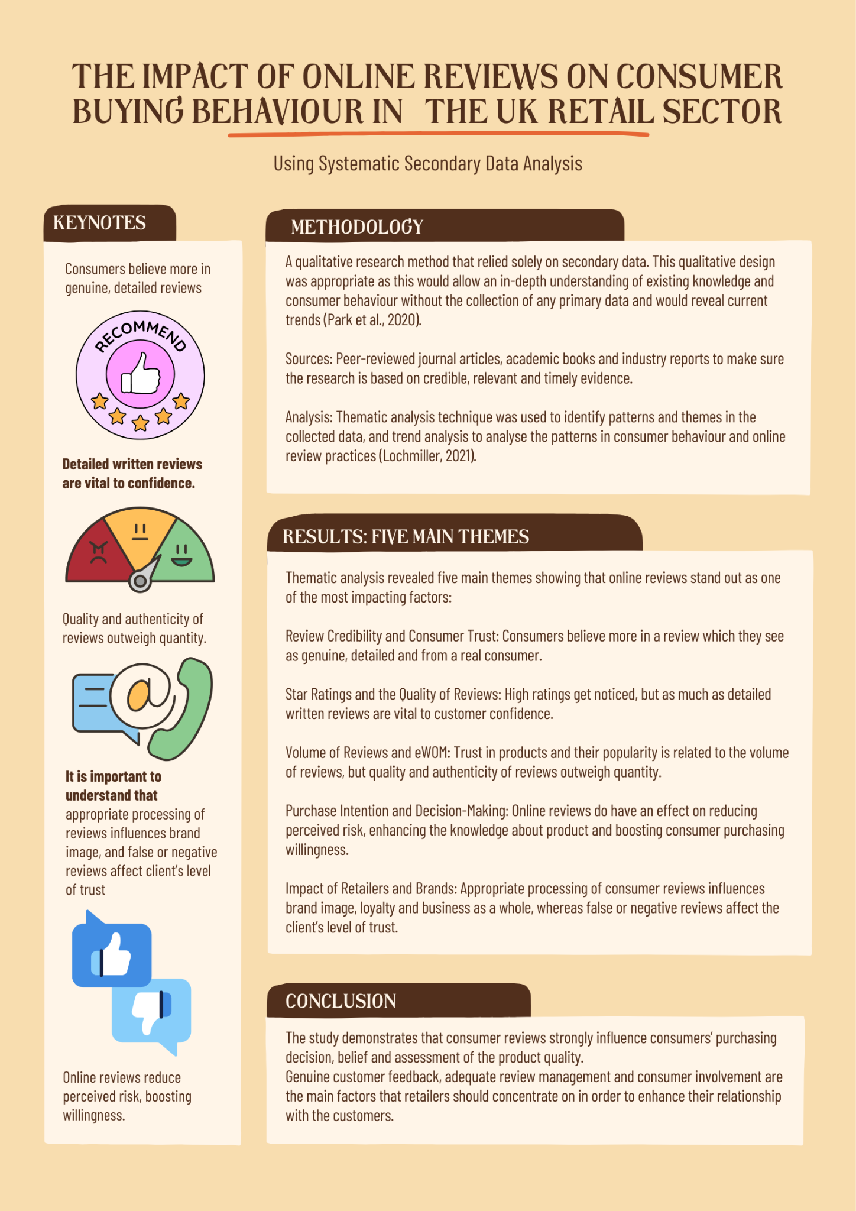

Element 3: Methodology Poster
The current study aimed at exploring how online reviews affect consumers' purchasing behaviour in the UK retail sector in a qualitative research method that relied solely on secondary data. It was decided that the qualitative design was appropriate as this would allow an in-depth understanding of existing knowledge and consumer behaviour without the collection of any primary data and would reveal current trends (Park et al., 2020). The secondary sources were peer-reviewed journal articles, academic books and industry reports. The focus was selected to make sure the research is based on credible, relevant and timely evidence. The data collection process for this study was a literature review process and secondary qualitative papers that included studies on online reviews, electronic word-of-mouth (eWOM), consumer trust, purchase intention and digital retailing. Thematic analysis technique was used to identify patterns and themes in the collected data, to analyse the findings on the topic and trend analysis to analyse the patterns in consumer behaviour and online review practices (Lochmiller, 2021). This mix of techniques enabled an in-depth understanding of how online reviews affected purchasing behaviour, in the context of UK retail.
The results of the research show that online reviews stand out as one of the most impacting factors in the digital purchasing environment. Thematic analysis revealed five main themes. The first theme, review credibility and consumer trust, showed that consumers believe more in a review which they see as genuine, detailed and from a real consumer. The second theme focused on star ratings and the quality of reviews, and it revealed that high ratings get noticed, but as much as detailed written reviews are vital to customer confidence. The third theme, which is the volume of reviews and electronic word-of-mouth (eWOM) found, showed that trust in products and their popularity is related to the volume of reviews, but that quality and authenticity of reviews outweigh quantity. The fourth theme, purchase intention and consumer decision-making found that online reviews do have an effect on reducing perceived risk, enhancing the knowledge about product and boosting consumer purchasing willingness.
Finally, the fifth theme, the impact of retailers and brands, discusses how appropriate processing of consumer reviews influences brand image, loyalty and business as a whole, and how false or negative reviews affect the client’s level of trust. All in all, the study demonstrates that consumer reviews strongly influence consumers’ purchasing decision, belief and assessment of the product quality. It can be concluded that genuine customer feedback, adequate review management and consumer involvement are the main factors that retailers should concentrate on in order to enhance their relationship with the customers.

References
Park, Y.S., Konge, L. and Artino Jr, A.R., 2020. The positivism paradigm of research. Academic medicine, 95(5), pp.690-694.
Lochmiller, C.R., 2021. Conducting thematic analysis with qualitative data. The qualitative report, 26(6), pp.2029-2044.

