MeMory Matters: enhancing alzheiMer’s care with Cognicare
Student Name: DISHALI BHUVA Student ID: 2437480 Module: Population Health And Digital Health Promotion
Program: MSc in Public Health And Social Care

Alzheimer’s Disease

BACKGROUND
- HEALTH PROMOTION VALUES AND PRINCIPLES
- Health promotion emphasises empowerment,

- Alzheimer’s disease is a progressive neurological disorder that affects memory, thinking, and behaviour, and is the leading cause of dementia worldwide. It gradually interferes with daily functioning, reducing independence and overall quality of life for affected individuals (Ahmed et al, 2018; Anwal et al, 2021).
- In the UK, around 900,000 people are living with dementia, with Alzheimer’s accounting for approximately 60–70% of cases (Shah et al, 2024).
- The number of cases is expected to rise significantly due to an ageing population, increasing the public health burden (Shah et al, 2024).
- The condition creates emotional, social, and financial challenges for individuals,
families, and healthcare systems (Ahmed et al, 2018).
Non-Digital Technologies: Traditional treatments include medication, cognitive therapy, and caregiver support, but access to these can often be limited (Zucchella et al, 2018).
Digital Technologies: Digital solutions like CogniCare have emerged to provide cognitive training, daily reminders, and structured support. These technologies help improve independence, enhance care management, and promote better health outcomes (Suvish et al, 2025).

BEHAVIOUR CHANGE THEORY
prevention, accessibility, and equity to improve quality of life (Morganti, 2025).
  - It focuses on enabling individuals to manage their own health while addressing wider determinants such as ageing and social support (Yazdanmanesh et al, 2023).
  - CogniCare supports empowerment by helping users maintain independence through structured guidance and reminders (Olivari et al, 2023).
  - It promotes accessibility by offering digital support that can be used anytime, reducing reliance on in-person services (Morganti, 2025).
  - The app encourages prevention by tracking cognitive changes and enabling early intervention (Morganti, 2025).
  - It also supports equity by providing affordable and scalable care options for diverse populations (Olivari et al, 2023).

Transtheoretical Model (TTM): The Transtheoretical Model (TTM) explains behaviour change as a gradual process involving stages: precontemplation, contemplation, preparation, action, and maintenance (Prochaska, 2020).
- Precontemplation: Individuals or caregivers may be unaware of early cognitive decline and not yet considering any intervention (Blotenberg et al, 2025).
- Contemplation: They begin recognising symptoms of Alzheimer’s and start thinking about the need for support or management (Chang et al, 2022).
- Preparation: CogniCare supports this stage by providing tools like reminders and cognitive exercises to encourage proactive planning (Prochaska, 2020).
- Action: Users actively engage with app features such as daily tracking and brain- training activities to improve cognitive function (Chang et al, 2022).
- Maintenance: Continuous use of the app helps sustain routines, reinforce positive behaviours, and slow cognitive decline progression (Prochaska, 2020).

EXPECTED OUTCOMES
- The use of TTM-based digital interventions like CogniCare is expected to improve engagement in self-care and cognitive support activities (Finnegan et al, 2022).
- It can enhance early detection of symptoms and promote consistent management of daily routines (Finnegan et al, 2022).
- Outcomes include improved quality of life and reduced caregiver burden (Prochaska,
2020).
- However, effectiveness depends on user engagement and progression through behavioural stages (Blotenberg et al, 2025).
- Long-term use can support sustained cognitive health and independence (Finnegan et al, 2022).
  - 6. References
- Anwal, L., (2021). A comprehensive review on Alzheimer’s disease. World J Pharm Pharm Sci, 10(7), p.1170.
- CONCLUSION
- Digital interventions like CogniCare have important implications for healthcare policies by offering scalable and cost-effective dementia care solutions (Sankar, 2017).
- They support education by raising awareness about cognitive health and encouraging proactive management (Avramovic et al, 2023).
- For research, they provide insights into behaviour change models like TTM in real-world settings (Yousaf et al, 2020).
- Overall, integrating such technologies can improve accessibility, support caregivers, and enhance Alzheimer’s care at both individual and population levels (Yousaf et al, 2020).

- 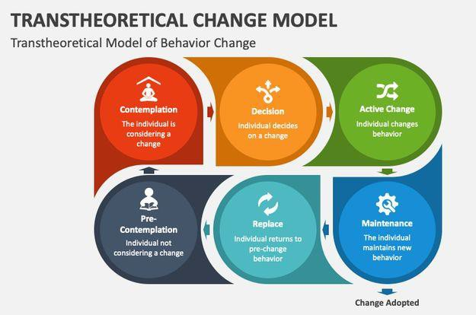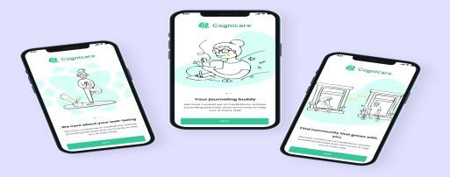Avramovic, P., Rietdijk, R., Attard, M., Kenny, B., Power, E. and Togher, L., (2023). Cognitive and behavioral digital health interventions for people with traumatic brain injury and their caregivers: a systematic review. Journal of neurotrauma, 40(3-4), pp.159-194.
- Ahmed, M.Q., Alenazi, F.S., Fazaludeen, M.F., Shahid, S.M.A. and Kausar, M.A., (2018). Pathology and Management of Alzheimer's disease: A review. International Journal of Pharmaceutical Research & Allied Sciences, 7(2).
- Blotenberg, I., Zülke, A.E., Luppa, M., Wittmann, F., Fankhänel, T., Weise, S., Döhring, J., Escales, C., Kosilek, R.P., Michel, I. and Brettschneider, C., (2025). Factors associated with a healthy diet and willingness to change dietary behavior in older adults at increased risk of dementia. Journal of Alzheimer’s Disease, 105(2), pp.634-645.
- Chang, C.F., Wang, J.Y., Kuo, T.H., Lin, Y.L. and Yang, S.Y., (2022). Stages of change in dairy intake among older adults: application of the transtheoretical model. International journal of environmental research and public health, 19(3), p.1146.
- Finnegan, H.A., Daari, L., Jaiswal, A., Sinn, C.J., Ellis, K., Kallan, L., Nguyen, D. and Gallant, N.L., (2022). Changing care: Applying the transtheoretical model of change to embed equity, diversity, and inclusion in long-term care research in Canada. Societies, 12(3), p.87.
- Morganti, F., (2025). Quality of Life in People Living with Dementia: Personalized Early Diagnosis, Individual Empowerment, and Community Inclusion. In Longevity and Geriatrics. IntechOpen.
- Olivari, B.S., Jeffers, E.M., Tang, K.W. and McGuire, L.C., (2023). Improving brain health for populations disproportionately affected by Alzheimer’s disease and related dementias. Clinical gerontologist, 46(2), pp.128-132.
- SANKAR, S.K., (2017). Scalable business model of digital solutions, to assist elderly patients with mild cognitive impairment.
- Prochaska, J.O., (2020). Transtheoretical model of behavior change. In Encyclopedia of behavioral medicine (pp. 2266-2270). Cham: Springer International Publishing.
- Suvish, Ghamari, M. and Sundaram, S., (2025). Digital Dementia: Smart Technologies, mHealth Applications and IoT Devices, for Dementia-Friendly Environments. Journal of Sensor and Actuator Networks, 14(6), p.112.
- Shah, R., Salek, M.S., Ali, F.M., Nixon, S.J., Otwombe, K., Ingram, J.R. and Finlay, A.Y., (2024). Dementia and its profound impact on family members and partners: a large UK cross-sectional study. Alzheimer Disease & Associated Disorders, 38(4), pp.338-343.
- Yazdanmanesh, M., Esmaeili, R., Nasiri, M. and Vasli, P., (2023). Relieving care burden and promoting health-related quality of life for family caregivers of elderly people with Alzheimer’s disease via an empowerment program. Aging clinical and experimental research, 35(1), pp.73-83.
- Yousaf, K., Mehmood, Z., Awan, I.A., Saba, T., Alharbey, R., Qadah, T. and Alrige, M.A., (2020). A comprehensive study of mobile-health based assistive technology for the healthcare of dementia and Alzheimer’s disease (AD) Yousaf K. et al. Health Care Management Science, 23(2), pp.287-309.
- Zucchella, C., Sinforiani, E., Tamburin, S., Federico, A., Mantovani, E., Bernini, S., Casale, R. and Bartolo, M., (2018). The multidisciplinary approach to Alzheimer's disease and dementia. A narrative review of non-pharmacological treatment. Frontiers in neurology, 9, p.418708.

