Leadership, Innovation and Product Development

Title: Innovative Approaches

Author: David Whitmore
Email: David.Whitmore@vale.com
Number: 01792 841331
Address:
Vale Europe Limited,
Clydach Refinery,
Clydach,
Swansea,
SA6 5QR

Contents
- Introduction
- Radical Innovation
  - Advantages
  - Disadvantages
- Incremental Innovation
  - Advantages
  - Disadvantages
- Disruptive Innovation
  - Advantages
  - Disadvantages
- Areas of Innovation
  - Product Innovation
  - Process Innovation
  - Service Innovation
- Implementation of Innovation at VALE Europe Ltd
- Change Management
  - McKinsey’s 7S Model
  - Kotters
  - ADKAR Model
- Conclusion
- References

- Introduction
Innovation is an extensively researched topic with many different classifications suggested; Radical vs incremental (Damanpour, 1991; Henderson, 1993); Competence enhancing vs competence destroying (Gatignon et al, 2002) and administrative vs technical (Kimberly and Evanisko, 1981). However Baumol (2004) warns, that while dividing innovation into categories is useful many real-world innovations generally fall somewhere in between.
The focus of this paper is to analyse the different sources of innovation open to organisations and the areas where they can be implemented. It will also assess the advantages and disadvantages of each and provide examples where they have executed successfully. But what does it take for an innovation to be successful? Ultimately it needs to meet the three criteria below:
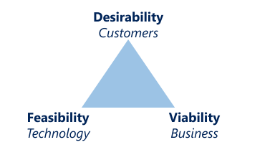
- Desirability - There must be a perceived value.
- Viability - Does it create profit and fit within an organizations values and strategy.
- Feasibility – Are the required resources, technology and funds available.

Of the literature reviewed, radical and incremental innovation seem to be the most predominantly covered with radical being defined frequently as a technological advancement (Hill and Rothaermel, 2003; Sorescu, Chandy, and Prabhu, 2003). Radical is also closely linked with “market breakthrough” and “disruptive” innovation (Baumol, 2004). Incremental innovations are perceived to be less risky and build on from the initial technological advancements when the novelty wears off and the existing commercial market increases. As a result the analyses will be based on the innovation types below.
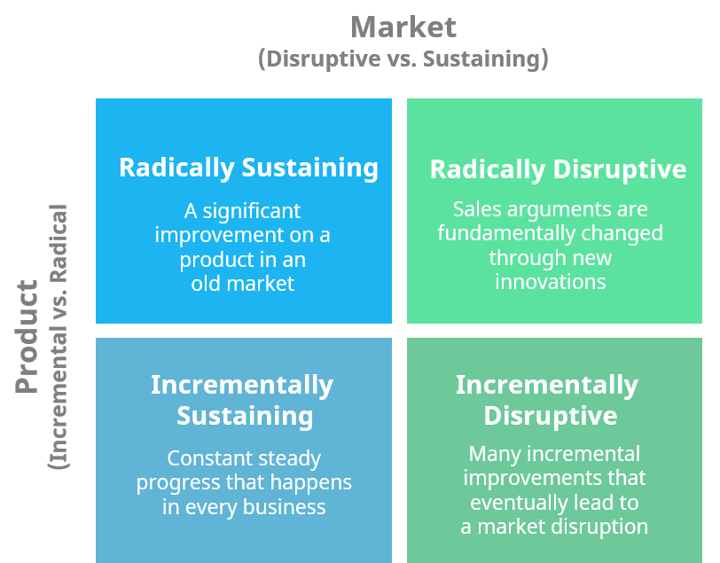

- Radical Innovation
Historically radical innovation would have been regarded as rare, however due to the emergence of global markets and the rapid developments in technology it has become more common place in recent times. One factor of radical innovation that hasn’t differed that much over time is the initial resistance it faces at the outset, however if this is overcome successfully it invariably provides a solution to previously unidentified problems or needs and often results in both the creation of a new market and the potential fall of the process or technology it replaces. Executed well it creates a platform for subsequent innovation to build on and has the potential to not only transform markets and economies but in the case of the Internet change the way the entire world communicates and behaves.

According to investment company ARK Invest, there are numerous radical innovations currently experiencing various stages of resistance that are about to become mainstream

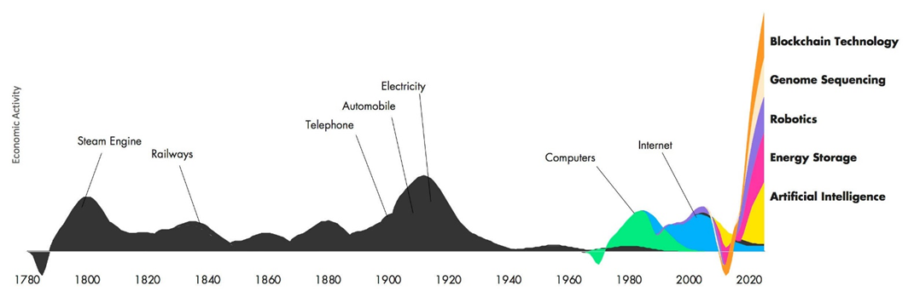
Figure 1: Source: ARK Invest

  - Advantages of Radical Innovation
The potential gains are huge. If the innovation is a pioneer in the field and creates a market with no competitors then a monopoly can be established, allowing aggressive pricing regardless of demand (Askar, 2013)
The creation of a new markets opens the door to further development and innovations. Once the platform is in place then the potential for additional innovations is usually very high meaning value creation will be much easier than in mature markets (Gardner, 2017).

  - Disadvantages of Radical Innovation
Radical innovation solutions are generally built on knowledge that a company does not yet have expertise in or that differ from existing experience (Danneels, 2002), therefore development times are invariably both lengthy and costly and these factors coupled with the uncertainty of demand can often result in a lack of appetite or support from leadership and management.

- Incremental Innovation
The most common form of innovation is incremental, where gradual, continuous improvements are made to an existing product, service or process. Its aim is not to create new markets or a new solution but to create value through satisfying the needs of existing customers. This is achieved through affordable development with small improvements, modifications and varients that have been realised through existing knowledge resources (Danneels, 2002) and customer feedback. The product of incremental innovation projects are predominantly small variations of existing products, services, practices or approaches (Damanpour, 1991).

  - Advantages of Incremental Innovation
Incremental product or process innovations will usually promote innovation in other areas of the value chain
•Encourages brand loyalty by acknowledging and meeting the customer’s needs e.g. software upgrades
•Stay competitive - Grow sales from existing products and services and maintain market position,
•Protects your current business model
•Subtle, gradual ideas of change are easier to sell to key stakeholders
•Innovation is less costly and more affordable

  - Disadvantages of Incremental Innovation
• Getting small, subtle changes noticed in a crowded, noisy marketplace can be difficult.
•It can be difficult to tell how different your product really is after the change
•Competition - Competitors are playing the same game, making similar, if not the same changes.

- Disruptive Innovation
Christensen et al (2015) first coined the term “disruptive Innovation”. It is a form of innovation that exploits weakness in an existing market where the current incumbents have become too focused on maximizing the existing product, service or business model and neglected to invest time in the other opportunities available. The disruptive innovation has usually reached the mainstream before the incumbents realise and at this point it is too late to respond as the new entrant is delivering an alternative solution to their customer’s needs. This can involve launching new products or expanding to new markets. One good example of this would be Netflix, which adopted disruptive technology to revolutionize the video rental marketplace. Despite the suggestion, disruption does not happen suddenly. Netflix’s initial movement in the market was a mail in movie subscription and didn’t really threaten the current market leaders such as blockbusters but through continued disruption Netflix developed its online web streaming model. Now there are numerous online movie subscription services adopting this model, which has now become the norm, completely transforming the movie rental industry.

  - Advantages of Disruptive Innovation
• Expand your market through new innovations creating a platform to build on.
• Develop business model and improve current procedures and policies.
• Unlock new markets and create significant improvements and value in a short time.

  - Disadvantages of Disruptive Innovation
• Success is unknown and expanding to a new marketplace is high risk without significant, costly analysis.
• Competition is high, so getting your ideas noticed can be difficult
•You are competing against established companies who will have a vested interest in your failure

- Areas of Innovation
  - Product Innovation
This area of innovation is the most common as there are more products than there are processes or services. Product innovation is predominantly incremental with its aim to improve quality and reliability ensuring the product continues to satisfy the needs of the customer therefore maintaining your competitive edge and sustaining your market position. Product innovation can also be radical and a good example of both types of innovation within the product area is Apple with its innovative “iphone”. The mobile phone market was well established when Apple revolutionised the boundaries of what a phone could perform by introducing a touchscreen phone with camera and music capabilities. They have since effectively executed incremental innovation by continuously upgrading the phones operating system, quality of the camera and more to remain a market leader (Adner, 2012).
  - Process Innovation
This area of innovation improves the way something is produced or acquired. It doesn’t necessarily change the actual product or service but creates value for the supplier or the customer or both through the implementation of a new or improved production or delivery system. Process innovation can be achieved through the use of improved technology or improved methods and invariably results in a saving in time and money or an improve service to the customer. A good example is how Amazon innovated the process of purchasing a book. They didn’t change what a book was they simplified the process to enable you to browse and buy online as opposed to visiting a store.
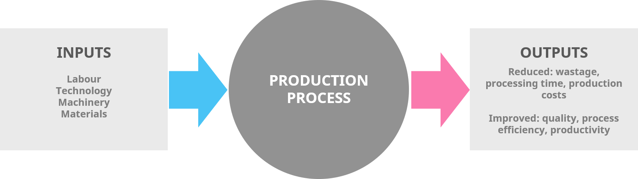
  - Service Innovation
A proven strategy for adding value is to differentiate yourself from competitors so introducing and improving the way you serve your customers whether it is a new or emerging market will increase your revenue. There has been more focus on service innovation in recent times which has been reflected in the increase in academic research (Dotzel, et al, 2013, Ordanini and Parasuraman, 2010). An excellent example of a recent service innovation is Uber, who have created additional growth and value to its business through the UberEATS initiative. Uber used its existing strengths and capabilities together with its well known, trusted brand name to enter into an alternative market. They capitalized on their existing transportation business that people were already using them and offered them the added value of providing them with a food delivery service.

- Change Management

Change management is an approach to transitioning individuals, teams, and organizations to a desired future state. Why does change fail?
Conflicting priorities • Culture • Politics • Regulatory Compliance • Market pressures • Leadership alignment and desires • Cost • Time / Patience to make it happen Sense of loss, confusion • Mistrust and a “what’s in it for me” focus • Fear of letting go of the past • Uncertainty, emotional stress, anxiety • Perceived high levels of inconsistency • Fear of loss of control • Conflict increases — especially between groups
In his book, Leading change, John Kotter states:
” From years of study, I estimate today more than 70 per cent of needed change either fails to be launched, even though some people clearly see the need, fails to be completed even though some people exhaust themselves trying, or finishes over budget, late and with initial aspirations unmet. “

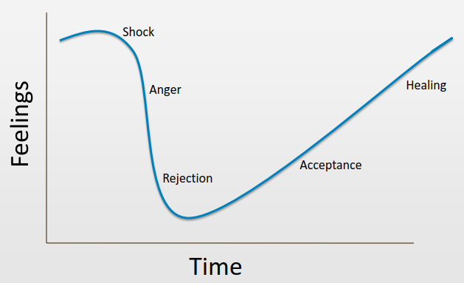

6.1 McKinsey 7 S Model
McKinsey 7S model, as shown below, was developed by consultants working for McKinsey & Company in the 1980s and is structured in the form of an atom to show seven stages for managing change. It is one of those few change models that has managed to remain current.
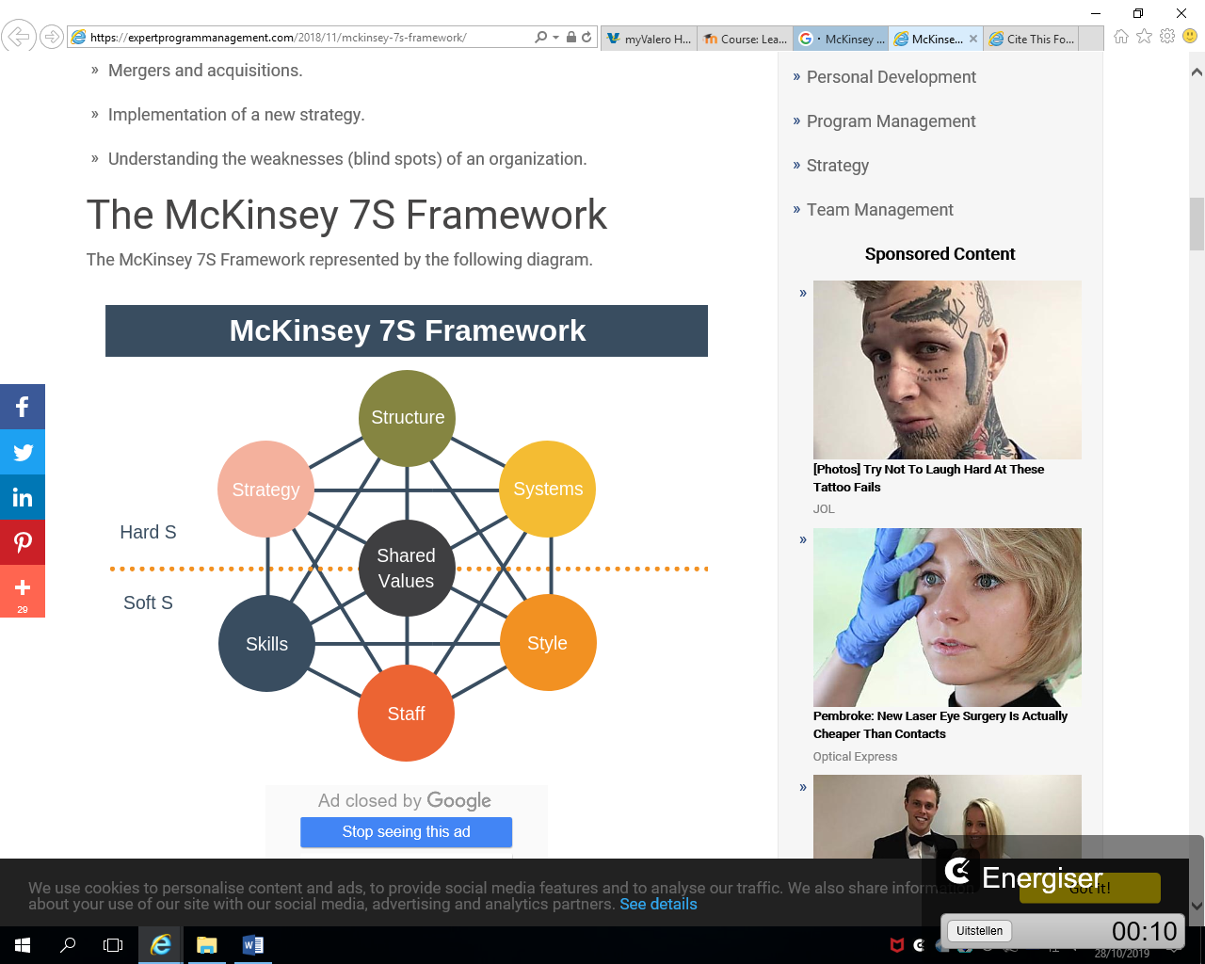

Stages
Strategy – According to McKinsey’s 7-S framework this is the first stage of change and involves the development of a step-by-step future plan.
Structure – Structure is the stage or attribute of this model that relates to the way in which the organization is divided or the structure it follows.
Systems – A set of procedures and protocols that detail how the organisation will work.
Shared values – Shared values refer to the core values of an organization that represent how it runs or works. In the case of Vale Ltd they are 1. Value our People 2. Prize our Planet 3. Improve Together 4. Do What is Right 5. Make it Happen.
Style – The way in which the changes and leadership are adopted or implemented.
Staff – The workforce/employees and their working experiences and capabilities.
Skills – The knowledge and competencies possessed by the company’s employees.

Benefits of this model
This model offers ways and methods to understand an organization and get a deep insight into the way it works.
This model integrates both the emotional as well as the practical components of change that is something that is important to create ways to enable employees deal with transition easily.
This model considers all parts to be important and equally worth addressing and thus does not leave out some aspects that may be of importance.
This model also offers directional factor to organizational change.

Disadvantages of this model
Since all the factors are interrelated and interdependent on one another, the failing of one part means failing of all and this is the greatest disadvantage of this model.
This model is complex as compared to the others and differences are not focused upon in it.
Organizations that have used this model have experienced more cases of failure, and this too can be considered as one negative associated with it.

6.2 Kotter’s change management theory- Eight Steps
Kotter’s change management theory is another concept that is popular and well adopted. This theory was devised by John P. Kotter, who is a Harvard Business School Professor and author of several books based on change management. The theory consists of eight steps that are categorised into 3 stages 1. Creating a climate for change 2. Engaging and enabling the organisation and 3. Implementing and sustaining change. These 3 stages are consistent with Lewin (1951) model of Unfreeze-Move-Refreeze. Each of the steps focuses on a key principle that is associated with the response of people to change.

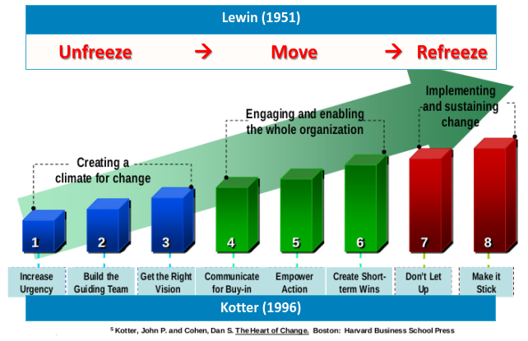

Stages
Increase urgency – Creating a sense of urgency among the workforce to motivate them to achieving the objectives.
Build the team – Appointing people with the right combination of skills, knowledge and commitment.
Get the vision correct –Incorporate the creative, emotional connect and objectives into the strategy.
Communicate – Communicate the change and validate its need to employees at all levels
Get things moving – Make it happen. Provide support, remove the roadblocks and implement feedback in a constructive way.
Focus on short term goals – Divide the ultimate goal into small and achievable elements to simplify success without too much pressure.
Don’t give up – Maintain focus and drive however hard things get.
Incorporate change – After initiating and managing change it is important to reinforce it and make it a part of the workplace culture.

Benefits of this model
This is a step-by-step model that is easy to follow and incorporate.
The main idea behind it is to accept the change and prepare for it rather than changing itself.

Disadvantages of this model
Since it is a step-by-step model, no step can be skipped to reach the one after that.
The entire process given in this model can be very time-consuming.

ADKAR model

The ADKAR change management model is a goal-oriented tool that focuses on the activities that are directly related to the desired outcome. The goals and performance criteria are set in a sequence. This means the model drives the change through set behaviours and criteria to ensure it is implemented and sustained successfully. The model is used by managers of change to identify the various holes or gaps in the process of change management so that effective training can be offered to the employees.

ADKAR Model basically stands for
Awareness – of the need and requirement for change
Desire – to bring about change and be a participant in it
Knowledge – of how to bring about this change
Ability – to incorporate the change on a regular basis
Reinforcement – to keep it implemented and reinforced later on as well.

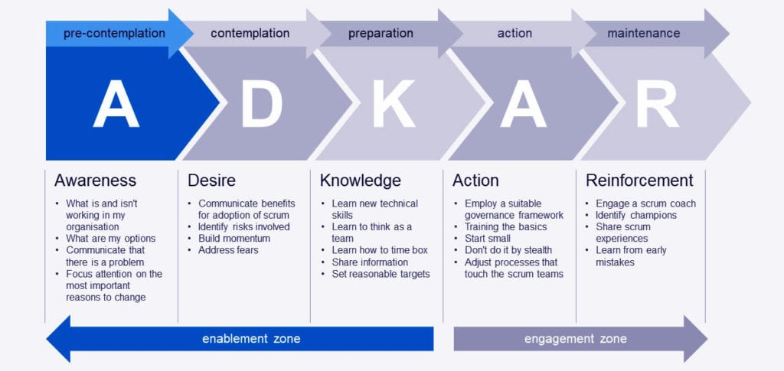
Benefits of ADKAR Model
The model offers the capability of Identification and evaluation of the reasons why changes made are not working and why desired results are not being obtained.
The model makes it possible for one to break the changes into different parts and then figure out the point where change may not be as effective as planned.
It offers both business dimension of change as well as people dimension of change.

CONCLUSION
So, innovation can take a lot of forms, from small steps to big leaps, and from wholly original new products to changes in process, communication, and organisation that can radically reshape the world we live in. Don’t get hung up on innovative ideas having to be wholly new, original, and radical. Far more innovation is incremental and no less valuable for it.
HE STRATEGIC IMPLEMENTATION OF AN IDEA THAT WILL CREATE a tangible VALUE FOR EITHER THE ORGANISATION OR THE CUSTOMER or both” (Whitmore. D 2019)
In fact, out of the Fortune 500 companies in 1999, 40% were no longer there 10 years later (Doblin, 2013).
In fact, 96% of new offerings released by over
2,000 of the world’s top companies failed to make a return on investment (Doblin, 2013)

8.0 References
Balogun, J. 2006. Managing change: steering a course between intended strategies and unanticipated outcomes. Long Range Planning, 39(1): 29–49
Boulding, W., Ruskin M. and Richard S. (1997), “Pulling the Plug to Stop the New Product Drain”, Journal of Marketing Research, pp. 164-176.
Christensen, C.M. and Raynor, M. (2003), The innovator’s solution : creating and sustaining successful growth, Harvard Business Press, Cambridge, MA.
Cooper, R. G. and Edgett, S. J. (2008), “Maximizing productivity in product innovation”, Technology Management, Vol. 51 No. 2, pp. 47–58.
Crawford, Merle C. and Di Benedetto, Anthony (2002), New Product management, 7th edition, McGraw Hill, Boston.
Dawson, P. 2003. Understanding Organizational Change: The Contemporary Experience of People at Work, London: Sage
Damanpour, F. 1991. Organizational Innovation: A Meta-Analysis of Effects of Determinants and Moderators. The Academy of Management Journal 34(3) 555-590.
Danneels, E. 2002. The Dynamics of Product Innovation and Firm Competences. Strategic Management Journal 23(12) 1095-1121.
Doblin, L. K. (2013). Ten Types of Innovation: The discipline of building breakthroughs. New Jersey: Wiley.
Dotzel, T., Shankar, V., and Berry, L. L. Service innovativeness and firm value Journal of Marketing Research, 50 (2) (2013), pp. 259-276
Gale, S. F. (2010), “The bigger picture: The trends shaking up the business world are the same ones that can make or break your project”, PM Network, Vol. 24 No.5, pp. 30-36.
Gardner, D.G. (2017) Radical vs. Incremental Innovation: The Right Approach For The Right Time.
Ireland, R. D., Kuratko, D. F. and Covin, J. G. (2003), “Antecedents, elements, and consequences of corporate entrepreneurship strategy”, Academy of Management Proceedings, L1-L6.
Kingsland, B. (2007), “U.S. Department of Commerce, Economics and Statistics Administration in response to Request for Comments on Innovation Measurement”, Federal Register, Vol. 72, No. 71.
Kleinschmidt, Elko J. and Cooper, Robert G. (1991), “The Impact of Product Innovativeness on Performance”, Journal of Product Innovation Management, Vol. 8, pp. 240-251.
Kotter, J. P. 1995. Leading change: why transformation efforts fail. Harvard Business Review, 73(2): 59–67.
Kotter, J. P. 2008. A Sense of Urgency, Boston, MA: Harvard Business School Press.
Kumar, A. and Singh, R. (2006), “Risk and Innovation – Case for building a Methodology tool to assist informed decision making for Managers”, working paper, available at SSRN: http://ssrn.com/abstract=919180 (accessed 15 March 2010)
McKinsey and Company. 2006. Organizing for successful change management: a McKinsey global survey. The Mckinsey Quarterly, July, pp. 1–8
Mark Hughes (2011) Do 70 Per Cent of All Organizational Change Initiatives Really Fail?, Journal of Change Management, 11:4, 451-464, DOI: 10.1080/14697017.2011.630506
A. Ordanini, A. Parasuraman Service innovation viewed through a service-dominant logic lens: A conceptual framework and empirical analysis Journal of Service Research, 14 (1) (2010), pp. 3-23
Palmer, I., Dunford, R. and Akin, G. 2009. Managing Organizational Change: a Multiple Perspectives Approach, Boston, MA: McGraw Hill.
Tushman, M.L and O’Reilly, C.A. (1996), “Ambidextrous organizations: Managing evolutionary and revolutionary change”, California Management Review, Vol. 38 No. 4, pp. 8 – 29.

Urban, Bruce D. Weinberg, and John R. Hauser (1996), “Premarket Forecasting for Really-New Products,” Journal of Marketing, Vol. 60, pg. 47-60.

