Georgia Amman P150983
Surface Pattern Design, Year 2.
Dissertation Proposal
Symbolism, Consumerism & Emotive.

I am interested in how semiotics and symbolism are used within design and how words and metaphors can offer a way of understanding how we make. I would like to focus on sustainability and the damage that fast fashion is causing. The three key words I wish to explore are consumerism, symbolism and emotive. These words are important to me within my creative practice because they play a part in the way I think about and create my design work. I design with the customers’ best interest in mind. When creating the designs, I make sure they are representing and portraying a message. They are interlinked because the symbols in my designs are what hold the emotion, which the consumer will be able to engage with, enjoy and also purchase.

I will begin with my first word:

Consumerism

OED Definition

- The protection or promotion of the interests of consumers.
‘the growth of consumerism has led to many organizations improving their service to the customer’
- The preoccupation of society with the acquisition of consumer goods.
‘many people are becoming increasingly conscious of the environmental impact of consumerism’

(Simpson and Weiner, 2000)

The word consumerism can be interpreted in many different ways. An example of how this word is used in a different context would be how consumerism means how to classify animals feeding behaviors. Someone who works within the animal industry could be referring to a carnivore or a herbivores’ eating habits. It could also be used referring to technology consumerism. The word is often used metaphorically linking it to someone’s feelings. Two simple examples of this would be “I had to consume a lot of information” and “it was great but it completely consumed me”.
The version of the word I will be referring to is shopping consumerism within the fashion industry. I am particularly interested in how patterns and design choices effect the way we purchase. I want to focus on the new contemporary designer and how they are trying to shift fast fashion by bringing more awareness to the reality of the damage the industry is causing, to people and the environment.
I have been studying Euromonitor International and the idea of “New Consumerism”. It is showing how modern day consumers are thinking differently about buying. They are questioning the need and usefulness of the item. It is believed that new consumerism has the potential to impact across a multitude of different sectors and even have a transformative impact on many established industries. I think its really important to focus on how fashion may shape social conduct, but how consumerism shapes fashion and the ideology of consumerism that permeates everyday life.

Choosing to focus a lot of my research on fast fashion consumerism will enable me to shape my dissertation and final collection. It will allow me to portray how passionate I am about sustainability. I hope to bring awareness to environmental issues through my work and my brand identity. It is clear that sustainability is a defining theme of the 21st century, with many young and emerging designers choosing ecofriendly ways of producing and selling.
Reading the Green Consumerism book by Juliana Mansvelt, I have discovered how fashion brands are creating an ecofriendly way of producing. An example of this would be the ‘Fur Council of Canada’, they are now seeking to reposition its fur products as a natural, renewable and recyclable resource for the creation of fashion garments in a clear attempt to move away from the ethical arguments against the use of fur. In reality it doesn’t matter whether the company are doing this because they simply do not want the bad press, or whether they do care about the animals involved, they are making the positive changes, regardless.
For my dissertation I will be talking about the production of fabrics and the damage they can do to our environment. ‘Sharkah Chakra’ is a denim based brand that distinguishes itself as pursuing a slow fashion aesthetic and produces its expensive denim jeans from Fair Trade, organic cotton and using only natural dies. Social media is raising awareness of these problems and is promoting companies to tackle the issues within the fabric industry, which is known for using vast amounts of water and contaminating waterways with the chemicals used to treat the material.

“I don’t want to wear something on my body that hurts the environment or the people in it. It’s hard to know what is good and what is bad on the high street and equally hard to find fashionable or youthful ethical clothing. It shocks me that even today only 1% of cotton produced in the world is Fair Trade and organic. I decided to work with People Tree to put together a collection I could be proud of in terms of both ethics and design.” (Watson, 2010)
I think this is an important quote because it is inspiring and shows Emma Watson expressing her feelings about fashion consumerism. It is important that a young, successful person is giving this message to the industry, which is setting an example and teaching others. The quote is allowing the reader to understand that celebrities are getting involved with sustainable brands to create a better environment.

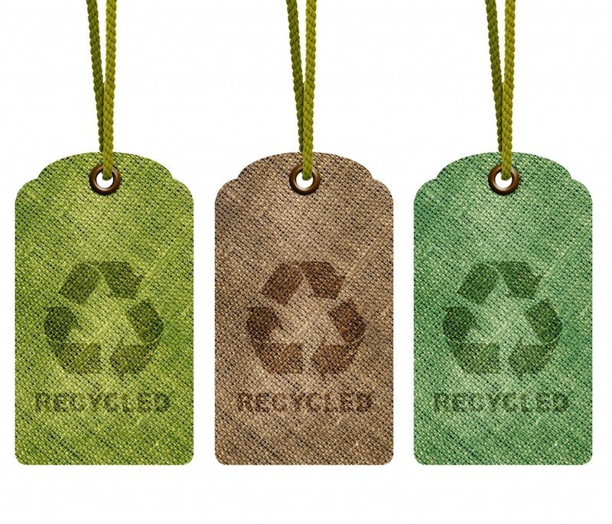
(Redress Raleigh, 2014)

My second word is:

Emotive

Adjective
OED Definition

- Arousing or able to arouse intense feeling.
‘animal experimentation is an emotive subject’
‘the issue has proved highly emotive’

- Expressing a person's feelings rather than being neutrally descriptive.
- ‘the comparisons are emotive rather than analytic’

(Simpson and Weiner, 2000)

This adjective can be used in regards to a number of different scenarios. A writer may use this word to express passion in the dialogue of a story. Many people would agree that money is a highly emotive subject. Emotive is a strong word used within a wide range of industries such as film, advertising, music, funeral directory, art and opinions within politics.
I chose this word because my work is full of emotion, even if it is not easily perceived by the viewer. I aim to design with reason in hope to portray a message to the audience about how I feel or an opinion on a particular subject, usually raising awareness about something. I think about the patterns I use and the colours I choose, and I like to think about how these choices could evoke the viewer. It is often a very personal experience to each viewer, as there could be unknown triggers in my work which could ignite different feelings for different people, or there could be an intentional design or theme to make the viewer feel a certain way.
Whilst reading ‘Fashion Design for Living’ by Alison Gwilt, I have been learning about the emotional impact the customer has whilst interacting with a garment to transform their feelings into a state of comfort. However, I am more interested in what emotion the garment holds and brings out in the customer. How people associate affective meaning with colour fascinates me.
‘New Directions in Colour Studies’ by Carol Biggam, examines the significance and emotion within colour and the theory based on the hypothesis that colour preferences are caused by people’s general affective response to colour associated items. Meaning that most people like to buy things in the colours of what they are associated with. An example would be the colour green, reminding the customer of the summer fields or a fresh plant.
Colour and emotion both play a huge role within our lives. It is far more powerful than many people could imagine. Colour influences all aspects of who we are, both internally and externally. It effects us emotionally, psychologically and physically. Our colour choices within fashion often represent our personality or feelings, which are linked to our emotions. I will be combining colour with emotion for my work.

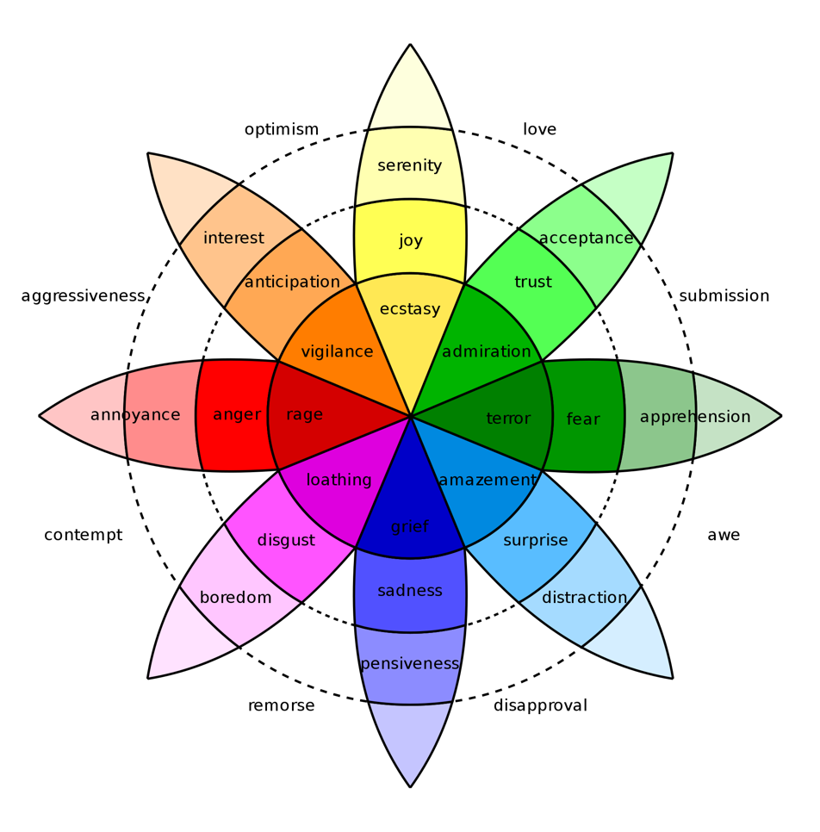
(Plutchik’s Wheel of Emotion, 1980)

The last word I will be looking at is:
Symbolism

- The use of symbols to represent ideas or qualities.
‘he has always believed in the importance of symbolism in garden art’

- Symbolic meaning attributed to natural objects or facts.
‘the old-fashioned symbolism of flowers

- An artistic and poetic movement or style using symbolic images and indirect suggestion to express mystical ideas, emotions, and states of mind. It originated in late 19th-century France and Belgium, with important figures including Mallarmé, Maeterlinck, Verlaine, Rimbaud, and Redon.

‘Several former communist leaders used symbolism, religion and outfight dictatorial tactics to remain in power.’
‘According to the artist, the painting is full of symbolism.’

(Simpson and Weiner, 2000)

I will be focusing on symbolism within the contemporary fashion design industry. Acknowledging the importance of historical symbolism within design around the world is crucial because it enables how significant it is to look at the past to understand the present.

There are many patterns and symbols in design that have their roots in ancient and modern cultures, which have evolved and have developed to be more stylized over time. Some symbols have lost their context, or the meaning has changed due to shifts or developments in society.
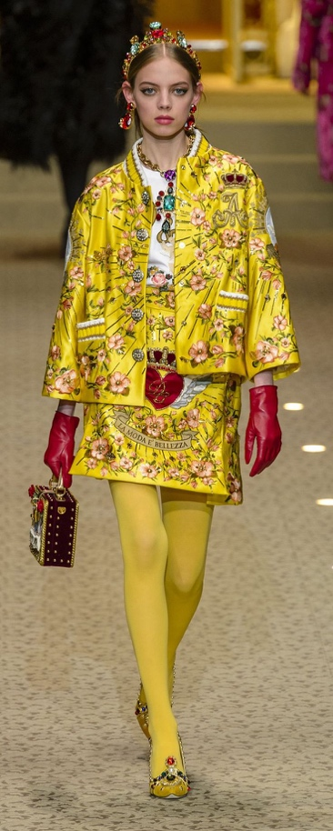
The use of symbolism within fashion is part of our common culture, whether or not we are consciously aware of it. Some historical symbols have been rejuvenated or have been used in order to give a historical context. These symbols tend to be simplistic in form, which makes them just as significant and usable today.
Design is the ability to communicate through an intuitive sense of pattern and recognizing pattern is one of humanity’s greatest abilities.

Dolce and Gabana’s Fall 2018 Ready to Wear Collection was inspired by Catholicism and made of everything from exquisitely crafted Vatican City vestment brocades, cut velvet, sumptuous embroidery, to cheap, bold slogans on sweatshirts and T-shirts appropriated from the aesthetics of the souvenir stall. This symbolized their passion for their religion through the clothes they designed.

(Dolce and Gabana, 2018)

Miuccia Prada uses symbolism within her work to target social issues. In her recent spring collection called ‘New Wave’, she was suggesting militant women in a very practical way, through clothes. Her thoughts and feelings were driving towards wanting to change the world, especially for women, because she believes there is still so much against us.
Even something as simple as a stripe pattern still holds great symbolism within the design world. A blue and white stripe jersey was first worn by French sailors since the mid-19th century and made fashionable by Coco Chanel at the end of the first world war. Jean Paul Gaultier has repeatedly included it in his fashion collections over a 40-year career. The stripe is seen everywhere from a pinstriped business suit, pastel striped pyjamas, bed linen, school uniform and football kits.
However, wearing stripes in medieval times represents the clothes of the criminal, crippled and insane. This shows how one simple pattern can have a large identity and can portray different ideas depending on who is viewing it.

“One picture is worth a thousand words. Yes, but only if you look at the picture and say or think the thousand words” (Saroyan, 1943)
This quote is showing how a picture could either portray a thousand words, or could portray none. There would be many different outcomes of what a single picture represents, depending on the viewers understanding and intelligence, thoughts and personal opinions. If you stare at the picture blankly, no words will come to mind. However, if you really study the picture, you could create a whole story or scenario in your mind. Symbolism within the fashion industry can be subtle or obvious depending on the consumers’ knowledge. A consumer could buy a garment without understanding what it is actually representing.

Although I had an idea of the type of question I wanted to answer for my dissertation, this research has helped me to shape the question in context and relevance for my dissertation. I now know that the question will either be:

How are contemporary designers using symbolism to effect the way we buy fashion?

Or

How are contemporary designers having a positive impact on consumerism?

Or

How are contemporary designers effecting the way we buy fashion?

Harvard Reference List

Books

Macnab, M., 2008. Decoding Design: Understanding and Using Symbols in Visual Communication. Mexico: HOW Books, pp. 2, 8, 124.

Campbell, C., 2005. The Romantic Ethic and the Spirit of Modern Consumerism. Great Britain: Writers Print Shop, pp. 20-24, 153, 232, 261.

Chapman, J., 2015. Emotionally Durable Design: Objects, Experiences and Empathy. Great Britain: Routledge, pp. 10, 43, 57, 66, 118.

Gardetti, A, M., 2015. Handbook of Sustainable Luxury Textiles and Fashion, Volume 2. New York City: Springer, pp. 45, 76, 122, 125.

Kidd, A., and Nicholls, D., 1999. Gender, Civic Culture and Consumerism: Middle Class Identity in Britain, 1800-1940. Great Britain: Manchester University Press, pp. 65, 93, 99, 186-190.

Fletcher, K., 2016. Craft of Use: Post-Growth Fashion. Great Britain: Routledge, pp. 3-7, 49-53.

Cline, L, E., 2012. Overdressed: The Shockingly High Cost of Cheap Fashion. New York City: Penguin, pp. 14-19, 53, 68.

Etkins, P., 1989. Sustainable Consumerism: A New Consumerism: Theoretical Basis and Practical Applications. Great Britain: New Economics Foundation, pp. 11-15.

Mansvelt, J., 2011. Green Consumerism: An A-to-Z Guide. California: SAGE, pp. 142-143, 319.

Singh, A., 2013. Managing Emotion in Design Innovation. United States: CRC Press, pp. 45-50.

Gwilt, A., 2014. Fashion Design for Living. Great Britain: Routledge, pp. 141-142.

Atwood, R., 2016. Living with Pattern: Color, Texture, and Print at Home. New York City: Potter/Ten Speed/Harmony/Rodale, pp. 93, 113.

Planalp, S., 1999. Communicating Emotion: Social, Moral, and Cultural Processes. Great Britain: Cambridge University Press, pp. 33, 41-44, 70, 72, 125, 196.

Dael, N., Perseguers, M., Marchand, C., Antonietti, J., and Mohr, C., 2016. Put on that Colour, it Fits Your Emotion: Colour Appropriateness as a Function of Expressed Emotion. Great Britain: Routledge, Taylor & Francis, pp. 13-23.

Ritberger, C., 2009. What Colour Is Your Personality? California: Hay House Inc, pp. 26, 145.

Lynch, A., and Strauss, M., 2007. Changing Fashion: A Critical Introduction to Trend Analysis and Meaning. London: Berg, pp. 34, 49-53, 67-68, 91.

Day, L., 2013. Pattern Design. San Francisco: Courier Corporation, pp. 16, 47, 83, 104, 124.

Bartholomew, J., and Rutherford, S., 2015. The Design Student’s Handbook: Your Essential Guide to Course, Context and Career. Great Britain: Routledge, pp. 11-19, 41-42.

Websites

Fraquoh, F., 2013. [Article] Clothing As Symbols. The Attire Club Organization website. Available at: https://attireclub.org/2013/05/19/clothing-as-symbols/ (Accessed: 22 April 2018).

Wheatley, R., 2015. [Website]. Origins of Symbols And Patterns – The Japanese Seigaiha Symbol In The Modern Context. Available at: https://blog.designcrowd.co.uk/article/710/origins-of-symbols-and-patterns--the-japanese-seigaiha-symbol-in-the-modern-context (Accessed: 6 May 2018).

Semiotics. 2017. [Website]. The history graphic design website. Available at: http://www.historygraphicdesign.com/the-age-of-information/the-international-typographic-style/734-semiotics (Accessed: 22 April 2018).

Pierce’s Theory of Signs. 2006. [Website] Stanford Encyclopedia of Philosophy. Available at: https://plato.stanford.edu/entries/peirce-semiotics/ (Accessed: 22 April 2018).

Ferreira, A., 2007. [Article]. How useful is semiotics as a method for analyzing works of art? Available at: http://artandperception.com/2007/02/how-useful-is-semiotics-as-a-method-for-analysing-works-of-art.html (Accessed: 13 April 2018).

Semiotics. Undated. [Website]. Visual Memory website. Available at: http://visual-memory.co.uk/daniel/Documents/S4B/ (Accessed on: 13 April 2018).

Plutchik’s Wheel of Emotion. Undated. [Website]. The Interaction Design Foundation website. Available at: https://www.interaction-design.org/literature/article/putting-some-emotion-into-your-design-plutchik-s-wheel-of-emotions (Accessed: 13 April 2018).

New Consumerism. 2016. [Website]. Euromonitor International website. Available at: https://blog.euromonitor.com/2016/05/what-is-the-new-consumerism.html (Accessed: 5 May 2018).

High-tech Consumerism. 2015. [Website]. The conversation website. Available at: https://theconversation.com/high-tech-consumerism-a-global-catastrophe-happening-on-our-watch-43476 (Accessed: 6 May 2018).

The Impact of Ethical Concerns on Fashion Consumerism. 2016. [Article]. A Review. Available at: http://digitalcommons.uri.edu/cgi/viewcontent.cgi?article=1019&context=mgdr (Accessed: 8 May 2018.)

Quotes

Simpson, J. and Weiner, E. (2000). Symbolism. [online] Available at: https://en.oxforddictionaries.com/definition/symbolism [Accessed 5 May 2018].

Simpson, J. and Weiner, E. (2000). Consumerism. [online] Available at: https://en.oxforddictionaries.com/definition/consumerism [Accessed 5 May 2018].

Simpson, J. and Weiner, E. (2000). Emotive. [online] Available at: https://en.oxforddictionaries.com/definition/emotive [Accessed 5 May 2018].

Wastson, E. (2010). People Tree. [online] Available at: https://kindnessovercruelty.wordpress.com/2016/08/15/the-fashion-industrys-effect-on-the-environment/ [Accessed 16 April 2018].

Saroyan, W. (1943). Words. [online] Available at: https://www.goodreads.com/author/show/4095.William_Saroyan [Accessed 16 April 2018].

Images

Redress Raleigh. (2014) Eco-friendly Fashion Can Be Easy [ONLINE]. Available at: https://factory45.co/ignore-hype-eco-fashion-can-easy (Accessed: 8 May 2018)

Dolce and Gabana. (2018) Fall Collection [ONLINE]. Available at: http://www.orientpalms.com/Dolce-Gabbana-7161 (Accessed: 8 May 2018)

Robert Plutchik. (1980) Plutchik’s Wheel of Emotion [ONLINE]. Available at: http://www.6seconds.org/2017/04/27/plutchiks-model-of-emotions/ (Accessed: 8 May 2018)

