DS1 – Digital Technology Examples

Screenshot 1 – WhatsApp Communities
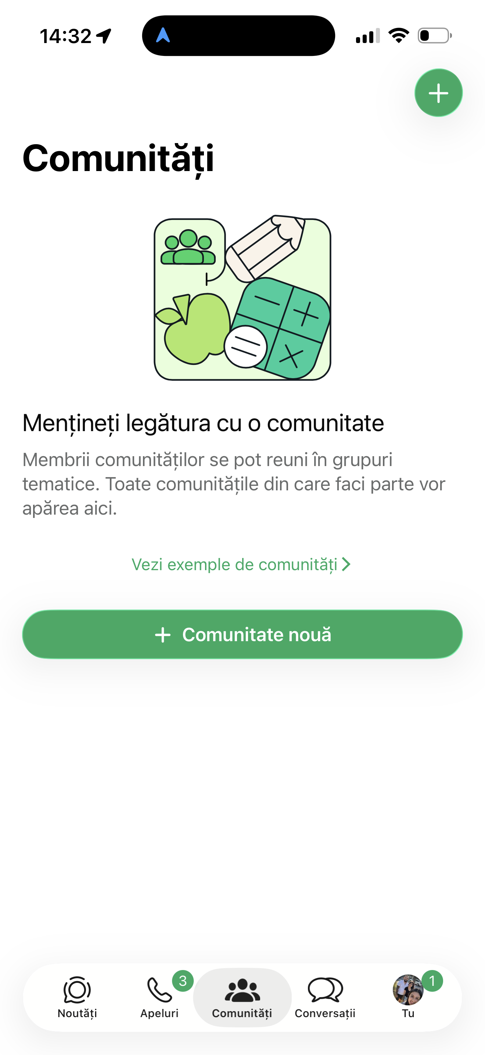
This screenshot shows the WhatsApp Communities feature. I use WhatsApp to communicate with family, friends and groups.

Screenshot 2 – Waze Navigation
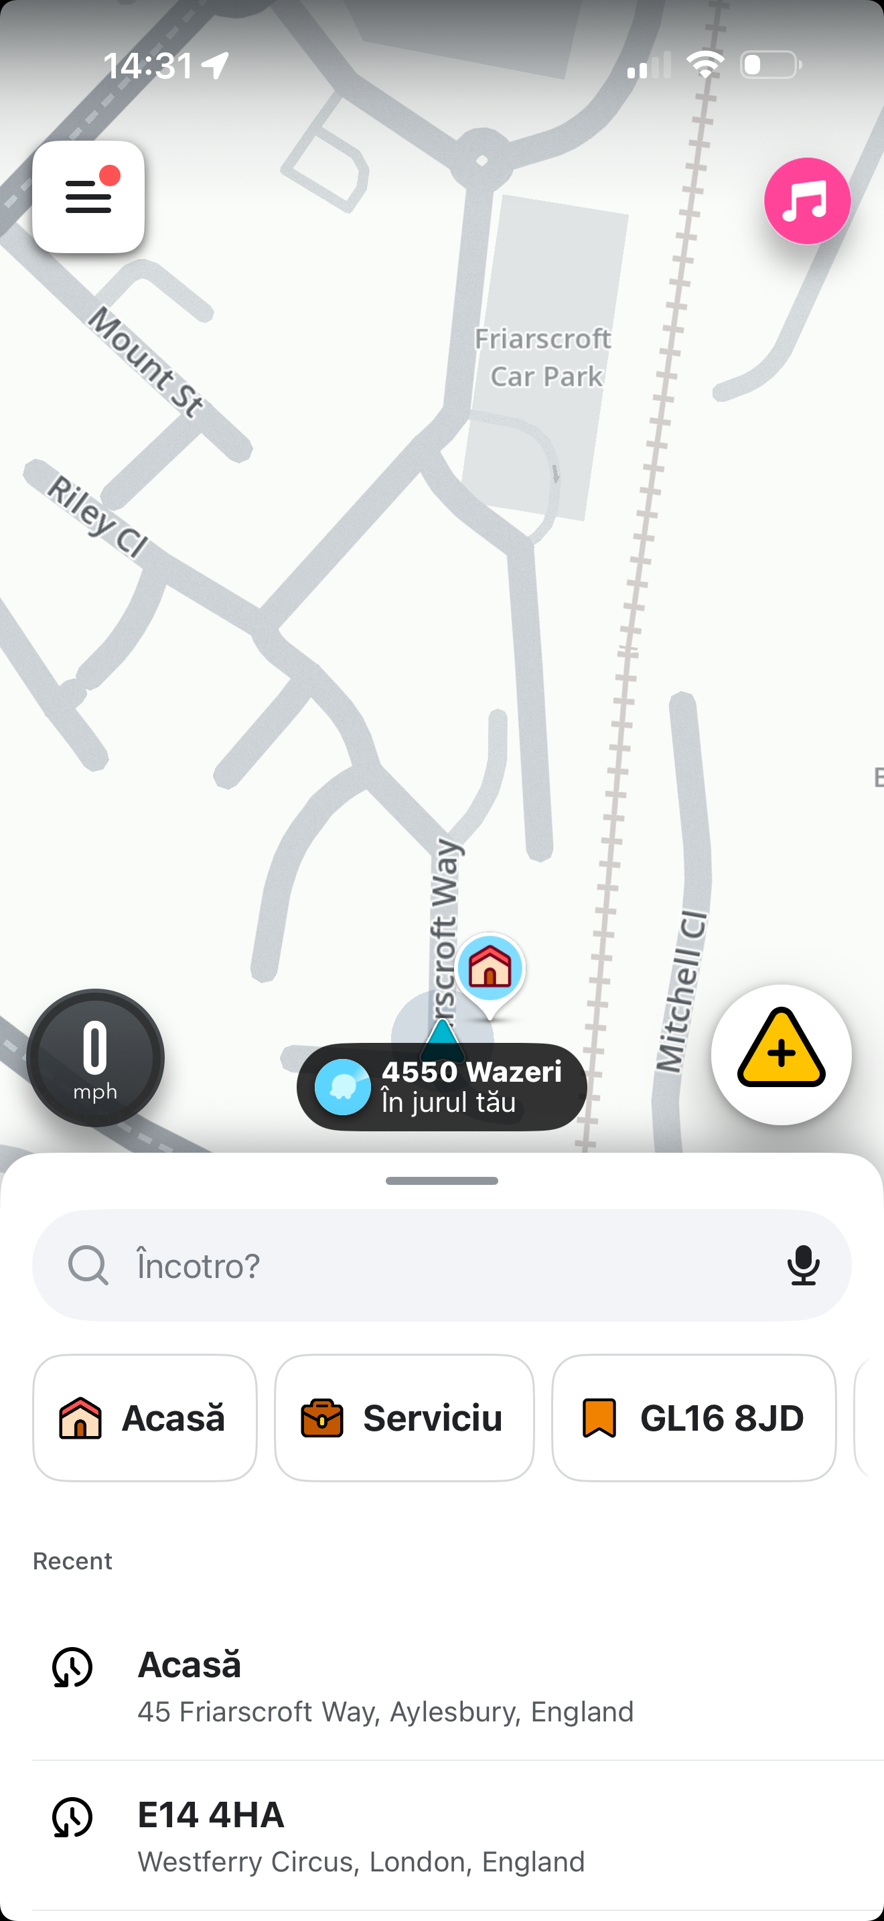
This screenshot shows the Waze navigation app. I use it to find the best routes when travelling to work or university.

Screenshot 3 – Google Search
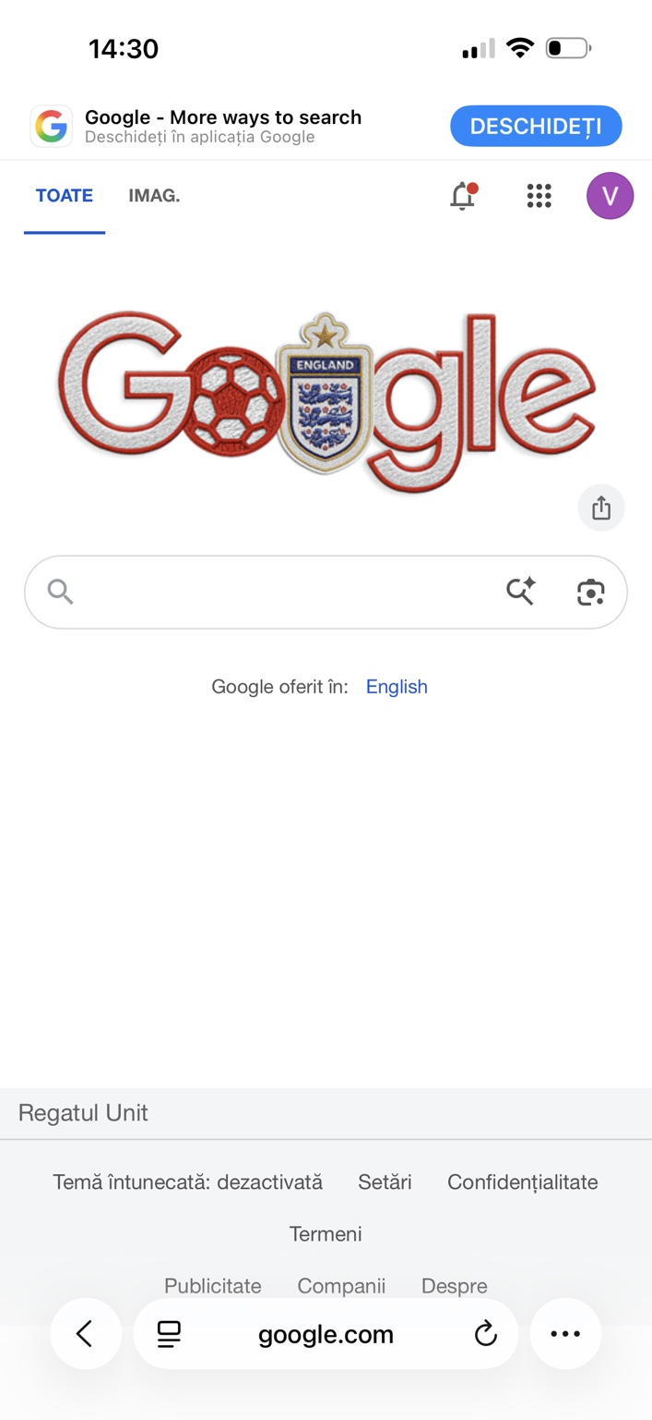
This screenshot shows Google Search. I use Google to find information, complete research and answer study questions.

Screenshot 4 – University Hub
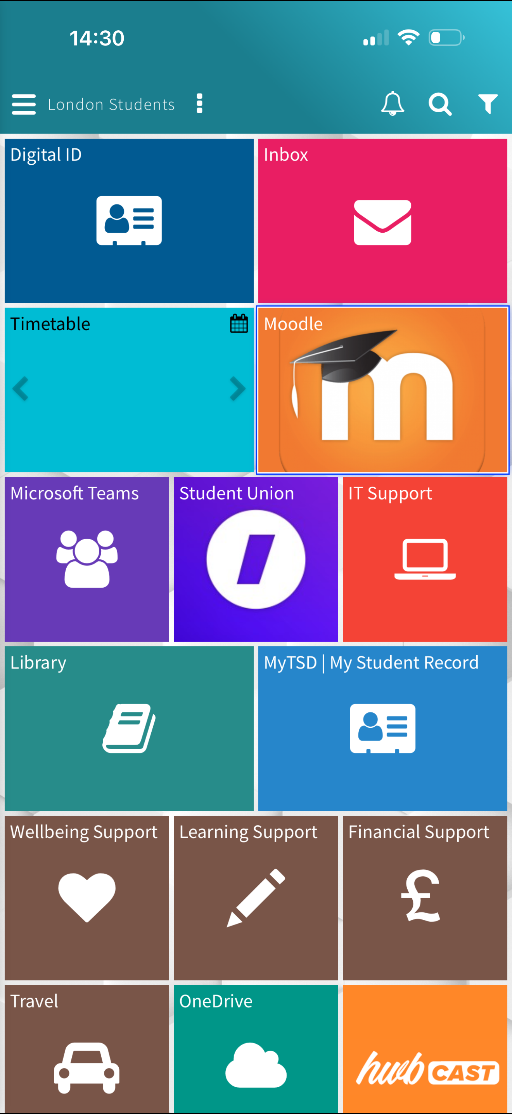
This screenshot shows my university Hub. I use it to access my timetable, Moodle, library resources and student services.

Screenshot 5 – Apps on My Phone
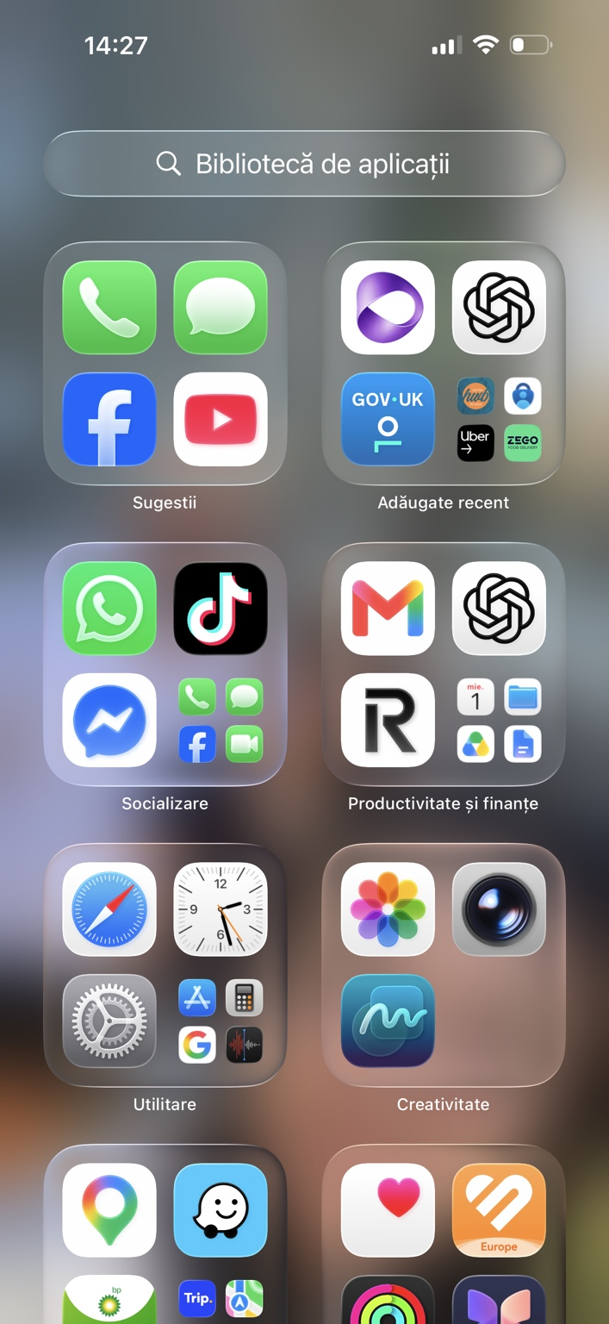
This screenshot shows some of the apps I use every day for communication, studying, navigation and productivity.

Reflection
Digital technology is an important part of my daily life. I use different apps to communicate with people, study at university, travel safely and find information. The university Hub helps me manage my learning, while Google supports my research. Navigation apps help me arrive at work on time. Technology saves me time, improves my organisation and helps me balance work, study and family responsibilities.

