NHS Sustainable Workforce in rural Wales

Hywel Dda University Health Board-The challenges of rural health and well-being

Sarah Jane Bowen, 19th October 2019
Wales is known for its coastlines and beautiful surroundings and is a distinctive part of the UK, with its own character, culture and way of life. However, it is not very well understood, how and why the health of the people in such areas varies from those in the country’s more populated areas, with vast impacts on the workforce.

In Wales, one in three people are living in areas defined as rural and to some, not all, rural is assumed that these areas are healthier, many think of ‘rural idyll’ as green countryside, fresh air and better health, however, not everyone is healthy in an area with good health averages and not everyone in poor health averages is of poor health, along with not everyone living in areas which are considered to have good health services find it easy to access their local services. Rural areas have a low level of social housing, residential care and day care, which makes access to social care more difficult, its influenced by income, housing, education, and deprivation in general often leading to poor health. Unless there are innovative ideas to improve services offered in deprived rural areas it can leave the NHS staff feeling demotivated and hopeless, this then impacts on recruitment and retention of staff.

Within the Hywel Dda Health Board, work is challenging like most organisations, and so to recruit and retain staff support, motivation and appreciation is key. Appreciation of work being done encourages staff to continually go the extra mile with their care and support they give the patients. However, the view of some, not all is ‘thanking staff for doing what they are paid for shouldn’t have to happen,’ why not? yes, they are getting paid for what they are doing, yet most, if not all go the extra mile. NHS staff don’t have a 9-5 working day and can’t always clock off at the end of day, yes, NHS staff are aware of the long hours prior to taking on the role, but even so, it’s lucky for us we have people like these, who take on the emergency admissions or crisis instead of getting home to their loved ones and staying on to care for other people, working extra hours to try and cover chronic staff shortages. All these challenges are building, and staff should always feel valued and supported. Every effort should be made to ensure a good work life balance is in place to maintain the right support and health for staff, because without them the NHS is in trouble. There are other areas that help to recruit and retain staff, for example, having different career paths and training opportunities, the challenge of extending their skills within their current roles and fair grading of pay scales are all ways to motivate and retain staff.
Challenges in rural areas are due to increased remoteness and population dispersal leaving rural communities to travel longer distances to access services than those in the city areas. Especially the elderly who have retired here to these remote areas, not all having access to their own vehicles, and with public transport facing its own workforce and financial pressures it proves difficult for them, with Wales already having a high population of people aged 85+ and with high levels of deprivation in areas leading to an increased demand on the services.
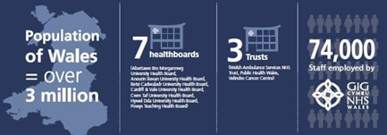
Dahlgren and Whitehead (1992) suggest a model that looks at wider determinants of health such as living and working conditions, which are important in understanding possible reasons for inequalities.
Gwent local medical committee chair, Deborah Waters, stated in an article by Jenny Sims, 2018, Doctor shortages in the valley town that inspired the NHS “Primary care is in crisis because we can’t recruit enough GPs or retain them, over 74 practices across Wales are in danger of closure due to recruitment challenges.

Rural Health and Care Wales (RHCW)
With the NHS continuing to develop new ways of delivering its services for the population as the demand increases for patients who require care, treatment and support, and with the help of many Health Boards throughout Wales supporting Rural Health and Care Wales, with the vision to become a world-leading organisation, training, recruitment and best practice.

RHCW held their first conference on 14th November 2017, with Co-Chair Dr Ruth Hall, commenting on Peter Saul from ‘The Wales Deanery’ who presented “the recruitment and training of rural GP’s”, stated,
‘The perspectives given on recruiting and training the wider impacts of issues such as rurality, were extremely relevant and appreciated by the audience.’
Dr Phil Kloer, Executive Medical Director and Director of Clinical Strategy with Hywel Dda University Health Board was amongst many other experts responding to questions.
@RHCWales tweeted,
The Third conference, ‘Rural Resilience in Health and Care’ is taking part on 5th and 6th November 2019 at the Royal Welsh Showground, Berth Wells.’
NHS Developing
The NHS are focusing on ways to develop services with the opportunities provided by digital technology and multi-disciplinary working.
Vaughan Gething, Health secretary since 2016, was made responsible for social services in November 2017, has called for radical change in how both services are run to ensure the survival in Wales NHS. Vaughan Gething @wgmin_health official channel of the Minister for Health Service tweeted, September 2019 “I have announced plans to transform digital services for health and care, as set out in #AHealthierWales. Our long-term vision for the NHS a Healthier Wales, sets out the importance of digital technology in future health care, playing an absolute essential role throughout the health service and in social care, empowering patients and the public to manage their own health and well-being”.
The ambition of ‘A Healthier Wales’ is for the health and social care systems to work together, to help people live well in their communities, like it was many years ago, meeting their health and care needs effectively and provide more services closer to or at home, ensuring that they only need to use a hospital for treatment that cannot be provided safely anywhere else.
The NHS is aging, and the pressures and demands are significantly growing as the workforce is under considerable pressures to provide a service. The kind of care envisioned in the ‘A Healthier Wales’ programme can provide challenging and motivated work for health care professionals leading to better recruitment and retention of rural staff.

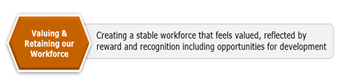
Hospitals in rural areas find recruiting junior doctors more challenging as there is more attraction to city areas due to the lifestyle and training offered.
The Health, Social Care and Sport Committee, in their 2017 inquiry into medical recruitment suggest, that young people who train in Wales are considerably more likely to stay working in Wales after they have completed their qualifications. To this end, we welcome the Welsh Governments, ‘Train,Work,Live’ campaign aiming at attracting medical staff to Wales.
Preparing to launch the latest campaign, #Trainworklive, Health secretary Vaughan Gethin has stressed the importance of building on its success to date.
With this action being put in place, involving planning, funding, recruitment and training to maintain our health care workers in our rural areas, it is hoped to meet the public’s well-being needs and the needs of our staff.

The challenges of delivering health and care services in rural areas fall within a number of sub groups, achieving continuous access to services, overcoming challenges related to small population’s bases, delivering services sustainably, addressing loneliness and isolation, recruiting and training the required workforce, and ensuring provision of service in a patient’s chosen language.
Integration is required between health, social care and support organisations, focusing their attention on where care is delivered. The design of required jobs and the skills needed to fulfil those jobs.
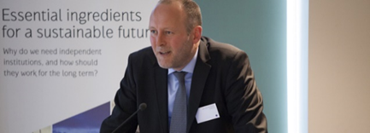
. “Every interaction with patients is an opportunity for health improvement” (Jenny sims, 2018,)
A sustainable society is founded on equal access to health care, education, economic opportunities, employment and many others.
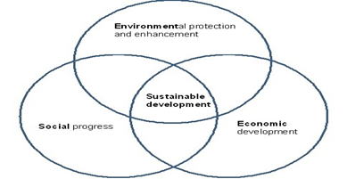
For many, sustainability is defined through environment, economic and social, however a fraction of the population disagrees on political thought, what is and what isn’t economically sound. A thought is a set of normative beliefs and values that a person or other entity has for non-epistemic reasons. These rely on basic assumptions about reality that may or may not have any truthful basis.
Future Generations Act 2015
Hywel Dda University Health Board has an individual and collective responsibility to publish well-being objectives which has been running since the introduction of the well-being of future generations (Wales) Act 2015 in April 2016.
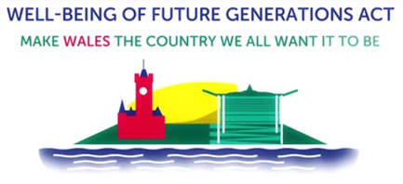
Hywel Dda have agreed there is a strong alignment of the strategic objectives set out in an annual plan submitted to Welsh Government and their contributions to maximise the delivery of the principles of the Act and the Seven National Well-Being goals for Wales, the Health Board have defined it’s objectives as:
• Improve population health through prevention and early intervention.
• Support people to live active, healthy lives
• Improve efficiency and quality of services through collaboration with people, communities and partners
• Ensure a sustainable, skilled and flexible workforce to meet the changing needs of the modern NHS.
The well-being of Future Generations (Wales) Act 2015 is breaking new ground and Wales is the first country to legislate for the Well-being of future generations through establishment of seven national well-being goals and five ways of working. Together, the seven Well-Being goals for Wales and the Five Ways of Working provided by the Act are designed to support and deliver a public service that meets the needs of the present generation, without compromising the ability of future generations to meet their own needs. This being known as ‘The Sustainable Development principle.’ The new way of working is challenging to review and re-focus the processes for establishing long term priorities, which will have the greatest impact on meeting the needs of the population.

The Government is committed to continue to invest in primary care and to take action to attract and train more GPs, Nurses and other health professionals, this work has been underway over the past three years with plans to increase exposure to foundation training and provide incentives to attract people into Wales with the Health Board recruiting staff, and supporting GP’s who are interested in working in Wales.
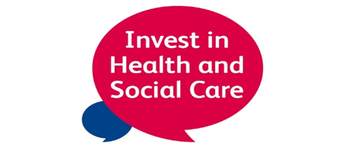
The Seven National well-being goals - provides official definition by Welsh Government.
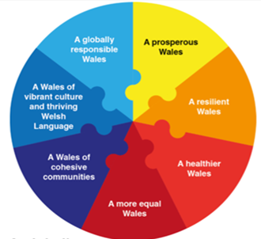
1.Prosperous Wales – where everyone has jobs and there is no poverty. Acting on climate change, using resources efficiently and proportionately.
2. Resilient Wales – being prepared for floods, adapting to change, for example, climate change.
3. Healthier Wales – Healthy and be able to see a Dr when needed. Maximising peoples physical and mental well-being.
4. Equal Wales – equal chance whatever their background, enabling people to fulfil their potential.
5. Cohesive Communities – live happily together as communities, safe and well-connected.
6. Vibrant culture and thriving Welsh language – opportunities to do lots of things and more of the population speak Welsh, promoting and protecting culture.
7. Responsible Wales – looking after the environment, making a positive contribution to global well-being.
Five ways of working.
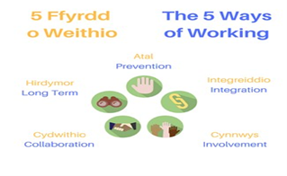
1. Objectives are designed to respond to long-term opportunities and challenges.
2. Involved in several different collaborative arrangements, committed to partnership working with individuals, communities and organisations.
3. Committed to the development of integrated services that support people to improve their health and well-being.
4. Committed to fully engage and involve individuals as services are developed and challenges are responded too.
5. Prevention and early intervention agenda are central to the UHB’s Well-being Objectives and reflects the ambition to become a population health organisation.
Ensuring a sustainable, skilled and flexible workforce to meet the changing needs of the modern NHS. By supporting staff to stay in stable jobs and sustain long-term employment this will help to sustain a fully functioning NHS service in rural Wales. Recruitment has been a priority across all clinical groups and there is a need to continue to work collaboratively to secure innovative results to the workforce challenges. Measuring the success will include reductions in variable pay costs for agency and locum staff, the increase in staff retention and developing a carer’s policy in order to support the workforce with their caring responsibilities.
And so, with all the challenges the delivery of the health services in rural areas within Wales are facing, with workforce issues, it proves difficult for the Health Board to provide the services in communities, but with the campaigns, #Trainworklive, ‘A Healthier Wales’ programme and the support of Rural Health and Care Wales being in place, are all motivation strategy’s to encourage professionals to live and work in rural areas in Wales to enable healthcare to be reachable for all.

References:
https://www.uos.ac.uk/sites/default/files/basic_file/REAMS_1-(1)_WALES-v2.pdf
Dahlgren, G. and Whitehead, M. (1992) Policies and strategies to promote social equity in health. World Health Organisation, Stockholm.
Du Pisani, J.A (2006) Sustainable development – historical roots of the concept.
Consultant Crisis - Wilson, Caitlin; Hall, Lyndall; Chilvers, Rupa. Midwifes; London vol,20. (Winter 2017): 62-63 – search-proquest-com.ezproxy.uwtsd.ac.uk
Dixon, Jennifer. BMJ: British Medical Journal (online): London Vol.357, (Apr 18, 2017) DOI:10.1136/bmj.j1.826 - Making the NHS and social care system sustainable -
www.Thekingsfund.org.uk – Naylor, Chris. 25 April 2019
www.gov.wales
www.wales.nhs.uk
Human resources on campaign for workforce in rural wales – Tina.coleman@wales.nhs.uk
www.wales.nhs.uk/siteplus/documents/866/3.3%20Appendix%20NHS%20wales%20workforce%20key%20Themes%20%202014%20-%2017.pdf – workforce education development services – NHS Wales Workforce – Key themes and trends April 2014 – JED14.04.14v2
Getting Welsh GP’s back on their feet - Anonymous GP; London (Feb23, 2015): 14
Sims, Jenny. BMJ: British Medical Journal (online): London Vol.362 (Aug 22, 2018). DOI:10.1136/bmj.k3600
VaughanGething@wgmin_health official channel of the Minster for health services. Wales – Joined June 2012. 994 following 15.7k followers
https://www.bing.com/search?q=Vaughan+Gething&filters=ufn%3a%22Vaughan+Gething%22+sid%3a%2290940d0b-e6f2-f8e6-6442-ab41d54dd1bf%22&FORM=SNAPST
https://www.bbc.com/future/article/20170705-how-climate-change-could-transform-the-work-force
https://heiw.nhs.wales/files/workforce-strategy-for-consultation/
https://ruralhealthandcare.wales/news/press-release-inaugural-rural-health-care-wales-conference/
https://www.theguardian.com/healthcare-network/2018/may/22/south-wales-town-forged-nhs-points-future-tredegar
Aneurin Bevan. Photograph: George Konig/Getty Images
https://www.bing.com/images/search?q=five+ways+of+working&FORM=HDRSC2
https://www.bing.com/search?q=gwent+local+medical+committee+chair%2C+deborah+waters&form=EDGEAR&qs=PF&cvid=2cb10af555cb4dca941e18b1b74e50e5&cc=GB&setlang=en-US&plvar=0&PC=LCTS
Dr Ruth Hall - https://ruralhealthandcare.wales/public-staff-engagements/events/rhcw-conference-2017/
https://www.nhsconfed.org/resources/2018/04/rural-health-and-care-in-wales
https://www.nhsconfed.org/-/media/Confederation/Files/Wales-Confed/Rural-Health-and-Care-Services-in-Wales.pdf

