

L7: Artificial Intelligence
(ACCA7026)

MNIST Handwritten Digits Recognition

MSc Data and Artificial Intelligence
Linghao Kong 2106315
Wales Institute for Science and Art (WISA)
University of Wales Trinity Saint David

January 4th, 2022

Introduction

Handwritten Digits Recognition
Digit Recognition is the ability of a computer to receive, understand and recognize readable numbers from paper documents, photographs, or other sources. According to the different ways of the number source, the number recognition problem can be divided into handwritten number recognition, print number recognition, optical number recognition, natural scene number recognition and so on, which has great practical application value.
Handwritten number identification can be applied to bank money order number identification, postcode identification and other scenarios, which greatly reducing labor costs. At the beginning of the research, the text objects identified were only numbers 0-9. Until some simple products began to emerge from 1965 to 1970, digital recognition technology began to be applied in working scenarios such as postcode recognition.

MNIST
MNIST is a handwritten digits recognition data sets (image classification dataset). Including handwritten digital images, which have already been processed, and the corresponding category labels. Each image is a handwritten Arabic numeral, corresponding to a tag among 0 to 9. The question based on the data set is very simple and clear - to identify the numbers according to the digital images.
This dataset is very old and was published in 1998 as a by-product of Yann LeCun's paper^{[1]}. In this thesis, the application of convolutional neural network in handwriting character recognition is discussed. In order to compare the advantages and disadvantages of several handwritten font recognition methods. The author made this dataset as an experimental dataset.
This dataset is one of the most famous dataset and is used as “Hello Word” by many deep learning frameworks.

Structure of the article
The structure of the article is defined as follows:
- Give the introduction of the algorithms used in this assignment, including classification neural network, support vector machine and K-Nearest neighbor.
- Process the raw data of the MNIST dataset, and make the data useable by the functions in MATLAB.
- Apply the algorithms on MNIST dataset and display the performances respectively.
- Discuss and analyze the performances of the algorithms, and try to explain the reason of the results.

Classification neural network

Feedforward neural network
The classification neural network used in this assignment is feedforward, fully connected neural network.
Feedforward neural network (FNN), which adopts a unidirectional multilayer structure, containing several neurons each layer, is a kind of artificial neural network. In FNN, each neuron belongs to different layer. Neurons in each layer can receive signals from neurons in the previous layer and generate signals to output to the next layer. The zeroth layer is called the input layer, the last layer is called the output layer, the other intermediate layer is called the hidden layer, and the neurons of the two adjacent layers are fully connected^{[2]}.
Feedforward can also be called forward. In terms of signal flow direction, the signal flow is one-way after the input signal enters the network, that is, the signal flows from the previous layer to the next layer and all the way to the output layer. There is no feedback between any two layers, that is, the signal does not return from the next layer to the previous layer. In terms of the input-output relationship, when the input signal enters, each layer after the input layer takes the output of the previous layer as the input.
A typical multilayer FNN is shown in Fig.1.
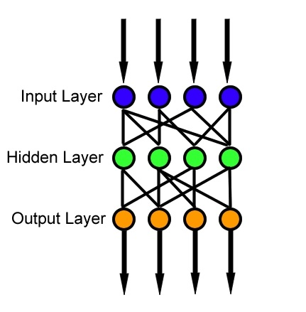
Fig.1 A typical multilayer feedforward neural network
The multilayer FNN has one input layer, one or more hidden layers in the middle, and one output layer. The transformation relation between input and output in the multi-layer perceptron network is:
$$s_{i}^{(q)}=\sum_{j=0}^{n_{q-1}}{ω_{ij}^{\left(q\right)}x_{j}^{\left(q-1\right)},(x_{0}^{\left(q-1\right)}=θ_{i}^{\left(q\right)},ω_{i0}^{\left(q-1\right)}=-1)}$$
$$x_{i}^{(q)}=f\left(s_{i}^{\left(q\right)}\right)=\left\{\begin{aligned}1,s_{i}^{(q)}≥0 \\ -1,s_{i}^{(q)}<0\end{aligned}\right.$$
$$i=1,2,… ,n_{q};j=1,2,…,n_{q-1};q=1,2,…,Q$$
At this point, each layer is equivalent to a single-layer FNN. For example, for the $q^{th}$layer, it forms an$n_{q-1}$-dimensional hyperplane. It classifies the input patterns of this layer linearly, but because of the combination of layers, it can finally achieve a more complex classification of the input patterns.
FNN has simple structure and wide application, and can approximate nonlinear functions, which is usually difficult to tackle using model based methods. However, lack of dynamic behavior makes the error large in some rapidly change situations.
Most FNN are learning networks, and their classification ability is generally stronger than those of feedback networks.

Softmax logistic regression
Softmax logistic regression model is the extension of Logistic regression model in multi-classification problem. It changes the results of multiple categories into probabilities, which is serviceable for problems such as MNIST handwritten number classification.
The computing method of Softmax is as Fig.2. The Softmax value for the element in sample which is being classified is the ratio of the exponent of this element to the sum of the exponent of all the elements. The calculation formula is as follows:
$$S_{i}=\frac{e^{i}}{\sum_{j}{e^{j}}}$$
Where $j$ is the total number of elements in array $V$.
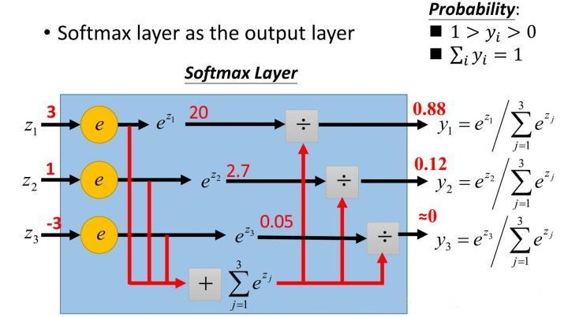
Fig.2 Computing method of Softmax

Neural network structure
The structure of the classification neural network used in this assignment is as Fig.3. Every sample in MNIST dataset is an image of $28×28$, so the node numbers of input layer is 784. The node numbers in the hidden layers are 100 and 50 respectively. The activation function applied to the first hidden layer is ReLu, which does not have the influence of other complex activation functions such as exponential function and therefore simplifies the calculation process^{[3]}. Softmax is applied as the activation function of the final hidden layer to correspond the result to the predicted classification scores.
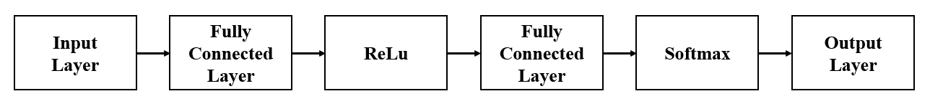
Fig.3 Structure of the classification neural network

Support vector machine

Basic concept of Support vector machine
The core of SVM is to map the input vector to a high-dimensional feature vector through a nonlinear mapping. In this higher dimensional characteristic region, the optimal separated hyperplane is formed. The sparsity of solutions is one of the important features of support vector machines, that is, most optimal solutions $a_{i}$ is 0, and as long as a small number of $a_{i}$ is 0, that is, only a small number of samples can constitute the optimal classifier, so the useful sample data is greatly compressed^{[4]}.
The process of dividing a hyperplane can be defined as a linear equation:
$$ω^{T}X+b=0$$
The dimension of $ω$ is the dimension of the characteristic space. Once the normal vector $ω$ and the displacement $b$ are determined, a partition hyperplane can be uniquely determined, which divides the hyperplane and any point in the marginal hyperplane on either side of it by the distance $\frac{1}{\left\|ω\right\|}$.
The problem can be transformed into a convex quadratic optimization problem, using some mathematical derivation. Using the Karush-Kuhn-Tucker (KKT) condition and Lagrange formula, it can be deduced that MMH can be expressed as decision boundary. The formulas are as follows:
$$y_{i}\left(ω_{0}+ω_{1}x_{1}+ω_{2}x_{2}\right)≥1, ∀i$$
$$d\left(X^{T}\right)=\sum_{i=1}^{l}{y_{i}α_{i}X_{i}X^{T}+b_{0}}$$
Where $l$ is the number of support vector; $X_{i}$ is the eigenvalue of support vector; $y_{i}$ is the class label of $X_{i}$, such as +1 and -1; $X^{T}$ is the sample to test; $α_{i}$ and $b_{0}$ are numerical values, calculated by the optimal algorithm mentioned above.

Kernel method
In the case of linear inseparability, the vectors corresponding to a data set in space cannot be distinguished by a hyperplane. A nonlinear mapping can be used to transform a vector point in the original data set into a higher dimensional space (for example, a point in a two-dimensional space is mapped to a three-dimensional space). In this higher dimensional space, we can handle it linearly separable. The process of sample mapping to higher dimension is shown in Fig.4.
When linear SVM is converted into optimization problem, the formula calculation is solved in the form of dot product, where $∅(X)$ is the nonlinear mapping function to transform vector points in the training set into high-dimensional. Since the algorithm complexity of inner product is very large, we use kernel function to replace calculation of inner product of nonlinear mapping function.
The kernel function used in this assignment is polynomial kernel function, which can be represented as follows:
$$K\left(X_{i}, X_{j}\right)={(X_{i}, X_{j}+1)}^{h}$$
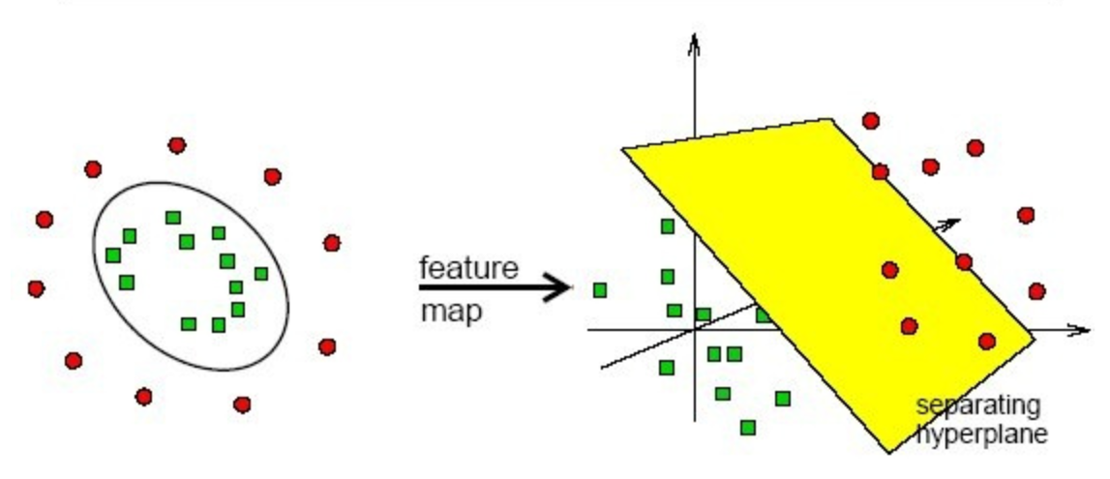
Fig.4 Mapping to higher dimension

K-Nearest Neighbor
K-nearest Neighbor (KNN) is one of the simplest machine learning algorithms, which can be used for classification and regression, and is a supervised learning algorithm. The idea is that a sample belongs to a category if most of its K most similar (that is, closest neighbors in the feature space) samples in the feature space belong to that category. In other words, the method only determines the category of the samples to be classified according to the category of the nearest one or several samples^{[5]}.

KNN used for classification
As shown in Fig.5, the square and triangle in the figure are labeled label data, respectively representing different labels. The green circle is the data to be classified.
If we choose K=3, then the K points closest to the green point have 2 triangles and 1 square, and these 3 points vote, triangles account for 2/3, so the green point is in the triangle category.
If we choose K=5, then there are 2 triangles and 3 squares in the K points closest to the green point, and 3/5 of the 5 points vote for blue, so the green point is a square.
As can be seen from the above examples, KNN is essentially a method based on data statistics. In fact, many machine learning algorithms are also based on data statistics. At the same time, KNN is a kind of instance-based learning, which belongs to lazy learning. In other words, it has no obvious pre-training process. When the program starts to run, data sets can be directly classified after being loaded into memory. Where, every time an unknown sample point is judged, K nearest points near the sample point are found to vote. This is the meaning of K in KNN, and K is usually an integer not greater than 20. The K value used in this assignment is 10.
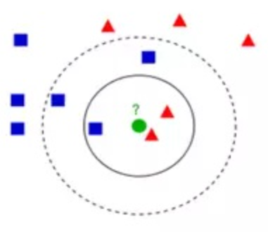
Fig. 5 process of KNN classification
The calculation process of KNN classification algorithm is as follows:
1) Calculate the distance between points to be classified and points of known categories.
2) Sort according to increasing distance order.
3) Select K points with the minimum distance from the points to be classified.
4) Determine the frequency of occurrence of the category of the first K points.
5) The category with the highest frequency of occurrence of the first K points is returned as the predicted classification of points to be classified.

Raw data process

Read the IDX file
The dataset is stored in IDX format that is unable to load into MATLAB directly, a code to read it is needed. I had started to work on the assignment a few days before the codes which are used to loading the file to MATLAB were uploaded to Moodle, so I found it on the internet.
After running the codes, the datasets are saved in the folder as ‘.mat’ format whose names are respectively train_x, train_y, test_x, test_y, shown in Fig.6. The features are saved in train_x and test_x, the corresponding labels are saved in train_y and test_y.
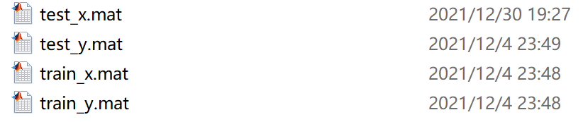
Fig.6 Dataset after format conversion

Data process
The labels are stored as One-hot encoding. It has massive advantages, such as the ability of dealing with discontinuous numerical characteristics, and extending the features to some extent.
However, the class labels must be transferred as type array rather than matrix while using ‘fitcnet’ classification neural network function, which means we need to transfer One-hot encoding into numbers. Use ‘vec2ind’ function to do this. The shape of train_label, numbers transformed from One-hot encoding, and train_y are shown in Fig.7.
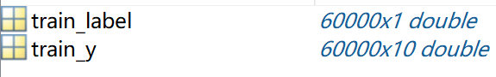
Fig.7 Shape of train_y and train_label
When using SVM classifier function ‘fitcecoc’, the input data format needed is ‘table’. Use ‘array2table’ function to achieve the requirement.
The test data, which is a dataset to test the performance of the trained model, is processed using the same method mentioned above.

Results
After preprocessing the raw data, we can feed the data to the prepared model for training. The indicators we select to measure and analyze the performance of different algorithms are, respectively, accuracy, confusion matrix and operating time log. The results are shown as follows:
(1) Classification neural network
The accuracy, operating time log and confusion matrix of classification neural network are shown in Fig.8 and Fig.9.
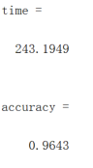
Fig.8 Time and accuracy of classification neural network on MNIST
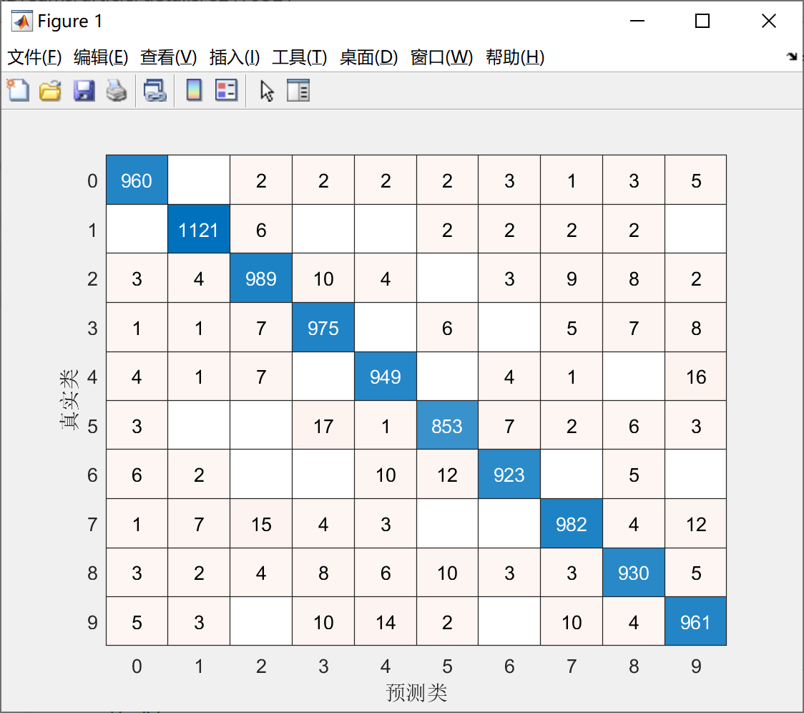
Fig.9 Confusion matrix of classification neural network on MNIST
The x label of the confusion matrix is predicted value while the y label is the true label.
(2) Support vector machine
The accuracy, operating time log and confusion matrix of classification neural network are shown in Fig.10 and Fig.11.
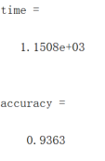
Fig.10 Time and accuracy of SVM on MNIST
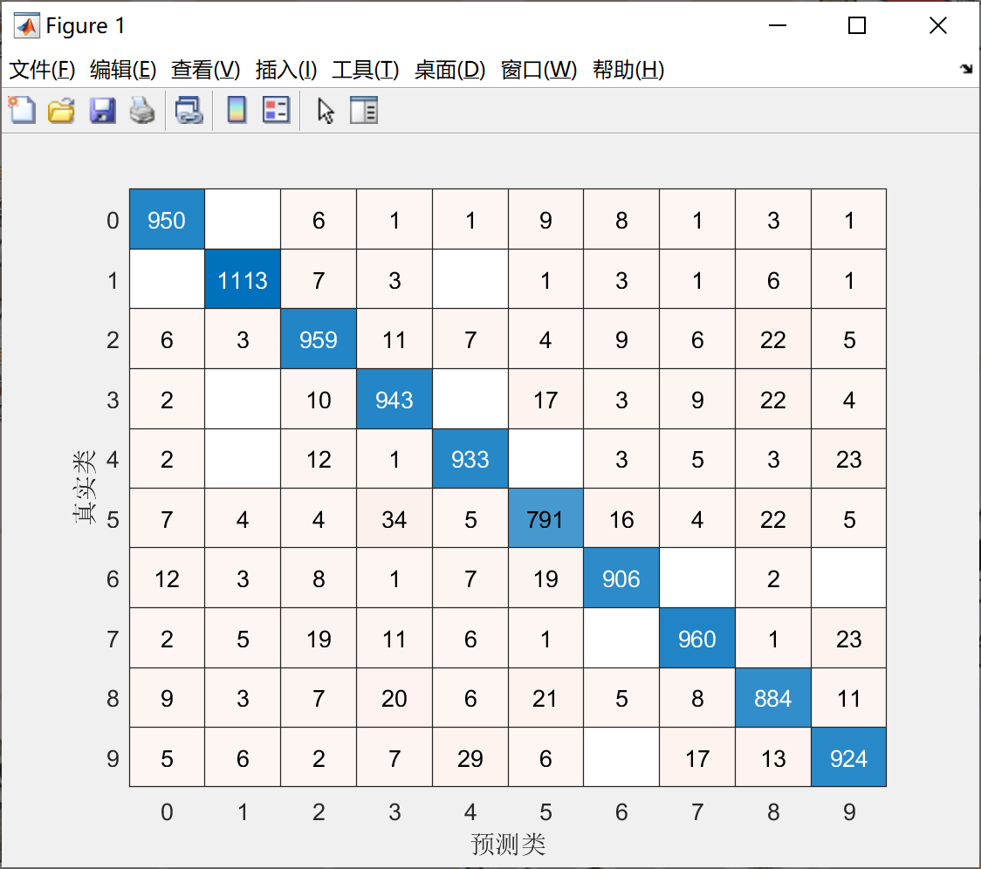
Fig.11 Confusion matrix of SVM on MNIST
The x label of the confusion matrix is predicted value while the y label is the true label.
(3) K-Nearest Neighbor
The accuracy, operating time log and confusion matrix of classification neural network are shown in Fig.12 and Fig.13.
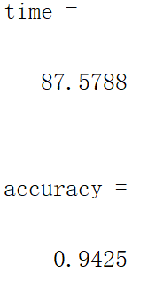
Fig.12 Time and accuracy of KNN on MNIST
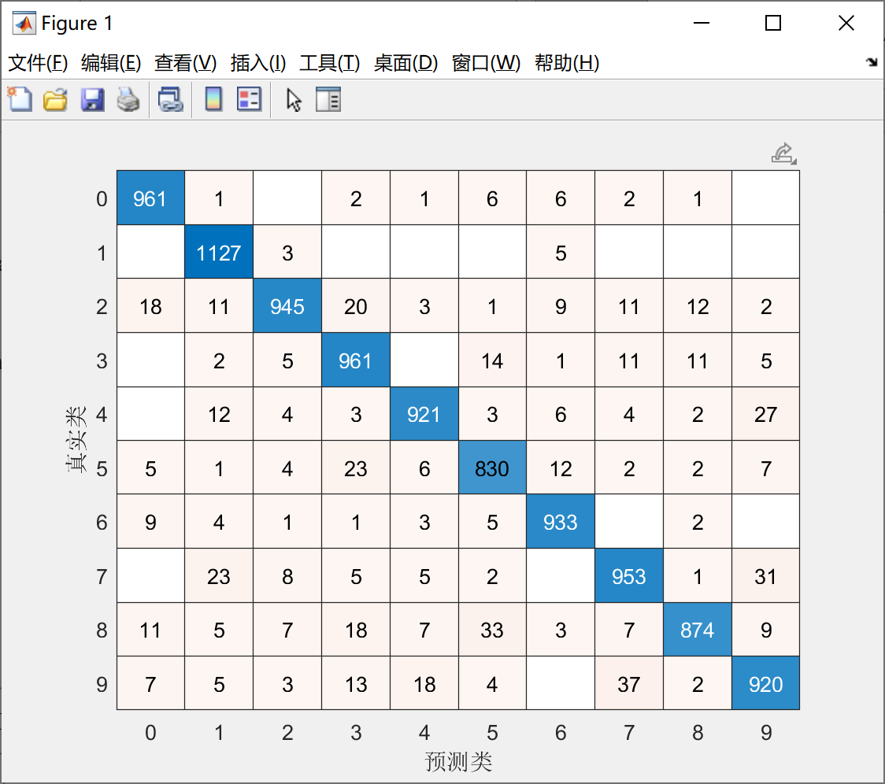
Fig.13 Confusion matrix of KNN on MNIST
The x label of the confusion matrix is predicted value while the y label is the true label.
Comparison of the algorithms are shown in Table 1.
Table 1 Comparison of the algorithms
Algorithm | Accuracy | Operating time log / s
Neural Network | 0.9643 | 243.2
SVM | 0.9363 | 1150.8
KNN | 0.9425 | 87.6

Discussion
As we can see in Table 1, the classification neural network has the best accuracy, 0.9643, among the algorithms, while KNN has the shortest operating time log, 87.6s.
The classification neural network, based on a massive number of nodes, is able to obtain complex nonlinear processing capabilities and, therefore, reach a high performance. It is also because of the large number of nodes, which takes some time to study the features.
KNN performs beyond my estimation. It reaches the accuracy of 0.9425 in merely 87.6s. It is mainly because the MNIST dataset is never a complex dataset, and the quantity of the sample is relatively balanced, which covers up the disadvantages of KNN, so it has a high accuracy. KNN is a lazy learning method that basically has no study process, which determines KNN the fastest algorithm in the methods used.
As for SVM, surprisingly, it has the lowest accuracy and the longest operating time log. In my opinion, firstly, the MNIST dataset has 60000 train samples, which is a huge number, so it takes a long period to learn the features. Secondly, SVM has plenty of parameters to choose, which may influence the performance. The SVM used in this assignment is the ‘templateSVM’ and ‘fitcecoc’ functions of MATLAB, which have no enough choices of the parameters, and it is essentially a combination of 45 binary SVM classifiers, which may cause the low accuracy.
Comparing with the accuracy on the webpage of MNIST where the highest accuracies of the three algorithms are respectively 0.52% for KNN, 0.56% for SVM and 0.35% for neural network. As far as I can gather, the differences in accuracy are mainly lie in the parameter adjustment. The functions used in this assignment are all functions in MATLAB toolboxes, the parameters are already set, and most of them are unable to change, which influences the accuracy greatly.

Conclusion
In the first part of the article, an introduction of handwritten digits recognition and MNIST dataset is made. Then all the algorithms used in this assignment are explained, including classification neural network, SVM and KNN. Thirdly, the raw data of MNIST is transformed into train data in MATLAB. After that, all the algorithms are trained and tested on MNIST, the performances are shown, by operating time log, accuracy and confusion matrix, and a table to compare the performances of the algorithms is established. Finally, a discussion on the time and accuracy of algorithms are made.
Among the algorithms, the classification neural network reaches the highest accuracy which is 0.9643, and the SVM’s accuracy is the lowest which is 0.9363. The KNN has the shortest running time which is 87.6s, and the SVM has the longest running time which is 1150.8s.
By comparing the performances of the codes used in this assignment with the accuracy listed on the webpage of MNIST, an analysis is made that the parameters of the algorithms are vitally significant, which may influence the performance greatly. When using the algorithms, we need to adjust the parameters to gain the best performances.

Reference
- Yann LeCun, Gradient-based learning applied to document recognition, Proceedings of the IEEE, 1998
- Glorot, Xavier, and Yoshua Bengio. “Understanding the difficulty of training deep feedforward neural networks.” In Proceedings of the thirteenth international conference on artificial intelligence and statistics, pp. 249–256. 2010.
- R Hahnloser, H.S. Seung (2001). Permitted and Forbidden Sets in Symmetric Threshold-Linear Networks. NIPS 2001.
- Statistical Learning Theory by Vladimir Vapnik , Wiley Interscience ; 1998
- Wang, H., Xu, P., & Zhao, J. (2021). Improved KNN algorithms of spherical regions based on clustering and region division. Alexandria Engineering Journal.

Appendix
- Classification neural network
clear
clc
close all
tic

%% load train data
load("train_x.mat")
load("train_y.mat")
% train_x = train_x(1:2000,:);
% train_y = train_y(1:2000,:); %these codes are for test run

%% onehot to number
train_label = vec2ind(train_y')-1;

%% Define the network
Mdl_net = fitcnet(train_x,train_label,LayerSizes=[100, 50]);

%% Load test data
load("test_x.mat")
load("test_y.mat")
test_label = vec2ind(test_y')-1;

%% Predict
predict = predict(Mdl_net,test_x);
Loss = loss(Mdl_net,test_x,test_label,"LossFun","classiferror");
confusionchart(test_label,predict)
toc
time = toc
accuracy = 1-Loss

- Support vector machine
clear
clc
close all
tic

%% load train data
load("train_x.mat")
load("train_y.mat")
% train_x = train_x(1:2000,:);
% train_y = train_y(1:2000,:); %these codes are for test run

%% onehot to number
label_train = vec2ind(train_y')-1;
train_data = array2table(train_x);
train_data.label = label_train';

%% Define and train SVM
t = templateSVM('Standardize',true);
Mdl_SVM=fitcecoc(train_data,'label','learners',t);

%% load and manipulate test data
load("test_x.mat")
load("test_y.mat")
label_test = vec2ind(test_y')-1;
test_data = array2table(test_x);
test_data.label = label_test';

%% test the SVM model
predict = predict(Mdl_SVM, test_data{1:end,1:end-1});

%% view performance
temp = predict-label_test';
num = 0;
for i = 1:length(label_test)
if(temp(i)==0)
num=num+1;
end
end
confusionchart(label_test',predict)
toc
time = toc
accuracy = num/length(label_test)

- K-Nearest Neighbor
clear
clc
close all
tic

%% Load train data
load("train_x.mat")
load("train_y.mat")
% train_x = train_x(1:2000,:);
% train_y = train_y(1:2000,:); %these codes are for test run

%% onehot to number
train_label = vec2ind(train_y')-1;

%% Define KNN model
Mdl_KNN = fitcknn(train_x,train_label,'NumNeighbors',10,'Standardize',1);

%% Load test data
load("test_x.mat")
load("test_y.mat")
test_label = vec2ind(test_y')-1;

%% Predict
predict = predict(Mdl_KNN,test_x);

%% view performance
temp = predict-test_label';
num = 0;
for i = 1:length(test_label)
if(temp(i)==0)
num=num+1;
end
end
confusionchart(test_label',predict)
toc
time = toc
accuracy = num/length(test_label)

