Student Name: | Rahima Begum
Student Number: | 1910783
Module No: | BMSK4003
Module Title: | Digital Skills and Research Methods

Statement of confirmation of authenticity
By the act of making this submission, the student declares that this is the work of the student named above. The work has not, in whole or in part, been knowingly presented elsewhere for assessment, or where assessment has been built on a previous assessment, this has been identified. Where materials have been used from other sources it has been properly acknowledged. If this statement is untrue, the student acknowledges that an assessment offence has been committed.

Table of contents

Introduction …………………………………………………………………… Page 3
Evaluation of modern technology used in the workplace ……………. Page 3
LinkedIn profile ……………………………………………………………… Page 5
Personal and professional security and safety online ……………….. Page 8
Primary research ……………………………………………………………. Page 10
Secondary research …………………………………………………………… Page 11
Academic argument on primary and secondary research ……………… Page 11
Bar chart on which social media people would choose when staring a business ..………………………………………………………………… Page 12
Why new technologies have affected the modern workplace ………….. Page 12
Conclusion ………………………………………………………………………. Page 14
References ……………………………………………………………………….. Page 14

Introduction
In this assignment I will be talking about the use of modern technology in the workplace. I will talk about different social media platforms and the advantages of using them when it comes to creating a business. I will also design and show my LinkedIn profile. I will discuss the risks that can be made when it comes to making online payments. In general, I will talk about personal safety and the data protection. I’ll also talk about primary and secondary research and the advantages and disadvantages of both, I’ll add my own primary research but also use secondary research too and explain both. Lastly, I’ll explain how and why new technologies have affected the modern workplace and the impacts that it has on people.
Evaluation of modern technology used to improve workplace efficiency
Technology helps in keeping all businesses in control and fully organised. Technology can be used in several ways in workplaces such as data protection, knowledge management, communication within the company people work in, data and data sharing. Technology is used by many people and in most workplaces. In every workplace managers and sometimes employees can supervise workplace activities which will help in keeping things on track. In workplaces managers do keep their mobile phones with them as they can easily communicate with other managers in their store when needed. In my workplace there is a laptop in the office which is used by the area manager and store managers too. By having the laptop in the workplace, they can access data and check employees rotas too, but this can also be done on mobile phones as in my workplace we use an app to find out our work days and days off. On this app we will be able to see the hours we will work each week. In my workplace there is WIFI as managers will need to use WIFI when needed. In my workplace the payment taking options includes cash or card payments but no cashback can be done. Workplaces use social media so that they can advertise what’s new in their stores and this will attract customers attention quick which will allow them to visit stores and do their shopping. People can go on apps such as Facebook and Instagram to check stores out, by following stores on these social media apps they can see items on their phones before they go to the stores. They can also click and collect from store.
In my workplace the store business uses Instagram where they will upload new items that have come in from their delivery so that customers can see it online. They also have an online website where people can place their orders and collect their orders from the store. When it comes to advertising recruitment in my workplace there are posters on the windows where customers and others can see that my workplace are recruiting people. Social media and different technology methods benefits all sorts of businesses because it attracts customers attention. There are many stores that are alike but by having businesses run on social media too and by people commenting it allows customers to go to places they can trust. If a lot of customers online complain about a certain store, then other customers and people will be able to see it too however if good comments are made and customers see these comments then they will immediately go to that specific store as they know to trust it. Attracting customers in different ways is important as that’s how businesses run.
In the near future if I wanted to create my own small business and become a business owner I would use a social media apps such as Instagram, the reason why I would use Instagram is because I can easily make my business page, upload posts frequently and attract different customers. Instagram is a platform which is easily used for businesses and a lot of people use Instagram to form a personal connection with their customers. I would use Instagram for my business page as I can upload photos and videos too and I would love to gain happy customers but also engage my audience. I would also use another social platform which is snapchat because by using these two apps I can get family and friends to let their followers know that I am running a business online and they can share my page on their social media. By using social media to run a business I can discover new trends, bring attention to my work, build, craft and enhance my brand as I would want my brand/business to be known so that I get more customers but also make my customers happy with the items that I would sell.
There are quite a few social media platforms where people can start their business such as Facebook, snapchat, Instagram, WhatsApp business, YouTube and LinkedIn. All these apps are free to use and free to download too. On platforms such as Facebook and Instagram people can upload posts and videos of what they sell within their business which will allow people to easily access their page if their social media platform is on public and not private. By others seeing these business pages, if they are interested then they will tag peoples business pages which will allow a persons business and their page to be more known and get more followers which’ll benefit them because they will get more customers which they need. Nowadays a lot of people are self employed and they make accounts on YouTube and do YouTube for a living. By people doing YouTube they will gain subscribers, likes and comments. YouTube can be used to make so many different videos such as cooking, hacks, vlogs, pranks, tutorials, guides, recipes, comedy shows and more. A lot of people on Instagram who are quite or more famous also do YouTube alongside. People who use social media platforms for business can eventually engage with brands. This means people who are continuously using a certain brand such clothing brand for example ‘prettylittlething’ which is a global online fashion brand. With the brand ‘prettylittlething’ they can collaborate with people who buy their clothes from their website.
By doing a collaboration they are working with others which will make their brand even more known. When it comes to doing business on social media platforms people should humanize their brand “to show the human side of” their brand and show people does their “product really work”. Showing the human side of a brand will show the human side of people behind their business, this is where honesty comes in. When setting up a business you have to be honest with what you sell and do because if you aren’t and your items aren’t doing what it says it should do for example ‘make up products’ or ‘skincare products’ then people will leave negative feedback on business pages which other people will be able to see. If this happens then those businesses will lose customers. People can show their products working through their customers feedback, uploading feedback is a good idea because people will certainly look for feedback and reviews before they make their purchase. On Instagram people can upload highlights and they can rename highlights to ‘customer feedback’ which will allow customers to check the highlight to see peoples responses. Having feedback and reviews on a business page will allow more customers to forward business pages to people they know which will then allow business pages to gain more customers and become more successful within their business that they’ve made. My views and opinions on people working from home on social media platforms is good because not everyone likes to work for others, a lot of people like to work independently. Also, not everyone likes to be told on what they should do so they may prefer to work from home.
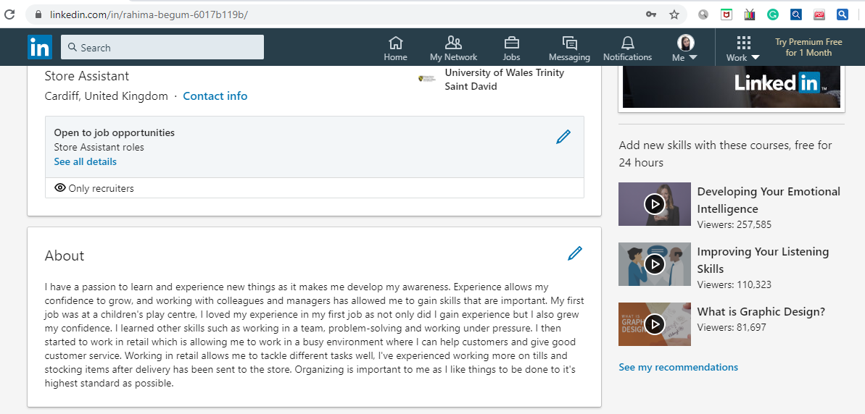
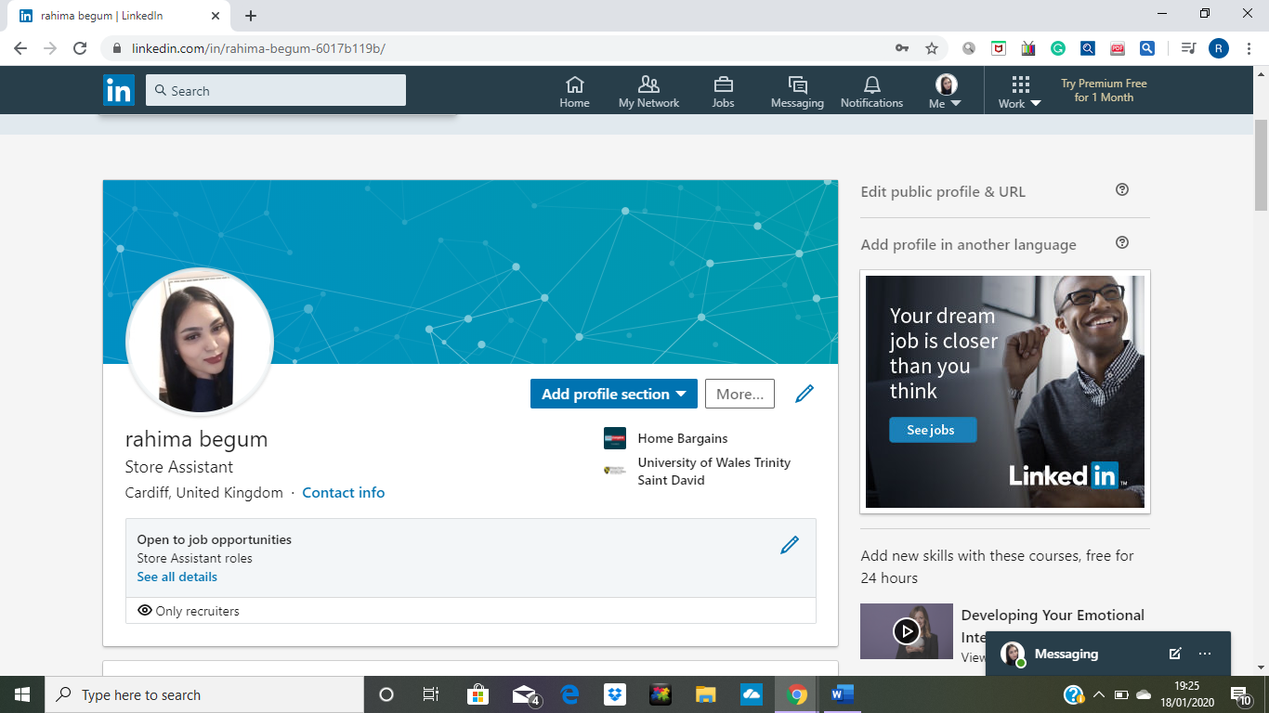
Personal LinkedIn profile
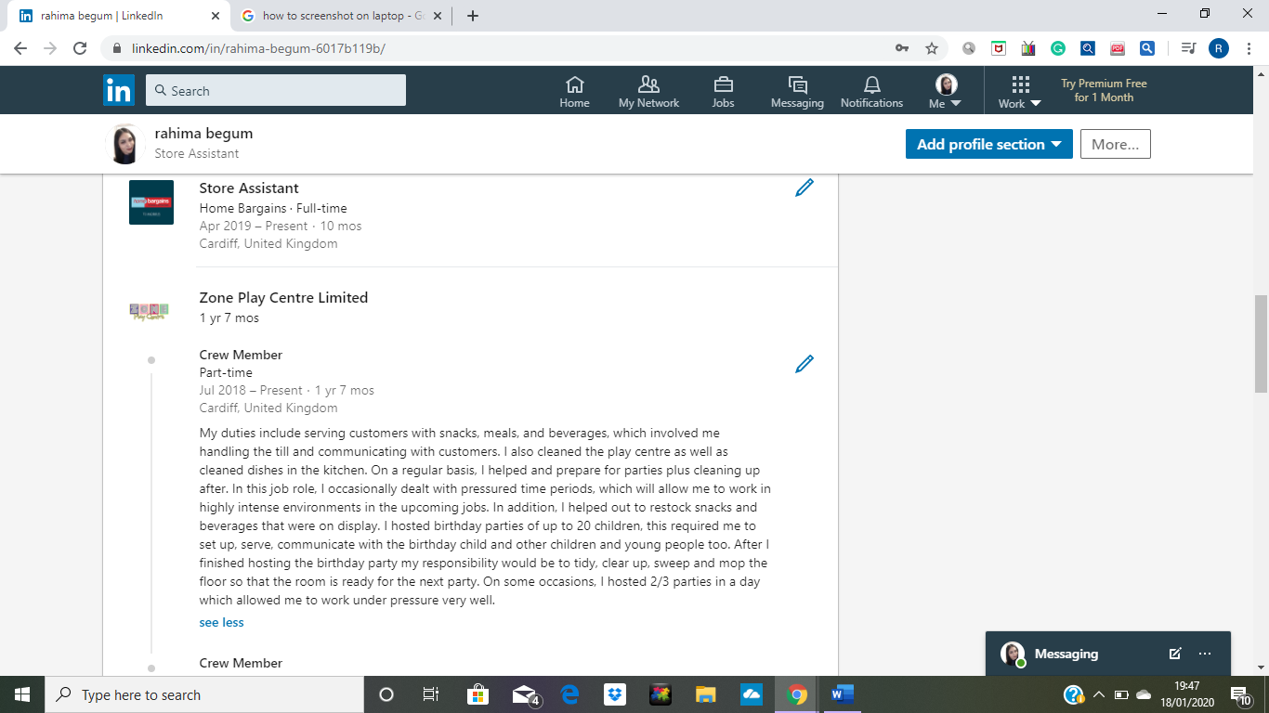
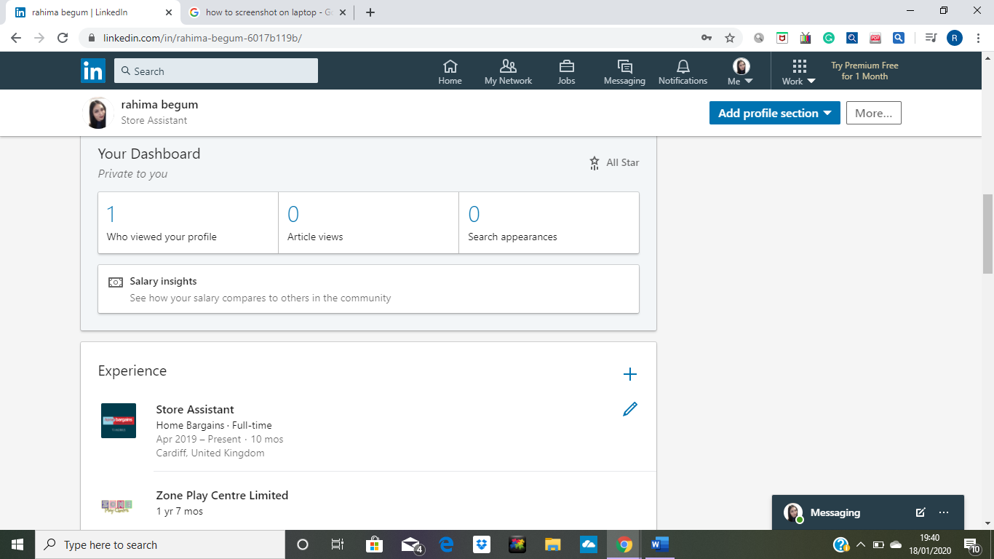
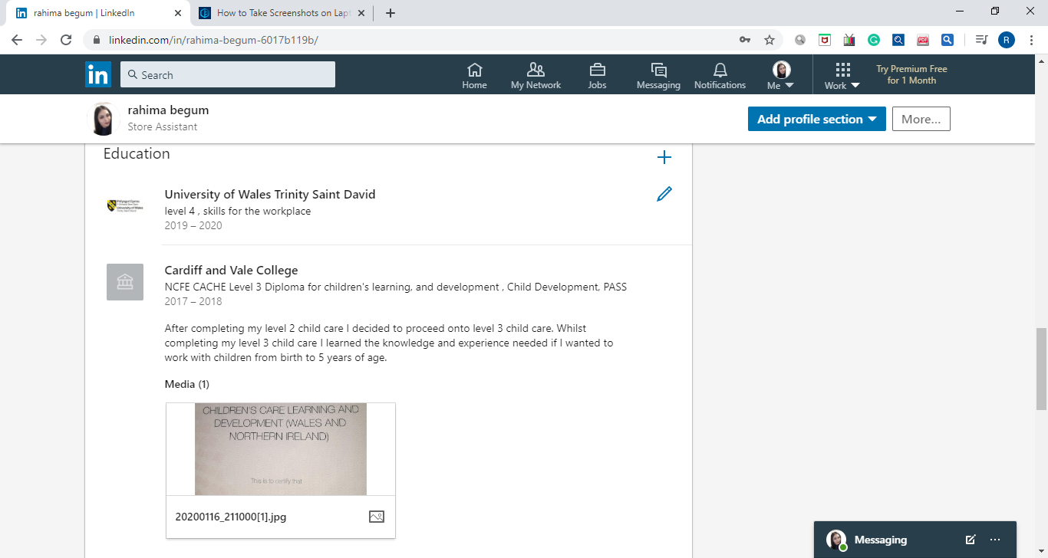
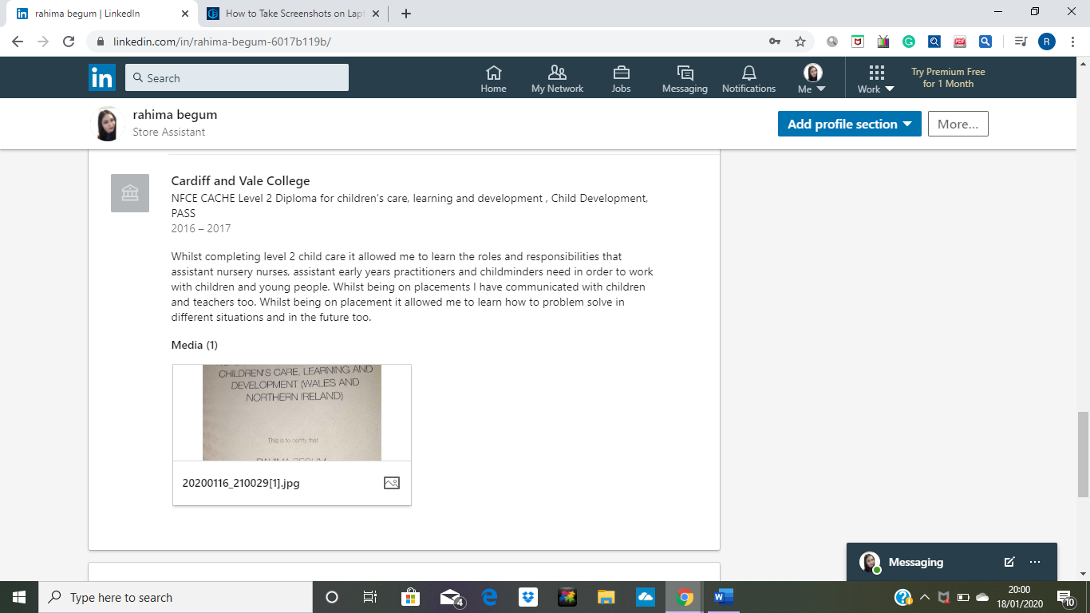
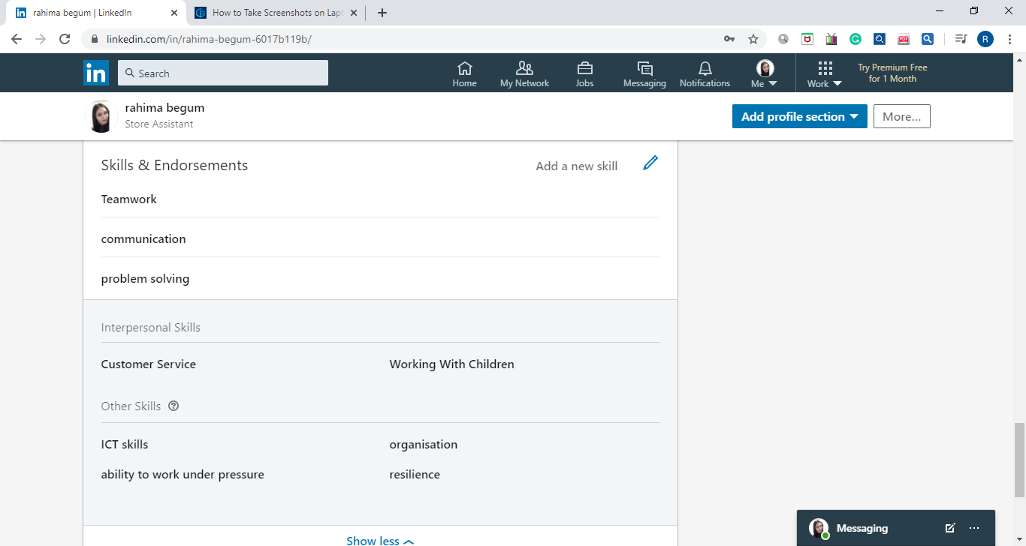

There are benefits/advantages of making a LinkedIn account and using it in general. Having a LinkedIn account, you can easily connect with people, view peoples work experience and help each other out, advice can be given on LinkedIn, recruiters will view people’s LinkedIn and they can organise interviews quickly. People who struggle searching and applying for jobs will find it easy to use LinkedIn. Also, a good advantage of using LinkedIn is the fact that people can apply to jobs without applications which saves time. People can post valuable posts which will help others learn from their internships. People can also post motivational posts which will help others. On LinkedIn it will say several people who have viewed your personal LinkedIn account.
Safety and security online
Safety and security online is important to check before considering to buy, sell and order online. When using websites online people should go on websites that have a padlock icon displayed on any web browser that they access. It’s important that people ensure using web browsers that have the padlock icon on them because as it is designed to prevent anyone from reading or modifying the data that people exchange with the website that they use. There is risks when ordering online such as viruses, stolen identity of someone, scams, stolen financial information and stolen account details. People should shop where they can trust the websites. People should read on general data protection regulation which is also known as GDPR. GDPR is a set of rules which is made to give everyone in UK “more control over their personal data”. By reading the GDPR people will know that no matter what social media they use such as Instagram, and websites too will collect data such as name, address and credit card number. Personal safety is important therefore people need to ensure to check web browsers that they are going to use and the important information that they will use such as their card details. Personal details can be stolen therefore the safest option for people would be to remove their bank details on apps such as Instagram and websites where they order so that they know that their details aren’t on there when they don’t need it to be. It should be only used when placing the order and removed immediately after placing the order. Workplaces such as nurseries keep children’s personal data safe such as address, parents mobile numbers safe and protected.
Many people on Instagram who have started their own makeup business have to keep their clients details safe too. Makeup artists who put make up on brides will ask the bride for permission if they can take pictures of the bride but they will also ask permission about whether they can upload the brides photos so that other Instagram users will be able to see their work and think about which makeup artist to go to when it comes to getting their bridal or party makeup done. When using PayPal to pay is a good idea as it is a more secure way to shop online because the seller will never be able to see peoples credit card number which means they won’t be able to steal it. The major benefit of using PayPal is that “you never again have to disclose your credit card information online” this is obvious that PayPal is created on the purpose of keeping peoples card details safe from any sellers that people will purchase their items from. With Instagram and Facebook people can take pictures of anything and tag their friends, with this some people may not want their photos to be exposed to others but as they are tagged people can click on the tag and simply go on to that person’s page. People can make it clear to others not to be tagged for their own safety as they may not wish to be. However, being tagged in photos creates a scandal brand, for small business this may be a good thing because people will be able to see how many people follow these brands, how known the brands are and is it trustworthy or not. Therefore, they will ask themselves why they should buy other people’s brands.

Part 2
When it comes to gathering information in the workplace there are quite a few research methods that can be used when collecting data such as direct observation, open ended surveys, focus groups, 1-on-1 interviews and questionnaires. Primary research allows us to collect our data that is needed and secondary data which is collected by another desk research for example online library, google scholar and articles. Sources should always be CRAAP tested. CRAAP testing stands for currency, relevance, accurate, authority and purpose. When using CRAAP testing it allows people to ask themselves a set of questions before using websites. The reason why CRAAP testing should be used is because it helps people to evaluate resources. It helps people decide on whether a source is credible or not.

I have done my own primary research where I asked people in my workplace which social media platforms, they would vote for to use if they were to start a business. I allowed them to vote more than once as I wanted to know if they would also choose other social media platforms. The table I have created underneath will make it clear on which social media platform is more popular and less too. I have asked 35 of my colleagues in my workplace to vote and I took notes of the votes and then I put them votes into a table.

Types of social media platforms | Number of votes
WhatsApp | 32
Facebook | 15
Instagram | 23
Snapchat | 19
Twitter | 20
LinkedIn | 6

Looking at the table I have created and the votes that have been made it shows that the highest number of votes is WhatsApp. Having WhatsApp business platform people can easily get in touch with anyone who has a business of their own. The social media platform with the least number of votes is LinkedIn. Instagram came second with the next highest votes with 23 votes.

Digital has definitely changed business I know this because I have done some secondary research where I have found out which social media platform is being used more and less within some businesses. There is a graph showing which social media platforms are used more.

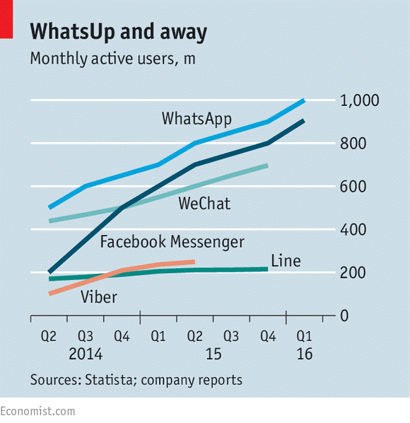

Nowadays teenagers and people from any age groups use Facebook messenger and WhatsApp more. “one-on-one messaging and private chat groups are on fire right now. Facebook messenger has 900 million global users” this tells me that lots of teenagers are using messenger apps more which shows that technology has affected the world of business as people are so busy making time for social media platforms. As this happens it does show how digital marketing has a massive influence on peoples work, life habits, interaction and purchases. This is because people spend a lot of time on these social platforms finding out more about other brands, using social platforms for work, purchasing items and generally just spending their time on social platforms as it can be their hobby.
Primary research is collected by one person for example someone making a questionnaire to find out research on their own. Secondary research is about finding research from others. Secondary research can be easily found from google. I will now explain the advantages and disadvantages of primary and secondary research. There are benefits with both primary and secondary research. With primary research people can ask tailored questions. When doing your own primary research, you won’t get biased opinions from others which is a good thing because with biased opinions people can give false opinions. However, if you create questionnaires and go to others to fill them in then people would answer and fill in the sheet honestly. Whereas with secondary research people can use websites such as Wikipedia where information is unreliable. Doing it yourself is even more reliable as you know you will get honest answers and the correct information needed. There is also disadvantages with primary research such as time consuming. The reason why time can be a problem is simply because creating questionnaires takes time, collecting data does take time too because you have to be patient when giving out questionnaires or putting stories up on social media platforms as people will answer the questions when they see it and not everyone is free at the same times. So, patience is needed when doing primary research. Making graphs also takes some time. If someone is working for a big company, then doing primary research can be costly and expensive. The advantages of secondary research is the fact that it is quick and easy because you can easily find information on google which doesn’t take too much of your time. The disadvantages of secondary research will include the fact that it could be outdated which means people’s opinions can be changed anytime for example information on google from 2005 to now in 2020 can be changed. Information and opinions can be biased, and some information can be false too. In my opinion I do think doing primary research is great because you get to experience finding out your own research however secondary research is straight forward and easy to find from websites such as google.

Underneath I have done my own primary research in finding out which social media platforms people would go to when starting their own small business. After doing my research I have found out that more people would use Instagram as their most go to platform when it comes to starting business. A lot of people do start their own business on Instagram and I do think it benefits them in many ways especially if they are serious about it and they are doing good in their brands and making their customers happy then their business will definitely get big and they would become more known or popular. Looking at the data that I have collected it clearly shows that snapchat is the least platform where people would want to do their business. I do see people using snapchat when promoting their business but it’s not that known. WhatsApp is the second platform which people agree to use when doing their own business which is also a good thing because using WhatsApp business people can create a seamless customer service experience for all their customers which will allow them to strengthen their loyalty and bond.
New technologies have affected the modern workplaces and it makes working together easier for people within the business and companies. There is many hardware used in different workplaces such as laptops, walkie talkies, card machines, fobs and keys, printers, scanners, bar code readers, till system, desktops, tablets, mobile phones and more. The software that can be used in different workplaces include online shopping, SAAS systems, CRM systems, WhatsApp and other social media platforms, apple pay, PayPal, emails and much more. In my workplace the hardware and software that is used includes walkie talkies, till system, card machines, printers, apple pay, social media and online shopping. In my workplace we use an app called kronos which allows us to see which days we are working and the days we have off. When it comes to checking our payslips, we must check them online we don’t get payslips handed to us. However, in other workplaces payslips can be handed in hand, my last job gave my payslips in hand, but I think viewing payslips online is so much easier as anyone can lose papers easily. I think having these different technologies is such a good advantage for us and companies itself. The biggest advantage of technology being around is the fact that team coordination has been made easier and it enables people to “work more closer in some ways”.
There are benefits when using new technology in the modern workplaces because it has made it much easier to work for example when applying for jobs people can have video interviews done. Meetings can straightforwardly be done through video conferencing technology. Now companies can simply track their teams progress on specific projects, and they can also track conversations too. On the subject of talking about technology in the workplace, in my workplace personally I think they could improve efficiency by making till systems easier to use. The reason being is because if we press card ready for the customer to pay but they change their mind and they want to pay cash instead then we must wait for a minute for the system to timeout. This does annoy some customers and not everyone has a good level of patience, hence why I think this could be changed so that things can be done easier and quicker especially because retails are very busy. There will be competitors, Asda uses a device called ‘scan and go’ this device is used by customers as they can easily scan items on the device and check the total on the device easily. Whilst doing this they can see offers popping up on the screens which will allow them to pick up similar or same items which are cheaper. Customers can track their spending on this device, they can remove unwanted items straight from the scanner and lastly, they will go to the dedicated tills where they would scan the screen and then scan the handset and lastly, they would pay with their card. Having this as an option makes shopping easier for a lot of customers. Having competitors people can go to easier places to shop if they wanted to. Having competitors is challenging in general but that wouldn’t stop people from going to different shops to shop and won’t stop them from shopping in more than one shop either.
As there is sometimes more than one of the same retails in other areas where people shop, not all have the exact same technology for example the retail I work in is the small Home Bargains. In my workplace there is no numbers written on the tills and we have to speak on the microphone when calling other tills however the bigger Home Bargains do the same but they have buttons that they can press which will clearly show customers which till is opening the number is shown and a light will be flashing. In the store that I work in customers would keep asking which till is opening as there’s no numbers showing. So, I do think things like this can be changed if there was a possibility to. Things like this may be small but customers can complain, and it doesn’t take long for them to but making things more easier and clear creates a nice environment.

Conclusion
In conclusion I have spoken about the use of technology in the workplace, why it’s good to use social media platforms in businesses and companies whether they are small or not, researched several of other social media platforms which are available for people to use and whether they are relevant or not, I have explained what LinkedIn is, spoke about the benefits of having a LinkedIn profile and keeping it in general. I have also done some research methodology where I have spoke about CRAAP testing, primary and secondary research but I have also used my own primary research and used secondary research too. I’ve explained the advantages and disadvantages of both primary and secondary research. Lastly, I have spoke about the new technologies in the workplace. Overall after completing my assignment my thoughts on creating a business and advertising it on social media platforms is a great option to do as it’s all free, easy to use and it can be used for a variety of different purposes.
References

Blog.hootsuite.com (2020) 23 Benefits of social media for Business. [online] blog.hootsuite.com accessed date 9th January 2020
Digitalmarketinginstitute.com (2019) 9 ways digital has changed business forever. [online] Digitalmarketinginstitute.com accessed date 8th January 2020
Digitalmarketinginstitute.com (2019) Which social media platforms should you use for your business? [online] Digitalmarketinginstitute.com accessed date 8th January 2020
Smallbusiness.chron.com (2020) How Does Technology Affect the Work Environment Today? [online] smallbusiness.chron.com accessed date 10th January 2020
Tipsandtricks-hq.com (2016) 7 advantages to using PayPal to Buy online. [online] tipsandtricks-hq.com accessed date 5th January 2020

