
APPENDIX GA36c

LEVEL 6 ASSESSMENT SPECIFICATION

Student name: | Rhys Williams | Student ID number: | 264482
Programme: | BSc (Hons) Applied Computing
Module: | Usability Engineering
Module code: | ACCB6017 | Contribution to Overall Module Assessment (%): | 50%
Lecturer: | Pauline Greenaway | Internal Verifier | Gaynor Thomas
Assignment Title: | Cluedo Part 2 | Word count (or equivalent): | 3000
Submission deadline: | 14/5/2023 | Return date of provisional marks & written feedback: | TBA
Submission method: | All written assessments, where practical and possible, must be submitted via Turnitin unless otherwise instructed by the Lecturer. (Please DO NOT put this assessment specification into Turnitin or it will match many similarities with other students’ submissions.)  Alternative submission method (if applicable):  Late submission of the assessment will result in a late penalty mark. Penalties for late submission: Up to one week late, maximum mark of 40%. Over one week late, 0%. Only the Extenuating Circumstances Panel may approve a change to submission dates.
Academic honesty / referencing: | Academic honesty is required. In the main body of your submission you must give credit to authors on whose research and ideas your work is based. Append to your submission a reference list that indicates the books, articles, etc. that you have used, cited or quoted in order to complete this assessment.

Module Learning Outcomes
(from module syllabus)
Upon the successful completion of this module, the student should be able to:
- Research and evaluate cognitive and social information processing
- Select, apply and analyse critically techniques of interface evaluation
- Synthesize a solution to a complex design problem from the concepts and principles of usability engineering and software development
- Critically analyse, individually and as part of a team exercise, input and output hardware appropriate for specialised applications, for example for use by disabled people, and for three-dimensional modelling applications

TASK DESCRIPTION

Task
The boardgame CLUEDO is familiar to many as one that requires players to move their pieces around a board that represents a country mansion, finding clues that will help them solve the murder of Dr Black.
You are to design a UWTSD version of this as a computer game.

“Oh no! The Vice-Chancellor has been murdered! Who did it?”

You may set the game on any or all of the university campuses, and may include up to 8 players who should represent different parts of the university.

You should submit a report containing the following:
- A complete set of full-colour storyboards with appropriate example content together with a short discussion of the changes made due to the feedback collected on the wireframe storyboards, together with evidence of usability testing of these changes.
- A description of the process used to collect feedback on your final storyboard prototypes and a summary of the positive and negative feedback elicited
- A discussion of what data would be gathered if a working version were to be build and released, and how that data could be used to influence the next version of the app.
- A reflective summary of the overall design process and how it has been informed by both usability theory and by the inclusion of the potential users in the design process
The report should include appropriate illustrations and references to research literature (at least two thirds of these should be books/journal papers).

Your submission should be presented in the form of a report that includes the following sections:
- (30%) Full colour design storyboards (not hand-drawn and scanned). They should show all of the major functionality of the app at a size appropriate for a mobile phone, and should take all of the usual aspects of interaction design theory into account in the design. Where the design differs from that of the wireframe model the reasons for this should be documented and justified. The complete set of storyboards should be presented in an appendix but significant elements such as the main screen designs should be discussed in the main body of the report. These can be created using any suitable software; Adobe XD is a good choice for this, but other packages are fine provided that you remember to show not only the screens but how the user moves between the screens.
- (20%) How did you collect feedback on your prototypes? How did you ensure that your test subjects covered the range of personas you defined earlier? What feedback did you get, both in terms of usability and of emotional response? Were these what you expected and, if not, why not?
- (20%) What information are you going to collect from you users in the working version? Why do you need it and how will you collect it? Can data be collected automatically or will you need to continue to interact directly with your users to get the data you need? Are there differences between collecting usage data and emotional response data?
- (20%) How would your storyboards have differed if you had approached the app purely from a usability viewpoint? Were there any conflicts between usability and user experience that you had to resolve? Use examples from your design process to explain these.

The final 10% will be awarded for document presentation and appropriate references to the research literature. The report should be submitted through Turnitin. Do not submit the assignment brief document with this.

GUIDANCE FOR Students IN THE COMPLETION OF TASKS

NOTE: The guidance offered below is linked to the five generic assessment criteria overleaf.

- Engagement with Literature Skills
Your work must be informed and supported by scholarly material that is relevant to and focused on the task(s) set; you should make use of scholarly reviews and primary sources, where appropriate (for example, refereed research articles and/or original materials appropriate to the discipline). You should provide evidence that you have accessed a wide range of sources, which may be academic, governmental and industrial; these sources may include academic journal articles, textbooks, current news articles, organisational documents, and websites. You should consider the credibility of your sources; academic journals are normally highly credible sources while websites require careful consideration/selection and should be used sparingly. Any sources you use should be current and up-to-date, mostly published within the last five years or so, though seminal/important works in the field may be older. You must provide evidence of your research/own reading throughout your work, using a suitable referencing system, including in-text citations in the main body of your work and a reference list at the end of your work.

Guidance specific to this assessment: You need to justify your decisions related to good design and poor design by suitable reference to the literature.

- Knowledge and Understanding Skills
At level 6, you should be able to demonstrate coherent and detailed knowledge and a systematic understanding of the subject area, at least some of which is informed by the latest research and/or advanced scholarship within the discipline. You should be aware of the uncertainty, ambiguity and limits of knowledge. Your work must demonstrate the growing extent of your knowledge and systematic understanding of concepts and underlying principles associated with the subject area. Knowledge relates to the facts, information and skills you have acquired through your learning. You demonstrate your understanding by interpreting the meaning of the facts and information (knowledge). This means that you need to select and include in your work the concepts, techniques, models, theories, etc. appropriate to the task(s) set. You should be able to explain the theories, concepts, etc. meaningfully to show your understanding. Your mark/grade will also depend upon the extent to which you demonstrate your knowledge and understanding; ideally each should be complete and detailed, with comprehensive coverage.

Guidance specific to this assessment: Consider how you could collect data in a real-world situation. This will involve identifying and selecting potential commercial data collection services as well as bespoke data collection options..

- Cognitive and Intellectual Skills
You should be able to: critically evaluate evidence, arguments, assumptions, abstract concepts and data some of which are at the forefront of a discipline (and that may be incomplete) to devise and sustain arguments, to make judgements and/or solve problems; describe and comment upon particular aspects of current research, or equivalent advanced scholarship, in the discipline Your work must contain evidence of logical, analytical thinking, evaluation and synthesis. For example, to examine and break information down into parts, make inferences, compile, compare and contrast information. This means not just describing what! But also justifying: Why? How? When? Who? Where? At what cost? At all times, you must provide justification for your arguments and judgements. Evidence that you have reflected upon the ideas of others within the subject area is crucial to you providing a reasoned and informed debate within your work. Furthermore, you should provide evidence that you are able to make sound judgements and convincing arguments using data and concepts. Sound, valid conclusions are necessary and must be derived from the content of your work. Where relevant, alternative solutions and recommendations may be proposed.

Guidance specific to this assessment: What changes did you make to the design as a result of the test carried out in the previous assignment? How will these solve your problems?

- Practical Skills
At level 6, you should be able to apply the methods and techniques that you have learned to review, consolidate, extend and apply your knowledge and understanding, and to initiate and carry out projects. You will deploy accurately established techniques of analysis and enquiry relevant to the discipline, and apply them in complex and unpredictable contexts, to devise and sustain arguments and/or to solve problems. You should be able to frame appropriate questions to achieve a solution - or identify a range of solutions. You should be able to demonstrate how the subject-related concepts and ideas relate to real world situations and/or a particular context. How do they work in practice? You will deploy models, methods, techniques, and/or theories, in that context or circumstances, to assess current situations, perhaps to formulate plans or solutions to solve problems, or to create artefacts, some of which may be innovative and creative. This is likely to involve, for instance, the use of real world artefacts, examples and cases, the application of a model within an organisation and/or benchmarking one theory or organisation against others based on stated criteria. You should show awareness of the limitations of concepts and theories when applied in particular contexts.

Guidance specific to this assessment: You should produce a full updated interface for this prototype design, using an appropriate workplace tool. This should be tested with real users rather than simply relying upon designer tests.

- Transferable Skills for Life and Professional Practice
Your work must provide evidence of the qualities and transferable skills necessary for graduate-level employment requiring the exercise of initiative and personal responsibility and decision-making in complex and unpredictable circumstances. This includes demonstrating: the learning ability for professional development to advance existing skills and acquire new competences of a professional nature that will enable you to assume significant responsibility within organisations; that you can initiate and complete tasks and procedures, whether individually and/or collaboratively; that you can use appropriate media to effectively communicate information, arguments and analysis in a variety of forms to specialist and non-specialist audiences; fluency of expression; clarity and effectiveness in presentation and organisation. Work should be coherent and well-structured in presentation and organisation.

Guidance specific to this assessment: This is a report, not a paper, so no abstract is needed. Ensure that your report looks professional. Document presentation is important. Remember to use technical English, to stick to the numerical referencing method, and to caption all of your illustrations.

Student FEEDBACK FORM

This section details the extent to which the assessment criteria are demonstrated by you, which in turn determines your mark. The marks available for each category of skill are shown. Lecturers will use the space provided to comment on the achievement of the task(s), including those areas in which you have performed well and areas that would benefit from development/improvement.

Generic Assessment Criteria | Marks available | Marks  awarded
1. Engagement with Literature Skills
.
Very little engagement with literature and reference are mainly confined to the data collection methods. |  | 13
 | 30 | 13
2. Knowledge and Understanding Skills

Discussion of data collection methods include supporting references and suitable external techniques that could be used to collect user data/feedback. More could have been included on different user experience and emotional response data collection tools. No specific recommendations made in relation to the final version of your prototype. |  | 16
 | 30 | 16
3. Cognitive and Intellectual Skills

You have produced full colour storyboard as a result of feedback previously obtained but very little explanation of this. Also, the prototype could have been more comprehensive in nature. No reference to design rules/principles applied. Heuristic evaluation – should have made clear what the scale represents (0-10). Main issues summarised. Reflective summary completed Reference made to focus group but no evidence of this provided. It is mainly focused on heuristic evaluation. Clear evidence of understanding of the relevant heuristics but lacking in supporting references. |  | 16
 | 30 | 16
4. Practical Application Skills

 | 0
5. Transferable Skills for Life and Professional Practice

Report format not fully applied. No front page but contents page, introductory but no concluding paragraph. Well-expressed throughout. | 10 | 6

Assessment Mark (Assessment marks are subject to ratification at the Exam Board. These comments and marks are to give feedback on module work and are for guidance only until they are confirmed. ) | Late Submission Penalties (tick if appropriate) |  | 51%
 | Up to 1 week late (40% Max) |  | 51%
 | Over 1 week late (0%) |  | 51%

GENERIC ASSESSMENT CRITERIA

Level 6
In accordance with the Framework for Higher Education Qualifications, at the end of Level 6 students should have coherent and detailed knowledge and a systematic understanding of their subject area, at least some of which is informed by the latest research and/or advanced scholarship within the discipline. They will be able to accurately deploy established techniques of analysis and enquiry within a discipline, using their conceptual understanding to devise and sustain arguments and/or to solve problems. They should be aware of the uncertainty, ambiguity and limits of knowledge. They should be able to critically evaluate evidence, arguments, assumptions, abstract concepts and data (that may be incomplete), to make judgements, and to frame appropriate questions to achieve a solution - or identify a range of solutions. They will apply the methods and techniques that they have learned to review, consolidate, extend and apply their knowledge and understanding, and to initiate and carry out projects. They will have the ability to manage their own learning, and to make use of scholarly reviews and primary sources (for example, refereed research articles and/or original materials appropriate to the discipline). They will demonstrate the qualities and transferable skills necessary for employment requiring: the exercise of initiative and personal responsibility; decision-making in complex and unpredictable contexts; the learning ability needed to undertake appropriate further training of a professional or equivalent nature.

Level 6 | FAIL | MARGINAL FAIL | SATISFACTORY  (3rd / Pass) | GOOD  (2.2 / Pass) | VERY GOOD  (2.1 / Merit) | EXCELLENT  (1st / Distinction) | EXCEPTIONAL  (1st / Distinction)
Category | 0-29% | 30-39% | 40-49% | 50-59% | 60-69% | 70-84% | 85-100%
Engagement with literature (including reading, referencing,  academic conventions and  academic honesty) | Little or no evidence of reading and/or reliance on inappropriate sources.  Views and findings mostly unsupported and non-authoritative.  Referencing conventions used incoherently or largely absent. | Poor engagement with essential reading. No evidence of wider reading. Reliance on inappropriate sources, and/or indiscriminate use of sources. Heavily reliant on information gained through class contact. Inconsistent and weak use of referencing. | Engagement with a limited range of mostly relevant and credible sources. Some omissions and minor errors.  Referencing conventions evident though not always applied accurately or consistently. | Engagement with an appropriate range of research-informed literature, including sources retrieved independently. Some over-reliance on texts. Referencing may show minor inaccuracies or inconsistencies. | Engagement with a wide range of research-informed literature, including sources retrieved independently.  Selection of relevant and credible sources. Very good use of referencing, with no/very few inaccuracies or inconsistencies. | Engagement with an extensive range of relevant and credible literature, informed by the latest research. Consistently accurate application of referencing. | Exceptional engagement with an extensive range of relevant and credible literature, informed by the latest research. High-level referencing skills consistently and professionally applied.
Knowledge and understanding (Coherent and detailed knowledge and systematic understanding of the subject area, at least some of which is informed by the latest research and/or advanced scholarship within the discipline.) | Major gaps in knowledge and systematic understanding of the subject matter. Substantial inaccuracies. No awareness of knowledge of the latest research and/or advanced scholarship within the discipline. | Gaps in knowledge, with only superficial systematic understanding. Some significant inaccuracies and/or irrelevant material. No awareness of knowledge of the latest research and/or advanced scholarship within the discipline. | Limited knowledge and systematic understanding of the relevant concepts and principles within the subject area which to some limited extent, is informed by current research and scholarship. | Knowledge is reasonably detailed, accurate with a good systematic understanding of the field of study and to some extent, current research and scholarship. | Knowledge is reasonably extensive coherent and detailed. Exhibits very good understanding of the breadth and depth of established views, and the work is, at least in part, well-informed by current research and scholarship. | Excellent coherent and detailed knowledge and systematic understanding of the principles and theories of current research and scholarship. Clear awareness of challenges to established views and the limitations of the knowledge base. | Exceptionally coherent and detailed knowledge and systematic understanding of the principles and theories of the subject, well-informed by current research and scholarship. A critical, sophisticated and nuanced awareness of the ambiguities and limitations of knowledge.
Cognitive and intellectual skills  (Conceptual and critical thinking, analysis, synthesis and evaluation of research, assumptions, abstract concepts and data (that may be incomplete); logic, argument and judgement.) | Wholly or almost wholly descriptive work. Little or no analysis, synthesis or evaluation.  Failure to develop arguments, leading to illogical or invalid judgements. Unsubstantiated generalisations, made without use of any credible evidence. | Largely descriptive work, with superficial use of critical evaluation. Weak development of arguments and judgements. Information accepted uncritically, uses generalised statements made with scant evidence and unsubstantiated opinions. Ideas sometimes illogical and contradictory. | Limited attempt at critical thinking, analysis, synthesis and evaluation, tending towards description.  Some evidence to support emerging arguments and judgements but these may be underdeveloped or with a little inconsistency / mis-interpretation.  Asserts rather than argues a case. | Some critical thinking, analysis, synthesis and evaluation. Can analyse new and/or abstract concepts and data without guidance.  An emerging awareness of different stances and ability to use evidence (that may be incomplete) to support the argument.  Mostly valid arguments and logical judgements. Some tendency to assert/state opinion rather than argue on the basis of reason and evidence. | Sound critical thinking, analysis, synthesis and evaluation demonstrating critical thinking. Ability to devise and sustain persuasive arguments, and to review the reliability, validity and significance of evidence (that may be incomplete) to make mostly appropriate and valid judgements. | Excellent critical thinking, analysis, synthesis and evaluation. Ability to investigate contradictory or incomplete information and make strong, persuasive, arguments and sophisticated judgements. Some evidence of independent thought and ability to ‘see beyond the question’, suggesting a grasp of the broader field and wider concepts. | Exceptional critical thinking, analysis, synthesis and evaluation based on judiciously selected evidence.  Ability to investigate contradictory or incomplete information and make strong, persuasive, arguments and sophisticated, nuanced, judgements. Evidence of independent thought and ability to ‘see beyond the question’, suggesting an outstanding grasp of the broader field and wider concepts.
Practical skills  (Apply/deploy accurately established tools and techniques; initiate and carry out projects; formulate solutions to solve problems in complex and unpredictable contexts.) | Limited or no use of methods, materials, tools and/or techniques.  Little or no appreciation of the context of the application.  Limited understanding of the application of theory to practice or making appropriate links between the two.  Very weak problem-solving skills in complex and unpredictable contexts. | Rudimentary application of methods, materials, tools and/or techniques but without consideration and competence. Flawed appreciation of the context of the application.  Weak understanding of the application of theory to practice, with only occasional evidence of making appropriate links between the two. Weak problem-solving skills in complex and unpredictable contexts. | An adequate awareness and mostly appropriate application of well-established methods, materials, tools and/or techniques.  Basic appreciation of the context of the application. Theoretical knowledge and understanding applied in practice, but not always making logical links between the two.  Can identify problems and propose basic solutions in complex and unpredictable contexts without fully appreciating the complexity. | A good and appropriate application of standard methods, materials, tools and/or techniques.  Clear appreciation of the context of the application. Mainly consistent, accurate and logical application of theory to practice, making appropriate links between the two  Can identify problems and propose mostly appropriate solutions in complex and unpredictable contexts. | A very good application of a range of methods, materials, tools and/or techniques.  Very good consideration of the context of the application, with perceptive insights. Can identify problems and propose appropriate solutions in complex and unpredictable contexts.  Evidence of some innovation and creativity. | An advanced application of a range of methods, materials, tools and/or techniques.  The context of the application is well considered, and insightful.  Application and deployment extend beyond established conventions. Can identify complex problems and propose excellent solutions. Innovation and creativity evident. | Exceptional levels of application and deployment skills in unpredictable, practical contexts, drawing skilfully on the latest research within the discipline. Can identify complex problems and propose sophisticated solutions. Assimilation and development of cutting edge processes and techniques.
Transferable skills for life and professional practice  (Exercise of initiative and personal responsibility; professional development; initiate and complete tasks and procedures: individually and/or collaboratively; use appropriate media to communicate effectively; fluency of expression; clarity and effectiveness in presentation and organisation.) | Communication medium is inappropriate or misapplied.  Work is poorly structured, disorganised and/or confusingly expressed. Very weak use of language and/or very inappropriate style. Little or no evidence of autonomy (or collaboration, where relevant) in the completion of tasks. Little or no evidence of the skills required in graduate employment. | Communication medium is poorly designed and/or not suitable for the audience.  Work is poorly presented in a disjointed manner. It is loosely, and at times incoherently, structured, with information and ideas often poorly expressed. Weak use of language and/or inappropriate style. Weak independent initiative (or collaboration, if relevant). Limited evidence of the skills required in graduate employment. | Can communicate in a suitable medium but with some room for improvement.  Mostly ordered presentation and structure in which relevant ideas / concepts are reasonably expressed. Work may lack coherence in places. Can work as part of a team, but with limited involvement in group activities.  Demonstrates the basic skills required in graduate employment, with some areas of minor weakness. | Can communicate effectively in a suitable format, but may have minor errors.  Mostly coherent, organised work, in a suitable structure and is for the most part clearly expressed. Can work effectively independently and/or as part of a team, with clear contribution to group activities.  Demonstrates the skills required in graduate employment, with some areas of strength and some of minor weakness. | Can communicate well, confidently and consistently in a suitable format.  Work is coherent, fluent, well-structured and organised. Can work very well autonomously and/or as part of a team, with very good contribution to group activities.  Demonstrates very good graduate employment skills, with just occasional minor weakness. | Can communicate professionally confidently and consistently in a suitable format.  Work is coherent, very fluent and is presented professionally. Can work autonomously with initiative. Where relevant can work professionally within a team, showing leadership skills as appropriate, managing conflict and meeting obligations. Demonstrates excellent graduate employment skills and an appetite for further development. | Can communicate with an exceptionally high level of professionalism.  Work is exceptionally coherent, very fluent and is presented professionally. Can work exceptionally well and professionally within a team, showing advanced leadership skills. Demonstrates exceptional graduate employment skills and an appetite for further development.

THIS DOCUMENT IS ALSO AVAILABLE IN WELSH

Contents
Task 1 11
Updated Application Designs 11
Feedback Collection Process 11
Feedback on Theoretical Application 11
Reflection 11

Introduction

This assignment will be covering the designs that were created in the previous assignment and show all of the different amendments that were made to the designs and showing how they create a satisfying experience for the user. The updates designs will also be put through an addition heuristics assessment to determine how much of an improvement the new designs are, as well as investigating whether there are any issues that are still present from the previous designs or whether there are new issues that arose after making changes to the old designs.

Task 1

Updated Application Designs
After having created a new version of the designs based on the feedback that was given on the initial designs, it was important to identify the changes that have been made to accommodate the feedback that was given. The changes that were made include making full colour versions of the designs, so it is not as boring on the eyes. This also includes adding the full colour logos as well as giving the headers more colour, as a result of this the back and exit button colours were also changed to have more contrast to its background so it was easier to see. The next change that was made was also related to the colour scheme, the text in the buttons were changed from being grey to black in order to put more emphasis on the buttons and catch the user’s eye better to give the user a greater idea as to where they need to press next. In addition to this, some of the text in the buttons were also increased in size to be easier to read, as well as moving some buttons further apart as to reduce the risk of the user accidentally clicking a different button than they meant to. Another change that was made was also the inclusion of a text to speech button in each of the pages where the rules are explain, this is because a lot of the rules are explained in long paragraphs which some people found difficult to read and it was much more efficient to include a text to speech option instead of attempting to reduce the amount of words that were used to explain each rule. An additional change that was made was the implementation of a dedicated Clue Sheet view, as in the original design it was very small and there was no way of enlarging it to get a better view. The final change that was made was the addition of the exit game menu, which would allow the user to leave the game and prompt them to either confirm that they want to exit or cancel the action and return to playing the game. If they chose to exit, they would be returned back to the main menu.
New designs:
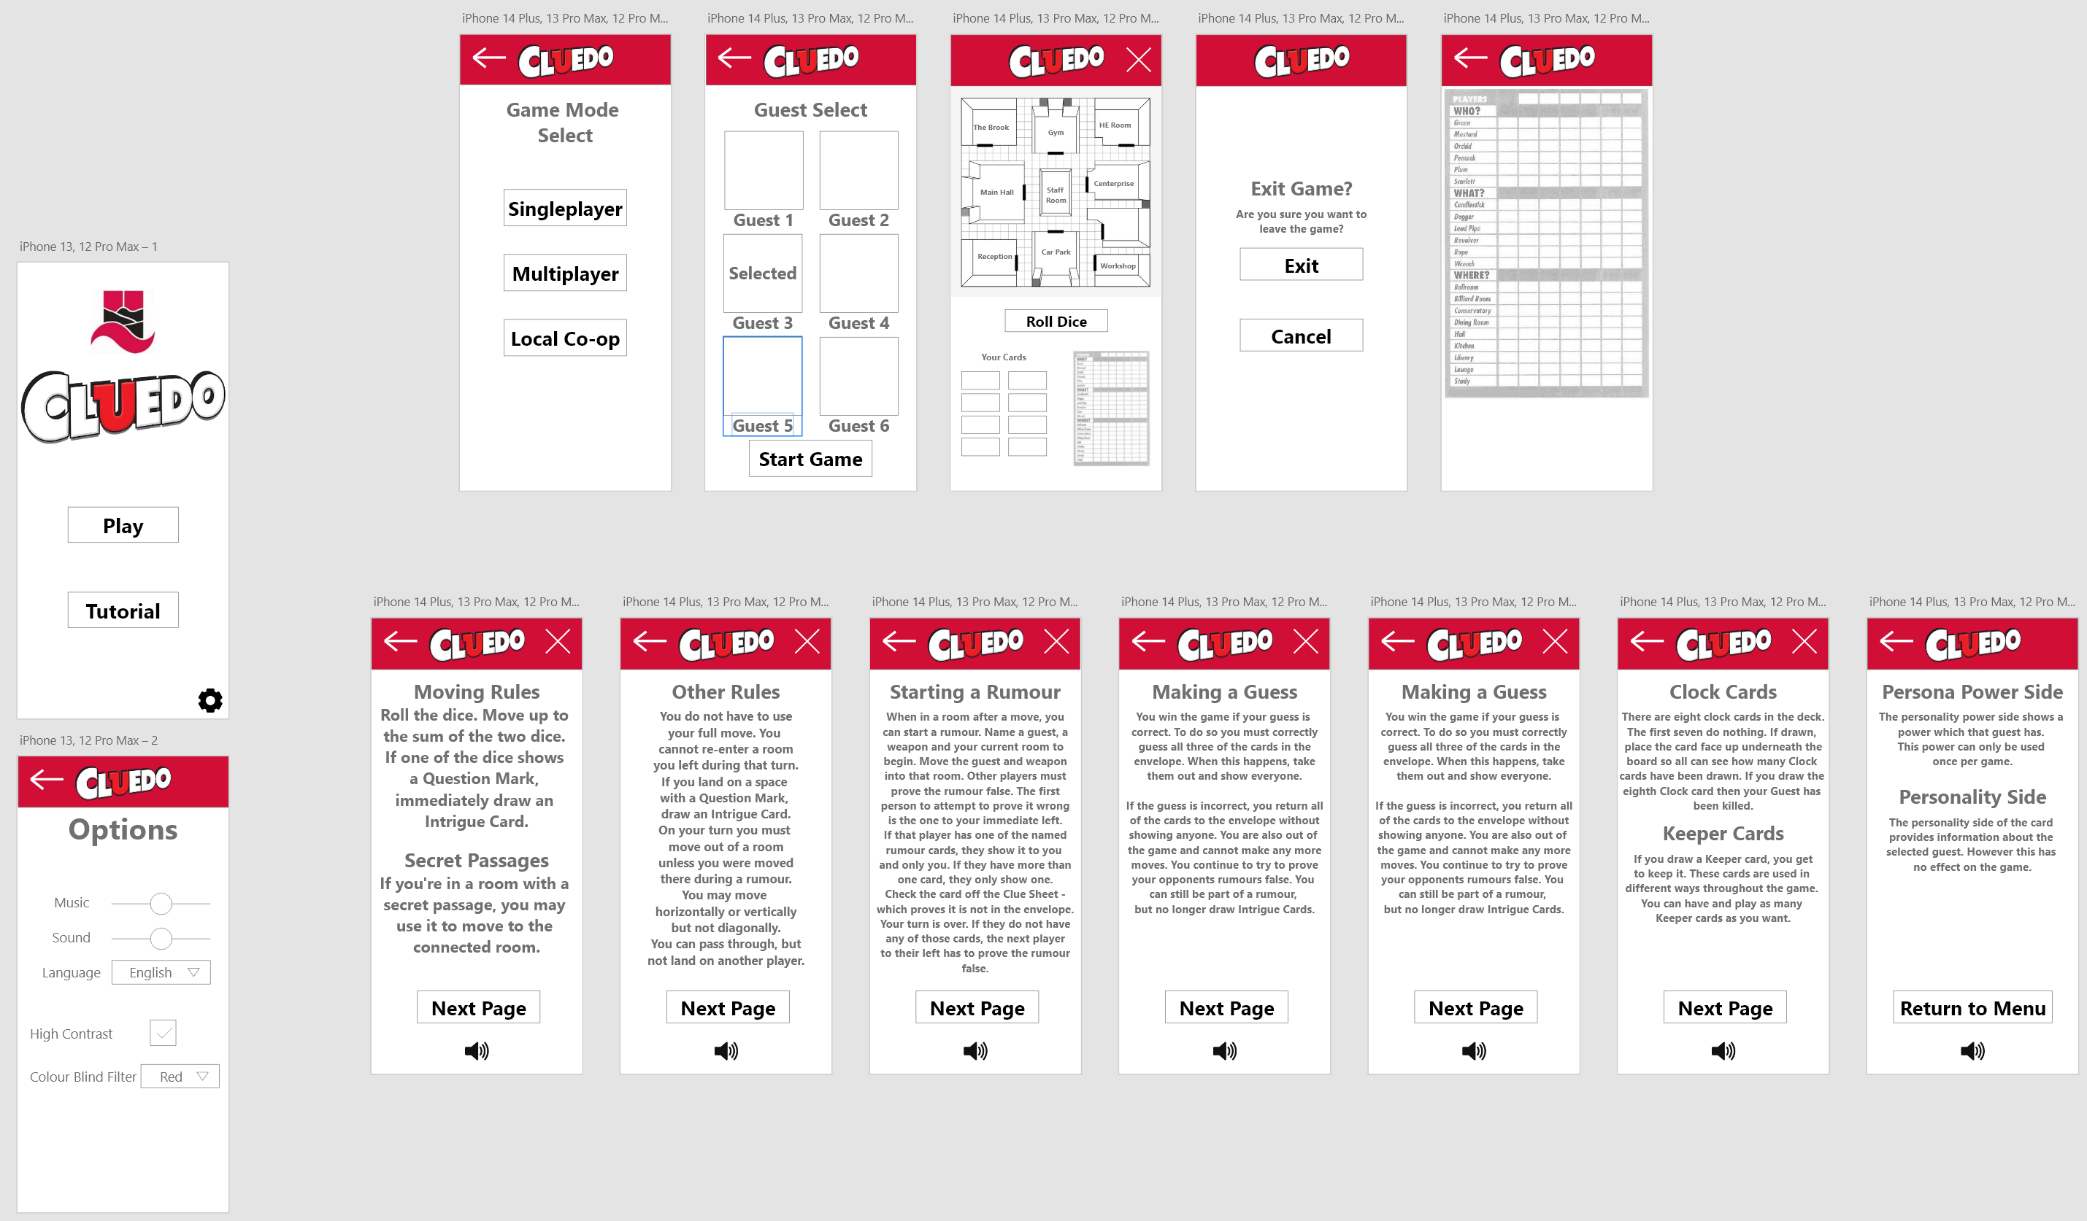
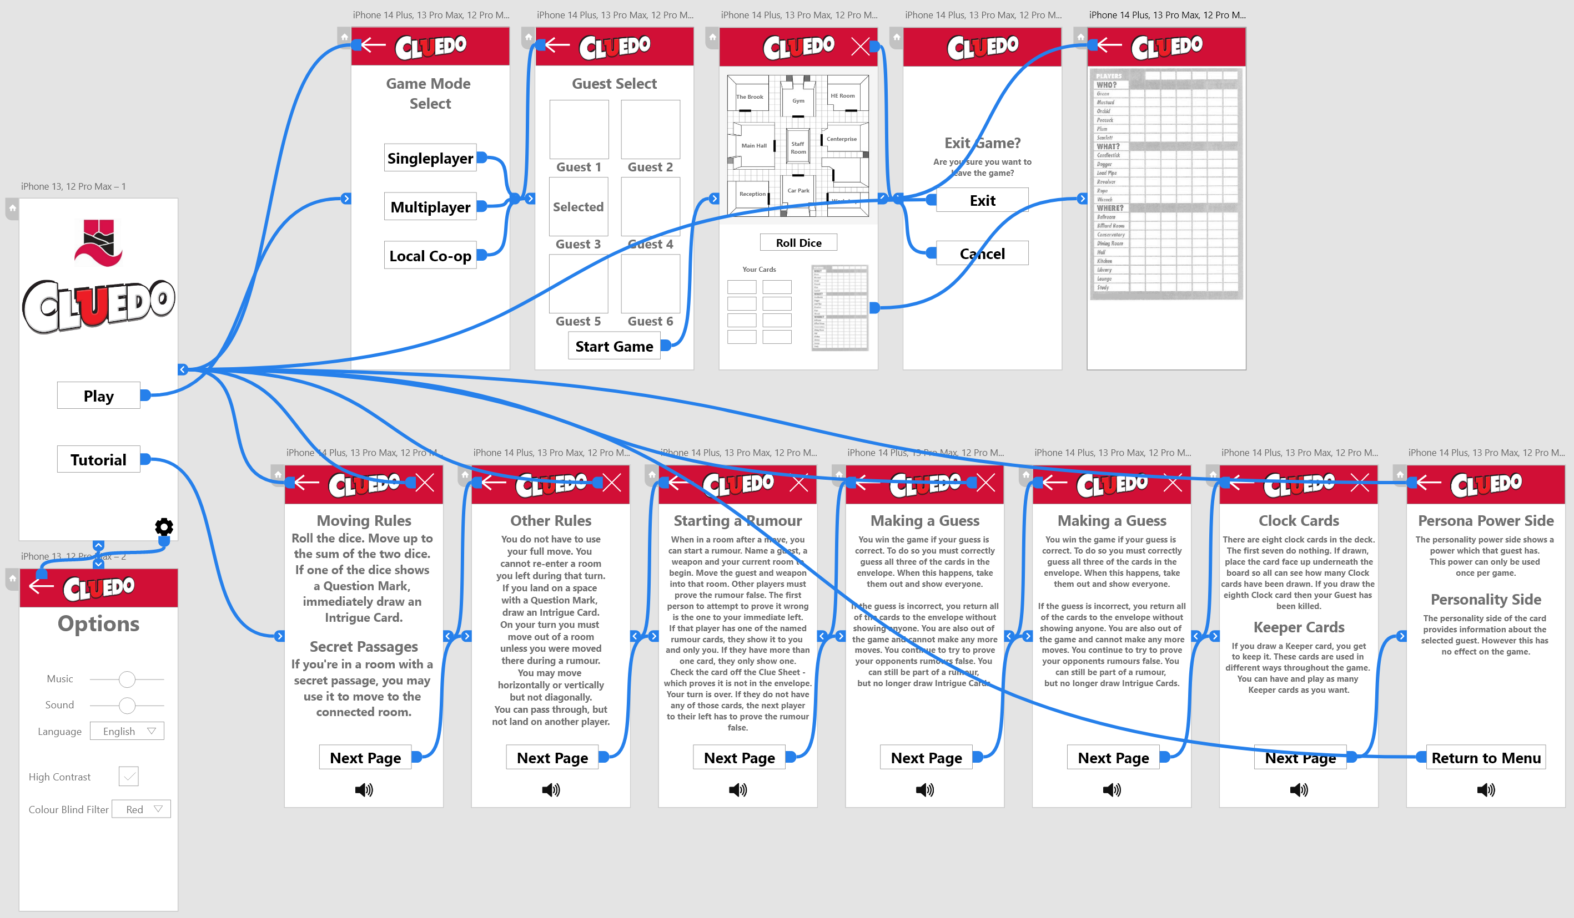
Old designs:
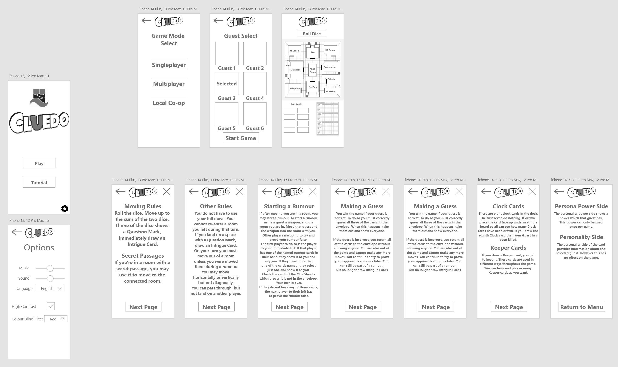
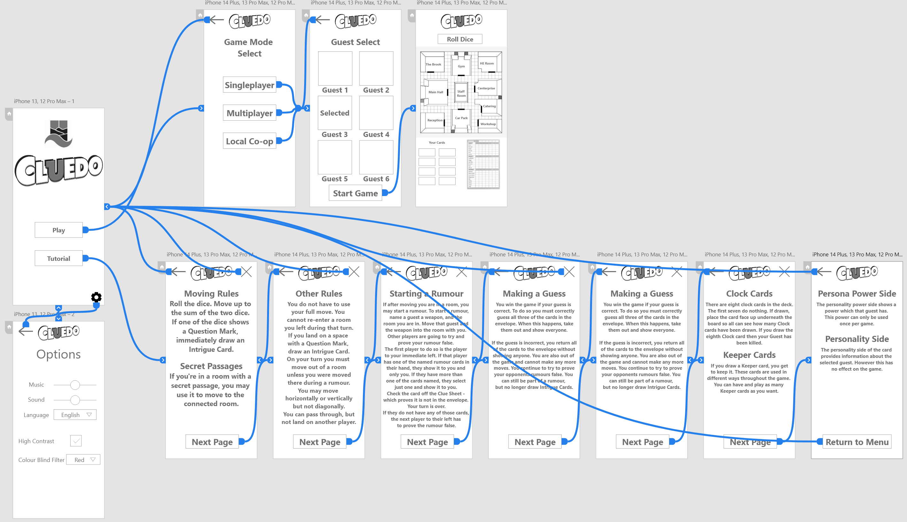
To be able to identify whether the changes that were made have been beneficial to the user experience, it was necessary to carry out another heuristic evaluation. This was achieved by taking the personas that were created previously. The heuristics evaluation that was used was created by Jakob Nielsen and is used to make sure that the designs that were created for the application are done in a way that provides the user with a satisfying experience when navigating through each of the different pages.
Feedback Results – Rebecca
Usability Heuristic | Rating (0-10) | Additional Comments from User
Visibility of system status | 9 | Good feedback given to the user when navigating the interface.
Match between system and the real world | 9 | Interface is easy to understand, does not use confusing wording.
User control and freedom | 4 | Does not offer a lot of customisability.
Consistency and standards | 9 | Interface is consistent, buttons are all standard designs and meaningful.
Error prevention | 6 | Prompts the user if they’re sure they want to leave a game, otherwise nothing else.
Recognition rather than recall | 7 | Uses widely recognisable symbols for different buttons.
Flexibility and efficiency of use | 9 | Design is simple and consistent, easy to understand for most people.
Aesthetic and minimalist design | 7 | Design is minimalist and does not overwhelm the user.
Help user recognise, diagnose, and recover from errors | 2 | Does not prompt user if any errors have occurred.
Help and documentation | 8 | Tutorial page gives in depth instructions, has text to speech button if the text is difficult to read.

Feedback Results – Chris
Usability Heuristic | Rating (0-10) | Additional Comments from User
Visibility of system status | 7 | Gives user feedback when navigating. More noticeable changes would be ideal.
Match between system and the real world | 8 | Instructions and navigation are clear.
User control and freedom | 8 | Allows for languages and volume changes.
Consistency and standards | 8 | Consistent design and usage of symbols to show different functions.
Error prevention | 7 | Little errors encountered, was not able to tell whether the is any error prevention.
Recognition rather than recall | 8 | Icons used in the interface are widely recognisable.
Flexibility and efficiency of use | 8 | Interface is welcoming for users of all different levels of experience.
Aesthetic and minimalist design | 7 | Design is not overwhelming to the user, new colour scheme is nice.
Help user recognise, diagnose, and recover from errors | 1 | No way of telling if something is going wrong.
Help and documentation | 9 | Detailed instructions, can go back a page, has text to speech button.

Feedback Results – Roger
Usability Heuristic | Rating (0-10) | Additional Comments from User
Visibility of system status | 8 | Good feedback when changing pages outside of the tutorial pages.
Match between system and the real world | 8 | Used easy to understand terms.
User control and freedom | 5 | Did not need to customise anything.
Consistency and standards | 8 | Was not thrown off when navigating pages.
Error prevention | 7 | No errors were encountered.
Recognition rather than recall | 6 | Did not recognise the cog for the settings menu.
Flexibility and efficiency of use | 9 | Navigation was simple.
Aesthetic and minimalist design | 9 | Clean design and easy to understand.
Help user recognise, diagnose, and recover from errors | 2 | My smartphone would freeze and there was no loading icon to indicate it still loading the page.
Help and documentation | 9 | Text to speech button helps greatly with understanding the rules. Colour blind filter also welcome.

Feedback Results – Rachel
Usability Heuristic | Rating (0-10) | Additional Comments from User
Visibility of system status | 6 | Walls of text made it a bit unclear when navigating tutorial pages. Page counter might be useful.
Match between system and the real world | 7 | Some phrases were difficult to understand.
User control and freedom | 8 | Volume control is a welcome feature.
Consistency and standards | 9 | Did not have to re-adjust my eyes when navigating.
Error prevention | 8 | User could exit game prematurely but not by mistake.
Recognition rather than recall | 8 | Recognisable icons used for different functions across the whole app. More would be ideal/
Flexibility and efficiency of use | 7 | Increased contrast on buttons is good for showing people where to go.
Aesthetic and minimalist design | 7 | Nice colour scheme, high contrast also helps greatly.
Help user recognise, diagnose, and recover from errors | 3 | Did not experience any errors.
Help and documentation | 8 | Still difficult to read but the inclusion of a text to speech button helps greatly.

Now that the second heuristics evaluation has been carried out using Jakob Nielsen’s tests, it has shown that the updates to the application design and the new pages and features that were added are an improvement over the previous designs from a usability standpoint. While the application designs are still not perfect and previous issues are still not prevalent as well as newer issues being found, these heuristic evaluations can be repeated for future versions of the designs until there are no issues left to deal with and every user’s needs are satisfied.

Feedback Collection Process
The process that was used to collect the feedback was done by doing a heuristic evaluation using the four personas that were created previously. By making use of the same personas that were used before, it allowed for them to be able to search for the same issues they were experiencing with the previous designs and determine whether those issues were resolved or not or whether other issues were identified. The heuristics evaluation covers a wide variety of different aspects of interface designs that need to be tested in order to determine whether the new designs are an improvement over the previous. When the feedback was gathered from the different users, it showed that the issues that were in the previous designs were solved in the updated designs with the updated colour scheme, new pages, and page improvements. These changes were made to accommodate the frustrations the users were experiencing with the old designs which might have caused a negative emotional experience when using an application that was built on the older designs. The positive feedback from the users include that the colour scheme was a lot more visually appealing and there was more emphasis on what they needed to click to get to the next destination. The next bit of positive feedback that was given by the users was the inclusion of a text to speech button in the rules page for those who are visually impaired and struggled to read the text heavy rules. However, for those that are both visually and audibly impaired this did not make any impact on their experience using the application. Another piece of positive feedback that was given was the addition of the exit game button, this was implementing as there was no clear method of the user exiting the game prematurely and would require them to finish the game before they could leave. Despite all of the positive feedback there was still some negative feedback, such as how the rules pages were still too text heavy and for those who suffered from audible impairments, the addition of the text to speech button did not help to create a satisfying user experience for them. Another piece of negative feedback includes how there was still not error handling so there was no clear way of the user telling what went wrong and how they could fix it if they did something wrong or if there was an error in the application.

Feedback on Theoretical Application
In the event that these designs should be created into a fully-fledged application, there are a wide range of different methods of collecting data on how people perceive the application, which can then be taken as feedback and used to improve the application to allow for a more positive and satisfying user experience. This is important because it exposes the application to a wider audience of users with different needs to those in the personas. Collecting this data would allow for the designs to accommodate those users who have different needs that they do not currently take into consideration.
When it comes to the different tools and techniques that could be used to collect data, many different sites and applications directly ask the user either for a rating, for them to give written feedback on what they do and do not like about the application, or for them to take a survey to get more specific information from the user. These methods consist of the user communicating with developers and designers about the application gathering specific information that can be used to fine tune the designs. There are also third party tools that can be used on a website or an application to gather information on how the user interacts with the interface. ⁽¹⁾ Some of the tools that can also be used to collect data on how the user interacts with the interface include Smartlook, Google analytics and UXCam. Smartlook allows for the collection of both qualitative and quantitative data, session recording and works on both mobile and desktop websites. Smartlook provides a dashboard that shows a wide range of different statistics on a website that could be useful to developers and designers in making meaningful improvements to their website. For example, it shows the active and completed sessions of each user that visits the website, as well as any errors on the site which could be causing issues for the user. It also shows where the user has clicked on the site or what they have typed in a text box and shows a heat map of where the user clicks or where their cursor spends the most time. ⁽²⁾ Google analytics only offers the collection of quantitative data, does not allow for session recordings, and works on both web and mobile. Google analytics also provides reports on statistics such as the number of views a specific page gets, active sessions, time spent on a page, bounce rates, and the user demographics. Google analytics can also be customized to include event tracking, user flow, and attribute conversion. ⁽²⁾ UXCam offers similar functionality to Smartlook as it offers both qualitative and quantitative data collection while also allowing for session recordings. However, UXCam is only available for mobile sites and does not allow for data collection on desktop sites. It offers a heatmap to show where the user clicks the most of where their cursor spends the most time, session funnels to filter out different types of users when analysing their behaviour, and event tracking to see what the user click or what they type into a text box. ⁽²⁾ These methods of data collection are all automatic and do not gather specific feedback from the user regarding what they like and do not like about the designs.
It is important to consider how the data is being collected, this is because when using a direct method of communication with a user to gather the feedback, such as a survey or focus group, it can be considerably more beneficial to finding specific issues each user has while also being able to communicate methods of improving the issue depending on which method of data collection was used. Using data collection methods that are automated give a more general idea as to how people use a site and make it much more difficult to for the designers to gather the emotional response data from the user.

Reflection
To reflect on the design process, it gave a clear reasoning as to why the heuristics that Jakob Nielsen has defined should be followed when designing an interface that will be used by a person. Following these design principles allow for a more satisfying interface to be created in a short time span, while also spending less time going back and making changes to the initial design. Should changes be necessary, each of these principles can be rated and changes can be made to the design based on what the designs are lacking in. Each new iteration of the design should have improved ratings over the previous. The heuristics evaluation was also one of the methods that was used to test the usability of both iterations of the designs that were made for the application, as well as using a focus group and a questionnaire. Using all of these methods of testing allowed for a wide range of different data to be collected, all being qualitative, quantitative or both. The focus group was used as it gathered information based on the user personas and the specific issue that each individual had and how the designs needed to accommodate those individuals.
Using the heuristic evaluation allows for each individual page to be reviewed with each of the principles that are introduced in the heuristic evaluation. In order to provide a positive and satisfying user experience across each page of the application, all of the heuristic principles must be highly rated. With the designs that were created for this application, it shows that most of the heuristic principles were rated well with some falling quite short due them not being as high of a priority as others in order to provide the experience that users look for when navigating an interface. The heuristics that Jakob Nielsen provides consist of the visibility of system status, match between system and the real world, user control and freedom, consistency and standards, error prevention, recognition rather than recall, flexibility and efficiency of use, aesthetic and minimalistic design, help users recognise, diagnose and recover from errors, and help and documentation.
Despite the successful implementation of many of the heuristic principles, many of them were still scored low, including the user control and freedom and helping the user diagnose and recover from errors. However, giving the user too much control and freedom over the customisability of the application could be overwhelming for some users and having less control could be what some people prefer. Having fewer options in the settings menu also means that people will be able to find the settings they are looking for quicker as opposed to if there were many different options for customisability. Helping users diagnose and recover from errors should be improved upon however as the heuristic evaluations have shown that people with older devices can suffer from slow performance when using the application and could be subject to long loading times with no indication to this being the case as there is no loading icon.

Sources

- How to collect customer feedback – 6 methods [Internet]. 2021 [cited 2023 May 14]. Available from: https://monkeylearn.com/blog/customer-feedback-methods/
- Bolf M. 7 best UX analytics tools for user research in 2023 [Internet]. 2023 [cited 2023 May 14]. Available from: https://www.smartlook.com/blog/ux-analytics-tools/
- Nielsen J. 10 usability heuristics for user interface design [Internet]. 2020 [cited 2023 May 14]. Available from: https://www.nngroup.com/articles/ten-usability-heuristics/

