ECEY4001-2310796
The importance of communication in transition
Handbook

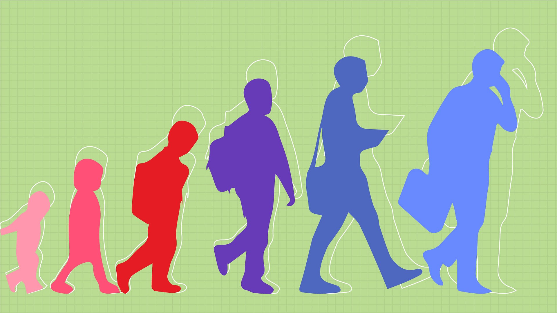
(NSCC, 2020)

Contents page

Page 1 front cover

Page 2 contents page

Page 3 Introduction

Page 4–5 The role of the adult

Page 6-7 The needs of a child

Page 8 Partnerships

Page 9-10 Interventions

Page 11- 12 Proposed outcomes

Page 13-14 Reference list

Introduction – This is a handbook for practitioners to guide them to understand and be effective in our job role by understanding how communication is important while working with children especially while they are transitioning. Communication is the key as this will help build positive relationships, be safe and the children will be ready to learn. Following the early years framework. It sets standards that we must meet as practitioners to help the children grow by interacting by using good communication. According to story (2021) Early Years practitioner can play a big role in helping children and families manage with changes. By building a secure attachment with staff members helps support a child who finds transitions hard by them being separated from their family may be challenging. as there might be a change of circumstances in the child’s family like moving house or even a new baby, by us as a familiar will help them reduce their anxiety.

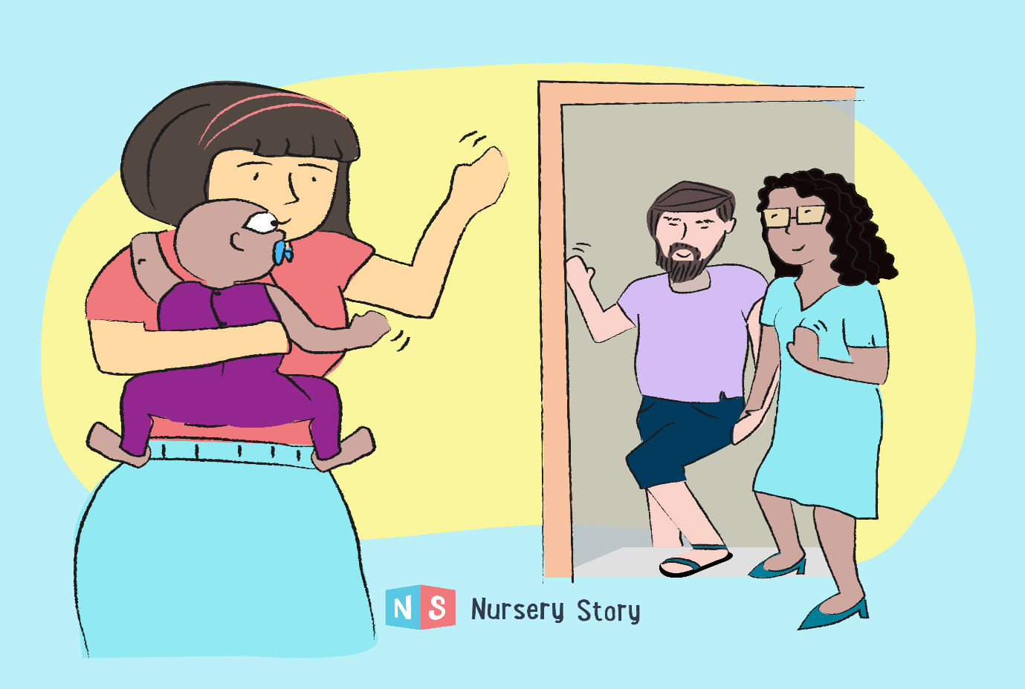
(Story, 2021)

The role of the adult-
we play a big part in the children’s life while they are at nursery or school, our role as an adult we can review children's play by simply checking in with the children using communication which will help build a positive relationship, then the children will feel safe and want to engage with us, by checking in with them we can use lots of different ways like zones of regulation that way we know what type of mood the children are in so we can gauge what type of communication is needed that day to help support the children in there learning and to engage. We also observe the child's play and listen to them which can lead to higher quality play experiences, this will build trust too as we are showing them that we are listening to what they need to help them develop, the adult can gauge what the child enjoys and understands them so they can make playtime more enjoyable, so they are more willing to learn new things and engage with others. our interactions with the children when doing a planned and child-initiated play or other activities by us using the right communication and modelling, showing, explaining, demonstrating, exploring ideas, encouraging, questioning, this will provide a narrative for what they are doing which will help the children develop in there early years by us adults demonstrating this all the time. According to Rose and Rogers (2012, p.34) the importance of the child’s voice we recognize and listen to, we support in different ways as some children are verbal and others are non- verbal, we model communications with children on a day-to-day basis so adults will support the language development by us doing this helps with the nature of communication as we are showing them they are listened too. By doing this it builds a positive relationship with the children which helps them model and feel they can communicate with us. While they are transitioning communication is importance, the children will show signs of being scared or anxious as they are leaving their home environment and family where they feel safe. So, it is our job to make them feel safe and wanted, so getting to know them as an individual and their family they will feel supportive. According to GOV.UK (2022 ) By us getting to know the children well as an individual, we will notice most children learn at different paces, some children may find is hard and struggle to do some of the things that other children may already be able to do. In most cases this is normal childhood development and just need a few adjustments to learning by trying different teaching styles, encouragement, and additional help. Progress will be made but it just means it can take longer or need more support. It is important that early delays or difficulties lead to the right sort of support and are not necessarily regarded as an indication of a long-term special educational need or disability. Below is a picture of the importance of the framework which all fits into place with good communication which is key for progress in learning.

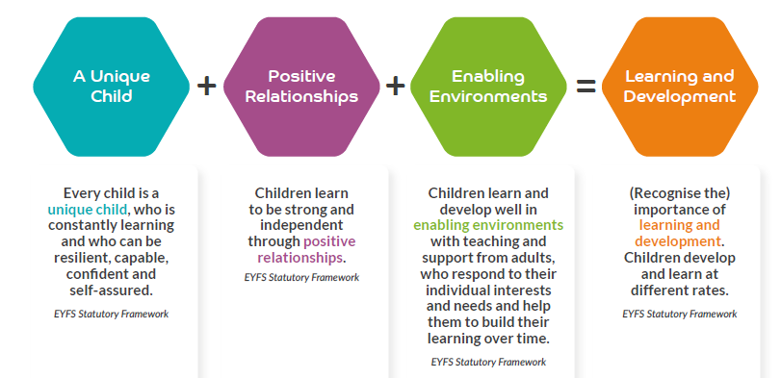

(Almondsbury Church of England Primary School, 2021)

The needs of a child-
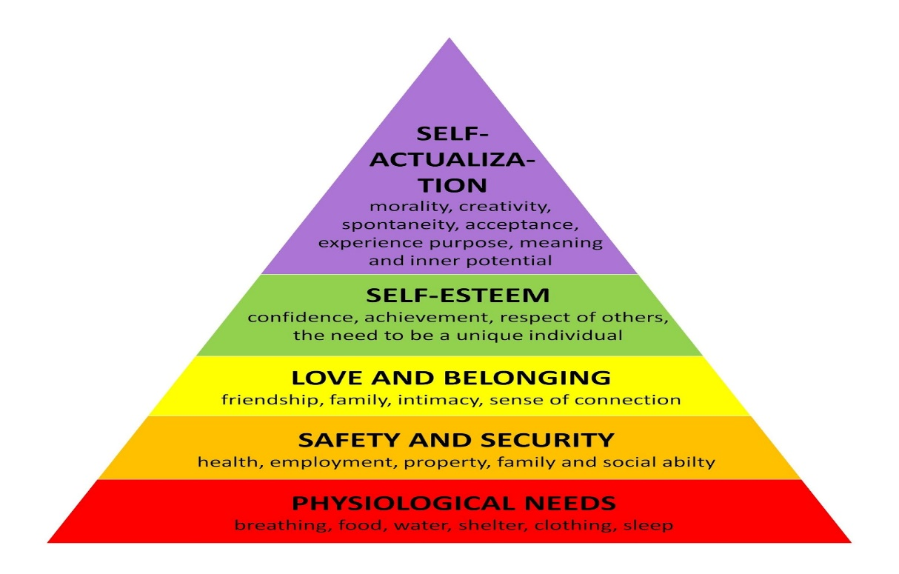(M, 2019)
This image above shows what a child needs. Before a child can develop in education, they need their basic needs met first which is shown in the picture above. Having a safe and loving home and spending time with family and friends by playing, singing, reading, and talking are very important. If they have them needs met this will help their development and will engage at school and be able to have friends and build positive relationships while being at school, they will feel safe and wanted which will make the children engage and want to explore and learn. Also, by having Proper nutrition, sleep can make a big difference in a child. Children build on their experiences the wider and deeper their exposure, the greater potential they have for secure development when their needs are met. Children need opportunities to practice what they know, to consolidate and apply learning from one context to another, and to develop new knowledge and skills by adults communicating by interacting with them. Children will build on experiences they come across in their life so it’s important to be a good role model and explore there needs as they are all individuals and may have diffident needs. Brain development plays a big part as better understanding of brain development will help early years practitioners to understand social and emotional development in children. Having this knowledge about brain development will help you understand the child’s needs so you can support. One of the main reasons is how fast the brain grows starting before birth and continuing into early childhood. Although the brain continues to develop and change into adulthood, the first 8 years can build a foundation for future learning. This is why communication is important. How the brain grows is strongly affected by the child’s experiences with other people and the world. Children grow and learn best in a safe environment where they are protected as they feel their needs are met. According to Garvey (2018, p.30) – the first months of a baby’s life, when the baby starts to interact in the environment, this is a crucial time for the brain development, the migration corresponds well with the development of more complex cognitive functions in babies. It says the arrival of the cells could play an important role in setting up the basis for complex human cognition. So, by the knowledge and understanding of the complex human cognition, babies start to learn and interact in the first few months of their life. So, babies can pick up through senses and experiences.

(better brains for babies, 2019BC) 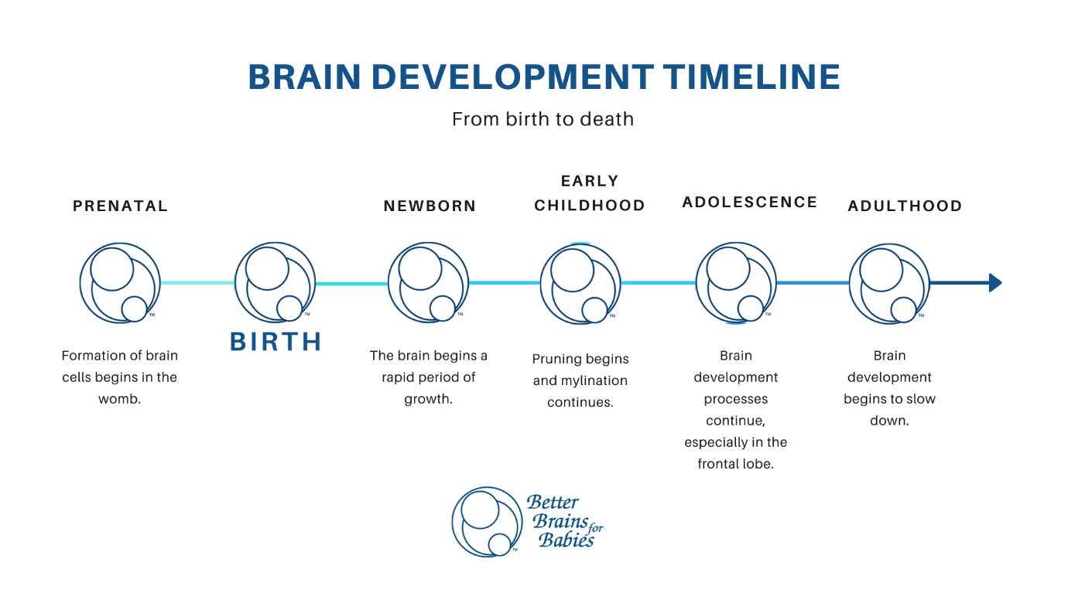

Partnership-
Following the Early Years Foundation Stage (EYFS) framework, a partnership is the parents, families and practitioners working together to support the children. For a partnership to go well it must be built on trust, transparency and responsibility from all of us involved with the children but also in some cases we have outside agencies as well with makes them a partnership too, they come into the children’s life while they are in early years and onwards to see if they are developing, in most cases some children are not so they have outside agencies like speech and language therapist as they might have difficulties with communication. Occupational therapist which helps with physical side like doing activities of everyday life, fine motor skills. Working all together is very important for the children as they will achieve more and seen happier in school when we work closely together with parents by sharing observations and ideas about how to promote learning and development. As parents could support schools at home by modelling what we do or we could model some ideas what parents do, like maybe ways they control behaviour, so it would support both home life and school life. The children will feel safe knowing we are communicating with each other. According to Cottle and Alexander (2013, p.3) There is a tradition of practitioners working closely with the parents of young children in England and practitioners can play a central role in helping children and parents to develop the skills and attitudes to successfully manage transition and change. But there are several other, often contradictory reasons for parent partnership, both historically and politically. most of these relate to the origins of different types of early childhood settings in the nineteenth century when nurseries and voluntary organisations provided care for the children of poorer working families and schools and kindergartens provided part time education for the children of middle-class families. Aspects of contemporary understandings of parent partnership are rooted in a compensatory model which dates to these nursery school origins. By all of us communicating together this has a big impact on the children’s development, working closely with parents supports the child in the setting.

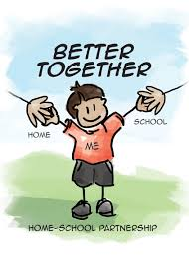
Interventions –
Interventions are put in place to help improve outcomes for the family with their children. The importance of helping families early is by us Identifying and addressing a child or the family's needs early this can increase protective factors that positively influence a child’s wellbeing and decrease risk factors that may be impacting a child’s life negatively. early intervention can be provided at any stage in a child life, from the early years right through to adolescence. Extra support can be delivered to parents, children, or whole families if needed. Early interventions we would discuss the child’s behaviour and relationships with others as they may need a little more support with communicating as they may struggle with their emotions, so we could put things in place like zones of regulations. The Zones of Regulation is a brilliant tool to use in schools and at home. This intervention will help children to manage difficult emotions, known as self-regulation. We use this by spending time on identifying facial expressions and body language associated with each Zone and will reinforce. Theres also lots of resources we can use like books, songs, videos to reinforce Zones concepts over time. In my setting I will with SEN children, and this works well they have their own zones in their class, and we communicate with them first thing and talk about how they feel and what zones they are in, then we know what will work for them that day as they may not be ready to learn. This helps them to communicate their feelings as some times they find it hard to talk to you so in a way this is a form of communication. For us to use this intervention as practitioners we need to be supportive and encouraging so building our trust with the child, we also need to be calm and model self-regulation too, so they can follow and feel comfortable to talk and feel safe. Sometimes we need to reduce unnecessary demands to build our trust to form a positive relationship. According to Thomson (2014,) for children to control emotional and physical impulses this should be developed in the early years this will help children embrace learning and grow into self-regulating as they get older. This will also help them learn to communicate early. According to Thomson (2014) she says there is increasing evidence that some children are not developing self-regulation naturally and at an early enough stage, so that problems with impulse control are affecting learning and behaviour, not just when they are young, but also in later life. As working in a SEN school, I agree with what she is saying by putting this intervention in place at an early age as a early help intervention will help them communicate with you before the behaviours start as when they are in the higher zone which is red, children cannot communicate by speaking as in most cases behaviour is a form of communication but its out of control. If they learn to self-regulate, they will be ready to learn and communicate without using behaviours. While the children are in transition like for example my setting, we have a lot of children coming from mainstream school to our school which is SEN, they will be on a transition plan which helps school and family to discuss their needs and to explore and agree a plan of support. The children are on a slow transition so they can build relationships first with the teachers and other staff so they are comfortable communicating with us so we can support them in there learning and making them feel safe, when they are ready, we will introduce them to their class, so they are used to the environment.
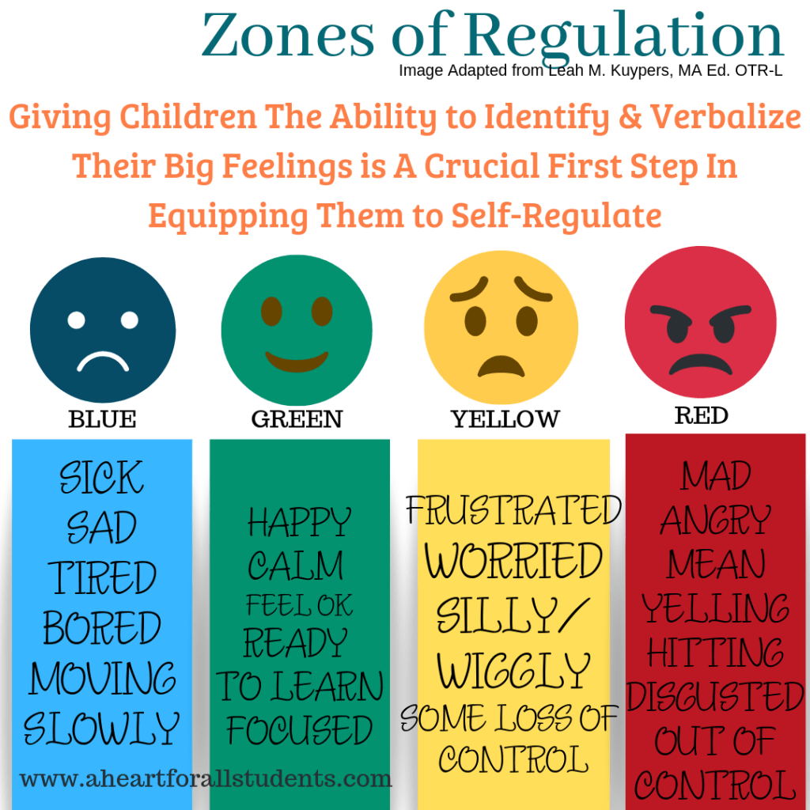 (MAT, 2023)

By the school and the family coming together and accepting early intervention for the child we can put lots of diffident activities in place to support the child as this can be a stressful like for them so if we make it more play based, they will interact, we can use fun-based activities like rhymes and songs to introduce them to the school environment. According to Media (2000) Children of all ages are usually able to make themselves understood by using face facial expressions and body language. It’s our role as a practitioner to understand children and actively listen to them all the time. This helps them to develop emotionally and socially which is what they need learn first. Practitioners make a difference to children’s lives. This is by keeping the unique child and their family central to provision by always communicating with the family, being inclusive and considering the wellbeing of their children, and by loving them, the family and the child feels supported.
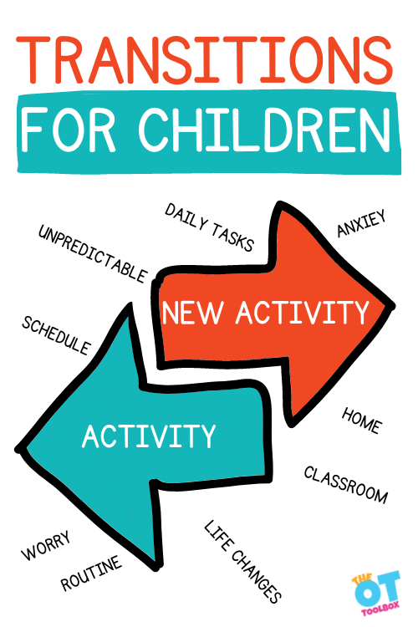 (Beck, 2023)
Proposed outcomes-
The positive side of early transitions is the importance of communication while transitioning, and following the early years framework to guide us through but the most effective way is to make the child feel supported, cared for as this will build positive relationships which will help for their learning, you will begin to see them engage. Supporting transitions in the early years not only helps support the child but also helps the family to feel comfortable. If they feel comfortable in their setting the children develop will improve. According to Birth To 5 Matters, High quality transitions recognise the importance of feeling “known”. Key to a high-quality experience for all children in the early years is ensuring continuity between home, key people and all the settings that make up children’s individual learning journeys. Today children may have many out of home experiences, through childcare, toddler groups, family day care and more than one nursery, and they may appear to straddle change with ease. But while transitions may occur with great frequency, not all children navigate these comfortably or happily. Transitions include not just movements between one setting and another in a linear way, but movements “horizontally” from one room to another within the same setting, moving to a more structured part of the day such as lunchtime, or moving from home to childminder, to nursery and back again all in the same day. When transitions in the early years are managed sensitively it lays the foundations for positive feelings towards the many other transitions children will face through life.
This can be very daunting on a child as there is a lot going on in a school day so by us interacting and making them feel known as an individual really helps with transitions that’s why it’s positive and works well within children by supporting there needs by maintaining the communication with them and their families. If we carry on this positive way this will see them through there life and process in all stages of learning.
(Harms, 2021)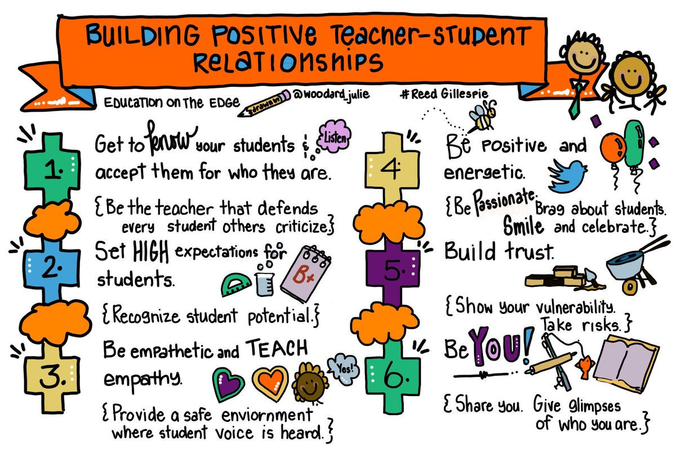
I hope this handbook helps you understand the importance of communication in transitions. The main thing is the remember is communication is the key to build positive relationships with the children and family.

Reference list
Almondsbury Church of England Primary School. (2021). Early Years Foundation Stage (Reception). [online] Available at: https://www.almondsburyprimary.co.uk/page/?title=Early+Years+Foundation+Stage+%28Reception%29&pid=1408.
Beck, C. (2023). Transitions for Children. [online] The OT Toolbox. Available at: https://www.theottoolbox.com/transitions-for-children/.
better brains for babies (2019BC). Brain Development Timeline | Better Brains for Babies. [online] www.bbbgeorgia.org. Available at: https://www.bbbgeorgia.org/brain-development-timeline.
Birth To 5 Matters (n.d.). Transitions – Birth To 5 Matters. [online] Birth to 5 Matters. Available at: https://birthto5matters.org.uk/transitions/.
Cottle, M. and Alexander, E. (2013). Parent partnership and ‘quality’ early years services: practitioners’ perspectives. European Early Childhood Education Research Journal, 22(5), pp.637–659.
Garvey, D. (2018). Nurturing personal, social and emotional development in early childhood: a practical guide to understanding brain development and young children’s behaviour. London; Philadelphia: Jessica Kingsley Publishers.
GOV.UK (2022). Meeting the Needs of All Children - Help for Early Years Providers - GOV.UK. [online] help-for-early-years-providers.education.gov.uk. Available at: https://help-for-early-years-providers.education.gov.uk/get-help-to-improve-your-practice/meeting-the-needs-of-all-children.
Harms, T. (2021). Ways to Build Positive,Long-Lasting Relationships With Students and Families. [online] Teaching for God’s Glory. Available at: https://teachforgodsglory.com/2021/08/29/ways-to-build-positivelong-lasting-relationships-with-students-and-families/.
M, M. (2019). Teacher’s Time Turner: Meeting Children’s Basic Needs. [online] Teacher’s Time Turner. Available at: http://teachers-time-turner.blogspot.com/2019/03/meeting-childrens-basic-needs.html.
MAT, L.L. (2023). Printable Zones of Regulation (ish) Worksheets for All Kids. [online] A Heart for All Students. Available at: https://aheartforallstudents.com/equipping-our-kids-emotional-toolbelt-zones-of-regulation/.
Media (2000), M. (n.d.). Developing a loving pedagogy in early years – How it boosts development | Positive Relationships. [online] Teach Early Years. Available at: https://www.teachearlyyears.com/positive-relationships/view/developing-a-loving-pedagogy-in-early-years [Accessed 6 Dec. 2023].
NSCC (2020). human development. [online image] nscc. Available at: https://pressbooks.nscc.ca/lumenlife/chapter/human-development/ [Accessed 27 Nov. 2023].
Rose, J. and Rogers, S. (2012). The role of the adult in early years settings. Maidenhead: Open University Press.
Story, N. (2021). Supporting Children and Parents with Transitions. [online] Nursery Story. Available at: https://nurserystory.co.uk/resource-centre/supporting-children-and-parents-with-transitions/.
Thomson, ruth (2014). EYFS Best Practice: All about... Self-regulation. [online] Nursery World. Available at: https://www.nurseryworld.co.uk/features/article/eyfs-best-practice-all-about-self-regulation#:~:text=The%20ability%20to%20control%20emotional [Accessed 6 Dec. 2023].

