“Financial Management for the Hotel Industry”
“Business Report: Comparison of Two Hospitality Organisations”
“Assessment 1”
MODULE CODE: BMIH5007
STUDENT NAME: GINA STEFANUTA
STUDENT ID: 2120011
MODULE LEAD: TRISTAN HAWKINS

Table of Contents
Executive Summary 3
1.0 Introduction 3
1.1 Background of report 3
1.2 Purpose of report 3
2.0 Discussions 3
2.1 “Identification of differentiation regarding revenue position of both businesses” 3
2.2 “Recognition of current market structure and engagement for both businesses” 6
2.3 “Analysis of general growth related to both Organisations” 7
2.4 “General CSR processing related to both businesses based on current position” 8
3.0 Recommendation 9
4.0 Conclusions 10
References 11

Executive Summary
The applicability of financial management has been initiated for the formulation of performance development including the financial analysis reasons. The engagement of financial analysis is mainly evaluated in this report with the initiated support of comparative analysis between the Corinthia Hotel Group and Ibis Hotels. To initiate the comparison, the market structure including the operating performances are evaluated including the CSR engagement also which represents a contemporary performance beneficial approach in a proper basis. Including those above a formulated performance evaluation is also provided for the reasons of recognising the most beneficial business for initiating and investment for investors.

1.0 Introduction

1.1 Background of report
Identification of the measuring support of financial information for every individual business is necessary as it allows for the identification of the strategic benefit. Applicability of the benchmarking approach is considered as one type of strategic evaluating process with the initiative of which comparative positions of the business along with the competitors can be initiated. Under financial management, the applicability of this type of measuring support has been initiated to provide a compatibility initiative including the feasibility positioning reasons that are accountable for maintaining the consistent values. In the present situation, the hospitality sector in the UK is rapidly expanding along with a proper marketing demand which formulates the market position including the competitive advantages on a systematic basis.

1.2 Purpose of report
The primary identified approach regarding this report provides a general significance over the benchmarking approach between two different hospitality sectors with the intention of competitive advantage recognition. In the present situation, the financial and operating positions of Corinthia Hotel Group and Ibis Hotels are mainly evaluated with the general intention of identifying the revenue, and market position including the CSR engagement in a standardised order for compatibility recognition.

2.0 Discussions

2.1 “Identification of differentiation regarding revenue position of both businesses”
The importance and measuring support of contemporary financial values is identified for measuring support of business revenue which is one of the potential sources of business operating engagement. The determination of positive financial revenue volume is initiated for measuring the profitability value as well which ultimately provides a positive opportunity for the business progress and stakeholder engagement. The structural positions of proper revenue approach are also implemented for the reasons of consistency reasons which ultimately defines the earning potentiality value simultaneously.
The conceptual structure of this type of approach is initiated for the reasons of reformulating the branding approach that ultimately maintains the structural performances including the customer engagement position on a progressive basis. Concerning the general identification, the benchmarking analysis between Corinthia Hotel Group and Ibis Hotels are provided.
Corinthia Hotel Group
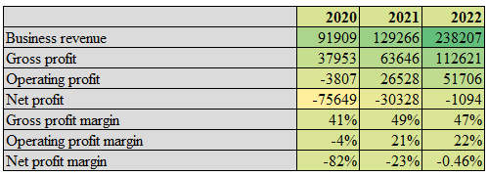
Ibis Hotels
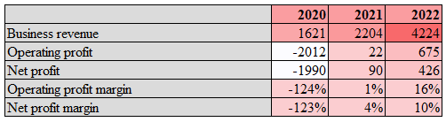
The fundamental initiative related to the revenue position for both businesses generally represents progressive expansion support which indicates a proper volume of competitive market positioning benefits. Generally, the application of profit is considered one of the primary indicators related to the business revenue position in a proper manner. According to the basic identifications the generated volume of profitability in the case of Corinthia represents a comparatively lower financial approach differentiated from the position of IBIS.
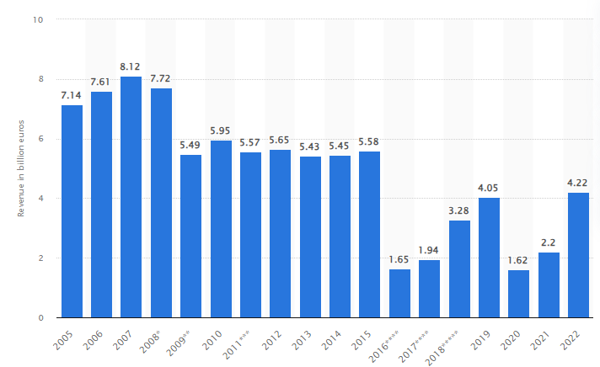
Figure 1: Revenue of Accor Group worldwide from 2005 to 2022
(Source: Statista, 2022)
In the present situation expanded profitability position with the 10% performance support including the initiated 92% progress in business revenue position represents a systematic and progressive opportunity from the business financial aspect (Framatome Espace Presse, 2022). Depending on the market position in the present situation with the intentions of expansion Accor commenced 93 different hotels with 15300 rooms support which is generally able to expand the profitability position up to 2.40% within the last 12 months. Including, the business also provides a focus on the new hotel portfolio concept under which the business is mainly intended to launch 789,152 rooms (5,357 hotels) and a pipeline of 212,000 rooms (1,218 hotels) with the formulation support of RevPAR volume of up to 83%. Application of this approach can expand the revenue volume up to €1,149 million within the next financial period (Zhang, 2022).
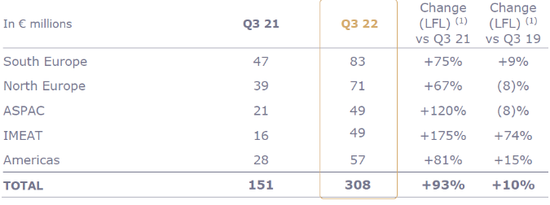
Figure 2: Revenue of Accor Group in a segregation
(Source: group.accor.com, 2022)
Considering the same approach in the present situation, “the initiated development for the business of Corinthia mainly represents the declined revenue position by €176 million, from €268 million in 2019 to €91 million in 2020, resulting in pre-tax losses of €90.3 million (MaltaToday.com.mt, 2022). The volume of this declining approach generally imposes a certain volume of burden on the financial statutory performances and as a result, the overall comparative formulated marketing advantages are not fruitfully initiated for this business to maintain the statutory growth systematically. Considering this approach, the financial revenue structure related to the business of IBIS represents a comparatively optimised development position in the present market position.”

2.2 “Recognition of current market structure and engagement for both businesses”
The market initiative concept is one of the primary approaches which provides a proper opportunity for gaining competitive advantages compared to the competitor. Applicability of proper market initiative also represents the statutory positioning benefit as well which is accountable to measure the formulated compatibility value. Concerning the present hospitality business in the United Kingdom, the present market position of Corinthia Hotel Group represents the existence of 23 hotels in 16 different countries which represents the Global operation engagement. On the other side, the performances of IBIS (Accor the parent company) consisted of 53 different hotels on a worldwide basis. Therefore, the general operating positions related to IBIS indicate a comparatively optimised Market Positioning support compared to the competitor.
Associated with the same approach some other financial analyses related to the market positions are initiated with the initiative of which the following comparative positions are provided.
Corinthia Hotel Group
According to the provided financial details the current market equity volume of this particular business is 817,892 million which indicates a progressive position support compared to the previous value of 838,216. The present market capitalisation structure related to International Hotel Investments PLC (IHI plc), the investment company of Corinthia mainly indicates a market capitalisation value of €332.47 million (reuters.com, 2023). The present market demand including the customer potentially in this business mainly represents a positive volume of market opportunity which is progressive and also represents the competitive positioning support. Associated with the present operating structure the constant Dividend policy engagement has been initiated in this business which is initiated to recognise the comparative development positioning support.
The current initiated branding approach by this organisation also represents a proper volume of statutory support and a market potential approach in a formulated manner. To formulate a proper volume of market development initiative in the present situation the investment company of this business also initiated 18 beachfront luxury Villas and Corinthia Yacht Club for operating development support (corinthia.com, 2022).
Ibis Hotels
For this business the parent company is Accor. At the present situation, the market capitalisation level of this particular business group is around 8.87 billion and the market beta level is 1.28 Times. The primary recognitions related to the value of the PE ratio represent the growth structure of 17.32 times along with the EPS structure of 2.03 times support. The present volume of equity performance is related to the business indicating the level of €4597 million that was identified as an optimise positioning support of the financial capital for the business (uk.finance.yahoo.com, 2023). In related to the present performance initiative the application of the Gordon model is generally noticed in this business which defines the optimise position including the market value determination support. The operating structure including the diversified marketing engagement of this particular business represents a positive opportunity related to the market capitalised value including the value-based performance approach. The present strategic approach related to the branding positions along with the structure of four different factors trendy, playful, surprised and joyful is mainly committed by the management of this business which provides a positive opportunity and progressive structural development position support. The applicability of the current unique branding initiatives of this business along with the social media formulation also represents and optimises development opportunities that are accountable for maintaining the business's progressive positioning support in the present market values.

2.3 “Analysis of general growth related to both Organisations”
The overall operating structure related to both the initiated businesses has been evaluated with the general intention of operating support that represents the marketing position support including the compatibility positioning support. The engagement of the current growth approach for both businesses is provided.
Corinthia Hotel Group
In the present position, the managerial department of the business has initiated rollover bonds valued at €45 million that initiate the compatibility positioning support. Associated with the general intention the management of the business also initiates the commence seven hotels in the pipeline through 2026.
Additionally, the business group committed to spread across Europe, the USA, the Middle East (Doha in 2025 and Diriyah in 2026), and South Asia (Maldives in 2026). Within 2024 the management of the business is intended to commence 126 additional rooms grand ballroom, an 850 sqm spa, various dining venues, luxurious boutique meeting facilities, as well as high-end retail outlets (whoswho. mt, 2023). Even in the present position the business acquire12% equity share of GHA Holding Limited to expand the business operations globally.
Ibis Hotels
The present operating engagement, the initiated joint venture engagement between Accor and InterGlobe Hotels represents a progressive operating support with the expansion of business in India. At the present situation through the processing of this joint venture, the business is mainly intended to formulate in networking development including 25 ibis’ hotels with 3‚000 rooms across India (interglobe.com, 2023).
Additionally, to initiate the expansions of business operations organisation also initiated ibis Styles Phuket Bangtao in Thailand where with the application of robust networking supported 73 hotel projects. In Indonesia, the group committed to initiating an investment in the project of the 36-floor hotel with an additional 175 rooms to operate development including global operating support.

2.4 “General CSR processing related to both businesses based on current position”
Corinthia Hotel Group
The primary identifications related to the present operating structure of the business represent a proper volume of sustainability support along with governance engagement which is compatible with the maintenance of CSR development in this business. In the present situation, 13 different staff has been initiated involvement in this particular business to conduct the CSR activity in a supportive order so that the overall sustainability approach can be managed (Guilding, 2022). The present level of energy consumption level in this business is also represents a positive controlling support that formulates the environmental engagement in a formulated basis.
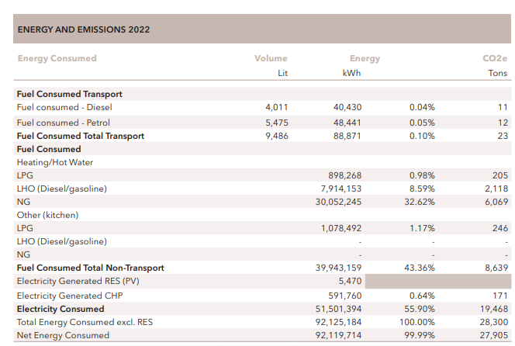
Figure 3: Energy consumption in Corinthia
(Source: interglobe.com, 2023)
The primary engagement of the CSS strategy mainly provides focus on resource allocations, sustainability processing, conducting some philanthropic support, charity, staff welfare and also the community engagement approach so that the compatibility initiative can be managed. Additionally, this group also provide primary importance over the food, water facility and accommodation support along with the maintenance of carbon emissions structure to manage a proper volume of environmental stability approach. Even the current commitment towards the children's educational processing including the initiated engagement of SOAR group related to the elimination of violations against women and children also provides proper CSR support.
Ibis Hotels
According to the present CSR committee, the overall business provides a primary volume of importance over the committed development including the environmental progress on a supportive basis through the maintenance of controlling the carbon emissions volume. Even in the present situation along with providing a primary strategic development for the operating progress the management also provides importance to the global warming positions so that statutory development can be implemented towards the environment and aspects. In the present position to eliminate the carbon emissions level and also the avoidance of global warming trajectory of +1.5°C by 2050 the organisation initiated a positive development initiative through waste management initiatives.

3.0 Recommendation
Under the present situation, the managerial department of Corinthia needs to provide focus on the market capitalisation processing including the diversified capital engagement properly for the standardised growth of business capital value. Even the management of the business also needs to provide primary formulation support over the capital risks assessment approach along with the risk assessment processing so that the overall financial statutory growth can be maintained. A proper volume of financial source arrangement including the maintenance of market capitalisation structure needs to be controlled with beta support so that the risk assessment and diversified financial values can be maintained
On the other side, the management of IBIS in the present situation along with the promotional approach a proper volume of market development initiative is required so that a positive amount of customer engagement can be initiated. Including the same approach, a progressive restructure support related to service engagement and also quality formulation is required to be reformulated properly so that the expansion volume of customer engagement along with revenue development can be initiated.

4.0 Conclusions
In summary, the fundamental approach related to the processing of financial data engagement is necessary for maintaining the contemporary positioning support which ultimately defines the financial health of the business. On the other side, the applicability of non-financial measurements is equally progressive to determine the progressive performance value including some of the competitive positioning approach in a formulated order that ultimately defines the consistency positioning growth.
In association with both the financial and operating evaluation for the hospitality business, it is identifiable that in the present situation, the performance structure of IBIS represents a comparatively sustainable progressive position compared to the other one. This particular position represents the initiated investment approach over this business will be beneficial in the future for an investor along with maintaining the consistent positioning performances of the business.

References
Atrill P, and McLaney E (2021) Management Accounting for Decision Makers, FT Prentice Hall
corinthia.com (2022). UPLIF TING LI V ES. [online] Available at: https://www.corinthia.com/globalassets/corinthia-global/documents/development/corinthia-development-presentation-may-2023-compressed.pdf [Accessed 20 Jan. 2024].
Drury C (2021) (11th Ed) Management and Cost Accounting, London, Prentice Hall
Framatome Espace presse. (2022). Ibis family reaches over 1,700 hotels and pursues its pioneering revolution - Truffaut. [online] Available at: https://press.accor.com/la-famille-ibis-depasse-les-1-700-hotels-et-poursuit-sa-revolution-pionniere_5714_5714/?lang=en [Accessed 20 Jan. 2024].
group.accor.com (2022). Annual report. [online] group.accor.com. Available at: https://group.accor.com/-/media/Corporate/Investors/Documents-de-reference/ACCOR_RI_2022_UK_vlast.pdf [Accessed 2 Feb. 2024].
Guilding, C. (2022) (3rd Edition) Accounting Essentials for Hospitality Managers, London, Routledge
interglobe.com. (2023). InterGlobe Announces Major Expansion of ibis Hotel Network in India | InterGlobe. [online] Available at: https://www.interglobe.com/InterGlobe-Announces-Major-Expansion-of-ibis-Hotel-Network-in-India [Accessed 20 Jan. 2024].
MaltaToday.com.mt. (2022). Difficult pandemic year costs Corinthia Hotels owner IHI €90 million in losses. [online] Available at: https://www.maltatoday.com.mt/business/business_news/110107/difficult_pandemic_year_costs_corinthia_hotels_owner_ihi_90_million_in_losses [Accessed 20 Jan. 2024].
reuters.com (2023). Market value of International Hotel Investments PLC. [online] www.reuters.com. Available at: https://www.reuters.com/markets/companies/IHI.MT [Accessed 20 Jan. 2024].
Seal W (2019) (6th Ed) Management Accounting, London, McGraw Hill
Statista. (2022). Accor Group: revenue 2022. [online] Available at: https://www.statista.com/statistics/266261/revenue-of-the-accor-group/#:~:text=The%20revenue%20of%20Accor%20Group [Accessed 2 Feb. 2024].
uk.finance.yahoo.com. (2023). Accor SA (AC.PA) stock price, news, quote & history – Yahoo Finance. [online] Available at: https://uk.finance.yahoo.com/quote/ac.pa/ [Accessed 20 Jan. 2024].
Walker J (2021) Introduction to Hospitality, Harlow, Pearson
whoswho.mt. (2023). Corinthia to inaugurate seven new hotels by 2026. [online] Available at: https://whoswho.mt/en/corinthia-to-inaugurate-seven-new-hotels-by-2026#:~:text=Corinthia%20Group%20has%20seven%20hotels [Accessed 20 Jan. 2024].
Zhang, C. (2022). Third-quarter 2022 revenue of €1,149 million up 83% like-for-like. [online] Accor – Newsroom. Available at: https://press.accor.com/third-quarter-2022-revenue-of-e1149-millionup-83-like-for-like/?lang=en [Accessed 20 Jan. 2024].

