MANAGING PEOPLE

LCBB5004

ASSESSMENT 1 - INDIVIDUAL PRESENTATION
SPEAKER NOTES

Name: Karol Kutak
Student ID:2030580

Slide 1: Cover



Slide 2: Content

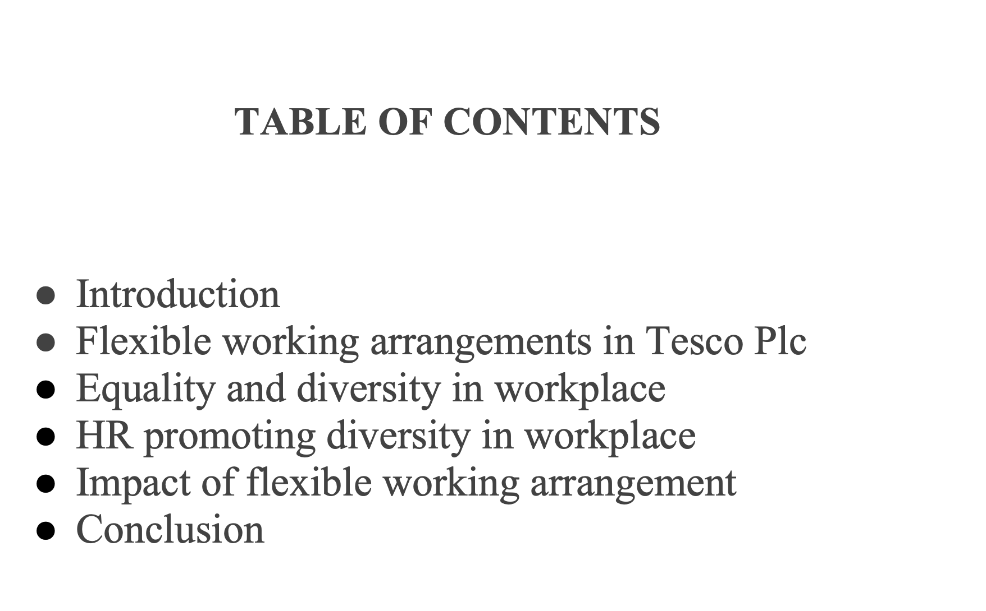

Slide 3: Introduction

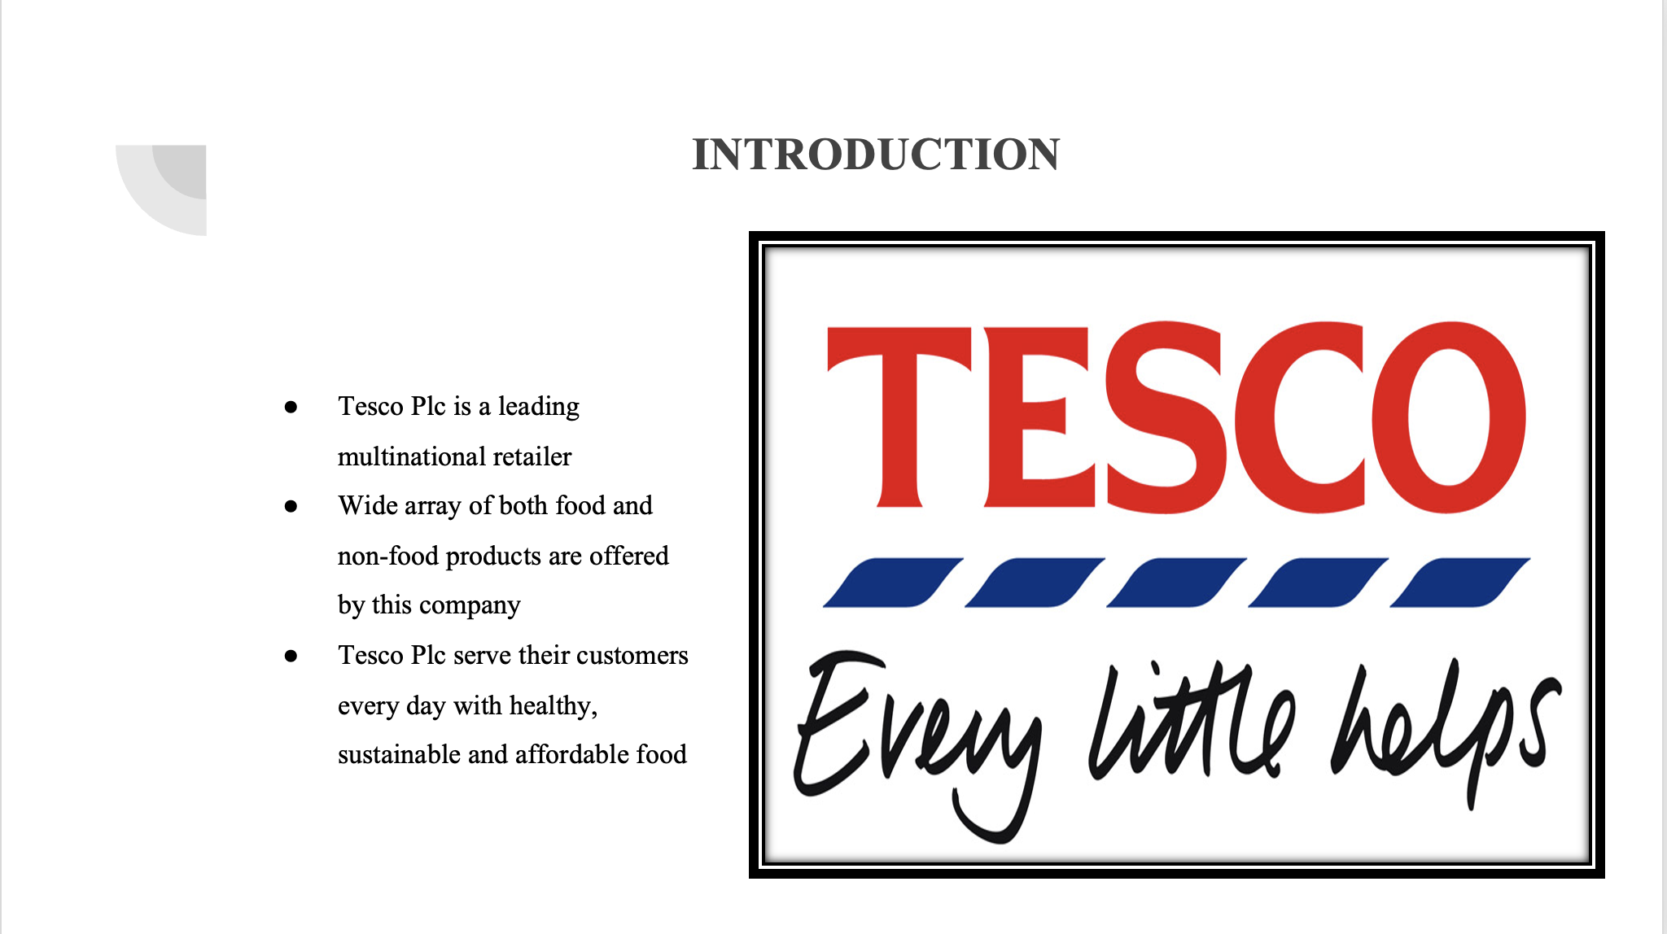

Tesco Plc is a leading multinational retailer that employs more than 345000 employees. The company through both online and multi-format stores carries out its business proceedings. These formats are different on the basis of the range and size of products being sold. The main aim of Tesco Plc is to serve their customers every day with healthy, sustainable and affordable food that will further help people enjoy an easier way of living and better quality of life (tescoplc, 2022). A wide array of both food and non-food products are offered by this company that includes: loathing, home appliances, fresh food, bakery, drinks, baby care products, electric goods and many more. In the UK the company also offers services such as retail banking, insurance and consultancy services. In terms of flexible working patterns, the company maintains diverse shift-patterns and keeps employee well-being as their prime concern.

Slide 4: Flexible working arrangements in Tesco Pls
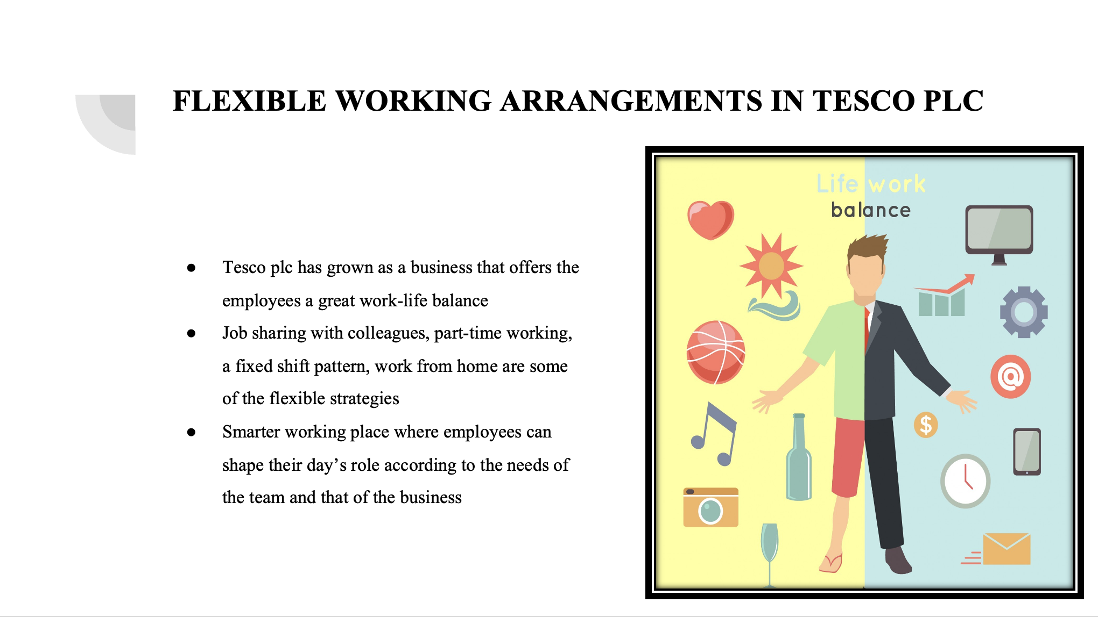

Tesco Plc has grown as a business that offers the employees a great work-life balance. Job sharing with colleagues, part-time working, a fixed shift pattern, work from home are some of the flexible strategies that the company follows to ensure they have something in store to meet the needs of every employee working in Tesco Plc. This helps employees enjoy the best of both worlds that is their personal and professional. In addition to this, Tesco Plc. also partnered with the Retail Pioneers Programme and Timewise in order to help this retail giant maximise workplace flexibility (Tesco-careers, 2022). Moreover, the recent developments made in the office campus at Welwyn Garden City introduced a smarter working place where employees can shape their day’s role according to the needs of the team and that of the business. This includes everything whether be to work from home, or working from 4pm-8pm. For Tesco Plc changing the workplace environment is considered very essential to bring about flexibility and inclusiveness within the organisation. Thus one can find informal meeting places, hot desking and ample other meeting rooms within the offices of Tesco Plc. The company greatly believes that a happy work environment attracts happier customers.

Slide 5: Excess supermarket spaces turned into hybrid office spaces

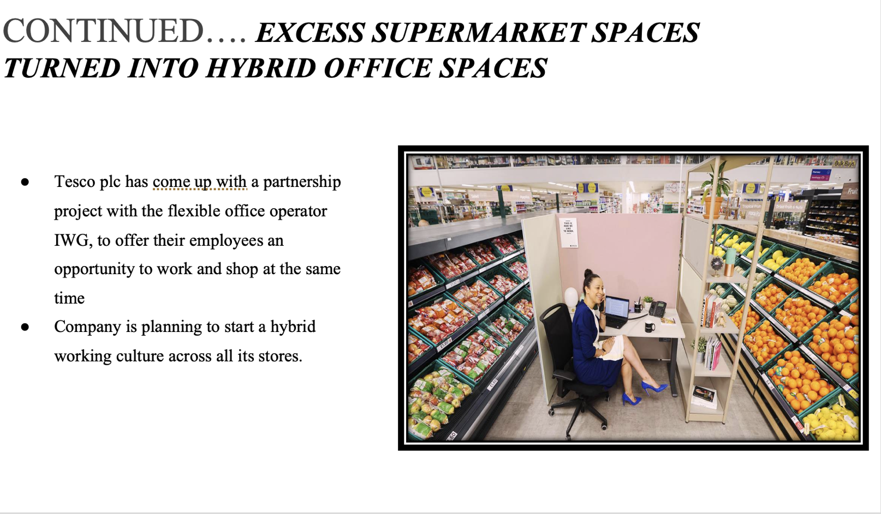

Tesco Plc has come up with a partnership project with the flexible office operator IWG, to offer their employees an opportunity to work and shop at the same time, in response to the flexible working habit developed among the employees during the Covid-19 pandemic (tescoplc, 2021). The “Spaces” project will be using the excess space in the supermarkets that were previously used to keep items related to entertainment as well as electrical goods. Since most of these items are purchased by the consumers online, the main aim of this project is to use the floor space more effectively. This way the company is planning to start a hybrid working culture across all its stores. Thus a new attitude towards employment is being noticed in the post covid times. Also a survey conducted by International Working Group (IWG) found that 74% of the workers are preferring to work flexibly rather than returning to the old system of working five days a week in their offices (itpro, 2022).

Slide 6: Equality and diversity in workplace
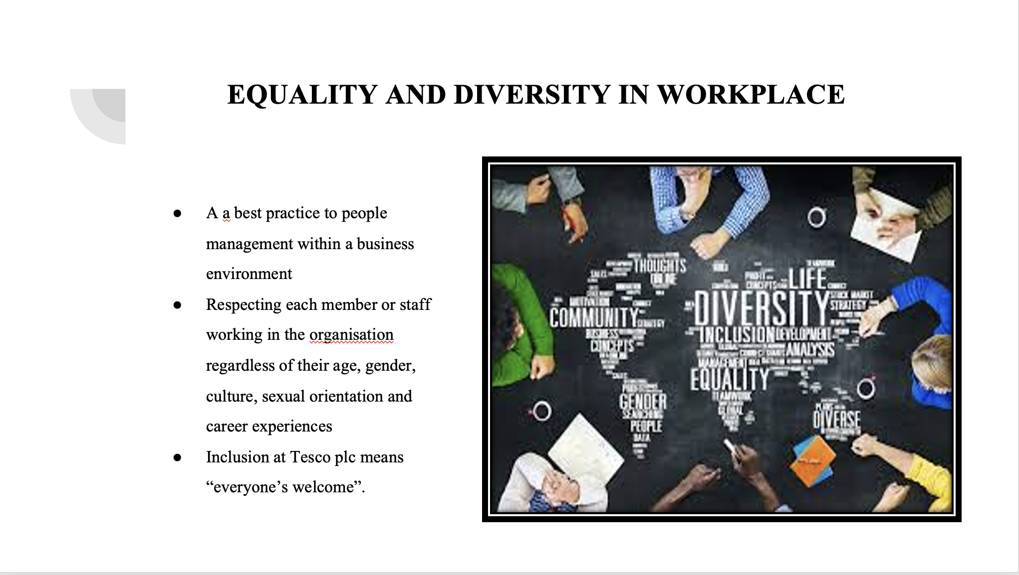

The terms inclusion and diversity are often heard together. As a best practice to people management within a business environment they play a very important role. Diversity and equality in the workplace includes a handful of things that should be kept in mind to ensure a successful business and effective people management (hrdept, 2022). These include: respecting each member or staff working in the organisation regardless of their age, gender, culture, sexual orientation and career experiences. Treating each member or staff with equality and dignity and using fair means to evaluate their performances.
Inclusion at Tesco Plc means “Everyone’s Welcome”. A sense of belonging is created in the company culture by valuing the uniqueness and individuality of every employee. Inclusion and diversity has always been at the heart of Tesco Plc’s HR strategies. The company ensures that the colleagues feel that their individuality is respected and decide their own working procedures. In addition, Tesco Plc is committed to help their employees be at their best (tescoplc, 2021). An inclusive workplace is fostered through the celebration of personalities, cultures and preferences of their colleagues. These people in turn, help Tesco Plc reflect the diversity of the communities they serve.

Slide 7, 8 and 9: HR promoting diversity in workplace

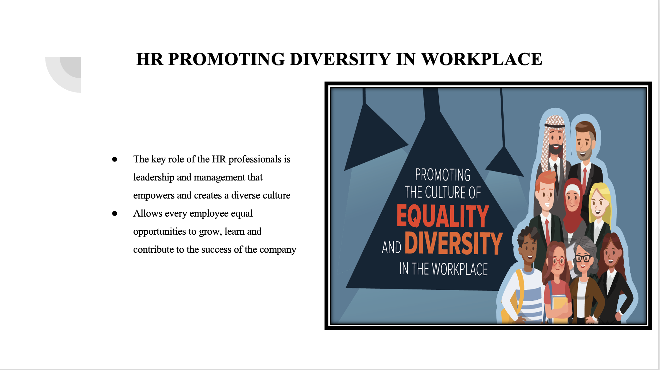
The key role of the HR professionals is leadership and management that empowers and creates a diverse culture. One that is inclusive and respectful and allows every employee equal opportunities to grow, learn and contribute to the success of the company (hrexchangenetwork, 2018).

Recruitment
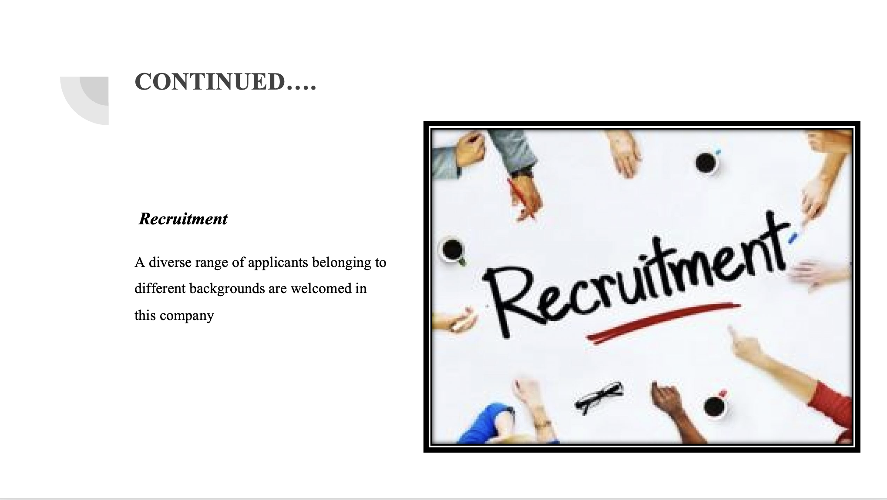
The HR department of Tesco Plc creates a workforce that not only reflects the customers in the United Kingdom, but across the world. A diverse range of applicants belonging to different backgrounds are welcomed in this company. In addition, the department have zero tolerance towards harassment, discrimination and bullying (Torrington et al., 2020).

Women at Tesco
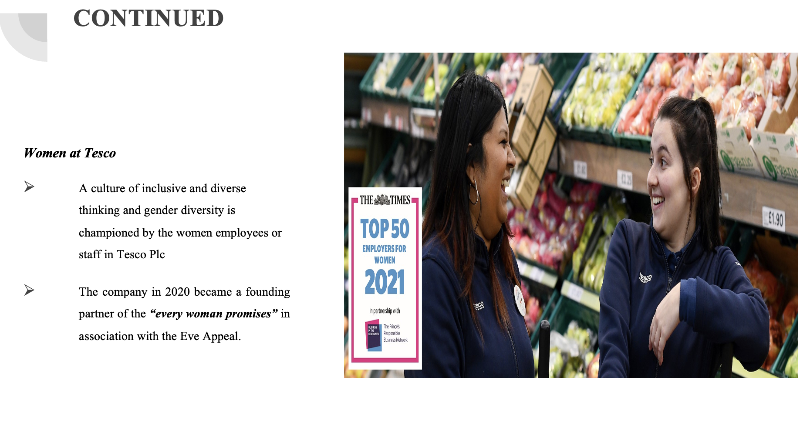

A culture of inclusive and diverse thinking and gender diversity is championed by the women employees or staff in Tesco Plc. Here, women feel empowered to articulate how they add value to the business as well as share their thoughts and views with others. The HR department excellently supports the mental well-being and health of the women folks working in this organisation. For instance, the company in 2020 became a founding partner of the “every woman promises” in association with the Eve Appeal.

Slide 10: Impact of flexible working arrangement

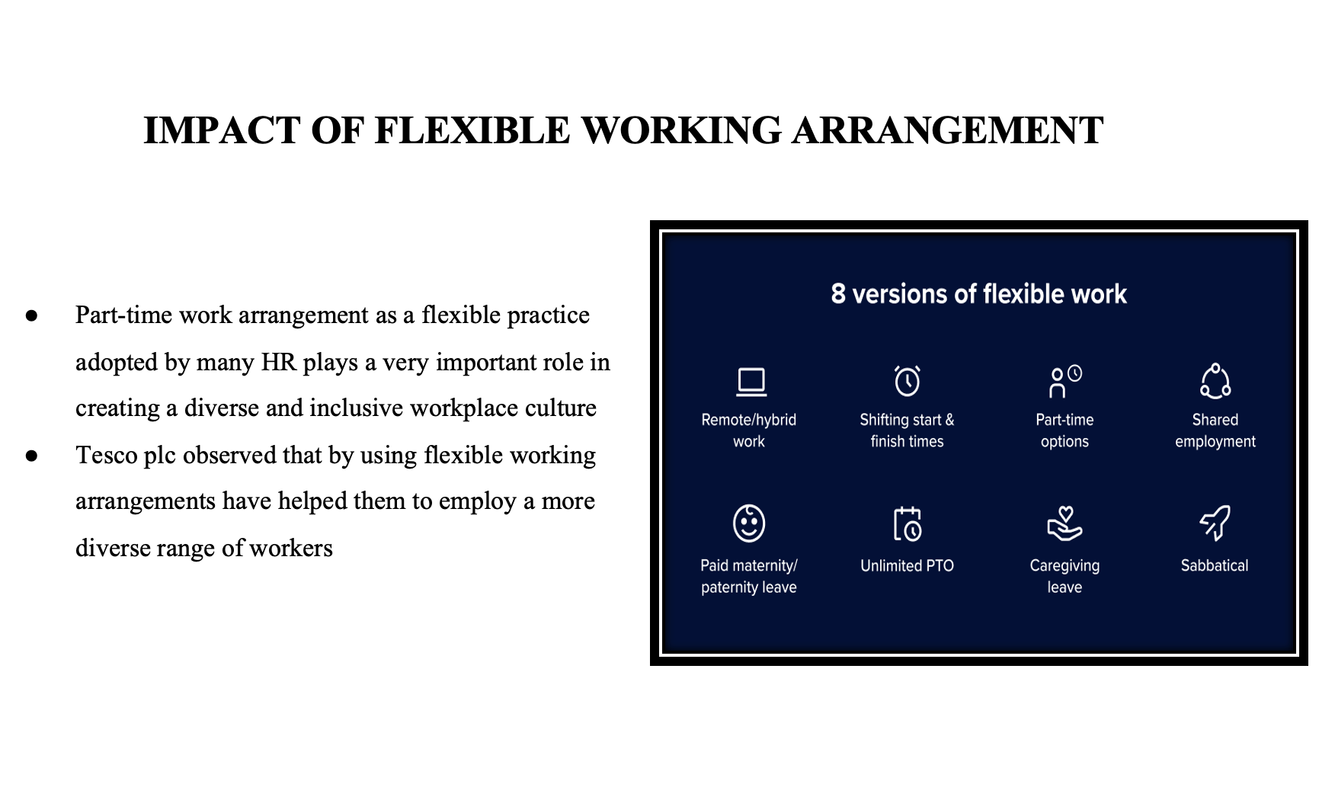

Part-time work arrangement as a flexible practice adopted by many HR plays a very important role in creating a diverse and inclusive workplace culture. Most of the businesses like the Tesco Plc observed that by using flexible working arrangements have helped them to employ a more diverse range of workers as well as improve talent retention (Chung and Van, 2020). In addition, companies that offer part-time opportunities are greatly preferred by employees post covid as they give them a better chance to manage both professional and personal life.

Slide 11: Conclusion
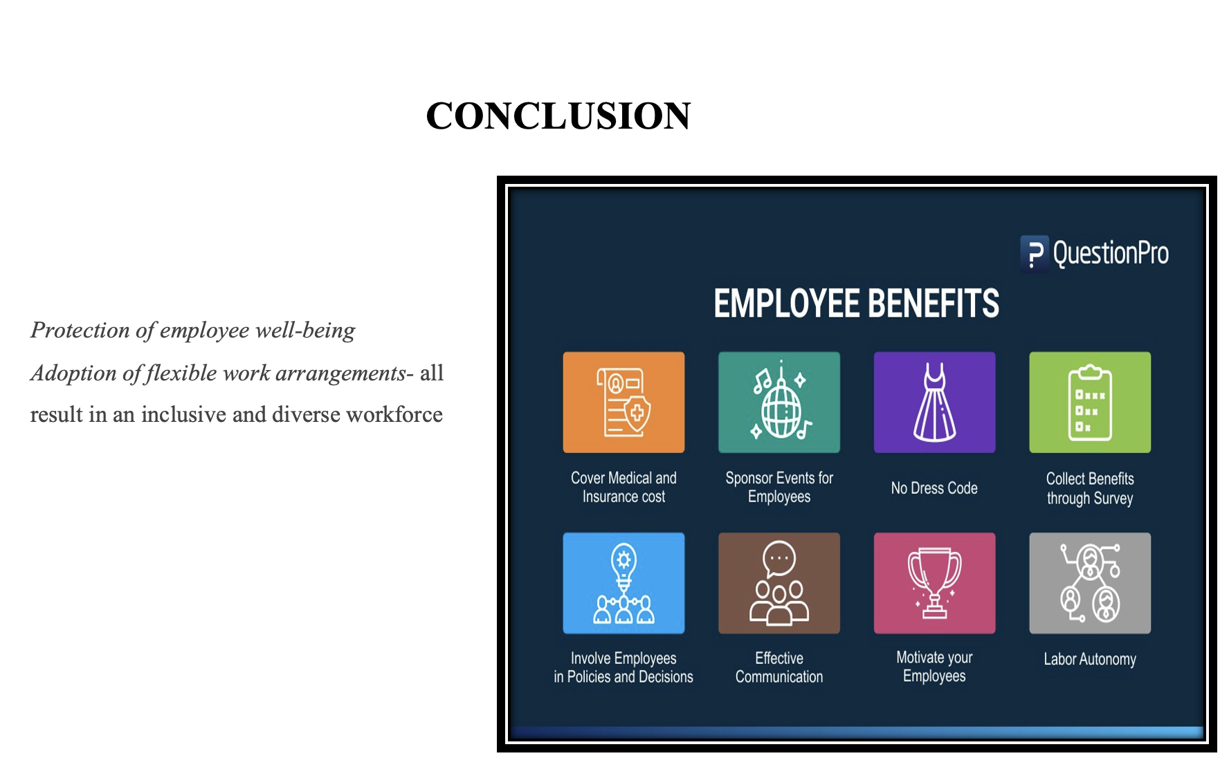

Therefore, it can be concluded that to bring about inclusion and diversity in the workplaces, the HR department of retailers like Tesco Plc are adopting flexible work practices that results in retention of talent pools and enhanced productivity.

Reference list
Chung, H. and Van der Lippe, T., (2020). Flexible working, work–life balance, and gender equality: Introduction. Social Indicators Research, 151(2), pp.365-381.
hrdept, (2022). Diversity, inclusion and equality. Available at: https://www.hrdept.co.uk/services/diversity-inclusion-equality-workplace/#:~:text=What%20is%20equality%20and%20diversity,orientation%2C%20career%20experiences%20and%20more. [Accessed on: 10 August 2022]
hrexchangenetwork, (2018). Diversity: HR’s Role. Available at: https://www.hrexchangenetwork.com/hr-talent-management/articles/diversity-hrs-role#:~:text=HR%20professionals'%20key%20role%20is,and%20contribute%20to%20the%20company. [Accessed on: 10 August 2022]
itpro, (2022). Tesco to pilot in-store flexible working spaces. Available at: https://www.itpro.co.uk/business-strategy/flexible-working/367660/tesco-to-pilot-in-store-flexible-working-spaces [Accessed on: 10 August 2022]
tesco-careers, (2022). Life at Tesco. Available at: https://www.tesco-careers.com/explore-our-world/life-at-tesco/ [Accessed on: 10 August 2022]
tescoplc, (2021). Flexible Working at Tesco. Available at: https://www.tescoplc.com/sustainability/documents/policies/flexible-working-at-tesco/ [Accessed on: 10 August 2022]
tescoplc, (2021). How we create an inclusive working environment. Available at: https://www.tescoplc.com/sustainability/documents/policies/how-we-create-an-inclusive-working-environment/ [Accessed on: 10 August 2022]
tescoplc, (2022). About Us. Available at: https://www.tescoplc.com/ [Accessed on: 10 August 2022]
Torrington, D., Hall, L., Atkinson, C. and Taylor, S., (2020). Human resource management. Pearson UK

