UWTSD
International Business Communications
Individual Presentation
Dr. Husam Helmi
Penko Nedelchev
SN 2112415

Slide 1

Slide 2
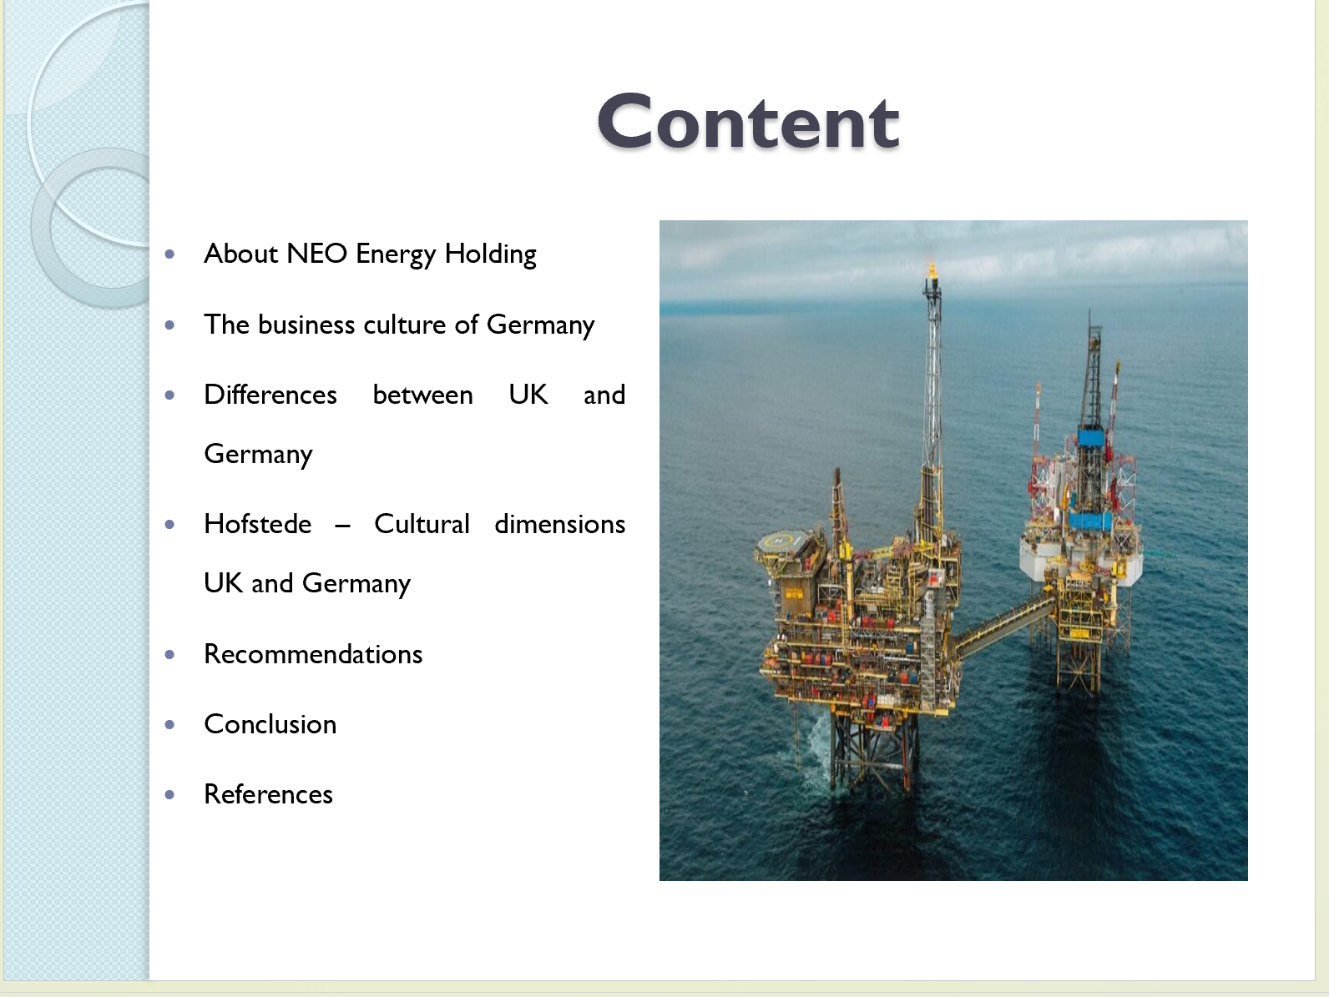

Among the top 5 producers, NEO Energy Holding Ltd. is a well-known UK Continental Shelf (UKCS) energy company (Gov UK, 2019). With an emphasis on providing energy in an ethical and sustainable manner, NEO Energy manages a superior asset base and strives to be the top operator in the UKCS. Their dedication to expansion and innovation is demonstrated by their recent acquisition from JX Nippon and the management team's modifications (Kulovic, 2021).

Slide 4

The employees of Germany first focus on the work and then emphasize relaxing, they understand that taking time for recharging helps them to be more productive in the workplace (Quassoli & Dimitriadis, 2019). Moreover, in Germany, if an employee is sick he had to stay at home by having a sick leave. It allows the employee to rest and recover properly, which means they are always fit for work and in a short space of time, they are more productive.

Slide 5

The values of Germany such as loyalty, fairness, professionalism, punctuality, and reliability should be reciprocated as the business is taken seriously. At German companies, transparency is important, which means corruption is uncommon (Quassoli & Dimitriadis, 2019).
There is formalism in the communication in the business culture and the employee speaks to each other politely and efficiently. In the daily practice of German business, ethics are central as in corporate social responsibility. German work ethics means employees have to do work full day and turn up on time, in turn, they are rewarded with good pay and fair working situations. Germans focus on the quality of their services and products. Employees are mainly loyal to their employers and they share their desire to make high-quality products and offer good services.
Shaking hands is a vital feature in the German culture. At the first meeting, it is expected to shake hands with any clients, employers, employees, or colleagues. When you shake hands during a meeting in Germany, The left hand should not be in the pocket while shaking with your right hand. During handshake, it is important to maintain eye contact.
In the majority of places in the workplace of Germany, there is a formal dress code. The woman wears skirt suits or simple trousers while the men wear dark suits and ties. In emerging companies such as start-ups, it is common to find people who dress in informal wear in the workplace.
Punctuality is very important to the Germans and is vital in the business. It is important to arrive early and it permits plenty of time where you need to be. If you are late during a business meeting, always call to let the manager know as early as possible. It is a sign of reliability and if you are late they will judge you harshly.

Slide 6

Language differences between the UK (English) and Germany (German) impact communication. The UK's ethnically diverse population contrasts with Germany's homogeneity. Social structures reflect the UK's multiculturalism, while Germany tends to be more uniform. Religious values vary, with the UK exhibiting religious diversity and Germany historically influenced by Christianity. Acknowledging these distinctions is crucial for effective cross-cultural communication, fostering understanding in business interactions, and ensuring successful integration into each country's social fabric (Great Gov UK, 2023).

Slide 7

As the NEO Energy Holding Ltd company is thinking of moving to Germany for the expansion of its trade, there arises a lot of questions in the mind about the work culture of Germany. There are many challenges while moving to a new country. The company has to do everything to get familiarized with the customs of Germany to assist in integrating into a new team (Diao, et al., 2021). There are some differences and similarities between the cultures of the UK and Germany. It is common to hear that Germans are being highly regarded around the globe for their office efficiency and workplace. The stereotypes of the British moreover stay in the cautious and class-structured hierarchy. The employees of Germany are indeed more productive as compared to the other neighbors of Europe, as they take more leaves and sick days holidays, as compared to the British employees.

Slide 8

The Germans have a better work-life balance, so they are more productive in the office and also they relax and unwind more effectively. To refuel themselves, the workers of Germany take an extra day or two off work by preparing themselves mentally for the work ahead. The employees of Germany first focus on the work and then emphasize relaxing, they understand that taking time for recharging helps them to be more productive in the workplace. On the other hand in the British office, the employees had to do work if they were ill and downplay any sickness in front of the management. This may create a negative impact on productivity as they are providing more time to the office and it also creates a risk of passing illness between the employees and colleagues. Moreover, in Germany, if an employee is sick he had to stay at home by having a sick leave (Great Gov UK, 2023). It allows the employee to rest and recover properly, which means they are always fit for work and in a short space of time, they are more productive.

Slide 9

Hofstede cultural dimension theory is a framework used to differentiate between the cultural dimensions and national cultures and their impact on the setting of business.
Power Distance: Germany and the UK are not among the lower power distant countries and their score is 35 (Sheffer, 2022).
Individualism: The society of Germany is an individualistic one. They focus on the parent-child relationship instead of uncle and aunt in common. The score for individualism in Germany is 79 whereas the score in the UK is 76. The British are highly individualistic and private people.

Slide 10

Motivation towards achievement and success: At 66, Britain and Germany were a decisive society which means highly driven and success-oriented.
Uncertainty avoidance: Germany is among the uncertainty-avoidant countries with a score of 65 and the score of the UK is 35 which means that as a nation they are happy with what the day brings by not knowing (The Culture Factor, 2023).
Long-term orientation: the score of Germany is 57 and that of the UK is 60, they both have a pragmatic culture. In societies with a pragmatic orientation, people believe that truth depends very much on situation, context, and time.

Slide 11

There are some recommendations to expand business from UK to Germany:
Understand Liabilities: First, register the new company in Germany while keeping the original business in the UK. Set up a branch office to expand activities in Germany (The Culture Factor, 2023).
Consider regulations: Get an authorization to provide a service

Slide 12

Consider benefits: Germany has a highly educated population with a large consumer market and a stable political and stable market.
Consider taxes: The corporate tax rate in Germany is 15%, with a combined rate of approximately 30-33%.
As a potential new market competitor, Germany is considered for its large consumer expanding power and innovative business culture (The Culture Factor, 2023).

Slide 13

In conclusion, the NEO Energy Holding Ltd Company thought to move to Germany to expand its trade. Germans are more productive and relaxing more efficiently by having a better work-life balance. There are some cultural differences between the UK and Germany. The workers in Germany can take breaks when they feel sick but in the UK, the employees have to do work if they feel sick. Expanding business in other countries is a challenge for the company. Besides this, there are several benefits of expanding the business to Germany.
Slide 14

References
Diao, Y. et al., 2021. Influence of population density, temperature, and absolute humidity on spread and decay durations of COVID-19: A comparative study of scenarios in China, England, Germany, and Japan. One Health , 12(1), p. 100203.
Gov UK, 2019. Upstream oil and gas in the UK. [Online]
Available at: https://www.gov.uk/government/publications/extractive-industries-transparency-initiative-payments-report-2018/upstream-oil-and-gas-in-the-uk
[Accessed 10 11 2023].
Great Gov UK, 2023. Exporting guide to Germany. [Online]
Available at: https://www.great.gov.uk/markets/germany/
[Accessed 5 11 2023].
Kulovic, N., 2021. How NEO Energy’s growth surge is turning it into one of top five North Sea players. [Online]
Available at: https://www.offshore-energy.biz/how-neo-energys-growth-surge-is-turning-it-into-one-of-top-five-north-sea-players/
[Accessed 4 11 2023].
Quassoli, F. & Dimitriadis, I., 2019. “Here, There, in between, beyond…”: Identity Negotiation and Sense of Belonging among Southern Europeans in the UK and Germany. Social Inclusion, 7(4), pp. 60-70.
Sheffer, A., 2022. Applying the Country of Origin Effect in Teaching a German-Austrian Business Case. Global Business Languages, 22(1), pp. 38-54.
The Culture Factor, 2023. COUNTRY COMPARISON TOOL Germany - UK. [Online]
Available at: https://www.hofstede-insights.com/country-comparison-tool?countries=germany%2Cunited+kingdom
[Accessed 28 10 2023].

