Continuous/Enhanced Provision –Year 2 Darpariaeth wedi’i Gyfoethogi
Welsh Area  Ardal Cymraeg  Esgidiau Newydd  Can you pretend you’re at the shoe shop buying shoes like Mrs Tomos. Use the sentence patterns to speak in Welsh or act out the original story. | 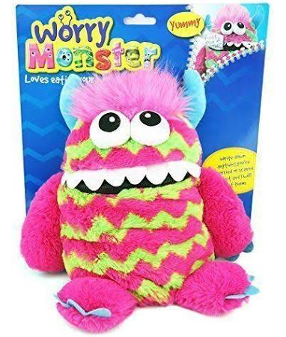PSD  To create a leaflet or poster about clean drinking water.  Where do we get clean drinking water from? Why might it be dangerous to drink dirty water? | Paint  Paent   | Investigation  Use an atlas to discover the names of all of the oceans and write them down. | 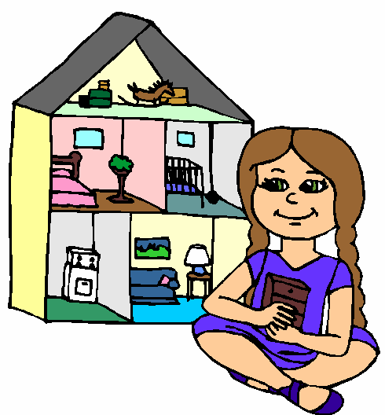Small World  Byd Bach  Can you act out some people going on a boat journey?  HINT: Use the idea cards to help you.
Construction  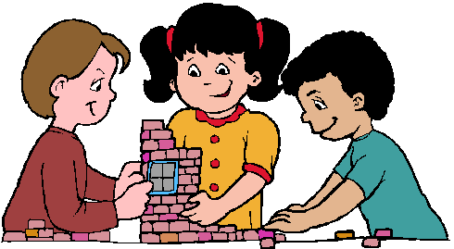Adeiladu  To build a bridge out of Lego. Could you build cars to go across it, or boats in the water below? | Role Play  Chwarae Rôl | I.C.T  Can you create a picture of a body of water using Jit? | Writing Area  Ardal Ysgrifennu  Can you design a poster describing the different bodies of water? | Creative  Cornel Creu  Can you make a boat that will float on water?  HINT: You can test it in the water tray outside.
Book Corner  Cornel Ddarllen  Use an atlas to find out the  names of some rivers in Wales and write them down. | Outdoors  Using the buckets, jugs and guttering – can you transport the water from one part of the outdoor area to another?  Can you measure how much water you have transported using the measuring jugs? | Maths  Rhif | Let’s Investigate  Ardal Ymchwilio  Using research, can you find out about any places that use boats to get around? | Physical  Corfforol
Additional Experiences (Profiadau Ychwanegol): Shine Time work to be shared in their INDEPENDENT LEARNING BOOKS. Pupil Voice highlighted in Yellow. C = Continuous.
09.03.20 – Journeys of Water

