Forensics Assignment
Computer Forensics Assignment Report

Cyber Security & Networks - Part Time
Neil O’Mahoney 0351709
Table of Contents
Task 1 3
Task 2 11
Abstract 11
Introduction 11
Chain of Custody 12
Retrieving Files 14
Report Writing 15
Conclusion 16
References 16
Appendix A 19
No Stone Unturned 19
ESTIMATE ONLY 19
To: 19
For: 19
Appendix B 20

Task 1

If possible, there are 3 A’s that should be adhered to when selecting an approach to the methodology which has been chosen. Acquire of evidence which should not have been tampered with if possible. If time or lives are at stake this should be minimised.
Authentication should take place, so that the original drive is left untampered with and the evidence has a hash number against it which can be replicated under instructions or in a lab environment. This is important so that it is not later challenged in a court of law.
Analysis of the data without altering it. Later the author will explain that this isn’t always possible if the forensics analysis is looking at the live data. To that end the original drive should be preserved and put into a read-only state.
Due to the time taken to find evidence on a suspect’s computer and the time taken to bring a case to prosecution there is an increasing demand to “Do more with less” [1] To achieve this quicker there have been several methodologies that have developed to expedite the problem.
Digital Field Triage (DFT) is one method whereby a non-digital evidence technician is dispatched to the location to provide on-site analysis in an attempt to focus their efforts on the investigation in hand without disturbance and aims to reduce a backlog when the data goes for deeper analysis.
Computer Forensics Field Triage Process Model (CFFTPM), is a model that was first proposed by Rogers et al 2006, focused around identifying that increasing numbers of criminals were using technology to hide their crimes. In time critical cases, such as kidnap or terrorist activities, a quick result on certain parts of evidence outweighed the closer inspection of a Forensic Lab in the short term. The aims of the process model are as follows:
- Find usable evidence immediately.
- Identify victims at acute risk.
- Guide the ongoing investigation.
- Identify potential charges.
- Accurately assess the offender’s danger to society. [1]
Priority evidence which can fast disappear such as “volatile need to be deal with first.’ [2]
A Digital Forensic tool is a tool that can be used to examine the contents of an electronic record. These tools in many cases are bespoke and perform specific tasks, ‘..Many of the tools still used in digital forensics are home-grown, built by the practitioners that have to get at the evidence in a case.’ [3]
Criminals are becoming ever more difficult to capture and alter their methods of being detected and becoming digitally aware. Tools are also required to have increasing levels of sophistication to capture those that warrant it, ‘Some are even developing “anti-forensic” methods and tools specifically designed to conceal their activities and destroy digital evidence, and generally undermine digital investigators.’ [4]
A key point in the tools used is knowing their limitations. There is no way of having a calibration test (working out tolerances of a measured device) therefore forensic investigators should be aware of this and ideally test on known documents with key pieces of evidence hidden inside them to know that the tools they are using are capable of finding the limits of their capabilities. Similarly, there should be no single reliance on one particular tool to complete a job as ‘Reliance on a single application platform will significantly hinder the review and subsequent analysis of digital evidence.’ [4]
Initially after seizing the suspect’s computer the device should be connected to a power source. This is to prevent a sudden loss in power which may result in Live Data Acquisition from being lost.
Next the forensic investigator should take photographs of the screen on a camera with the time and date already setup on it of the computer, all sides then underneath, particularly focusing on the serial number and any external USB/ hardware devices. This is particularly important later on when documenting the process.
Live Data Acquisition is a method of acquiring data from a computer that is still switched on that would normally lose data if it is turned off. Vital data can be lost when the medium is turned off and depending on the source there are two distinct types; System and Network information.
An order of volatility must be established in live data acquisition so that the appropriate data which is most at risk of disappearing (and valuable to the case) is recovered as a matter of urgency. Request For Change 3227 details the Order of Volatility in the image below:
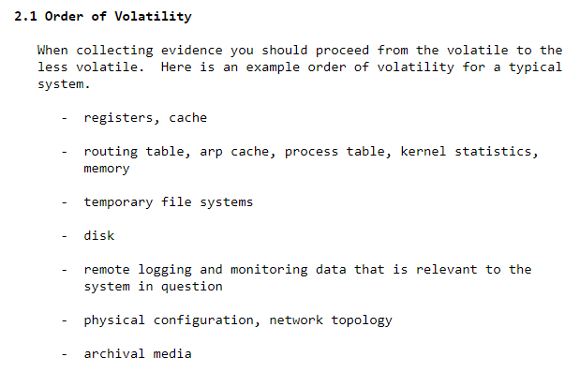
[5]
Evidence investigators would commonly be looking for system information such as commands, history, timestamps and running processes.
A potential downside to acquiring data from a live system is that they can produce something called a slurred image. ‘…A slurred image is the result of acquiring a file as it is being updated.’ [6] This can also happen to metadata (subsets of data) as mismatches, between reading and acquiring of the data can cause data sectors to give differing results.
To monitor current open TCP and UDP connections the ‘netstat –an’ command opened in Windows Command Prompt is a tool designed to open and monitor current connections that are established with the suspect’s computer. The ‘-an’ switch at the end is for all active connections (‘a’) and for TCP connections its ‘n’.
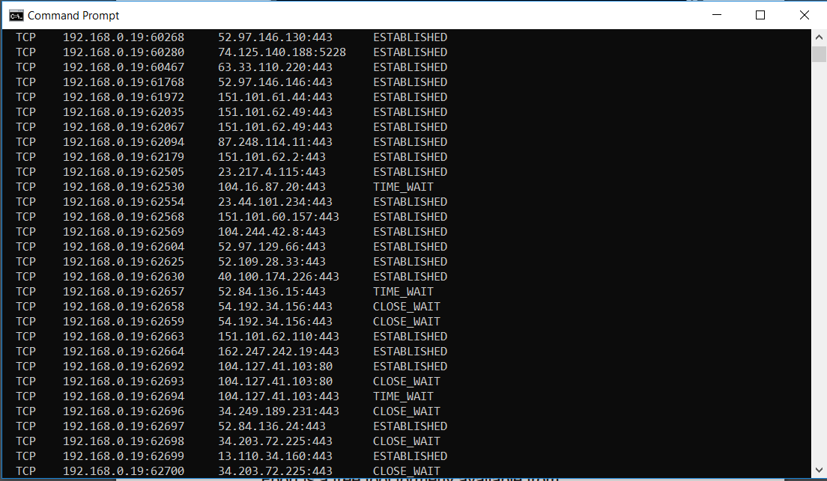
[7]

The registry is somewhere in a modern Windows operating system that can contain information such as usernames, passwords, network information as well as hardware and software configuration to name but a few. OSForensics have created a tool which examines this in more detail. It features the ability to:
- Last edit time and date for keys
- Easily open offline registry hives (e.g. those stored on a portable drive)
- Fast searching and ability to go directly to a known key location
- Bypasses windows permission enforced on some parts of the registry
- Can display registry locations that might be hidden due to actions of malicious software / rootkits
- Easy exporting to text of a single key, all of the subkeys or the entire registry file
- Can add keys and their values to the current case
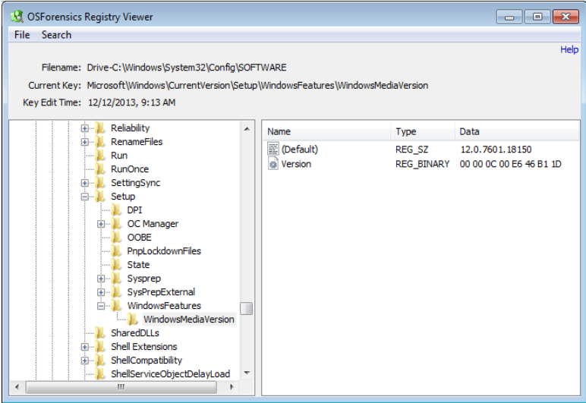
[8]

Wireshark is a common Network Tool that can help an investigator look at source and destination packets of a device on a network. It can provide ‘Surveillance requires sniffing data transmissions between a suspect’s computer and a network server.’ This is a real time tool and can be used prior to a warrant to an address and seizure of equipment if needed.
[9]
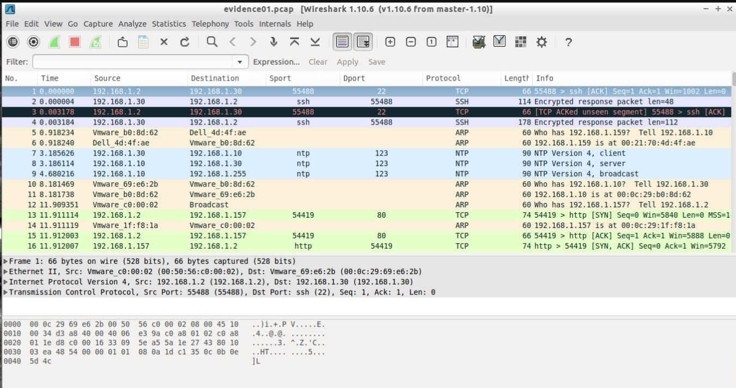

Physical memory or RAM is something that is stored as a running process. This continues to change even when it is being copied. According to Locard’s Exchange Principle which basically states that ‘…To collect the contents of RAM, they must be loaded into RAM as a running process.’ [10] In short the result being that data will be lost as a result of running a process on the device.
Win32dd is a tool which is designed to capture the data associated with the physical RAM of a computer. FTK also does this however a larger footprint is left with it (155MB as opposed to 13MB). It features an ability to crash dump file which is capable of being read by Microsoft Debugging Tools. This also includes command line
At this point the suspect’s computer should be shutdown, recorded and moved directly to a secure forensically approved location swiftly). The device should be enclosed in a faraday type bag and sealed with a signature or recorded label and not opened until it reaches the lab.
Static Data Acquisition is the ability to gather data on the suspect’s machine, USB or smart device to name but a few. Essentially all data that would not be affected after a standard shutdown. This should be immediately followed up with changing the registry key that stops the static data from being written to. This is found in: ‘HKEY_LOCAL_MACHINE\SYSTEM\CurrentControlSet\Control\StorageDevicePolicies’ and the ‘Write Protection’ key is changed to ‘0’:

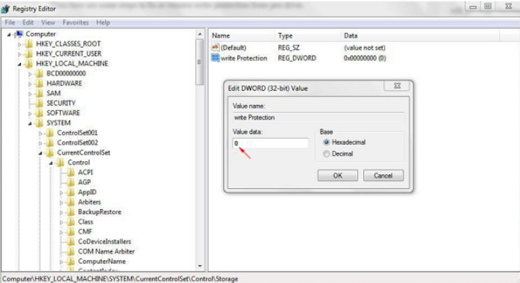
[11]
An MD5 calculator is a tool that is used once a suspects computer has been apprehended and the forensics investigator wishes to make a hash value that represents the untouched contents of a hard drive which can be copied multiple times and provides validation that as long as the hash authenticates with that of the original then there is a high degree of reliability that the evidence has not been tampered with when presented to a court of law.
Password Cracking
‘The efficiency of cracking the key and determining the password are the two essentials on which the effective of those procedure depends on.’ [12] To crack a password it is a process of guessing what is found in a location on the computer or during a transmission. Tools are available to use a dictionary as a source, depending on the length and complexity of the password will depend on how long this takes. Special Characters can increase the difficulty in getting access to the system. Tools such as Cain and Able are one of the common tools used to decipher encrypted text to produce the plain text password.
Password kit Forensic (FKT)

Disk and Data capture
File Viewers
Internet Analysis
Email analysis
MailXaminer is mail analysis program. It is capable of analysing over 20+ varieties of formats and applications including desktop or web-based services. It is a GUI based software with the ability to allow multiple investigators to work on the case at the same time & can produce various formats of reports to be submitted as evidence. MailXaminer ‘…Software complies with the benchmarked values of EDRM model, thus, enabling the law enforcement agencies to execute investigation and detailed analysis of emails.’ [13]

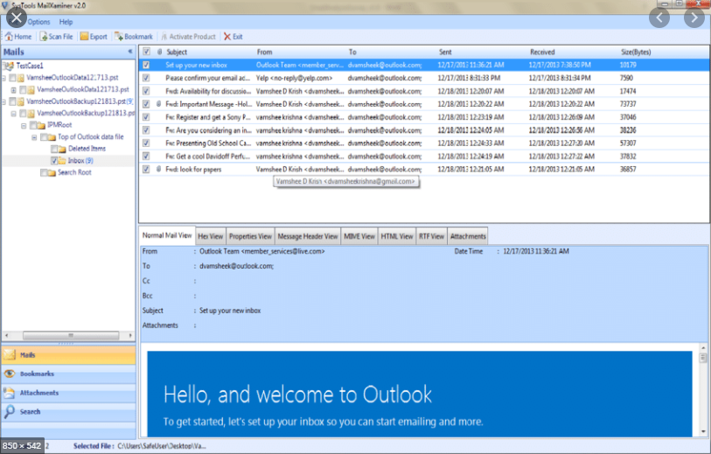

Mobile
Network
Cloud
Database
The art of hiding or obstructing a forensic investigator from going about their daily job or making it more difficult and increasing the time and effort exerted to gain information can be classed as anti-forensics. This can include altering data, timestamps, hiding and encrypting (including stenography) network traffic, reformatting/ reinstalling and the use of external drives which leave no trace when they are removed. “Anti-forensics” (AF) is a growing collection of tools and techniques that frustrate forensic tools, investigations and investigators.” [14]
Date wiping, although difficult to detect what was previously on the device, it might still be possible to detect whether a tool has been ran, this can include repeating characters, or patterns in filename or slack space (unused space at the end of a fixed sector size) or in Windows; deletion of a Master File Table (MFT), evidence of it being ran can be found in the User Assist log. Other areas where this maybe found can include: swap space, MFT, NTFS journal, Slack Space and any backups of the system.
Although isn’t always possible to find the lost data, it might be more important to prove that the anti-forensic tools have been ran in the first instance including the wiper.
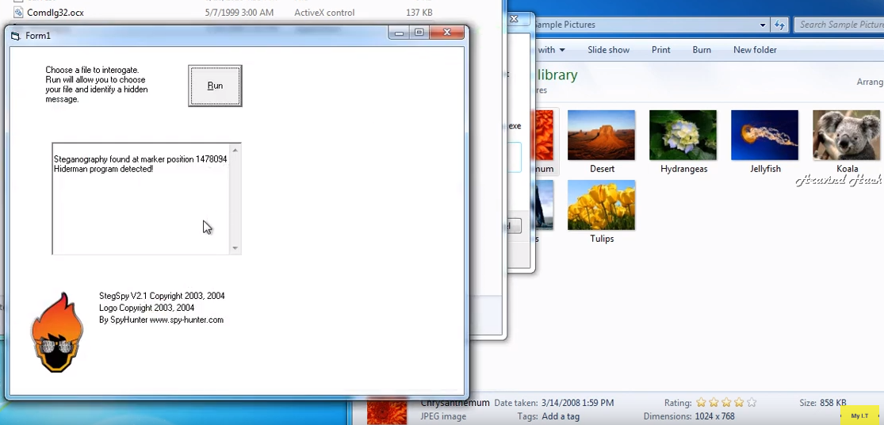
Above is an example of StegSpy detecting text within a JPEG image.

Number | Name of Product | Uses
1 | FTK Toolkit | Scans hard drives looking for data to be recovered.
2 | FTK Imager | Creates bit-by-bit copy of evidence without changing it, generates hash of file also.
3 | Autopsy | Forensics platform to investigate what happened on a computer, timelines, register and email included.
4 | OSForensics
5 | Cain & Able | Password recovery Tool & Crypto Analysis.
6 | Wireshark | Network analysis tool used for transmitted or received packets.
7 | MailXaminier | Email specific tool used to analyse emails from web and desktop computers.
8 | StegSpy | Software designed to detect algorithms linked to steganography.

Task 2

Abstract
A crime has taken place at Heathrow Airport that John Williams has been sent to forensically investigate. By prioritising and methodically going through the disks producing order of volatility John is to get capture as much information from the digital equipment as possible. It is then his job to produce a report that will be used in court. It is important that he adheres to guidelines, principles and the law to lessen any ambiguity.

Introduction
John has been requested to deploy at Heathrow Int. Airport in response to a call made by Mr Mark Wales (a Chief Investigator of Heathrow Police Dept) to provide a professional digital forensic investigation.
To ensure that the correct level of law is applied it is wholly relevant that logic is applied in the case of the terrorist incident at Heathrow Airport when searching and investigating the material found. To ensure a crime has taken place it has to be founded as falling outside of the law. Of course, in cases of surveillance the police department may already know that something is happening prior to arrest and to that end may already have search warrants and specialist investigating personnel (such as forensics) on scene to begin swift investigations.
The suspected terrorist was picked out by an electronic device designed to scan a known database of person of interest to the police. Although no specific legislation pertains to the biometric data being used, it is still subject to the Protection of Freedoms Act 2012, Human Rights Act and Data Protection Act so that the data is not kept for any longer than is necessary to be used by police forces.
Under the Police And Criminal Evidence Act and the Association of Police Officers use of lethal force, the terrorist was shot dead.
As defined by the Home Affairs Select Committee of the UK Parliament, the word cybercrime and e-crime are interchanged and used for the same thing. Defined by the Police as ‘The use of any computer network for a crime.’ [15]
Digital forensic science is the ‘…Process of obtaining analysing and using digital evidence in investigations.’ [16] Within the UK there are several laws that must be complied with and several guidelines that should be followed.
First and foremost, the device must have been seized lawfully under the Police and Criminal Evidence Act 1984, Investigatory powers Act 2006 and the Police and Criminal Evidence Act 1984.
Additionally, the suspect was also potentially committing a terrorist act therefore he was also subject to Section 58 of the Terrorism act which states that a ‘Person commits an offence if…
(a)he collects or makes a record of information of a kind likely to be useful to a person committing or preparing an act of terrorism, F1...
(b)he possesses a document or record containing information of that kind [F2, or
(c)the person views, or otherwise accesses, by means of the internet a document or record containing information of that kind.] [17]

There are also certain guidelines and accreditations that make the evidence more reliable. These standards are used to show that procedures have been followed and that the same results can be replicated in a different laboratory if so required. They are however quite general and refer to principles and 3rd parties being involved rather than specifics. These guidelines are based around 4 principles from the Police College;
‘2.1.1 Principle 1: No action taken by law enforcement agencies, persons employed within those agencies or their agents should change data which may subsequently be relied upon in court.
2.1.2 Principle 2: In circumstances where a person finds it necessary to access original data, that person must be competent to do so and be able to give evidence explaining the relevance and the implications of their actions.
2.1.3 Principle 3: An audit trail or other record of all processes applied to digital evidence should be created and preserved. An independent third party should be able to examine those processes and achieve the same result.
2.1.4 Principle 4: The person in charge of the investigation has overall responsibility for ensuring that the law and these principles are adhered to.’ [18]
The Lab that the forensic data is transferred to must adhere to standards, these standards are laid out in ISO 17025. It ensures that the results can be replicated time after time. They are reviewed by a 3rd party and regularly reassessed, the technicians within them have to reach a certain standard also to continue their compliance level and all equipment where possible is calibrated. Here is the tick box standard that they are required to reach:
- Traceability of measurements and calibrations to national standards
- Technical competence of staff
- Maintenance of test equipment
- Quality assurance of test and calibration data
- Validity and appropriateness of test methods
- Appropriate handling and transportation of test items
- Quality of testing environment and sampling
[19]

Chain of Custody
When tasked to examine the device initially John should begin a chain of custody document immediately, filling out as much information as possible, there should be a search warrant detailing that the work about to commence is legally allowed.
Paperwork should be completed correctly but swiftly John should then switch his camera on and begin to take photographs of the computer device, focusing on the front, back and both sides, and wherever cables might be leading to. Also, what initially they are confronted with when the screen saver is taken off or what is the first thing on the screen.
The laptop device should be put into read-only mode (following a process sheet to change the registry key) then a bit-stream copy taken straight away. Once this is labelled and put into an electro static sensitive bag the forensic investigation can begin on site. This is because it would save time later on and evidence can be immediately examined in case there is anything of a time sensitive nature that needs to be read now.
Notes should also be made if there was an accompanying bag, whether there was anything inside there, such as USB sticks, bits of paper with usernames and passwords contained within, listed and bagged as evidence if found.
John should have a ‘flyaway bag’ containing a power supply with a universal adapter, write blocker, spare 3TB brand new hard drives, IDE, SCSI, SATA, Ethernet and USB cables etc, software for forensic analysis, Allen keys, a range of screw drivers, a blank paper copy of a document containing volatility in order of priority that should be secured along with some blank paper and pen to sketch the scene.
[5]

John should first however, connect the laptop up to a universal power supply so that the volatile evidence cannot be lost. Once the power supply is confirmed as connected John should connect to a new virtual device on his own computer then make copies of the volatile data utilising FTK. The reason for using a virtual computer is because his own computer maybe infected with Malware. Using an image lessens this risk.
He should do it in this order as even by connecting to the device and opening files he could be changing the meta data of the file, making it potentially less reliable in a court. A copy of this should then be written to a separate hard drive and have read-only protection applied to it through the registry.
John should make a hash sum copy of both of the disks using HashCalc then check that they match one another, carefully he should open the casing of the laptop and photograph the connectors that are inside i.e. the ports connected along with the serial numbers, remove the original (hard drive) whilst wearing an anti-static band and placed into anti-static bags with a signature of himself and authorised police personnel. It is important to do so as the device could be wiped remotely ‘It is now standard practice to store phones in a shielded metal box, called a Faraday cage, which blocks radio waves. [20]. The serial numbers of the original drive serial number should be noted down, the bag should be sealed, signed on the opening of the bag and then handed over the original evidence to the police authority and signed before being put into the police official forensics laboratory. These disks be put into safe packing material and enclosed in a larger metal case which should have an Ingress Protection rating of at least IP55 which is waterproof, dust protected, lockable and should be able to withstand accidental drops and bumps (preferably foam lined). The copied devices should be sent to an official recognised Forensic Laboratory. Seizure log should be completed as well as tags, seals and labels.
The Chief Investigator Mr Wales should be approached if there is anything that may assist John in his investigation further i.e. passwords that maybe required or pressure applied to suspects to give up information. John should always adhere to Computer Forensics Field Triage Process Model (CFFTPM):
- Find usable evidence immediately.
- Identify victims at acute risk.
- Guide the ongoing investigation.
- Identify potential charges.
- Accurately assess the offender’s danger to society. [1]
John should begin to sketch where the drive was found and any connections that there are currently made to the laptop be, they cabled, WI-FI, Bluetooth etc and what programs are open on the computer when opened. He should then begin his forensic analysis of the drives in a safe area of the copied hashed hard drive.
John should use a windows recovery tool such as FTK or Autopsy would be used to recover the main windows file systems such as the Master File table if it has been changed or deleted, anything found in the recycle bin. Partition recovery is part of Autopsy so can be used to discover if anything can be recovered. Current system time, network connections and MAC time details as well as other volatile data should be covered also.
If possible, John should also a acquire witness statements from the Chief Investigator which may assist John in his investigation. This may take place at a later date however. John should flag to the Chief Investigator that Mason Airport has been featured quite heavily at this point and maybe a terrorist target.

Retrieving Files
Once John has left the scene and arrived back at his approved forensics lab, checked the hashed calculation authentication against his copy in the lab he is working on, John begins to look for Word, PDF Excel, images, video and movie files, this is also known as the ‘Static Data Acquisition’. A tool such as Forensic Toolkit Developer or Autopsy is designed to search for this. A copy of the hashed image is loaded and unzipped onto John’s computer where the software can search automatically for audio, video and text files. This can be quite granular in what is searched, depending on the requirements.

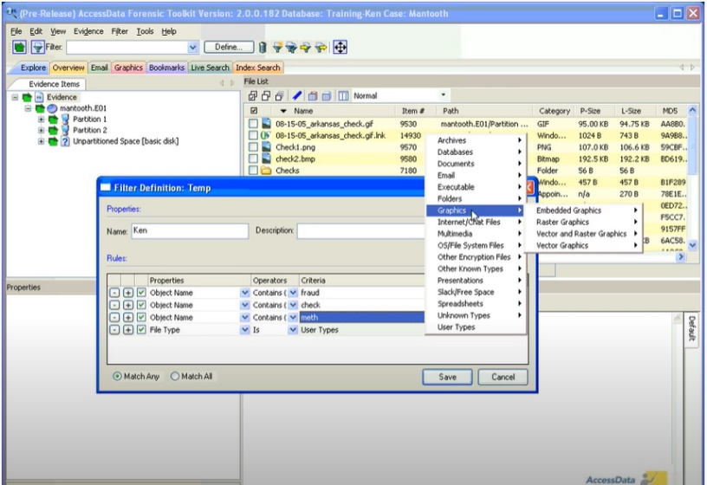
[21]

For a more granular approach John chooses to use MailXaminier which is a proprietary tool used specifically to recover desktop and mail client (such as Hotmail) from the computer. This can be used to search for particular contacts within the mailboxes.
The benefits of using such tools is that they search slack space (an area that exists on the Windows disk between the end of the file and the last cluster), recycle bin, deleted items, Master Boot File (MBF); the pointer for each partition on the disk including file type. Within the Slack Space there could be usernames, passwords or other sensitive data hidden away.
Due to the type of computer being a Windows device the toolkit selected would also search the New Technology File System (NTFS) which allows for permissions and security of the file system. NTFS uses Master File Tables (MFT), this does include Modified Accessed Changed – which is essentially a more granular way of when files were created, accessed etc. The exact place where these are stored in is called $BITMAP.
It should be noted that the suspect may have employed anti-forensics onto their computer. Anti-Forensics being defined as any intentional or accidental change that can obscure encrypt or hide data from the forensic tools. This can include, but is not limited to, overwriting or changing metadata, encryption of files, partitions, network traffic, external devices that leave no trace and finally steganography.
This case is unique in that if there is encryption that has been used or other methods of deception, with the suspect now dead it would be relied upon that they might have passwords or other suspects that may know the same deception techniques.

Report Writing
For John to write a report on his findings he must state facts not opinion. John should remember that this document could be used in a court of law and it is up to the jury to decide if the suspect is guilty or not. From the beginning to the end of the end of the recovery of the data up to and including any flaws or errors that may have been listed during the course of evidence gathering. Rather than describing what is going on in the videos to the court which could be manipulated by the prosecution or defence perhaps a video clip to be played to the court or perhaps still images would be better presented.
FTK can be used to create the report with multiple screen shots of what is being gathered at the time.
The report that John writes should be checked through by someone who has experience of court trials, weeding out spelling, grammar or other mistakes as well as explaining technical terms and references.
A copy of this report can be seen at Appendix B.

Conclusion
As long as John adheres to the Science, Law and guidelines that have been set out at every level there is very little ambiguity that the defence or prosecution can pick away at. From starting the chain of custody very early to the completeness of his reports will show the evidence in a reliable light. Minimising time with the original data and early gathering of connections as well as good husbandry will lessen the risk of data being altered accidentally. By establishing the former from an order of volatility John can work fast at gathering the evidence. Should John encounter anything that could give reason that there is an imminent threat to life, John should raise this with Mr Wales. The whole purpose of the following the guidelines laid down by the CFFTPM are designed to prioritise this crucial data. This also recommends that John solely works on one piece of evidence and completes this before moving onto the next one.
By using well established tools and noting down their firmware etc, this can cutdown on the time taken to analyse the data, updates to this software can also search in places that the investigator hadn’t previously considered as well as doing it efficiently. The official software will already have undergone some scrutiny and are very well versed at producing reports for courts.
As long as John sticks to the facts when documenting his findings and following the set format, there can be very little that the court can question. John should be careful when creating an invoice and sending it to the Chief Investigator as this should only be a quote and things might take a lot longer than anticipated. Perhaps a very rough estimate, followed by a bill at the end would suit both parties better.

References

[1] | N.-A. L.-K. M. S. Ben Hitchcock, "Tiered forensic methodology model for Digital Field Triage by non-digital evidence specialists," Digital Investigation, vol. 1629, pp. 75-85, 2016.
[2] | J. G. R. M. T. W. S. D. Marcus K. Rogers, "Computer Forensics Field Triage Process Model," Journal of Digital Forensics,, vol. 1, no. 2, p. 22, 2006.
[3] | K.-K. R. C. Xiaolu Zhang, Digital Forensic EducationAn Experiential Learning Approach, Cham, Switzerland: Springer, 2020.
[4] | E. Casey, Handbook of Digital Forensics and Investigation, Burlington, MA: Elsevier Inc. , 2010, p. 2.
[5] | T. K. D. Brezinski, "Guidelines for Evidence Collection and Archiving," IETF, 1 Feb 2002. [Online]. Available: https://tools.ietf.org/html/rfc3227. [Accessed 17 March 2020].
[6] | C. Easttom, System Forensics, Investigation and Reponse, Burlington: Jones & Bartlet Learning, 2018, p. 461.
[7] | N. O'Mahoney, Netstat, Swansea: None, 2020.
[8] | OS Forensics, [Online]. Available: https://www.osforensics.com/registry-viewer.html. [Accessed 17 March 2020].
[9] | S. Alonso, "Network Forensics – Traffic Analysis," Cyber-IR, 21 July 2015. [Online]. Available: https://samuelalonsog.files.wordpress.com/2015/07/wire.jpg. [Accessed 17 March 2020].
[10] | H. Carvey, Windows Forensic Analysis, Burlington: Syngress Publishing Inc, 2014, p. 98.
[11] | J. Liu, "[Fixed] 'Current Read-Only State Yes' on USB Flash Disk/Memory Card," easeus, 16 Sept 2019. [Online]. Available: https://www.easeus.com/partition-master/current-read-only-state-yes.html. [Accessed 17 Mar 2020].
[12] | S. M. P Cisar, "ETHICAL HACKING OF WIRELESS NETWORKS IN KALI LINUX ENVIRONMENT," Annals of the Faculty of Engineering Hunedoara; , vol. 16, no. 3, pp. 181-186, 2018.
[13] | None, "Law Enforcement," MailXaminer Website, 2020. [Online]. Available: https://www.mailxaminer.com/law-enforcement.html. [Accessed 02 April 2020].
[14] | S. Garfinkel, "Anti-Forensics: Techniques, Detection and Countermeasures," Navel Postgraduate School, Monterey, 2017.
[15] | H. A. Committie, "E-Crime," 17 July 2013. [Online]. Available: https://publications.parliament.uk/pa/cm201314/cmselect/cmhaff/70/70.pdf. [Accessed 02 April 2020].
[16] | P. O. o. S. &. Technology, "Digital Forensics and Crime," 01 March 2016. [Online]. Available: http://researchbriefings.files.parliament.uk/documents/POST-PN-0520/POST-PN-0520.pdf. [Accessed 02 April 2020].
[17] | Govenment, "Legislation.Gov," 01 Jan 2000. [Online]. Available: http://www.legislation.gov.uk/ukpga/2000/11/section/58#commentary-key-958aed83b6f6c7041cad6f7da254b116. [Accessed 02 April 2020].
[18] | J. Williams, "Digital evidence," 2012. [Online]. Available: http://library.college.police.uk/docs/acpo/digital-evidence-2012.pdf. [Accessed 09 Mar 2020].
[19] | ISO, "ISO/IEC 17025 - GENERAL REQUIREMENTS FOR THE COMPETENCE OF TESTING AND CALIBRATION LABORATORIES," Jan 2020. [Online]. Available: https://www.iso.org/publication/PUB100424.html. [Accessed 09 Mar 2020].
[20] | S. L. Garfinkle, "Digital Forensics," American Scientist, vol. 101, no. 3, pp. 370-377, 2013.
[21] | M. Bolat, "Forensic Toolkit Filtering Basics," 20 Sept 2015. [Online]. Available: https://www.youtube.com/watch?v=mfdN0YHkRnc. [Accessed 2020 April 01].

Appendix A
Forensices Investigation UK  No Stone Unturned  10 King Road  London NW1  Phone: 020 123456 Fax: 020 123455 | ESTIMATE ONLY  Invoice #ABC1234  Date: 01 April 2020
To:  Criminal Prosecution Service  15 Crown Court  Westminster | For:  Case number #123456
DESCRIPTION | HOURS | RATE | AMOUNT
Call Out To Site Fee  Secure Device(s) | 1  3 | 200  100 | 100  200
Hard Drive Investigation | 20 | 50 | 1000
Detailed Report  Meeting With Client  Court Appearance(s) | 20  5  15 | 50  100  100 | 1000  500  1500
Nothing Further Below This Line | NIL | NIL | NIL
TOTAL | 4500
This is an estimate only not a final bill of sale.

Appendix B
Report
http://www.rnyte-cyber.com/uploads/9/8/5/9/98595764/exampledigiforensicsrprt_by_ryan_nye.pdf
Digital Forensics Report
Evidence Analysis of Case #12345
By John Williams
Forensics Investigation UK

Investigator
Mr Mark Wales Chief Investigating Officer Heathrow Police Department

Digital Forensic Examiner (technical)
Mr John Williams Professional Detective for Forensics Investigation UK

Subject Digital Forensics Exam Report
Accused: <insert name here>
Offence - Terrorism, plotting terrorism
Date of Request - 1 Feb 2020
Date of conclusion - 2nd March 2020
Report Published - 12th March 2020
Abstract
The purpose of this report is to provide findings and report on procedures from the event that took place on Monday 1st of Feb 2020 at Heathrow Airport. Included within this report details the processes that have taken place, evidence gathered, methods used to gather and the principles guiding.
It (the report) is designed to be unbiased and to guide the court to the digital findings surrounding the case.
Case Background.
On Monday 1st of Feb 2020 A terrorist was shot down at Heathrow International airport. His face matched with the terrorist list. He tried to escape when the police confronted him; eventually they shot him. He was carrying a laptop briefcase when he was shot down.

Mr. Mark Wales, the Chief Investigator at The Heathrow Police Department made a phone call to Forensics Investigations UK, a professional investigation service, and asked them to investigate the items in the brief case.
The investigation was conducted in accordance with the procedures and guidelines of <insert reference here> and Forensic ToolKit (FTK) was used to find and recover files from the laptop that was found.
Standards, Principles and Criterial Followed
<ISOXXX>
<Police Guidelines>
<ETC>
Acquisition
Data can be manipulated and changed by accident or by malicious intent. It is most secure to make a copy of the original evidence then work on the copy of it. There is however, volatile data which cannot be copied and must be worked on immediately to preserve the evidence. This is assessed by the forensics investigator who arrives on site.
Examination
This is the process of copying the data from the original source and placing it into software which is capable of making it human readable again.
Documentation and Reporting
All processes conducted as well as observations are recorded within this documentation.
Search and Seizure
Search warrants for digital evidence were granted by Mr Mark Wales after
http://www.rnyte-cyber.com/uploads/9/8/5/9/98595764/exampledigiforensicsrprt_by_ryan_nye.pdf
Legal Issues
Issues can arise from any given evidence; the following has been specially selected for this case. Issues that the investigator has encountered are admissibility and reliability in court.
Offence
Police and Criminal Evidence Act 1984
Investigatory powers Act 2006
Section 58 of the Terrorism Act 2000

Search and Seizure
Mr Mark Wales granted authority by way of a warrant to analyse evidence on the terrorist suspects laptop device. The search warrant granted access to the contents of the laptop case after it had been searched for explosives.
The investigating officer Detective John Williams attended the scene of the crime to a security room nearby with the contents of the laptop and laptop bag. Immediately photographs were taken of the front of the devices, the back and the sides. All makes, models and serial numbers were taken down. As the computer was in standby mode, power was applied and the device turned on. The laptop was not locked at the time and a photograph of what the suspect was last looking at was taken. An order of volatility was followed with current network connections, date, time and timezone all noted. Subsequent interviews with associates of the terrorist showed that he was the only one using this device. The devices were packed securely once the order of volatile data had best been recorded, signed, bagged and tagged.
There did not appear to be any additional media to analyse. The area where this was conducted was in an office space which was in good condition and tidy and free of electromagnetic interference or liquid.
Processing location
The device and ancillaries were taken to the Forensics Investigation Lab in Central London which is an accredited laboratory. This lab has qualified and competent staff who undergo security cleared vetting on a yearly basis. Non volatile data is analysed by impartial staff and take around 30 days to turn around then report on a recovered disk.
The certification is such that:
Evidence can be assured of secure transit to the site
Storage of evidence from outside factors such as liquid or electrical are mitigated to almost zero.
Documentation is complete and accurate
Continuous improvements to better processes are ongoing at this site.
Chain of Custody
All evidence is correctly labelled on the outside then sealed by the person handing it in and the person receiving it.
Accurate location within the safe area is recorded
If the package is opened or moved this is also recorded
Forms are completed to high accuracy (serial number, make, model etc).
Storage
This takes place in a static free environment, in a high secure safe area within a forensics storage unit. It has 24-hour security, all staff are security cleared to be in the building. All staff are required to have retina recognition before access is granted to the safe area, and again to the individual locker where the evidence is kept. These are kept to strict security hours, the logs of which are sent to the security team and are reviewed on a regular basis.
Alarm systems are tested regularly at this building and the doors are military grade strength. Each deposit box is checked on a weekly basis to ensure its contents comply with the register and anomalies are reported straight away to the security team.

Evidence Examination
Preparation
Item No | Owner | Description | Operating Sys | Serial No. | Tool
1 | Suspect | Dell Laptop | Windows 10 | XX12345 | Access Data FTK

Extraction
The non-volatile data extraction was performed on the above-named device. Included but not limited to: Master Table Records, current files, deleted files, slack space, unallocated space. The tool used automatically did this for the user.

Analysis of Extracted Data
Data was extracted as to be expected from the drives. Files recovered were: videos, documentation, images and emails. Files containing key works such as ‘Mason’, ‘Mason Airport’, ‘Terrorism’ and ‘Bomb’ were recovered.

Data Hiding Analysis
The non-volatile data was also subjected to a hidden data search, which concluded that there were some images and text found amongst some pictures. There was some encrypted data that was also found on the device suggesting that someone had been trying to hide data on this laptop.
Determining Ownership of the Data
Following interviews with the police and the user account found on the laptop the device seized only appeared to have one user account associated with it. Evidence gathered from the interviews also matched the timestamps that would have placed the suspect alone with the laptop device at the time.
Device | Owner | Evidence
Dell Laptop | Suspect | Suspect and interviews, one admin account on this device.
Evidence Processing
Objective
Device Type
Serial #
OS
Charge with
Detective
Evidence
Chain of Custody
Location of Lab
Tools
Assessment
Acquisition
Examination
Documentation & Report
Detective Comments

Evidence Hash
The evidence of the original disk was calculated in an MD5 hash. A bit-by-bit copy of the disk was made again this produced an MD5 hash. Both were compared to ensure that they were an equal match. If they were an equal match this means that both are identical copies. If there is a difference in the hash it means that something has been altered.
Evidence Analysis
Data disco

