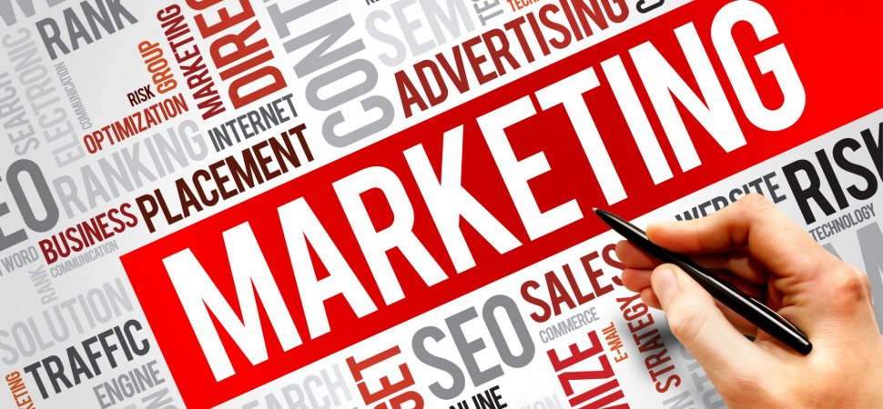

Course title: Marketing Essentials

Name: Biswajit Mukherjee

1815040

M4x01916

Assignment 1

Lecturer: Dale Clark

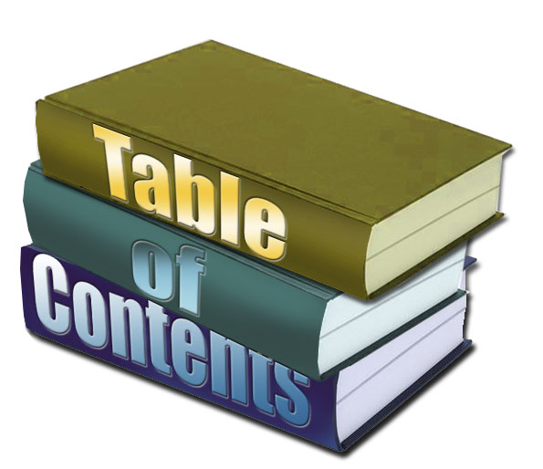

Introduction …………………………………………………………………..P1

MIS for marketing…………………………………………………………………..P2

MIS for Information Gathering…………………………………………………….P3

MIS for Communication ……………………………………………………………P4

Conclusion……………………………………………………………………………P5

Reference……………………………………………………………………………..P6

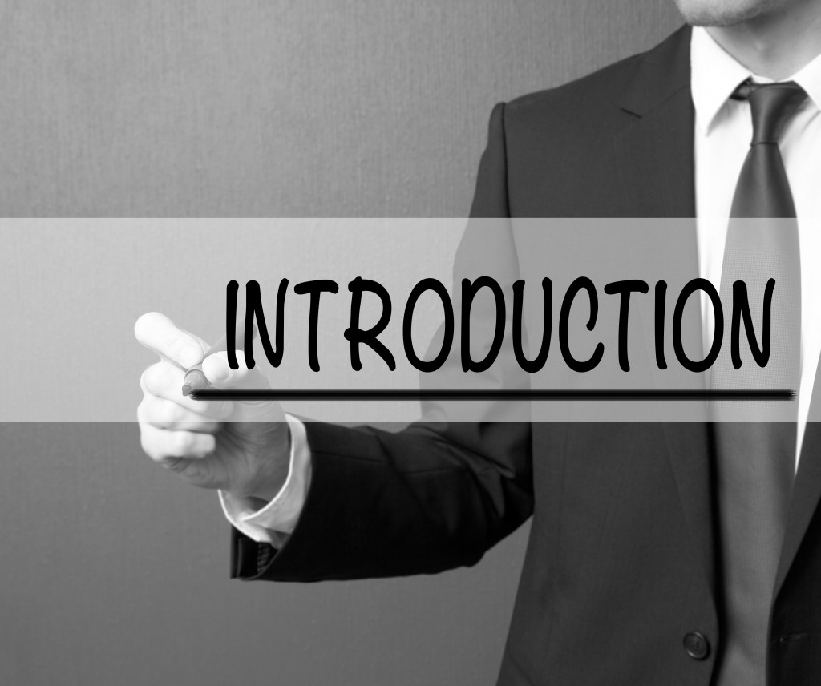

This report is structured around Hyatt group of hotel marketing
Information systems.
Marketing is one of thinking which is based on human needs and wants by
exchange. Marketing Information System is going to more important and our economic strength depends on this service and understand about customers’ demands. company can collect about market information, they can make plan their strategy how they will develop, and their policies make easier for customers by this System. This Marketing helps analysis system and based on the project that customer get support. A good customers relation, a good service, information about their competitors that helps to know the current situation about market. It is important to understand that about individual customers, about company, or customers who takes decision to make purchase.

- In according to Jobber and Fahy in 2006
“Quality project to help in the decision-making process composed of four elements; Database (internal reports), Marketing intelligence (Economy market, business environment) market research (regular and special occasion/goal specific) analysis of marketing information (decision support system)”

- In according to James in 1998
“A complex interacting structure of people machines and procedures to generate, in an orderly and pertinent manner, internal and external information to the organization used as a base for the decision-making process.”

- Gronroos, C. (1981) ‘Internal marketing: an integral part of marketing theory’, in Donnelly, J. and George, W. (eds), Marketing Services, Chicago, American Marketing Association.

- Berens, J.S., "The Marketing Mix, the Retailing Mix and the Use of Retail Strategy Continua," Proceedings of the 1983 Academy of Marketing Science (AMS), [Part of the series Developments in Marketing Science], pp. 323–27

Here assigned to do for marketing product, price place promotion and also have been assigned to do cost, convenience, communication and consumer wants and needs. Here can use different types of method for marketing. They can get help use web traffic or they can do advertise their product by websites. Company can use different types of methods in web site, such as text, graphics and other types of web design. conversion is always helpful for marketing and it can be a company strategy. Amount of online customer or newly joined customers will be increase. Advertise is the important process and this process use every business industry. They do product promotion for their potential buyers. It is integrated process through which create value for customers and build strong relationship with customer order to capture.

There is an example of one hotel which is HYATT GROUP is famous hotel industry. They dedicate trustable service to their customers. so, they try to give their best service. Employees are friendly, and they look after their customers with full responsibility. They are designed their website with very easy way for their guest. Guest easily can access their service. They are giving service since 1957.In time of social media they expanded their service in social media and that reason guest are really finding to easy way to access their service.

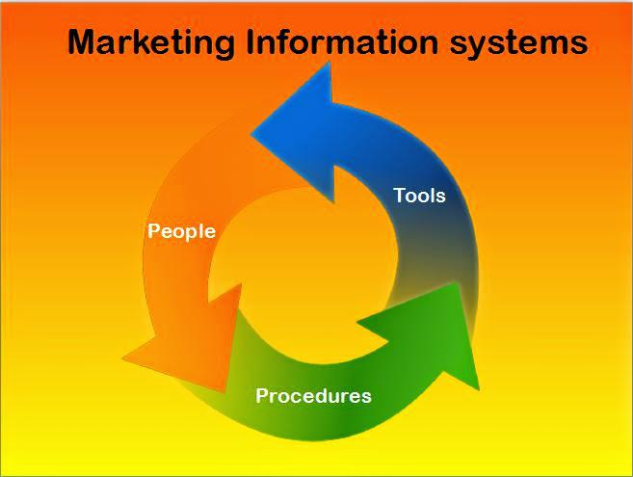

Marketing information system for marketing

This system analyses and assesses marketing information. The organization gathered their source from outside and inside. Marketing information is very important for every company because they supply their information about growth and refinement of product. This system also provides the knowledge about pricing, packaging, distribution, media selection and promotion.
In according to (Jobber, 2007) defines it as a “system in which marketing data is formally gathered, stored, analysed and distributed to managers in accordance with their informational needs on a regular basis”.
Marketing manager face numerous problems from time to time during the conduct of marketing activities. They need information upon which they may take proper decisions. Manager is by profession is decision maker. Manager is one of the important roles in marketing. As per work experience can say manager responsibility to make sound and rational decision. The quality of decision is determined by the skill of decision maker plus the quality of the information. To satisfy the modern concept of marketing, the availability of adequate information on consumer requirements and preferences must be regard as key factors in marketing planning a firm or company must continuously receive and monitor environmental information if it must face the dynamic environment. Availability is a most important part for the company. Always sales depend on availability for every company.

Above discussed about what marketing information is. Now question is only for base of information cannot get proper knowledge about marketing, and that’s why added some more information about marketing. Whenever explanation about any company knowledge is main important parts of marketing. Such as: product development, price, product packaging, distribute product, media and product promotion on behalf of company.
Product Development | - Product development is important thing for every company. it is the base of the company. Before introduce any product must have idea about the products.  - Judge the product.  - Need to take strategy  - Create plan
Price | - when any new product launched then price need to be select of the product.so it is another part of the marketing.  - People when get information about the new product then they can easily think about their own budget.  - High price less demands  - Good price setup feels customer fair deal
Product Packaging | - Cannot sell product without packaging.so it is another important part.  - Its cover health and safety issue for the customer.  - How good I am packaging customer impression depends on that.  - Customer can judge easily about the product depth  - Increase sells depends on product packaging.
Distribute Product | - Before distribution have to study market thoroughly.  - For the customer loyalty can achieve by distribute of the product.  - Save customers time.  - Happy customer gain business sells.  - Collect trust for the company by distribute product.
Media | - It is one of the most important. Social  - Media marketing increase customer loyalty  - Make more different types of customer and build relationship with customers. increase  - Awareness of the products.  - Every day more than three billion people are increase
Product promotion | - Introducing product customer.  - Explain about feature of the product  - Awareness  - Approx.…. three billion people are using social media.  - Create interest.  - Increase profits.  .

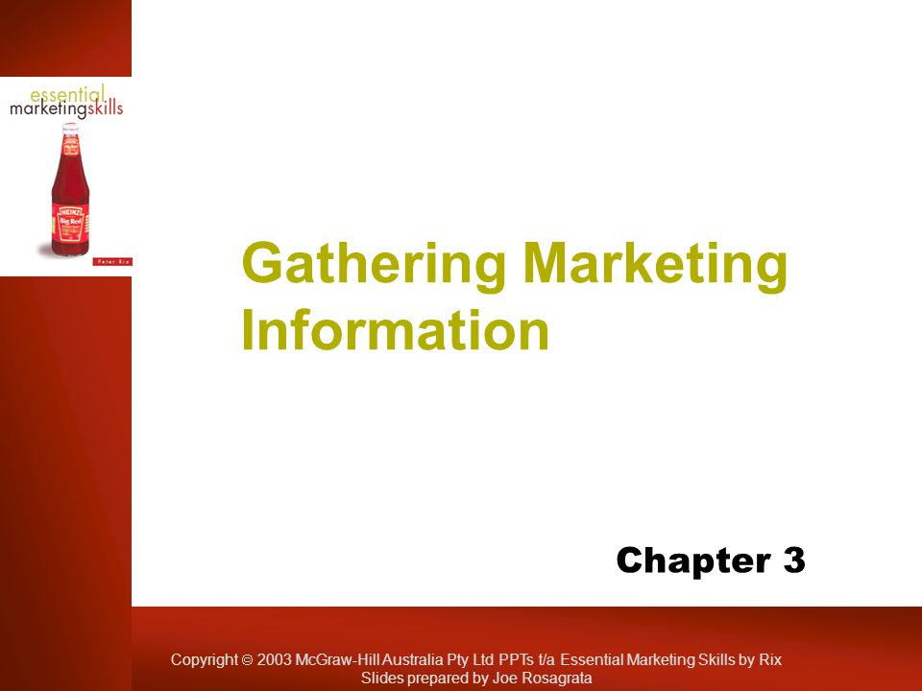

previously discussed introduction about marketing information system for marketing and now will discuss how to gather information about marketing.
Gather information means collecting data. So, company gather information or collect data reason is to grow their business. It is very important to collect data, because they can easily get information about their customers what they want, or it says about knowledge of their customers and competitors in markets. This information they can collect but they have to follow our data protection act.
Now the question is how it is possible to collect or gather information?
Discuss few points about that. Such as

1: strengths

2: weakness

3: After complete market research changes about pricing strategically.

4: Gather information which product is suitable for which place.

5: Gather information about competitors surrounding your place.

6: Collect information about customers essential products of their daily life.

Giving one example base on above our MIS for gathering-

We know that present market situation is very competitive.so I am going to talk about one sector which is retail.
They are always customer oriented. They think about customers. Here I want to mention one retailer which is not only United Kingdom even most of the places in the world thy have branches. I want to talk about Hyatt group of hotel
They are always helpful for customers. They have lots of hotels in London.700 hotels in out of 63 countries. Most of the places in London they opened their business because customer prefer Hyatt hotels. This is one of the strategies.
They selected reasonable tariff and their quality of service in their hotel. Every hotels launched their customers membership cards, but Hyatt launched contactless membership or club card first than other hotels.
They are gathering information from customers club card that what kind of customers is coming and about their demands. They send free coupons, vouchers, and many more offers.
So, we easily understand why important gathering information for marketing is.

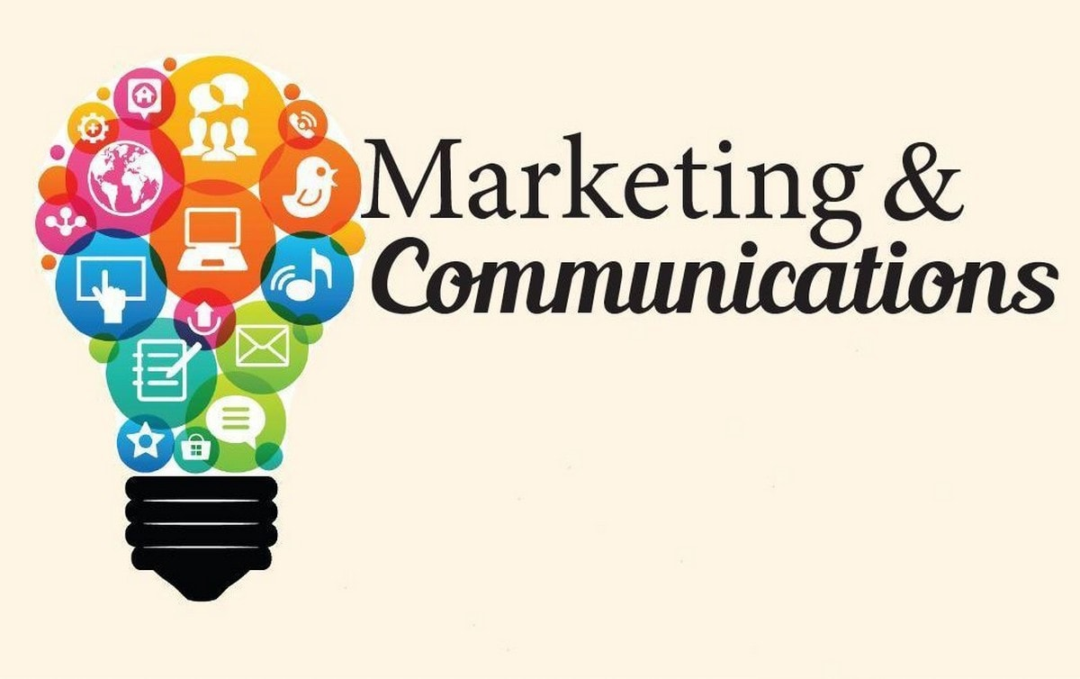

Marketing communication is another important part and we cannot ignore this point from marketing. Every companies have different way of communication, but it is true that without communication in marketing cannot achieve their goal. Company always put some efforts to communicate about products, sells, market current positions, about competitors, and brand of the products which they are selling at present or future product which they will launch. There are so many ways to do communicate but six major methods are most important. Such as:

1: Describe about products.

2: personal selling

3: Marketing via promotions

4: promotion of products

5: Relationship with customers.

6: Financing

So, these are always must follow when they do marketing for their company. There is important thing which they need to do and that is not only communicating outside communicate each other inside the company also. That are most important things
which can say.

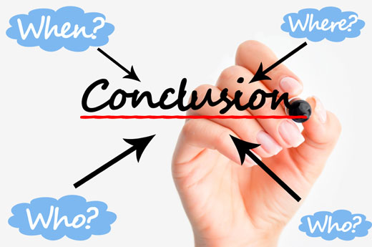

After exploring the Hyatt hotel group of Marketing information systems, and the above discussion which been discussed that the whole part of the marketing for any company is very important part. A company when they decide that they will do business and attract customers then they need to think about how they can promote their business and how quick they will be reach at top.so from this assignment already been discussed that the 4 ps are very important and as well as management team need to be more active and they need to understand about marketing mix. When they will gather all information and apply to their company then company will be improving and can take better position in this world. communication is one of the biggest points in marketing. Without communication a company will not get proper and appropriate information from either outside or inside.



- Blythe, J. (2001) Essentials of Marketing, 2nd edition, Prentice Hall

- Baker, M. (2000) Marketing Management and Strategy, 3rd edition,
Macmillan Business.

- Davies, M. (1998) Understanding Marketing, 1st edition. Prentice Hall

- Fill, C (2002) Marketing Communications, Contexts, strategies and

applications, Prentice Hall

- Kotler, P. and Armstrong, G. (1997) Marketing an Introduction. Fourth
Edition. New Jersey. Prentice Hall International

