

LOCATION: Swansea | LLEOLIAD: abertawe
LEVEL 6 | LEFEL 6
EXAMINATION PERIOD | CYFNOD ARHOLIADAU
January 2018 | Ionawr 2018

MODULE CODE: ACCA6001
Network & Data Centre Management
TIME: 2 HOURS

answer THREE quESTIONs out of FoUR

Equipment or materials required – None
Adnoddau neu ddefnyddiau sydd eu hangen - Dim

ANSWER THREE QUESTIONS

Q1.

- In reference to Network Management:

  - The International Organization Standards (ISO) divided it into five functional areas, name and discuss them.
(20 Marks)
  - Network Management platform is a software package, state some basic features that are included in it. (5 Marks)

Q2.

Figure 1 below is a poorly designed network that is being implemented by a medium size business. The network personnel who are responsible for managing the network are quite inexperienced. You are required to:
- Make a list of all the problems you can identify.
(6 Marks)
- State the job function/responsibility for:
  - Network Manager
  - Network Administrator
(4 Marks)
- Rebuild/design the current network infrastructure
  - All problems and weaknesses identified in ‘a.’ above must be addressed and measures taken to correct them explained.
  - The improvement of network infrastructure should incorporate VOIP and a PBX server as part of a server farm.
  - State all assumptions made.
(15 Marks)
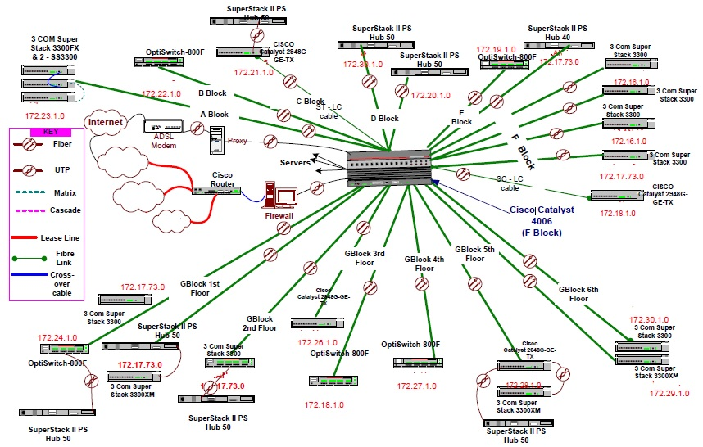
Figure 1: Poorly design network

Q3.

- Server virtualisation comprises several components working in synergy to deliver a holistic solution. With reference to this explain the following:

- Type-1 and Type-2 Hypervisors
(10 Marks)
- Virtual machines
(5 Marks)
- Virtual switching
(5 Marks)
- Management tools
(5 Marks)

Q4.

- Data centres are designed to host business applications in a centralised place. When you scale out and add new servers, a server load-balancing solution is required to distribute the client load between these servers.
i. What is Server Load Balancing (SLB)?
(5 Marks)
ii. List some of the benefits of SLB?
(4 Marks)
iii. Explain server-based and network-based load-balancing solutions.
(16 Marks)

Diwedd/End

