M6X01244
Major Project: Design Realisation and Communication - CW2
BA Automotive Design
UWTSD
Harry Cuthbert

Executive Summary
This major design project I have chosen to do is a luxury yacht, designed with Mercedes brand vision. This 30m yacht is designed for 2025 and is powered from renewable power sources as yacht regulations head towards zero emissions in the next few years. This yacht envisions the future of yachting through the advanced technological features that step towards a more renewable future. The yacht visualised the sea life scenery through the design by taking inspiration from creatures like sailfish and sharks. The yacht mixes luxury and performance to create a high end luxury yacht perfect for the Ports of Monte Carlo or docked in St Tropez.

Evaluation of the design development and realisation process
Week 1 (January 2021)
This term I started with working on refining my design after the feedback I received from my December presentation. The final drawing was an extremely bold design, that used this gill like shape along the edge of the hull. The problem with the design was not being suitable as a functioning design and so a reshape would be needed. Another problem with the design was the inspiration from Sea life and Mercedes Benz is what needs to stand out in the design, however this design was described as sharper and more aggressive and had more distinct Lamborghini design features instead of a more curved and flowing design.
I started with trying to shape the fins as separate structures in the water through earlier design ideas and giving these fins a wave inspired shape to the design. This was inspired through looking back at my mood board and creating softer shapes in my drawings to allow for smoother and easy on the eye design. My design needed to have a feature piece that would stand out from other yachts across the luxury docks of South Europe, by having these sculpture like designed pieces that sat in the water, it had an art piece design to it.
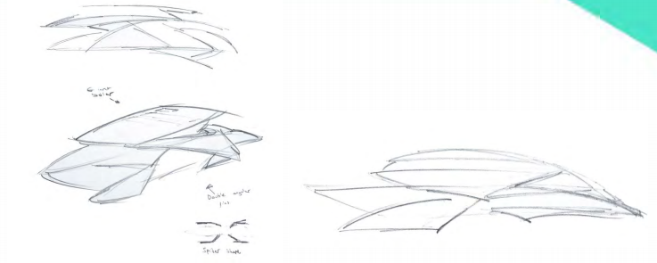

Week 2+3
This week I started to create these wings and fin structure that I had redesigned to the hull of the boat. By using Alias, I was able to start to create a simple shape and layout for this fin and wing design allowing me to use this for reference images when further developing my design.
I then designed this curved shape as the roof to my design with these side curves that swooped from the flybridge to the main deck. This was inspired from the shape of a door handle in a Mercedes interior and the shape I looked and forming into yachts structure. The design needed to reshape the upper superstructure because of the blocky design to the centre structure.
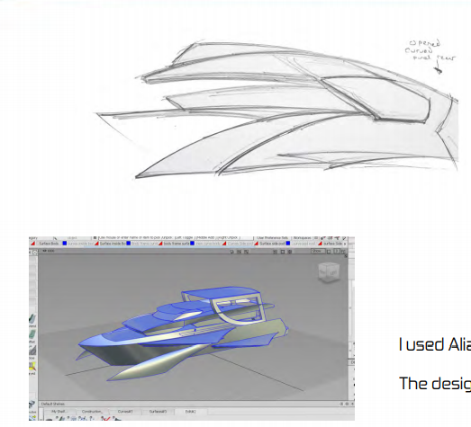
I then started to create this developed roof design in Alias, using a template drawing simply drawn over the shape to allow the curves to follow the lines and create my design as the model. The design featured this swooping side curve which attaches to the roof piece, designed as a big solar panel skylight.

Week 4
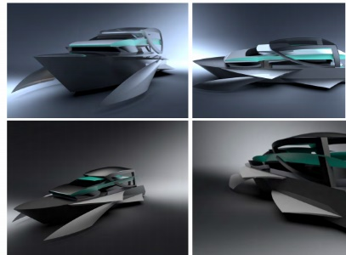
Development continued on my Autodesk Alias model to put together a
more complete model. This design was a more complete and working shape
and allowed me to have a basic design I could use for reference angles.
The design was modelled in Autodesk Vred with a basic early colour
scheme using a black design with the turquoise accent.
I started to plan the layout of the yacht as well using Adobe illustrator
to be able to layout the rooms and make sure the yacht had enough space on board.

Week 5 (February 2021)
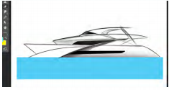
February started with feedback from the January model, the main feedback for the design was to redesign the superstructure. Mainly the simple blocky shape needed to be redesigned to flow with the yacht as one complete design. This design needed a major change that would redesign the main upper structure of the yacht to flow with these sidepods and fins that had been created.

I used Photoshop to redesign the side view of my design. I played with shaping
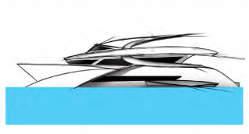
different layouts and angles and following a more similar curve lines to create
a design that stands out as a sculptured luxury vehicle that has the modern
approach to the design.

The most important design change for the yacht was to focus on creating the
curve along the side of the flybridge deck as one single structure as the previous
design of my model had it separated through the design of the structures on the
main deck. However, this design focuses on creating a design that stands out and
so, this new design was meeting the criteria I was looking for in the design of the yacht.

Week 6 and 7
The design that I liked the most was then used in Autodesk Alias as a template
image for me to then redesign the upper structuring to the yachts design. By
redesigning the superstructure section as one flowing piece will allow the model
to be more useful in template images as will be a more flowing shape to follow for
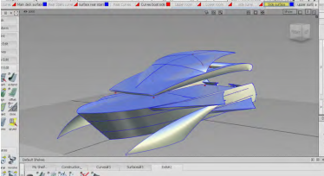
my yacht’s main structure.
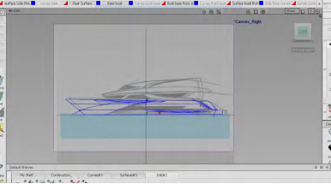
I was also developing my designs shape still in Photoshop. I looked at adjusting
the curve on the back of the design to see if I could still keep that early shape
design. However, the overhanging shaped design was the preferred design shape
for the yacht and kept the rear open and clean allowing the light into the yacht.

A design idea that went further to develop was the reshaping of the main deck
lounge area and by creating this wing like structure on the side but expanding
the deck out the side over the wings. The design looked at inclosing and having
a conservatory like design, as well as focusing on shaping like vents on the side
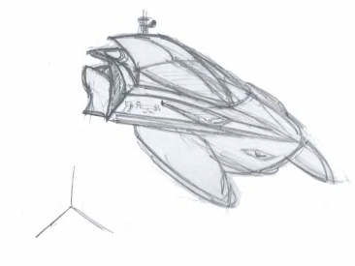
and having the design and open side lounge decking area.
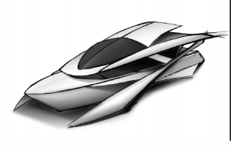

Week 8
This week I added the wing feature to the design, and was thinking about how
the front could reshape and connect to this side design in creating a flowing
shape that could still allow for this wider main deck structure. I focused on
trying to avoid reshaping the curve along the flybridge deck.

The design in the end removed this wing feature and extended deck design
because of the shape change to the design would be too dramatic to the
soft flowing curved shape and that it did not fit onto the design. However, looking back the design of the interior decking overhanging onto the wings would have been a great additional feature to the design to make this an open and luxury yacht.

Week 9 (March 2021)
Heading into March I was looking at creating an iconic feature into my design
Which would meet the brief of my design to create this luxury yacht that fits into
its ocean environment.

A big interest of mine from the research stages was the design of a triple front
hull. The design from my moodboard that inspired me was the Bluebird that was
a speed record boat and this history in boating as well as the racing history was
definetly a boat to be inspired by for my yachts design to envision this new high power
era of yachting. The design idea I had seen on a Lamborghini Super Veloce and the boats
design had triple front like design that I looked to incorporate in my design.

Week 10

The developed idea of a new designed hull using this split front was not
further developed due to the marital problems with changing the hull shape.
The design shape however from an aerial view was wanted to be kept and so
redesigning the front meant reverting back to the orginal hull shape.
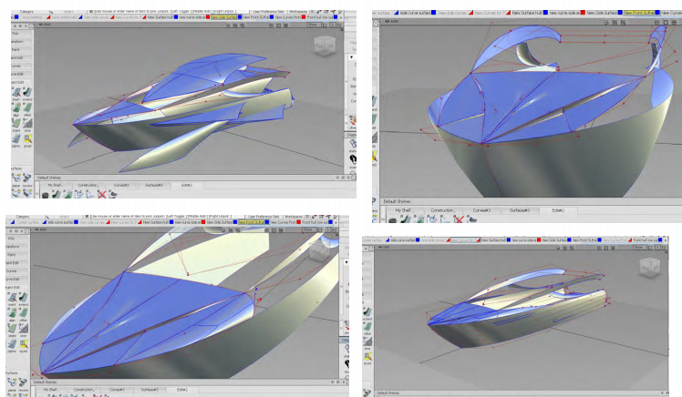
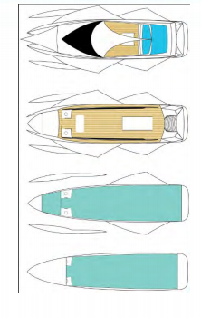
I started to get a rough layout plan for the deck layouts as this is an important
part of the design that needs to consider the layout of the yacht as could effect
the shape of the exterior.

Week 11

Development to the roof began, as a simple initial shape for viewing this initial
design needed to be developed into the 3D shape of the roof. The design looked
at creating a roof vent over the cockpit, and connecting the side of this roof panel to the fillets on edge of cockpit to create and enclosed smooth surface on the flybridge deck.
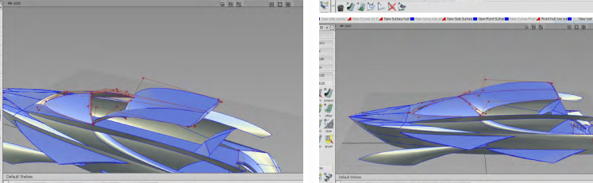
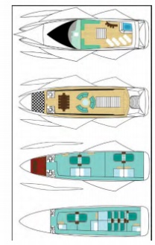
I also was developing the Photoshop layout of the yachts deck plans as these would show each level of the yacht and the room layouts on each level. The design was fairly easy to shape as similar rooms kept similar objects and layouts such that of the guest rooms.

Week 12

Once the roof had been surfaced and windows cut out the surfaces for the windows were then placed into the roof and allowed a more detailed roof piece to be ready to have colour materials added in the VRED software. Once the roof was complete the flybridge deck needed to be finished with the walls and inside surfaces needing to be put together, which with the exterior surfaces already in place is easy to create the curves and shapes and create the flybridge deck interior walls.

Week 13 (April 2021)

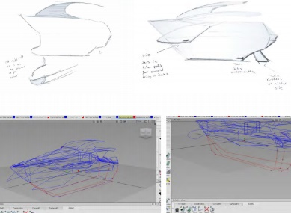
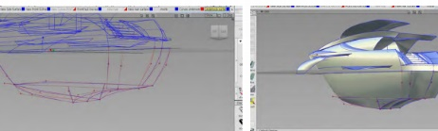
This month started with the design of the underbody of the boat in the model. This is important for getting the scale of the size of the yacht, This allows a break down side view of each level on board the yacht. This needed to be aligned well to make sure the levels of the hull all connected avoiding gaps in the hull of the Alias model. This week I also developed the stairs on the yacht that still wasn’t too scale with the size of yacht, this was just needing to multiply the curves created for the stairs.

Week 14

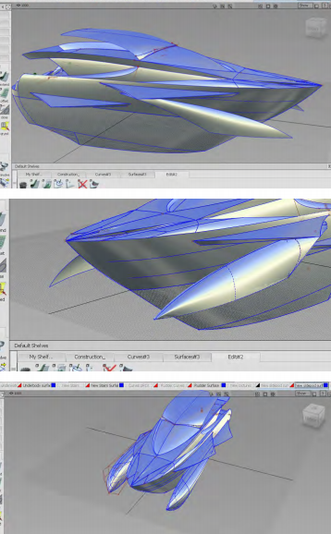
This week I started on developing the sidepods design. By using a side view drawing of the new pods shape I was able to follow the curves of my design to reshape a cylinder object in Alias to create my new designed sidepods for cutting through the water efficiently. These new pods needed to be designed as the shape previously was a single skin shape and by giving this design the full shape and 3D look this comes together with the model to create a closer to a final model.

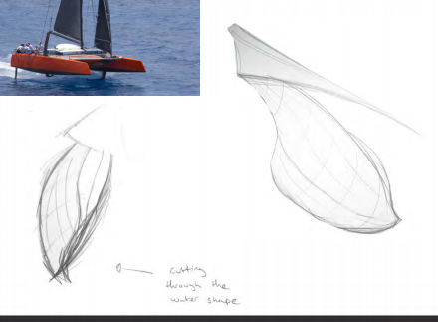

Week 15
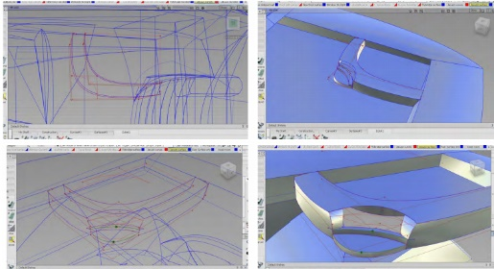
This week I worked on the flybridge deck and for building part of the interior into the design, the Jacuzzi design was incorporated into the corner of the decking area. Using a template top view image of the upper decking, this made it easier for the roof window curves as well as the shape of the Jacuzzi.
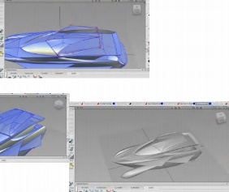

Week 16

This week I saved my surfaces in there assigned groups in Alias for exporting the model to Vred. This makes it easier to assign colours to specific surfaces all grouped together. Once the model was in vred, the material editor allows me to assign the chosen colours specific to materials for reflections and textures. The colour scheme I went for in my boat was one that was chosen from the early stage which was so representative of Mercedes branding using the Silver which is predominent in their colour brand. Once the final colours had been put onto the model,the environment can be edited to allow for different lighting in scenarios. Initially I rendered a few image scenes using the studio lighting. I then added natural lighting to the environment and set the time to an evening sunset. Once the angle is set for the model I added a backdrop of the ocean to get in the sunset light for the rendered images.

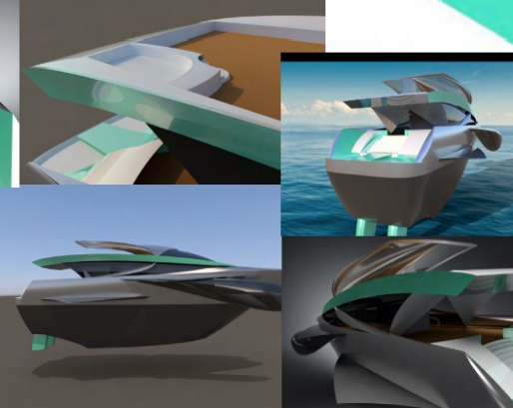
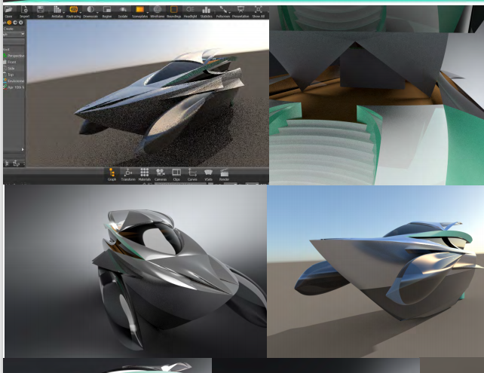

The problems I faced when Photoshopping my rendered designs was that the initial renders I had made in Autodesk Vred used the studio lighting and so the designs didn’t reflect in the environment they were Photoshopped into. I found a solution through the use of sceneplates in Vred to initially get an ocean background, and by setting the lighting to a sunset environment my renders created a much better quality image for developing in Photoshop.

Week 17 (May)

I used Adobe Photoshop to finalise the rendering photos, by adding final touches to the image to create a scene that brings this yacht to life and into an image that is seen as a photo. I added waves created on the surface formed by the yacht as well as creating the underwater shadow from the yacht in these sunset lit ocean scenes. The interior images also were rendered using angles on the boat to create the room layouts and then furntiure was photoshopped into place for final images.

The Photoshop work was always adapting each design so that any edits to a small design change or added feature each image would need to have the adjustments made to have consistent designs. This was especially important when I designed the sales brochure, as these main designs were showing features of my yachts design.

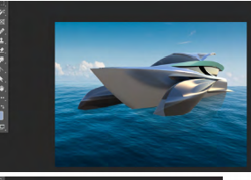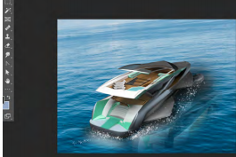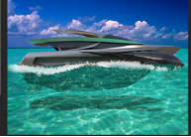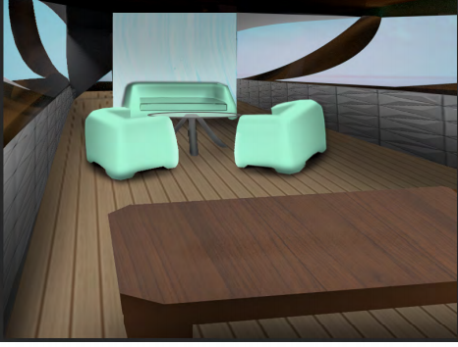
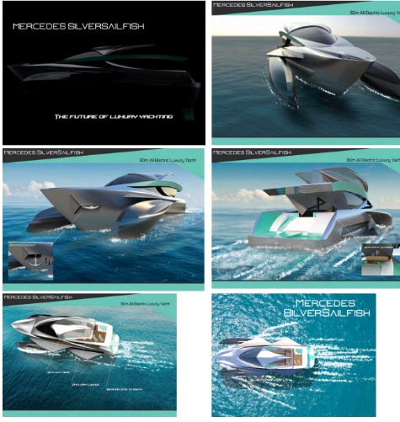
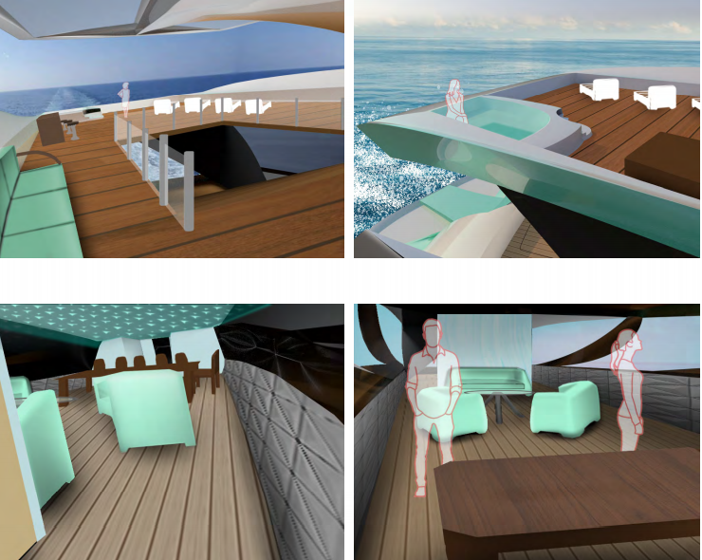

Week 18

This week I was finishing the graphics design to my silent salesman board. The design shows the eco friendly power system and its zero emmision cruise mode that is needed for a sustainable future in yachting, as well as the technical data regarding the yacht. The graphics board was tweaked a few times before getting to my final design. The main change to my graphics board was when I used half of the Mercedes logo to split the images from technical information. This was not suitable for the sales board as Mercedes brand would not want there logo half shown. The design came up with a solution of using an earlier design idea I had used with this turqoise arrows. The turqoise arrows was a much cleaner and easier on the eye sales board that showed off my yachts design much better.

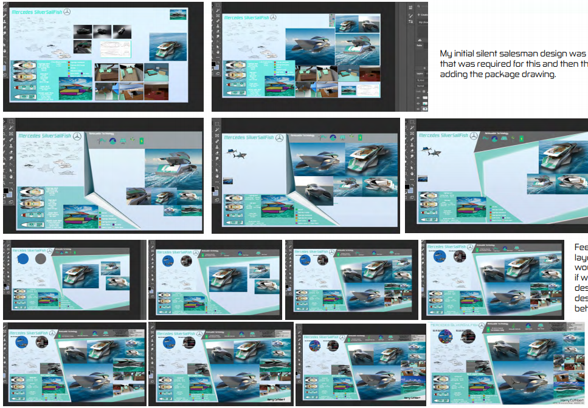

Design Outcome
My design looks at becoming the future of sustainable yachting, I look at how to power a 30m yacht using all electric power to create a luxury performance yacht that is not producing emissions when traveling around ports of Europe.

My designs side pods use a sustainable method of harvesting wave power from the under currents in the oceans. My design uses the design used on the suntory mermaid ii, however my design uses more flippers as well as being larger to produce more energy. This design was made on a smaller 30ft yacht and so considering a more efficient design of the flippers, as well as the additional flippers required for the size of my yacht. This then produces a much larger amount of energy to store in the generators however is able to give the yacht extra power when required. (https://inhabitat.com/transportation-tuesday-the-wave-powered-boat/)

The yacht outsources its electrical power from Nidec ASI, the power management system has x2 531kw electric motors, x4 350kw generators and 544kw battery packs. This system is able to power my 30m yacht efficiently and using the additional power harvested from the solar panel skylight and the wave powered sidepods gives the yacht its performance status on the ocean. (https://www.nidec-netherlands.nl/media/4380-wider-165-mega-yacht-onboard-power-system.pdf)

The design is built from an aluminium alloy structure as well as using basalt fibre in the hulls design. The use of basalt fibre it is more sustainable than glass fibre but also a more cost effective alternative and a more durable material that is UV stable. The design wanted a more sustainable material choice in the design, although carbon fibre is still use for the wings on the yacht as well as accent features to show the luxury styling on this high end yacht. (https://www.basaltft.com/hist.htm)

Overall the outcome of the yacht came to a high standard luxury yacht, which was the plan for my design at the beginning. Some additional changes to the design would be maybe to look at improving the interior design and creating a new way of living on yachts and finding more technoligical functions for items onboard the yacht.

Evaluation
Overall I am pleased with the luxury yacht I designed, the yacht I feel personally looks how I expected a luxury high end yacht to look like. My design ended up having a change to the front design of my alias model when I had to fix a watertight issue in the alias model, this meant the final complete alias model didn’t have the open ornament shaped front design, that had an extra luxurious detailing to the front inspired from hood ornaments found on luxury cars. This would be the only editing to the Alias model I would have liked to have, but my final designs still had the luxurious design. The Photoshopped designs of the exterior of the yacht did not need to much attention as using Autodesk Vred my Alias model in a sunset ocean background created a very clean photorendered design. This was something I was impressed by as the quality of the camera shots using Vred meant I just needed to add the details to the exterior in Photoshop. This part of my project went very successfully and I am impressed with my final exterior shots to my design. I initially designed my interior using just photoshop, however to get the perspective of the rooms better I decided to design the rooms as models and render them in Vred. These simple models I designed for the yachts interior allowed a much higher quality interior renders to be completed for my salesboard.

Overall I am glad that I was able to start designing the Autodesk Alias model sooner, as this allowed me to have a basic shape for developing my designs from the early stages. Also by having the main design built so soon this gave me the freedom to use Alias to design more complex features into my yachts design. The only additional model I would of liked to have produced would have been a 3D printed model or even a hand made model showing the design as a scaled version.

References

https://www.nidec-netherlands.nl/media/4380-wider-165-mega-yacht-onboard-power-system.pdf - Accessed December

https://www.basaltft.com/hist.htm - Accessed December

https://inhabitat.com/transportation-tuesday-the-wave-powered-boat/ - Accessed December

