Professional Career Development in Health and Social Care (LCHS 4009)

ASSIGNMENT 2

Name of Student: Salina Begum

I.D. Number:2437215

Name of Tutor: Amitave Banik

Acknowledgement of AI use: I confirm that I have not used AI to complete my work.

Job found based on what I would like to apply for:

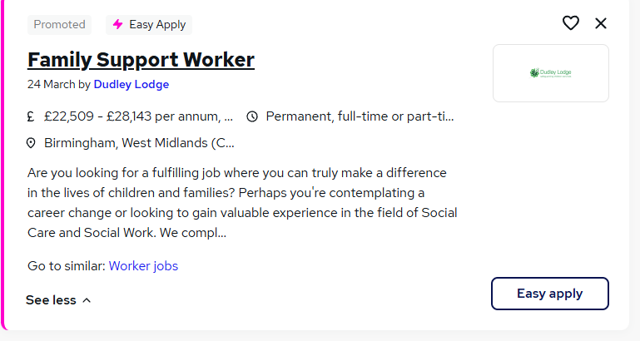

Practical Portfolio

Introduction:

Personal portfolio is visualizing your accomplishments such as skills, academic qualifications and achievements to potential employers.it also provides insight of your personality and work ethics.

Curriculum Vitae

Name: Salina Begum
Address: 34 Conway Road, Luton, LU4 8JA
Phone:07727213596
Email: selinabegum@mail.com

Personal Profile

I am a mature team worker and adaptable to all challenging situations. I like helping families on a personal level and show empathy towards them and support them during difficult times. I have experience in working as a family support worker, where I have developed strong communication skills which have enabled me to build strong relationships with clients and colleagues.

Education

University of Wales Trinity, Saint David (UWTSD)
Certificate of higher Education Skills for the Workplace (Health and Social Care)
2025-present

South Birmingham College
Level 3 in Childcare
2008-2009

Burleigh Community College, Loughborough
8 GCSES including Maths and English
1993-1995

Work Experience

SureStart Children’s Centre (Family Support Worker)
2006-2018

- Outreach work
- Family Assessment
- Safeguarding
Leading Stay and Play sessions for mother and toddlers
- Collaborating with schools or social services to improving family well being
- Dealing with housing issues for families

Skills

- Good communication skills
- Safeguarding Awareness
- Teamwork and partnership working
- Great working under pressure

Hobbies/Interest

I believe self-care is very important to everyone, I enjoy travelling solo and with family and friends. I love swimming and enjoy walking and going to Zumba classes.

Language Spoken

English, Hindi, Urdu and Bengali

References

Available upon request

Personal Statement

My greatest strength is I'm able to remain calm and work on high pressure. During my experience working as a family support worker, my ability to connect with diverse groups of people, this is a strength which I believe is essential for this field. I am bilingual and can speak fluent English, Bengali, Urdu and Hindi, which helped me to build strong relationship with families from various background.
I am a quick learner, and my ability to adapt to new situations make me a proactive and collaborative team member. Throughout my career, I have developed strong communication skills, and my empathetic nature allows me to connect with families on a personal level and help them during difficult times. I can affectively listen to families concerns and collaborate with social services, schools and health care providers.
A family support worker provides crucial assistance to families facing various challenges, their responsibility often includes working with parents on a one-to-one level. Sometimes to support families with parental skills, such as encourage them to attend learning workshops. They play a key role in supporting children's emotional and physical well-being. They work with vulnerable families ensuring they receive the practical and emotional support needed to overcome difficulties.
Family support worker focuses on early help, practical guidance such as budgeting, parental skills.
They do not have legal powers like social worker; however, they work alongside social workers. Family support workers provide ongoing support to families while social workers manage legal aspects.
During my several years of experiences as a family support worker I have successfully assisted family in crisis, developed action plans and worked along other services to ensure positive outcomes for families.

I was regularly tasked with families in crisis with housing, and financial crisis, I was able to quickly assess their needs and support them with appropriate resources.
In this field you must have strong safeguarding knowledge, which I have demonstrated in my role as a family support worker. I have handled cases involving at- risk children and women who were DV victims. I collaborated with social services to implement protective measures.
I want to make a positive impact on the lives of families, and I'm deeply committed to empowering families to overcome challenges. I am excited to contribute my skills to a role where I can make a difference to people's lives.
My passion began when I was voluntarily working in the children's nursery, where I saw firsthand how timely support can transform lives. It was very rewarding for me and with my excellent communication skills and passion for empowering families. I am confident in my ability to make a positive impact on people's lives.
I have gained a Level 3 qualification in childcare which is the minimum requirement for a job as a family support worker. To gain further skills and knowledge I'm currently studying health and social care, I'm confident after completing my degree I will gain more knowledge, and I look forward to the possibility of contributing to your team and further developing my career in family support.

A SWOT analysis is a framework which has four components: strength, weakness, opportunity and threats. This is planning tool which seeks to identify any situation or role and to plan in making any decision making.

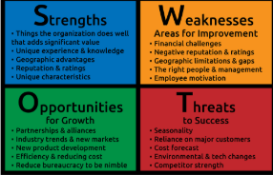
(googles images, definition of SWOT analysis)

Strength
I have good communication skills when I speak with clients and colleagues and, I am an active listener, which helps me to build trust and good relationship with people. As a family support worker, you must have good knowledge on safeguarding, and I have demonstrated that I am able to take protective measures and have the experience in handling at-risk cases with children.

Weaknesses
I need to build more confidence in handling more intense and complex cases, which will come with more experience and appropriate training. Am not very good in speaking in a large group of people, I become very nervous and anxious.

Opportunities
- Training opportunities
- Promotion
- Pay rise after 6 months’ probation period
- Annual holiday pay/sick pay
- Pension schemes
- Travel arrangements

Threats
- Violence or verbal abuse from families
- Unsafe environment
- Managing high stress situation like domestic abuse/addiction
- Experiencing intense emotional fatigue
- Requiring strong professional boundaries
- High workload and pressure

Plan how to develop skills needed for family support worker, it supports self-reflection and continues learning in Health and social care. (Gov.UK)

Reflective Practise: Regularly reflect on cases to improve emotional intelligence and understand professional boundaries and self-care.
Smart description: by June 2027 read Gibbs reflective model.
Importance: risk of burnout and emotional fatigue. Also improves service quality, build self-awareness.
Development and evaluation: regular one to one meeting with supervisor for feedback. Also take regular breaks and prioritise cases on urgent basis.

Reflective practise: improve knowledge on safeguarding.
smart description: by April 2027 complete safeguarding training and familiarising with local safeguarding procedure.
Importance: Identifying risk and addressing behaviours that can cause significant harm to children an adult.
Development and Evaluation: Know how to share information legitimately to protect children and practise maintaining accurate, precise and objective records of observations during home visits.

Reflective practise: improve knowledge I'm skills on software on technology.
smart description: by July 2027 attend workshops and practise regularly on the computer.
importance: secures record keeping unimproved communication between staff, client and other professionals...
Development and Evaluation: Regular training on up-to-date software.

Introduction

After presentation we were told to write a report on reflection. This was to identify our feelings, thoughts and what went well during the presentation. I had to process the whole situation and reflect on what was my weakness about how I could have presented better.
I will be using the reflective model (Gibbs model) which will guide me as it has 6 stages of reflection: Description, feelings, evaluation, analyse, conclusion and action plan.

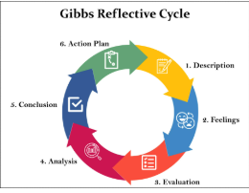

Description
I chose to do my presentation on communication skills in health and social care. I Spoke about the importance of good communication skills, briefly added definition of communication skills. I had five minutes to deliver my presentation, in which I explained why it is important to have good communication skills in healthcare, such as it reduces error, saves time and enhances patient's satisfaction. I also gave a practical case scenario of how a doctor should communicate with his patient.
To back this up I used the Berlo’s model of communication. This framework has broken down communication into four key components: source, message, channel and receiver. It emphasises that communication depends on factors like skills, attitudes, knowledge, social system and culture.

Feelings

I was the last person to do my presentation in front of the class. During the whole time I watched the other students in my class delivering their presentation. I Was feeling very nervous and a lot of thoughts were going through my mind. I was thinking they all appeared to be very confident, Will I able to deliver my presentation in such confidence as them.
When it was my turn to do the presentation, I was feeling very anxious, then when I stood up in front of the class, I became less anxious and was at ease. I started talking normally as I would do to another person and all I was thinking at that time is “Salina, you can do it”. I felt much happier and confident during and after the presentation, because I believed I tried my best in delivering this presentation.

Evaluation

Overall, the presentation was good, however there is always room for improvement. I realised a couple of times whilst I was presenting I was lost for words and wasn't making eye contact to the audience as often as I should have, because I kept looking down at my notes. My teachers feedback inspired me; he told me that I delivered my presentation with confidence. Also, he did mention that I didn't add any insight text citation nor I added enough references. He advised me in future to add my author, date etc in my sources.
In the last minute I didn't realise that my slides were not in order, I had made an error. My tutor told me in future I should be more careful and be more organised. I should present my slides in the correct order.

Analyse

I have found that through research communication skills in social care is very important. Also, clear and simple information to support this is vital, people should understand your message without getting bored. My teachers feedback also helped me, that I should always back up my evidence with reliable sources.

Conclusion

In general, I enjoyed delivering my presentation. I become very anxious in public speaking; however, this gave me the confidence to overcome my fears and anxiety. I also learned that I need to take time in presenting my work in order and not to rush. Overall, according to my tutor I delivered my presentation very well, I spoke in a clear manner and my research on the topic was good. I believe taking criticism and feedback in a positive way, helps you to see weaknesses in your work, while criticism can be painful, approaching it with open mind allows you to refine skills and a tool for improvement that helps you to learn and grow.
. I analysed that reflection is a powerful tool for learning, without reflection it is easy to repeat the same mistakes or fail to understand the factors behind a successful outcome. (The open University)

