

Part 1- analysing Excel data, correlation, and evaluation
Part 2 – analysing COVID19 cases in Asia, America, EUROPE, text mining methods and discussion on Excel and SSPSS
By Asen Asenov
Student ID:2028526
Course: Business and Management
Module: Data Handling and Business Intelligence
Module code: LCBB5000
Module Leader: Khaza Ahmed
UWTSD Birmingham

Table of Contents
Part 1 3
Introduction -Excel Case 3
Ice Cream Data 3
Relationship/correlation Analysis 4
Analysis Conclusion 10
MS Excel Evaluation 10
Conclusion 11
Part 2 12
Introduction -COVID-19 case 12
COVID-19 Cases Data 12
COVID-19 data Analysis 13
Table 1- Total number of cases by using SPSS 13
Continents- highest deaths row and lowest deaths row. 15
COVID-19 data Analysis 16
Correlation- COVID19 cases and deaths in America 17
Text mining methods 17
SPSS and MS Excel Evaluation 20
Conclusion 22
References 22

Part 1

Introduction -Excel Case
The report provides an analysis and illustrates a relationship between the outcome measure, which is the student's preferred flavour of ice cream (either vanilla, chocolate, or strawberry), the video game scores (video), the puzzle scores (puzzle), and the student's gender. The report provides information about the student’s favourite flavour of ice cream (either vanilla, chocolate, or strawberry). The report demonstrates the pre-processing, analysis, and visualisation of the data with charts and graphs in Excel. Excel's potential applications in the business world, including pre-processing, visualising, and analysing data, are broken down in this article.

Ice Cream Data

Description of the Data
The report provides an analysis and illustrates a relationship between the outcome measure, which is the student's preferred flavour of ice cream (either vanilla, chocolate, or strawberry), the video game scores (video), the puzzle scores (puzzle), and the student's gender. The report asks the students to choose their favourite flavour of ice cream (either vanilla, chocolate, or strawberry). The report demonstrates the pre-processing, analysis, and visualisation of the data with charts and graphs in Excel. Excel's potential applications in the business world, including pre-processing, visualising, and analysing data, are broken down in this article.

Relationship/correlation Analysis

Data analysis by Excel
Data can be analysed and interpreted in a variety of ways using Microsoft Excel. Data can come from a variety of different places, and it is possible to be manipulated. Using the appropriate Excel commands and tools, such as Conditional Formatting, Ranges, Tables, Text functions, Date functions, Time functions, financial functions, Subtotals and so on, it can be evaluated in a variety of ways - covering Subtotals, Quick Analysis, Formula Auditing and so forth. (Tutorials Point,2016)
Pre- processing Data by Excel

Excel Data Visualization
Excel's great data visualisation tools make it a popular choice for data analysis. Using Excel's data visualisation features it can create engaging visuals. Excel charts each have a distinct purpose. Excel has a wide variety of built-in charts that may be used to make the best use of the information. (Thakur M., 2022)
The paper employs multiple charts to illustrate Excel's ability to display data in an aesthetically pleasing manner and demonstrates two of them in practise. By following this approach, it may utilise these Excel visualisations to acquire insights from the data. (Thakur M., 2022)
Various Types of Visualizations in Excel:
- Column Graph
It is a straightforward chart type that displays data as vertical bars. As seen below (Table 1 and 2), to create a column chart, the data was first picked, followed by the required option from the Column chart option. As shown, the Column chart contains multiple possibilities, and the appropriate one must be selected. By following the steps, a column chart is generated, as depicted in the image below. It is a straightforward column chart that displays total sales by area. (Thakur M., 2022)
- Line Graph
This chart is good for trend analysis. (Thakur M., 2022)
- Pie Chart
Contribution to a category is depicted by a Pie Chart. (Thakur M., 2022)

- Bar Graph
This chart type is identical to a column chart except that it contains horizontal bars. To create a horizontal bar, the appropriate bar chart option was picked from the Bar option, as seen in the accompanying image (Table 3 and 4). Using this image, it is possible to compare student preferences for three flavours of ice cream by gender and video/puzzle by gender. (Thakur M., 2022)
- Area Diagram
This graph illustrates the trend of a measurement for various categories through time. The chart utilises regions to display the data. Area Diagram
This graph illustrates the trend of a measurement for various categories through time. The chart utilises regions to display the data. (Thakur M., 2022)
- Scatter Graph
This graphic facilitates the analysis of the relationship between two variables. Additionally known as the X-Y chart. The graphic requires two series and x and y coordinates that correspond to individual values. (Thakur M., 2022)
- Stock Chart
These are specialised types of charts used to analyse stock prices. (Thakur M., 2022).
- Donut Diagram
This graphic represents data in the form of a doughnut-shaped pie chart. (Thakur M., 2022)
- Bubble Diagram
Bubble charts, despite their complexity, may be utilised beautifully to extract insights from data. This graphic takes three values into account. (Thakur M., 2022)

Student Favourite Ice cream- Analysis (Table 1)
The table below shows that the student favourite ice cream is vanilla with result 95.
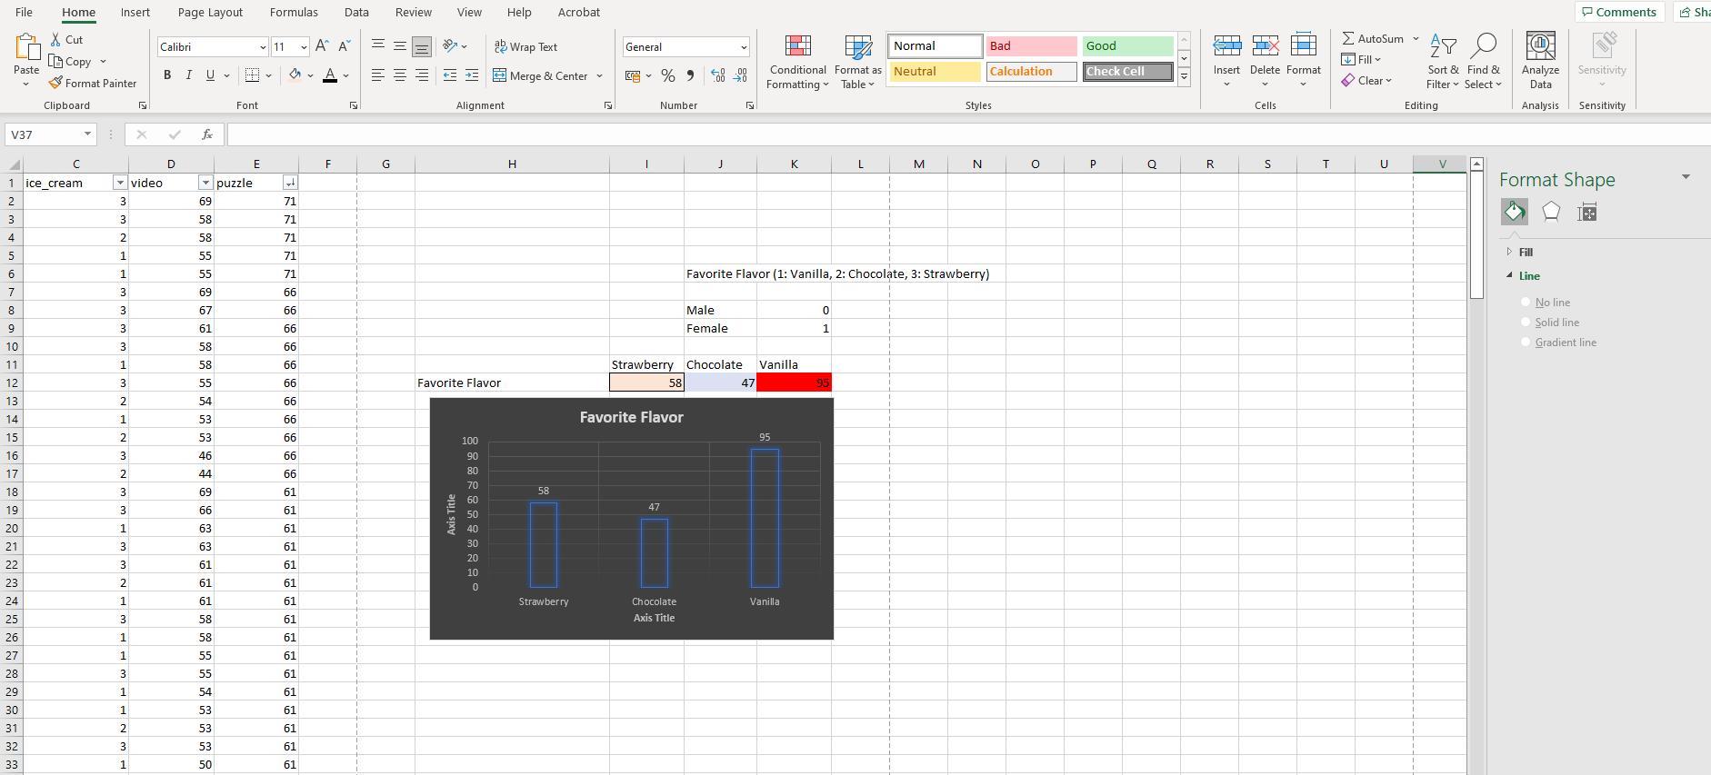

Student preference in total video or puzzle (Table 2)
The results of the pictures below introduces that the students prefer puzzle (10481) than videos (10370).
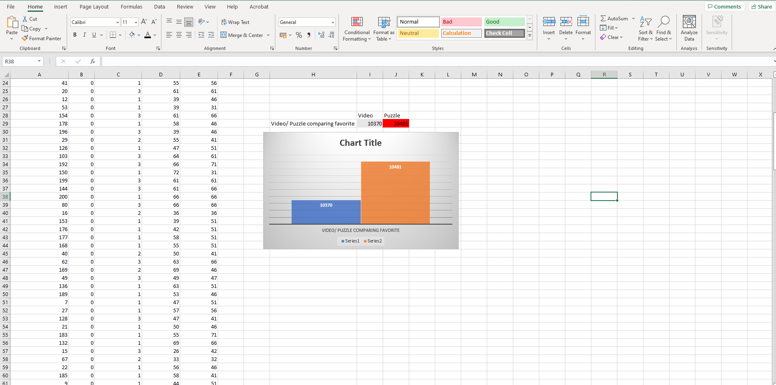

Student Favourite Ice cream by gender (Table 3)
The chart and the calculations below determinates that the female prefer vanilla flavour more than the males, and the results from the chocolate flavour preferences shows that the females prefer more this flavour than the males, but for the strawberry one the results are equal between the genders.
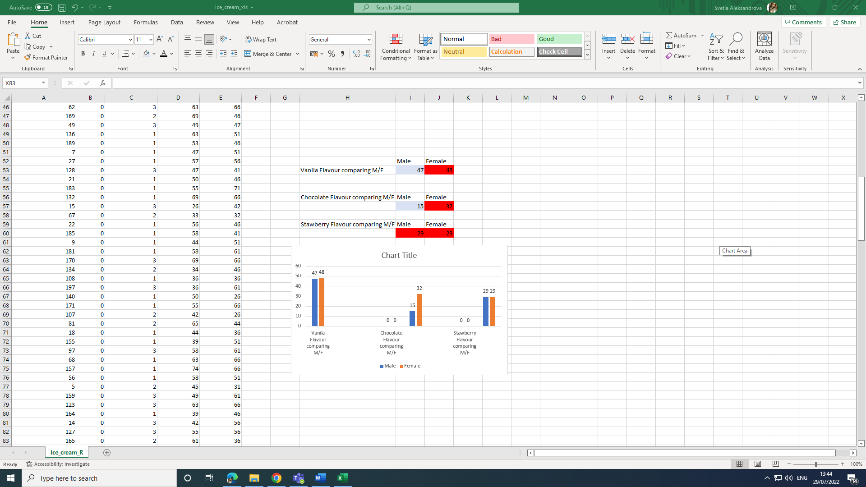

Student preferences source - Video/Puzzle by gender (Table 4)
The picture below shows that the female video scores its bigger than male one and the puzzle score for both genders are equal.
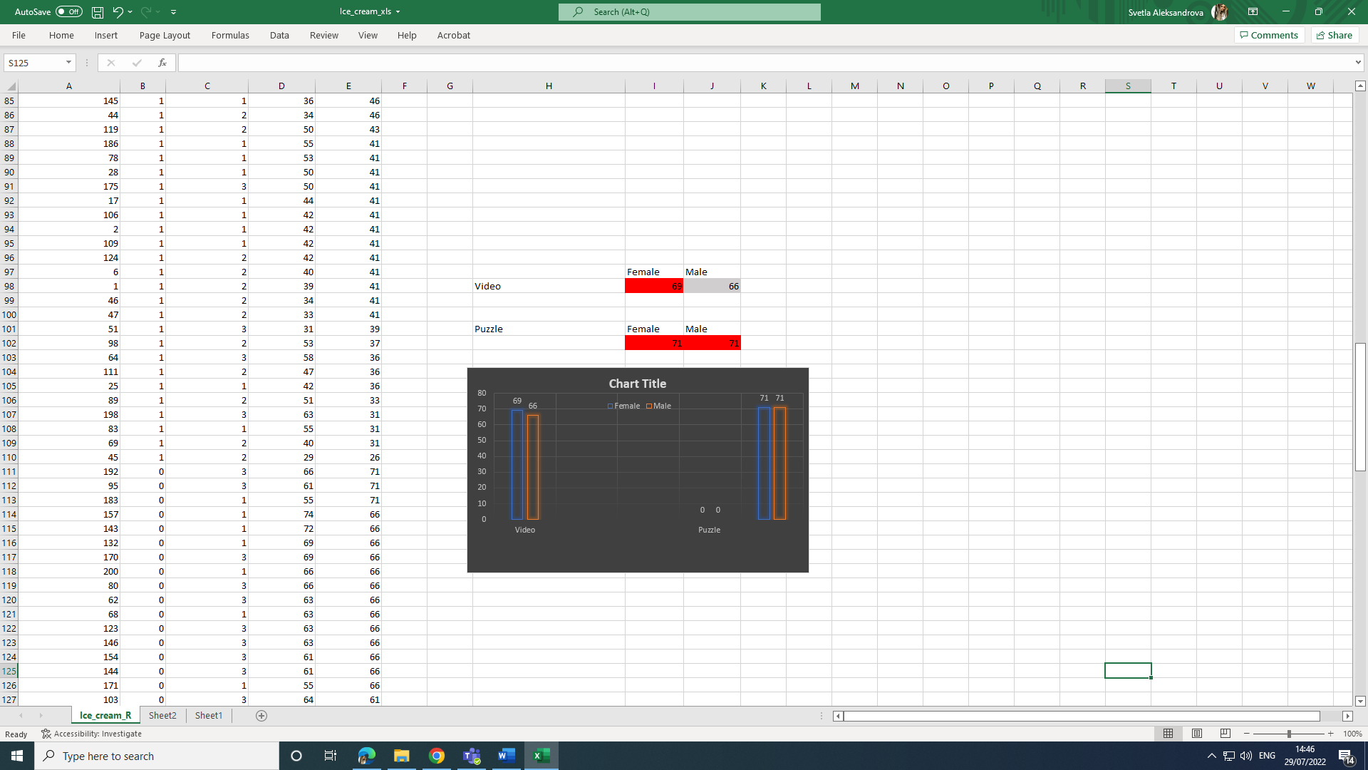
Relationship/Correlation Analysis
Correlation interpretation Coefficients in Multivariate Correlation

It has the dependent variable (Y) and the independent variable (X). In multiple regression analysis, the multiple correlation coefficient is employed to evaluate how well the dependent variable is predicted (Y). It is equivalent to the squared correlation between the dependent variable's actual and expected values. It can alternatively be understood as the percentage of the variance of the variable Y that the variable X accounts for. (Wikitekkee, 2022)
The direction and quality of the link are indicated by the correlation coefficient. The strength of the association increases with the correlation coefficient's proximity to 1 or -1. (Wikitekkee, 2022)
For instance, a correlation coefficient of 0.90 implies a strong positive relationship between two variables, whereas a correlation coefficient of 0.10 shows a weak positive relationship. (Wikitekkee, 2022)
Below they are two examples (Table 1 and Table 2), which shows practical examples of correlation.

Ice Cream and Video (Table 5)
This table shows the correlation between ice cream and video.
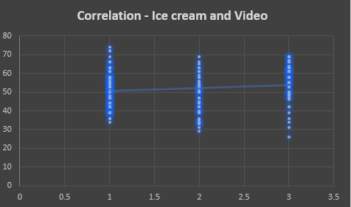

Video by gender vs Ice cream (Table 6)
This table shows the corelation between video by gender (female, male) and ice cream.
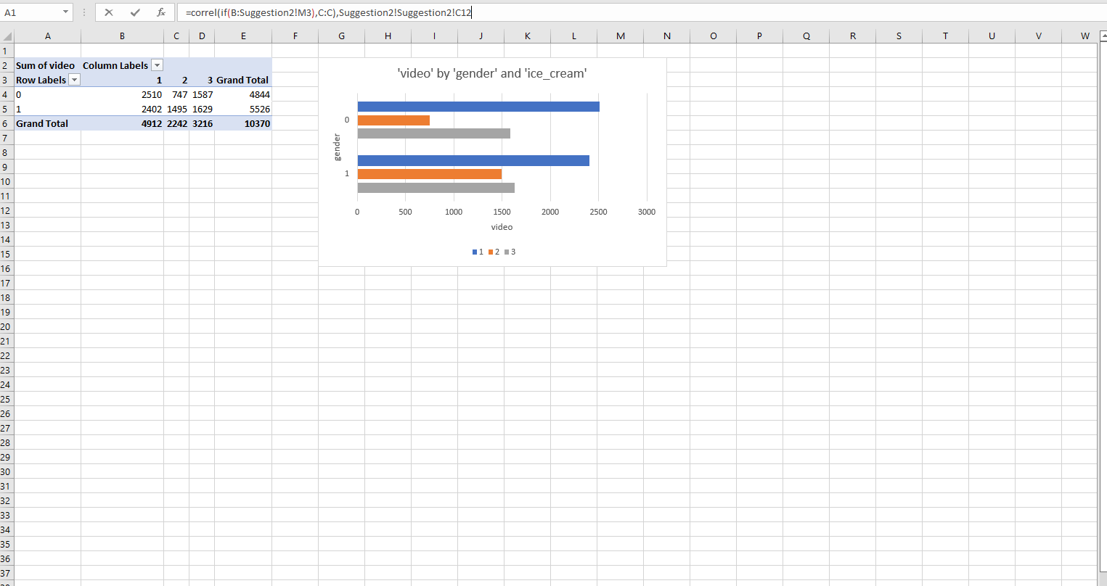

Analysis Conclusion
The report contains the correlation analysis and its results: The results of the table (1) below indicate that 95 percent of students prefer vanilla ice cream. Students prefer puzzles (10481) to videos (10481), as evidenced by the results of the images in Table 2. (10370). According to the chart (Table 3) and the calculations that follow, females prefer vanilla flavour more than males. Similarly, females prefer chocolate flavour more than males, but the results are the same for strawberry flavour. The image (table 4) below demonstrates that the female video score is greater than the male video score, while the puzzle score is equal for both genders. This table (5) illustrates the link between ice cream and video. This table (6) illustrates the relationship between video consumption by gender (female, male) and ice cream. The report establishes that Excel's data visualisation capabilities enable the creation of engaging visuals. Excel charts each serve a unique function. Excel has a variety of built-in charts that can be used to make the most of the data, and the correlation coefficient indicates the degree to which two variables are related.

MS Excel Evaluation
Excel in the business world
Excel is one of the most effective methods for streamlining business operations. Excel is a powerful tool, and the majority of employees and business owners have likely used it before. Excel's plethora of options for storing and analysing data, as well as its ability to automate repetitive daily tasks, make it one of the most compelling reasons to use it for business purposes. This report discusses several business applications of Excel and provides an overview of why this software is so important and useful. Excel's first version, released in the early 1980s, allowed users to transition from manual macro programming to automated Excel processes. Since then, the application has evolved significantly to support graphs, charts, and histograms that can be embedded in spreadsheets or added as standalone articles. (The Excel Experts, 2022)
Microsoft Excel is utilised globally for a variety of purposes due to its feature-rich design. Excel's significance in the business world cannot be overstated, given that millions of companies use the programme daily. MS Excel's increasing popularity is due to its user-friendly, straightforward interface, which enables users to take control and complete tasks quickly and efficiently. Numerous employers now require candidates to have Excel skills, as well as a broader set of skills, and thus list Excel skills. Accounting, stock management, sales reporting, product information management, and automation are just a few of the purposes for which MS Excel is used in business. (The Excel Experts, 2022)
Excel's multiple business applications are one of the primary reasons why Excel is used daily by businesses. For example, maintaining accurate and up-to-date product information is crucial for generating online sales, reducing returns, and gaining repeat business for an eCommerce business. The platform on which your website is built can be one of the primary obstacles to providing complete and accurate product information. Many content management systems, including WordPress, Magento, and others, are not designed to efficiently manage large amounts of data in the backend. Virtually all websites offer the ability to export and import data in CSV and XLSX format. Once the data has been exported and imported into Excel, Excel has complete control over the data. Using a variety of Excel features, it is possible to drill down into the data and optimise product information to fuel eCommerce expansion. (The Excel Experts, 2022)

Conclusion

In addition to the students' video game scores (video), puzzle scores (puzzle), and gender, the students' preferred flavour of ice cream was also included as an outcome measure in the report. This flavour may be either vanilla, chocolate, or strawberry. The report includes information regarding the student's preferred flavour of ice cream (either vanilla, chocolate, or strawberry). To illustrating the pre-processing, analysis, and visualisation of the data, Excel charts and graphs are utilised. The article discusses the potential business applications of Excel, such as the pre-processing, visualising, and analysing of data.

Part 2

Introduction -COVID-19 case

In order to determine the highest and lowest death rates, the research analyses data from a survey that was conducted on the daily number of new COVID-19 cases and fatalities in three continents, including Europe, Asia, and America. The case discusses the most popular text mining techniques that may be applied in business with actual examples from the real world, as well as the benefits and drawbacks of using SPSS and Excel.

COVID-19 Cases Data
Description
The provided data in the Excel sheet from the company shows few sections of information-
- Month, year, cases, deaths, countries And Territories, geoId, country territory Code, continentExp and Cumulative_number_for_14_days_of_COVID-19_cases_per_100000.
- It has 60474 rows.
- It’s useful for research and analysis connected to COVID 19 cases and deaths in the continents and will help the company to take decisions.

COVID-19 data Analysis

Table 1- Total number of cases by using SPSS
- America- total number of cases
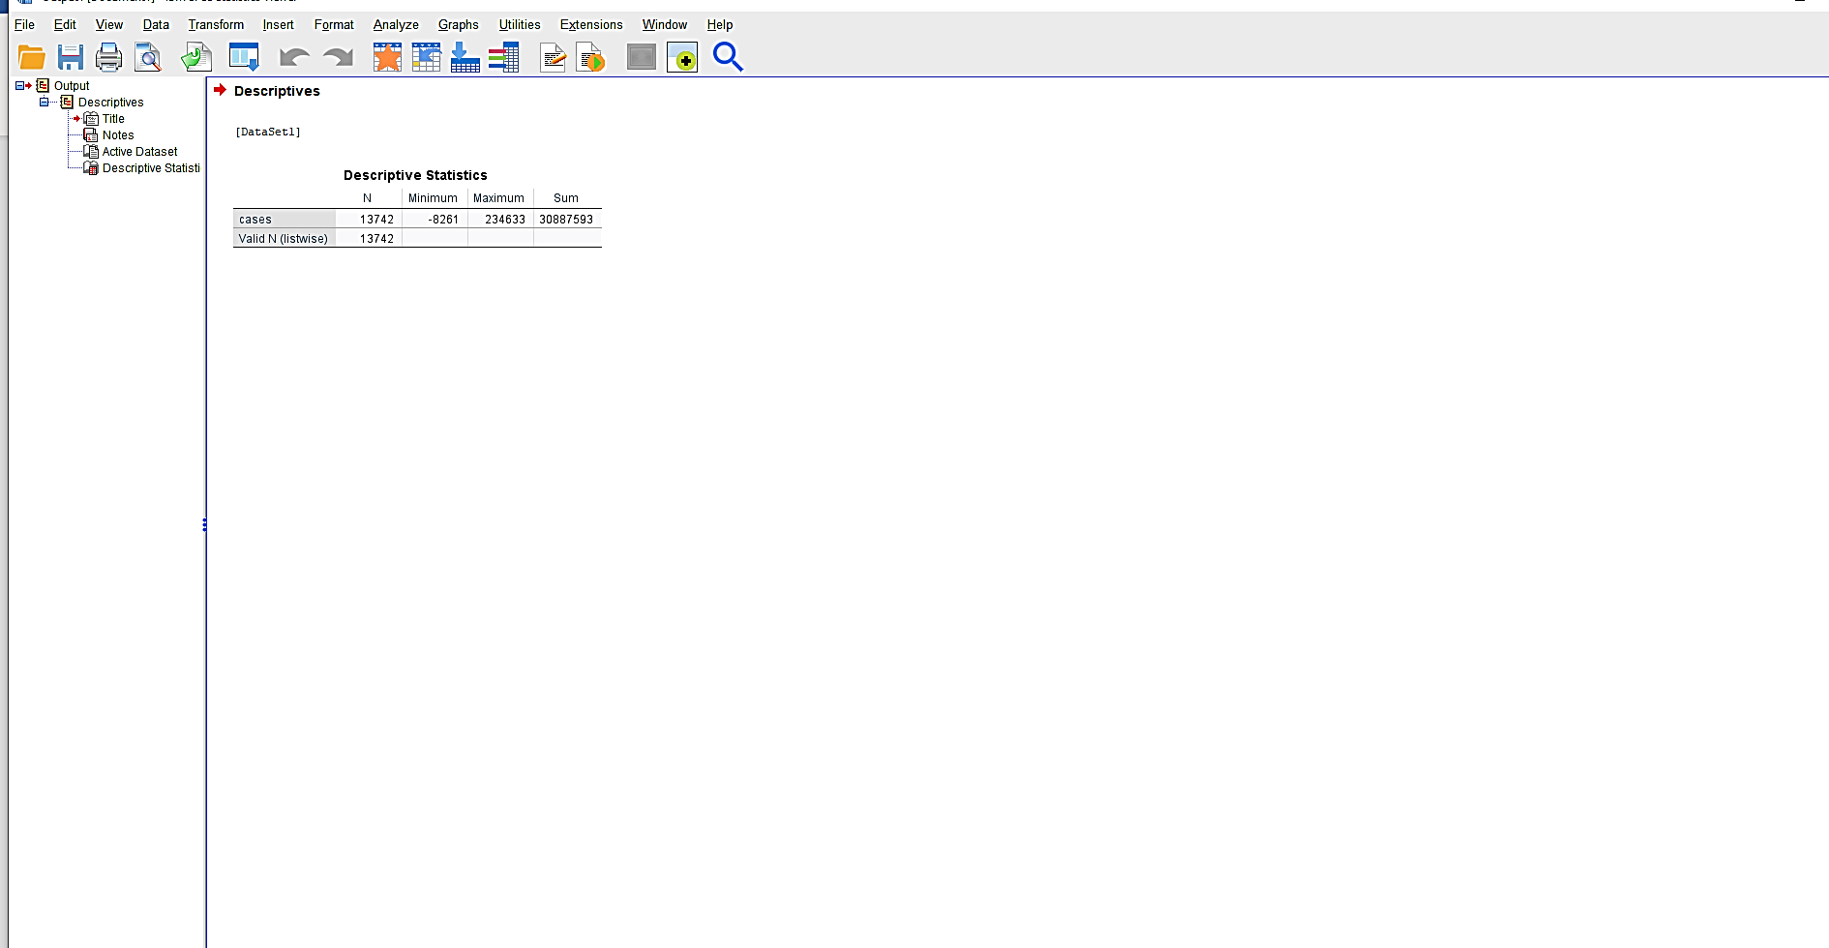

- Asia-total number of cases
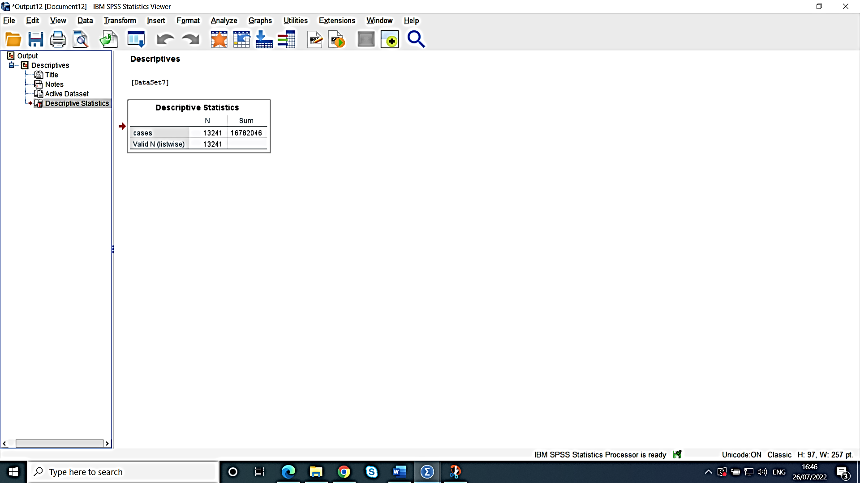

- Europe-total number of cases
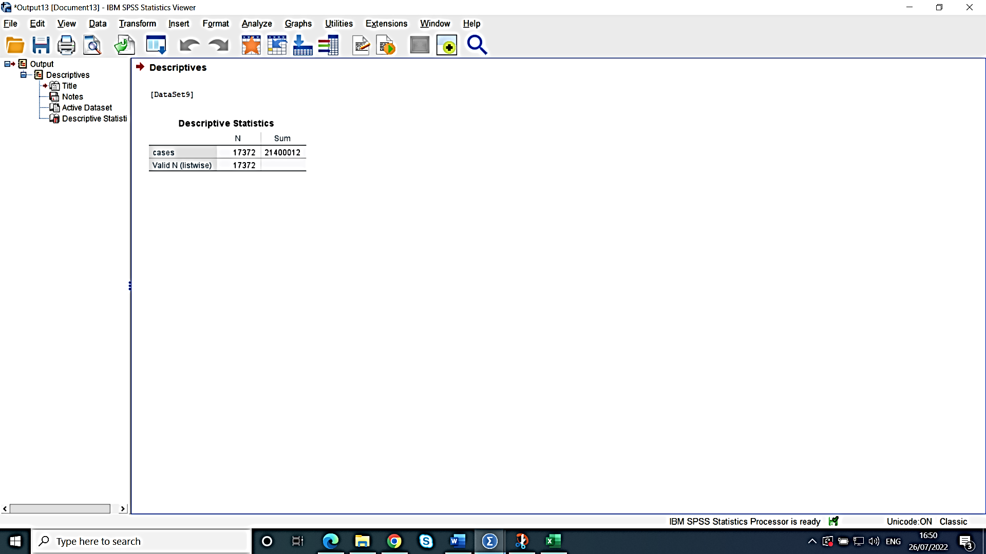

Comparing to the tables it shows that the highest level of COVID19 cases is in America (30887593).

Continents- highest deaths row and lowest deaths row.
The tables below shows that the continents with lowest deaths rate is Europe and the continent with the highest deaths rate is America. The tables also show the case processing summary and the report which summarized the numbers in each continent.

Table 1
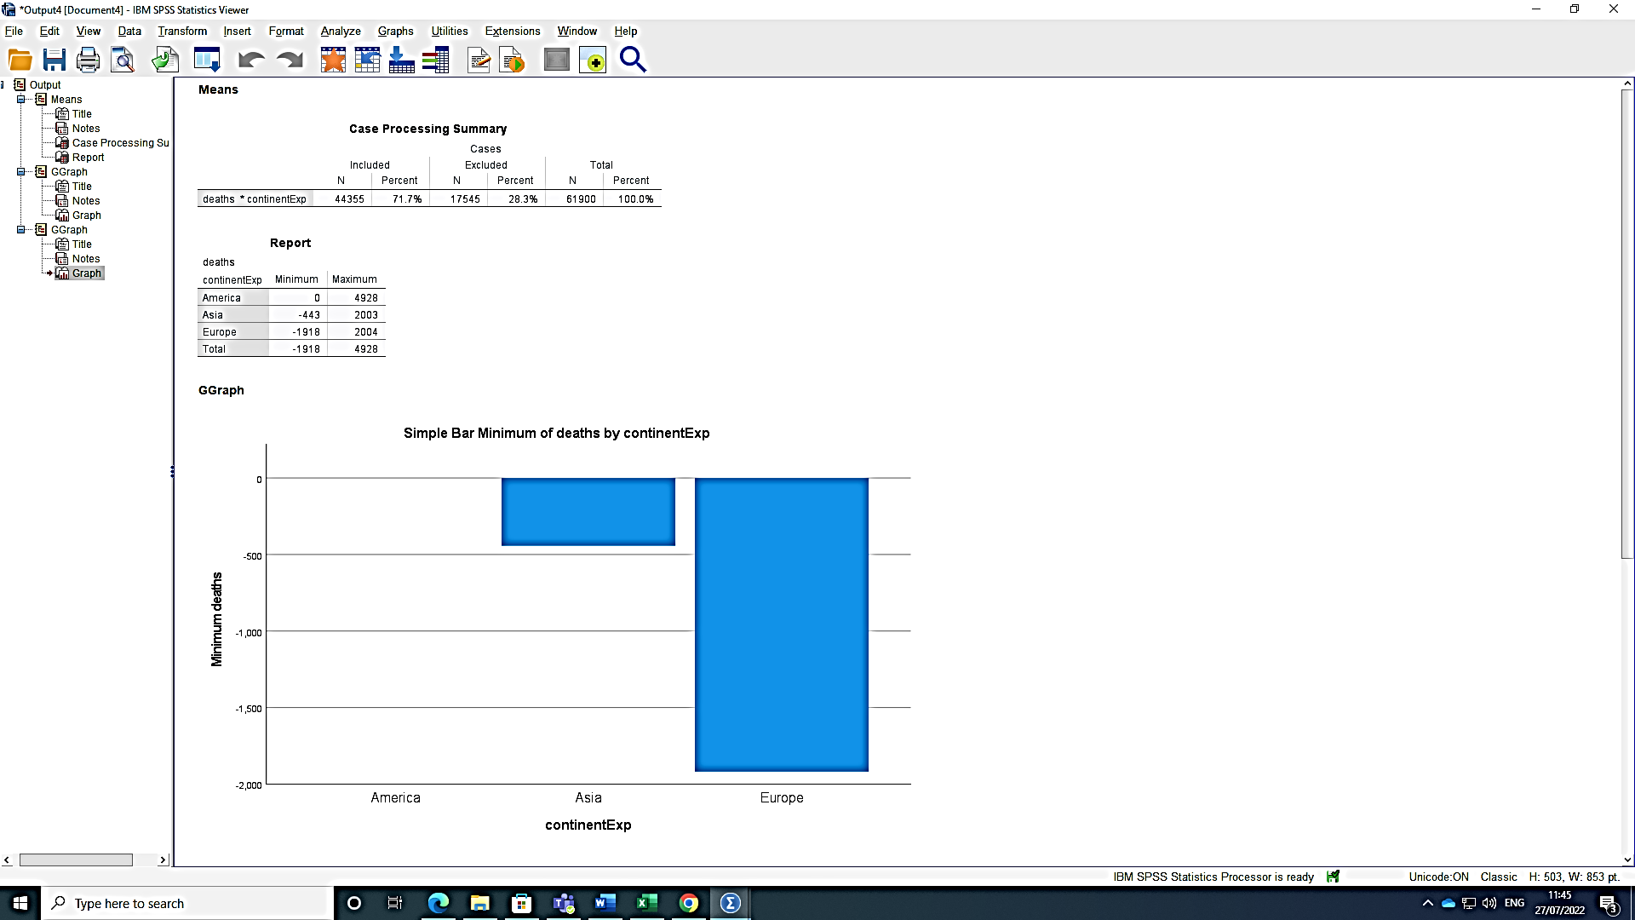

Table 2
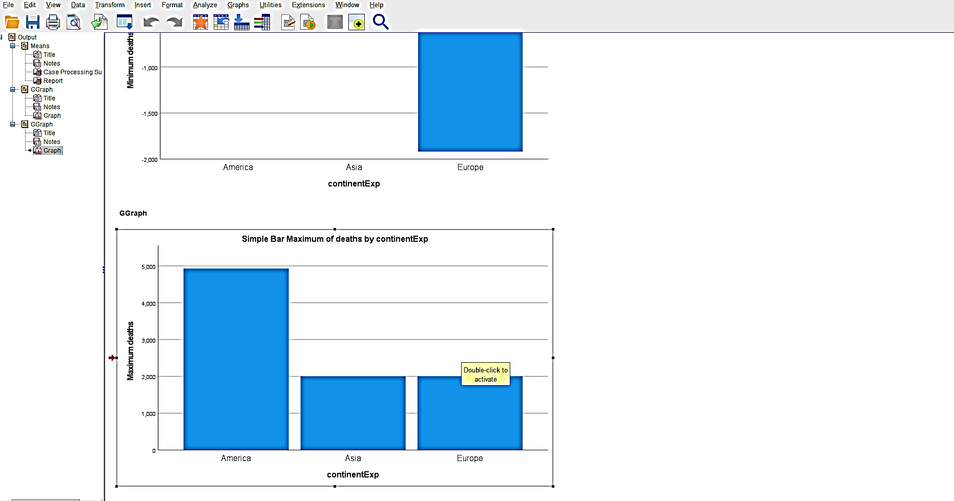

COVID-19 data Analysis

Correlation- COVID19 cases and deaths in America
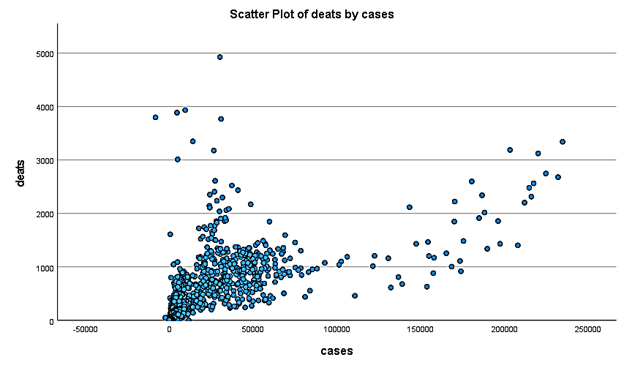
The graph illustrates the relationship between COVID19 cases and deaths in the United States. In the beginning, when the number of cases is between 0 and 20,000, the death rate will be extremely high (around 1000). When the number of cases increases, the number of deaths falls. For example, when there are 250,000 cases, there are no fatalities.

Text mining methods
The challenge of text mining, which is nothing more than the retrieval of pertinent information in accordance with user requirements, has historically been solved using a variety of ways. There are generally four approaches utilised for information retrieval: the Term Based Method (TBM), Phrase Based Method (PBM), Concept Based Method (CBM), and Pattern Taxonomy Method (PTM). (Elabd S., 2014)
For instance, the pattern taxonomy technique analyses documents based on patterns. The is-a connection can be used to organise patterns into a taxonomy. In the data mining communities, pattern mining has long been the subject of in-depth research. Data mining methods including association rule mining, frequent item set mining, sequential pattern mining, and closed pattern mining can be used to find patterns. Because certain helpful long patterns with high specificity lack in support, using learned information (patterns) in text mining is challenging and ineffective (i.e., the low-frequency problem). (Elabd S., 2014)
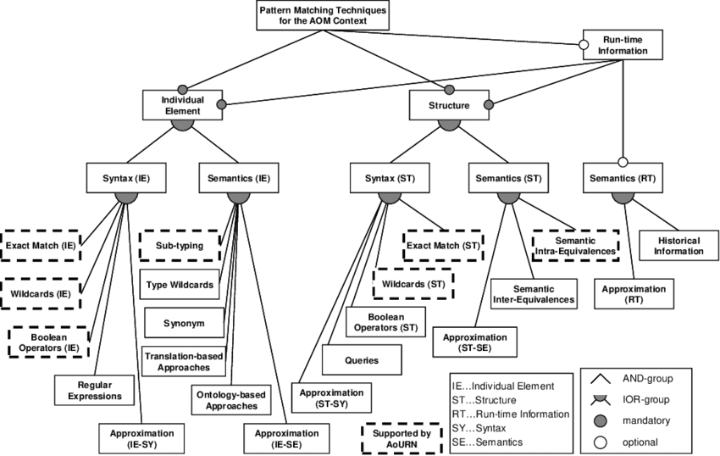

Example:
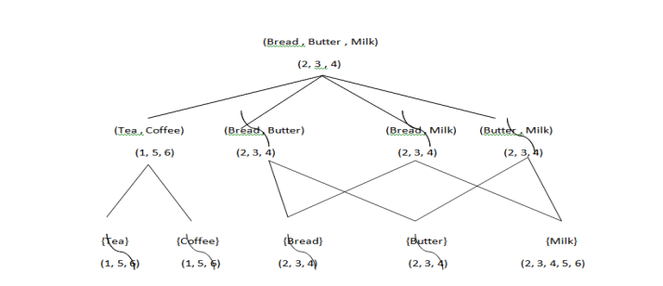
The use of an is a (or subset) connection allows patterns to be categorised into taxonomies. Tables 1 contain a collection of document paragraphs. Ten frequent patterns, with a minimum strength of 0.2, are shown in Table 2. In this case, there are only three closed patterns: tea, coffee, and bread, butter, and milk (milk). (Patil M., Subramanium P., 2015)
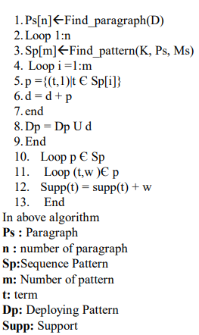

Process for Mining Patterns
This serves as a training module or a pattern preparation in this case with a minimum of assistance. The algorithm's inputs are as follows: D training manual, minimal assistance The pattern's ms value Keywords List K. (Patil M., Subramanium P., 2015)
Each document's paragraph is generated, and then patterns are discovered by running it through the keyword set K, paragraph Ps, and minimal support Ms. This will produce several sequence patterns; gather them in Sp; and then determine the frequency of the phrases in the paragraph. Finally, build the deploying pattern after calculating the weight for each phrase. For every term in each pattern in each paragraph, create a closed pattern. (Patil M., Subramanium P., 2015)
Not all often occurring short patterns are beneficial; hence, misinterpretations of patterns are known as them and result in unsuccessful performance. (Elabd S., 2014)
Technologies are created by natural language processing to educate computers how to analyse, comprehend, and produce text. The text mining process makes use of technologies including information extraction, summarization, categorization, clustering, and information visualisation. (Elabd S., 2014)

SPSS and MS Excel Evaluation
There are many types of statistical analyses that SPSS Statistics may perform, including data collection and preparation, visualisation and modelling, and analysis itself. It was previously referred to as the Statistical Package for the Social Sciences when it was first introduced in 1968. It swiftly became one of the most widely used statistical applications in a variety of fields, including market research, surveys, healthcare, and the social sciences. (Flatworld Solutions Pvt.,2015)
Consider adopting SPSS for market research or any other business-related data analysis if Microsoft Excel is already being used by the company. When compared to Microsoft Excel, the SPSS software is more efficient and user-friendly than Excel because it is specifically designed to perform statistical analysis. With the help of SPSS, you may do a variety of analyses, including ANNOVAs, Clusters and Discriminant Analysis. Aside from reporting and testing, this software can also be used for Curve Estimation and Linear Regression, Crosstabs, Descriptive Ratio Analysis and PLUM regression. There are many similarities between the interfaces of Microsoft Excel and SPSS when it comes to menus, spreadsheets and statistical operations, but SPSS is the clear winner when it comes to data analysis. For example, descriptive statistics are easier to retrieve in SPSS's pull-down menus than they are in Microsoft Excel. There is a large selection of graphs and charts to pick from. Access to statistical tests in a timely manner. (Flatworld Solutions Pvt.,2015)

For both qualitative and quantitative data, SPSS is useful. About 85% of study academics use quantitative data for further analysis, thus the general public assumes that the SPSS software is more useful for quantitative data than for qualitative data, but no SPSS offers equal weight age to both data types. Even though there are several software programmes on the market for analysing quantitative data, SPSS is still the best option. Because SPSS is user-friendly software that is simple for beginners to use, it aids in analysis even as data sets grow larger. (Writeneed Admin,2017)
The following are the top three advantages of conducting market research with SPSS: Complete data management, a variety of options, and improved output structure are all included. (Flatworld Solutions Pvt.,2015)
SPSS is applicable to all technical industries and major businesses, whereas Excel is applicable to businesses where sensitive data on a wide scale must be managed. (EDUCBA,2022)
According to the needs of the research, there are 15 modules in IBM SPSS statistics for data analysis:
- One can use tiny samples with the SPSS Exact Tests module and be confident in the results. (Writeneed Admin,2017)
- Without having to be a professional statistician, analysts can predict trends and create projections using the SPSS forecasting module. (Writeneed Admin,2017)
- The SPSS Missing Values module identifies any connections between your own data's missing values and other factors. Your models and findings can be significantly impacted by missing data. Data miners, social scientists, survey researchers, and market researchers utilise it to validate data. (Writeneed Admin,2017)

Conclusion
By using SPSS software, the report showed the results from the data connected with the deaths and COVID19 cases in each continent and the correlation between COVID19 and the deaths in America. Determined significant methods used in the text mining and the importance of that, by example. The importance, benefits and the differences between Excel and SPSS software. The report examined that the SPSS is common use in the businesses area (major business and technical industries), that Excel.

References

Amyot D. (2010), Towards a Taxonomy of Syntactic and Semantic Matching Mechanisms for Aspect-Oriented Modelling, October, Available at: https://www.researchgate.net/publication/221030062_Towards_a_Taxonomy_of_Syntactic_and_Semantic_Matching_Mechanisms_for_Aspect-Oriented_Modeling (Accessed:26 July 2022)
Differences Between SPSS vs EXCEL, Available at: https://www.educba.com/spss-vs-excel/ (Accessed:26 July 2022)
Elabd S., (2014), Text Mining Methods and Techniques, 17th January, Available at: https://d1wqtxts1xzle7.cloudfront.net/53280170/10.1.1.428.8805-with-cover-page-v2.pdf?Expires=1658835638&Signature=ftVqJ8tLGkIuBeHW7wi0HAlg2qbM5dMor4JSCNSPijfvKzvbvuF2TXX5eE1n1ykUnBG-t19y1GtCxXAhQ5lwc4kQpwp~Du3WkvQ8xnySKSyyQLBOQXQmLUKZDMnO70W-SRbfblMSqzWdBCG4x5MjzY3wZXYh5iN1VPv30TUrCkmfNW5aceVHQdZRjmBcMK0Icr5dRc8~R3N54L9PwzpyzFpSKXPuiQeqIXTeYreflYoo0YPUnCP2saJTyiFuRI~1Vp6pywJ1jJ5mLiRiAifZsSR5XmLNhaEdz41b8Zcgg0eIFQRWxG6oPjmoU5p1HvLTGG-hoJpu2jfy5WCpnFLDSQ__&Key-Pair-Id=APKAJLOHF5GGSLRBV4ZA (Accessed:26 July 2022)
Microsoft Excel Vs SPSS Statistics Software: Which Should You Use for Market Research, 24th January, Available at: https://blog.outsource2india.com/microsoft-excel-vs-spss-statistics-software-use-market-research/ (Accessed:26/07/2022)
Patil M., Subramanium P. (2015), Pattern Taxonomy Model Technique for
Retrieving the Pattern to Classify Text Document, February, Available at: https://www.ijaiem.org/Volume4Issue2/IJAIEM-2015-02-23-41.pdf (Accessed:26 July 2022)
Thakur M. (2022), Data Visualization by Excel, Available at: https://www.educba.com/excel-data-visualization/?source=leftnav (Accessed:30 July 2022)
The Excel Experts (2022), 7 Ways You Can Use Excel In Business To Save Time & Money, Available at: https://www.theexcelexperts.com/importance-excel-business/ (Accessed:31 July 2022)
Tutorials Point (2016), Data analysis with Excel, Available at: https://www.tutorialspoint.com/excel_data_analysis/excel_data_analysis_tutorial.pdf (Accessed:30 July 2022)
Wikitekkee (2022), Available at: https://wikitekkee.com/correlation-in-excel-data-analysis/ (Accessed:30 July 2022)
Writeneed Admin (2017), Importance and benefits of SPSS in research, 11th June 2020, Available at: https://www.writeneed.com/post/2017/07/05/importance-and-benefits-of-spss-in-research (Accessed:27 July 2022)

