Planning and delivering an International Meeting/Event.

Name: Syeda Rabna Begum
Student Number: 2131253
Module: BMIH6007
International meetings management
Lecturer: Jemma Smith

Executive Summary
This report will look at event management. Event management is the planning process behind the event. This event is based on technology and innovation. The event is a conference event. The venue is held in a hotel in London the Marriott Courtyard London Heathrow airport. There will be 150 attendees attending this event. This event is sponsored by Siemens. There will be various influential speakers talking about technology trends, AI, hotel tech.
An event cycle will be used to see if the event is feasible. Event cycles have many phases the cycle used in this report is a three-phase cycle. Before the event, during the event and after the event. For an event to be successful there must be a clear set of aims and objectives. A SMART acronym can be used to conform the objectives of an event. Event operations are people behind the event. Events help boost brand awareness and achieve many business goals.
For the event a clear budget needs to be set and followed by. Also, a specific timeline needs to be followed. To be able to manage these efficiently various skills will be required for this event. Understanding the process to event management will help to make the event successful.

Table of Contents

Executive Summary…………………………………………………………………..Page 2
Introduction…………………………………………………………………………….Page 4
The Event Cycle…………………………………………………………………….Page 5-6
Event Concept………………………………………………………………………Page 7-8
Aim and Objectives of the Meeting/Event…………………………………………..Page 9
Event Operations……………………………………………………………….,,Page 10-12
Event Budget…………………………………………………………………………Page 13
Industry Trends/Issues/Impacts……………………………………………………Page 14
Cultural and Situational Considerations…………………………………………...Page 15
Conclusion……………………………………………………………………………Page 16
Reference List……………………………………………………………………Page 17-19

Introduction
This report will investigate the process of an event management. Event management is the process to planning, organising, executing the events to achieve the desired goal or objective. Events help to drive the business goals in many ways. Events boost brand awareness, generate leads and supports customer retention. This is why event management plays a major part for many organisational strategies (Cook, 2024). The event this report will focus on is a conference event. This conference event is based on technology and innovation. This event will be held in one of Marriotts hotel the Marriott Courtyard London Heathrow airport (UB3 5EY). The hotel venue has parking available on site. This hotel has 10 meeting rooms. The conference will be held in the Boeing 1 room which holds up to 300 people (Marriott International, 2024). There will be 150 attendees attending this event. This event has been chosen for educational purposes. Conferences provide opportunities for key individuals in the field of specialism to come together and collaborate all over the world. Hosting a conference attracts many types of leaders, a mix of thinkers and experts. All emerging together to develop skills and talents (Business events, 2024). Lunch and refreshments will be provided for this event. There will be various speakers attending. This event is going to be sponsored by Siemens. Siemens uses digitalisation to empower their customers to accelerate key sustainable goals. Siemens introduced a new label scaling sustainability impact by using echo-tech (Siemens. 2023).

The Event Cycle
For a successful event management an event cycle is used. A successful event revolves around making the participants experience worthwhile. At the end of the day the participants are the ones that decide if the event was successful or not. (Lyyti, 2024). The event cycles this report will refer to is a three-phase event cycle.
Before the event – this is before the planning phase to check if the event is feasible, will it work, if it is possible. This stage looks at defining the goals and objectives, creating a budget for the event, securing the date and the venue, the type of event it will be, searching for sponsors speakers and entertainment, envisioning the sales and event website and how to promote the event (Hubilo, 2022).
During the event – detailed planning of the process. this should identify the vision and detail the actions that will achieve this vision. Implement operational plans, consider the feasibility. Ensure a smooth check in process for all attendees. Assembly of the room. Make sure there is enough staff. Having the right team on hand will ensure things go as planned. This will give the attendees a seamless experience (Smart works events, 2019).
After the event – Reflect on the results. This is the perfect opportunity to reflect on what worked and what did not. Send out post event surveys to be able to engage with the guests. Remember the goals set at the beginning and compare with the actual results to what has been achieved (Austin, 2023).
For this conference this event cycle was implemented to help in planning and organising the event.
Before the event: the location of the venue was picked and booked for the 27th May 2024. Creating a conference event for educational purposes. The amount of people attending and which room needed to be booked to hold 150 people. Booked the Boeing room. A budget was set of £25,000. Reach out and book the speakers. A suitable timeframe of 4 months. A team of staff needed for the day. Social media, ads, websites, emails was used to promote the event. Hiring caterers’ cleaners and the speakers. Hiring a photographer to take pictures. Creating the mobile app for check-ins and to be used for booking the tickets.
During the event: enough staff on duty on the day to make sure everything goes as planned. Going by the planned schedule. Guest check-in will be through the app created for the event for a seamless check in.
After the event: at the end of the event there is feedback questionnaires to receive feedback of the guests a ten-minute survey to complete on the app to make it more seamless when finishing.

The Event Concept
An event concept is the practical application of an event theme. The event concept is important because it provides a framework for the planning and organising of an event. By following a concept, this will ensure all aspects are aligned with the overall goals and objectives. Event concepts can help to create a memorable experience for guests (Piratex, 2023).
This event is related to technology and innovation. Technology and innovation are the creation of new or improved technologies, tools, systems, and processes that bring advancements for various fields. Improved technology can develop innovative solution that solve problems (Jain, 2023). The topics of discussion at the event will be about tech risks and trends, the use of AI cyber security, and technology risk functions (Grant Thornton, 2024). There will also be discussions related technology in hospitality what are the hot trends in guestroom tech (Hospitality technology, 2024).
On the day itinerary for 27th May 2024.
Guest arrival from 9am
9am to 9.30am there will be a welcoming session served with refreshments.
9.30am to 10.30am there will be a speaker
10.30am to 10.45am will be a short refreshment break
10.45am till 12pm will be another speaker
From 12pm till 1pm going to be lunch break
1pm to 2.30pm another speaker
2.30pm till 3pm refreshments break
And 3pm to 4.15pm finishing the event Q&A’s and getting guest feedback with a survey and then ending this session for 4.15pm.
Lunch and refreshments will be provided £100 ticket per person. Lunch is a buffet.
There is going to be various speakers such as Zoe Kleinman, who is a technology editor for BBC. She specialises in gadgets, cyber security, and AI. She works with BBC World TV, which is the UK’s most watched news. Christina Griddle a technology reporter who specialises on artificial intelligence (Riva media, 2024). And Pierre Hayden Mark who innovates in sustainability, net zero and climate change (Sustainability speakers, 2024).

Aim and objectives of the Meeting/Event
When hosting an event, it is essential to have a very clear set of aims and objectives. The aims and objectives for the event should be defined and agreed at the outset, while developing and refining them as project progresses. Aims are related to the overall intent and objectives are normally aims broken down into specific targets (Carmarthenshire. 2023).
The overarching aim for this event is to be successful and gain a brand image, also to be able to work with more sponsors in the future and educating small business owners using digital marketing for growth.
SMART acronym is enabled to conform the objectives of an event.
Specific – areas for the event
Measurable – through numbers
Agreed – tasks assigned by organisers that are achievable
Relevant – to overall aims of the event
Timed – within the time schedule
The SMART goals help to keep the event planning timeline focused and clear for evaluating the events impact (Charlton, 2024).
It is important to identify the target market for the event. This will determine which individuals or groups this event wants to attract. The target market for this conference event is business guests and hotel owners as this conference will also talk about technology for the hotel industry.
SMART Objectives
To create personalised experience and satisfaction that will cater to the attendees need.
To achieve a minimum satisfaction rating of 4 out 5 for the after-event feedback surveys.

Event Operations
Event operations are people behind the events. Event operations do everything that is needed to keep the event running smoothly. This is from organising the event to the execution of the process (Curran, 2024).
Below is an image of the EMBOK model.
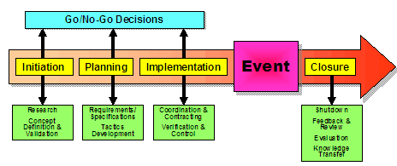
The phases of the EMBOK model are:
- Initiation
- Planning
- Implementation
- Event
- Closure
(EMBOK, 2024).
This model is used for event management. Event management is the process for planning, organising, and executing events to achieve the desired or set goals. Events help boost brand awareness and drive many business goals. Event management plays a critical role in many organisational strategies (Cook, 2024).
The resources required for this conference event is:
- Caterers
- Cleaners
- Photographer
- The marketing staff
- Speakers
- The event venue
- The app
The skills required for this conference event is:
Organisational and time management skills – the work will need to be completed on a tight deadline, and will need to keep on top of budget so it is best to stay organised.
Communication skills – strong communication skills are necessary so everyone in the event is clear on what they are doing and what their role is.
Tech savviness – as this event is based on technology it is essential to understand event technology. The team will need to work with IT and tech teams to understand the technology that need to be delivered for the event.
Problem solving and flexible – dealing with unexpected challenges. If things go wrong at the event the event manager will need to keep a cool head and adapt quickly to the situation.
Creativity – to be able to use creativity to bring the vision to life and create memorable experiences for the attendees.
Leadership - leaders are responsible for helping to deliver a strategy to ensure the event runs smoothly to be able to deliver the key objectives.
Budget management – the event budget will need to be met to make sure that the budget does not go over (Cvent, 2023).
Marketing strategy for the event:
The use of social media: these platforms reach a broader audience, from attendees to vendors interested in partnership. For the event the team will create catching posts, and have running ads to boost the reach. There will be email campaigns with engaging newsletters, updates and exclusive content to keep the audience informed about the event. There will be exclusive access and special perks for early sign up (Okere, 2023).
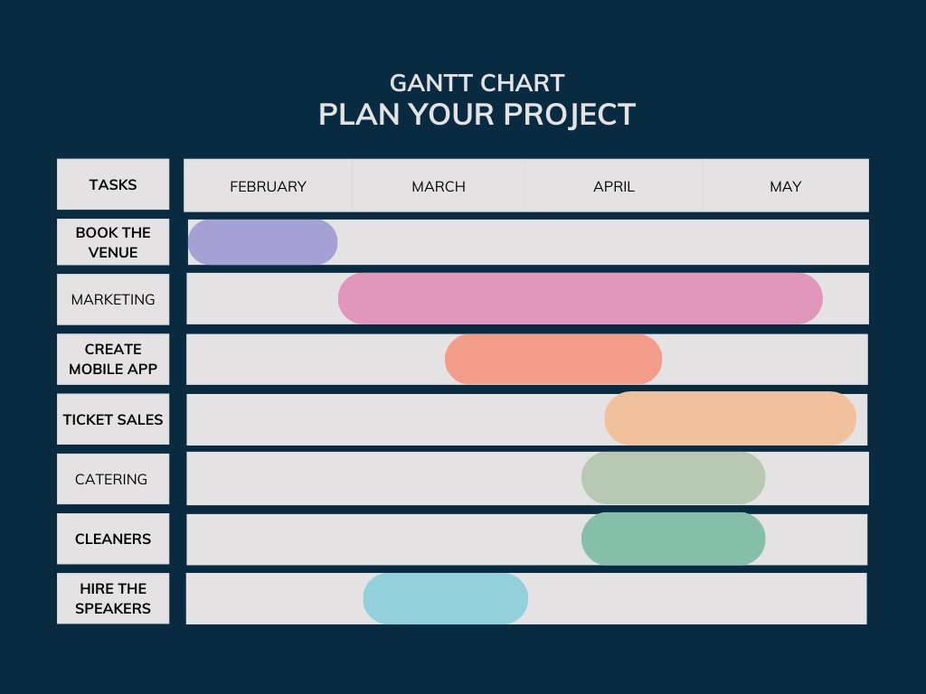
(Canva, 2024).
Above is a Gantt chart to show the timeline of the planning of the event. To successfully complete this event a timeframe of four months is set. From February to May.

Event Budget
An event budget is needed for any event whether large or small. The event budget is the estimation of the costs an event will incur based on the research and the plans. The company should not exceed the budget (Stova, 2024).
Below shows a table of the Income and Expenditure for the event.
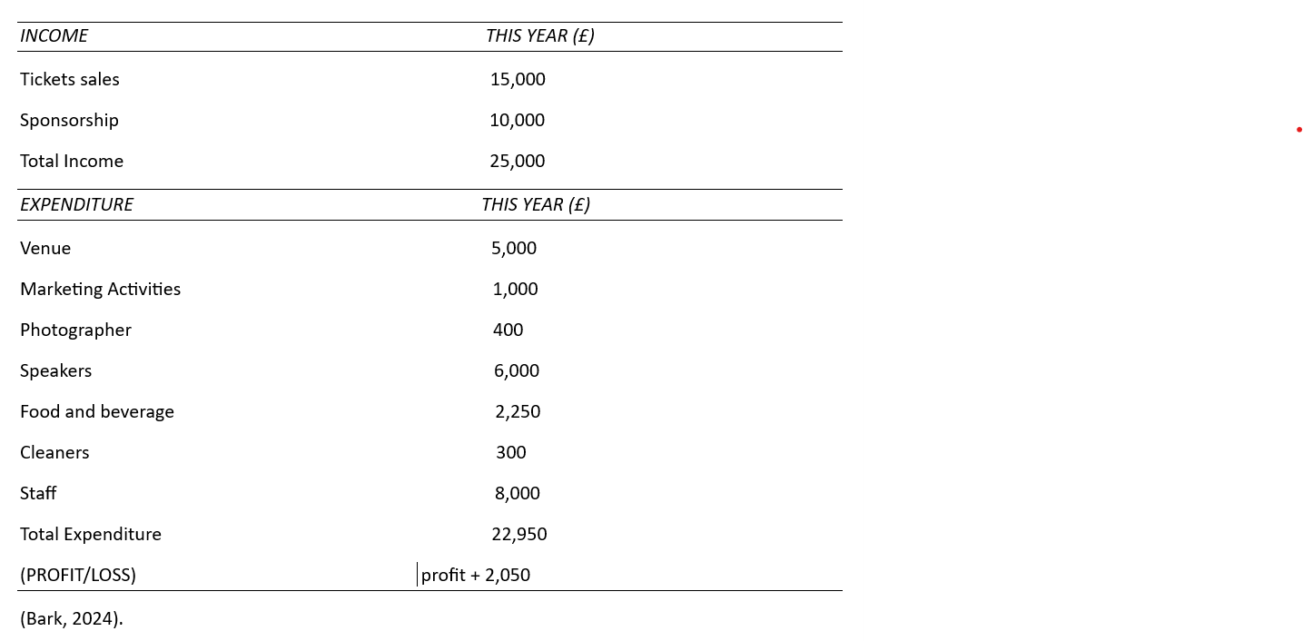
The main funding sources for the event will be coming from the ticket sales as there will be 150 attendees, each ticket will cost £100 per person this which will generate £15,000 from ticket sales. The sponsorship from Siemens will be of £10,000 and the total income will be £25,000.
The Expenditure the event will be spending on is the venue will cost £5,000. Marketing activities such as social media posts, Ads, fliers, websites/blogs, this will cost £1,000. A photographer for the event will cost £400. There will be 3 speakers so a cost £2,000 per speaker so a total of £6,000. Food and beverage this will be served as a buffet so £15 per head will be looking at a total of £2,250. Cleaners for the cleanup after the event will be £300. The staff’s cost will be of £8,000. This totals to £22,950. This event will generate a profit of £2,050.

Industry Trends/ Issues/ Impacts
The event industry is evolving rapidly. With the rise of hybrid events to virtual events and the use of AI personalisation. Every day trends are popping up that is shaping the entire landscape of events. To create a memorable and impactful event experience the event industry needs to keep an eye on key trends (Weezevent, 2024). AI chatbots are the new trend. There are endless opportunities with the use of AI. AI has the power to enhance an event experience in so many ways. Facial recognition is becoming increasingly popular. This is used to streamline the check-in process and to keep a track of event attendees. Virtual and hybrid events have become increasingly popular due to the flexibility and accessibility. The attendees will be able to attend from anywhere with virtual events, while hybrid events offer both in-person and virtual components. Hybrid and virtual events help to reach a wider audience and engage with audiences in new and innovative ways. These can be more cost effective as well (Lancashire, 2023).
This event is influenced by technology and the new and innovative ways technology is growing. This event is using AI and chatbots in the app which will have chatting and messaging functions. The mobile app will help the audience to discover information in real time and access the content. The use of AI and virtual assistants will give a more personalised experience.
The impacts technology has is huge. Some form of technology is used on a day-to-day basis. Technology advances has had a huge impact on events. These developments have changed in the way an event is deigned, produced, planned, and manage the events. Technology has enabled events to be more sustainable. Having a hybrid conference will be more cost effective as the event can be live streamed from a studio. This route will also have a huge carbon footprint (Julia Charles, 2024).

Cultural and situational considerations
Cultural considerations during an event planning would look at things like: language, etiquette, dietary restrictions, and religious observances. By understanding and respecting culture even planners can ensure a successful event (Charlotte, 2024).
The cultural considerations for this event would look at the music playing appropriate for everyone attending. Any dietary requirements for guests and providing any services for religious observances throughput the day.
Situational considerations during an event would look at managing the unexpected. There could be many situations such as weather disruptions, equipment malfunctioning, and last-minute guest cancellations. It is important to have a contingency plan (Garcia, 2024).
The situational considerations for this event would be equipment malfunctioning, last minute guest cancellations, and venue changes.
A SWOT analysis conducted for the event
Strengths | Weaknesses
- In door event so the weather will not be an issue  - Location in the central city of London easily accessible  - Good network of speakers  - Sponsorship by Siemens | - Trends  - Location may be too busy for some
opportunities | Threats
- Successful brand image  - Working with more sponsors  - New revenue streams | - Competition from other similar events  - Technology is everybody’s market these days  - Market development

Conclusion
Event management is essential to event planning. For a successful event an event cycle is used which has three phases. Before the event, during the event, and after the event. Following these essential phases will help to ensure the event goes smoothly on the day. This event should be beneficial to the guests as it looks at digital solutions and tools that improve technology, using virtual event tech, chatbots powered by AI. Modern technology brings a huge range of compelling advantages. Technologies help with increased efficiency, better networking, and boosted engagement, software platforms offer valuable data for better user experiences. Overall, this event should be very successful.

Reference List
Austin, A. (2023) ‘Event life cycle: Before, During, and After an event,’ [blog]. 19 January. Available at: https://www.eventbrite.co.uk/blog/event-life-cycle-ds00/ (Accessed: 2nd November 2024).
Business events Perth (2024) Why host a conference? Available at: https://www.businesseventsperth.com/host-an-event/plan-a-conference/why-should-i-host-a-conference/# (Accessed: 1st November 2024).
Canva, (2024) Canva. Available at: https://www.canva.com/design/DAGEqxiIHXI/sDaoEQldm8goagfHQdwgLQ/edit (Accessed: 6th November 2024).
Carmarthenshire (2023) Establishing aims and objectives. Available at: https://www.carmarthenshire.gov.wales/business/organising-events/community-toolkit/establishing-aims-and-objectives/# (Accessed 3rd November 2024).
Charlton, J. (2024) ‘What are the 7 stages of event planning,’ [blog]. 9 June. Available at: https://passkit.com/blog/what-are-the-7-stages-of-event-planning/ (Accessed: 3rd November 2024).
Charlotte (2024) Cultural considerations. Available at: https://edabroad.charlotte.edu/students/im-approved-whats-next/travel-and-life-abroad/cultural-considerations/#: (Accessed: 6th November 2024).
Cook, P. (2024) ‘What is event management? A complete guide,’ [blog]. 10 May. Available at: https://www.cvent.com/uk/blog/events/what-event-management (Accessed 1st November 2024).
Curran, W. Event operations: everything you need to know. Available at: https://helloendless.com/event-operations/#: (Accessed: 3rd November 2024).
Cvent (2023) ’12 event planning skills you need for success,’ [blog]. 2 March. Available at: https://www.cvent.com/uk/blog/events/12-event-planning-skills-you-need-success (Accessed: 3rd November 2024).
EMBOK (2024) Event management body of knowledge. Available at: https://www.embok.org/index.php/phases-page (Accessed: 2nd November 2024).
Garcia, S. (2024) ‘Managing the unexpected at an event: essential tips and strategies,’ [blog]. 17 May. Available at: https://eventscase.com/blog/managing-the-unexpected-at-an-event-strategies (Accessed: 6th November 2024).
Grant Thornton, (2024) Trends in technology risks 2024. Available at: https://www.grantthornton.co.uk/insights/trends-in-technology-risks-2024/ (Accessed: 3rd November 2024).
Hospitality Technology (2024) How vending tech can enhance restaurant revenue. Available at: https://hospitalitytech.com/events (Accessed: 3rd November 2024).
Hubilo (2022) ‘The event life cycle: your guide to using the right tech at every step.’ [blog]. 4 December. Available at: https://www.hubilo.com/blog/the-event-lifecycle-your-guide-to-using-the-right-tech-at-every-step# (Accessed: 2nd November 2024).
Jain, N. (2023) ‘What is technology innovation? Definition, examples, and strategic management,’ [blog]. 15 July. Available at: https://ideascale.com/blog/what-is-technology-innovation/ (Accessed: 3rd November 2024).
Julia Charles (2024) The impact of technology on the events industry. Available at: https://www.juliacharleseventmanagement.co.uk/impact-of-technology-on-events-industry/# (Accessed: 5th November 2024).
Lancashire, M. (2023) ‘Top 8 event technology trends to track in 2024,’ [blog]. 3 November. Available at: https://www.cvent.com/en/blog/events/event-tech-trends (Accessed: 4th November 2024.
Lyyti (2024) ‘Introducing the event cycle-the core of event success management,’ [blog]. 21 June. Available at: https://www.lyyti.com/en/blog/introducing-the-event-cycle-the-core-of-event-success-management?gclid=undefined (Accessed: 2nd November 2024).
Marriott International (2024) Courtyard by Marriott. Available at: https://www.marriott.com/en-gb/hotels/lhrcy-courtyard-london-heathrow-airport/overview/ (Accessed: 1st November 2024).
Okere, R. How to plan a tech event: a step-by-step guide with examples. Available at: How to Plan a Tech Event: A Step-by-Step Guide with Examples | by Ruthie Okere | Medium (Accessed: 6th November 2024).
Piratex (2023) ‘Event concept: what it is and why it is essential to have one?’ [blog]. 20 March. Available at: https://piratex.com/blog/event-concept-important/ (Accessed: 2nd November 2024).
Riva Media (2024) The top 10 best technology speakers. Available at: https://www.rivamedia.co.uk/news/the-top-10-best-technology-speakers/ (Accessed: 2nd November 2024).
Siemens, (2024) Scaling sustainability impact. Available at: https://www.siemens.com/global/en/company/sustainability.html?gclid (Accessed: 4th November 2024).
Smart works events (2023) ‘The 3 stages to organising and event,’ [blog]. 23 April. Available at: https://www.smartworksevents.com/the-3-stages-to-organize-an-event/#: (Accessed 2nd November 2024).
Stova (2024) The complete guide to creating an event budget. Available at: https://stova.io/event-budget/ (Accessed: 4th November 2024).
Sustainability speakers (2024) The 1 international environmental & sustainability speakers Agency. Available at: https://sustainability-speakers.com/?gad_source= (Accessed: 2nd November 2024).
Weezevent (2024) ‘6 key event industry trends you should be aware of,’ [blog]. 27 September. Available at: https://weezevent.com/en-gb/blog/key-event-industry-trends/#: (Accessed: 4th November 2024).

