L 4 - Computer Architecture and Operating Systems (ACCA4022) (SEM 2)

Curtis Butler (2517431)
2026
Contents
1. Introduction 3
2. Key Functions of General Operating Systems 3
2.1 Process Management 3
2.2 Memory Management 3
2.3 File & Directory Management 3
2.4 Device Management (I/O) 3
2.5 Networking Functions 3
2.6 System Security 3
2.7 System Performance Monitoring 3
3. Use of Windows OS CLI Commands 3
3.1 File & Directory Management 3
3.2 Process & System Monitoring 3
3.3 Network Testing & Monitoring 3
3.4 User Management 3
3.5 Task Scheduling 3
4. Use of Linux OS CLI Commands 3
4.1 Process Management 3
4.2 File & Directory Management 3
4.3 Network Testing & Monitoring 3
4.4 User Management 3
4.5 Task Scheduling 3
5. Windows OS Scripting 3
6. Linux OS Scripting 3
7. Conclusion 3
References 3
Appendices 3
1. OS Types 3
2. Lecture Activity Log 3
3. Evidence of Course - Cisco Networking Academy: Operating Systems Basics 3

1. Introduction
Operating systems are a core part of modern computing, acting as the layer that allows hardware, applications, and users to work together. They manage system resources, coordinate processes, maintain security, and provide the interfaces that make devices usable. This report outlines the key functions of general‑purpose operating systems, including process and memory management, file and device handling, networking, and system security. It also demonstrates practical use of Windows and Linux command‑line tools, along with scripting examples, to show how these features operate in real environments and support reliable system performance.

2. Key Functions of General Operating Systems
Operating systems provide the essential foundation that allows computer hardware and software to work together. Although Windows, macOS and Linux differ in design, they all perform a similar set of core functions that ensure programs run smoothly, resources are managed efficiently, and users can interact with the system safely.

2.1 Process Management
One of the most important responsibilities of an OS is managing processes — the running instances of programs stored in memory. The OS creates, schedules and terminates processes, ensuring each one receives CPU time when needed. Windows uses a process scheduler to switch rapidly between tasks, giving the appearance of multitasking even on a single CPU core. This prevents conflicts, reduces the risk of deadlocks, and ensures the system remains responsive. [1]
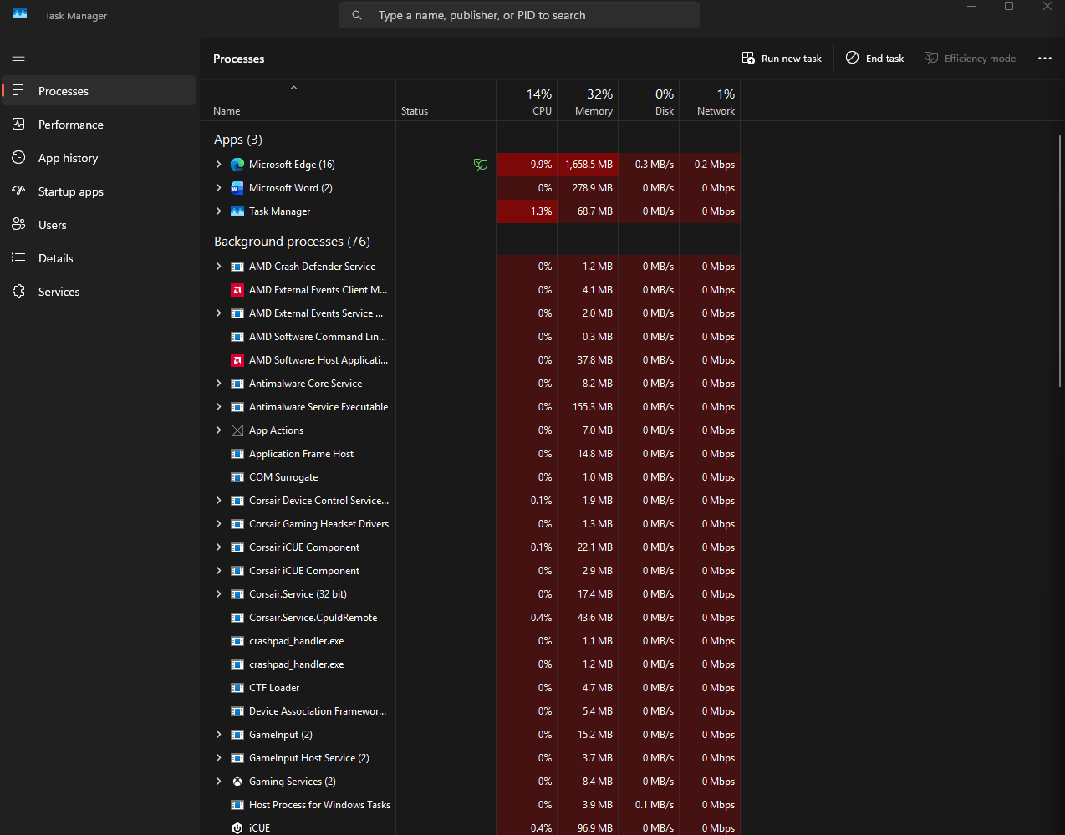

2.2 Memory Management
Memory management controls how RAM is allocated to processes. When an application is opened, the OS loads it from storage into RAM and tracks how much memory it uses. If RAM becomes full, Windows uses virtual memory by moving inactive data to the page file on the disk. This prevents crashes and allows more programs to run simultaneously. 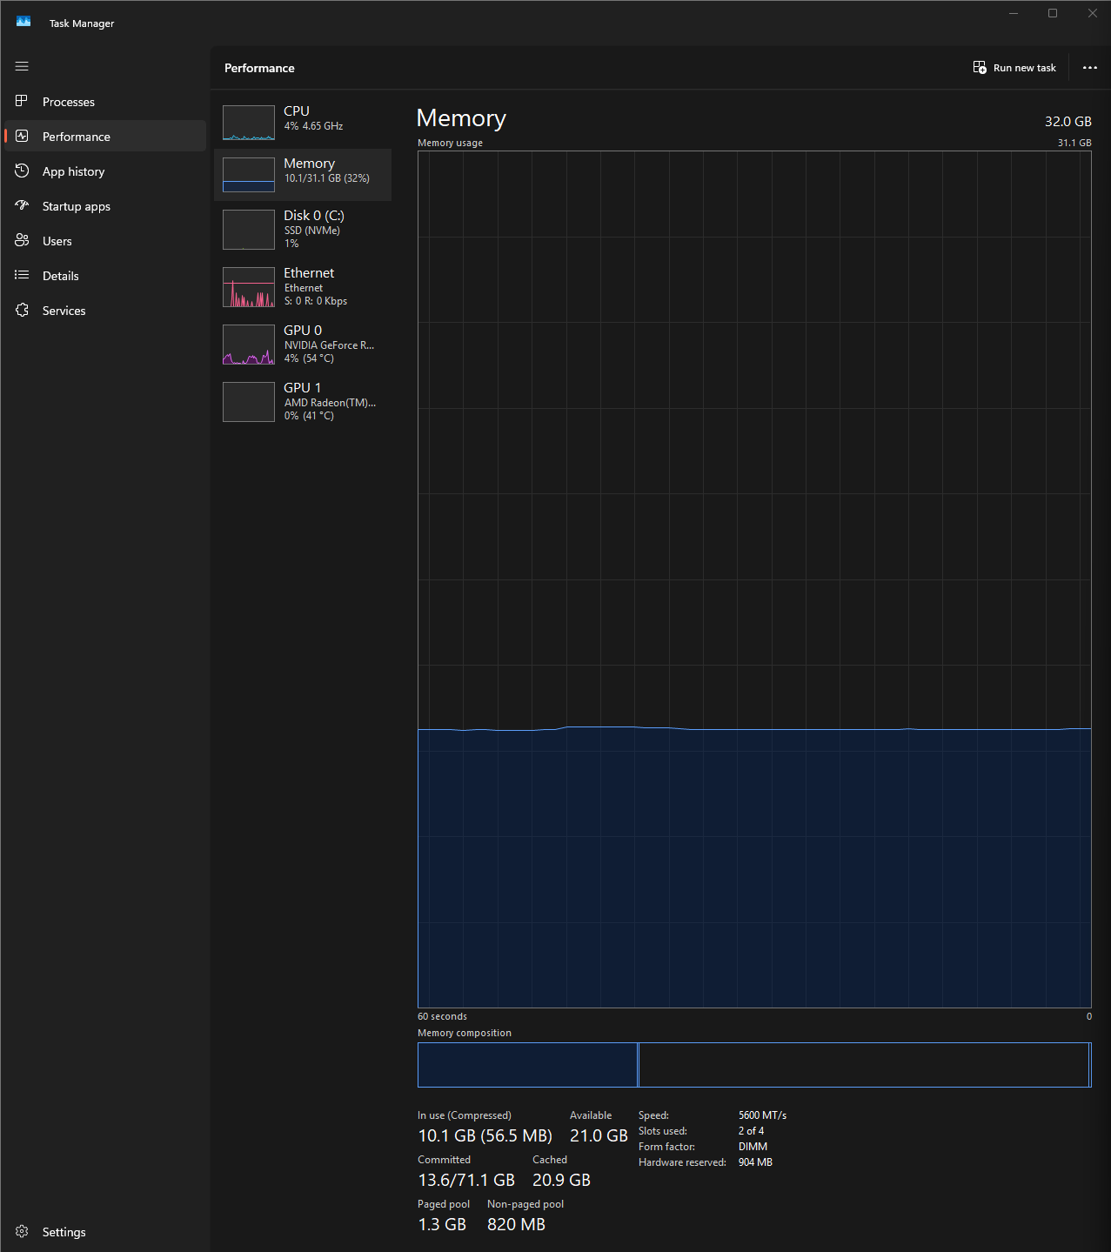

2.3 File & Directory Management
Operating systems provide a structured way to store, organise and retrieve files. Windows uses the NTFS file system, which supports permissions, metadata, encryption and file indexing. The OS handles file creation, deletion, naming, and access control, ensuring that programs and users can work with files safely and efficiently. [2]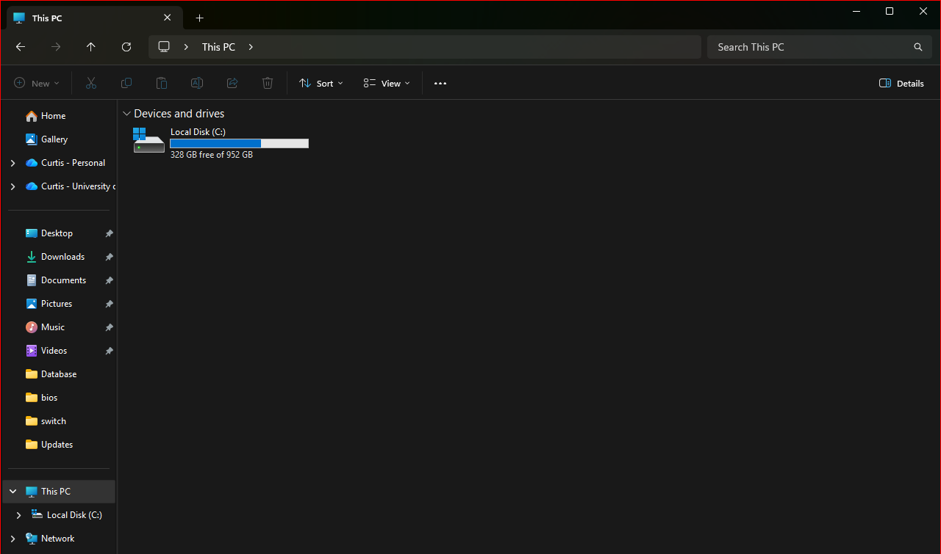

2.4 Device Management (I/O)
Modern computers rely on many input/output devices such as keyboards, mice, printers, displays and storage drives. The OS communicates with these devices through drivers, which act as translators between hardware and software. Windows manages device allocation, handles interrupts, and ensures each device is used safely and efficiently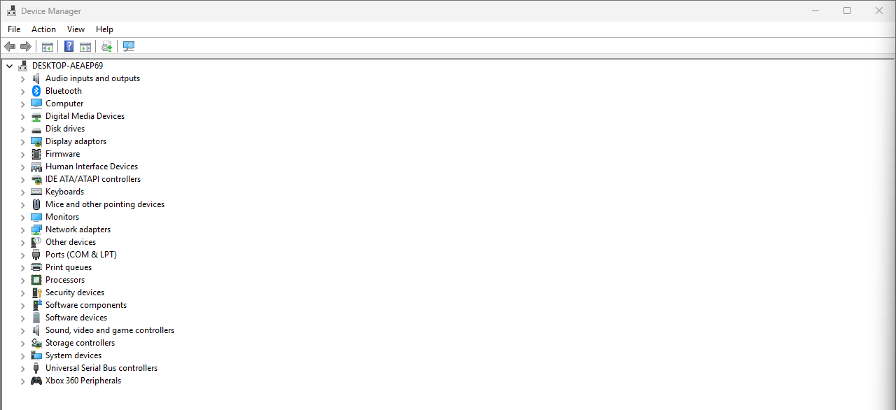

2.5 Networking Functions
Operating systems include built-in networking capabilities that allow devices to connect, communicate and share resources. Windows manages IP addressing, network adapters, Wi-Fi connections, Bluetooth, and protocols such as TCP/IP. It also provides tools for diagnosing and monitoring network activity. 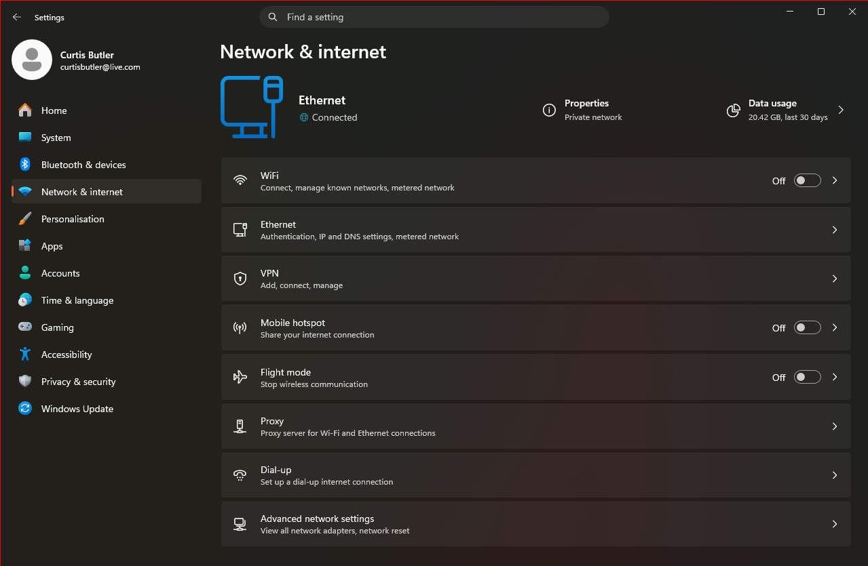

2.6 System Security
Security is a core OS function. Windows 11 includes authentication (passwords, PIN, biometrics), built-in antivirus protection, a firewall, encryption tools such as BitLocker, and protection rings that separate user processes from kernel-level operations. These features help prevent malware, unauthorised access and system tampering. [3] 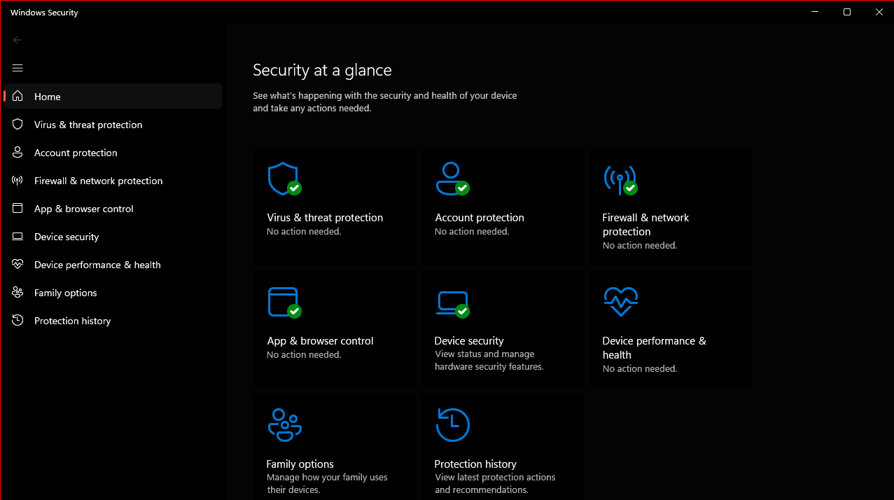

2.7 System Performance Monitoring
Operating systems provide tools to monitor CPU usage, memory consumption, disk activity and network performance. Windows includes Task Manager and Resource Monitor, which allow users to identify performance issues, track running processes and analyse system behaviour in real time. [4]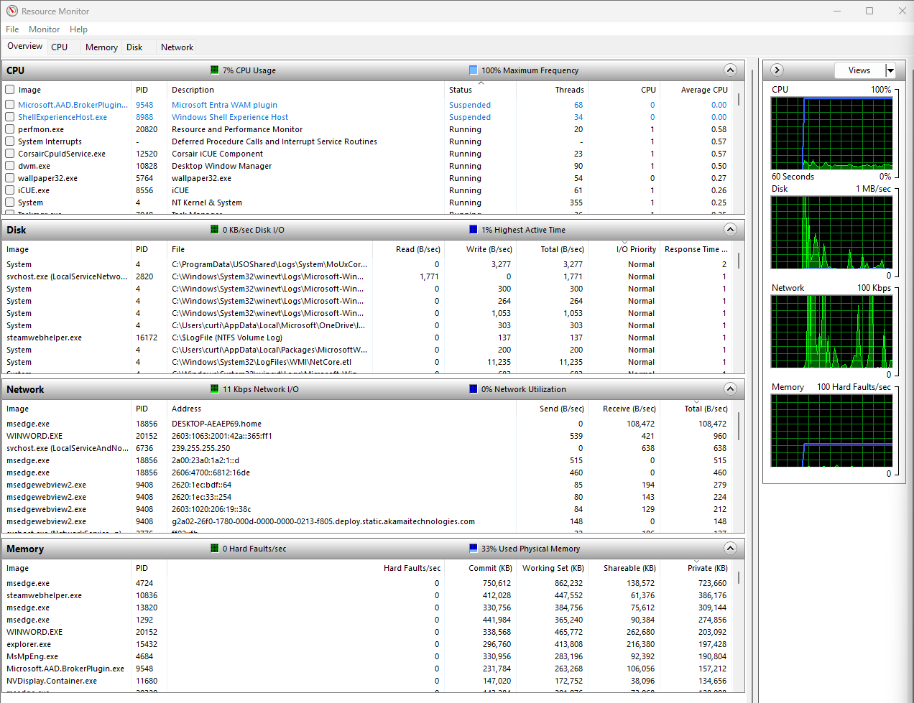

3. Use of Windows OS CLI Commands
Windows provides a wide range of command-line tools that allow users to manage files, monitor processes, test networks, and administer the system without relying on graphical menus. For this task, a selection of Batch commands were used to demonstrate key areas of system management, each supported with screenshots and short explanations. [5]

3.1 File & Directory Management
Basic directory commands allow users to navigate and organise the file system. The dir command lists the contents of the current folder, while dir | more displays the output one page at a time. mkdir testdir creates a new folder, and cd testdir moves into it. A simple text file can be created using echo "Hello World" > newfile.txt, and its contents viewed with type newfile.txt. Files and folders can be removed using del newfile.txt and rmdir testdir. These commands demonstrate how the OS manages files at a low level. When attempting to remove the folder from inside it, the command produced an error. After navigating up one directory using cd .., the rmdir command worked correctly. This demonstrates how Windows resolves paths and why directory context matters.
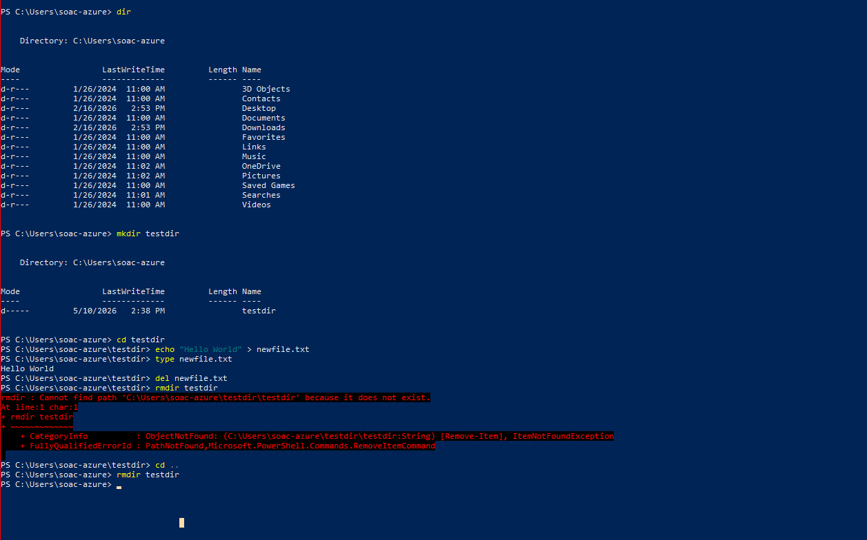

3.2 Process & System Monitoring
The tasklist command displays all running processes, including their memory usage and process IDs. Using tasklist /v provides a more detailed view with additional information such as user accounts and CPU time. Processes can be terminated using taskkill /pid <ID> /f, which forces the selected process to close immediately. To gather broader system information, the systeminfo command was also used. This outputs OS version, hardware details, installed updates, and system configuration, making it useful for diagnostics. [6]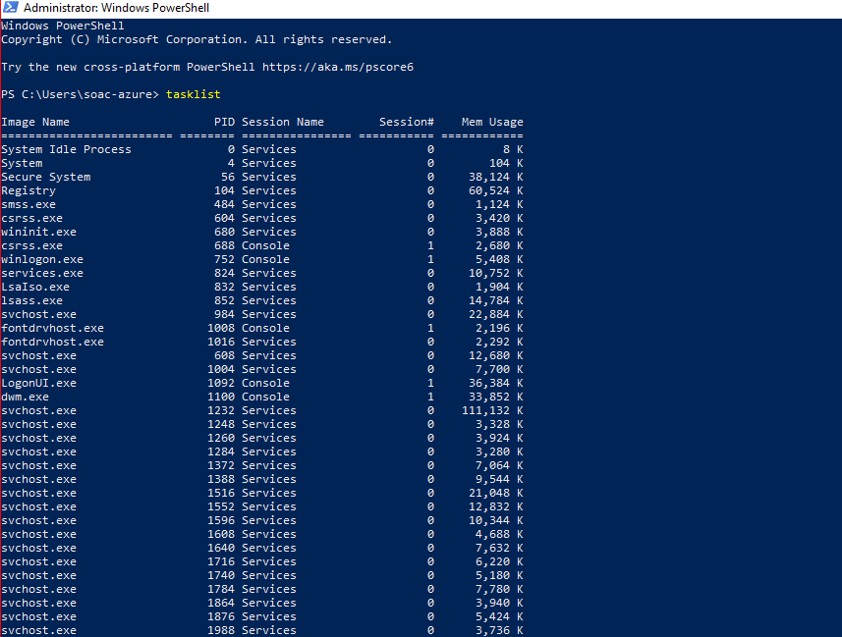
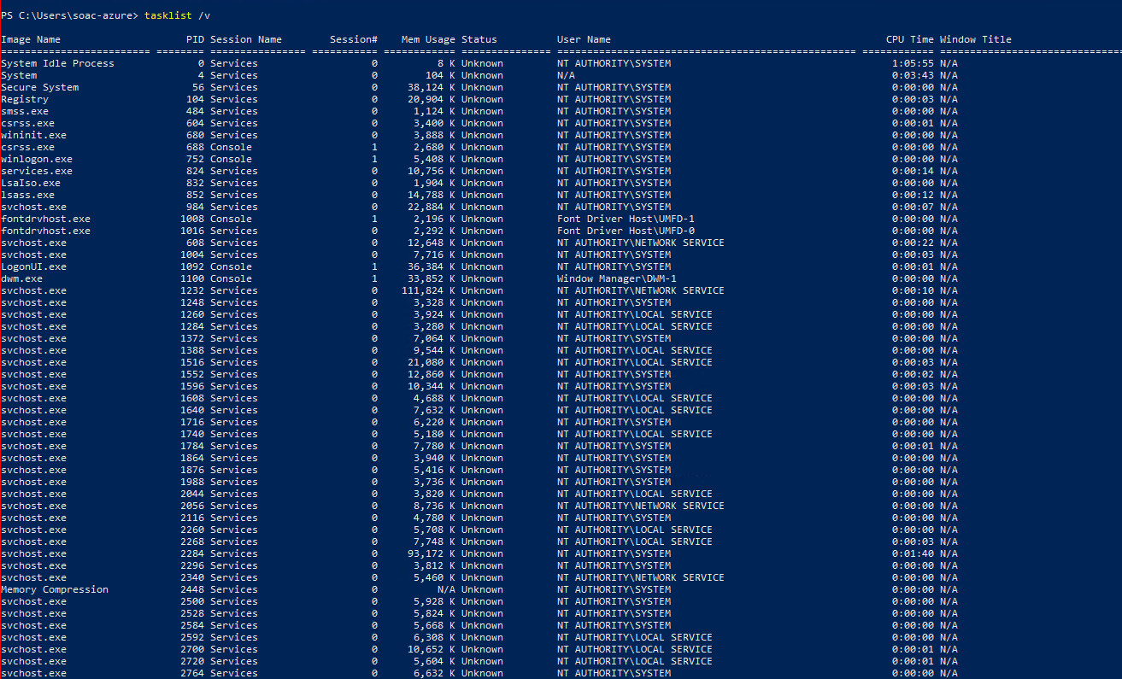

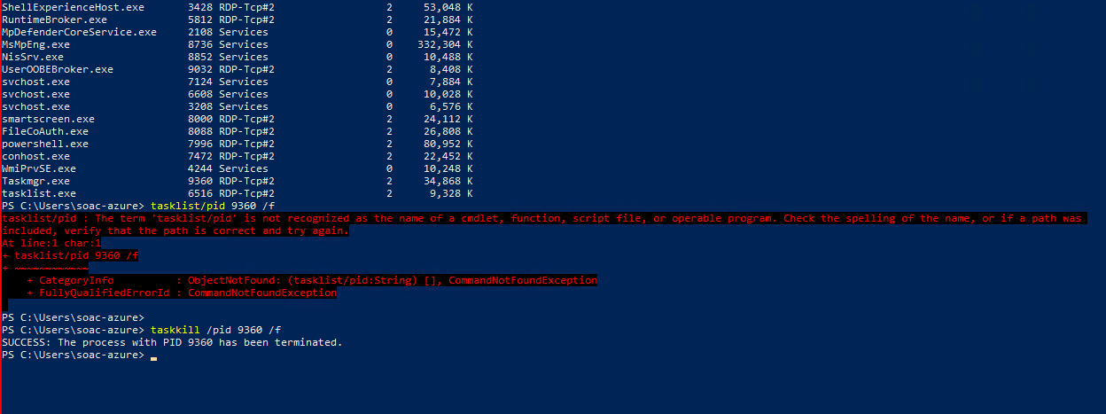
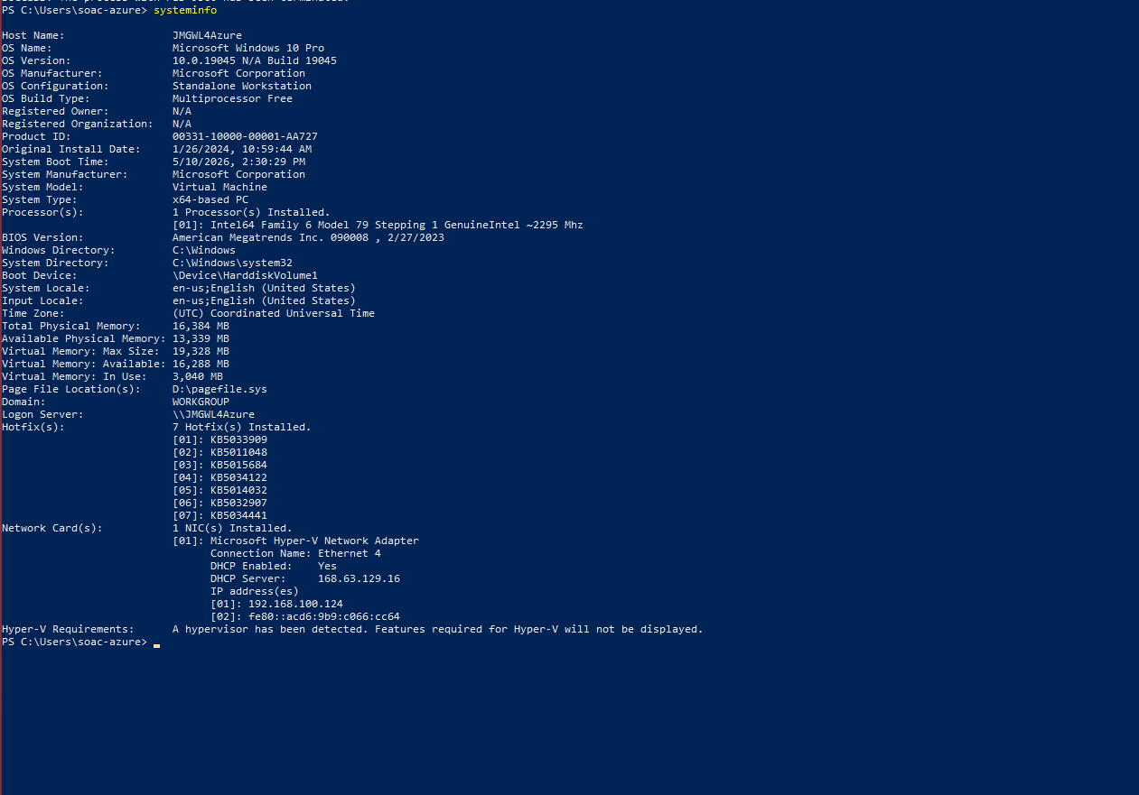

3.3 Network Testing & Monitoring
Networking commands are useful for diagnosing connectivity issues and understanding how a system communicates on a network. The ipconfig /all command displays full network configuration details such as IPv4 address, DNS servers, MAC address, and DHCP information. A filtered version, ipconfig /all | findstr IPv4, can be used when only the IPv4 address is needed.
To test external connectivity, I used ping google.com. Although the requests timed out due to the VM’s restrictions, the command still demonstrated how Windows sends ICMP packets to check if a host is reachable. The netstat -o command was used to list active network connections along with the process IDs responsible for them, which helps identify which applications are communicating on the network.
I also used getmac /v to display MAC addresses and adapter details. Finally, netsh wlan show wlanreport generated a detailed HTML Wi‑Fi report containing connection history, signal quality, and diagnostic information, which is useful for analysing wireless performance.[7]
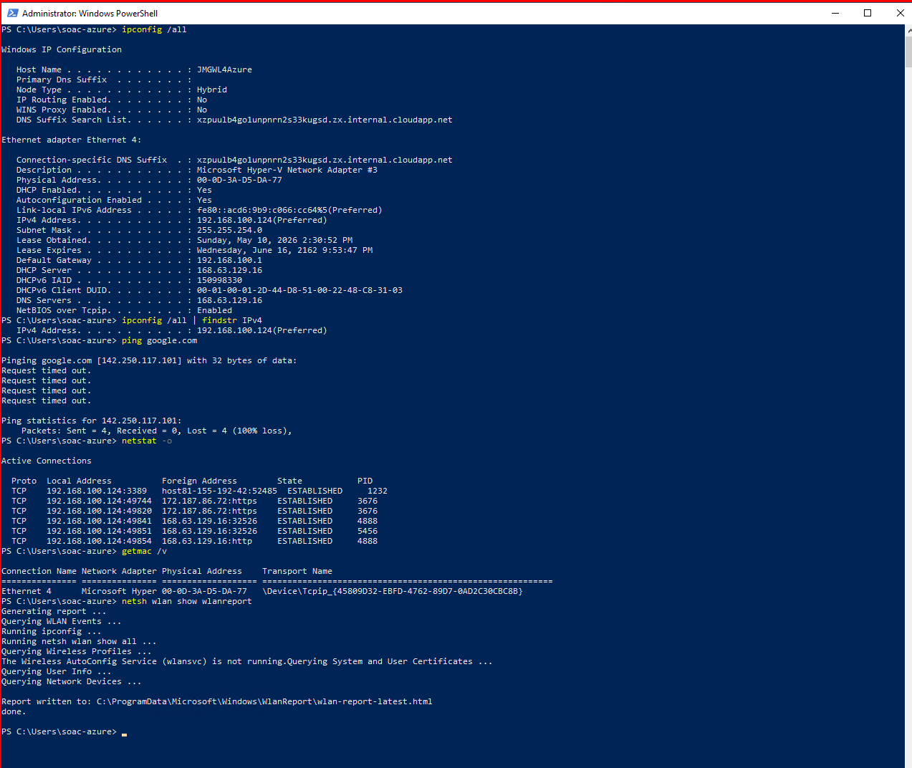

3.4 User Management
User management commands allow administrators to create and control local accounts. The net user command was used to list existing users, and a new account was created with net user testuser password /add. The account was then added to the Administrators group using net localgroup administrators testuser /add. Additional commands were used to show deeper administration: net user testuser displayed detailed account information, net user testuser /active:no disabled the account, and net localgroup listed all local groups. These commands demonstrate how Windows manages user accounts, permissions, and security. 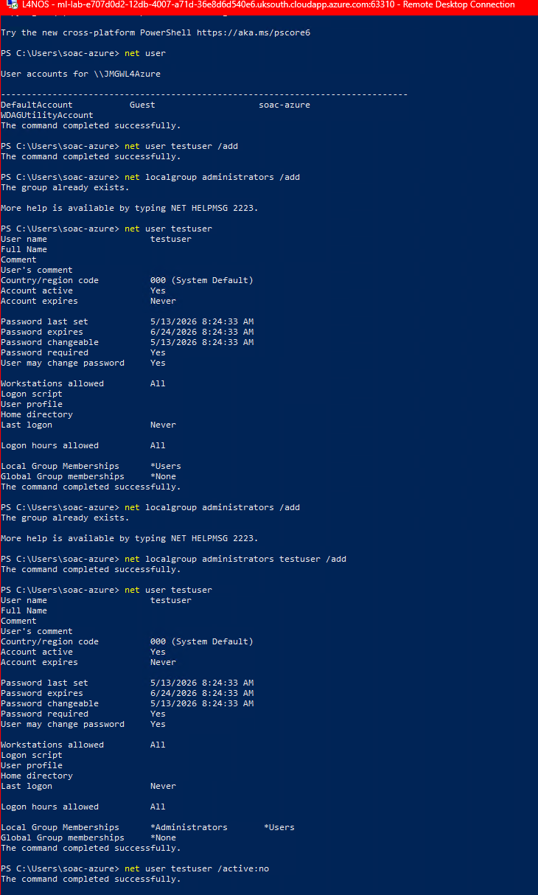
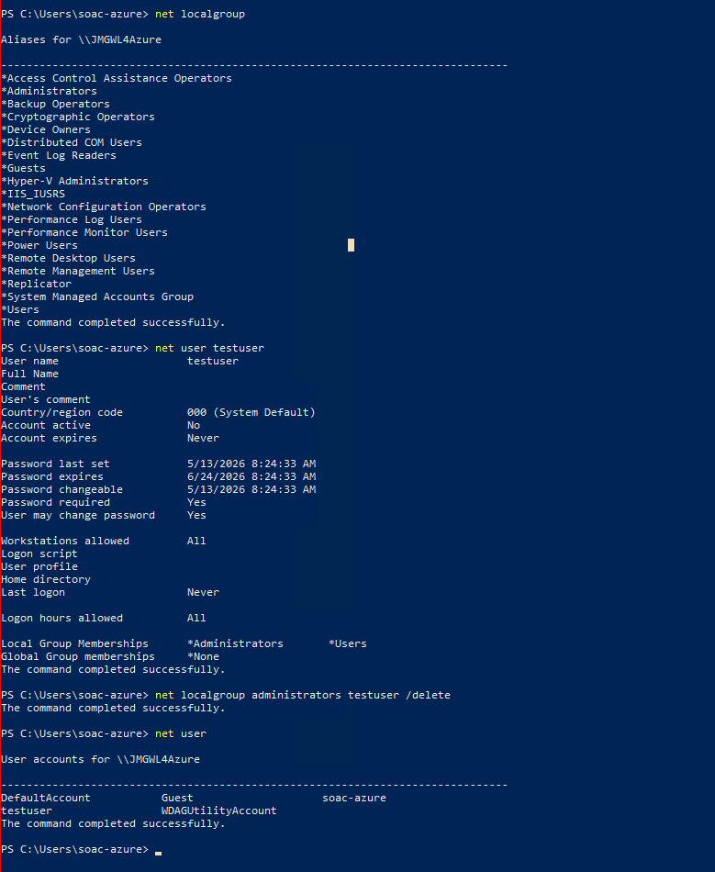

3.5 Task Scheduling
Task scheduling allows Windows to run programs automatically at specific times. The schtasks /query command was used to list existing scheduled tasks. A new task was then created using schtasks /create /tn TestTask /tr notepad.exe /sc once /st 12:00, which schedules Notepad to run once at the specified time. Finally, schtasks /query | findstr TestTask was used to confirm that the task was successfully created. 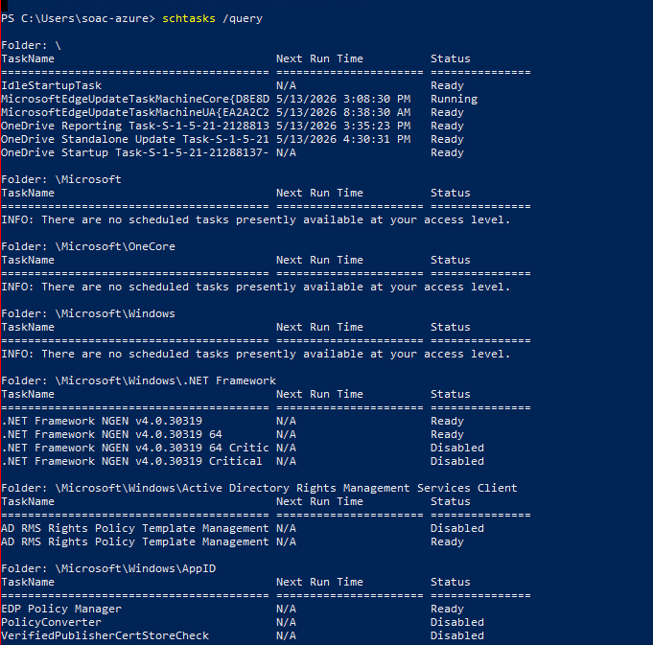
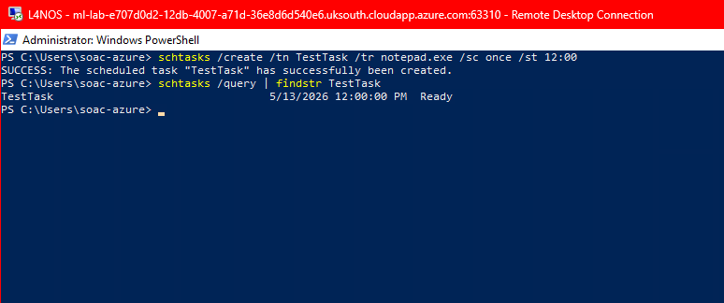

4. Use of Linux OS CLI Commands

4.1 Process Management
Linux provides several commands for monitoring and controlling running processes. The ps aux command lists all active processes, including their CPU and memory usage. For real-time monitoring, the top command displays an updating view of system activity, allowing processes to be sorted by CPU or memory consumption. Individual processes can be terminated using kill -9 <PID>, which sends a force-terminate signal. The htop tool (installed via sudo apt install htop) offers an interactive interface for managing processes more efficiently. These commands are essential for diagnosing performance issues and managing system resources. [8]
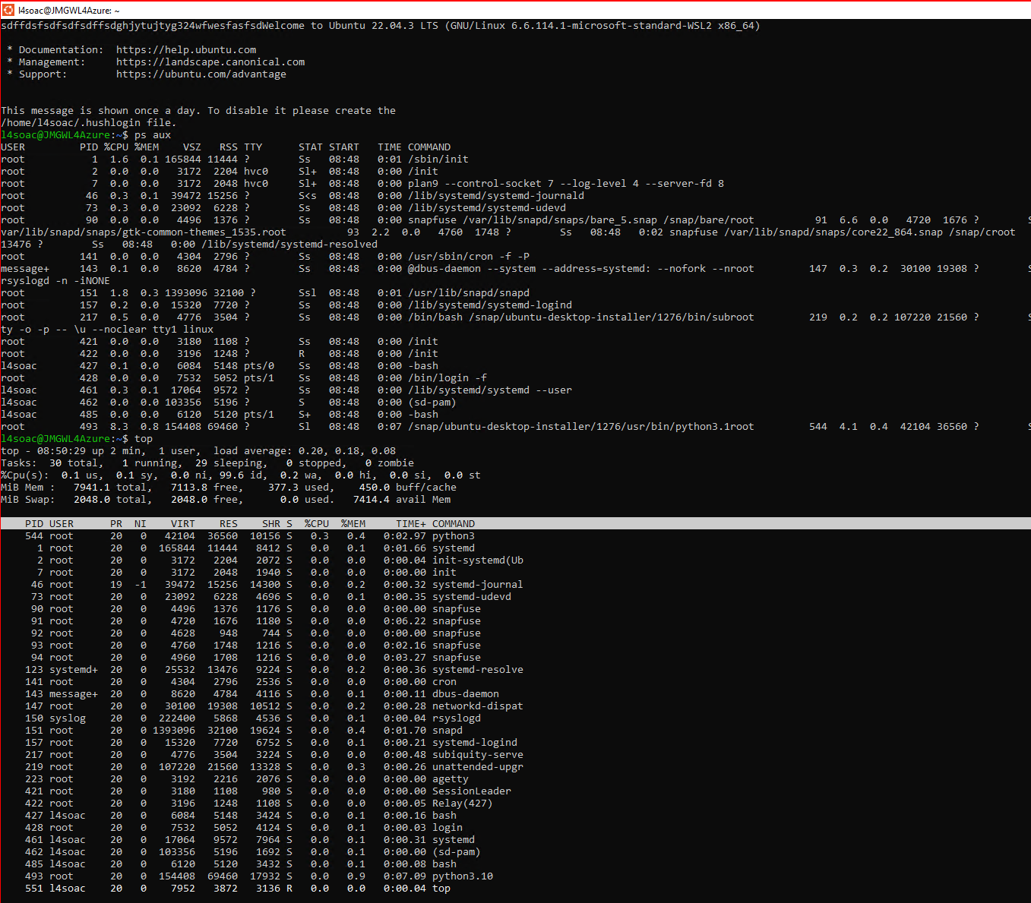. 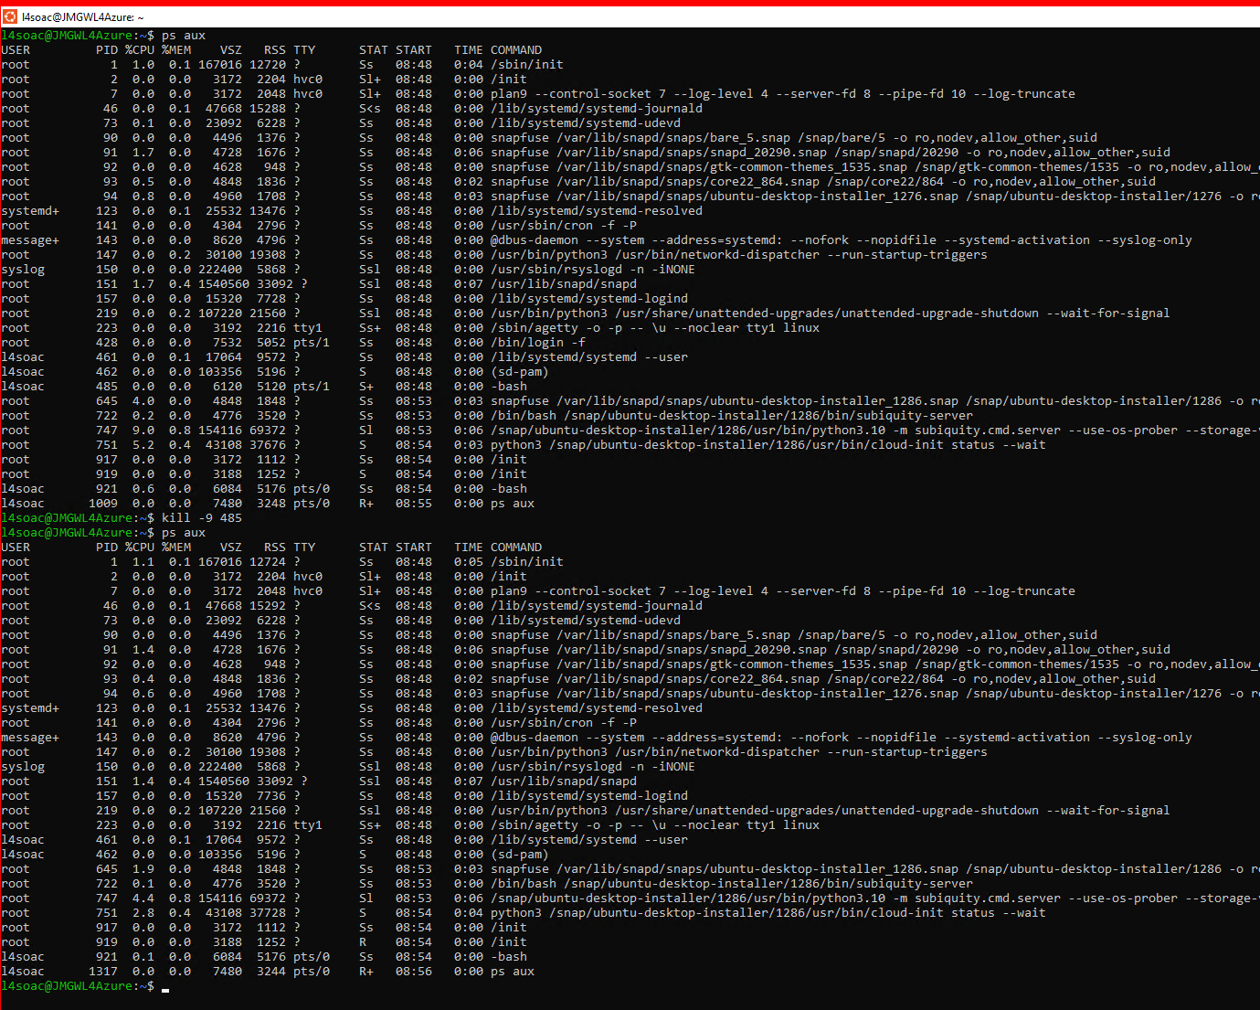
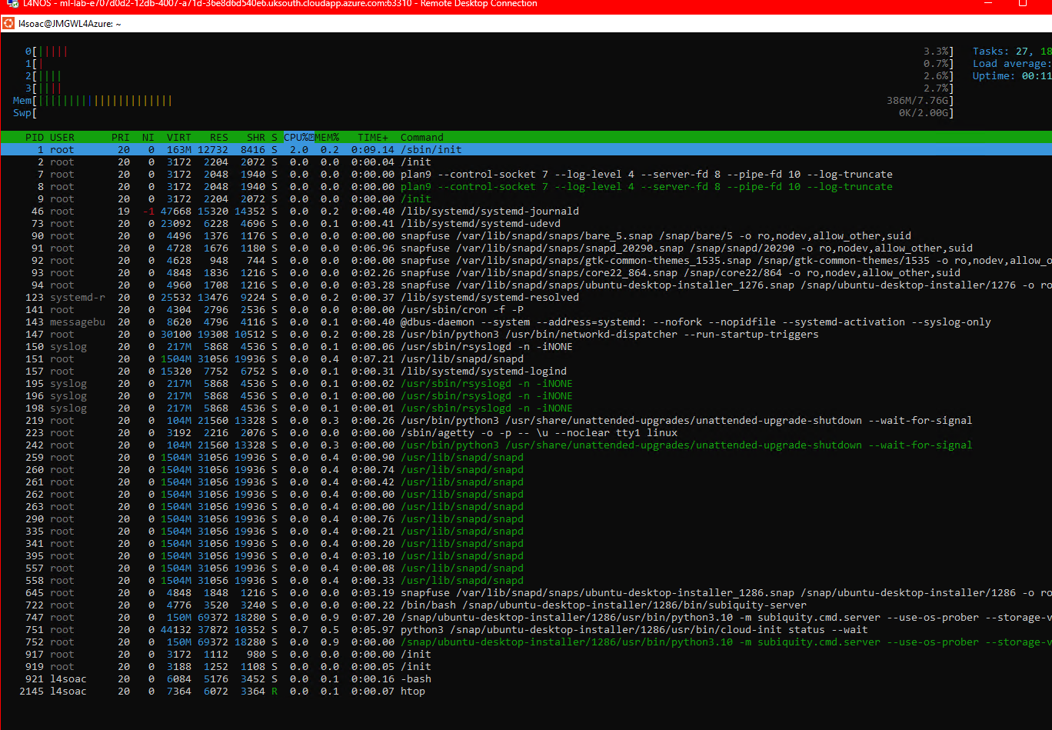

4.2 File & Directory Management
The Linux CLI allows users to manage files and directories efficiently. The pwd command was used to display the current working directory, confirming the user’s location in /home/l4soac. The mkdir testdir command created a new directory, and cd testdir navigated into it. Files were created using touch file1.txt and edited with nano file2.txt. Text was added using echo "Hello World" > file1.txt, and verified with cat file1.txt. The ls -l command listed files with their permissions, while chmod u+x file1.txt and chmod 755 file2.txt modified access rights. Finally, rm file1.txt and rm -r testdir removed files and directories, demonstrating full control of the file system. The clear command was used to tidy the terminal between steps for clarity. [9]
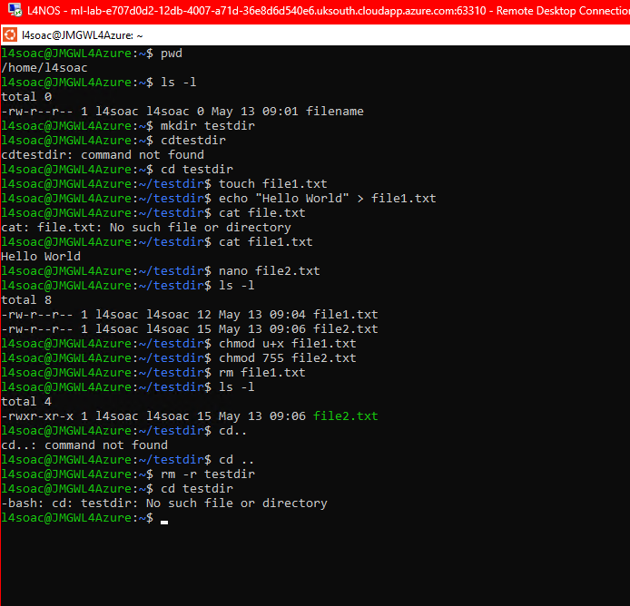

4.3 Network Testing & Monitoring
Several Bash commands were used to analyse network connectivity and inspect active network activity. The ip -4 addr command displayed the system’s IPv4 address and interface configuration. Connectivity was tested using ping www.google.com, which attempted to send ICMP packets; however, the WSL environment returned 100% packet loss, which is expected behaviour in virtualised cloud environments. Active network connections were viewed using netstat -tunap, showing open TCP/UDP ports, listening services, and associated process IDs. The arp -a command listed local ARP table entries, identifying nearby devices on the network. The traceroute command was also attempted, but it failed to run due to WSL network restrictions that block UDP/ICMP probing. This still demonstrates awareness of the tool and its purpose in mapping packet routes across a network. Together, these commands provide a clear overview of system connectivity and network diagnostics. 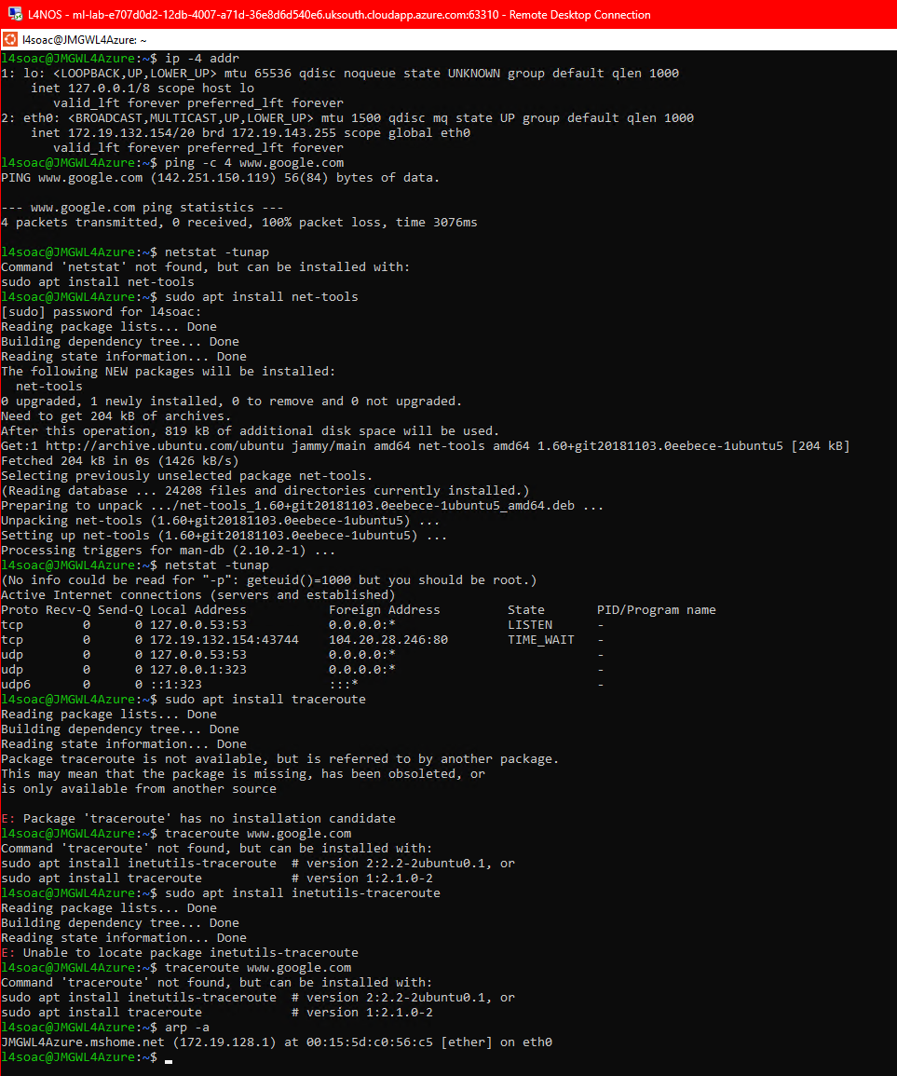
4.4 User Management
User and group administration was demonstrated using several Bash commands. A new user account was created with sudo adduser testuser, which set up the user’s home directory and prompted for a password. The list of system users was viewed using cat /etc/passwd, showing both system accounts and the newly created user. Group membership was modified using sudo usermod -aG sudo testuser, adding the user to the sudo group. The groups testuser command confirmed the user’s group assignments. The su - testuser command was used to switch into the new account, demonstrating how to log in as another user, and exit returned to the main account. The user was then removed from the sudo group using sudo gpasswd -d testuser sudo, and the account was deleted with sudo userdel testuser. These commands collectively demonstrate essential Linux user-management tasks, including account creation, privilege assignment, verification, switching users, and account removal. [10]
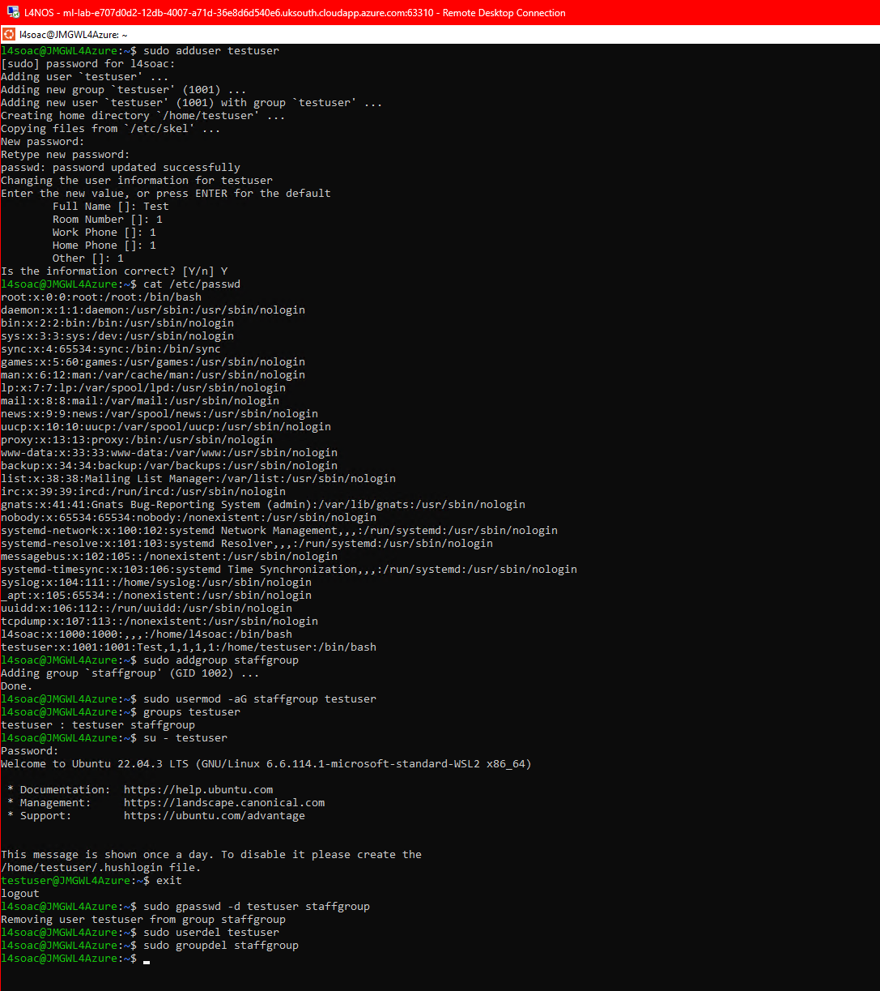

4.5 Task Scheduling
Linux uses the cron service to automate tasks at scheduled intervals. The crontab -l command was first used to check for existing jobs, confirming none were present. A new cron job was then created using crontab -e, which opened the user’s cron table in the nano editor. During editing, the system initially reported a “bad hour” error due to incorrect formatting, demonstrating cron’s strict syntax validation. After correcting the entry, the job was successfully installed. The line * * * * * echo "Cron test successful" >> /home/l4soac/cronlog.txt was added to run every minute and append a message to a log file. The crontab -l command verified the job’s presence, and cat ~/cronlog.txt confirmed successful execution by displaying the message “Cron test successful.” This process illustrates how cron validates syntax, schedules tasks, and automates routine operations such as logging and backups.
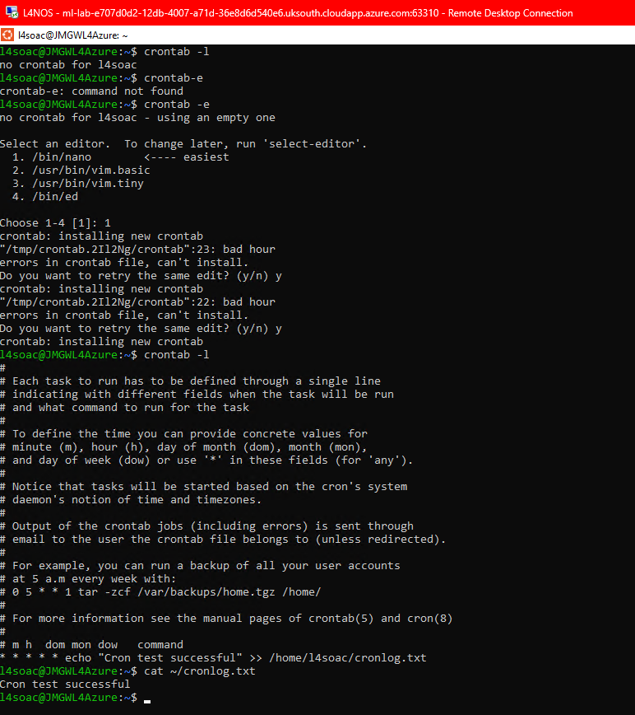

5. Windows OS Scripting
This task demonstrates key features of a Windows scripting language using a single PowerShell script that showcases variables, user input, conditional logic, arrays, loops, functions, and parsing command output. PowerShell was chosen because it is the modern Windows automation language and provides clearer syntax and more powerful features than traditional Batch scripting. [11]
The script begins by declaring two variables, $name and $age, and printing their values using Write-Host. This demonstrates how PowerShell stores and outputs data. User input is handled using Read-Host, which pauses execution and waits for the user to enter a value. This input is then evaluated using an if/else structure. If the user enters “1” or “2”, the script prints a corresponding message; otherwise, it outputs “Invalid choice”. This shows how PowerShell performs decision-making based on user-provided data.
An array is created using the @() syntax, containing three names. The script outputs a specific element using $names[1], demonstrating indexed access. A foreach loop is then used to iterate through the array and print each value. This illustrates how PowerShell handles collections and repetition.
A function named Say-Hello is defined using the function keyword and a param block. When called with Say-Hello -person "Curtis", it prints a personalised greeting. This demonstrates modular code design and reusability, which are essential scripting concepts.
Finally, the script performs command output parsing by retrieving the first five running processes using Get-Process | Select-Object -First 5. A pipeline passes each process object into ForEach-Object, where the script prints the process name and ID. This shows how PowerShell works with objects rather than plain text, making it suitable for system administration tasks. [12]
The screenshot provided shows the script file on the desktop, the code open in Notepad, and the script running successfully in PowerShell. This confirms correct execution and demonstrates all required features of the assignment in a single, well-structured script. [13]
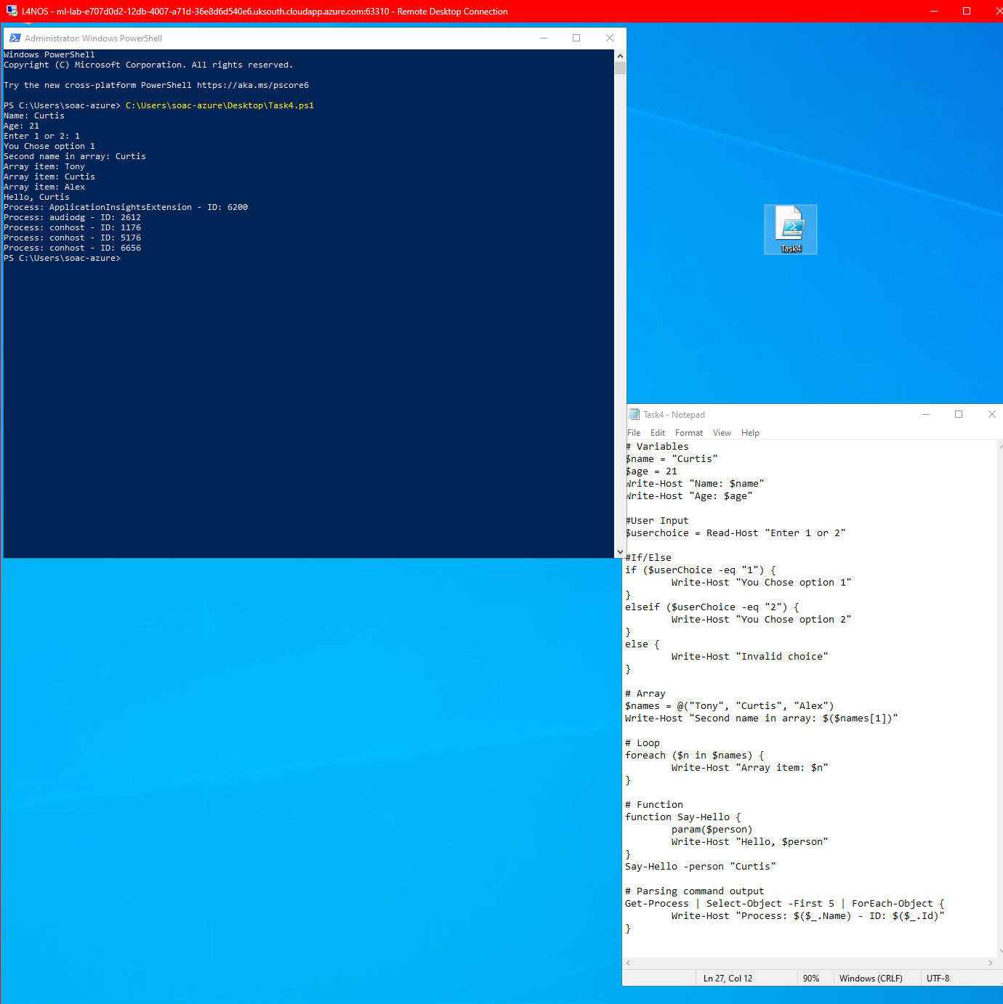

6. Linux OS Scripting
This task required me to create a Bash script that demonstrates key shell-scripting concepts, including variables, user input, conditional logic, arrays, loops, case statements, functions, and parsing command output. The script runs interactively and responds to user choices, showing how Bash can automate tasks and make decisions based on input. [14]
The script begins by defining two variables, name and age, and printing them to the terminal. This demonstrates how Bash stores and reuses data. It then collects user input using read -p, asking the user to enter either 1 or 2. An if/elif/else statement processes this input and prints a different message depending on the value, showing how conditional branching works in Bash.
Next, I created an array containing three fruits. The script prints the second item and then uses a for loop to iterate through all elements. This demonstrates how Bash handles lists of data and performs repeated actions without duplicating code. Loops are essential for automation tasks that involve processing multiple items.
The case statement section asks the user whether they like Linux and responds differently depending on the input. Case statements are cleaner than long chains of if statements and are useful when handling multiple possible responses. This part of the script shows how Bash can manage structured decision-making.
I also included a function called greet, which prints a message using an argument. Functions help organise code and make it reusable, which becomes important in larger scripts. Finally, the script uses a pipeline (ps -e | head -5) to display the first five running processes, demonstrating how Bash can combine commands and filter output. [15]
During development, I encountered several syntax errors caused by small typos in the script, particularly around quotation marks, parentheses, and the case statement formatting. These mistakes caused Bash to interpret lines incorrectly and report unexpected-token errors. I resolved the issues by reviewing each section carefully, retyping the affected lines, and testing the script repeatedly until it executed cleanly. This troubleshooting process strengthened my understanding of how Bash parses commands and how precise syntax needs to be when writing shell scripts. [16]

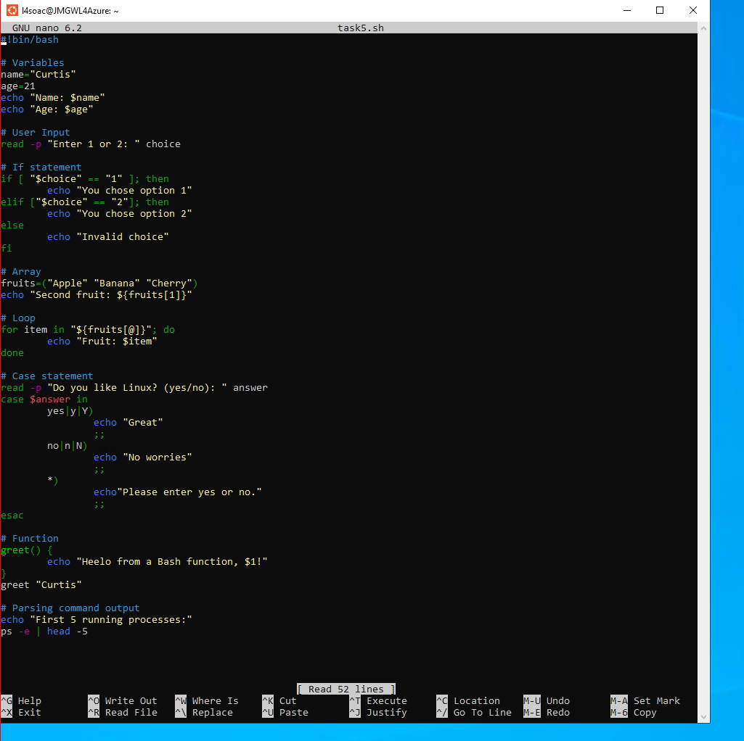
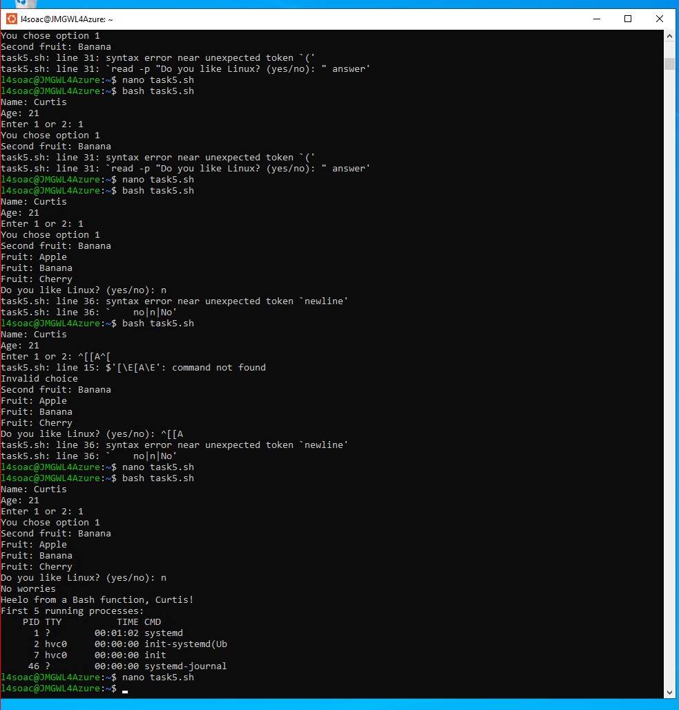

7. Conclusion
This module has strengthened my understanding of how operating systems work, both conceptually and in practice. The lectures and tutorials helped me build a clearer picture of how processes, memory, file systems, and user interaction fit together to form a functioning OS. The practical scripting tasks supported this by giving me hands‑on experience with the command line and showing how the OS responds to commands, manages input, and handles processes.
Working through the Bash scripting task also improved my troubleshooting skills. Several small syntax mistakes caused unexpected behaviour, and resolving them required careful checking, retyping lines, and testing the script repeatedly. This process helped reinforce how precise OS‑level scripting needs to be and gave me more confidence when working in a shell environment.
As part of my independent learning, I started the Cisco Networking Academy: Operating Systems Basics course. Although I have not yet completed it, the early sections have already supported my understanding of OS architecture and command‑line fundamentals. I plan to finish the course as part of my ongoing development, as it aligns well with the skills required for this module.
Overall, the combination of taught content, practical scripting, and independent study has given me a solid foundation in operating systems. I now have a clearer understanding of how they function internally and how to interact with them effectively using the command line, which will be valuable in future modules and technical roles.

References

[1]
A. I. Martyshkin and E. I. Markin, “Modeling of Task Manager with Dynamic Distributed Queue of Reconfigurable Computing System,” in International Conference on Industrial Engineering, Applications and Manufacturing (Online), IEEE, May 2025, pp. 889–895. doi: 10.1109/ICIEAM65163.2025.11028348.
[2]
Hoboken, NJ. Windows 10 for dummies organizing files & apps course. Displaying the File Explorer panes in Windows 10, (2015).
[3]
N. Rawlinson, “WINDOWS DEFENDER,” Web user, no. 485, Future Publishing Ltd, London, pp. 48–50, October 2, 2019.
[4]
T.-C. Singerean, B. G. Draghici, A. Elena Dobre, O. P. Stan, and L. Cristian Miclea, “Development of a Comprehensive Process Management and Optimization System Using the Windows API,” in International Conference on System Theory, Control and Computing, IEEE, Oct. 2025, pp. 397–402. doi: 10.1109/ICSTCC66753.2025.11240416.
[5]
T. Dawson, “Introduction to the Windows Command Line with PowerShell,” The programming historian, no. 5, July 2016, doi: 10.46430/phen0054.
[6]
V. Bulatetskyi, L. Bulatetska, and T. Hryshanovych, “ANALYSIS OF OS WINDOWS 10 FILE OBJECTS FOR SYSTEM PARTITION SPACE CLEANING AND OPTIMIZATION,” Kìberbezpeka. osvìta, nauka, tehnìka, vol. 3, no. 15, pp. 71–84, 2022, doi: 10.28925/2663-4023.2022.15.7184.
[7]
W. Fuqua, Windows Terminal Tips, Tricks, and Productivity Hacks: Optimize your command-line usage and development processes with pro-level techniques, 1st edition. Birmingham: Packt Publishing, 2021. doi: 10.0000/9781800209640.
[8]
O. Pelz, Fundamentals of Linux: Explore the Essentials of the Linux Command Line, 1st ed. Birmingham: Packt Publishing, Limited, 2018. doi: 10.0000/9781789537529.
[9]
S. Kumari, Linux Shell Scripting Essentials. Packt Publishing, 2015.
[10]
K. Makan, Penetration testing with the bash shell: make the most of the Bash shell and Kali Linux’s command line-based security assessment tools, 1st ed. PACKT Publishing, 2014.
[11]
B. J. W. Blawat, Mastering Windows PowerShell scripting: master the art of automating and managing your Windows environment using PowerShell, 1st ed. Birmingham: Packt Publishing, 2015.
[12]
Thomas Lee, Windows Server Automation with PowerShell Cookbook - Fourth Edition. Packt Publishing, 2021.
[13]
V. Saini, Birmingham, England. Managing software installations with PowerShell, (2023).
[14]
M. Ebrahim and A. Mallett, Mastering linux shell scripting : a practical guide to linux command-line, bash scripting, and shell programming, Second edition. Birmingham: Packt Publishing, 2018. doi: 10.0000/9781788990158.
[15]
S. Lakshman, Linux shell scripting cookbook: solve real-world shell scripting problems with over 110 simple but incredibly effective recipes. Birmingham: PACKT Publishing, 2011.
[16]
Ron Brash and Ganesh Sanjiv Naik, Bash Cookbook. Packt Publishing, 2018.

Appendices

1. OS Types
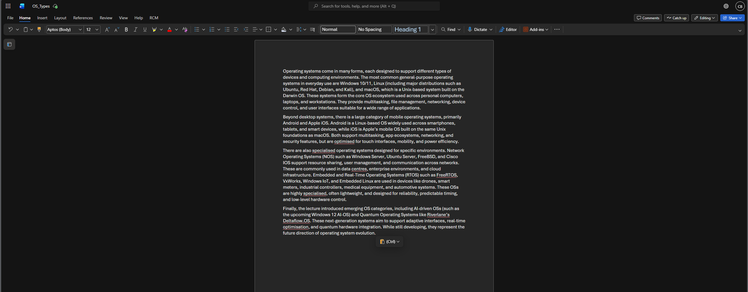

2. Lecture Activity Log
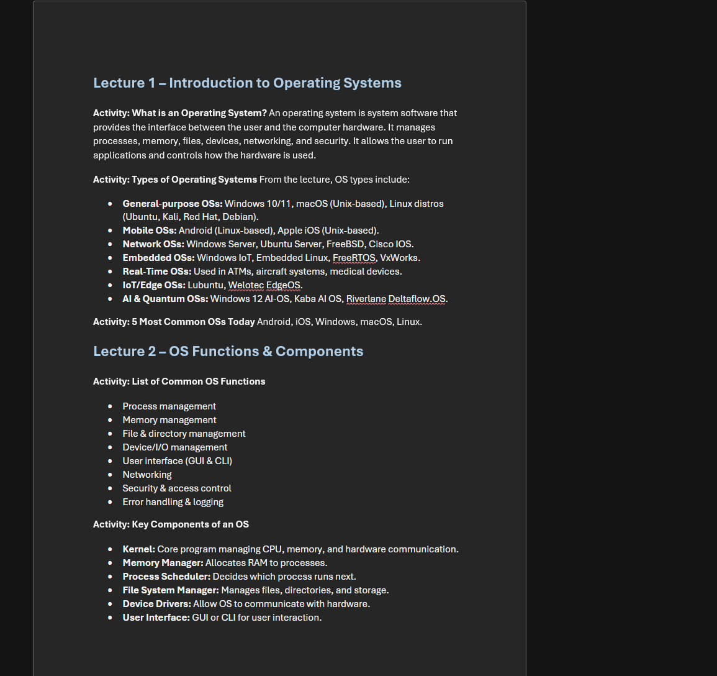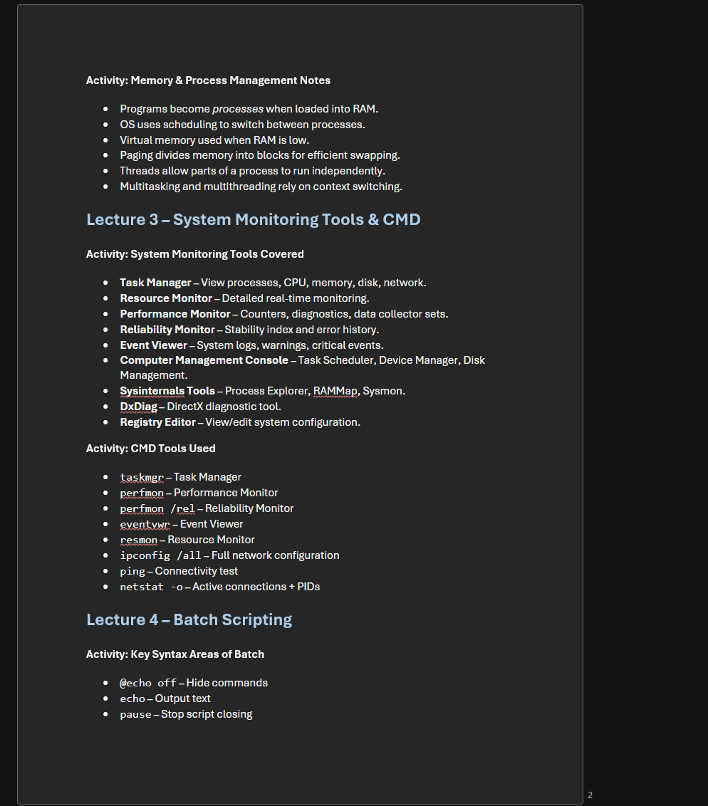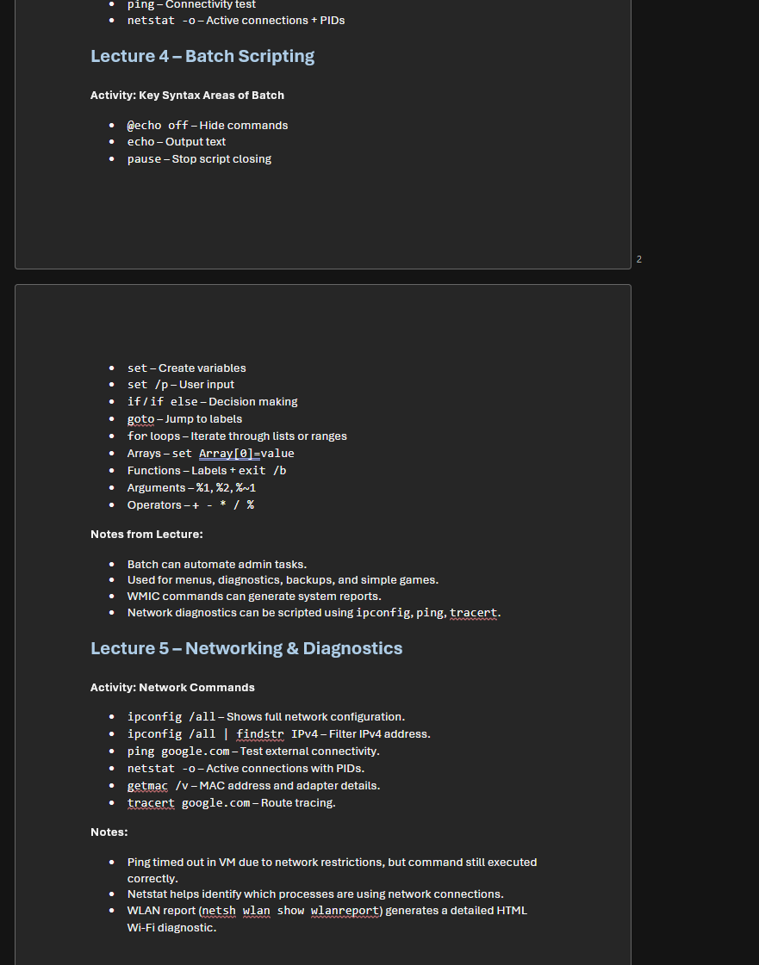

3. Evidence of Course - Cisco Networking Academy: Operating Systems Basics


