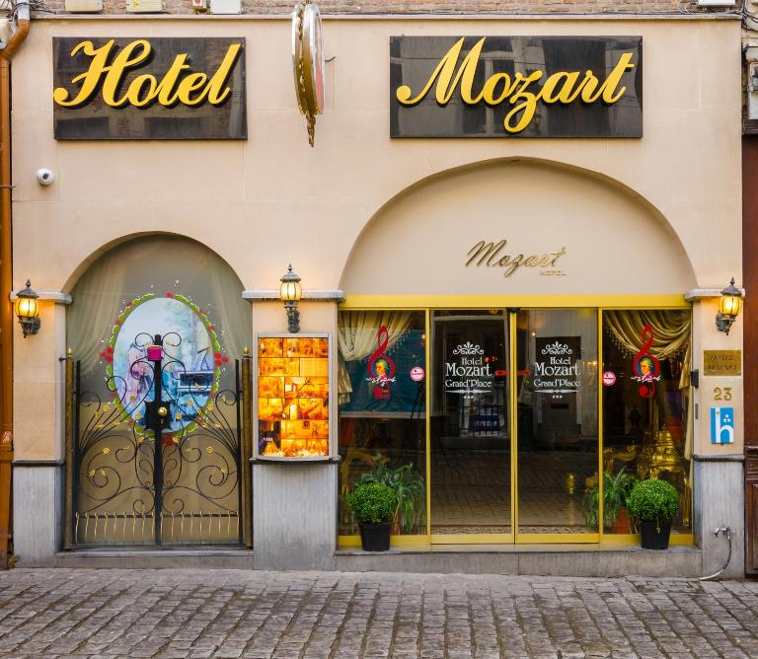
Hotel Mozart Brussels Consultancy Report
Organisational Consultancy, BMIH6005
Alina Pruteanu | 2209886

DATE REPORT WILL BE DELIVERED TO CLIENT 5 NOVEMBER
I acknowledge using the Grammarly App and Microsoft Word Editor on 14th November 2024 to check my grammar, syntax and misspellings.

Executive Summary

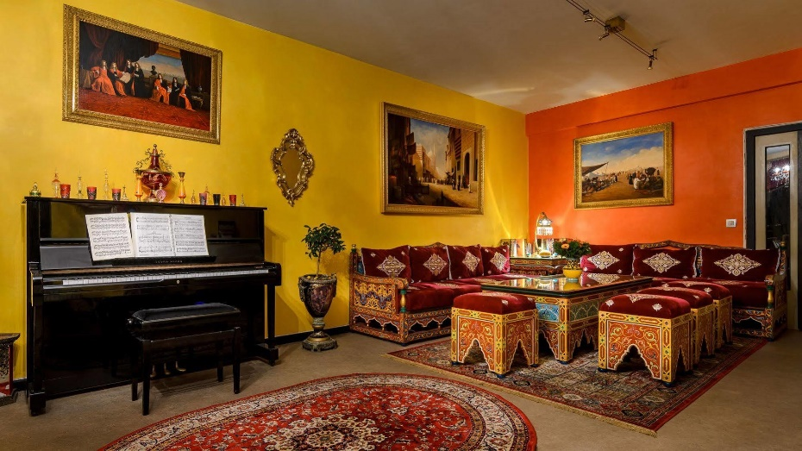
Objective
Hotel Mozart, a boutique hotel located in the heart of Brussels, has faced persistent challenges in maintaining high hygiene standards, facility maintenance, and customer service, resulting in a decline in guest satisfaction and overall reputation. This report aims to assess these operational issues and provide targeted recommendations. The focus of this assessment is threefold: identifying hygiene lapses that have led to negative guest experiences, addressing maintenance deficiencies that detract from the hotel’s perceived quality, and enhancing customer service practices to foster better guest relations. By implementing these improvements, Hotel Mozart can restore guest confidence, boost satisfaction, and solidify its position in Brussels’ competitive hospitality market.

Key Findings
An analysis of recent guest feedback on platforms such as TripAdvisor and Booking.com highlights three significant areas of concern that are impacting Hotel Mozart’s reputation and guest retention:
- Hygiene Issues: Guest reviews consistently cite cleanliness as a primary concern. Specific complaints include the presence of bed bugs, insects, stained bedding, and unpleasant odours throughout the hotel. These hygiene-related complaints suggest inadequate cleaning and pest control protocols, leading to negative guest experiences and reluctance to return. Research shows that hygiene directly influences guest comfort, satisfaction, and safety, with poor cleanliness often discouraging future bookings and damaging reputation.
- Maintenance Problems: Guests have noted several maintenance issues, including malfunctioning amenities like toilets and televisions, clogged drains, and worn-out furniture. The condition of the hotel’s physical assets plays a crucial role in guest satisfaction, and maintaining facilities is essential for a comfortable stay. The current state of amenities indicates a lack of routine maintenance and timely repairs, leading to further negative feedback and potentially deterring new guests.
- Customer Service Challenges: Guest interactions with staff are critical to shaping overall impressions, yet reviews need to be revised in this area. Complaints describe unprofessional behaviour, insufficient handling of issues, and a lack of empathy from staff. Effective customer service is paramount in the hospitality industry, with studies showing that personalised, responsive service significantly increases guest loyalty. Poor customer service at Hotel Mozart exacerbates guests' negative experiences, affecting overall satisfaction and loyalty.

Analysis Summary
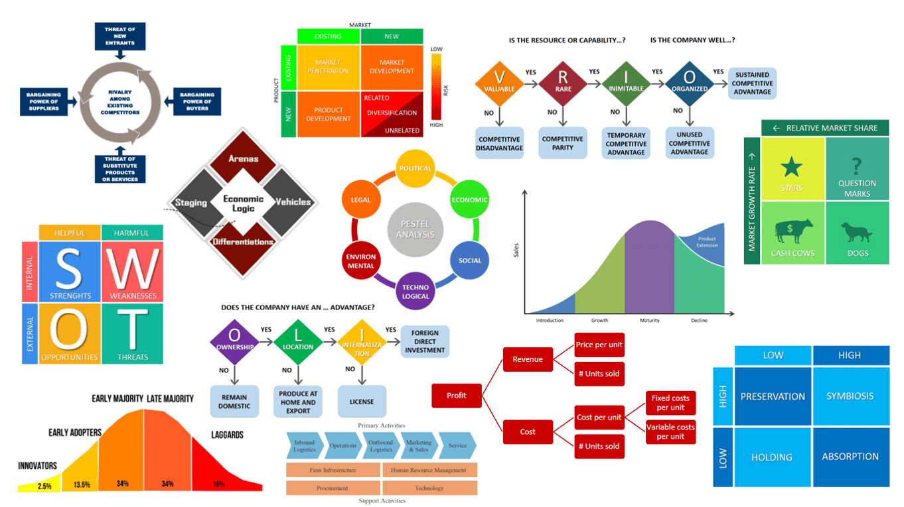
To thoroughly assess these issues and devise practical solutions, the report utilises four analytical frameworks:
- SWOT Analysis: This tool identifies Hotel Mozart’s primary strengths (e.g., prime location, unique décor) and weaknesses (e.g., hygiene, maintenance, and customer service deficiencies). Opportunities (e.g., increased operational standards and sustainable practices) and threats (e.g., nearby competition and potential regulatory scrutiny) are also highlighted, providing a holistic overview of the hotel’s current situation.
- TOWS Analysis: The TOWS framework explores strategies that influence the hotel’s strengths to mitigate external threats, such as accentuating improvements in hygiene and maintenance to attract guests. It also suggests addressing weaknesses (e.g., operational gaps) to take advantage of potential opportunities, such as appealing to eco-conscious travellers through sustainable cleaning practices.
- PESTEL Analysis: This analysis examines the external factors that impact the hotel, such as Belgium’s strict health and hygiene regulations (political), economic fluctuations in Europe affecting tourism demand (financial), the impact of online reviews on guest decisions (social), and the benefits of adopting advanced cleaning technologies (technological). The analysis also highlights environmental considerations, such as sustainable practices and legal obligations related to health and safety in the hospitality sector.
- Porter’s Five Forces: This framework evaluates competitive pressures in Brussels' hospitality industry, including the threat of new entrants with higher standards, the bargaining power of customers influenced by online reviews, and the intensity of rivalry in the area. It underscores the importance of maintaining competitive standards to withstand these pressures.

Recommendations

The report outlines key recommendations designed to address Hotel Mozart’s operational challenges and improve guest satisfaction:
- Hygiene Improvement Measures: A comprehensive cleaning and pest control protocol is recommended, focusing on structured daily and weekly cleaning routines. Professional pest control services should be contracted, and staff should receive training on proper sanitation techniques. These measures are essential to eliminating recurring issues like bed bugs and unpleasant odours, directly improving the hotel’s cleanliness standards.
- Maintenance Overhaul: Routine checks for plumbing, furnishings, and electrical appliances should be instituted to ensure consistent functionality. Immediate repairs for reported issues and systematically replacing outdated or broken items are crucial. Adopting a digital maintenance management system would streamline issue tracking, enabling staff to address problems promptly and maintain high operational standards.
- Customer Service Training: Staff retraining programs focusing on professionalism, empathy, and effective issue resolution are recommended. Implementing a guest feedback mechanism, such as post-stay surveys, would provide valuable insights into service performance, allowing for continuous improvement based on guest feedback.
- Management and Accountability: Appointing a Quality Assurance (QA) Manager to oversee operational standards and instituting a complaint logging system would increase accountability. These steps ensure that issues are addressed systematically, maintaining a consistent and high standard of service.
- Change Management Strategy: Introducing these changes in stages, supported by clear communication with staff, would help mitigate resistance and ensure successful implementation. Staff feedback mechanisms should be utilised to assess the effectiveness of new protocols and make necessary adjustments.

Conclusion
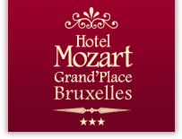
Implementing these recommendations can significantly improve guest satisfaction, reputation, and competitive positioning for Hotel Mozart. Reinforced cleanliness standards, well-maintained facilities, and a refined customer service approach would contribute to positive guest reviews, repeat bookings, and overall brand reputation. True Path Hotel Consultants appreciates Hotel Mozart for considering our firm to address these critical improvements. We are enthusiastic about working together to improve Hotel Mozart’s service quality and market reputation, and we look forward to future opportunities to support your continued success in the hospitality industry.

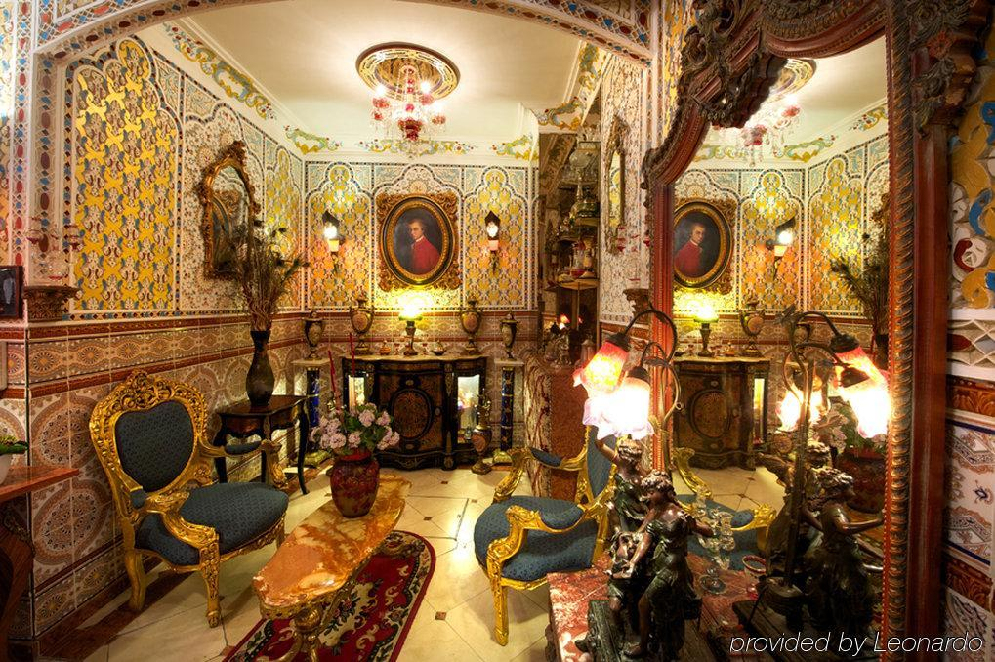
- Introduction

Hotel Mozart, a distinctive boutique hotel in the heart of Brussels, offers guests a unique cultural experience with its Oriental-style décor and historic architecture. Situated near the iconic Grand Place, a UNESCO World Heritage site, and other notable landmarks, the hotel’s central location makes it an attractive option for tourists eager to explore the city’s cultural and historical attractions. The hotel’s interiors reflect a traditional aesthetic, with vibrant colours, ornate furnishings, and detailed décor, providing a memorable ambience for guests seeking a more individualised and exotic experience. With its proximity to major attractions, restaurants, and public transportation, Hotel Mozart has significant potential to appeal to tourists looking for convenience and an authentic local experience.
True Path Hotel Consultants, the consultancy firm selected to address the operational challenges at Hotel Mozart, specialises in providing targeted solutions to improve operational efficiency, enhance guest experience, and improve brand reputation. Our firm has extensive experience in the hospitality industry, with a proven track record of successfully addressing issues in diverse hotel settings. We focus on analysing core operational aspects—hygiene standards, facility maintenance, and customer service—to help our clients offer their guests a seamless and high-quality experience. True Path Hotel Consultants leverages data-driven insights and industry expertise to address critical areas of improvement, ensuring that hotels not only meet but exceed guest expectations.
Following an in-depth analysis of Hotel Mozart’s guest reviews, three critical areas of concern have emerged: hygiene, maintenance, and customer service. Numerous guest reviews on platforms such as TripAdvisor and Booking.com highlight recurring issues with cleanliness, including bed bug infestations, unpleasant odours, and insufficient pest control measures. Maintenance challenges, such as non-functional amenities, broken furniture, and plumbing issues, have also been widely noted, detracting from the overall guest experience. Additionally, frequent complaints about poor customer service, including inadequate handling of guest complaints and unprofessional interactions with staff—further compound the hotel’s challenges. Addressing these areas effectively is essential to reversing negative guest perceptions, increasing guest retention, and positioning Hotel Mozart as a competitive option in Brussels.
To comprehensively analyse these issues and devise practical recommendations, this report employs several well-established frameworks: SWOT analysis, TOWS analysis, PESTEL analysis, and Porter’s Five Forces framework. The SWOT analysis will provide an overview of the hotel’s strengths, weaknesses, opportunities, and threats, offering a holistic view of its current standing and areas of potential. The TOWS analysis will explore strategic approaches to maximise strengths and opportunities while mitigating weaknesses and threats. The PESTEL analysis will examine macro-environmental factors - political, economic, social, technological, environmental, and legal - impacting the hotel’s operations and strategic positioning. Finally, Porter’s Five Forces framework will assess the competitive pressures within Brussels’ hotel industry, examining how factors like industry rivalry, the threat of new entrants, and bargaining power affect Hotel Mozart’s market positioning.
Using these frameworks, True Path Hotel Consultants will provide a structured assessment of its current operations and offer evidence-based recommendations to address its hygiene, maintenance, and customer service challenges. This approach aims to resolve existing issues and establish a foundation for sustainable improvements that will improve Hotel Mozart’s reputation and market competitiveness.

- Issue Identification and Impact
Hotel Mozart in Brussels has been criticised extensively on reviews like TripAdvisor and Booking.com, highlighting hygiene, maintenance, and customer service issues. These persistent complaints are significant in understanding how operational shortcomings can impact the hotel’s reputation, guest retention, and overall market competitiveness.
Hygiene Issues
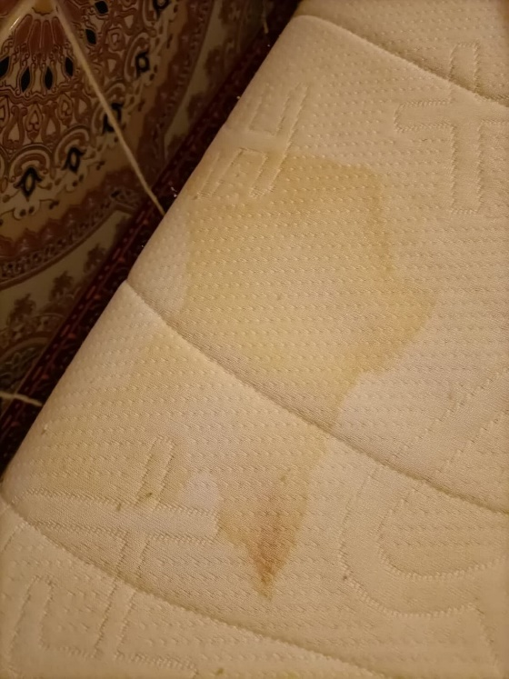
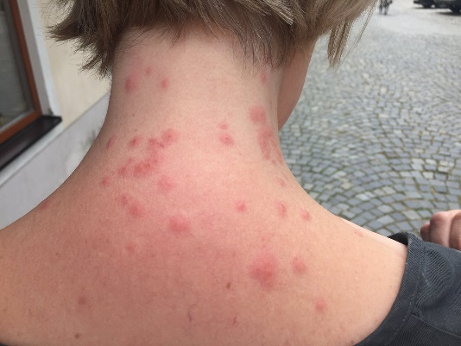
The most prominent issue in guest reviews is the lack of hygiene, with complaints regarding bed bugs, insects, stained bedding, and unpleasant odours. Multiple guests reported bed bug infestations, experiencing bites and discomfort, which is particularly alarming for potential customers (TripAdvisor, 2024). Insects in rooms and bathrooms are frequently mentioned, suggesting that pest control measures may be insufficient (Booking.com, 2024). Academic studies draw attention to the impact of cleanliness on guest satisfaction; for example, research by Park et al. (2019) highlights that hygiene is one of the primary drivers of hotel guest satisfaction, significantly affecting perceived safety and comfort. Poor cleanliness discomforts guests and can lead to negative psychological responses, reducing their willingness to recommend or revisit (Islam et al., 2023). As mentioned in guest feedback, odours from carpets and bathrooms contribute further to these negative experiences, aligning with Kim et al. (2022) findings that cleanliness is directly associated with guests' emotional comfort and overall satisfaction.
Maintenance Issues
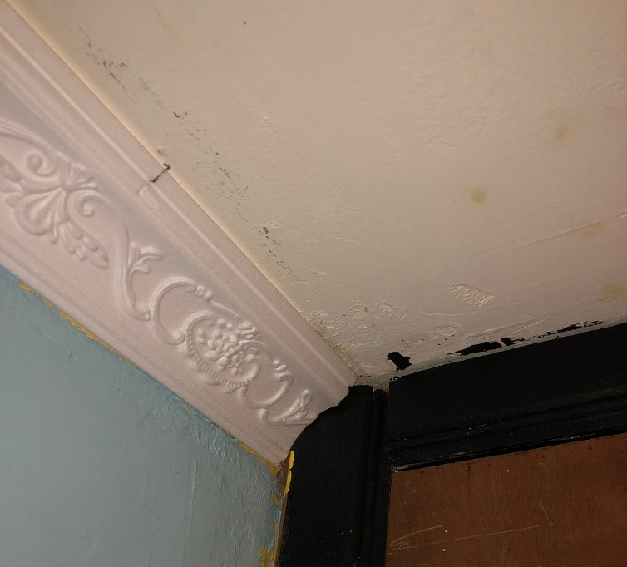
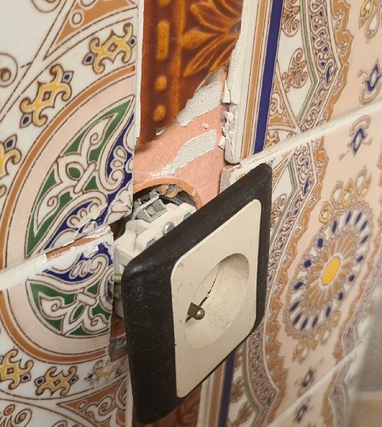
Guest feedback also reveals several maintenance issues at Hotel Mozart, including broken toilets, clogged drains, malfunctioning televisions, and worn-out furniture. Guests report frequent plumbing problems, such as non-functional toilets and showers, significantly impacting their stay quality (Booking.com, 2023). Functional amenities are considered baseline hotel expectations, and meeting these standards can lead to satisfaction and positive reviews (Mohsin and Lengler, 2015). Additionally, guests have noted ageing and broken furniture, which detracts from the perceived value of the accommodation. Research by Pizam and Tasci (2019) suggests that well-maintained physical amenities are crucial for improving guest comfort, as they convey a sense of professionalism and care. Maintenance deficiencies, as observed at Hotel Mozart, can erode trust and reduce the likelihood of repeat visits, as they indicate neglect and a lack of quality control (Akbaba, 2006).

Customer Service Issues
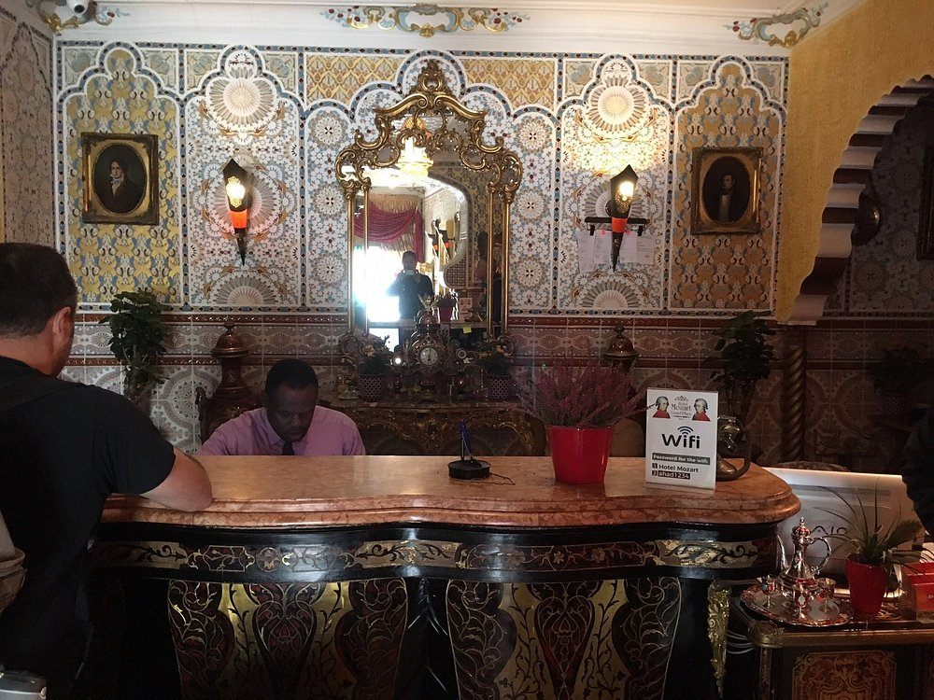Customer service is another area of concern, with guests citing unprofessional behaviour, lack of empathy, and inadequate complaint resolution. Reviews describe instances where staff dismissed hygiene and maintenance complaints, leading to frustration and dissatisfaction (TripAdvisor, 2024). Customer service is critical in shaping guests' experiences and encouraging loyalty in the hospitality industry. Studies by Han, Kwortnik Jr and Wang (2008) underline that guests who feel valued and respected are more likely to return and recommend the hotel. Inadequate complaint handling leads to immediate dissatisfaction and impacts the hotel’s reputation, as potential guests are deterred by reports of poor service (Kim, Lee, and Yoo, 2006).
Impact on Reputation
The cumulative effect of these hygiene, maintenance, and customer service issues is a deteriorating reputation for Hotel Mozart. Research by Sparks and Browning (2011) demonstrates that negative online reviews significantly reduce booking intentions, as prospective guests often view repeated complaints as indicators of systemic issues. Poor reviews reduce guest confidence and willingness to book, especially in a competitive market with smoothly available alternatives. Negative perceptions of poor hygiene, maintenance, and service reduce the hotel's marketability, ultimately impacting its revenue potential (Sparks and Browing, 2011).

- Strategic Analysis
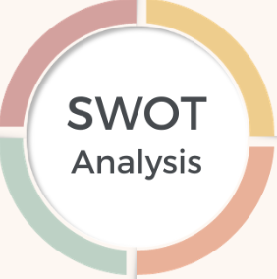
SWOT Analysis
A SWOT analysis reveals both the competitive advantages and challenges facing Hotel Mozart's potential opportunities for improvement and external threats impacting its position in the market.
Strengths
One of Hotel Mozart's main strengths is its prime location near Brussels' iconic Grand Place, a UNESCO World Heritage site, which makes it a highly convenient choice for tourists (Unesco, 2024). The hotel’s distinctive Oriental-style décor and architecture also provide a unique atmosphere that appeals to guests seeking an aesthetic experience different from standard hotel chains. These characteristics could be leveraged to differentiate the hotel from competitors and attract niche market segments interested in cultural and historical aesthetics (Chathoth et al., 2013).
Weaknesses
As highlighted in online reviews, the hotel faces significant operational weaknesses, particularly in hygiene, maintenance, and customer service. Poor cleanliness and frequent maintenance issues create a negative guest experience, which undermines its unique positioning and deters repeat business (Juliana et al., 2021). Additionally, substandard customer service further compounds these weaknesses, leading to reputational damage and decreased guest loyalty (Jasinskas et al., 2016). These operational deficits require urgent attention to prevent further impact on the hotel's brand.
Opportunities
The hotel has an opportunity to improve its reputation by capitalising on its central location and enhancing operational standards. Given the rising importance of online reviews in travellers’ decision-making, addressing issues in hygiene and service could significantly improve guest satisfaction and future bookings (Sotiriadis, 2017). Furthermore, aligning with sustainable practices in cleanliness and maintenance could attract environmentally conscious guests, a growing demographic in hospitality (Jones et al., 2016).
Threats
Hotel Mozart faces substantial threats from nearby competitors with better reputations and standards. Additionally, continuous negative reviews pose a risk of regulatory scrutiny, especially concerning health and safety in hospitality (Phillips et al., 2015). Numerous alternative accommodations in Brussels amplify the challenge, as travellers may easily choose hotels with higher ratings and positive guest feedback.
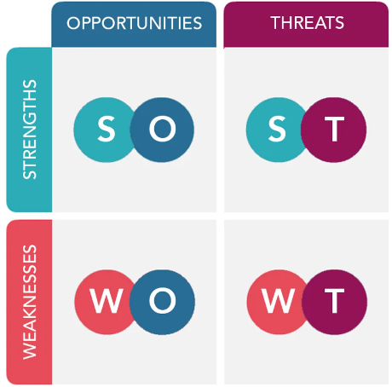
TOWS Analysis
The TOWS analysis for Hotel Mozart focuses on strategic approaches that utilise the hotel’s strengths to counter external threats and weaknesses, address operational issues, capitalise on opportunities, and mitigate potential risks.
Using Strengths to Counter Threats
One effective strategy to counteract competitive threats is to use Hotel Mozart’s prime location by accentuating improvements post-renovation. The hotel’s proximity to the Grand Place, a major tourist attraction, is a significant advantage (Hassanien and Baum, 2002). With strategic marketing that highlights both the convenience of the location and the recent improvements in services, the hotel can appeal to tourists looking for accessible and improved accommodation. Targeted advertising around high-traffic tourist periods and online promotion can help differentiate the hotel from nearby competitors (Yusof et al., 2018).
Addressing Weaknesses Via Opportunities
To improve its reputation, Hotel Mozart should prioritise systematic cleaning and maintenance to address persistent hygiene and repair issues. Investing in regular deep cleaning and pest control measures can resolve recurring complaints about bed bugs and odours (Juliana et al., 2021). Furthermore, maintaining the facility’s distinctive décor while ensuring cleanliness can attract travellers who value both aesthetics and hygiene (Ali et al., 2023). By systematically addressing these weaknesses, the hotel can capitalise on opportunities to build a cleaner and more comfortable environment, which may improve guest satisfaction and retention.
Combining Threats and Weaknesses
Hotel Mozart’s weaknesses in hygiene and maintenance make it vulnerable to regulatory scrutiny, particularly regarding health and safety standards. Immediate actions to rectify hygiene issues and upgrade facilities can prevent legal or regulatory actions due to guest complaints (Buhalis and Law, 2008). By adopting a proactive approach to cleanliness and compliance, the hotel can mitigate the threat of legal penalties and reduce negative reviews, which are crucial for maintaining a positive reputation in the competitive hospitality industry (Proserpio and Zervas, 2015).

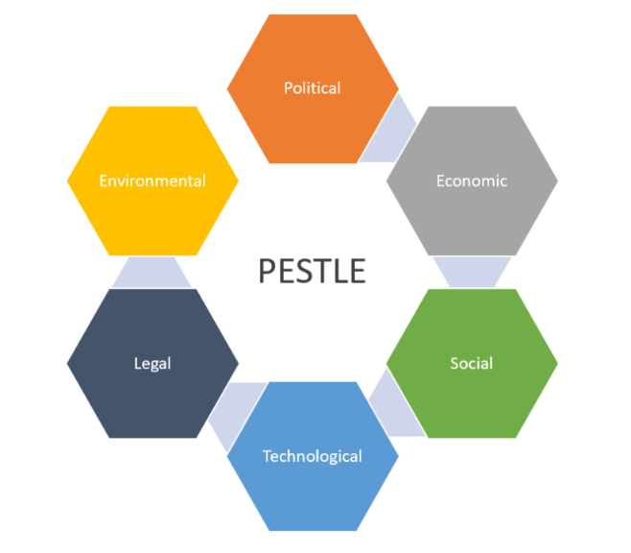
PESTEL Analysis
A PESTEL analysis of Hotel Mozart’s operational environment identifies key macro-environmental factors that influence the hotel's strategic positioning and decision-making, including political, economic, social, technological, environmental, and legal aspects.
Political
Hotel Mozart operates under strict Belgian and EU regulations regarding health, hygiene, and safety standards, which is particularly significant in the wake of increased scrutiny of public health in the hospitality industry (Bianchi and Stephenson, 2014). Compliance with these regulations is essential to avoid penalties and maintain operational legitimacy, as lapses in hygiene standards can lead to legal and reputational repercussions.
Economic
The hotel’s financial health is closely tied to the European economic climate. Economic downturns in Europe affect disposable income, reducing the number of travellers and impacting hotel bookings (Smeral, 2009). Conversely, economic recovery phases often increase tourist inflow, creating opportunities for hotels to capitalise on the rebound in travel demand and adjust pricing strategies to maximise revenue.
Social
Guest satisfaction and the importance of online reviews are critical social factors. Modern travellers heavily rely on digital platforms like TripAdvisor and Google Reviews to assess hotel standards, particularly hygiene and service quality (Mauri and Minazzi, 2013). Negative reviews on such platforms damage the hotel’s reputation and discourage potential customers, making it essential for Hotel Mozart to prioritise guest experience.
Technological
Technological advancements in cleaning and maintenance management provide tools for hotels to improve service efficiency. Systems that automate and track cleaning schedules and maintenance requests improve accountability and response times, ensuring consistent service standards (Longart, 2020). For Hotel Mozart, adopting such technology could help address ongoing issues with cleanliness and maintenance, improving guest satisfaction.
Environmental
Adopting sustainable practices is increasingly essential in the hospitality industry. Hotel Mozart could appeal to eco-conscious travellers by incorporating environmentally friendly cleaning products and waste reduction measures, which align with a growing preference for sustainable travel options (Boley and Uysal, 2013).
Legal
Adherence to Belgian health and safety regulations is mandatory for Hotel Mozart. Strict compliance reduces the risk of fines and operational disruptions while also signalling a commitment to guest safety and welfare, which is particularly important for maintaining a competitive edge (Miller et al., 2010).

Porter’s Five Forces Analysis
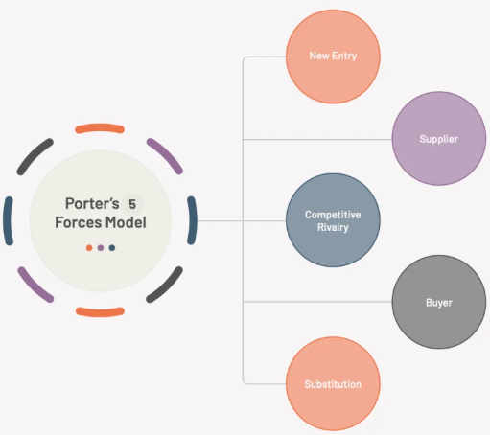
Porter’s Five Forces framework helps evaluate the competitive pressures facing Hotel Mozart in Brussels, explicitly considering the unique challenges posed by its location and operational issues.
Threat of New Entrants
The Brussels hotel industry has relatively low entry barriers, especially for small or boutique hotels targeting niche markets. Competitors with higher hygiene standards and better-maintained facilities could easily capture Hotel Mozart’s potential clientele. According to Hjalager (2010), new entrants with a focus on quality and customer experience can disrupt existing businesses, particularly those with operational weaknesses like Hotel Mozart. The ease of entry and growing demand for clean, well-managed accommodation make it essential for the hotel to improve its standards to remain competitive.
Bargaining Power of Suppliers
The bargaining power of suppliers is moderate but may increase if Hotel Mozart opts to source high-quality cleaning and maintenance supplies to meet hygiene expectations. For instance, upgrading to eco-friendly and effective cleaning products could imrpove operational costs due to the higher price of sustainable products (Pulido-Fernández and López-Sánchez, 2016). Additionally, dependency on local suppliers for specialised maintenance could increase expenses and make the hotel vulnerable to supply chain disruptions, thus affecting its service consistency (Shi and Liao, 2013).
Bargaining Power of Customers
Customers in the hospitality industry wield significant power due to the transparency of online reviews. Platforms like TripAdvisor and Booking.com amplify guest feedback, making it easy for potential guests to compare hotels based on quality and service (O’Connor, 2010). Negative reviews, especially those criticising hygiene and service, directly influence booking rates, as guests can switch to competitors with more favourable reputations. Hence, customer expectations and reviews heavily pressure Hotel Mozart to improve its service quality.
Threat of Substitutes
Brussels offers a variety of accommodation options, including Airbnb rentals, hostels, and other budget hotels, providing strong alternatives for budget-conscious travellers. Substitutes allow guests to seek similar experiences elsewhere, particularly if Hotel Mozart fails to address recurring issues (Mody et al., 2017). This threat is heightened by the availability of nearby accommodations that maintain better standards and competitive pricing, encouraging guests to explore other options.
Industry Rivalry
Brussels' hotel market is highly competitive, particularly in central areas with a dense concentration of hotels. Intense rivalry arises from the proximity of similar hotels, which strive to capture tourists visiting major attractions (Lin and Chen, 2014). For Hotel Mozart, this rivalry is further compounded by the pressure to improve its services to prevent loss of market share to better-rated competitors.

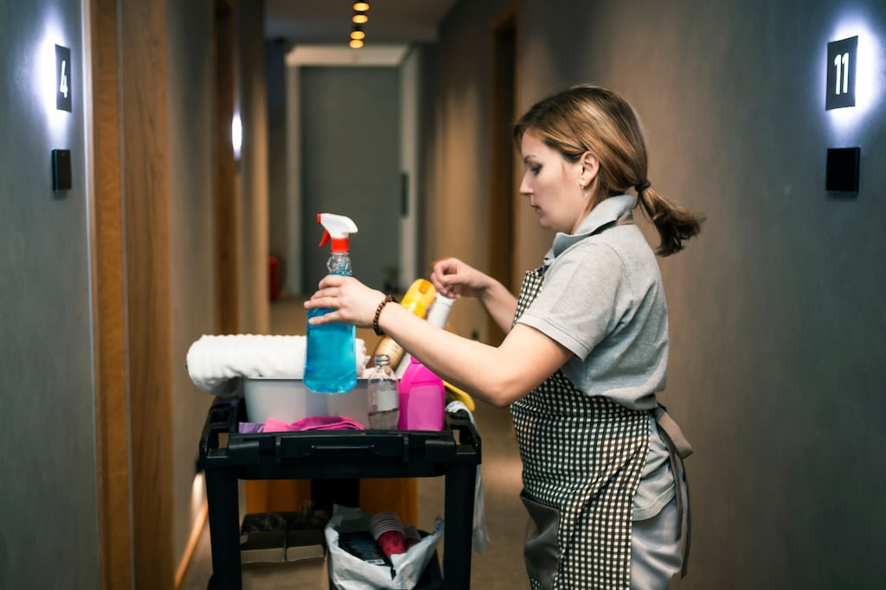
- Operational Improvement Measures
Hygiene Improvement Measures
A comprehensive cleaning and pest control protocol is essential to address the persistent hygiene issues at Hotel Mozart. Implementing these measures involves structured procedures, regular monitoring, and the use of effective products to ensure a consistently clean and comfortable environment for guests.
Comprehensive Cleaning and Pest Control Protocol
A thorough cleaning protocol should include daily and periodic cleaning tasks, differentiated by frequency and level of attention. Daily cleaning should cover basic sanitation such as vacuuming, dusting, and disinfecting high-touch surfaces like door handles, light switches, and remote controls to prevent the spread of germs (Sharma and Kaushik, 2021). Additionally, with targeted measures for toilets, sinks, and showers, bathroom sanitation is crucial, given the high guest traffic and potential for bacterial growth (Almaza et al., 2015).
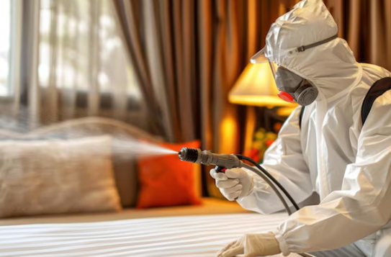
The pest control component should be an integral part of this protocol, especially considering complaints of bed bugs and other insects in guest reviews. A pest control plan should include regular inspections, with licensed pest control providers conducting quarterly assessments to detect and address infestations before they escalate (Penn and Hu, 2017). Integrated Pest Management (IPM) strategies, which combine preventive measures, inspection, and chemical control as a last resort, can minimise health risks associated with pests while aligning with sustainable practices (Dara, 2019).
Weekly Deep Cleaning
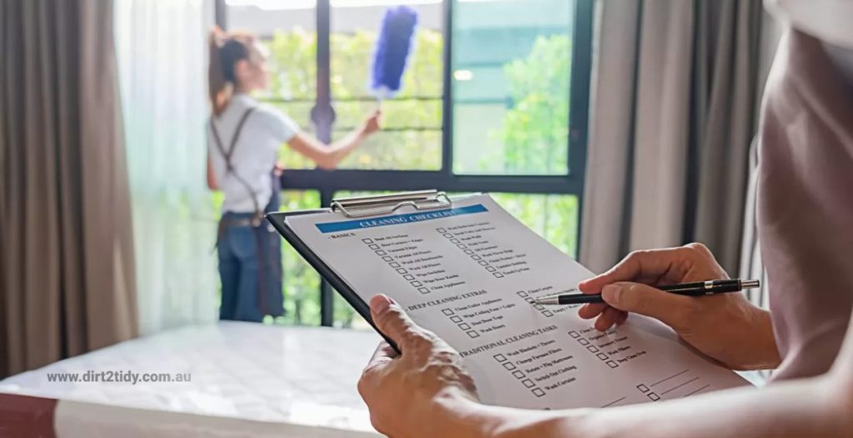
Hotel Mozart should implement a weekly deep cleaning routine focusing on high-traffic and high-touch areas and known problem spots identified from guest feedback, such as carpets, mattresses, and upholstered furniture (Juliana et al., 2015). This deep cleaning should involve using professional-grade cleaning equipment, such as steam and vacuum cleaners with HEPA filters, to effectively remove allergens, bacteria, and embedded dirt (Bloomfield et al., 2017). Carpets should be shampooed weekly, and mattresses should be steamed to reduce allergens and prevent pest infestations, particularly bed bugs, which can severely impact guest comfort (Wu et al., 2012).
A dedicated housekeeping supervisor who monitors adherence to cleaning protocols and conducts regular audits should manage the cleaning schedule. Research indicates that structured cleaning schedules and supervisory checks are critical in maintaining high hygiene standards in hotels (Pittet and Donaldson, 2006). Training staff in effective cleaning practices, including correct disinfection methods and appropriate handling of equipment, ensures that standards are consistently met (Sharma and Kaushik, 2021). Staff should also be encouraged to report maintenance issues related to hygiene, such as dampness or mould, which could lead to pest problems if left unaddressed (Wu et al., 2018).
The implementation of these hygiene improvement measures will not only increase guest satisfaction but also reduce the likelihood of negative reviews related to cleanliness. A strong commitment to cleanliness can significantly influence guest perceptions, encouraging repeat bookings and positive word-of-mouth, which are vital for sustaining a competitive advantage in the hospitality market (Randle et al., 2016).

Maintenance Repair
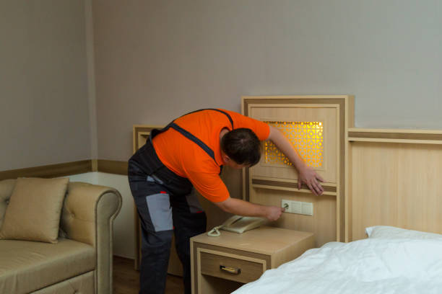
Hotel Mozart requires a comprehensive overhaul of its maintenance protocols to improve the guest experience and reduce negative reviews related to maintenance issues. This includes routine checks for essential systems, immediate repairs for reported problems, and replacing outdated or damaged items. An organised and proactive maintenance strategy can improve room conditions, ensuring guests enjoy a comfortable and well-functioning environment.

Routine Checks for Plumbing, Appliances, and Furnishings
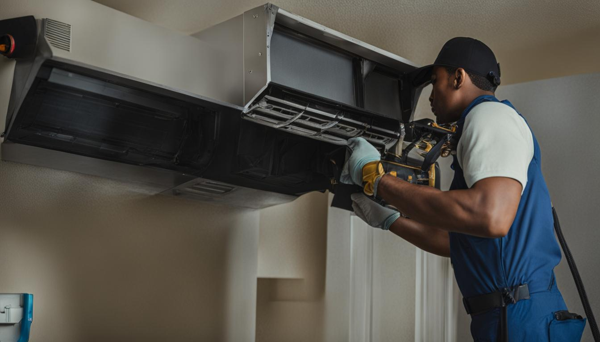
Routine inspections are essential to identify and address wear and tear before it becomes problematic. Plumbing systems, for example, require regular checks to prevent issues such as clogged drains and non-functional toilets, which have been noted in guest complaints. Regular inspections can prevent leaks, optimise water flow, and ensure fixtures operate correctly (Leftwich et al., 2021). Research by Sahid et al. (2021) suggests that consistent plumbing maintenance can significantly reduce water-related complaints, improve guest satisfaction, and reduce long-term repair costs.
Appliances, including air conditioning, televisions, and lighting fixtures, should be evaluated weekly to ensure they are functioning correctly. In-room appliances are critical for guest comfort; non-functional equipment can detract from the overall experience (Mohsin and Lengle, 2015). Additionally, all furnishings, particularly high-contact items like desks, beds, and chairs, need regular checks to identify structural weaknesses or damage. Preventative furniture maintenance improves aesthetics and reduces the likelihood of injuries caused by broken furnishings (Longart, 2020).

Immediate Repairs for Reported Issues and Replacement of Outdated or Broken Items
Guest-reported issues should be addressed immediately, as prompt repairs are key to maintaining high service standards. Studies show that hotels with rapid maintenance response times receive better guest feedback, as guests perceive swift repairs as a sign of attentiveness and care (Sahid et al., 2021). A dedicated team responsible for addressing urgent maintenance requests can help maintain an efficient response time and ensure problems are resolved before they affect subsequent guests.
In addition to immediate repairs, Hotel Mozart should replace outdated or broken items as part of an ongoing investment in property maintenance. Replacing old mattresses, for example, can improve guest comfort and reduce complaints related to sleep quality (Kang et al., 2015). Similarly, updating worn-out furniture, carpets, and fixtures improves the room's aesthetic appeal, creating a more welcoming and well-maintained environment (Turner and Hesford, 2018). Regularly replacing items that end their useful life also prevents minor issues from escalating into significant complaints that could harm the hotel's reputation.
Finally, implementing a digital maintenance management system (CMMS) can streamline the tracking of maintenance tasks and reduce oversight errors. CMMS systems enable staff to log, monitor, and track maintenance activities, ensuring all issues are recorded and promptly addressed (Lai and Yik, 2012). With a CMMS, Hotel Mozart can improve coordination among staff, set reminders for routine inspections, and monitor repair timelines, leading to a more organised and efficient maintenance process.
Customer Service Training
Improving customer service at Hotel Mozart requires a focused retraining program that accentuates professionalism, empathy, and effective issue resolution. Additionally, implementing a guest feedback mechanism can offer valuable insights into service quality and highlight areas for continuous improvement.

Staff Retraining on Professionalism, Empathy, and Issue Resolution
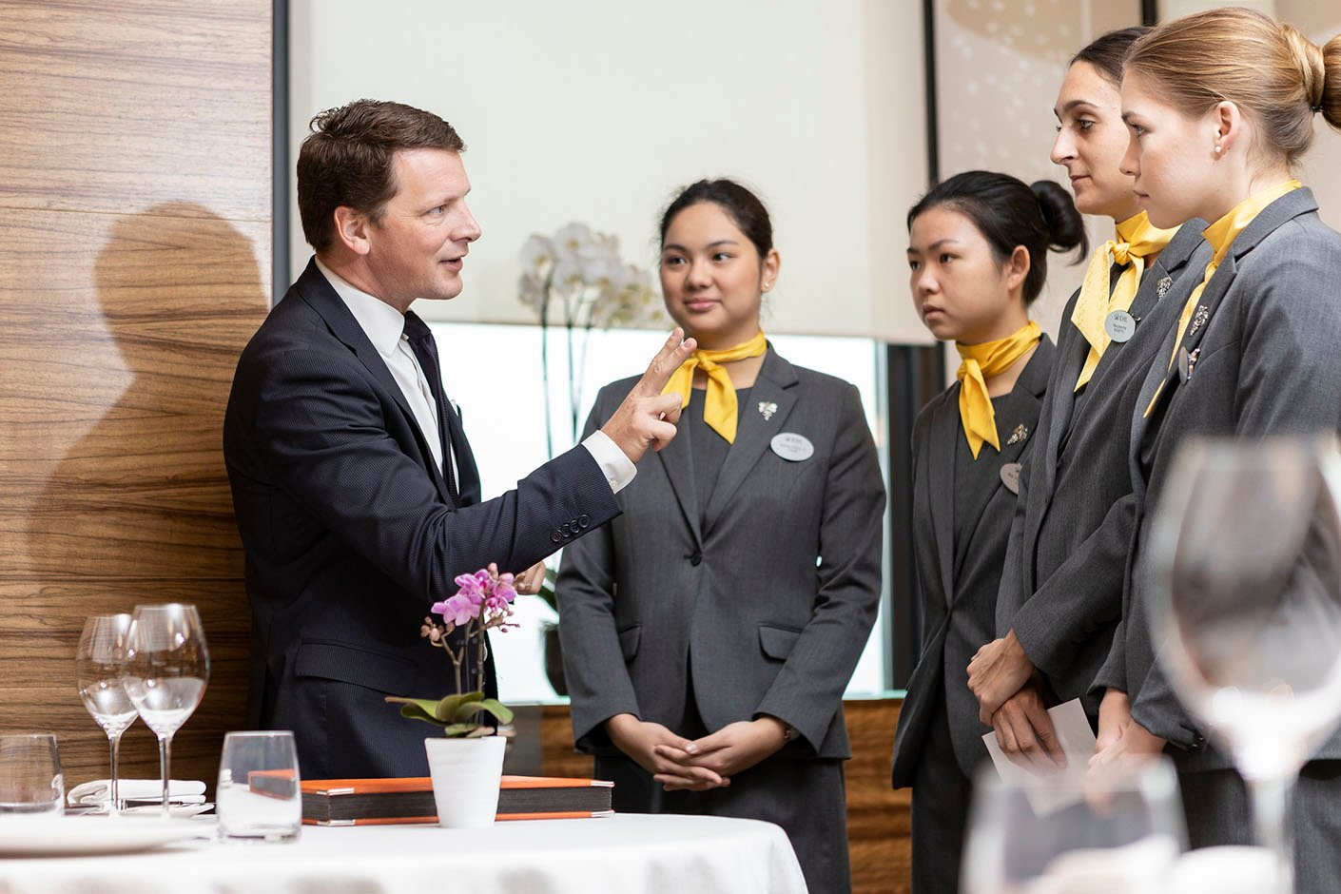
The first step in improving customer service standards involves retraining all staff members in key areas that directly impact guest satisfaction. Professionalism is crucial in creating a positive first impression and maintaining a consistent service standard throughout each guest's stay. Training on professionalism should include best practices for communication, body language, and attitude, as these non-verbal cues heavily influence guests' perceptions (Tsaur and Lin, 2004). Professionalism fosters respect and trust, making guests feel valued and comfortable.
Empathy training is equally important, as empathetic interactions improve the guest experience by making guests feel understood and cared for. Research by Umasuthan, Park and Ryu (2017) shows that empathy positively affects guest satisfaction by creating emotional connections, leading to repeat business and recommendations. Staff should be taught to actively listen, acknowledge guest concerns, and offer support with genuine care. This approach is particularly beneficial for handling complaints, as guests are more likely to feel satisfied with resolutions when they feel their concerns have been understood (Homburg et al., 2009).
Issue resolution training is essential for equipping staff with the skills to resolve problems swiftly and effectively. The training should focus on conflict de-escalation techniques, decision-making autonomy, and clear communication, ensuring staff members feel empowered to handle complaints confidently and professionally. Oh (2003) noted that immediate resolution of issues improves guest satisfaction and reduces the likelihood of negative reviews. Staff should be encouraged to take ownership of guest concerns, follow up after resolving problems, and ensure guest satisfaction.
Introducing Guest Feedback Mechanisms

Hotel Mozart should implement a robust guest feedback system to continually refine customer service. Feedback can be collected through in-room surveys, digital questionnaires sent post-stay, or quick rating forms accessible through QR codes in the lobby or rooms (Narayan et al., 2022). This enables guests to provide feedback immediately after their stay or during their visit, capturing real-time insights into their experience.
Examining feedback data enables management to identify patterns in guest concerns and recognise recurring issues in service delivery. As documented by Narayan et al. (2022), implementing feedback loops in the hospitality industry improves service by identifying actionable areas for improvement. Furthermore, acknowledging feedback publicly, whether through personal replies to online reviews or displaying positive feedback, demonstrates responsiveness and commitment to service quality.
Combining staff retraining with systematic feedback mechanisms allows Hotel Mozart to improve guest interactions and increase overall service quality. This approach supports a service culture centred on professionalism, empathy, and adaptability, fostering higher guest satisfaction and loyalty.

- Management and Accountability
Hotel Mozart should implement a robust management and accountability framework to ensure that the improvements in hygiene, maintenance, and customer service are sustained over time. This involves appointing a dedicated quality assurance (QA) manager to oversee operational standards and implementing a systematic complaint logging system to consistently monitor and address guest feedback.
Appointing a Quality Assurance Manager

The role of Quality Assurance (QA) Manager is central to maintaining high operational standards across all departments. This individual would be responsible for conducting regular inspections, ensuring compliance with cleaning and maintenance protocols, and providing feedback to staff on areas for improvement. By setting measurable service standards, the QA Manager can identify performance gaps, making it easier to apply targeted training and resources to problem areas (Karatepe and Uludag, 2008). This position also enables Hotel Mozart to standardise processes and maintain consistency across shifts, essential for delivering a uniform guest experience (Llach et al., 2016). In the competitive hospitality industry, a QA Manager ensures operational effectiveness and improves overall service quality, which is critical for sustaining customer satisfaction and loyalty (Amin et al., 2017).
Implement a Complaint Logging System
A complaint logging system is essential for systematically capturing, tracking, and resolving guest issues. Such a digital or paper-based system would allow staff to log complaints, prioritise urgent issues, and assign responsibilities for resolution, making the process transparent and efficient (Ogbeide et al., 2017). Each entry should include the nature of the complaint, the time of reporting, the staff member responsible, and the resolution status. Research shows that formal complaint logging improves service recovery and strengthens guest loyalty, demonstrating the hotel’s commitment to accountability (Kandampully and Suhartanto, 2000). Moreover, a well-maintained complaint record enables the QA Manager to identify recurring issues, allowing management to implement long-term corrective actions rather than addressing problems only reactively.
By combining the role of a QA Manager with a structured complaint logging system, Hotel Mozart can improve accountability at every service level, creating a transparent and responsive environment that prioritises guest satisfaction and operational excellence.

- Cost Management and Financial Projections

Implementing the recommended improvements at Hotel Mozart involves specific costs per area. Each cost is estimated based on real data from industry sources, with an anticipated return through improved guest satisfaction, reviews, and occupancy rates.
1. Hygiene Improvement Measures
- Comprehensive Cleaning and Pest Control Protocol: Pest control treatments in central Brussels average £175-£350 per treatment, depending on the hotel size and frequency (Pestuk, 2024)
- Weekly Deep Cleaning: Professional deep cleaning services cost around £22-£30 per hour (Fantastic Services UK). Weekly sessions total approximately £900-£1,300 monthly.
2. Maintenance Overhaul
- Routine Checks and Immediate Repairs: Skilled maintenance services range from £45-£65 per hour, which includes plumbing and electrical work (Checkatrade, 2024).
- Replacement of Outdated Items: Replacing room furnishings, including beds and seating, costs £1,700-£4,200 per room depending on the quality (Furniture at Work, 2024).
3. Customer Service Training
- Staff Training Programs: Hospitality training courses cost £90-£180 per employee (High-Speed Training, 2024), totalling £1,800-£3,600 for a 20-person team.
- Guest Feedback Mechanisms: Installing digital feedback systems costs £450-£900 initially, with ongoing maintenance fees of £45-£90 per month (Haije, 2024).
4. Management and Accountability
- Quality Assurance Manager Salary: An experienced QA manager in Brussels typically earns £34,000-£51,000 annually (Glassdoor, 2024).
- Complaint Logging System: A digital complaint management setup can cost £900-£2,700, with monthly fees of £90-£180 (Zendesk, 2024).
Potential ROI: Improved service and operational standards could increase occupancy rates by 5-10%, adding £35,000-£50,000 to annual revenue through improved reviews and guest retention.

5. Financial Feasibility and Revenue Projection

Initial Investment and Operational Costs
The planned improvements at Hotel Mozart will require an initial investment of £46,475 - £69,450, with ongoing monthly costs estimated at £1,125 - £1,570 for maintenance, cleaning, and feedback systems. A Quality Assurance (QA) Manager, with an annual salary between £34,000 and £51,000 will add to fixed costs and is crucial for ensuring service standards.
Projected Revenue Increase
These improvements in hygiene, maintenance, and customer service are projected to increase occupancy by 5-10%, generating an additional £35,000 - £50,000 in annual revenue. This estimate is based on expected gains in guest satisfaction and online reviews, potentially supporting a slight increase in room rates.
Impact on Rates and Occupancy
Improved guest experiences may allow for a nightly rate increase from £77 to £80-85 without negatively affecting occupancy. This increase would strengthen revenue further as occupancy rates improve.
Feasibility of the Plan
The financial outlook suggests the plan is feasible, with the potential to recover the initial investment within 1-2 years if occupancy gains are achieved. Success depends on effective execution and consistent feedback monitoring.

- Change Management Strategy
A structured, phased approach to implementing changes at Hotel Mozart will help ensure smooth adaptation and minimise disruption. The change management process should begin with clear communication to all staff members, explaining the reasons for each new measure and its expected benefits. An initial meeting with department heads followed by individual team briefings will ensure everyone understands their role and responsibilities in the change process (Shulga, 2020). By keeping staff informed and involved, the hotel fosters a supportive culture that encourages employees to embrace these improvements positively.
The staged approach would start with the immediate implementation of high-priority measures, such as improved hygiene protocols and customer service training, followed by gradual improvements in maintenance and quality control processes. To assess the effectiveness of these changes, management should use feedback tools such as anonymous staff surveys and monthly team meetings, allowing employees to voice concerns or suggest adjustments (Barzilay et al., 2018). Additionally, guest feedback will be collected regularly, enabling management to identify any areas for further improvement based on customer experience.
This feedback-centric strategy improves adaptability and signals to staff and guests that the hotel is committed to continuous improvement and responsive management.

Action Plan
Problem | Solution | Time Scale | Completion Date | Planned Budget
Hygiene Issues | Comprehensive cleaning and pest control protocol | 1 month | 12/01/2024 | Pest control: £175-£350 per treatment, deep cleaning: £900-£1,300 monthly
Hygiene Maintenance | Weekly deep cleaning services | Ongoing | Monthly | £900-£1,300 per month
Maintenance Overhaul | Routine checks and immediate repairs | 2 months | 02/15/2024 | £45-£65 per hour, estimated £3,000 for initial period
Facility Upgrades | Replacement of outdated items, including furnishings | 3 months | 03/15/2024 | £1,700-£4,200 per room (furnishings)
Customer Service Quality | Staff training programs for hospitality | 1 month | 12/15/2024 | £1,800-£3,600 for 20-person team
Feedback and Monitoring | Install guest feedback mechanisms | 1 month | 12/15/2024 | Setup: £450-£900, ongoing: £45-£90 per month
Quality Control | Appointment of Quality Assurance Manager | 1 month | 12/15/2024 | £34,000-£51,000 annually
Complaint Management | Implement a digital complaint-logging system | 1 month | 12/15/2024 | Setup: £900-£2,700, ongoing: £90-£180 per month

Total Initial Budget: Approximately £46,475-£69,450, with ongoing monthly costs as outlined.
This action plan provides clear timelines and detailed financial estimates, ensuring that Hotel Mozart can implement each improvement in a structured manner while managing financial impact effectively.

Conclusion
The analysis of Hotel Mozart’s operations has identified critical areas for improvement in hygiene, maintenance, and customer service, each essential to strengthening guest satisfaction and market competitiveness. Guest reviews from platforms like TripAdvisor and Booking.com reveal frequent complaints regarding cleanliness, outdated amenities, and inconsistent service quality, highlighting these issues' impact on the hotel’s reputation and guest loyalty. Addressing these issues is key to restoring confidence in the hotel and enhancing its market standing.
The recommended improvements promise substantial benefits. Implementing a comprehensive cleaning and pest control protocol, alongside regular deep cleaning routines, will directly address hygiene concerns, significantly enhancing guest comfort and satisfaction. Cleanliness is widely recognised as a core determinant of guest experience, and improving these standards will contribute to positive reviews and repeat business.
An overhaul of maintenance protocols will ensure the reliability of essential facilities, reducing guest complaints about malfunctioning or worn-out amenities. Routine checks, immediate repairs, and timely replacements of outdated items will reinforce the hotel’s commitment to quality, creating a more appealing and well-maintained environment that meets guest expectations.
Moreover, customer service training will foster professionalism, empathy, and effective problem-solving among staff, enhancing the quality of guest interactions. A guest feedback system will provide valuable insights into service performance, allowing for continuous improvement. Additionally, appointing a Quality Assurance (QA) Manager and establishing a complaint logging system will strengthen accountability and responsiveness, ensuring service standards are consistently upheld.


True Path Hotel Consultants extends our appreciation to Hotel Mozart for considering our firm to address these critical improvements. We are enthusiastic about the prospect of working together to improve Hotel Mozart’s service quality and market reputation, and we look forward to future opportunities to support your continued success in the hospitality industry.

Appendix 0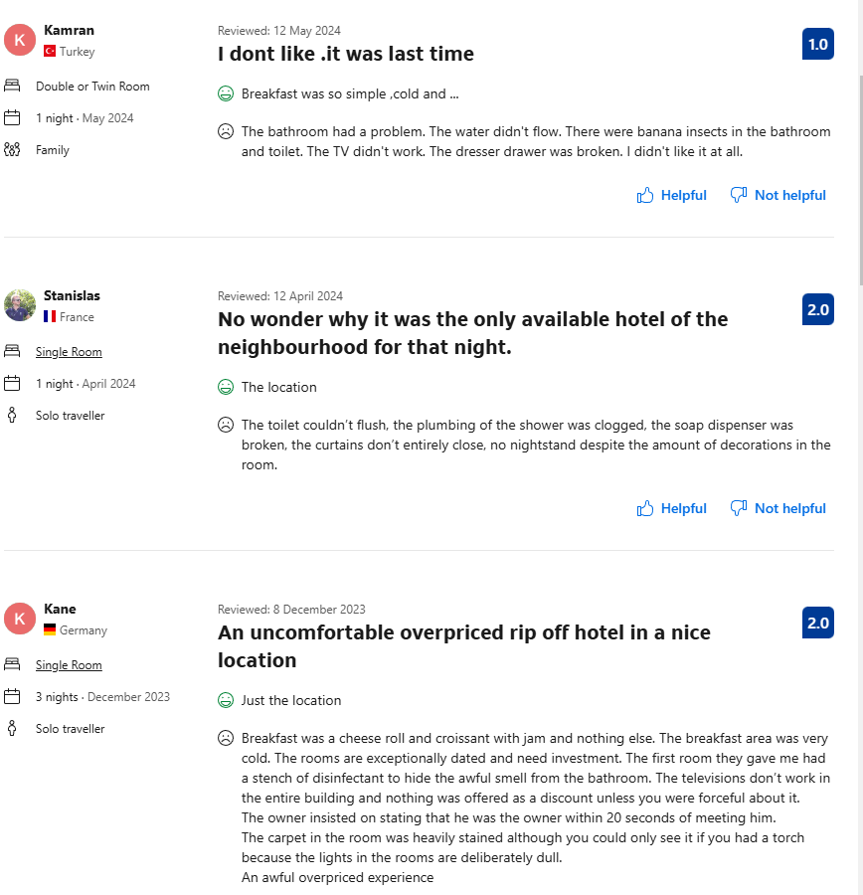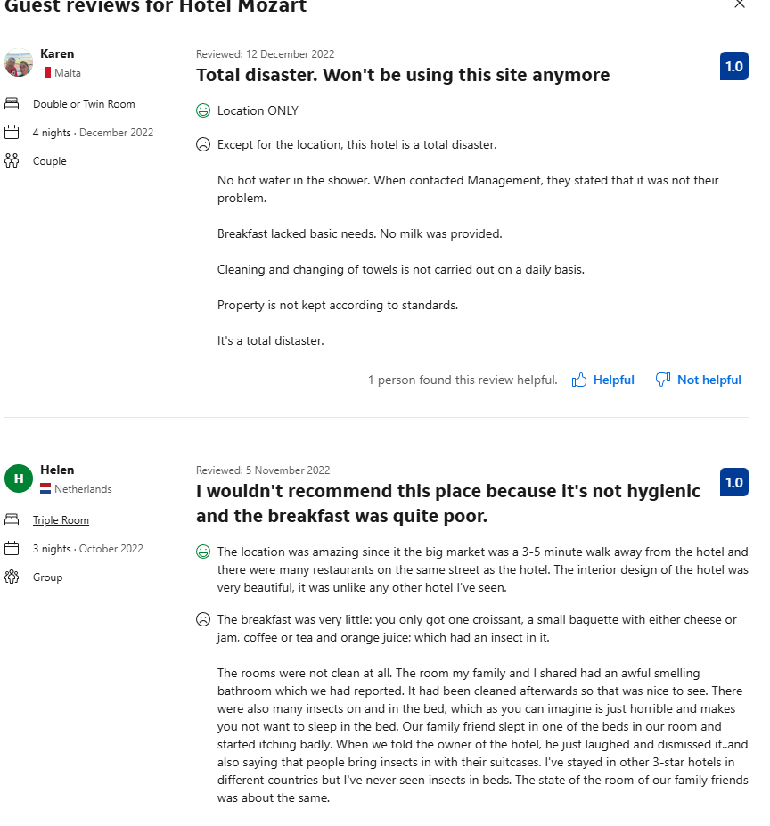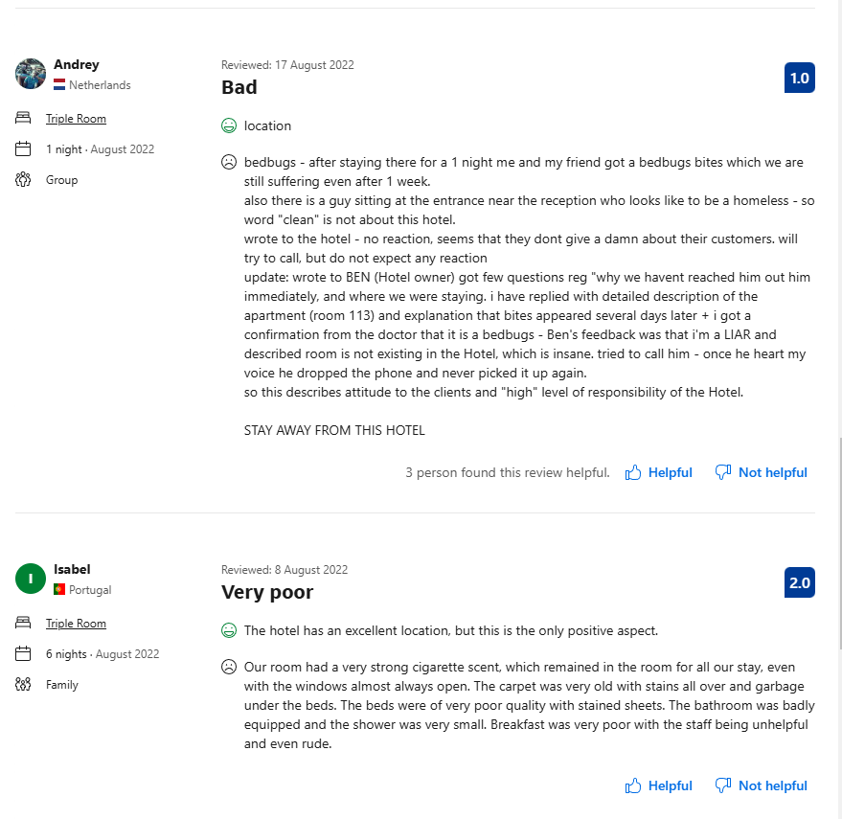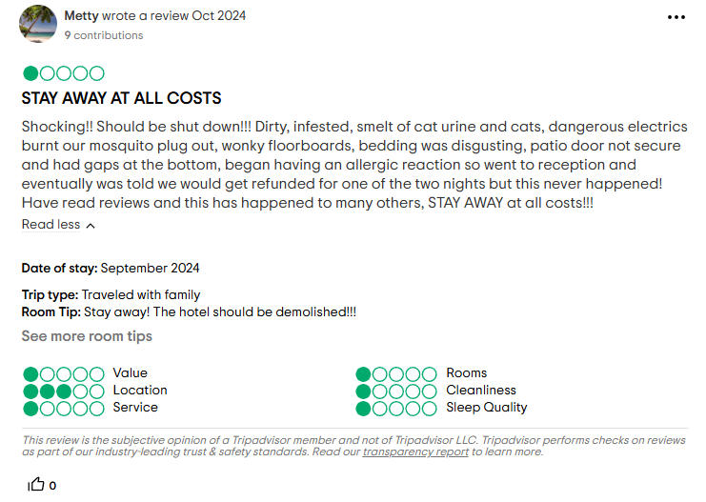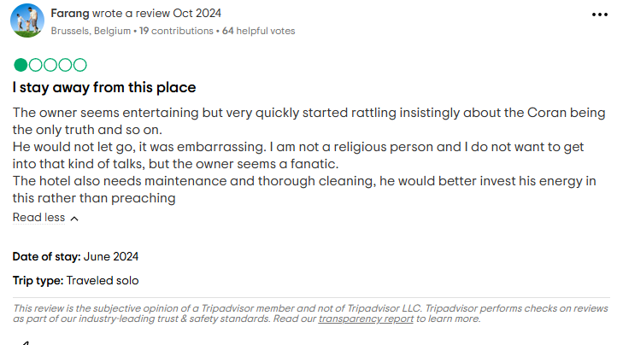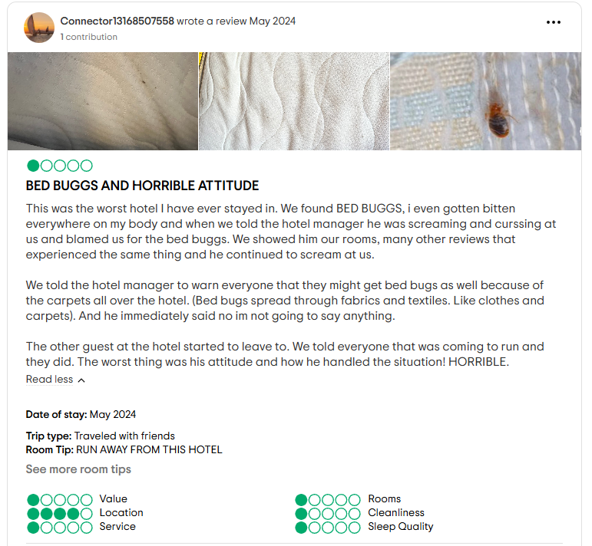

References
- Akbaba, A., 2006. Measuring service quality in the hotel industry: A study in a business hotel in Turkey. International Journal of Hospitality Management, 25(2), 170-192. https://doi.org/10.1016/j.ijhm.2005.08.006
- Ali, A., Nurin, S., and Mohi, Z., 2023. Room guest satisfaction towards guestroom physical environment quality in the theme hotel. JOURNAL OF TOURISM, CULINARY AND ENTREPRENEURSHIP (JTCE). https://doi.org/10.37715/jtce.v3i2.3966.
- Almanza, B.A., Kirsch, K., Kline, S.F., Sirsat, S., Stroia, O., Choi, J.K. and Neal, J., 2015. How clean are hotel rooms? Part I: Visual observations vs. microbiological contamination. Journal of Environmental Health, 78(1), pp.8-13. https://www.proquest.com/scholarly-journals/how-clean-are-hotel-rooms-part-i-visual/docview/1695785997/se-2?accountid=130472
- Amin, M., Aldakhil, A., Wu, C., Rezaei, S., and Cobanoglu, C., 2017. The structural relationship between TQM, employee satisfaction and hotel performance. International Journal of Contemporary Hospitality Management, 29, pp. 1256-1278. https://www.proquest.com/scholarly-journals/structural-relationship-between-tqm-employee/docview/1891765287/se-2?accountid=130472
- Barzilay, E., Vandi, H., Binder, S., Udo, I., Ospina, M., Ihekweazu, C., and Bratton, S., 2018. Use of the Staged Development Tool for Assessing, Planning, and Measuring Progress in the Development of National Public Health Institutes.. Health security, 16 S1, pp. S18-S24 . https://doi.org/10.1089/hs.2018.0044.
- Bianchi, R., and Stephenson, M., 2014. Tourism and Citizenship: Rights, Freedoms and Responsibilities in the Global Order. Routledge. https://repository.uel.ac.uk/download/058ed9504881b8bf5a45c98627876916d240e5c62610adb52a1ad667e7d4bbf6/523008/CHAPT_3_Tour_Citz_RB.pdf
- Bloomfield, S.F., Exner, M., Signorelli, C., Nath, K.J. and Scott, E.A., 2011, April. The infection risks associated with clothing and household linens in home and everyday life settings, and the role of laundry. In International Scientific Forum on Home Hygiene. https://europeantissue.com/wp-content/uploads/The-infection-risks-associated-with-clothing-and-household-linens.pdf
- Boley, B. B., and Uysal, M., 2013. Competitive synergy through practicing triple bottom line sustainability: Evidence from a tri-cultural study. Tourism Management, 37, 73-82. https://doi.org/10.1016/j.tourman.2012.11.001
- Booking.com, 2024. Hotel Motzard Review. https://www.booking.com/
- Buhalis, D., and Law, R., 2008. Progress in information technology and tourism management: 20 years on and 10 years after the internet—The state of eTourism research. Tourism Management, 29(4), 609-623. https://doi.org/10.1016/j.tourman.2008.01.005
- Chathoth, P., Altinay, L., Harrington, R., Okumus, F., and Chan, E. S. W., 2013. Co-production versus co-creation: A process-based continuum in the hotel service context. International Journal of Hospitality Management, 32, 11-20. https://doi.org/10.1016/j.ijhm.2012.03.009
- Checkatrade, 2024. Electrician cost guide. Retrieved from https://www.checkatrade.com/blog/cost-guides/handyman-prices/
- Dara, S., 2019. The New Integrated Pest Management Paradigm for the Modern Age. Journal of Integrated Pest Management. https://doi.org/10.1093/JIPM/PMZ010.
- Fantastic Services UK, 2024. Professional cleaning services prices. Retrieved from https://www.fantasticservices.com/one-off-deep-cleaning/
- Furniture at Work, 2024. Office and hospitality furniture. https://www.furniture-work.co.uk/
- Gavilan, D., Avello, M., and Martinez-Navarro, G., 2018. The influence of online ratings and reviews on hotel booking consideration. Tourism Management. https://doi.org/10.1016/J.TOURMAN.2017.10.018.
- Glassdoor, 2024. Quality Assurance Manager salary in Brussels. Retrieved from https://www.glassdoor.com/Salaries/brussels-belgium-quality-manager-salary-SRCH_IL.0,16_IM992_KO17,32.htm
- Haije, E.G., 2024. Top 29 Best Customer Feedback Tools 2024. Mopinion. https://mopinion.com/customer-feedback-tools/
- Han, X., Kwortnik Jr, R.J. and Wang, C., 2008. Service loyalty: An integrative model and examination across service contexts. Journal of Service Research, 11(1), pp.22-42. https://doi.org/10.1177/1094670508319094
- Hassanien, A., and Baum, T., 2002. Hotel Repositioning through Property Renovation. Tourism and Hospitality Research, 4, pp. 144 - 157. https://doi.org/10.1177/146735840200400205.
- High Speed Training, 2024. Hospitality training courses. https://www.highspeedtraining.co.uk/
- Hjalager, A. M., 2010. A review of innovation research in tourism. Tourism Management, 31(1), 1-12. https://doi.org/10.1016/j.tourman.2009.08.012
- Homburg, C., Jozic, D. and Kuehnl, C., 2017. Customer experience management: toward implementing an evolving marketing concept. Journal of the Academy of Marketing Science, 45(3), p.377. https://www.proquest.com/scholarly-journals/customer-experience-management-toward/docview/1881682533/se-2?accountid=130472
- Islam, M., Pandey, U., Sinha, S., and Hussin, S., 2023. How does a hotel’s hygiene protocol quality trigger guests’ revisit intention during the pandemic? Evidence from Chinese guests. International Journal of Tourism Cities. https://www.proquest.com/scholarly-journals/how-does-hotel-s-hygiene-protocol-quality-trigger/docview/3060949344/se-2?accountid=130472
- Jasinskas, E., Štreimikienė, D., Švagždienė, B., and Simanavicius, A., 2016. Impact of hotel service quality on the loyalty of customers. Economic Research-Ekonomska Istraživanja, 29, pp. 559 - 572. https://doi.org/10.1080/1331677X.2016.1177465.
- Jones, P., Hillier, D. and Comfort, D., 2016. Sustainability in the hospitality industry: Some personal reflections on corporate challenges and research agendas. International Journal of Contemporary Hospitality Management, 28(1), pp.36-67. https://www.proquest.com/scholarly-journals/sustainability-hospitality-industry/docview/1752974457/se-2?accountid=130472
- Juliana, J., Pramezwary, A., Madeline, M., Valerie, N., Andrian, S., and Ventyani, V., 2021. INVESTIGATING IMPACT OF SERVICE AND HYGIENE ON HOTEL REPUTATION DURING THE COVID -19 PANDEMIC : A PERSPECTIVE SIGNALING THEORY. Jurnal Hospitality dan Pariwisata. https://doi.org/10.30813/jhp.v7i2.2734.
- Kandampully, J., and Suhartanto, D., 2000. Customer loyalty in the hotel industry: The role of customer satisfaction and image. International Journal of Contemporary Hospitality Management, 12(6), 346-351. https://www.proquest.com/scholarly-journals/customer-loyalty-hotel-industry-role-satisfaction/docview/228310387/se-2?accountid=130472
- Kang, J., Boger, C., and Back, K., 2015. Improving sleep quality in hotels: Insights from customer experience studies. International Journal of Hospitality Management, 47, 107-114. https://doi.org/10.1016/j.ijhm.2015.04.005
- Karatepe, O.M. and Uludag, O., 2008. Affectivity, conflicts in the work–family interface, and hotel employee outcomes. International Journal of hospitality management, 27(1), pp.30-41. https://doi.org/10.1016/j.ijhm.2007.07.001
- Kim, M., Lee, E., Kim, S., Cha, J., and Cichy, R., 2022. Impact of Indoor Environmental Quality on Hotel Guests’ Behaviors. International Journal of Hospitality & Tourism Administration, 24, pp. 288 - 313. https://doi.org/10.1080/15256480.2021.1981188.
- Kim, W.G., Lee, Y.K. and Yoo, Y.J., 2006. Predictors of relationship quality and relationship outcomes in luxury restaurants. Journal of Hospitality & Tourism Research, 30(2), pp.143-169. https://doi.org/10.1177/1096348005285086
- Lai, J., and Yik, F. (2012). Hotel engineering facilities: A case study of maintenance performance. International Journal of Hospitality Management, 31, 229-235. https://doi.org/10.1016/J.IJHM.2011.05.002.
- Leftwich, B., Opoku, S., Yin, J., and Adhikari, A. (2021). Assessing Hotel Employee Knowledge on Risk Factors and Risk Management Procedures for Microbial Contamination of Hotel Water Distribution Systems. International Journal of Environmental Research and Public Health, 18. https://doi.org/10.3390/ijerph18073539.
- Lin, Y., and Chen, C., 2014. Research Note: Service Quality and Market Structure in the International Tourist Hotel Industry. Tourism Economics, 20, pp. 647 - 654. https://doi.org/10.5367/te.2013.0284.
- Llach, J., Alonso‐Almeida, M., Martí, J., and Rocafort, A., 2016. Effects of quality management on hospitality performance in different contexts. Ind. Manag. Data Syst., 116, pp. 1005-1023. https://doi.org/10.1108/IMDS-06-2015-0235.
- Longart, P., 2020. Understanding Hotel Maintenance Management. Journal of Quality Assurance in Hospitality & Tourism, 21, pp. 267 - 296. https://doi.org/10.1080/1528008X.2019.1658148.
- Mauri, A. G., and Minazzi, R., 2013. Web reviews influence on expectations and purchasing intentions of hotel potential customers. International Journal of Hospitality Management, 34, 99-107. Available at: https://doi.org/10.1016/j.ijhm.2013.02.012
- Miller, G., Rathouse, K., Scarles, C., Holmes, K., and Tribe, J., 2010. Public understanding of sustainable tourism. Annals of Tourism Research, 37(3), 627-645. https://doi.org/10.1016/j.annals.2009.12.002
- Mody, M., Suess, C., and Lehto, X., 2017. The accommodation experiencescape: A comparative assessment of hotels and Airbnb. International Journal of Contemporary Hospitality Management, 29(9), 2377-2404. Available at: https://www.proquest.com/scholarly-journals/accommodation-experiencescape-comparative/docview/1940546593/se-2?accountid=130472
- Mohsin, A., and Lengler, J., 2015. Service experience through the eyes of budget hotel guests: Do factors of importance influence performance dimensions?. Journal of Hospitality and Tourism Management, 23, pp. 23-34. https://doi.org/10.1016/J.JHTM.2015.03.001.
- Narayan, R., Gehlot, A., Singh, R., Akram, S., Priyadarshi, N., and Twala, B., 2022. Hospitality Feedback System 4.0: Digitalization of Feedback System with Integration of Industry 4.0 Enabling Technologies. Sustainability. https://doi.org/10.3390/su141912158.
- O’Connor, P., 2010. Managing a hotel’s image on TripAdvisor. Journal of Hospitality Marketing & Management, 19(7), 754-772. https://doi.org/10.1080/19368623.2010.508007
- Ogbeide, G., Böser, S., Harrinton, R., and Ottenbacher, M., 2017. Complaint management in hospitality organizations: The role of empowerment and other service recovery attributes impacting loyalty and satisfaction. Tourism and Hospitality Research, 17, pp. 204 - 216. https://doi.org/10.1177/1467358415613409.
- Oh, H., 2003. Price fairness and its asymmetric effects on overall price, quality, and value judgments: The case of an upscale hotel. Tourism Management, 24(4), 387-399. Available at: https://doi.org/10.1016/S0261-5177(02)00109-7
- Park, H., Kline, S., Kim, J., Almanza, B., and Ma, J., 2019. Does hotel cleanliness correlate with surfaces guests contact?. International Journal of Contemporary Hospitality Management. https://www.proquest.com/scholarly-journals/does-hotel-cleanliness-correlate-with-surfaces/docview/2283793829/se-2?accountid=130472
- Penn, J., and Hu, W., 2017. A Choice Experiment of Traveler Willingness to Pay for Proactive Protection against Bed Bugs in Hotels. . https://doi.org/10.22004/AG.ECON.252819.
- Pestuk, 2024. Price for Pest Control Services. https://www.pestuk.com/prices/
- Phillips, P., Zigan, K., Silva, M., and Schegg, R., 2015. The interactive effects of online reviews on the determinants of Swiss hotel performance: a neural network analysis.. Tourism Management, 50, pp. 130-141. https://doi.org/10.1016/J.TOURMAN.2015.01.028.
- Pittet, D. and Donaldson, L., 2005. Clean care is safer care: the first global challenge of the WHO World Alliance for Patient Safety. Infection Control & Hospital Epidemiology, 26(11), pp.891-894. https://scholar.archive.org/work/mdpejchdmbbvjjmdwson3mh2ny/access/wayback/http://www.who.int/patientsafety/information_centre/ICHE_Nov_05_CleanCare_1.pdf
- Proserpio, D., and Zervas, G., 2015. Online Reputation Management: Estimating the Impact of Management Responses on Consumer Reviews. Proceedings of the Sixteenth ACM Conference on Economics and Computation. https://doi.org/10.2139/ssrn.2521190.
- Pulido-Fernández, J. I., and López-Sánchez, Y., 2016. Are tourists really willing to pay more for sustainable destinations? Sustainability, 8(12), 1240. https://doi.org/10.3390/su8121240
- Sahid, A., Wardhana, A., Cahyani, R., and Suganda, Y., 2021. Effective Maintenance Management in Indonesian Hotel Industry. Proceedings of the International Conference on Industrial Engineering and Operations Management. https://doi.org/10.46254/an11.20210221.
- Sharma, S., and Kaushik, T., 2021. Aesthetically clean to clinically clean – A study on new housekeeping practices in Delhi hotels beyond COVID-19 pandemic. Worldwide Hospitality and Tourism Themes. https://www.proquest.com/scholarly-journals/aesthetically-clean-clinically-study-on-new/docview/2580315753/se-2?accountid=130472
- Shi, X., and Liao, Z., 2013. Managing supply chain relationships in the hospitality services: An empirical study of hotels and restaurants. International Journal of Hospitality Management, 35, 112-121. https://doi.org/10.1016/J.IJHM.2013.06.001.
- Shulga, L. (2020). Change Management Communication: The Role of Meaningfulness, Leadership Brand Authenticity, and Gender. Cornell Hospitality Quarterly, 62, 498 - 515. https://doi.org/10.1177/1938965520929022.
- Smeral, E., 2009. The Impact of the Financial and Economic Crisis on European Tourism. Journal of Travel Research, 48, pp. 13 - 3. https://doi.org/10.1177/0047287509336332.
- Sotiriadis, M., 2017. Sharing tourism experiences in social media. International Journal of Contemporary Hospitality Management, 29(1), 179-200. https://www.proquest.com/scholarly-journals/sharing-tourism-experiences-social-media/docview/1860054313/se-2?accountid=130472
- Sparks, B.A., and Browning, V., 2011. The impact of online reviews on hotel booking intentions and perception of trust. Tourism Management, 32(6), 1310-1323. https://doi.org/10.1016/j.tourman.2010.12.011
- TripAdvisor, 2024. Hotel Mozart Review. https://www.tripadvisor.com/Hotel_Review-g188644-d238262-Reviews-Hotel_Mozart-Brussels.html
- Tsaur, S. H., and Lin, Y. C., 2004. Promoting service quality in tourist hotels: The role of HRM practices and service behavior. Tourism Management, 25(4), 471-481. https://doi.org/10.1016/S0261-5177(03)00117-1
- Turner, M., and Hesford, J., 2018. The Impact of Renovation Capital Expenditure on Hotel Property Performance. Cornell Hospitality Quarterly, 60, pp. 25 - 39. https://doi.org/10.1177/1938965518779538.
- Umasuthan, H., Park, O., and Ryu, J. (2017). Influence of empathy on hotel guests’ emotional service experience. Journal of Services Marketing, 31, 618-635. https://www.proquest.com/scholarly-journals/influence-empathy-on-hotel-guests-emotional/docview/2533452706/se-2?accountid=130472
- Unesco, 2024. La Grand-Place, Brussels. World Heritage Convention. https://whc.unesco.org/en/list/857/#:~:text=La%20Grand%2DPlace%20in%20Brussels,important%20political%20and%20commercial%20centre.
- Wu, F., Wu, M., Pierse, N., Crane, J., and Siebers, R., 2012. Daily Vacuuming of Mattresses Significantly Reduces House Dust Mite Allergens, Bacterial Endotoxin, and Fungal β-Glucan. Journal of Asthma, 49, pp. 139 - 143. https://doi.org/10.3109/02770903.2011.654023.
- Wu, H., Ng, T., Wong, J., and Lai, K., 2018. Environmental Sustainability and Mold Hygiene in Buildings. International Journal of Environmental Research and Public Health, 15. https://doi.org/10.3390/ijerph15040681.
- Yusof, J., Ahmad, N., Ariffin, S., and Mohid, F., 2018. Examining the Effects of Service Performance, Hotel Attributes and Experiential Quality on Brand Loyalty: The Case of Hotel Impiana Morib. International Journal of Academic Research in Business and Social Sciences. https://doi.org/10.6007/ijarbss/v8-i11/5570.
- Zendesk, 2024. Pricing for customer service and complaint logging systems. https://www.zendesk.com/pricing/

